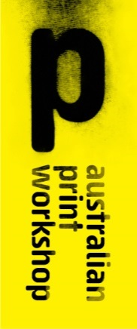

210 Gertrude Street, Fitzroy, Victoria 3065 Australia

PO Box 1236, Collingwood, Victoria 3066 Australia

Telephone 03 9419 5466

[auspw@bigpond.com](mailto:auspw@bigpond.com)

[www.australianprintworkshop.com](http://www.australianprintworkshop.com)

LAITH McGREGOR

Statement of Artwork and Resume

In 2014 Laith McGregor took part in the prestigious APW Collie Print Trust Printmaking Fellowship.

During his fellowship project Laith produced a series of lithographs and a large scale multi-panel etching. APW is submitting the large scale etching titled ‘DARK WAS THE NIGHT’ for the City of Yarra 2015 New Acquisition program.

The APW Collie Print Trust Printmaking Fellowship has become a significant annual printmaking award in Australia. The fellowship facilitates an extraordinary opportunity for a leading Australian Artist to work in collaboration with APW’s highly skilled printers to develop a major body of work in the print medium at APW’s professional studio base in the heart of Gertrude Street, Fitzroy.

Laith McGregor completed studies in painting at the Victorian College of Arts and became known for his meticulously detailed large scale drawings on paper.

Laith was commissioned to produce a large scale drawing for the National Gallery of Victoria’s exhibition *Melbourne Now, 2013/14.* He has also exhibitedhis custom made ping pong tables in Melbourne Now and *The Red Queen* at the Museum of Old and New Art, Hobart in 2013/14.

McGregor has been awarded a number of important awards including the National Works on Paper Prize, Mornington Peninsula Regional Gallery and a residency at the Australia Council’s studio in Barcelona in 2012; the Robert Jacks Drawing Prize, Bendigo Art Gallery in 2008.

McGregor commented about his fellowship at APW, ‘I approached each print in an intuitive manner, allowing the subconscious to take a major role in directing the outcome of the work and the possibilities of further exploration. The potential for what is hidden holds the possibilities of further implications. It is this illusory state which affirms the position of the subconscious as the major pretext for my practice.’

Laith McGregor’s exhibition *Storyteller* was shown at Australian Print Workshop Gallery

from 29 March to 17 May 2014.

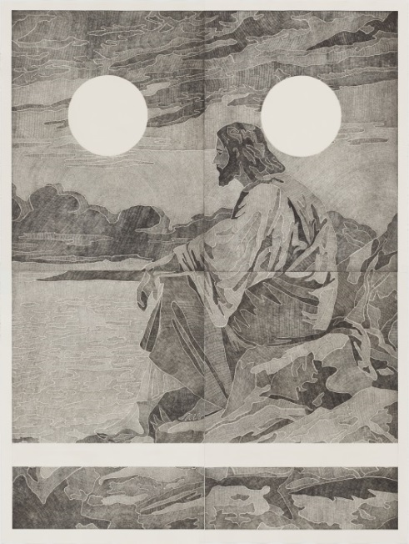

Details of Artwork

Laith McGregor

*‘DARK WAS THE NIGHT’*

Etching

Drawn on four copper plates by the Artist and printed in an edition of 10 plus proofs by APW Senior Printer Martin King at Australian Print Workshop, Melbourne 2014.

Image size: 240 x 180cm

Paper size: 249 x 188cm