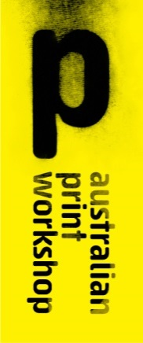

210 Gertrude Street, Fitzroy, Victoria 3065 Australia

PO Box 1236, Collingwood, Victoria 3066 Australia

Telephone 03 9419 5466

[auspw@bigpond.com](mailto:auspw@bigpond.com)

[www.australianprintworkshop.com](http://www.australianprintworkshop.com)

RICK AMOR

Statement of Artwork and Resume

In 2014 Australian Print Workshop was invited by The Collie Print Trust to reinstate and administer the George Collie Memorial Award.

Established in honour of the late George Collie (1893-1961), who worked for his father's print ink manufacturing company R. Collie & Co Pty Ltd, the award was originally created to acknowledge excellence in the commercial printing industry.

The prestigious George Collie Memorial Award has been re-established as an annual award for fine art printmaking; to recognise and celebrate those who have made significant and enduring contributions to Australian printmaking.

The inaugural APW George Collie Memorial Award was presented to two highly respected and influential Australian artists; Noel Counihan and Rick Amor.

APW is submitting Rick Amor’s lithograph titled *Lost Time* for the City of Yarra 2015 New Acquisition program.

Rick is renowned for his evocative and powerful prints, which reflect Melbourne inner city streets. He has a lifelong dedication to the art of printmaking. Rick’s creative relationship with Australian Print Workshop spans almost three decades. Over the years, Rick has produced over 80 fine art limited prints in collaboration with APW Printers that have been exhibited and acquired by major Art Galleries and Museums throughout Australia and overseas.

Rick Amor’s lithograph *Lost Time* was specially commissioned by APW as part of the George Collie Memorial Award.

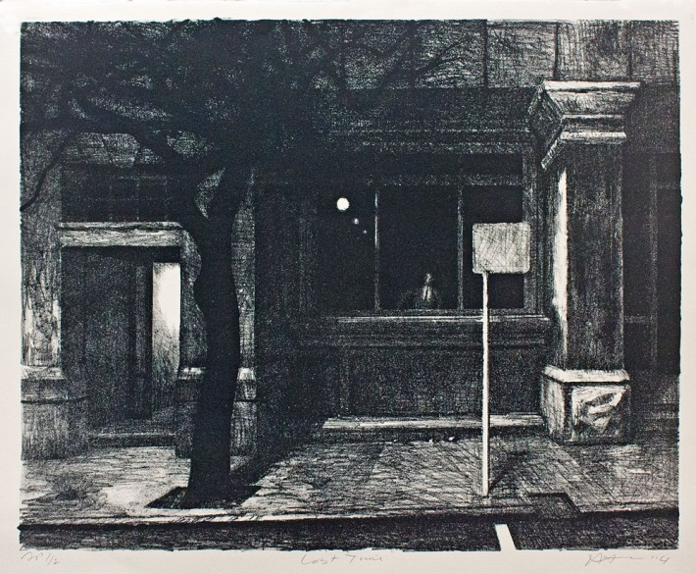

Details of Artwork

Rick Amor

*Lost Time*

Lithograph

Drawn on the stone by the Artist and printed in an edition of 15 plus proofs by APW Senior Printer Martin King at Australian Print Workshop, Melbourne 2014.

Image size: 51.5cm x 64cm

Paper size: 56 x 76cm

This work was specially commissioned by APW for the APW George Collie Memorial Award exhibition.