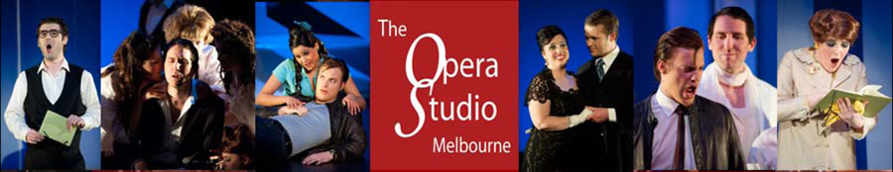

**What we do**

The Opera Studio Melbourne supports and facilitates development for highly trained aspiring operatic artists through performance.  We encourage exploration of potential in rehearsal, concert and theatrical contexts, and before an audience.  By simulating a repertory company, with extra training, attention and preparation, we provide an invaluable opportunity for a singer to learn and to practise essential skills to immerse fully in the craft of story-telling through singing, with the advice and guidance of industry professionals. Experience, in intensive rehearsal and performance, provides the means for refining skills and defining an artistic personality, crucial for a career in opera in the 21st century.  We aim to provide experiences that are both challenging and inspirational, and simulate real pressures and working conditions.  In order to perpetuate the relevance and possibilities for opera and employment into the future, our program is a mixture of the traditional and the daring.

**What we are**

We are an independent training program, incorporated as a not-for-profit association, with Deductible Gift Recipient Status, on the Register of Cultural Organisations, and a Tax-Exempt Charity. Formed in 2008, we opened our doors to our first intake of singers from VIC, NSW, QLD, WA and NZ in March 2009. We are fortunate have a highly experienced voluntary committee of management, chaired by Melbourne barrister Bill Gillies. Artistic Director Linda Thompson, Head of Music Andrea Katz, Head of Direction Cameron Menzies, and a casual Administrative Assistant make up the core staff. The goodwill and generosity of opera and industry professionals, who give of their time in Master Classes for the benefit of the establishment of our Studio and the young singers we guide and train, has meant that we have, on a shoe-string, achieved a reputation in two short years for the quality and professionalism of our singers. We have attracted international attention, from prospective singers and from vocal arts practitioners, for the unique and intense nature of our program. Now into our third year, we welcome singers from Mexico, Hong Kong and the U.K., as well as from VIC, ACT, WA and NSW.

**How we came to be**

In 1936, soprano Gertrude Johnson started the first Opera School in Australia. In the 1970s, the Opera School at the National Theatre was taken over by the Victorian College of the Arts, and over the next 25 years or so, the VCA opera course provided part-time training in theatre, music and languages, for many successful singers who went on to have international careers. The Opera School at the VCA ceased operation in 2007, and there is no opera-specific course of study at the University of Melbourne. The Melba Conservatorium, started by Dame Nellie in 1901, closed in 2008, and the privately funded Australian Opera Studio in Perth closed in 2009. As Head of Voice at Monash University, Linda Thompson saw a need and opportunity, with the wealth of experienced professionals available in Australia, for the provision of both training *and* experience for our highly trained singers coming out of University and private study programs. Now entering our third year, the value of devotion to a daily grind of singing with peers, surrounded by the guidance of professionals, in an intense, demanding public performance program is borne out by our early success. In 2010, three of our ‘graduates’ gained professional contracts with Opera Australia-OzOpera, two with Victorian Opera, and one was recently seen onstage in a small role with Melbourne Opera.