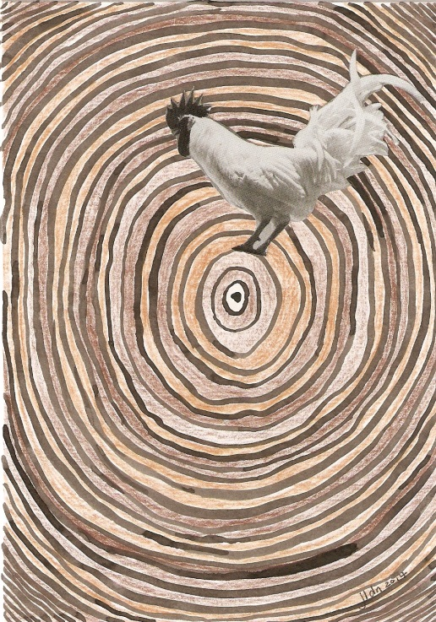 ‘Wake the hell up’, mixed media on card, 2014

‘Where to from here?’, mixed media on card, 2014 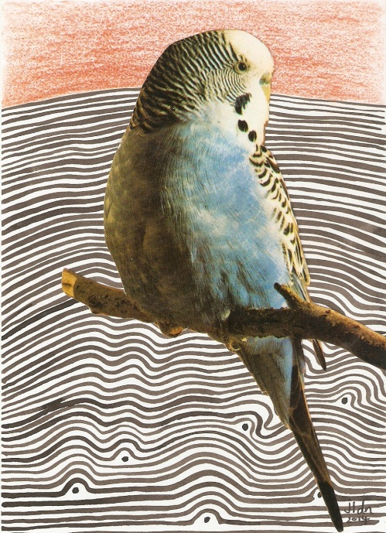

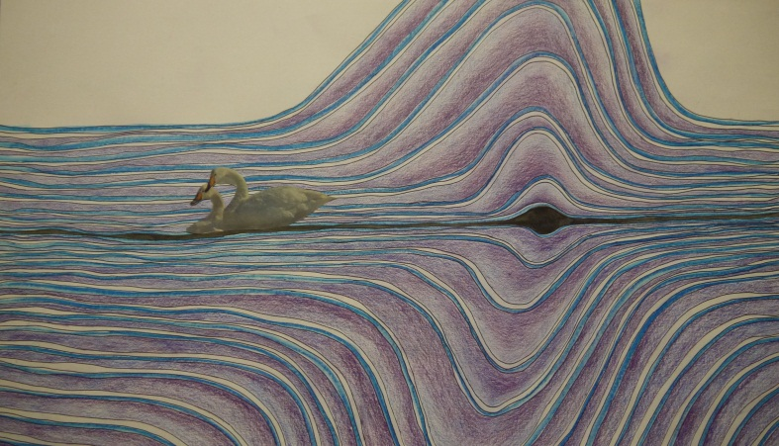

‘When a drop arises in our ocean’, mixed media on paper, 2014