Query1: Monthly Usage Trends
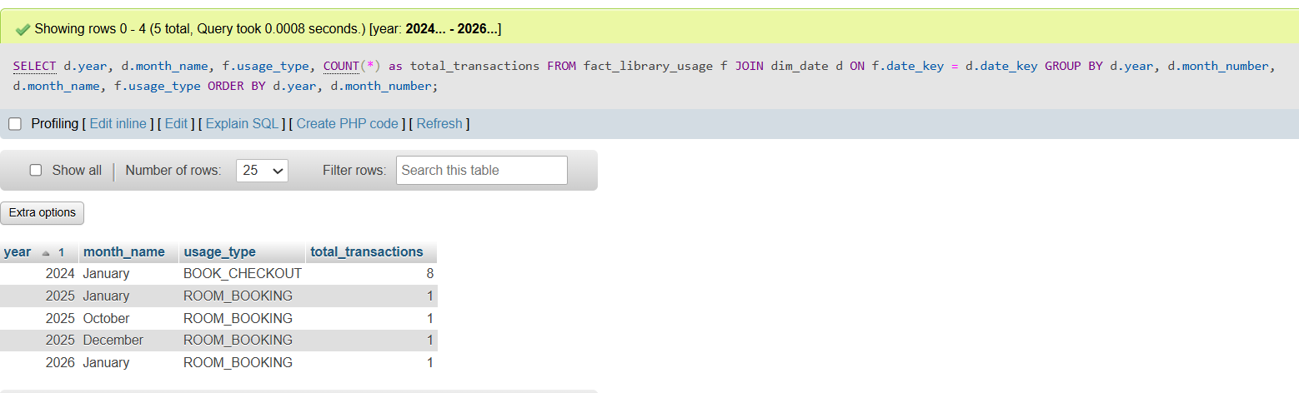
Query 2: Department Usage Ranking
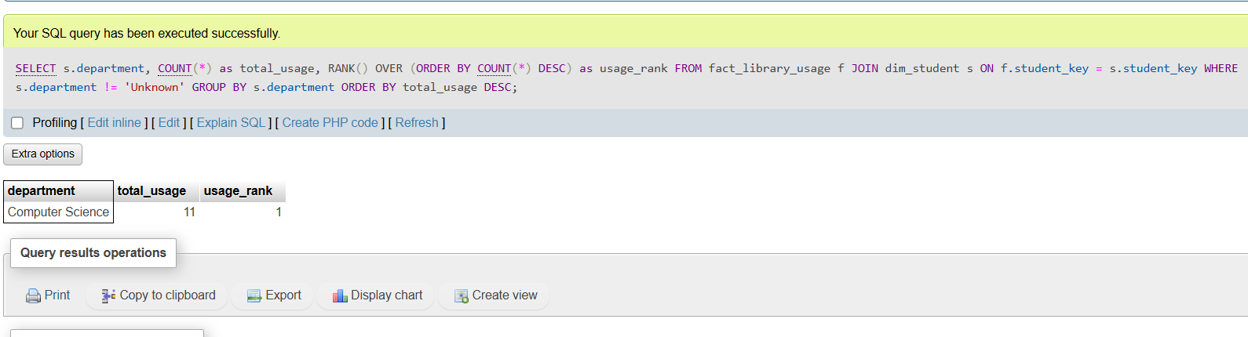
Query 3: Peak Times for Room Bookings
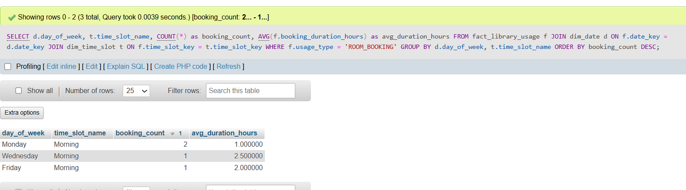

Query 4: Top 10 Resources

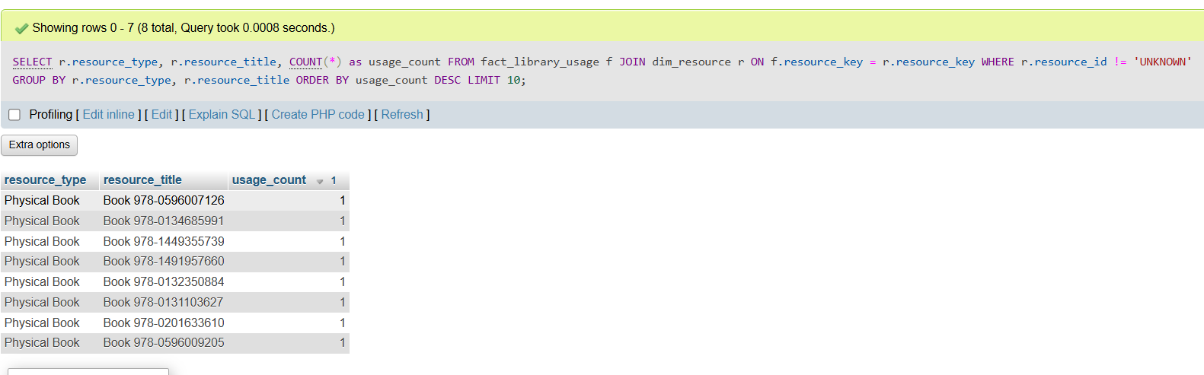
Query 5: DRILL-DOWN Analysis (Year to Month)
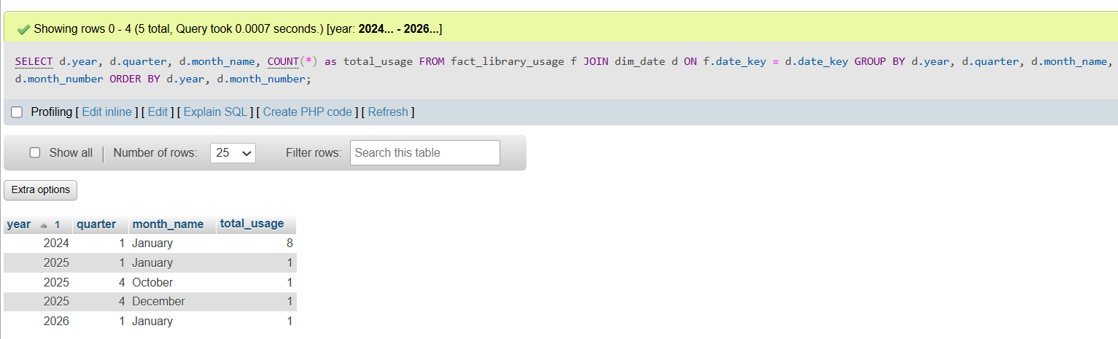
DRILL-DOWN Analysis (Year to quarter)
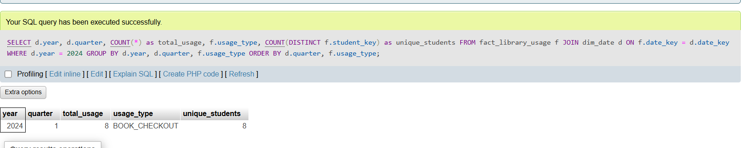
#Drill down to daily: January 2024
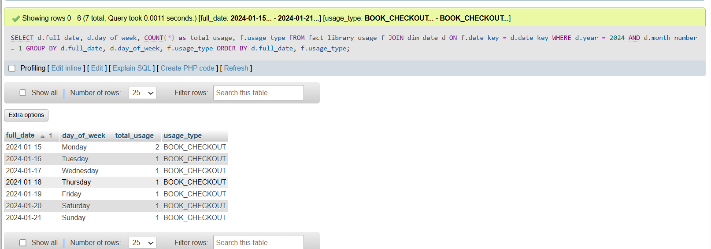
Query 6: ROLL-UP Analysis (Day → Week → Month → Quarter)
-- Business Question: Aggregate daily room bookings into higher levels
-- Daily bookings
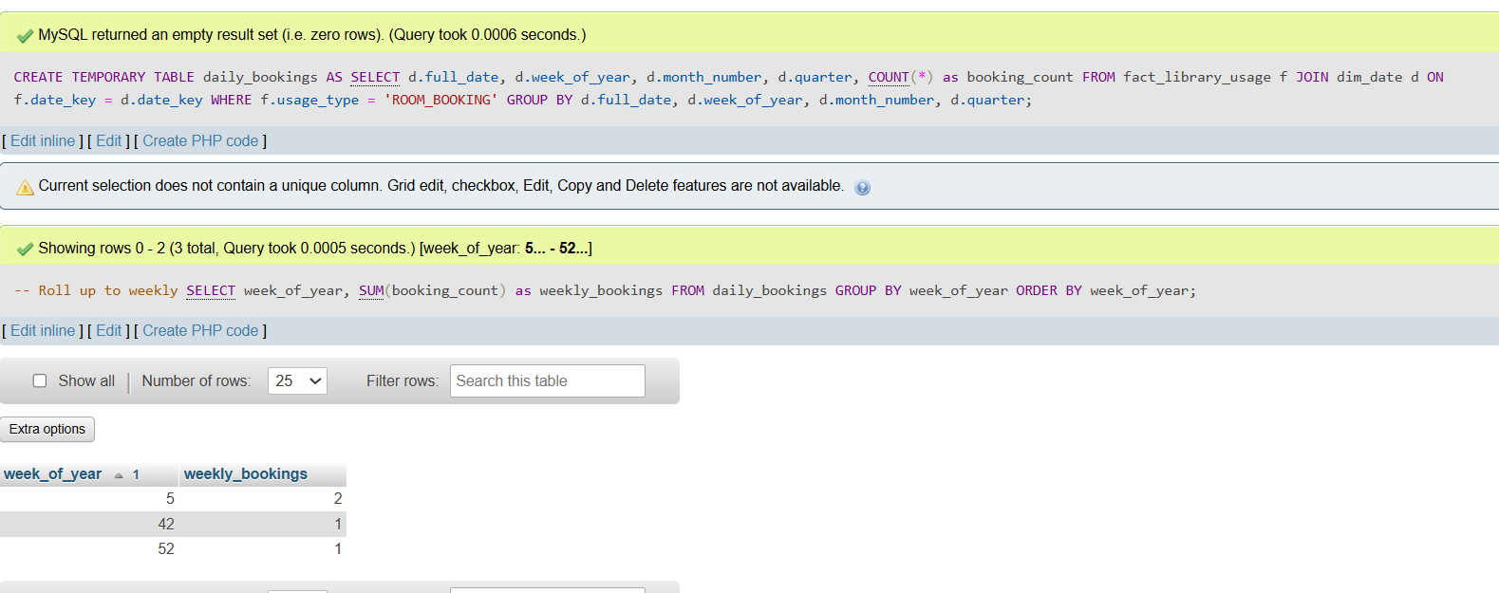
-- Query 7: SLICING - Specific Time Period Analysis
-- Business Question: View all data for 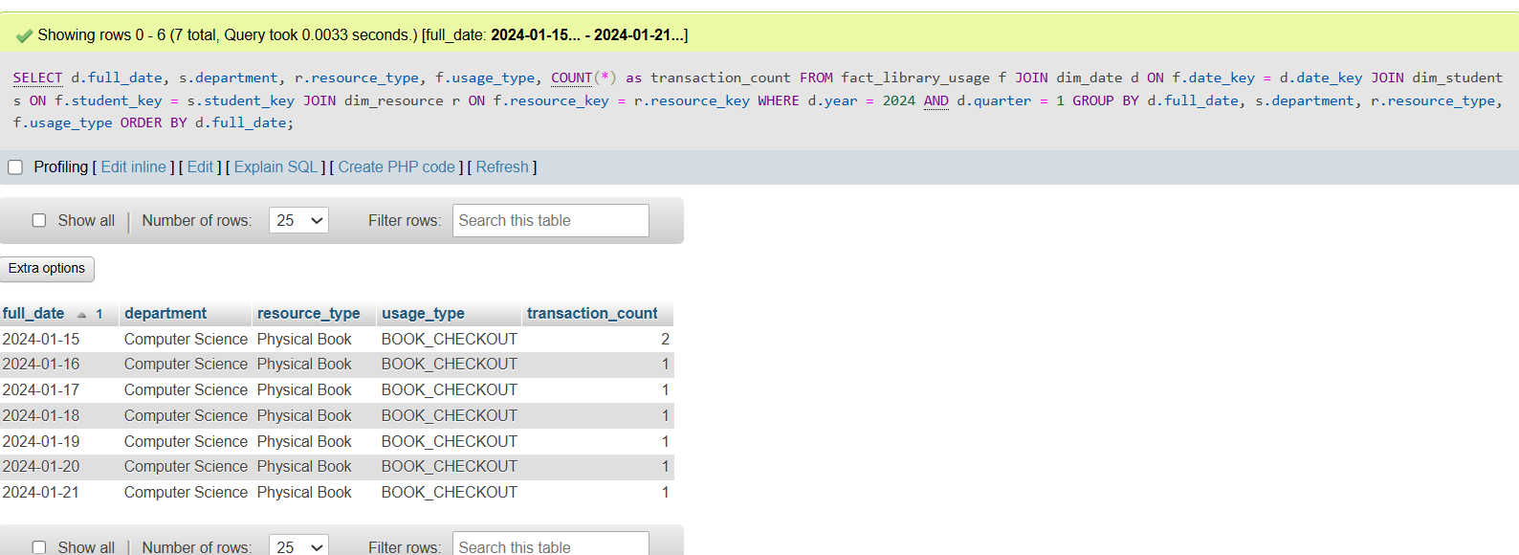

-- Query 8: PIVOT Analysis - Cross-tabulation
-- Business Question: Compare resource types across departments in matrix format
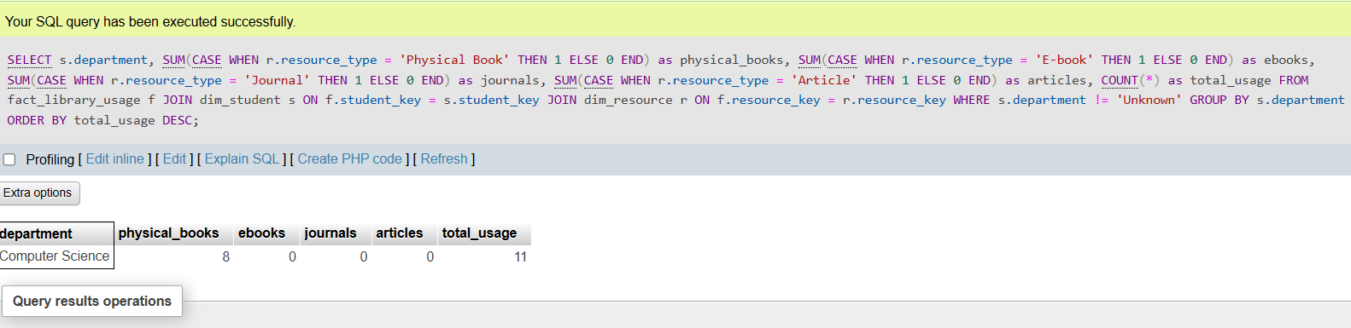
Query 9: Trend Analysis with Moving Averages
-- Business Question: Identify usage trends over time
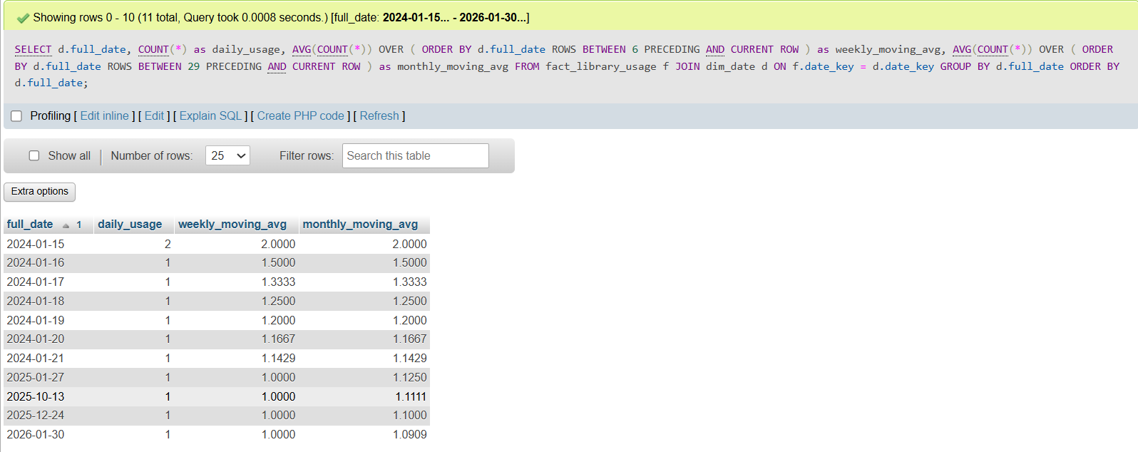
Query 10: Anomaly Detection
-- Business Question: Identify unusual patterns (sudden drops/spikes in usage)
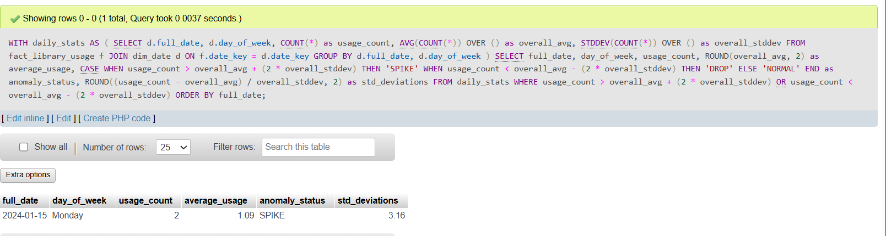
Query 11: Student Engagement Score
-- Business Question: Calculate engagement score based on multiple factors
