Digital Electronics and Computer Organisation (CSE-207)
Project Report
MORSE CODE DECODER
A synchronous hardware decoder using counters, shift registers, a ROM look-up table and a 14-segment display
Submitted by
[Student Name 1] – [Roll No.]
[Student Name 2] – [Roll No.]
[Student Name 3] – [Roll No.]
Submitted to
Dr. Sarita Kumari
[Department of Computer Science and Engineering]
[Institute Name]
[Month Year]

Abstract
Morse code represents each letter and digit as a short sequence of dots and dashes separated by silent gaps of defined length. This project designs a purely digital Morse code decoder that accepts hand-keyed input from a push button and displays the decoded character on a 14-segment display. Time is measured by counting pulses of a 40 Hz clock: one counter classifies every key press as a dot or a dash, a second counter detects the end of a character, a shift register and a counter record the received pattern and its length, and an EEPROM acting as a look-up table converts the pattern into segment signals. The whole circuit is synchronous, uses standard 74HC-series ICs, and needs no microcontroller. A clock-accurate behavioural model of the circuit decoded every test message correctly, including the full pangram and all ten digits, even with ±25 % random timing error on every element.

1. Introduction and Objectives
Morse code is one of the oldest digital communication schemes and is still used in amateur radio, aviation beacons and emergency signalling. Decoding it is a natural digital-electronics problem because it combines timing measurement (counters), sequence storage (shift registers), control (a small finite-state sequence built from flip-flops and gates) and code conversion (a ROM decoder driving a display). These are the core topics of CSE-207.
The objectives of the project are:
- to classify each key press as a dot or a dash by measuring its duration digitally;
- to detect the gap that separates characters and to store the received dot/dash pattern;
- to translate the pattern into the corresponding letter (A–Z) or digit (0–9) using a ROM look-up table; and
- to display the decoded character, give audible feedback, and allow the operator to adjust the keying speed.

2. Background: Morse Code Timing
International Morse code (ITU-R M.1677-1) defines every duration as a multiple of a basic unit equal to the length of one dot. Table 1 lists the rules. At a speed of W words per minute the unit length is T = 1.2 / W seconds, so at 12 WPM one unit is 100 ms.
Element | Key state | Duration
Dot (•) | pressed | 1 unit
Dash (–) | pressed | 3 units
Gap between symbols of one character | released | 1 unit
Gap between characters | released | 3 units
Gap between words | released | 7 units
Table 1. Morse code timing rules
A decoder therefore needs two thresholds. A press longer than 2 units (midway between 1 and 3) is a dash; otherwise it is a dot. A silence longer than 2 units marks the end of a character. Placing each threshold in the middle gives a tolerance of almost ±1 unit, which matters because human keying is never perfectly regular.

3. System Overview
Figure 1 shows the block diagram. A single NE555 clock of 40 Hz drives every flip-flop, so the clock period (25 ms) equals one quarter of a dot at 12 WPM. Each duration is measured as a count of clock ticks, and each 2-unit threshold becomes a count of 8 ticks. Because 8 = 1000₂, the threshold test needs no comparator: it is simply output Q_{D} (the 8s bit) of a 4-bit counter.
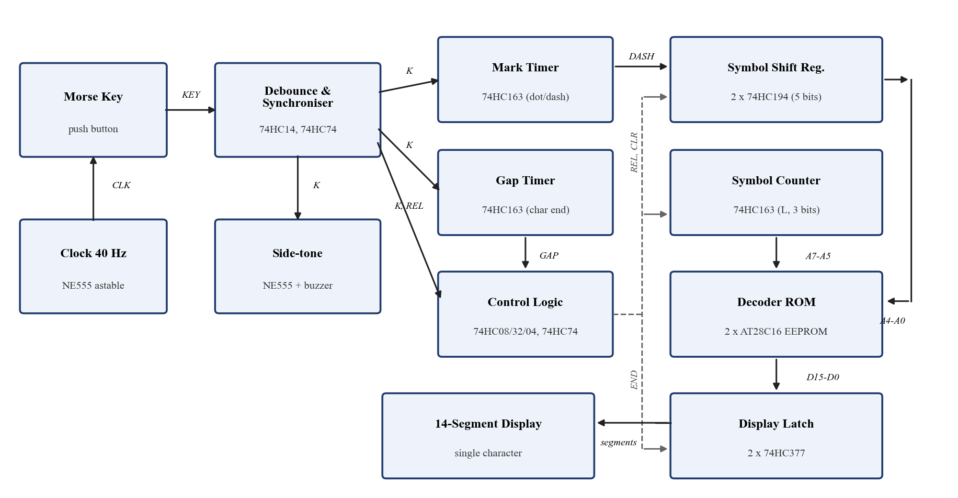
Figure 1. Block diagram of the Morse code decoder
The signal flow is as follows. The key is debounced and synchronised to the clock (signal K). While K is high, the mark timer counts; on release it holds the result DASH = 1 if the press lasted at least 8 ticks. A one-clock REL (release) pulse shifts DASH into the symbol shift register and increments the symbol counter L. While K is low the gap timer counts; when it reaches 8 ticks the control logic produces an END pulse, which latches the ROM output into the display latch. A CLR pulse on the following clock resets the shift register and counter, ready for the next character.

4. Detailed Design

4.1 Clock Generator
An NE555 in astable mode generates the system clock with frequency
f = 1.44 / ((R₁ + 2R₂) C)
With C = 1 µF, R₁ = 1 kΩ and R₂ = 10 kΩ in series with a 20 kΩ potentiometer, f can be set from about 24 Hz to 69 Hz. Since one unit equals 4 ticks, the keying speed is W = 0.3 f, so the potentiometer acts as a speed control covering roughly 7 to 20 WPM. The nominal setting is 40 Hz (12 WPM).

4.2 Key Input, Debouncing and Synchronisation
The key connects to ground with a 10 kΩ pull-up and a 10 kΩ / 100 nF RC filter (time constant 1 ms), followed by a 74HC14 Schmitt-trigger inverter, so a pressed key gives logic 1. Two D flip-flops of a 74HC74 then sample this signal on every clock edge. The first output is the synchronised key K; the second is K delayed by one clock, K_{d}. Sampling every 25 ms also removes any remaining contact bounce, which normally lasts less than 5 ms. The release pulse is
REL = K̅ · K_{d}
REL is high for exactly one clock period after the key is let go.

4.3 Mark Timer (Dot/Dash Classifier)
A 74HC163 synchronous 4-bit counter measures the press length. Its count enables are ENP = ENT = K · Q̅_{D}, so it counts while the key is down and stops at 8; it can never wrap around and turn a long dash back into a dot. Its active-low synchronous clear is CLR̅ = K + K_{d}, so it clears only when the key has been up for two clock edges. This is the key timing point: during the REL clock cycle the count is still held, so DASH = Q_{D} is valid exactly when the shift register samples it. A nominal dot gives a count of 4 (DASH = 0); a nominal dash gives a count of 8 (DASH = 1).

4.4 Symbol Shift Register and Symbol Counter
Two 74HC194 4-bit universal shift registers are cascaded (Q_{D} of the first drives the serial input DSR of the second) to give 8 bits, of which 5 are used. Mode inputs are S₁ = 0 and S₀ = REL, so the register shifts right on the REL clock and holds otherwise. The serial input DSR receives DASH. After n symbols, Q_{A} holds the most recent symbol and the first symbol sits n − 1 places further along, so Q_{E} … Q_{A} form the Morse pattern read as a binary number (dot = 0, dash = 1, first symbol most significant).
Because “E” (•) and “I” (••) both give the pattern 0, the pattern alone is ambiguous. A third 74HC163 therefore counts the number of symbols L (ENP = ENT = REL). Both the register and the counter are cleared by CLR.

4.5 Gap Timer and Character-End Control
A fourth 74HC163 measures silence. It is enabled by ENP = ENT = K̅ · Q̅_{D} and cleared by CLR̅ = K̅ (that is, it clears while the key is pressed). Its output GAP = Q_{D} rises after 8 ticks (2 units) of silence. This happens after the 3-unit character gap but never after the 1-unit gap between symbols. A third 74HC74 flip-flop stores the previous value GAP_{d}. The control equations are:
END = GAP · GAP̅_{d} · (L₂ + L₁ + L₀) CLR = END delayed by one clock
The (L ≠ 0) term stops END from firing at power-up, when no symbols have been received. Because the gap counter stops at 8, END fires only once per gap, so a long pause leaves the last character on the display. The fourth 74HC74 flip-flop generates CLR. Table 2 summarises the control logic.
Signal | Logic equation | Function
K, K_{d} | D-FF outputs (74HC74) | synchronised key and its 1-clock delay
REL | K̅ · K_{d} | key released: shift DASH in, increment L
DASH | Q_{D} of mark timer | press ≥ 8 ticks (2 units)
GAP | Q_{D} of gap timer | silence ≥ 8 ticks: character finished
END | GAP · GAP̅_{d} · (L ≠ 0) | latch decoded character into display
CLR | END delayed 1 clock | clear shift register and symbol counter
Table 2. Control signals and logic equations

4.6 ROM Decoder
The decoder is a look-up table stored in two AT28C16 (2K × 8) EEPROMs that share the same address. The 8-bit address combines the length and the pattern:
Address = 32 · L + Pattern (A₇–A₅ = L, A₄–A₀ = Q_{E} … Q_{A}, A₁₀–A₈ = 0)
For example, “A” = •– has L = 2 and pattern 01₂, giving address 32 × 2 + 1 = 41h. Every one of the 36 characters gets a unique address (Table 3). The low EEPROM supplies segments A–G2 and the high EEPROM supplies segments H–N and the decimal point. Addresses that are not valid Morse codes, including any sequence longer than 5 symbols (L = 6 or 7), contain the pattern for “?”, so keying errors are shown clearly instead of producing random segments. The contents were generated by the script morse_model.py as the files rom_lo.hex and rom_hi.hex and can be written with any universal programmer, such as a TL866.
Char | Code | Addr | Char | Code | Addr | Char | Code | Addr
A | •– | 41h | M | –– | 43h | Y | –•–– | 8Bh
B | –••• | 88h | N | –• | 42h | Z | ––•• | 8Ch
C | –•–• | 8Ah | O | ––– | 67h | 0 | ––––– | BFh
D | –•• | 64h | P | •––• | 86h | 1 | •–––– | AFh
E | • | 20h | Q | ––•– | 8Dh | 2 | ••––– | A7h
F | ••–• | 82h | R | •–• | 62h | 3 | •••–– | A3h
G | ––• | 66h | S | ••• | 60h | 4 | ••••– | A1h
H | •••• | 80h | T | – | 21h | 5 | ••••• | A0h
I | •• | 40h | U | ••– | 61h | 6 | –•••• | B0h
J | •––– | 87h | V | •••– | 81h | 7 | ––••• | B8h
K | –•– | 65h | W | •–– | 63h | 8 | –––•• | BCh
L | •–•• | 84h | X | –••– | 89h | 9 | ––––• | BEh
Table 3. ROM addresses of all 36 characters (Address = 32·L + pattern)

4.7 Display Latch, Display and Side-tone
Two 74HC377 octal D flip-flops with enable hold the 16 ROM outputs. Their clock is the system clock and their active-low enable is END̅, so the display updates on exactly one clock edge per character and stays steady while the next character is being keyed. The latch outputs drive a common-cathode 14-segment display through 330 Ω resistors (about 6 mA per segment). A second NE555 runs at about 700 Hz, and K drives its RESET pin, so a piezo buzzer sounds while the key is pressed. This side-tone helps the operator key with even timing.

5. Worked Example: Decoding the Letter “A”
Figure 2 shows the waveforms from the clock-accurate model when “A” (•–) is keyed at the nominal speed.
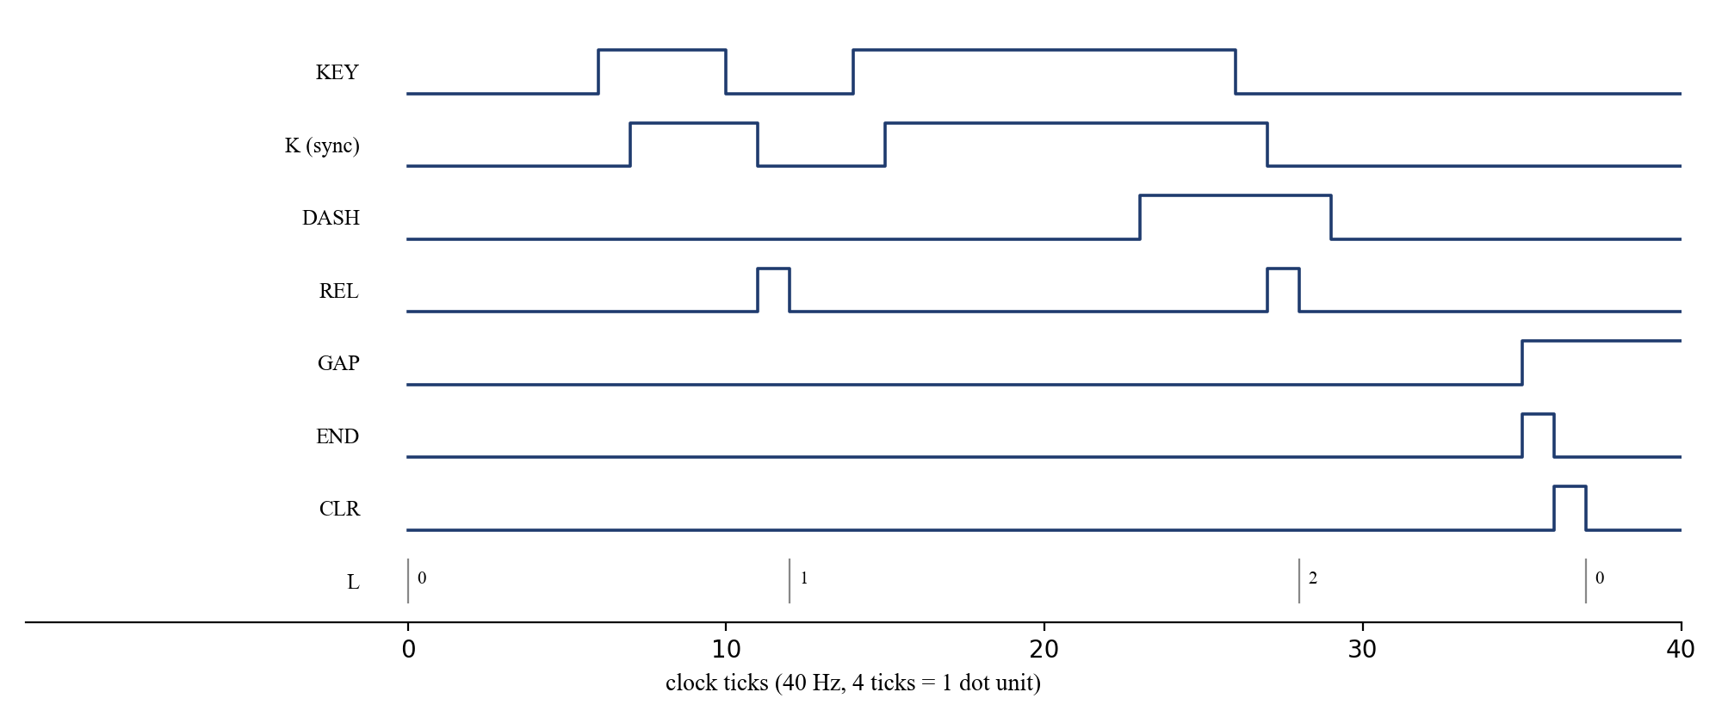
Figure 2. Timing diagram for the letter “A” (4 clock ticks = 1 unit)
- The dot lasts 4 ticks. The mark timer reaches 4, so DASH = 0. REL shifts 0 into the register and L becomes 1.
- The 1-unit gap (4 ticks) is shorter than 8 ticks, so GAP stays low and the character is not finished.
- The dash lasts 12 ticks. The mark timer stops at 8, so DASH = 1. REL shifts 1 in and L becomes 2. The pattern is now 01₂.
- After 8 ticks of silence GAP rises and END pulses. The ROM is at address 32 × 2 + 1 = 41h, so the latch captures the segments of “A”.
- On the next clock CLR resets the register and L to 0, ready for the next character.

6. Verification
Before building the hardware, the design was checked with a clock-accurate behavioural model written in Python (morse_model.py). Like the real circuit, the model updates every register on a single clock edge using the logic equations above. It produces ideal keying waveforms for complete messages and then repeats each test with every element randomly lengthened or shortened by one tick (±25 % of a unit) to imitate an imperfect human operator. Table 4 lists the results.
Test message | Ideal timing | ±1 tick jitter
SOS | Pass | Pass
HELLO WORLD | Pass | Pass
THE QUICK BROWN FOX JUMPS OVER THE LAZY DOG (all 26 letters) | Pass | Pass
0123456789 (all digits, 5-symbol codes) | Pass | Pass
Table 4. Simulation results (decoded output compared with the transmitted text)
For hardware testing, the recommended order is: (i) check the clock frequency with an oscilloscope or frequency counter; (ii) watch K and REL on LEDs while pressing the key slowly; (iii) confirm that DASH lights only for long presses; (iv) read the EEPROMs back with the programmer before fitting them; and finally (v) key the test messages of Table 4. The design can also be entered into Logisim-Evolution, which provides all the counters, registers and ROM components used here, so it can be demonstrated in simulation during the presentation.

7. Components List
Component | Qty | Purpose
NE555 timer | 2 | 40 Hz system clock; 700 Hz side-tone
74HC14 hex Schmitt inverter | 1 | key debouncing; logic inversions
74HC74 dual D flip-flop | 2 | K, K_{d} synchroniser; GAP_{d} and CLR registers
74HC163 4-bit synchronous counter | 3 | mark timer, gap timer, symbol counter
74HC194 4-bit universal shift register | 2 | dot/dash pattern storage
74HC08 AND / 74HC32 OR | 1 + 1 | REL, enable and END logic
AT28C16 2K × 8 EEPROM | 2 | Morse-to-segment look-up table
74HC377 octal D flip-flop with enable | 2 | display latch
14-segment display (common cathode) | 1 | character output
Push-button key, piezo buzzer, 20 kΩ pot | 1 each | input, side-tone, speed control
Resistors, capacitors, LM7805, breadboard | – | biasing, timing, 5 V supply
Table 5. Bill of materials

8. Applications, Limitations and Future Scope
Applications: Morse training aids for amateur-radio learners; assistive communication, because a single switch can be operated by blinking, puffing or tapping; and teaching of sequential logic, since one small circuit shows counters, registers, ROM decoding and control timing working together.
Limitations: the speed is fixed by the potentiometer rather than tracked automatically; only one character is shown at a time; word gaps are not displayed; and punctuation (6-symbol codes) is shown as “?”.
Future scope: (i) cascading several 74HC377 latches as a shift chain to give a scrolling multi-character display; (ii) a third threshold of about 5 units on the gap timer to insert a blank for word spaces; (iii) an LM567 tone decoder or photodiode front end, so that Morse can be received from audio or light signals; and (iv) an adaptive threshold that tracks the operator’s average dot length.

9. Conclusion
A complete Morse code decoder was designed using only standard digital ICs. Measuring time by counting clock ticks, and choosing a threshold of 8 ticks, made both the dot/dash decision and the character-end decision depend on a single counter bit. Combining the symbol count with the pattern produced a collision-free ROM address, so one look-up table decodes all 26 letters and 10 digits. A clock-accurate simulation confirmed correct decoding of every test message, with a timing tolerance of at least ±25 %. The project brings together counters, shift registers, flip-flop-based control, memory-based code conversion and display interfacing from the CSE-207 syllabus.

References
- ITU-R Recommendation M.1677-1, International Morse Code, International Telecommunication Union, 2009.
- M. Morris Mano and M. D. Ciletti, Digital Design, 6th ed., Pearson, 2018.
- T. L. Floyd, Digital Fundamentals, 11th ed., Pearson, 2015.
- Texas Instruments, SN74HC163 Synchronous 4-Bit Binary Counters; SN74HC194 4-Bit Bidirectional Universal Shift Registers; SN74HC377 Octal D-Type Flip-Flops with Clock Enable, datasheets.
- Texas Instruments, NE555 Precision Timer, datasheet.
- Microchip Technology, AT28C16 16K (2K × 8) Parallel EEPROM, datasheet.

