Experiment 2 | Lead-Time Sensitivity
  - TA-RWARE sequential WAIT / ALERT policy - concise experimental report

Objective and protocol
We examine how the training reward saturation horizon (LEAD_MIN) affects the behavior of PPO task-level early-warning policies. Seven PPO policies were trained with LEAD_MIN = 2, 3, 5, 8, 10, 15, and 20; their other PPO settings and the original terminal reward structure were held constant. Each policy was evaluated deterministically on the same 50 held-out mission IDs, alongside an always-WAIT policy and a deadline-margin rule. Evaluation warning thresholds are common to all policies.
The evaluation comprises 1,919 monitorable tasks, including 296 deadline misses (15.4%). The reference comparison uses an actionable-warning requirement of 5 TA-RWARE time units before the deadline. Results reflect one training seed per PPO configuration; no uncertainty intervals can be inferred from these aggregates.

Key performance comparison
Policy | Precision % | Recall % | Timely recall % | FAR % | FP / FN
Margin rule | 88.1 | 100.0 | 58.8 | 2.46 | 40 / 0
PPO L=2 | 93.0 | 99.0 | 59.8 | 1.36 | 22 / 3
PPO L=5 | 88.6 | 99.3 | 62.5 | 2.34 | 38 / 2
PPO L=15 | 93.2 | 98.0 | 60.5 | 1.29 | 21 / 6
PPO L=20 | 91.8 | 99.0 | 61.5 | 1.60 | 26 / 3

Among the selected policies, PPO L=15 yields the lowest false-alarm rate (1.29%; 21 false alarms) and 60.5% actionable recall, but misses six monitorable deadline failures. PPO L=5 provides the highest actionable recall at the five-unit requirement (62.5%; 185 timely alerts), with 38 false alarms. PPO L=2 is a balanced alternative: 22 false alerts and only three missed alerts, compared with 40 and zero for the margin rule.
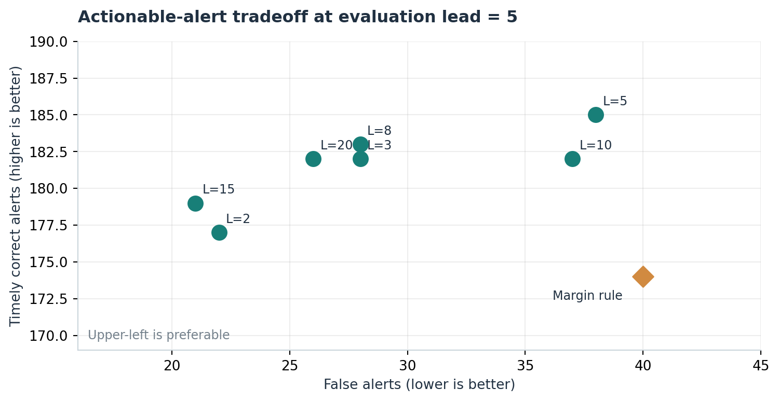
Figure 1. Counts of correct alerts with at least five time units of lead versus false alarms. Each point represents a distinct trained policy.

Lead-time robustness
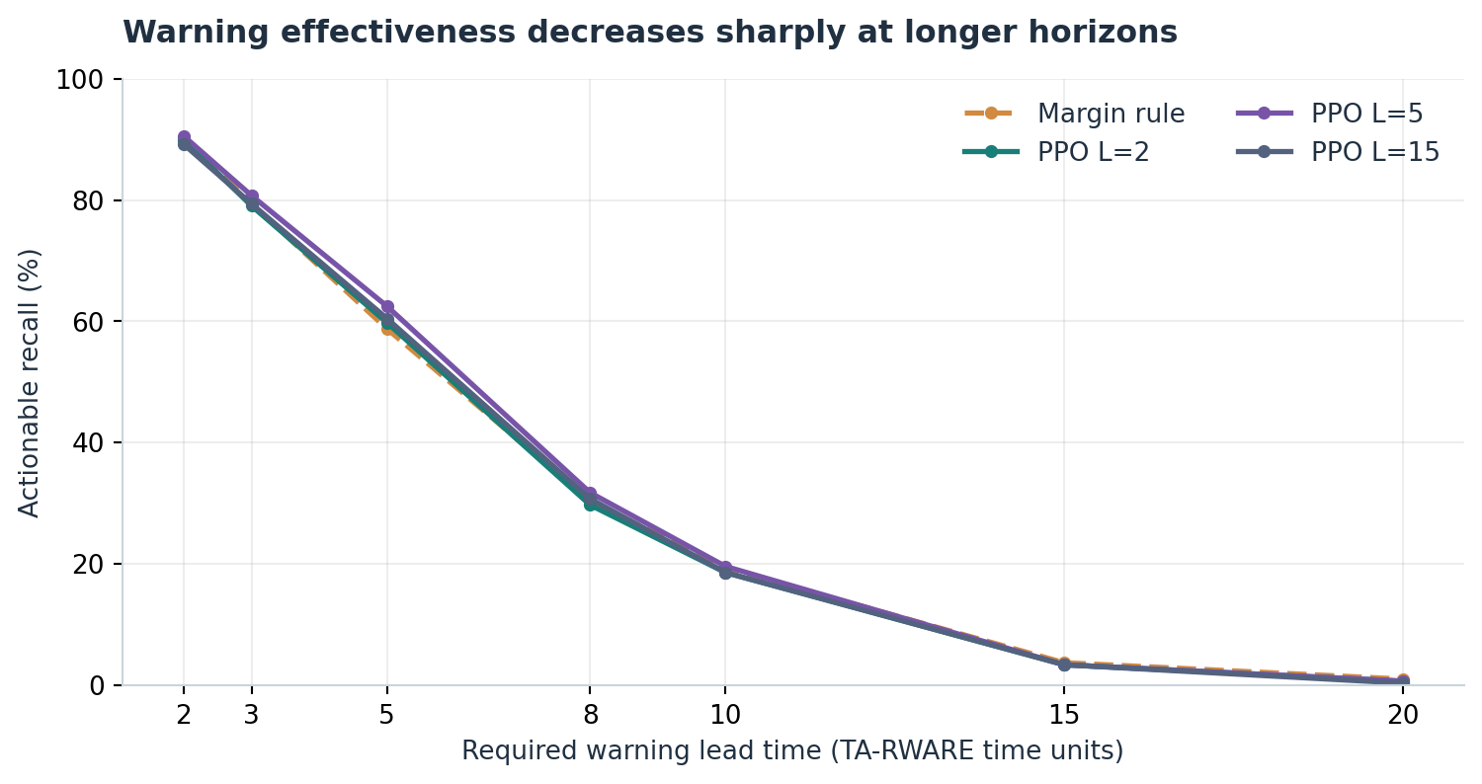
Figure 2. Actionable recall evaluated at several common warning horizons. Training LEAD_MIN and evaluation horizon are different parameters.
Across PPO variants, median true-positive warning lead time is only 5-6 units and tenth-percentile lead time is 2 units. At a requirement of 20 units, actionable recall for all PPO policies is at most about 0.7%. Thus, increasing training LEAD_MIN does not reliably shift warnings earlier; the main observed variation is in false-alarm behavior. Whether this stems from report timing, limited early predictive information, or the learned policies cannot be established from the aggregated CSVs alone.

Observability limit and interpretation
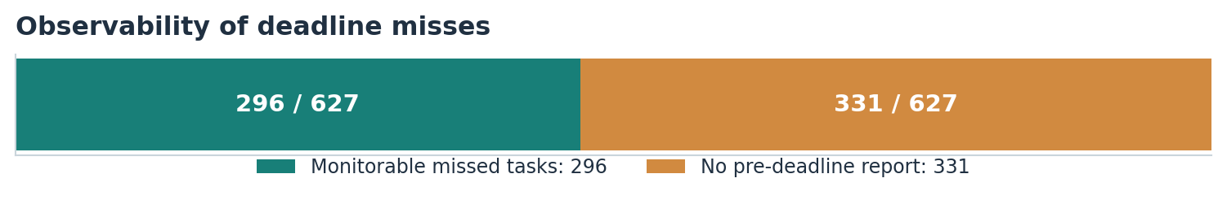
Figure 3. Of 627 deadline-missing tasks, 331 have no report before their deadline and are excluded from policy evaluation.
Conditional recall is calculated over the 296 monitorable deadline misses. Counting all 627 deadline misses, maximum detectable recall is 47.2%, even for an ideal trigger over the existing observation stream. For PPO L=5, its 185 actionable alerts correspond to 29.5% of all deadline misses, versus 62.5% of monitorable misses. The excluded cases should be treated as a monitoring-availability limitation, not PPO classification errors.

Conclusions and next checks
The lead-time sweep reveals a precision-versus-coverage tradeoff, rather than a consistent gain in early alerting. PPO often reduces false alarms relative to the margin rule while retaining near-complete conditional recall. The apparent advantages are preliminary because training was not repeated across seeds and the analysis contains only aggregate policy metrics.
Next, measure earliest report lead time per task, produce paired per-task alert-time comparisons, and rerun selected configurations across multiple independent seeds. Confirm that mission generation is deterministic for each held-out mission ID. A model should not be selected solely from the highest mean reward: the reward changes across training configurations and imposes an application-specific tradeoff.
Source: seven evaluation CSVs named lead_sensitivity_50missions_eval_lead{2,3,5,8,10,15,20}.csv. FP/FN counts were reconstructed from reported rates and shared class totals, with rounding to the nearest integer.

