Experiment 2 | Lead-Time Sensitivity
  - TA-RWARE sequential WAIT / ALERT policy - concise experimental report

Objective and evaluation scope
We evaluate the sensitivity of a task-level PPO early-warning trigger to the training reward parameter LEAD_MIN (2, 3, 5, 8, 10, 15, 20). PPO observes execution feedback for one active task at a time and chooses WAIT or ALERT; it neither changes robot execution nor performs repair. All policies were evaluated deterministically on the same 50 held-out TA-RWARE missions with common evaluation warning horizons. This is an assessment of task-level anticipation, not downstream failure prevention.
The evaluation includes 1,919 monitorable tasks, 296 of which ultimately miss their deadlines (15.4%). The main comparison uses a five-step actionable-warning requirement. One training seed was used per configuration; differences should be considered exploratory.

Key performance comparison
Policy | Precision % | Recall % | Timely recall % | FAR % | FP / FN
Margin rule | 88.1 | 100.0 | 58.8 | 2.46 | 40 / 0
PPO L=2 | 93.0 | 99.0 | 59.8 | 1.36 | 22 / 3
PPO L=5 | 88.6 | 99.3 | 62.5 | 2.34 | 38 / 2
PPO L=15 | 93.2 | 98.0 | 60.5 | 1.29 | 21 / 6
PPO L=20 | 91.8 | 99.0 | 61.5 | 1.60 | 26 / 3

Among the selected policies, PPO L=15 yields the lowest false-alarm rate (1.29%; 21 false alarms) and 60.5% actionable recall, but misses six monitorable deadline failures. PPO L=5 provides the highest actionable recall at the five-unit requirement (62.5%; 185 timely alerts), with 38 false alarms. PPO L=2 is a balanced alternative: 22 false alerts and only three missed alerts, compared with 40 and zero for the margin rule.
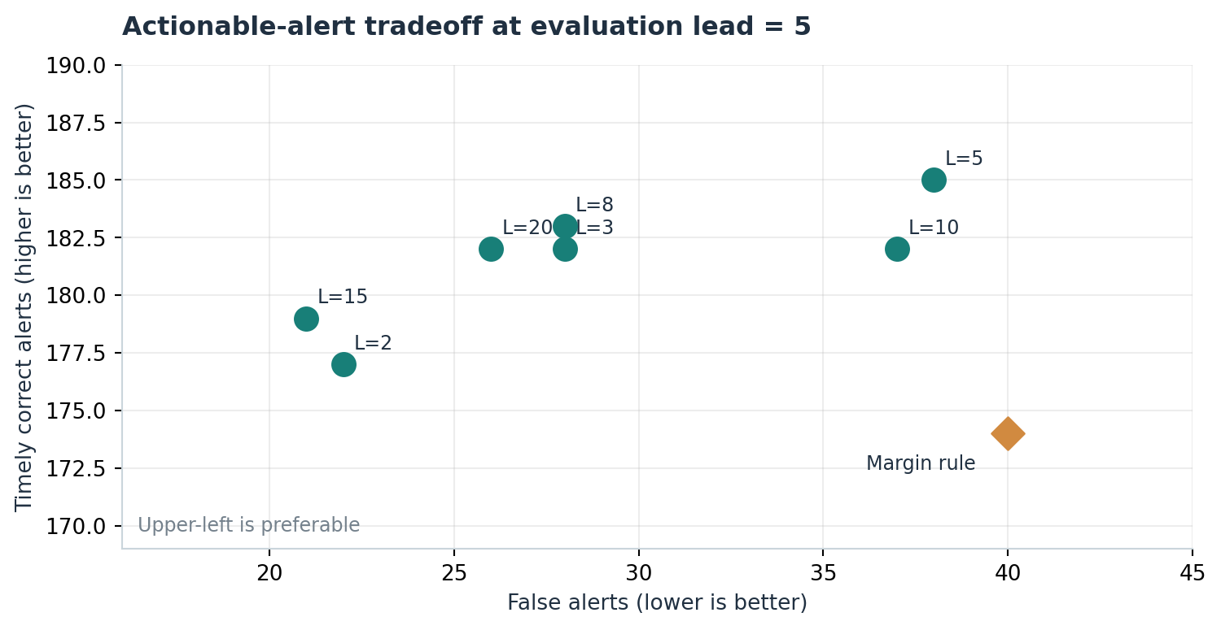
Figure 1. Counts of correct alerts with at least five time units of lead versus false alarms. Each point represents a distinct trained policy.

Lead-time robustness
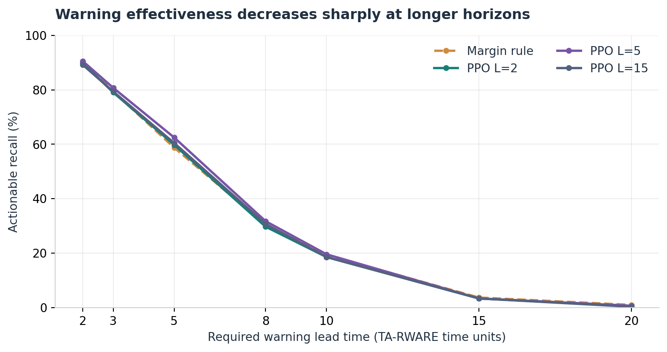
Figure 2. Actionable recall evaluated at several common warning horizons. Training LEAD_MIN and evaluation horizon are different parameters.
Warning lead time changes little across PPO configurations (median 5–6 simulation steps for true-positive alerts), even when the training threshold is increased substantially. At a 20-step warning requirement, the observed actionable recall of PPO variants is below 1%. This alone does not establish poor policy performance: a useful alert may occur on an upstream task before violations propagate to dependent tasks, and early observations may be insufficiently predictive.

First-report feasibility and workflow interpretation
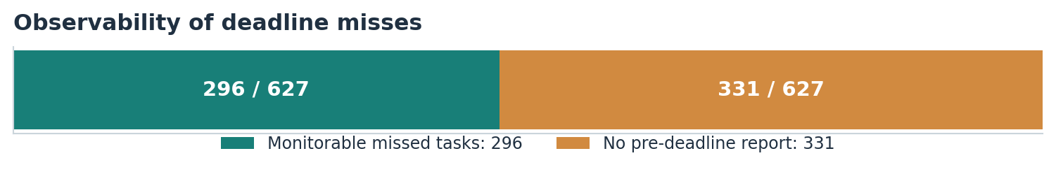
Figure 3. Monitoring availability for deadline-missing tasks. The 331 excluded tasks cannot be warned about individually under the current active-task observation protocol.
Of 627 deadline-missing tasks, 331 have no eligible pre-deadline report. First-report inspection shows that 330 started at or after their own deadlines, with one additional task having no report for another reason. This is a structural limitation of active-task monitoring, not evidence that PPO ignored available reports. Among the 296 monitorable misses, the median earliest available warning lead is 11 simulation steps. At a 10-step requirement, 167/296 (56.4%) could theoretically be warned at their first report, whereas PPO trained at LEAD_MIN=5 delivers 58/296 (19.6%) timely warnings. This feasibility gap does not measure policy error alone: immediate alerts may produce false positives.

Conclusions and next checks
The lead-time sweep reveals a tradeoff between reliable alerts and warning coverage, with limited evidence that larger training LEAD_MIN produces earlier alerts. In several settings PPO reduces false alarms compared with the margin rule while retaining high conditional recall. Crucially, many missed deadlines belong to tasks that begin after their deadlines; a task-local alert cannot anticipate those violations on the affected task itself. In the intended preventive-coordination system, an earlier alert on a predecessor may create an opportunity to modify dependent tasks before their deadlines are violated. Such upstream warning opportunity is not measured by the present task-level metrics, and no repair outcome is claimed.
Next, evaluate predecessor-to-successor warning opportunities using the task dependency chains and alert timestamps, checking whether an upstream alert precedes a downstream deadline with adequate intervention time. Then perform paired per-task policy comparisons and multi-seed training to assess stability. Distinguish task-level detection, workflow-level propagation warning, and actual repair success as separate endpoints.
Sources: seven 50-mission evaluation CSVs (LEAD_MIN 2, 3, 5, 8, 10, 15, 20), first_report_summary.csv, and report_availability.csv. First-report upper bounds assume an oracle could correctly alert at the first eligible report; they are not achievable recall guarantees at a given false-alarm rate.

