Linear Control Theory

Cyril Bernardo

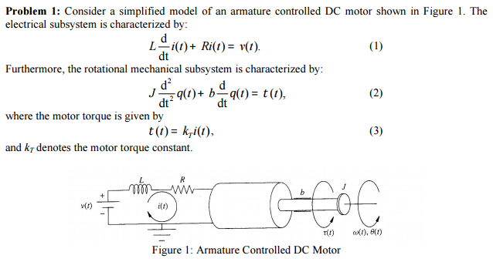

1. **Develop a state space model**
$$A=\left[\begin{matrix}0 & 1 & 0 \\ 0 & -\frac{b}{J} & \frac{k_{i}}{J} \\ 0 & 0 & -\frac{R}{J}\end{matrix}\right]$$

$$B=\left[\begin{matrix}0 \\ 0 \\ \frac{1}{L}\end{matrix}\right]$$

$$C=\left[\begin{matrix}1 & 0 & 0\end{matrix}\right]$$

$$D=0$$

2. **Develop a transfer function from the original data**
$$L(\frac{d}{dt}\left(i\left(t\right)\right)+R\left(i\left(t\right)\right)=v(t) \\ J(\frac{d^{2}}{dt^{2}}\left(θ\left(t\right)\right)+B\left(θ\left(t\right)\right)= τ\left(t\right)=k_{T}\left(i\left(t\right)\right) \\ Ls\left(I\left(s\right)\right)+RI\left(s\right)=V\left(s\right) \\ Js^{2}θ\left(s\right)+Bsθ\left(s\right)=k_{T}I\left(s\right) \\ I\left(s\right)=\frac{V\left(s\right)}{Ls+R} \\ Js^{2}θ\left(s\right)+Bsθ\left(s\right)=\frac{k_{T}V\left(s\right)}{Ls+R} \\ θ\left(s\right)=\frac{k_{T}V\left(s\right)}{\left(Ls+R\right)\left(Js^{2}+Bs\right)} \\ G\left(s\right)=\frac{k_{T}}{\left(Ls+R\right)\left(Js^{2}+Bs\right)}$$

3. **Using MATLAB, find the transfer function as in part B:**

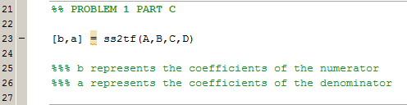

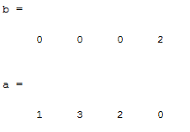

b is a matrix containing the coefficients of the numerator. 2 is the only value in the numerator.

a is the matrix containing the coefficient of the denominator. The denominator is s3 + 3s2 + s2.

1. **Analytically obtain a state-space model for this system from the transfer function found in (B).**

$$G\left(s\right)=\frac{k_{T}}{\left(Ls+R\right)\left(Js^{2}+Bs\right)}$$

$$\left(JLs^{3}+\left(bL+JR\right)s^{2}+bRS\right)θ\left(s\right)=k_{T}\left(V\left(s\right)\right)$$

$$θ_{1}\left(t\right)= θ\left(t\right) \\ θ_{2}\left(t\right)= \dot{θ}\left(t\right) \\ θ_{3}\left(t\right)= \ddot{θ}\left(t\right) \\ θ_{1}\left(s\right)= θ\left(s\right) \\ θ_{2}\left(s\right)= sθ\left(s\right) \\ θ_{3}\left(s\right)=s^{2}θ\left(s\right)$$

$$JLs^{3}θ\left(s\right)+\left(bL+JR\right)s^{2}θ\left(s\right)+bRsθ\left(s\right)=k_{T}V\left(s\right) \\ s^{3}θ\left(s\right)= -\frac{bL+JR}{JL}s^{2}θ\left(s\right)-\left(\frac{bR}{JL}\right)sθ\left(s\right)+\frac{k_{T}}{JL}V\left(s\right)$$ $\left[\begin{matrix}\dot{θ} \\ \ddot{θ} \\ \overset{⃛}{θ}\end{matrix}\right]=\left[\begin{matrix}0 & 1 & 0 \\ 0 & 0 & 1 \\ 0 & -\frac{bR}{JL} & -\frac{bL+SR}{JL}\end{matrix}\right]\left[\begin{matrix}θ \\ \dot{θ} \\ \ddot{θ}\end{matrix}\right]+\left[\begin{matrix}0 \\ 0 \\ \frac{k_{T}}{JL}\end{matrix}\right]$ V(s)

1. **Determine if the state matrix from (A) is diagonalizable**

$$\left[\begin{matrix}0 & 1 & 0 \\ 0 & -\frac{b}{J} & \frac{k_{T}}{J} \\ 0 & 0 & -\frac{R}{L}\end{matrix}\right]-diagonalizable?$$

$$\det\left(A-λI\right)= \left|\begin{matrix}-λ & 1 & 0 \\ 0 & -\frac{b}{J}-λ & \frac{k_{T}}{J} \\ 0 & 0 & -\frac{R}{L}-λ\end{matrix}\right|$$

$$λ=0, -1, -2$$

*Three distinct eigenvalues 🡪 the matrix is diagonalizable*

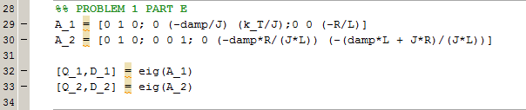

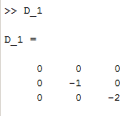

1. **Is the matrix from (D) diagonalizable?**

$$\left[\begin{matrix}0 & 1 & 0 \\ 0 & 0 & 1 \\ 0 & -\frac{bR}{JL} & -\frac{bL+JR}{JL}\end{matrix}\right]-diagonalizable?$$

$$\det\left(A-λI\right)= \left|\begin{matrix}-λ & 1 & 0 \\ 0 & -λ & 1 \\ 0 & -\frac{bR}{JL} & -\frac{bL+JR}{JL}-λ\end{matrix}\right|$$

$$λ=0, -1, -2$$

*Three distinct eigenvalues 🡪 the matrix is diagonalizable*



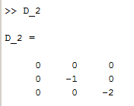

1. **Compare the diagonal realizations of (E) and (F). Are they the same?**

The diagonal realizations for both of these matrices yield the same values for the state matrix. Although they started as different matrices, since the matrix from (D) is an alternative state space model from the same state space in (A), it is predicted that the same eigenvalues would be found meaning the same diagonal matrices.

However, there are difference in both B and C matrices of both of these parts.

1. **Compute the controllability and observability matrices of the state space realization in (A)**

$$Controllability Matrix→\left[B AB A^{2}B\right] \\ \left[\begin{matrix}0 & 0 & \frac{k_{T}}{JL} \\ 0 & \frac{k_{T}}{JL} & -\frac{bk_{T}}{J^{2}L}-\frac{k_{T}R}{JL^{2}} \\ \frac{1}{L} & -\frac{R}{L^{2}} & \frac{R^{2}}{L^{3}}\end{matrix}\right]=\left[\begin{matrix}0 & 0 & 2 \\ 0 & 2 & -6 \\ 1 & -2 & 4\end{matrix}\right]$$

*The rank of the controllability matrix is 3 so that means the matrix is controllable.*

$$Observability Matrix→\left[\begin{matrix}C \\ CA \\ CA^{2}\end{matrix}\right] \\ \left[\begin{matrix}1 & 0 & 0 \\ 0 & 1 & 0 \\ 0 & -\frac{b}{J} & \frac{k_{T}}{J}\end{matrix}\right]=\left[\begin{matrix}1 & 0 & 0 \\ 0 & 1 & 0 \\ 0 & -1 & 4\end{matrix}\right]$$

*The rank of the observability matrix is 3 so that means the matrix is controllable.*

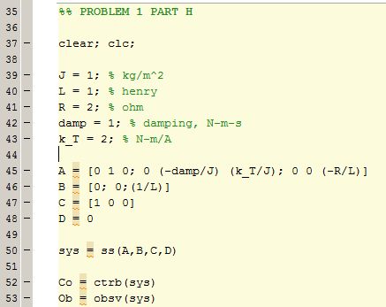

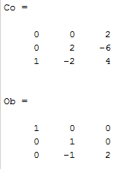

1. **Can you establish the controllability and observability by inspecting the transfer function in (B)?**

*The transfer function shows that the system is observable and controllable because no terms are cancelled out from the numerator by the denominator.*

1. **Establish the controllability and observability of the system found in (E).**
$$\left[\begin{matrix}0 & 0 & 0 \\ 0 & -1 & 0 \\ 0 & 0 & -2\end{matrix}\right]=A$$

2. **Transform the state space of (A) to controller canonical form**

$$A=\left[\begin{matrix}0 & 1 & 0 \\ 0 & -\frac{b}{J} & \frac{k_{T}}{J} \\ 0 & 0 & -\frac{R}{L}\end{matrix}\right] \\ B= \left[\begin{matrix}0 \\ 0 \\ \frac{1}{L}\end{matrix}\right]$$

$$C=\left[1 0 0\right]$$

$$D=0$$

$$S=\left[B AB A^{2}B\right]=\left[\begin{matrix}0 & 0 & \frac{k_{T}}{JL} \\ 0 & \frac{k_{T}}{JL} & -\frac{bk_{T}}{J^{2}L}-\frac{RK_{T}}{JL^{2}} \\ \frac{1}{L} & -\frac{R}{L^{2}} & \frac{R^{2}}{L^{3}}\end{matrix}\right]=\left[\begin{matrix}0 & 0 & 2 \\ 0 & 2 & -6 \\ 1 & -2 & -4\end{matrix}\right]$$

$$S^{-1}=\left[\begin{matrix}1 & 1 & 1 \\ 1.5 & 0.5 & 0 \\ 0.5 & 0 & 0\end{matrix}\right]$$

$$M_{1}=\left[0.5 0 0\right]$$

$$M= \left[\begin{matrix}M_{1} \\ M_{2} \\ M_{3}\end{matrix}\right]=\left[\begin{matrix}0.5 & 0 & 0 \\ 0 & 0.5 & 0 \\ 0 & -0.5 & 1\end{matrix}\right]$$

$$M^{-1}=\left[\begin{matrix}0.5 & 0 & 0 \\ 0 & 0.5 & 0 \\ 0 & -0.5 & 1\end{matrix}\right]$$

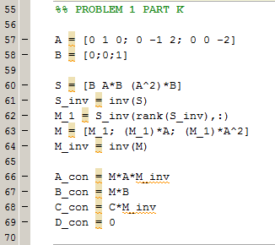

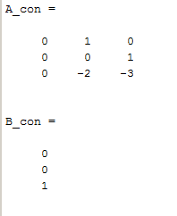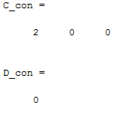

1. **Run the state space model for (A) until 8 seconds. Repeat for the controller canonical and the diagonal forms.**

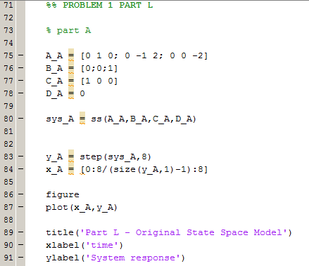

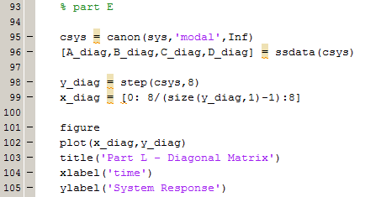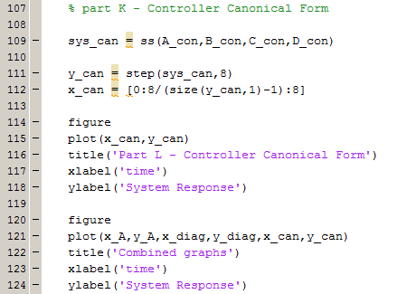

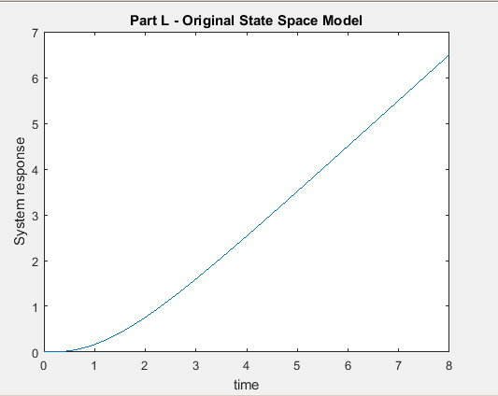

Figure : State Space Model - Part A

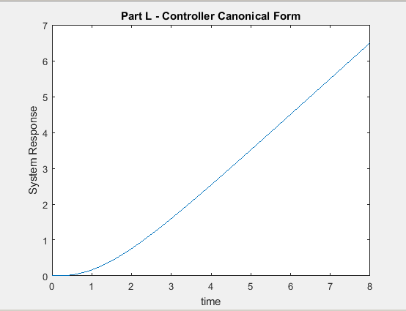

Figure : State Space Model - Controller Canonical Form

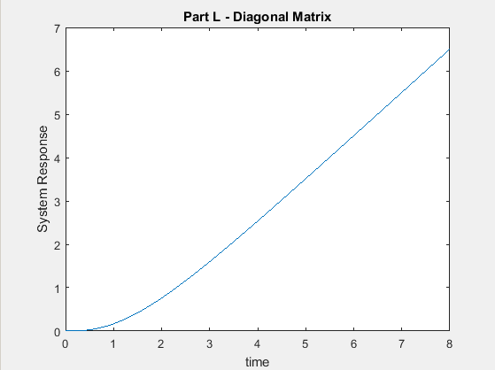

Figure : State Space Model - Diagonal Matrix

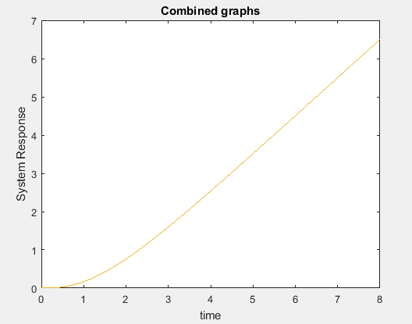

Figure : Obvious similarity between all three graphs

1. **Create a closed-loop feedback controller**

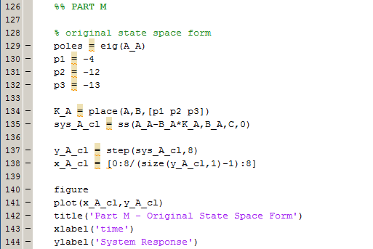

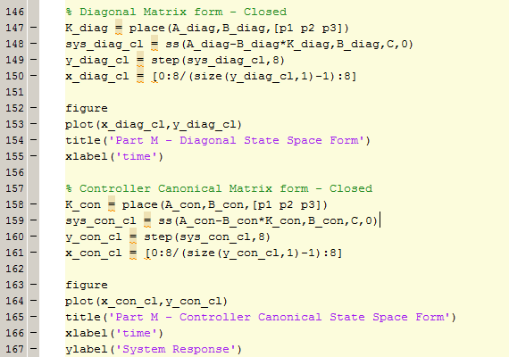

­

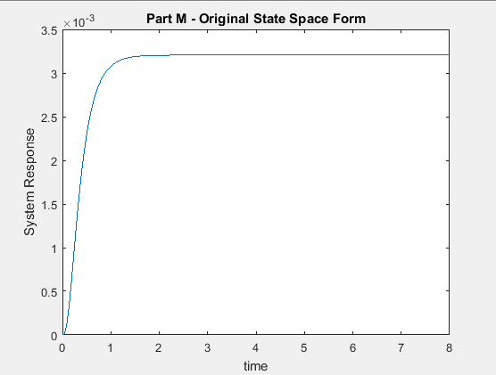

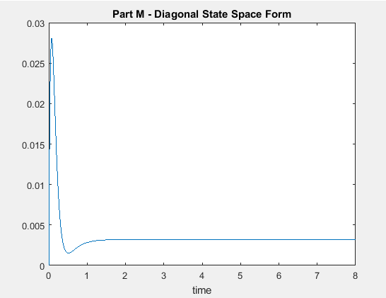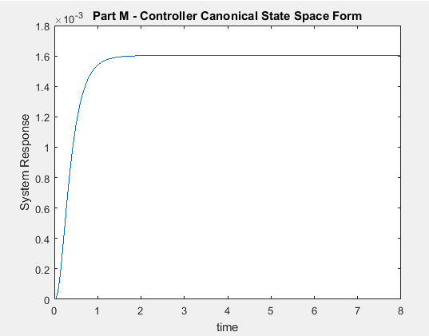

$$K_{controller,A}=[312 114 26]$$

$$K_{controller,diagonal}=[312-140 44.9073]$$

$$K_{controller,controller canonical}=[624 254 26]$$

R

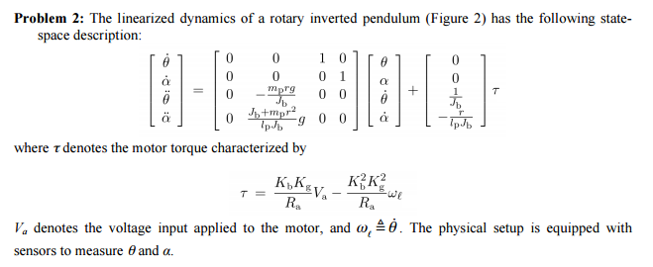

1. **Develop a state space model with the input being V­a**
2. **Design a feedback controller such that the poles are as designated**

