**FICHE FLASK**

**I. Creation Projet**

**React frontend setup**

npx create-react-app flask_react

cd flask_react

**Flask backend setup**

mkdir backend

cd backend

Virtual environment

-For mac/unix users: python3 -m venv env

For windows users: py -m venv env

-For mac/unix users: source env/bin/activate

For windows users: .\env\Scripts\activate

Installing flask

pip install flask

pip install python-dotenv

touch .flaskenv

FLASK_APP=base.py

FLASK_ENV=development

touch base.py

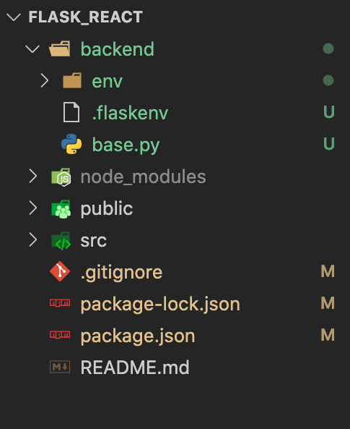

from flask import Flask

from flask_cors import CORS

api = Flask(__name__)

CORS(api,*origins*="*")

@api.route('/profile')

def my_profile():

    data=["juju","lena","lisa","jennie"]

    return jsonify(data)

if __name__ == '__main__':

    api.run(*debug*=True)

**Lancement Front**

"scripts": {

"start": "react-scripts start",

"start-backend": "cd backend && env/bin/flask run --no-debugger", //new line

"build": "react-scripts build",

"test": "react-scripts test",

"eject": "react-scripts eject"

},

"name": "flask_react",

"version": "0.1.0",

"private": true,

"proxy": "http://localhost:5000", //newline

Sur app

    axios.get("http://localhost:5000api/names").then((*response*) => {console.log(*response*.data)});

npm start pour lancer