**BSCPE**

**Java Lab Activity: Using statements, Integer & Double Data Types, and Scanner**

**Cyril Jann A. Agawin (884966)**

**Eng. Jamie Eduardo Rosal**

**09/13/2025**

Test Run #1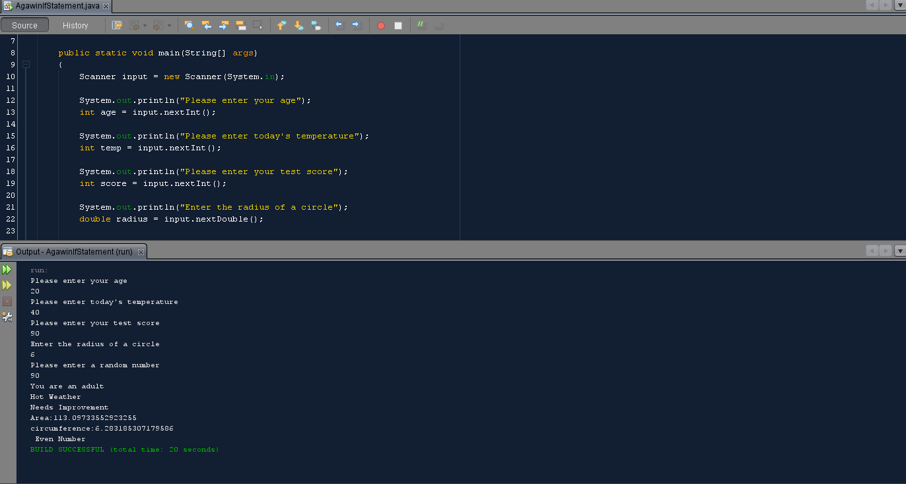

Test Run #2

