Financial Econometrics
Solution Sheet on Problem Set 4
OLS
Deadline: 21/04/2026
Solved by: Cyril Gabriele, Adriano Lama, Nilufar Ismayilova

Task |  | Points Earned
1. Estimate the three parameters with MLE, using the log-likelihood. Report and the irrespective standard errors. (3 points) | We estimate the regression model:  Rhitec=β0+β1Rmkt+uRhitec​=β0​+β1​Rmkt​+u  assuming that the error term follows a Laplace distribution with scale parameter ss. The parameters are estimated using maximum likelihood.  The estimated coefficients are:  - β₀ = 0.017754 (Std. Error = 0.008179)  - β₁ = 1.166466 (Std. Error = 0.003693)  - s = 0.546480 (Std. Error = 0.006614)
2. In order to test for ARCH effects, perform a Ljung-Box test with 12 lags on the squared returns of utils. Give your conclusion at the 5% significance level. (1 point) | To test for ARCH effects, we applied the Ljung-Box test with 12 lags to the squared returns of the hitec series.  The null hypothesis is that there is no autocorrelation in the squared returns up to lag 12.  The test results show a p-value smaller than 0.05 (p-value < 0.0001). Therefore, I reject the null hypothesis at the 5% significance level.  This means that the squared returns are autocorrelated, which indicates the presence of ARCH effects in the hitec returns.
3. Assuming that innovations follow a normal distribution, estimate an ARCH(4) model on the returns of utils. We will name it model 1. Comment on the QQ plot of standardized residuals (plot 9 using the uGARCHfit plot method with the which argument). (2 points) | We estimated model 1 as an ARCH(4) model under the assumption of normal innovations.  From the QQ plot of the standardized residuals, the points lie reasonably close to the straight line in the center, but there are clear deviations in both tails, especially for the most extreme observations. This suggests that the residuals are more heavy-tailed than a normal distribution.  Overall, the normality assumption is only partly supported. The model fits the center of the distribution fairly well, but it does not capture the tails very well.
4. Keeping the assumption of normally-distributed residuals, re-estimate your ARCH(4) ignoring the last nine observations of your sample. Then compute ten out-of-sample volatility estimates. (2 points) | We re-estimated the ARCH(4) model after dropping the last nine observations and then computed 10 one-step-ahead volatility forecasts.  The forecasted conditional standard deviations are:  - 0.947474  - 1.005804  - 1.037013  - 1.044430  - 0.939563  - 0.880562  - 0.894730  - 0.903183  - 0.886798  - 0.928251  These are the out-of-sample volatility estimates implied by Model 1.
5. Based on the results obtained in the previous question, compute a 10-day 95% Value-at-Risk, assuming that the returns are normally distributed. (3 points) | Using the 10 volatility forecasts from Exercise 4 and assuming conditional normality, we computed the 10-day 95% Value-at-Risk.  The summary values are:  - daily mean, μ = 0.101298  - 10-day mean = 1.012978  - 10-day standard deviation = 2.999682  - 5% normal quantile = -1.644854  This gives a 5% return quantile of:  - q₀.₀₅ = -3.921059  Therefore, the 10-day 95% VaR (loss) is:  - VaR = 3.921059  So the estimated 10-day 95% Value-at-Risk is approximately 3.92%.
6. Considering again the whole sample, re-estimate your ARCH(4) model but with a t-distribution for the residuals instead of a normal one (model 2). Report the shape coefficient from the estimation output. Relate it to your observation in question 3. (2 points) | We re-estimated the ARCH(4) model using a Student-t distribution for the innovations instead of a normal distribution.  The estimated shape parameter is:  - ν = 6.21  This value indicates heavier tails than the normal distribution. This is consistent with the QQ plot in Exercise 3, where the standardized residuals showed noticeable tail deviations from normality. So the t-distribution is more appropriate than the normal distribution for capturing extreme observations.  Estimated coefficients for Model 2:  - μ = 0.107058  - ω = 0.663775  - α₁ = 0.140665  - α₂ = 0.206700  - α₃ = 0.214369  α₄ = 0.230613  The QQ plot under the t-distribution appears closer to the reference line than under normality, especially in the tails, which supports the use of the Student-t specification.
7. Finally, estimate a GJR(1,1) model assuming a t-distribution for the innovations (model 3). Does the variance go up or down after a negative shock on the previous day? Is this move statistically significant at the 5% level? (2 points) | Model 3 is estimated as a GJR(1,1) model with Student-t innovations.  The coefficient on the asymmetry term is:  - γ = 0.0222  This coefficient is positive, which means that the conditional variance increases after a negative shock on the previous day. In other words, negative shocks have a stronger impact on volatility than positive shocks of the same size.  The effect is statistically significant at the 5% level, since the p-value is very small (p-value = 0.0002).  Therefore, there is strong evidence of asymmetric volatility in the hitec return series.
8. You want to compare the fit of model 2 to that of model 3. For each model, report the “ACF of standardized residuals” (plot10) and the “ACF of squared standardized residuals” (plot11). Comment. (3 points) | For both Model 2 and Model 3, we examined:  - the ACF of standardized residuals  - the ACF of squared standardized residuals  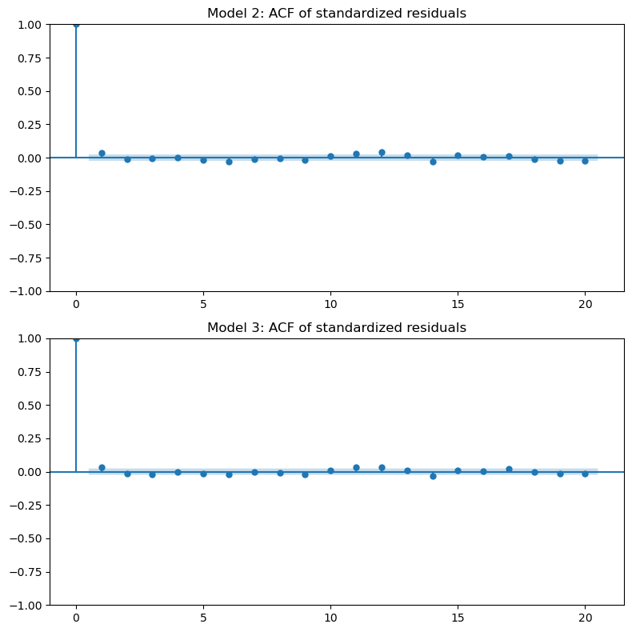  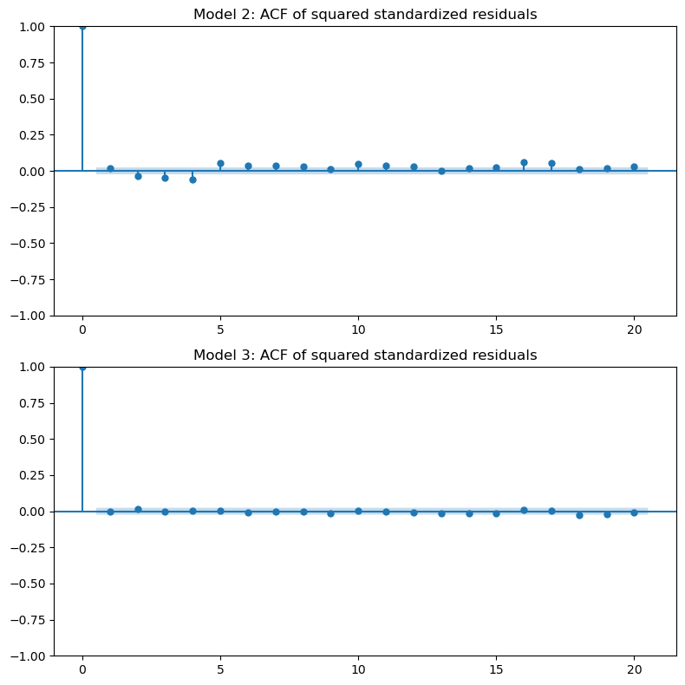  For both models, the ACF of standardized residuals shows no significant autocorrelation, indicating that the models adequately capture linear dependence in the returns.  The key difference appears in the ACF of squared standardized residuals. Model 2 still shows noticeable autocorrelation, which suggests that some volatility clustering remains.  In contrast, Model 3 shows much smaller and less significant autocorrelations in the squared standardized residuals. This indicates that Model 3 captures conditional heteroskedasticity more effectively.  Therefore, Model 3 provides a better fit to the data.
9. Compare your three models in terms of the AIC. Comment on the ranking obtained. (2 points) | The AIC values for the three models are:  - Model 1 (ARCH(4), normal): 23530.37  - Model 2 (ARCH(4), t): 23244.40  - Model 3 (GJR(1,1), t): 22778.17  Since lower AIC indicates a better trade-off between fit and model complexity, Model 3 is preferred.  This result shows that allowing for both heavy tails (Student-t distribution) and asymmetric volatility (GJR specification) significantly improves the model fit for the hitec return series.

