Cloning in AutoCAD 2000

Version 2.0

January 10th, 2000

Cyrille Fauvel
Autodesk Developer Consulting Group

Introduction
This document describes in detail all of the cloning operations available to AutoCAD 2000 and targets the advanced ObjectARX 2000 developers, who want to understand and take advantage of this often misunderstood area of ObjectARX. The cloning operations available to AutoCAD/ObjectARX 2000 are clone(), deepClone() and wblockClone(). It also covers some r13/r14 aspect of cloning which has changed in AutoCAD 2000.

- Cloning! What is it?

Conceptually cloning can be considered similar to copying. However, this is not how we should view the cloning process. Cloning in AutoCAD should be considered as creating a new object with the same references as the original object copied into it.

- Cloning! Why should I care?

AutoCAD commands use cloning, and it is important that professional applications maintain the integrity of a user defined structure across AutoCAD commands. As you will see later in this document, AutoCAD commands work in a manner, which may be not compatible with your structure. It is up to you to tell AutoCAD, how it should work in such a case.

In AutoCAD, there are three different cloning methods:
- Shallow Cloning
- Deep Cloning
- Wblock Cloning

The first of these methods and the easiest to implement is 'Shallow Clone' (i.e.: AcRxObject::clone()). This method performs a single copy of a simple object much like the C++ new and '=' operator. The clone() method does not clone any 'owned by' object(s) or 'pointed to' object(s) like the other cloning methods.

There other complex cloning methods which clone the 'owned by' and 'pointed to' object(s) are deepClone() and wblockClone() which will be discussed later in this document. For now, let's start our discussion with the 'Shallow Clone' process, clone().

Basics

Shallow Clone
In AutoCAD, this simply means you can make copy of an object/entity which already exists in a given DWG database. You may also clone a non-resident DWG database object if you want. For example, the following code fragment demonstrates how to clone/copy an AcDbLine entity:

Code abstract 1:
//----- Open the original object for read
AcDbLine *pOrgLine =NULL ;
acdbOpenAcDbObject ((AcDbObject *&)pOrgLine, idOfLine, AcDb::kForRead) ;
//----- Perform the clone() operation
AcDbLine *pClonedLine =(AcDbLine *)pOrgLine->clone () ;
//----- Append the new line to the same block definition
//----- And close the newly created object.
AcDbBlockTableRecord *pBlock =NULL ;
acdbOpenAcDbObject (
(AcDbObject *&)pBlock,
pOrgLine->blockId (),
AcDb::kForWrite
) ;
pBlock->appendAcDbEntity (pClonedLine) ;
pClonedLine->close () ;
pBlock->close () ;
//----- Close the original object
pOrgLine->close () ;

- How does clone() work?

virtual AcRxObject *clone () const ;

The clone() method is a virtual method implemented at the AcRxObject level. This means, you can can clone() any object derived from the AcRxObject class. When deriving your custom object, you do not need to implement/override the 'clone()' method, because the clone() method uses the RTTI (RunTime Type Identification) system of AutoCAD to identify the class descriptor of the original object and then make a new instance of that copy. When the C++ object has been created, the clone() method calls the copyFrom() method to copy all information that is required by the copied object. The clone() method implementation looks like this:

Code abstract 2:
AcRxObject *clone () const {
AcRxObject *pObj =this->isA ()->create () ;
pObj->copyFrom (this) ;
return (pObj) ;
}

As you can see, the AcRxObject::clone() method is performing a shallow copy of the original object. The resulting copied object is an identical copy of the original object, however there is one caveat when it comes to complex objects. If you apply the clone() method to either an AcDbBlockReference or an AcDb2dPolyline you will get unwanted side effects. The problem for complex objects like the ones mentioned earlier, is that those objects own other objects. The clone() method does not clone owned object.

If you need to clone complex objects, use the deepClone() method, discussed later.
As you may have noticed in 'Code abstract 1', a call to the clone() method does not make your resulting new entity a DWG database resident object. You are responsible for adding the new entity/object to the DWG database. This is an important issue to remember, because cloning objects across databases boundaries for example will not work with the clone() method unless you manually reassign all the AcDb(Hard/Soft)PointerId’s to the proper associated objects in the target database.

NB: If you are unfamiliar with hard/soft ownership and pointers, please refer to the ObjectARX Developer's Guide. See Chapter 12 'Deriving from AcDbObject' in particular the sections on 'Ownership References' and 'Pointer References'.

Sample code:

Load the ‘AdcgArxCloning.arx’ application in AutoCAD 2000, and execute the following commands:
- CLONE1: Performs a shallow clone of a non database resident object.
- CLONE2: Performs a shallow clone of a database resident object into the same database.
- CLONE3: Performs a shallow clone of a database resident object to another DWG database. Result is placed in 'Test.dwg'.

Consider the following scenarios with regard to the clone() method.

The 'CLONE1' command performs a non-database resident copy of an AcDbLine object that was never appended to the database. Neither the original or the copied entity has any hard pointer association to any layer table record. Both non-database entities are erased on exit of the function.

The 'CLONE2' command asks the user to select a line entity. Let's assume the user selects a line that is on the layer "TEST", and the current layer for the drawing is layer "0". What layer will the newly created cloned line reside on "TEST" or "0"? Right after the cloning process the line will point to the same layer table record, but the newly created entity has not been appended to the database yet. This does not mean that the layer was copied, it simply means the cloned line has all the same values as the original object. Remember an entity cannot belong to the Model or Paper space records without having a reference to some layer table record. In this case the newly created entity will have the same reference as the entity it was cloned from. However if after cloning the AcDbLine entity, we could have easily called 'setDatabaseDefaults()', in which case the newly cloned and appended entity would reside on layer "0", because as we stated earlier, layer "0" was the current layer.

The 'CLONE3' command again asks the user to select an AcDbLine entity. However it create a new database "test.dwg" and clones an AcDbLine across to the database. Even if the selected AcDbLine entity resided on layer "TEST" the corresponding layer will not be created in the new drawing. The cloned entity will reside on layer "0". Even if a layer "TEST" did exist in the new database, the cloned entity will reside on layer "0" (unless we intervene of course).

Deep Clone & Wblock clone
The deepClone() method clones an object and its hard/soft ownership references, but not hard/soft pointer references, any pointer references are ignored in the cloning process. However, pointer references of the original objects are copied into clone objects like it was done for the clone() method.

The wblockClone() method clones hard owners and hard pointers and ignores any soft references. In addition to cloning this hierarchy of owned objects, both the deepClone() method and the wblockClone() method also handle the cloned object's references, translating the references to point to new objects if necessary.

Unlike the clone() method, deepClone() and wblockClone() only work on database resident objects.

- Using clone() versus deepClone()

The AcRxObject::clone() method clones a single object. The AcDbObject::deepClone() method clones the object and any objects owned by that object. The deepClone() method also translates the cloned object's references.

In general, the deepClone() method is the safer of the two methods. If you are cloning a simple object such as an ellipse, the two methods may be considered as equivalent. But if you are cloning a complex object such as a polyline (AcDb2dPolyline), the clone() method isn't adequate in this case, because it only clones the polyline header object, not the vertices that are owned by the polyline header. With the deepClone() method however, you clone the polyline object as well as it's vertices.

See Technical Solution 13718: HOW TO MAKE A NON DATABASE RESIDENT COPY OF A COMPLEX OBJECT

- How does deep cloning work?

The deep clone and wblock clone operations both use object filing to clone an object. A new object is created, which will be the clone. Next, the original object is filed out to memory using dwgOut(). Finally, the data is filed into the new cloned object using dwgIn().
While processing the dwgOut() and dwgIn() operations the deep clone and wblock clone engines identify all the references they have to process (clone/copy and translate).

There are four possible types of relationships between ARX objects:
- AcDbHardOwnershipId
- AcDbSoftOwnershipId
- AcDbHardPointerId
- AcDbSoftPointerId

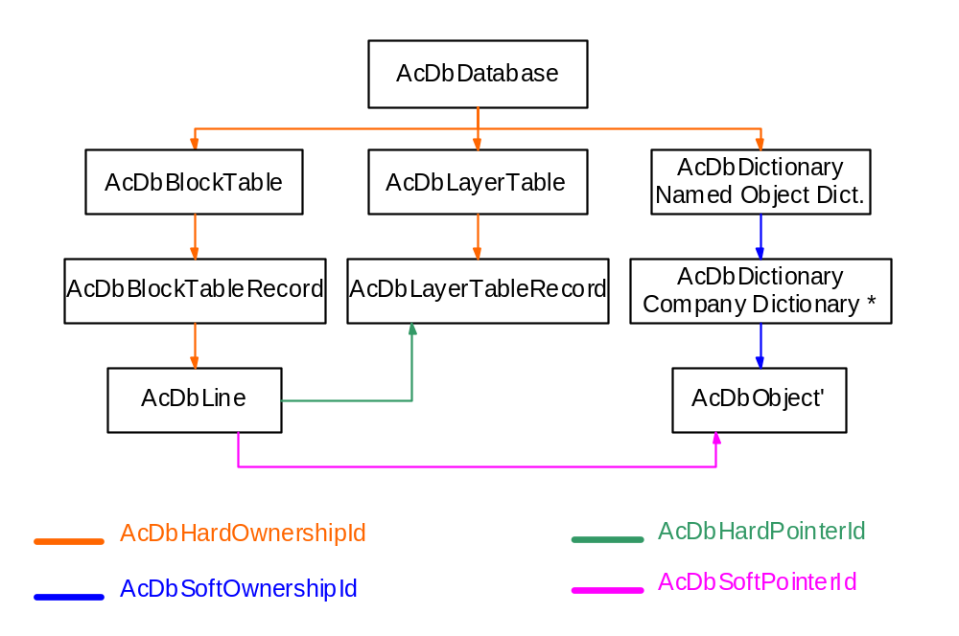The DWG database is built using the above references (see below).

(Refer to Appendix A below, for a complete list of existing relationships in AutoCAD)

(*) The intermediate ‘Company Dictionary’ is there to comply to the ObjectARX logo requirement, as well as we shall see later demonstrate some issues regarding cloning across databases.

deepClone() follows hard/soft ownership references (not pointer references), whereas wblockClone() follows only hard ownership and hard pointer references. This means that deepClone() while cloning an AcDbBlockReference object, will also clone the attributes owned by the AcDbBlockReference automatically, all without any additional coding on your part. But it will not clone any of the referenced layers, or the block definition (wblockClone() does this). This would result in a crash of AutoCAD if the clone operation were executed across databases.

- Cloning phases

When a deep clone operation occurs, AutoCAD carries out various operatons, which can be split into three distinct phases:
- Default cloning phase,
- Application cloning phase,
- ID Translation phase.

The first phase is always done automatically by AutoCAD and the result of that phase completely depends on the cloning operation in process (deep cloning or wblock cloning).

After that first automatic phase, AutoCAD notifies all applications that a cloning operation did occur, and then one can decide to process additional objects. This is the ' Application cloning phase', and this phase must be done before AutoCAD starts translating all AcDbObjectID's. It is important here to note that creating new objects is not the same as forcing new clones of objects. Newly created objects will not participate the ID Translation phase unless we tell those objects they are in a state of flux (AcDbObject::setAcDbObjectIdsInFlux();) and that we add a new pair in the idMap which is used by AutoCAD to track cloned objects.

The cloning process is like an iceberg. What you can see from the application is that objects are being copied from one database to the same or another database. But internally, AutoCAD does more. After copying all the objects, and after letting you adding some more objects (optional) to the cloning process, AutoCAD needs to translate all the cloned objects internal references to make those cloned objects functional. AutoCAD need to translates cloned objects:
- owner ID's,
- objects reference ID's,
- owned objects ID's

You cannot intervene during this process which occurs right after the AcEditorReactor::beginDeepCloneXlation() callback.

This is certainly the most important phase during a deep clone operation. This is where AutoCAD will change all internal cloned object's references to point to the clone of their original referenced objects. This phase is the last phase, and internal references can start to be used only after that phase.

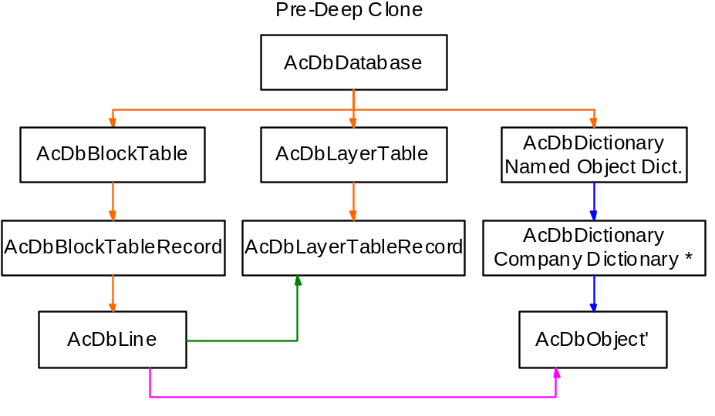Find below a sample of a typical deep clone operation within the same database.
When a user or an application generate a deep clone operation (from the AcDbLine in our case), AutoCAD starts by notifying all application that a deep clone operation will occur by calling the AcEditorReactor::beginDeepClone() callback method. Then AutoCAD starts its first cloning phase.
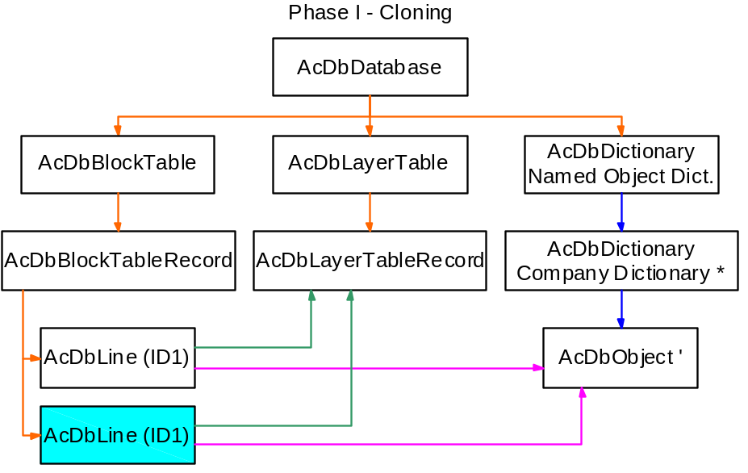
As you can see here, AutoCAD has cloned one single object, and internally the clone object point to the same objects as its source object. You can also see that the internal ID of the clone object is the same as its source. This is because the object is still in flux mode, and because the ID Translation phase has not yet occurred. Just after the cloning phase executed by AutoCAD, AutoCAD will notify all running applications by calling any implemented and registered AcEditorReactor::beginDeepCloneXlation() methods. This is where an application can decide to force AutoCAD to clone additional objects.

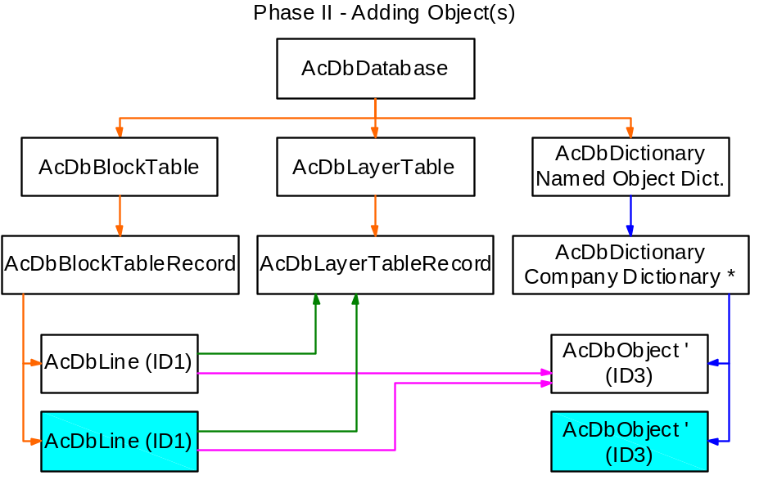
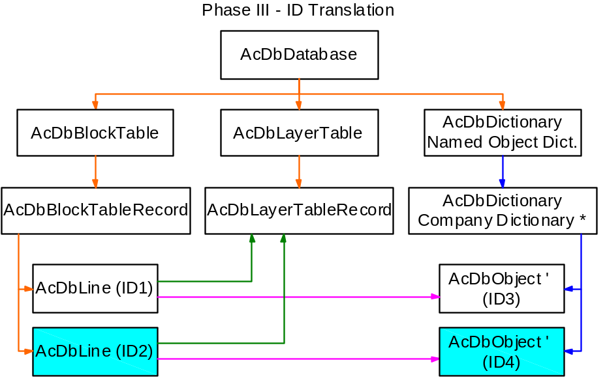Here an application decided to force a clone of the dictionary object. But the cloned line does not yet point to this new cloned object. This is because the ID Translation phase has not yet occurred. Just after that optional phase, AutoCAD will start to assign new IDs to each clone objects, and will start translating all references to those objects if appropriate.

New AcDbObjectID’ have been assigned to cloned objects, and the last thing AutoCAD will do is to notify all applications than the deep clone operation is terminated. The ID Translation phase is executed by AutoCAD, and you cannot intervene on it.

- Why can you not use AcDbObject::deepClone() or AcDbObject::wblockClone() directly?

These methods work properly to clone objects, but do not return valid objects which can survive in the database. This is because the objects are in a state of flux, meaning that AutoCAD thinks their ID’s have not yet been translated (Object ID translation is part of the cloning process - beginDeepCloneXlation()).

It should be noted that deepClone() and wblockClone() are not called directly by your application, but are called indirectly as a result of calling methods such as deepCloneObjects(), wblock() and insert(), see the following guidelines. In your application you will override the behaviour of deepClone() and wblockClone(), which will be called in response to deepCloneObject(), wblock() or insert().

As mentioned before access to deepClone() and wblockClone() is through the following methods:

- within the same database:
AcDbDatabase::deepCloneObjects()
NB: This one is hard coded to work only on the same database. If you use AcDbDatabase::deepCloneObjects() across databases, it will return Acad::eWrongDatabase.
- across databases:
AcDbDatabase::wblock()
AcDbDatabase::insert()

If you want to change/add/remove objects from a clone process while AutoCAD is cloning objects, you will need to use these helper functions as follows:

AcEditorReactor::beginDeepClone()
AcEditorReactor::beginDeepCloneXlation()
AcEditorReactor::abortDeepClone()
AcEditorReactor::endDeepClone()

or, if you have implemented custom classes, then

AcDbObject::deepClone()
AcDbObject::wblockClone()

could also be of help.

For example, calling deepClone() within an AcEditorReactor::beginDeepCloneXlation() callback is valid if the cloning context is any of the following:

kDcCopy, kDcExplode, kDcBlock

Finally,
- deepCloneObjects() instantiates a deep clone operation within the same database.
- wblock() instantiates a deep clone operation across databases, like the AutoCAD _WBLOCK command (an export operation).
- insert() instantiates a deep clone operation across databases, like the AutoCAD _INSERT command (an import operation).

NB: During the insert process, and if an AcDbBlockTableRecord, AcDbLayerTableRecord, etc... is already present in the target database AutoCAD will ignore the new definition and will process properly all the references to these objects (this is the default behavior of the AutoCAD command INSERT).

Sample code:
Load the ‘AdcgArxCloning.arx’ application in AutoCAD 2000, and execute the following commands:

- DCLONE1: Performs a deepClone operation of a database resident object into the same database (using deepCloneObjects())
- DCLONE2: Performs a deepClone operation of a database resident object across another database. !!! This operation will fail !!!
- DCLONE3: Performs a wblockClone operation of a database resident object across to another database. (using wblock()). Result is placed in 'Test.dwg'.
- DCLONE4: Performs a wblockClone operation of a database into another database (using insert()). Result is placed in 'Test1.dwg'.
- DCLONE5: Performs a deep clone operation of a database resident object into the same database (using deepClone ()) !!! This operation will fail !!!

NB: If you implement an AcDbDatabaseReactor::objectAppended() callback, you may detect the creation of the clone object in the database. But, you will not see it at the end of the command. This is because AutoCAD hinks that the object is not valid, and will then remove it from the database without any notification.

- Other Limitations:

- The main problem with deep clone operations (across databases mainly) is that AutoCAD follows hard/soft ownership references only during a deep clone operation, and follows hard ownership and hard pointer references only during a wblock clone operation. This can cause problems while copying an object which has some persistent reactor attached for example. The next section will try to address all these problems, and find a solution for each.

- Another limitation is copying an external drawing into the current model space of a given drawing. You can use the AcDbDatabase::insert() method to do this, but in case you wish to copy only part of the source database the supported method is to use a combination of AcDbDatabase::wblock() and
AcDbDatabase::insert(). First, you need to wblock() the external drawing database into a temporary in-memory database. You cannot wblock() directly into the current drawing, because wblock() is destructive on the target database. You need to use insert() to insert the temporary database of the current drawing. You cannot use insert() to insert the external drawing directly, because insert() uses 'cheapClone', which moves the objects from the source to the target database. Using this approach, all the symbol table get merged correctly into the current drawing database.

- Finally if the application which manages your deep clone behavior is not present, it is not guarantee that AutoCAD process complex structures properly. It may result in some information loss.

RefEdit.

From the documentation:
To increase AutoCAD's extensibility and aid collaboration in the design process, AutoCAD 2000 further enhances the reference capabilities in AutoCAD. Users may select a block reference or external reference (xref) and specify a portion of the reference to edit in-place. The selected geometry will be instantiated in the current drawing, edited, then saved back to the block definition or reference file.

This clearly means the AutoCAD RefEditing feature has been implemented for entities and only entities. This might be a problem in case your XREF'ed drawing structure is not only composed of entities, but also contains non graphical object either in the Extension Dictionary of the entity or in the NOD. Such non graphical object could either be data, or reactor. And they are not necessary maintained during RefEdit protocol.

The RefEdit feature starts with the AutoCAD '_REFEDIT' command and stops only when the AutoCAD command '_REFCLOSE' or '_REFSAVE' commands are called. During the RefEdit state, the user is allowed to work on a couple of entities (so called 'working set'). The working set is a selection set of clones made from entities contained in an XREF drawing.

- The checkout phase

RefEdit uses the wblock() mechanism to create the clones which compose the working set. Because it uses wblock(), you can already know that any soft references will be lost during the checkout procedure. Like before you can implement a AcEditor::beginDeepcloneXlation() notification callback to force additional clones.

- The checkin phase

Like the checkout phase, RefEdit uses the wblock() mechanism to do the checkin phase. However, only modified objects gets cloned at that stage.

An AutoCAD bug: However, there is a problem due to a defect into AutoCAD. An entity/reactor link will be broken, when you will return from RefEdit. This is a *bug* in the implementation of RefEdit, and fortunatelly there is a workaround to this. The problem is that the entity and its reactor will be properly cloned, but the entity will still reference the original reactor object as its reactor instead of referencing the clone which is the new reactor. The workaround is to implement an AcApLongTransactionReactor:: endCheckIn() callback and use the AcDbObject::swapReferences() API. For coding information, please look into the 'OPLineII' sample file 'rLongTransactionReactor.cpp'.

- Non entity object

As said before RefEdit handles entities properly, and may handle non-entity class instances properly if stored in the entity' Extension Dictionary. But you need to do more things if your object is stored into another place such as the NOD (Named Objects Dictionary). Look at the AsdkOPLineStyle::wblockClone() implementation. It is enough generic to be reused as is for your own custom object class.

- No error / not operational

During deep clone / wblock clone operation in AutoCAD, one may create object at any time to the target database and/or source database without any problem. He may also make that object part of the deep/wblock clone operation if he wish to… But RefEdit does not allow really such operation. The RefEdit protocol verifies at each phase that the original working set and the clone operation result set have the same entities, and that they are the same! If something doe sot fit that rule, then the comand aborts…

- Samples

Attached to that documents you will find 3 samples which all implement a Multi-Polyline (same as AcDbMLine but based on polylines).

The first sample 'OPLineI' implements a custom entity derived from AcDbPolyline, with a style stored in the NOD. We also have used solution 47354: "Deriving from AcDbPolyline" (http://partnersys.autodesk.com/cgi-bin/solution.pl?SID=47354) to solve problems due to the use of AcDbPolyline as base class. This is the solution, I strongly suggest that you consider if you wish to implement such complex structure.

This sample just show how to do things well using custom objects. But the second sample 'OPLineII', is there to show how the same principal should be implemented if you do not wish to use custom entity. In that case the use of a reactor is required, and it involves more work.

The last sample 'OPLineIII'. is just an aggregate of the two first solutions. It uses a custom entity as the first solution to maintain data when the application and DWG are both loaded. But does not save the custom entity in the DWG. Instead it saves standard AutoCAD entities in place of the custom entity into the DWG file. The advantage of that technique is that no DWG file will ever contain proxy entities. The custom entity is restored upon loading…

Note: We wish to thank you M. Jon Rizzo from 'Langan Engineering and Environmental Services, Inc.' for his contribution to DevCon in developing those samples

Advanced
In this section we will talk about some advanced deepClone behavior and programming techniques.

Removing an object from a deep clone operation.
You can do this by installing an AcEditorReactor, overriding the beginDeepClone() and beginDeepCloneXlation() notifications. Inside the beginDeepClone() method you put the object IDs of the objects that you don't want to be copied into the ID map. This will trick AutoCAD into thinking that
they have already been copied. Then you can remove these fake ids during beginDeepCloneXlation() notification.

Code abstract 3:
//----- 'id' containing the AcDbObjectId of the object which
//----- should not be copied.

void MyEditorReactor::beginDeepClone(AcDbDatabase *pTo, AcDbIdMapping &idMap){
if ( idMap.deepCloneContext () != AcDb::kDcCopy )
return ;
//----- Place our id in the map here
idMap.assign (AcDbIdPair (id, id, Adesk::kTrue, Adesk::kTrue)) ;
}

void MyEditorReactor::beginDeepCloneXlation (AcDbIdMapping &idMap,
Acad::ErrorStatus *) {
if ( idMap.deepCloneContext () != AcDb::kDcCopy )
return ;
//----- Remove it here
idMap.del (id) ;
}

This technique is safe during a deep clone operation in the same database, but may produce problems while deep cloning objects across databases (this is why the sample shows the technique for the kDcCopy only). However, it is still possible to use this technique for cloning objects across databases, but requires more attention to detail from your application. The main problem is that, by removing an object from the clone process, you prevent AutoCAD from cloning an object which might be referenced by another object. Inside the same database, the resulting clone object will still continue to reference the same original (not cloned) object. While across database, the clone object, will reference a NULL pointer.

See Technical Solution 2351: DISABLING COPY COMMAND FOR CERTAIN ENTITIES

Another technique, if you do program custom object(s), is to return AcDb::kVetoed from the object deepClone()/wblockClone() methods.

Adding another object to a deep clone operation.
Removing an object from the cloning process as we have seen above, is not really difficult, if you are careful with the dependencies. However, adding new objects to the cloning process is more difficult, and requires more code and attention to detail.
- Persistent reactor.

A persistent reactor is an object derived from AcDbObject, which is attached to another object to trap events on the object to be notified. However, attaching a reactor to an object is not enough to make the reactor persistent. To be persistent an object needs to have an owner, and the notifier object is not the owner. This means that this object should be owned by another object somewhere in the DWG structure. A common practice is to make the Named Objects Dictionary the owner of the persistent reactor (it could also be owned by the Extension Dictionary of the object).
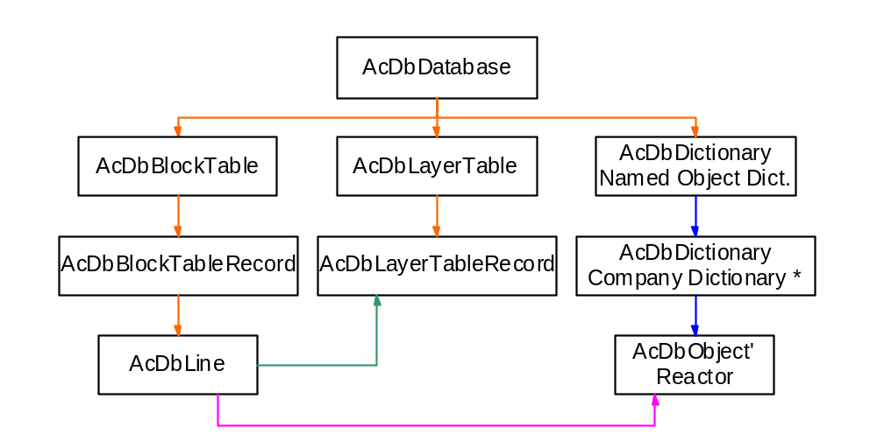
Because of this hierachy, the reactor could not be cloned when one is cloning the line object. This is because deepClone() is going through hard/soft ownership references, and wblockClone() through hard ownership and hard pointer references.
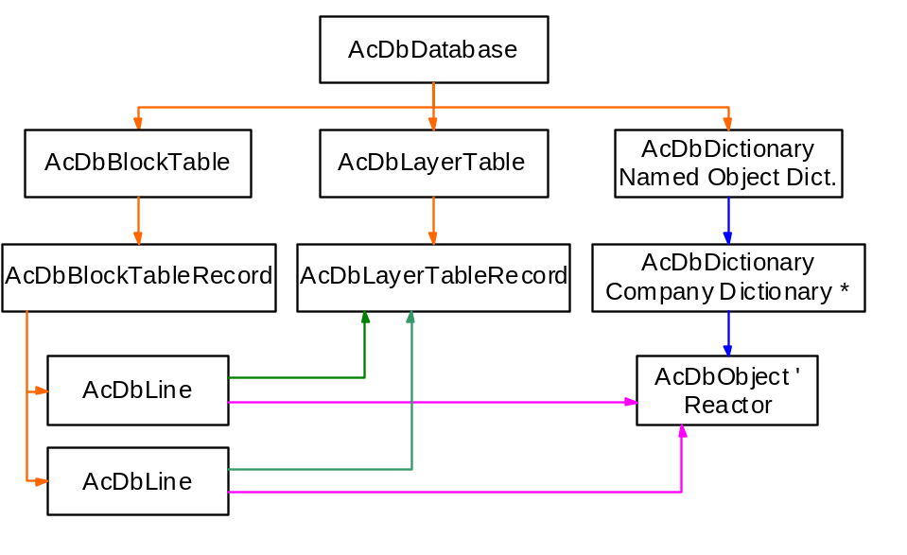But in a deep clone process the AcDbSoftPointerId value will be copied to the clone object, meaning the cloned AcDbLine entity will have the same reactor object attached as the original AcDbline object. If cloned within the same database, it might be not a problem if the reactor object knows how to work with multiple notifier objects.
(This is a result of a deepClone operation from the AcDbLine object)

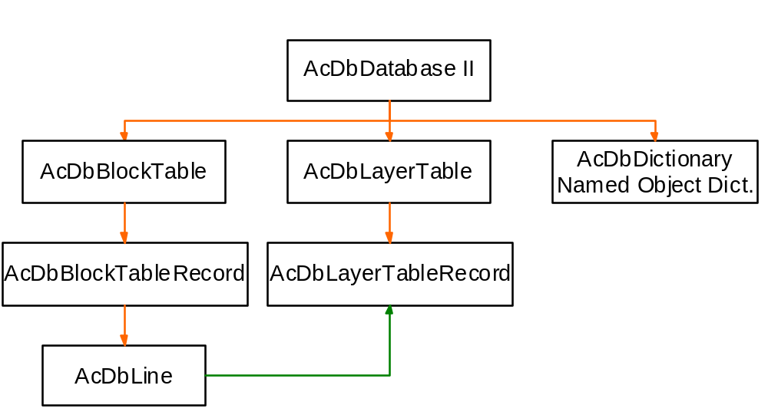Now in the case of a wblock clone process, the clone notifier object will be reset to point to a NULL pointer for its reactor reference. It is up to the application to decide what to do in that context. For example, the AcDbGroup object in AutoCAD is forcing a clone of itself if cloned within the same database (deep clone), but does not get cloned in a wblock operation. And an AcDbGroup is a reactor object.

(This is a result of a wblockClone operation from the AcDbLine object)
(Note that the AcDbLayerTableRecord object has been cloned across the database)

Note, that in case you want to force the clone of the reactor across databases, an ARX application for AutoCAD r13/r14 is responsible for providing a valid owner for the reactor object. In our scheme above, the reactor is not owned directly by the NOD of AutoCAD, so in this case if the application does not force the clone of the sub-dictionary, the reactor will be cloned properly, will work fine in the current session, but won't be saved in the DWG file (so not persistent), and therefore lost for the next session. In AutoCAD 2000, the operation scheme is different because after executing a wblock clone operation, AutoCAD will make sure to provide a valid owner to any non-owned cloned objects in the target database. This is a major difference between r13/r14 and r2000, but should be transparent to legacy code.

The save/open/wblock/insert/copy/block/explode are operations where an object can lose its relationship with its reactor. The next section will describe what you need to do to properly handle these situations.

What is the solution?

A first thought might be to have an AcDbHardOwnershipId reference of the object to its reactor. This will guarantee that filing like save/open/wblock/insert/explode and copy will take place without more coding because this is handled by default in deepClone() and wblockClone(). However, this is applicable only to your custom object, we cannot modify the AutoCAD class definitions.

Another approach, is to force a clone of the reactor while our notifier object is being copied. This can be achieved in two different ways:

- the first solution requires an overwrite the deepClone() and wblockClone() methods for object, which again requires custom object implementation.
Sample code: \ObjectARX\Samples\polysamp
- the second (and may be easiest) requires the implementation of an AcEditorReactor class. Sample code: \ObjectARX\Samples\clonemsg

However, depending of the AutoCAD release you want to use, your code will be different for the wblock process. This is because the wblock implementation in AutoCAD 2000 has changed. Now in AutoCAD 2000, AutoCAD will make sure to clone all necessary object owner of your clones and make them persistent in the target database. This is not done automatically in AutoCAD r13/r14, and requires additional coding from the developer.

- Another entity in the same owner block.

For this, you need to use an AcEditorReactor::beginDeepCloneXlation() callback, and work with the various deepCloneType to properly clone additional objects. It is not much different from the 'clonemsg' sample in case you are using standard AutoCAD entities. The only difficulty is to get a pointer to the target owner for your object. The solution is to go through the ID map, and reopen the target owner with the help of transactions. And in case you are using custom entities, then you can do it another way which is described in the 'Cloning complex structure' sample which follows.

- Cloning complex structure.

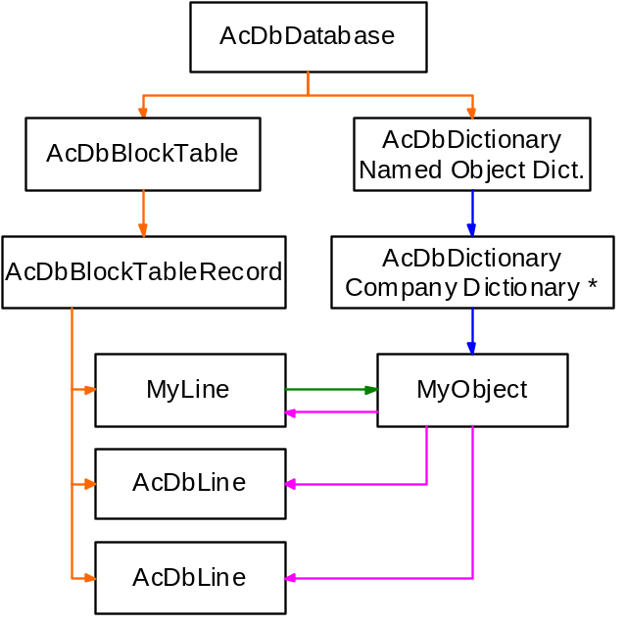Let's consider the following structure:

To summarize: Our custom AcDbLine class has an AcDbHardPointerId (this is an arbitrary choice for our sample) to our custom object stored in the NOD. That object has also a back pointer of type AcDbSoftPointerId to our custom line entity, as well as two other AcDbSoftPointerId pointing to two additional lines in the same custom line entity's block table record.

Now the implementation of deep clone for that structure will depend of two items:
- the type of references we have decided to use,
- and the functionality we want to have.

What we want is:
- if one clones the custom line (within or across database(s)), we want all the structure being cloned at once,
- if one clones one of the two lines, we don't do anything special,
- if one clones only the custom object in the NOD, we prevent the clones from being created.

a) If we implement our custom objects without additional coding, and in case we start the cloning operation from the custom line in the same database, AutoCAD will make a single clone of our custom line which will reference the same dictionary object as the original line. This behavior is the same for AutoCAD r13/r14/r2000.

To respect our design structure, the first thing we have to implement is to force a clone of the dictionary object while cloning within the same database, as well as the two associated AutoCAD lines. To do this we have the choice of using an editor reactor or the overriding the deepClone() methods of our custom objects. The use of the AcEditorReactor is demonstrated in the ObjectARX 'clonemsg' sample on the ObjectARX CD. So let's demonstrate the second solution here.

We have to:
- override the AdcgMyLine::deepClone() method
- clone the AdcgMyLine object first
- in case of the AcDb::kDcCopy AcDb::kDcObjects deep clone contexts (for r14: AcDb::kDcCopy AcDb::kDcBlock)
- (3) check that the dictionary object is not yet cloned
- (4) open the object we want to clone
- (5) open the owner of the object we want to clone
- (6) clone the object within the same owner as the original object. This is possible because we are cloning in the same database.
- (7) ensure the original object 'key' will not be reused as is by the cloned object.
- (8) close the objects we opened above
- (9) and the most important item, close the cloned dictionary object
NB: do not close the cloned custom line object here!

Overriding the AdcgMyLine::deepClone() method like this will force a clone of the dictionary object in a deep clone operation, and will provide a valid owner for the clone. However, it is not enough to force the cloning of the two associated lines. For this, we also have to clone the two lines as we did when cloning the dictionary object. This will provide support for the AutoCAD commands _COPY, _MIRROR, and _BLOCK.

We still have to make sure that _WBLOCK, _INSERT, _EXPLODE continue to work as we want them to behave correctly with our structure also (this will come later).

However, do not forget that we do want to create a clone of the structure if the dictionary object is the clone initiating object (primary object). To prevent this, we just test the presence of our custom line in the ID map, and then decide whether to clone the object or not. See AdcgMyDictObj::deepClone() implementation for details.

b) In case of a cloning operation from the custom line but across databases, AutoCAD will clone the line, plus the dictionary object automatically. However, the two AutoCAD associated standard lines will not be cloned, or referenced. This is because wblock() is going only through hard ownership and hard pointer references, and also because we have designed our structure with soft pointers. It will result in an uncompleted operation from our point of view.

Moreover, there is a difference between AutoCAD r13/r14 and AutoCAD r2000. In AutoCAD r2000, the cloned dictionary object will automatically have (and without additional coding from our side) a valid owner. This is because AutoCAD 2000 will clone all the needed owners of any clones to make them persistent in the target database. This is a new implementation of wblock() in AutoCAD 2000! In AutoCAD r13/r14. this is not done at all, and the application is responsible to provide valid owners for the clones when needed. The 'clonemsg' sample on the ObjectARX 2.0 CD shows how to do this in an AcEditorReactor::beginDeepCloneXlation() callback.

Here, we will override the AdcgMyLine::wblockClone() method as we did before for the AdcgMyLine::deepClone() method. This will now make our structure work with _WBLOCK. See also AdcgMyDictObj::wblockClone() method implementation for the same reason we implemented AdcgMyDictObj::deepClone().

c) Now we need to support _INSERT for both an internal block definition, and an external DWG insertion. When you insert an internal block into model space you can have two possible contexts:
- kDcInsert, which is cheapClone. A 'cheapClone' operation means that the source objects are not cloned, but moved from one AcDbDatabase to another.
- kDcInsertCopy, in this context AutoCAD does real cloning of the source objects.

but the code itself is not really different, please look at the AdcgMyLine::deepClone() method and its kDcInsert/kDcInsertCopy implementation.

d) What is left to implement is the _EXPLODE command (i.e. kDcExplode). The simplest method is to do the same as the kDcCopy.

e) The last item (not implemented here) could be the detection of an erase operation on the custom line which can occur on both the _ERASE, and _BLOCK commands. The AdcgMyLine::erase() and AdcgMyDictObj::erase() methods are the places to put some more code to fully finish our implementation. But because this is not related to the deep clone behavior, it is not implemented in the sample

Sample code:
Load the ‘AdcgArxCloning.arx’ in AutoCAD 2000, and execute the following commands:

- CRSTRUCT: Creates our structure
- QSTRUCT: Displays some information about our structure
- CSTRUCT: Initiates a deep clone operation from our dictionary object (This one is to show that nothing is copied).

to test our structure more deeply, please use the standard AutoCAD commands:
_COPY, _BLOCK, _ARRAY, _MIRROR, _WBLOCK, _INSERT, _EXPLODE

NB: In that sample everything has been implemented in the custom entity and custom object. It is one of the possible solutions, but not the only one. You may implement the same behavior with an AcEditorReactor. And the use of an AcEditorReactor is the only solution when the structure is made of standard objects where you cannot modify the deepclone() and wblockClone() methods of the standard class objects.

Tips & Tricks.
- Use AutoCAD's transaction manager to open object inside an AcEditorReactor::beginDeepCloneXlation() method.

This is possible only in ObjectARX application, because ObjectDBX does not support transactions.

- Force cloning of AcDbDictionary elements during wblock().

AcDbDictionary::setTreatElementsAsHard (bool doIt) ;

- Identifying the MODEL_SPACE in the target database while doing a wblock() operation during the beginDeepCloneXlation() callback.

Because the target database is still under construction at this point, the object ID's are not all translated yet, therefore it is not possible to go through the target database using the services of iterators. Another, method is required to identify the target owner if you want to perform more wblock clone operations.

AcDbDatabase *pFromDb, *pToDb ;
idMap.origDb (pFromDb) ;
idMap.destDb (pToDb) ;

AcDbBlockTable *pTable ;
AcDbBlockTableRecord *pFromMs, *pToMs ;
pFromDb->getBlockTable (pTable, AcDb::kForRead) ;
pTable->getAt (ACDB_MODEL_SPACE, pFromMs, AcDb::kForRead) ;
pTable->close () ;
AcDbObjectId idFromMs (pFromMs->objectId ()) ;
pFromMs->close () ;

AcDbIdPair pair (idFromMs, AcDbObjectId::kNull, false) ;
idMap.compute (pair) ;
acdbOpenObject (pToMs, pair.value (), AcDb::kForWrite) ;

...

pToMs->close () ;

- Identifying wblock() flavors.

To identify wblock()'s flavor, you need to get that information from the three following notification callback methods:
void AcEditorReactor::beginWblock (AcDbDatabase *pTo, AcDbDatabase *pFrom,
const AcGePoint3d *&insertionPoint) ;
void AcEditorReactor::beginWblock (AcDbDatabase *pTo, AcDbDatabase *pFrom,
AcDbObjectId blockId) ;
void AcEditorReactor::beginWblock(AcDbDatabase *pTo, AcDbDatabase *pFrom);
void AcEditorReactor::wblockNotice (AcDbDatabase *pDb) ;

FAQ.

- Is wblock() the same as saveAs()?

There is one AcDbDatabase::wblock() signature which looks similar to the AcDbDatabase::saveAs() method (i.e.: AcDbDatabase::wblock (AcDbDatabase *&pOutputDb)). However, remember that wblock() only follows the hard references, therefore wblock() and saveAs() are not the same as a result. saveAs() saves everything, wblock() will not save groups, dictionaries, etc...

- When does AutoCAD translate IDs in a deep clone operation?

AutoCAD translate all objects which have the InFlux flag set to Adesk::kTrue after the beginDeepCloneXlation() notification, and before the endDeepClone() notification. This is done internally, and no modification is allowed during this process while an ARX application is running.

- DeepCloneType signature?

struct AcDb {

enum DeepCloneType {

kDcCopy = 0, | Copying entities / objects within a database.  - r14/r2000: _COPY, _MIRROR, _ARRAY  - r2000 only: Drag'n Drop in the same database  - ARX API: AcDbDatabase::deepCloneObjects()
kDcExplode = 1, | AutoCAD has to explode an AcDbBlockReference entity.  - r14/r2000: _EXPLODE  - r2000 only: Drag'n Drop across databases, _PasteClip from the clipboard.  - ARX API: AcDbBlockReference::explode()
kDcBlock = 2, | A block definition gets created and AutoCAD has to copy entities to the new AcDbBlockTableRecord. This context exists only in r13/r14! It is not used in AutoCAD r2000.  - r14 only: _BLOCK
kDcXrefBind = 3, | AutoCAD has to bind an XREF using the bind type "bind".  - r14/r2000: _XREF _-BIND
kDcSymTableMerge = 4, | AutoCAD inserts a drawing and it has to merge the symbol tables.  AutoCAD clones only the symbol table records.  - r14/r2000: _IGESIN, _DXFIN, _XREF _-ATTACH  - r2000 only: _REFEDIT, _REFCLOSE (both on XREF's)
kDcInsert = 6, | AutoCAD has to insert an external drawing. AutoCAD just moves the entities from the external database to the current database (cheap cloning), so the entities / objects will be removed from the external source database.  - r14/r2000: _INSERT (on a file), Drag'nDrop a DWG file, _PASTECLIP  - r2000 only: Drop of one entity across databases  - ARX API: AcDbDatabase->insert(  const AcGeMatrix3d& xform,  AcDbdatabase *pDb,  bool preserveSourceDatabase);  with preserveSourceDatabase == false (cheapClone)
kDcWblock = 7, | AutoCAD has to copy entities / objects into an other database.  - r14/r2000: _WBLOCK, _COPYCLIP, _DXFOUT (entity selection)  - r2000: Start Dragging an entity  - ARX API: AcDbDatabase::wblock ()
kDcObjects = 8, | Deep cloning objects / entities in the same database.  - r2000 only: _BLOCK, _REFEDIT, _REFCLOSE (on internal blocks)  - ARX API: AcDbDatabase::deepCloneObjects();
kDcObjects = 8, | Deep cloning objects / entities in the same database.  - r2000 only: _BLOCK, _REFEDIT, _REFCLOSE (on internal blocks)  - ARX API: AcDbDatabase::deepCloneObjects();
kDcXrefInsert = 9, | AutoCAD has to bind an XREF using the bind type "insert"  - r14/r2000: _XREF _-INSERT
kDcInsertCopy = 10, | AutoCAD has to insert an external drawing and the entities/objects have to been copied (not moved).  - ARX API: AcDbDatabase->insert(  const AcGeMatrix3d& xform,  AcDbdatabase *pDb,  bool preserveSourceDatabase = Adesk::kTrue);  with preserveSourceDatabase == true
kDcWblkObjects = 11 | A call to wblockCloneObjects() has been performed. AutoCAD is cloning objects from different sources into the current drawing. Not available in AutoCAD r13/r14.  - r2000 only: _REFEDIT, _REFCLOSE (on XREF's), Long Transaction  - ARX API: AcDbDatabase::wblockCloneObjects();
} ;
} ;

- AcDbIdMapping::duplicateRecordCloning() method signification?

In AutoCAD 2000 the AcDbIdMapping class has the new method duplicateRecordCloning() which returns a flag specifying how to handle duplicate dictionary entries and symbol tables. This flag is specified in the call to AcDbDatabase::wblockCloneObjects().

The following table lists the possible values for this new flag during the different contexts during the AcEditorReactor::beginDeepCloneXlation() notification:

DeepCloneContext | DuplicateRecordCloning  returned value
kDcSymTableMerge | kDrcXrefMangleName | The symbol table entries have to been mangled in the form <xrefname>$0$<tablename>  - _-XREF _-ATTACH
kDcXrefBind | kDrcXrefMangleName | The symbol table entries have to been mangled in the form <xrefname>$0$<tablename>  - _-XREF _-BIND
kDcXrefInsert | kDrcIgnore | If there is already a record with the same name, keep it. Don't overwrite the existing record.  - _-XREF _-BIND (using bind type "insert")
kDcInsert | kDrcIgnore | If there is already a record with the same name, keep it. Don't overwrite the existing record. This is 'cheapClone'!  - _-INSERT (external drawing)  - Drag and Drop  - Paste Entity from the clipboard  - AcDbDatabase::insert() with preserveSourceDatabase set to false
kDcInsertCopy | kDrcIgnore | If there is already a record with the same name, keep it. Don't overwrite the existing record.  - AcDbDatabase::insert() with preserveSourceDatabase set to true
kDcWblkObjects | kIgnore | If there is already a record with the same name, keep it. Don't overwrite the existing record.  - _REFEDIT (on XREF's, disabling option "Enable unique layer and symbol names")
 | kDrcMangleName | Mangle the record names in the form $0$<recordname>  - _REFEDIT (on XREF's, using "Enable unique layer and symbol names")
 | kDrcUnmangleName | Unmangle the record name.  - _REFCLOSE (on XREF's)
 | kDrcReplace | Replace an already existing record  - Specify this flag when calling AcDbDatabase::wblockCloneObjects();

For all other deep clone contexts the duplicateRecordCloning() function returns kDrcNotApplicable.

- abortDeepClone() causes?

- Cannot acdbOpenAcDbObject the objects (for read),
- Error from deepClone (on the objects),
- Cannot append entities to the target owner,
- Some Application aborts the call from within its reactor callbacks (i.e. AcDbDatabase::abortDeepClone()),
- Objects have null database,
- Cannot force open object on locked layer,
- Cannot do the translation for pointers,
- Block that contains itself (or some other illegal circular structure),

Appendix A - Object Inter-Reference list.

This Object Owns / Points to This one
AcDbBlockTable - HardOwner -> AcDbBlockTableRecord
...
AcDbEntity (1) - HardPointer -> AcDbLayerTablerecord
AcDbEntity (1) - HardPointer -> AcDbTextStyleTableRecord
…
AcDbBlockReference - HardOwner -> AcDbAttribute
AcDbBlockReference - HardPointer -> AcDbBlockTableRecord
AcDbObject (1) - HardOwner -> AcDbDictionary (2)
AcDbObject (1) - SoftPointer -> Reactor (3)
AcDbEntity (1) - SoftPointer -> AcDbGroup
AcDbDictionary - SoftOwner -> AcDbDictionary
AcDbDictionary - SoftOwner -> AcDbObject (1)
AcDbText (1) - HardPointer -> AcDbTextStyleTableRecord

(1) and any derived class
(2) Extension Dictionary
(3) any kind of persistent reactor

Appendix B - Related DevCon Solutions & Samples.

Solution Title
1851 RETAINING AUTOVISION MATERIALS WHEN USING WBLOCK
2293 NEW HANDLES ASSIGNED ON DXFOUT / OBJECTS
2351 DISABLING COPY COMMAND FOR CERTAIN ENTITIES
2576 WBLOCK AND INSERT VS DEEPCLONE
13718 HOW TO MAKE A NON DATABASE RESIDENT COPY OF A COMPLEX OBJ
18235 FIX: GROUPS ARE NOT CARRIED OVER BY WBLOCK
19136 HOW TO RESTORE THE LOST REACTORS
21858 SOLVING CUSTOM ENTITY AS A REACTOR PROBLEM

Samples
ObjectARX CD: \ObjectARX\Samples\clonemsg
ObjectARX CD: \ObjectARX\Samples\clones
ObjectARX CD: \ObjectARX\Samples\polysamp
ObjectARX CD: \ObjectARX\Samples\Arxdbg

ObjectARX CD: \ObjectARX\docsamps\clonenod
ObjectARX CD: \ObjectARX\docsamps\clonreac
ObjectARX CD: \ObjectARX\docsamps\deepclon
ObjectARX CD: \ObjectARX\docsamps\othrwblk

