 Services Platform MyTask

**Finding people to supply your needs**

Innovation & Entrepreneurship - Professor Luc FerrierofficeArt object

Team : Cristian Grigoriu, Cyril Naves, Gabriel Moraes and Mustapha Abdulkadir - December 2017

CONTENTS

# Executive Summary

# Company Description

# Our Service

# Business Model - Our Canvas

# Marketing Plan

# Operational Plan

# Management and Organization

# Startup Expenses and Capitalization

# Financial Plan

# Executive Summary

MyTask is a platform envisage to change the offering of services in this fast paced demand driven world.It is an end to end solution for all service offering matching both the client as well as the fulfiller.Its main advantage which we would like to exploit upon is its online nature both mobile as well as web at the click of a button the process of creating a task and then followed by demanding a service starts by the client and then the same quote is read by a multitude of service deliverers who bid for the best price and offering.

This way an ecosystem for the people to communicate about their needs, offerings,job offering is offered all in one by this solution capturing the liking of common people, entrepreneurs, business houses,students,freelancers as well as professional consultants.We are having a modest start with our current focus only on Nice and thereby increasing our circumference in the whole of cote d'azur region.Our initial target is to capture the best possible consultants,service fulfillers and build up a strong arsenal of offering before it is offered to common people as the operational flow is essential to attract the customers quickly.

Also our verification process online via social media, legal clause for better agreements among people, multilingual support both in web and person offers a human touch to our portal where we aim to also target foreigners or people who moved recently into Nice neighborhood.

Our marketing strategy is both online as well as offline mode by running a campaign by publishing weekly tabloids , ahoc stalls in universities like Polytech,Eurecom,SKEMA as they are the zeitgeist thereby we want our name to be established locally in the minds of the people rather than investing in online ads only.

Our financial model is with a humble beginning from our own funds by which we aim to bootstrap at least for two years with aggressive focus only on Nice as we want to keep our costs low initially thereby ensuring freedom of ideas as well as flexibility of changing the business model when the demand of the people changes.We also have a strategy to go for crowdfunding options in order to attract best human resource for our organisation which may fit our idea thereby satisfying dual benefit of money as well as recruitment.

With a clear focus in mind we are also executing the end to end delivery of service thereby which we offer the assurance of a service delivered as well as guarantee of quality which will be a groundbreaking change but it also involves legal implications which might be an overhead for a young company with no legal experience as the quality of the service and the binding of the agreement can always be challenged and volatile in nature.But we aim to level this drawback by interning or volunteering fresh legal graduates and set up a proper workflow of our business with respect to this angle especially with the the local laws of Nice as well as French National law.

Our revenue has multiple baskets which can become cash cows in the future as we build our brand and reputation through paid and verified service fulfillment,contracting and coordinating multiple service providers for a single major owing the risk,leads generation and selling,job registration and job handling fees,With all these products in mind but shelved into one big platform called MyTask we desire to change the face of the service offering into a delightful experience both for the client as well as the contractor ensuring a WIN-WIN model for everyone.

# Company Description

### Mission statement

MyTask is a platform for supplying public needs offering the possibility both to require a service and to provide one. Our mission is to make services accessible and affordable for most of the people.

### Philosophy and vision

Our philosophy is to treat others as we want them to treat us – with trust, respect, kindness and care. Following these values our company will become the biggest international platform for offering and getting services.

### Goals & Milestones

One of the biggest long-term goals is to become a national well-known platform and to extend our service the biggest cities of the world, where there is a high need of accessible, affordable and qualitative services.

Our first milestone is to launch our service and make our presence notable in Nice. This will require developing Web and Mobile Applications and massive marketing campaigns.

After reaching the number of 30k active users and 10k successfully provided services we will extend our platform to all *Provence-Alpes-Côte d'Azur* region, with a big focus on Marseille city. At this second step, we will focus more on diversifying and improving our services, implementing new price policies, adding B-to-B model and opening a customer service center.

Next strategic step is to extend our services in *Île-de-France* region and then we will cover all France.

### Target market

We have a relatively wide target market, which can be divided in two sectors: clients and contractors. For contractors, the focus will be on students and young specialists, while the clients will be local people of group age 23 – 45 years, foreign people, in some categories focus will be on women. A more in-depth market segmentation and analysis can be found in the Marketing Plan section.

### Legal structure

MyTask will take form of corporation, because we need the flexibility to grow into a large organization. The ownership is divided equally between 4 people.

Our business will follow the French legislation as SA that adapts to the initial low budget and the sharing between the four members.

Our team members, responsibilities and short biographies can be found in the Management & Organization section.

# Our Service

### Problem

Nowadays, all individuals have a constant need of diverse services such as home repair, health and beauty, legal assistance, cleaning and household assistance etc. Finding a trustable contractor for certain services might become a cumbersome assignment especially when time, money and other concerns might come into equation. Along with general matters such as finances, time and quality of service foreign people might also meet the language constraints, making their task even more complicated.

On the other hand, there are many individuals that are confronting financial problems because of small salaries or inability to find a job. Finding a job is a challenge especially for students, that need a flexible work agreement in terms of time, for fresh graduates that don’t have any work experience, for foreigners that don’t speak language very well, for fresh parents that also need a flexible schedule and so on.

In order to solve all these problems, we will develop a multilingual web application that will allow users to create and execute tasks.

### Service description

MyTask is a web as mobile application that will help users to both find *clients* for offering services and find *contractors* for their personal or business needs. The mechanism is as simple as writing needs and getting offers from the potential contractors.

First thing that users will be asked to do before using the service is creating an account. To do that, they will be asked for some personal data such as full name, phone number, e-mail, social media accounts etc. After this short process, which might take at most 3 minutes, the user will have a *client account*. Additional data and verifications will be required to upgrade the profile to *contractor account*. Note that person which has a *contractor account* can also post tasks and act as a *client*.

Once the registration is done, our application has two main workflows first is *client process* (*Figure 1*) and second is *contractor process* (*Figure 2*).



**Figure 1 Client process**

First step in *client process* (*Figure 1*) is adding a *New Task*. This action can be done in several minutes by filling a form. The form fields will vary depending on the task’s category, but the most general are the following:

* ***I need*** – task title (e.g. I need an electrician)
* ***Task description*** – task details (e.g. Change the chandelier in Living room)
* ***Photo*** – optional (e.g. chandelier’s photo)
* ***Price*** – approx. budget (e.g. 50€)
* ***Location*** – full address
* ***Date / Time*** – desired date and time (e.g. Today at 18:00)

Second and third steps are optional. After posting the *Task*, user can invite contractors to apply, write or interview them before choosing one. After the contractor is chosen and the job is done, Client is must evaluate his contractor.



**Figure 2 Contractor process**

In Contractor’s process (*Figure 2*) first step is finding an available Task. This will be done by listening all Tasks or getting smart notifications based on abilities, current location, availability hours, spoken languages etc. Once the Task is found, Contractor can optionally chat with potential client before making an offer. If the offer is accepted, contractor gets the client’s personal details and perform the job. The process is finished by writing a review about the client.

These two processes, a well-defined *User Agreement* and *Privacy Policy* and a good *Customer Service* will entirely solve all the problems defined in the previous chapter.

### Competitive advantage

One of the most important advantages of our service is the lower price. Private contractors don’t have expenses such as office rental, additional personnel, advertising, debts that conventional companies usually include in the cost of their services. Furthermore, the *Client* specifies an approx. budget for the task and gets offers from many contractors.

Another advantage of our service is trusted contractors. We will assure that through our review system, which implies 3 factors: *Politeness*, *Punctuality* and *Service Quality* along with his clients’ comments. MyTask team will also monitor reviews, complains and the quality of their work.

Another advantage will be languages. This platform will support all the most spoken languages in the area. For example, if *Client* speaks more than 1 language, the task will be automatically translated to all languages that the *Client* speaks and shown to all *Contractors* that match at least one language.

Time saving will also be a strength of our service. A Task could be created within a couple of minutes, from a wide range of devices and seen by the contractors that matches all the requirements.

# Business Model - Canvas

Many aspects of services can be described using the canvas template, which have the segmentation of the business (Business model):

# 

# 

# 

# Marketing plan

Nowadays is more common that people use internet network to achieve things and complete tasks. As a difficult that most of these users may face is to match their expectations about what they are looking for and receiving the suitable products for their needs.

In addition, there are websites as lebonnecoin.com that provide products or Amazon that is well-know by the general public. These websites provide services oriented to delivery objects of the customers will and these companies accomplish their mission with success. As the technology grows also grows the expectation and the demand for new kinds of service, not only delivering of objects, this growth that our company aim to approach, those people that need services in general, such as, medical assistance, teaching assistance, home repair, translation assistance, etc. We developed a platform to be able to match users to skilled people available. We studied the market and verified a huge lack of support for assistance in country with large number of immigrants.

The opportunities to grow in cities with large numbers of immigrants as Nice and Marseille are potentially our first tries.

Only in 2013, It is estimated that 235 thousand immigrants arrived in France, which show a huge market and large population that aim to the target of our platform. But on the following image is logical the conclusion the the immigration in France was always high, creating a new market.

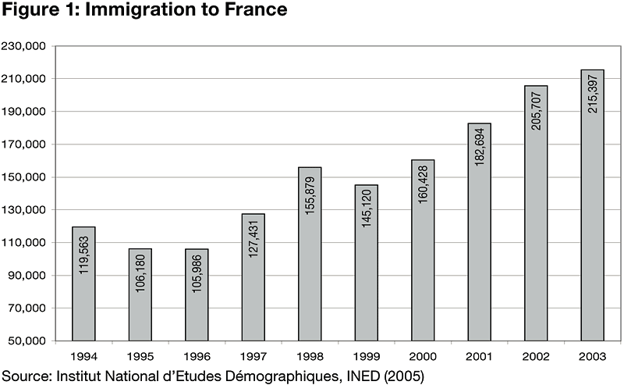

Also, the French market of non-immigrants that has high number and demands for services and products. The enrollment on higher education in France has increased and created a bigger market that our platform aim to reach the French students. Below the graph from Le Portail de Statistiques:

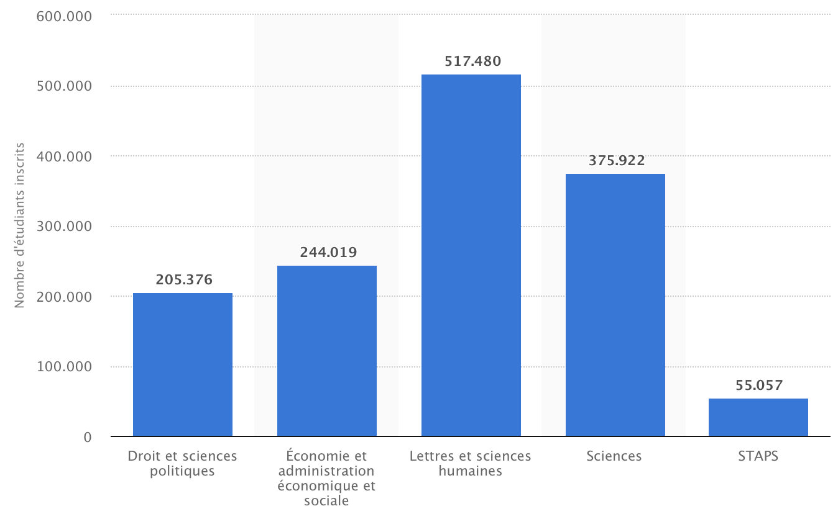

As one of the tests, we looked for Brazilian groups on Facebook and chose one called “Brasileiros em Nice” Brazilians in Nice. During the month of July to September three people ask for doctor assistance. They posted and explained their needs for a doctor that speaks Portuguese. Considering the target market ,between 23 - 45 years old , we have the facebook as sample of our target market:

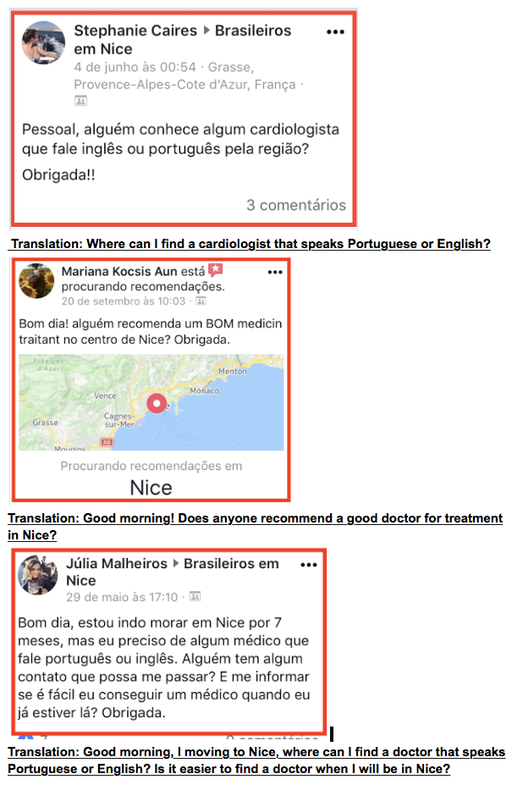

Considering this data, we can suppose that a small group on Facebook (Brazilians in Nice) gather three people interested in medical assistance then we can imagine a bigger market for the different groups from other countries on Facebook. Also, the experiment using survey show us that there is a even bigger market related to other services, such as home repair, caregiver of the elderly, teacher, between many other segments.

We intend to reach this immigration groups through different channels, such as tabloids and Facebook, increasing the popularity of platform and conquering new users initially in the Nice region. The city of Nice was chosen as the start point due the high number of immigrants living and their difficult to adapt to France.

Also, our business has been measured and expected the profit with ads in the future, which has been counted as the graph show below:

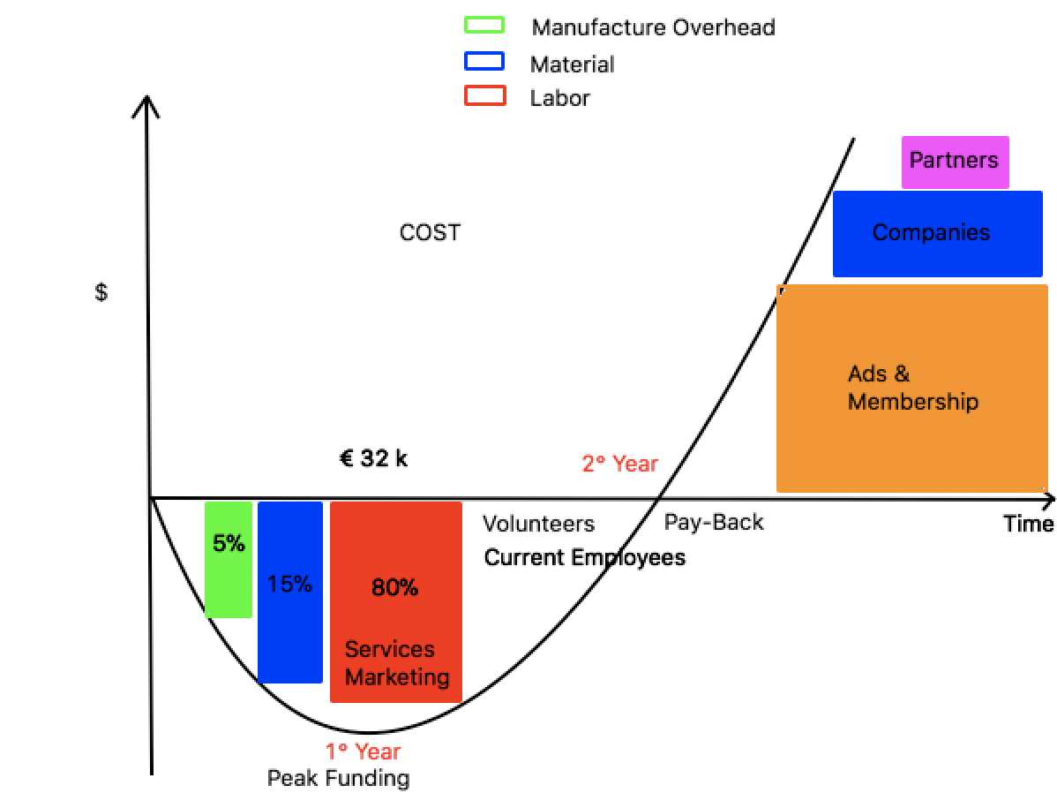

**SWOT**: Graph

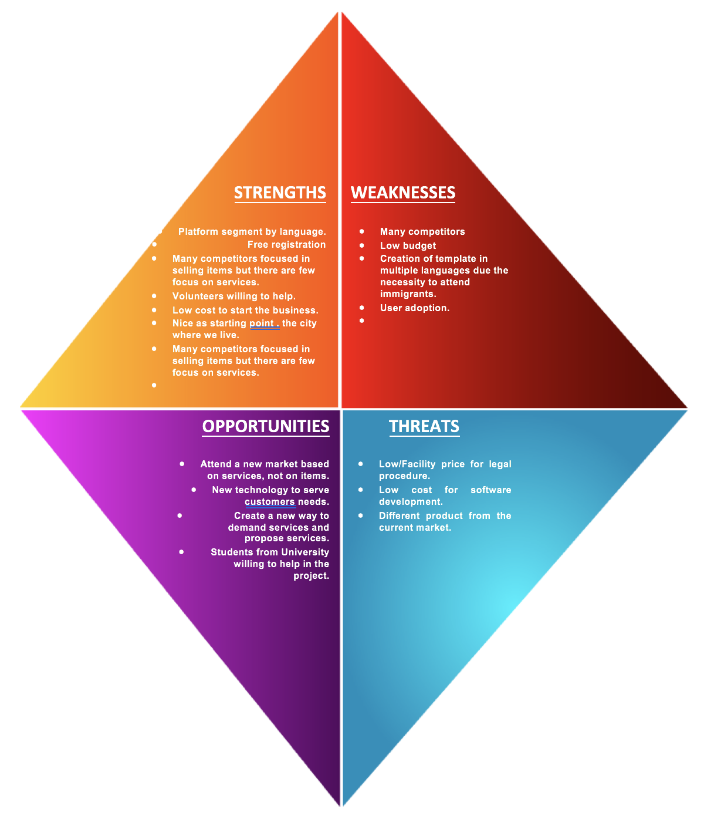

## 

## Competitor Data Collection Plan

|  |  |  |  |  |
| --- | --- | --- | --- | --- |
| **Name** | [leboncoin.com](http://leboncoin.com) | [expertforexpats.com](http://expertforexpats.com) | [clacdesdoigts.com](http://clacdesdoigts.com) |  |
| **Benefits/Features** | ***The company aim to create a virtual space to seller offer their products and services online.*** | ***The company provides advices for people moving to a new country, expatriates.*** | ***The admin analysis and price the service of the user based in what is necessary to do.*** |  |
| **Size/profitability** | ***Chiffre d’affaires***  ***214 000 000 €*** |  | ***Capital social***  ***14 852,00 €*** |  |
| **Market strategy** | ***The strategy adopted was use the high density of people seeking to sell items and on the other hand users trying to buy new items.*** | ***The strategy adopted by ExpertForExpat is to provide experienced professionals to support immigrants moving to a new country.*** | ***The strategy adopted by clacdesdoigts is based in communication by sms(Free in France), users send request and operators decide a price/profiossional.*** |  |

# Operational Plan

The day to day operation of our business will focus on providing the best services to our clients. The purpose of our platform is to connect service providers and clients, and we will remain focus on using our resources to provide variety of services to clients by connecting them with experts that render the services they need. We will establish a mutually beneficial relationship with clients by ensuring that their needs are met at affordable price. As part of our operational plan, initially registration is going to be free in order to attract clients and subsequently a specific amount will be charge for registration. we have no immediate plans to employ any additional personnel or open office for now, will do so when the business really took off and revenue begins to flow.

# Management & Organization

***Gabriel Moraes: CEO or Chief Eclectic Officer***

3 Years of experience as Data Engineer and development of platforms

Gabriel speaks: English , Portuguese and Spanish.

Responsibilities:Ensure the overall business growth and sustain the business from ensuring the overall business plan fall within the overall growth trajectory in the Nice neighborhood with a strong reputation and customer trust building.

***Cristian Grigoriu : CTO or Chief Innovation Officer***

3 years of experience on software engineering & Application development for web page

Cristian speaks : English, Romanian and Russian.

Responsibilities:Technological aspects of the company with respect to the website,app market as well as well as the business intelligence gathering is thrust upon this team,Ability to innovate and drive the tech savvy not only from the website and app but on operation efficiency including procurement and integration of IOT devices for security, customer satisfaction and overall ensuing technology leader in the business operation.

**Cyril Naves: COO or Chief Overall Efficiency Officer**

5 years of experience of Software development & Application management

He has experience developing, testing and creating enterprise applications for business in Airlines & Pharmaceutical domain

Cyril speaks: English and tamil

Responsibilities: Operation efficiency with Agile perspective and lean model ensuring minimum response time to customers attracting the target customers.Clear and streamlined flow of tasks to the business stakeholders as well as the tasks also ensuing accountability to the customers.

Involve in customer feedback and revamp the operation model if any of them fails thereby avoiding collateral damage for a brand new company which is prone to risks of bad reviews.

**Mustapha Abdul Kadir: CFO or Chief Financial Fidelity Officer**

7 years of experience in the Software Development area and Teaching

Mustapha speaks: English, Hausa and Arabic.

Responsibilities: “ Steam of the ship” is catapulted on the financial team and also ensure in integrity of the business thereby complying with legal aspects including local tax and external financial markets.Keep clear account of the inflows as well as outflows ensuring active operational money for immediate active ventures, be it customer satisfaction, pitching with the startup financiers.Also ensure the stocks of the company don't fall into the debt cycle and ability to atleast go for a graceful exit from the market without any legal repercussion.

# 

# Startup Expenses & Capitalization

|  |  |  |  |  |  |  |  |
| --- | --- | --- | --- | --- | --- | --- | --- |
| **StartUp Expenses** | **First Year( in €)** | | | | **Second Year( in €)** | **Total Cost ( in €)** | **Real Cost ( in €)** |
|  | **Quarter 1** | **Quarter 2** | **Quarter 3** | **Quarter 4** | **All Quarters** | **1st & 2nd year** | **1st & 2nd year** |
| Web - Designing | 1000€ | In maintenance phase | In maintenance phase | Minor Updates- 500€ | Minor Updates- 500€ | 2000€ | 0€ No cost incurred as it will be achieved by the founding team |
| Web- Hosting | 1000€ | In maintenance phase | In maintenance phase | In maintenance phase | Renewal -1000€ | 2000€ | 2000€ |
| App Development ios/ Android | 1000€ | In maintenance phase | In maintenance phase | Minor Updates -500€ | Minor Updates -500€ | 2000€ | 2000€ |
| Domain Name | 20€ | NA | NA | NA | 20€ | 40€ | 40€ |
| Stationery | 100€ | 100€ | 100€ | 100€ | 100€ | 500€ | 500€ |
| Legal Costs | 30€ | NA | NA | NA | NA | 30€ | 30€ |
| Printing for marketing: Placards, Tabloids, | 100€ | 100€ | 100€ | 100€ | 100€ | 500€ | 500€ |
| Recruitment | Volunteers | Volunteers | Volunteers | Volunteers | Volunteers | Probable Employment -1000€ | **Estimated to be minimal |
| Salary | 4000€ | 4000€ | 4000€ | 4000€ | 16000€ | 32000€ | *Only figure listed but it will be individuals contribution by the founding members* |
| Travel | 100€ | 100€ | 100€ | 100€ | 100€ | 500€ | 500€ |
| Miscellaneous | 100€ | 100€ | 100€ | 100€ | 500€ | 1000€ | 1000€ |
| Total | | | | | | 46070€ | **6570€** |

**Capitalization:**

Capitalization is essential for the startups as they decide how the team embraces their own funds or they are made to search for the funds in their initial phase.

Since our real cost is well within the limits of 6570€ it will be partnered and managed by ourselves with four team members ahring the funds responsibility.

Capitalization Plan for Initial 2 years

|  |  |  |  |  |
| --- | --- | --- | --- | --- |
| **Fund Source** | **Fund amount for** | **Work Contribution** | **Liability Constraints** | **Partnership Share** |
| Gabriel Pires | 2500€ | 20% | Shareholding in the startup | 28% |
| Cristian Grigoriu | 2500€ | 20% | Shareholding in the startup | 28% |
| Mustapha Sani | 2500€ | 20% | Shareholding in the startup | 28% |
| Cyril Naves | NA- Working Contribution | 40% | Shareholding in the startup | 16% |
| Total | 7500€ |  |  |  |

Since we have not included the web designing cost and salary realization it will be also included in the initial capitalization effort and based on those parameters we have partnership share between our members.

Post the 1 year initialisation phase we will be actively looking to expand our revenue and try to minimise the funding reliance on external funding partners as this will ensure our main priorities:

1. Independence of our Startup
2. Decrease bureaucracy hassles by avoiding fund creditors
3. Ability to Reshape our company based on the success or failure scenario
4. Evangelisation of the startup community by proving that a startup can grow without any investment constraints , regulations and policies

If at all we need funds to accelerate our aggressive expansion from Nice → Marseille → Cote d’Azur and then gradually expanding across french regions we’ll go via:

**CrowdFunding Options**: We create a initial campaign across university campus in Nice especially in our university of Nice Sophia Antipolis.

**Crowdfunding Campaign Strategy:** We start from University of Nice Sophia Antipolis which has a student base of 28000+ students and we aggressively market them our startup and our ideals.

We evangelise them with our concept with the motive of attracting students who would want to invest in a promising startup created by their own alumni.

1. Students have the potential to contribute in multiple of 5€, 10€,15€ and they benefit from possible recruitment as brand ambassador, marketing personnels, technology contributors or potential service providers.
2. Choosing the student ecosystem for our crowdfunding marketing campaign is crucial as we have word of mouth marketing which can help increase the brand portfolio as well as enhance the strategic plans we have aimed to cover the entire french region,

But crowdfunding would be the last option if we manage to fund our funds as well as balance with our revenue streams we aim to attract in our first and second year through our unique value proposition of services.

# Financial Plan

**Revenue Streams:**

1. ***Ads on website/tabloid(internal and external)_:***
2. General Ads Linked to Google Ads market which needs traffic base generated by our internal advice articles, product service review blogs
3. Ads on our fulfillment partners like the service providers who want to be in the limelight to attract services for the business

c)Ads generation using a printed tabloid delivered in the city of Nice enlisting the list of service and offers ( neighborhood newspaper model to attract offline customers)

1. ***Premium Membership*** - Customers and Fulfilment partners can upgrade to premium membership getting intelligent insights from the business support team as well as offers and potential consulting to expand their business perimeter
2. **Leads for business:** Large service fulfillment requires multiple stakeholder which cannot be delivered by one fulfillment member like for eg: “organizing a conference” - requires multiple partners to be sourced: Transport,Catering,Housekeeping, stationery, furniture which will be holistically owned by us and sub-business contract will be offered to specialised business players
3. ***Business Fulfillment and customer support brokerage:*** This is with the fulfillment of a service and ensured with an agreeable satisfaction both in monetary and quality aspects encompassing security, reliability and background verification including post service delivery support with extra brand accomplishment.This will be offered as a platinum service to repeat customers and big players.

**Year wise trajectory for Revenue**

**1 year:** *“Valley of Death”* - No major Revenue Accomplishment but Brand will be created in the community of Nice( Trust building among the customers which will be a potential revenue stream for the company)

***1-Quarter -*** Clearly no revenue income but stabilizing our operation by revenue spending - *“Period of Operation”$0*

2-Quarter - Traffic Generation by leading customers by the local aggressive offline tabloid as well as creating attractive articles - *“Period of marketing” $0*

3-Quarter - No revenue but can generate if more customers are generated in the 2nd quarter but a period of more stabilization $100-$500/month

4-Quarter: Minor Membership fees and Google Ads plus Ads on our fulfillment partners ( “*Period of aggression”* for revenue to close the fiscal report) $1000/month

**2 year: *”****Period of revamp”* engaging in big business consultancy to operate and expand the earlier revenue streams like Ads,Membership and also to build upon leads and consultancy including support and brokerage(Period of renaissance and new avenues exploration) $ 10000/month

**3 year**:Possible secure revenue stream from the earlier channels and continue to invest in expanding the operation to Marseille and Nice with a target of Cote D’Azure.$10000/month

# 