MPC Maid

Welcome to MPC Maid!

Get news, download updated versions and more at: http://mpcmaid.sourceforge.net/
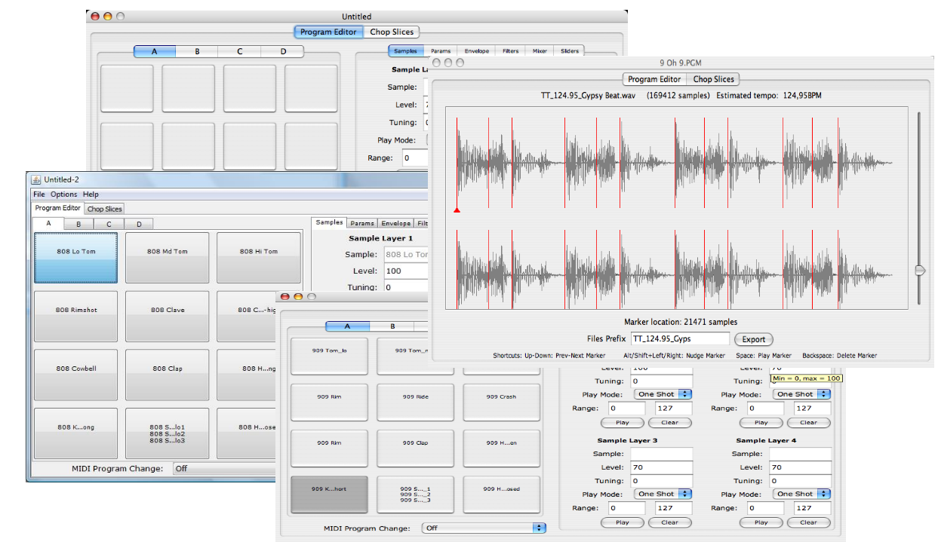

MPC Maid is an open-source (free) software editor for the Akai MPC 500 in particular (because of its limitations) but also suited for the MPC 1000 and MPC 2500.

It works on Mac, PC and other platforms (Java) and makes the creation and edition of MPC programs files easy, with some automated features for multisamples creation, batch creation of listing programs from nested folders of samples and loop slicing.

With MPC Maid, get the best out of your MPC!

Version beta 0.9

Basic Operations:
- Multiple window, one window for one program, simply drag and drop a .PGM program file will open a new window for this program.

- Switch between the MPC500 12-pads layout or the MPC1000 16-pads layout (and also the number of filters and sliders thanks to the built-in machine profiles).

- Simply drag and drop your samples files onto the pads, and it automatically assigns them, one on each pad or one on each sample layer.

- Export the full program and every related sample file together to the target location of your choice. If samples .wav files used in programs are longer than 16 chars (max length supported by every MPC) they are automatically shortened to fit (only when using Export, which is recommended).

Advanced Features:
- Slicing tool: Drag and drop your loop file (no longer than 2 bars) to have it chopped into slices based on a beat detection mechanism. Then directly export the chopped slices as multiple .WAV files, one corresponding .PGM program file and one MIDI groove .MID file.

- Multisample Creation: On drag and drop of .wav files with a consistent naming (that includes the note name, e-g "C#3", "E5" or "D 4"), you can automatically create Multisample program: MPC Maid calculates the allocation of the samples across pads and the tuning of each pad to reconstitute a complete chromatic scale.

- Edit / Batch Create Program: Automatically creates a program (.pgm) that lists every .wav sample in each directory and sub-directory from a chosen base directory. This allows for instant conversion of any .wav sound library into an MPC-readable library.

- Edit / Copy Settings to All Pads: You want to quickly change parameters for every pad? Set your parameters on one pad, then copy them to every other pad, except of course the sample name, tuning and midi note.

Known issues:
- In the chop slices tab, the focus is not guaranteed to be on the waveform zone, when it is not you need to click in this zone to make sure the keyboard shortcuts work.
- On Vista the sound playback can be non-reactive when multiple pads are pressed very quickly.
- On Mac OS X 10.4, in the chop slices tab, sound playback can in some rare case block the application, forcing to restart.

Installation
Download the unique .jar from https://sourceforge.net/project/showfiles.php?group_id=252031
Double-click on it, MPC Maid must show.

Requirements
In Windows, if Winzip or Winrar tries to decompress the file this probably means you do not have Java installed yet. Go to http://java.sun.com/javase/downloads/index.jsp and download the JRE (1.6 update 12 at the time of writing) then follow the very simple instructions. In 2mn you can be done.

Program Editor

On start-up the default view is an empty Program Editor (pictured below, on a Mac):

Below a view on Windows of a program that has already been created or opened:
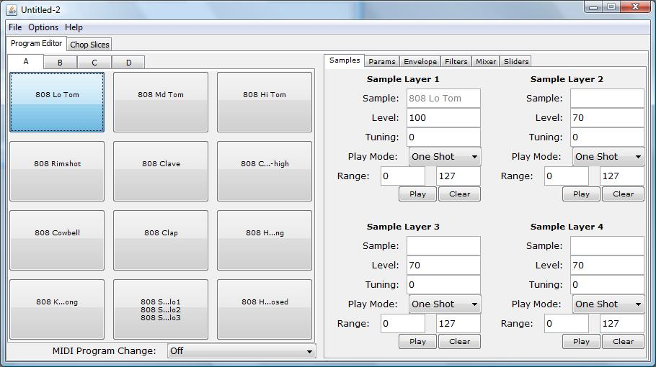
On the left half of the window there are the four banks of pads. Each pad shows the names of the samples assigned to it (zero to four samples per pad).

On the right half every parameter for the currently selected pad is shown. They are separated into several tabs for convenience. Note that the slider tab is global to the full program, it does not depend on the currently selected pad.

Edition is straightforward: change a value and that's it. When the mouse stops on top of a field a tool tip tells the minimal and maximal value allowed. In case you entered a wrong value you cannot quit the field and you can hear a beep of warning.

Clicking on a pad plays the sound assigned to this pad. There are several audition modes:
- Play first available sample
- Do not audition samples
- Play sample 1
- Play sample 2
- Play sample 3
- Play sample 4

A the time of writing the Preferences dialog does not allow to select them.

Selecting your MPC
The Options menu offers to toggle between the MPC 500 profile (12 pads, 1 slider, 1 filter) and the MPC 1000 profile (16 pads, 2 sliders, 2 filter2). This only takes effect for the next windows to be opened (new or open PGM files). This setting is remembered after you quit the program.

Here is a view of the pads layout for the MPC 500:

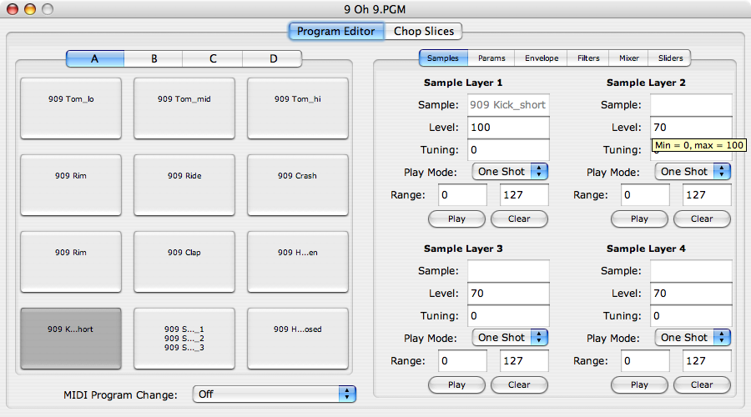

Adding samples to the pads
Simply drag and drop one or many .WAV file(s) from the Files Explorer (Windows) or from the Finder (Mac) into one pad in program editor area: you will be prompted whether you want to assign the files one on each pad (the PAD option) or one on each sample layer of each pad (the SAMPLE) option.
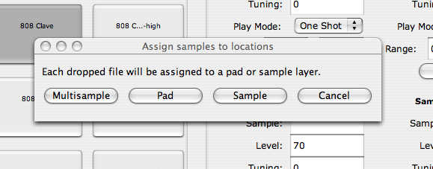
This feature allows for rapid creation of program by dropping up to 255 samples in one go.

The option MULTISAMPLE offers to create a multisample program. On drag and drop of .wav files with a consistent naming (that includes the note name, e-g "C#3", "E5" or "D 4"), MPC Maid calculates the allocation of the samples across the pads and the tuning of each pad to reconstitute a complete chromatic scale.

When the naming of the files does not allow for guessing the note of each sample then the option is not shown. If you want to use this convenient way to build multisample programs, just rename the samples so that:
- Each sample name has the same structure, e-g Rhodes_dark_C#3, Rhodes_dark_G3 etc
- Contains a note name in the form "C#3", "E5" or "D 4"
- Notes outside the range of the MPC (from B0 to A#4) will be ignored

Opening PGM files
To open you can select “Open” in the File meny or ctrl-O (Windows) / Command-O (Mac). The last opened directory is remembered after you quit the program. You can also simply drag and drop a .PGM file from the Files Explorer (Windows) or from the Finder (Mac) into the program editor area (but not straight on a pad).

Saving PGM files
To save a program you can select “Save” or “Save As...” in the File meny or ctrl-S (Windows) / Command-S (Mac). The last saved directory is remembered after you quit the program.

Exporting a PGM files bundle
The MPC expects every sample used in a program to be in the same directory as the .PGM file. After you created your program in MPC Maid you can select “Export” in the File menu, or ctrl-E (Windows) / Command-E (Mac) to export the .PGM program file and each related .WAV file together into the same target directory.

If samples .wav files used in programs are longer than 16 chars (max length supported by every MPC) they are automatically shortened to fit (only when using Export, which is recommended). Beware than in some cases several shortened files can have have the same name, which will cause the same sound to be assigned to several pads. To fix that, rename manually your wave files then re-import them.

Edit menu

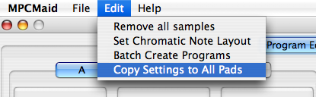
Remove all samples
Removes every sample of the current program. This is convenient to reuse a program as a template to create another: every parameter is kept, just drap and drop new samples to quickly create another program.

Set Chromatic
Changes the midi note of each pad so that they follow a chromatic scale (consecutive notes, as on a piano keyboard) rather than the weird MPC notes scale.

Batch Create Programs
Choose a root directory that contains wave files and /or sub directories that contain wave files, then MPC Maid automatically browses each directory and create a default program in each directory (based on the current program as a template) that lists every sample from this directory.

The name of the listing program is derived from the name of the directory it is in, shortened to 14 chars plus a number. When there are more than 48 samples (in MPC 500 layout) or 64 samples (in MPC 1000/2500 layout) then several listing programs (xxx1.pgm, xxx2.pgm etc.) are created to reference every file.

Copy Settings to All Pads
You want to quickly change one or many parameters for every pad?

Set your parameters on one pad, then copy them to every other pad, except the sample name, tuning and midi note that are of course very much pad-specific.

The slices editor
MPC Maid offers a small slice editor to chop loops into their beats quickly: just drag and drop a loop in .WAV format (16 bits 44.1KHz preferably) into the center of the scren:
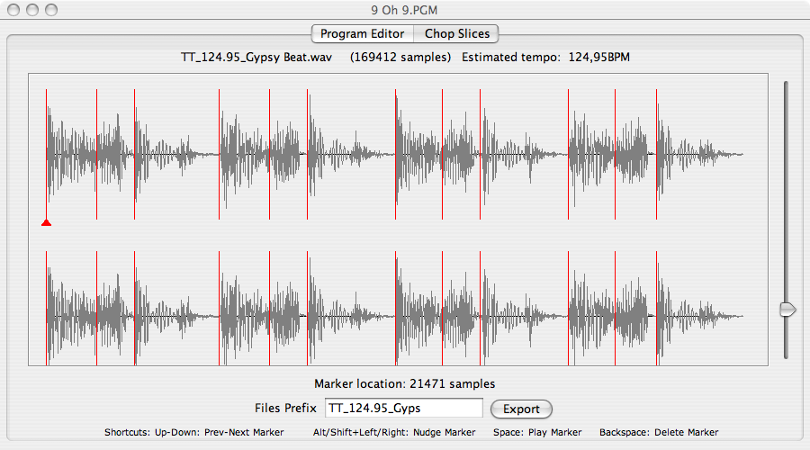
The editor seamlessly processes the file to detect every beat and marks them with red markers. The slider on the right is a sensitivity settings to help tweak the detection: just move it to see the changes.

Click the Export button, and the loop will be exported as several .WAV files (one for each slice), a MIDI groove .MID file (a chromatic sequence that has the same onset as the original loop), and of course the MPC program .PGM file that goes with the slices samples.

If you copy every exported file to your MPC, then open the .PGM, you have the loop chopped on each pad! If you also open the .MID sequence then you can replay the original loop, then vary its tempo in a REX-like fashion!

Slicing Edition
Pressing the space key plays the portion of the loop at the currently selected frame. Arrows up and down are used to navigate the markers, and the Backspace key can delete the marker. Shift + left/right arrow or Alt + left/right arrow can be used to nudge a marker.

Known issue: For the keys to work the focus must be on the center of the screen: if it is not, click the center of the screen, or use the Tab key to cycle through the items next to the top item.

Note: the tempo is estimated solely on the length of the loop, which is perfectly accurate for every commercial loop.

Addendum

Credits
MPC Maid ("MM") Copyright 2009 Cyrille Martraire
cyrille.martraire.com
Project homepage: http://mpcmaid.sourceforge.net/

MPC Maid is strongly inspired by the excellent MPC Pad 187 by Stephen Norum, that is unfortunately not portable on other OS'es than Mac OS X.
http://mybunnyhug.com

MPC1000 File Format
Based on the extensive documentation provided by Stephen Norum:
http://mybunnyhug.com/fileformats/pgm/

Automatic Slicing
Beat detection follows the excellent guide "Beat Detection Algorithms" from Frédéric Patin: http://www.gamedev.net/reference/programming/features/beatdetection/

Portable browser launcher (help):http://www.centerkey.com/java/browser/
Bare Bones Browser Launch Version 1.5 (December 10, 2005)
By Dem Pilafian. Public Domain Software -- Free to Use as You Like

MPC Maid is offered for free for everyone so that you can get the best out of your MPC. You can use it forever without any limitation. If you feel like supporting this project then you can send feedback, contribute to the code and testing, and you can also donate what you want.

Copyright Cyrille Martraire 2009 – LGPL license

