北京邮电大学2022—2023学年第二学期
《离散数学》期中考试试题
考 试 注 意 事 项 | 一、学生参加考试须带学生证或学院证明，未带者不准进入考场。学生必须按照监考教师指定座位就坐。  二、书本、参考资料、书包等物品一律放到考场指定位置。  三、学生不得另行携带、使用稿纸，要遵守《北京邮电大学考场规则》，有考场违纪或作弊行为者，按相应规定严肃处理。  四、学生必须将答题内容做在试题答卷上，做在草稿纸上一律无效。

- Construct the truth table for each of the following compound proposition.
(q → ¬ p) ↔ (p ↔ q)
[10 marks]

- Show that ¬(p ↔ q) and (p ∨ q) ∧ ¬ (p ∧ q) are logically equivalent.
[10 marks]

- Show that the argument with the following premises (前提) and conclusion (结论) is valid by using rules of inference.
Premises: p→ q, r→s, p ∨ r
Conclusion: q ∨ s
[10 marks]

- Let A, B and C be three sets. Show that
(A - B) - C = A- (B∪C).
[10 marks]
证明：左式 = (A− B) ∩ ~C
= A ∩ ~B ∩ ~C
= A ∩ (~B ∩ ~C)
= A ∩ ~ (B∪C)
= A- (B∪C)
= 右式

- Show that the set of real numbers between 0 and 1 is uncountable.
（2.5节课件例题）
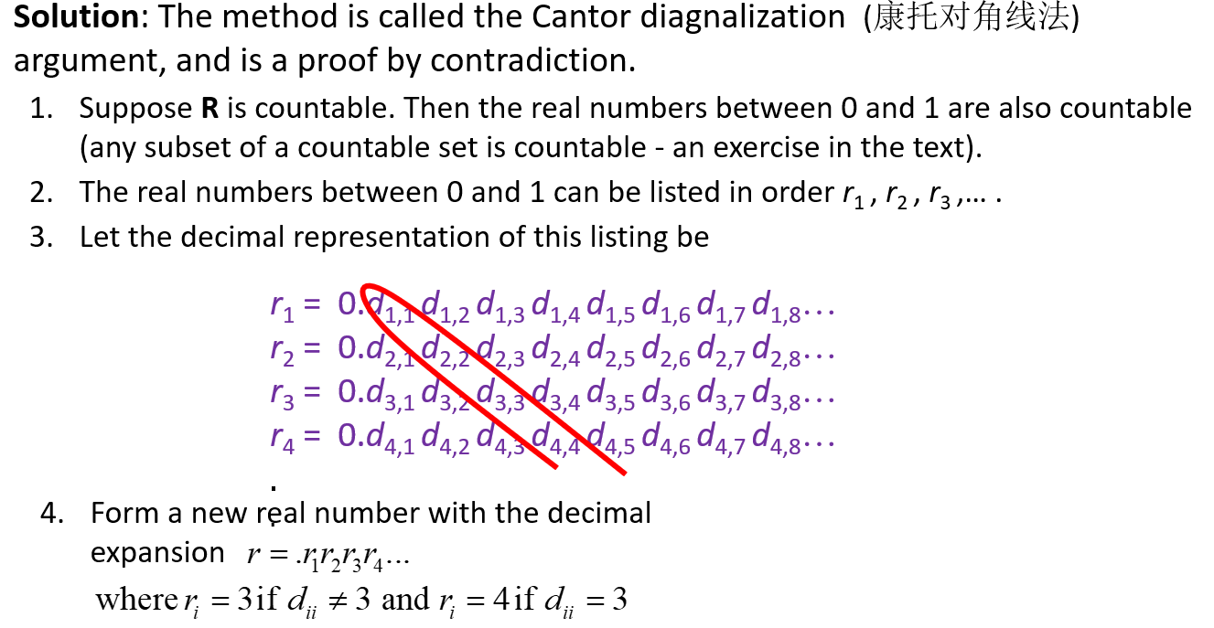
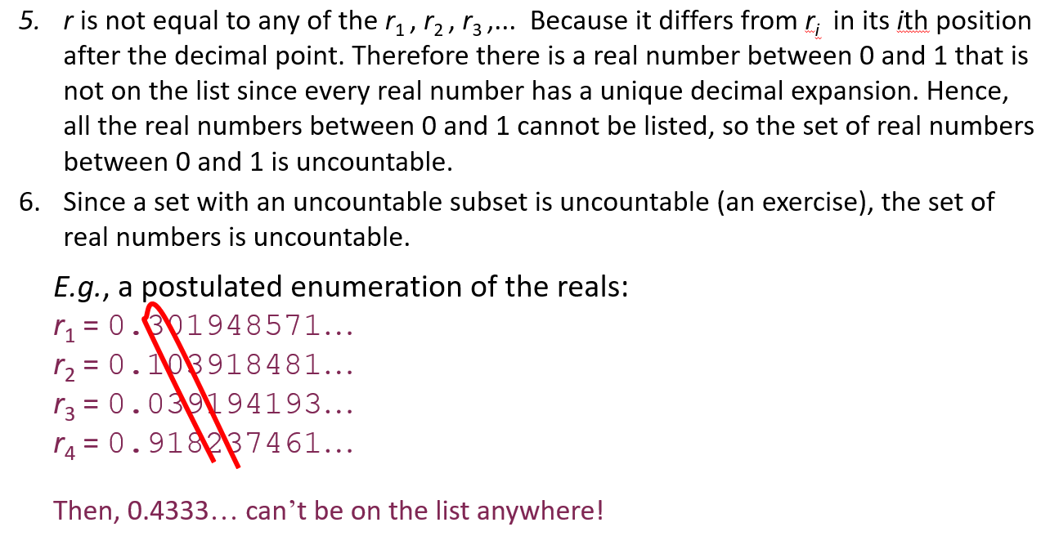

- Use the Euclidean algorithm to find the gcd of 168 and 300, please also write the gcd as a linear combination of 168 and 300.
[10 marks]
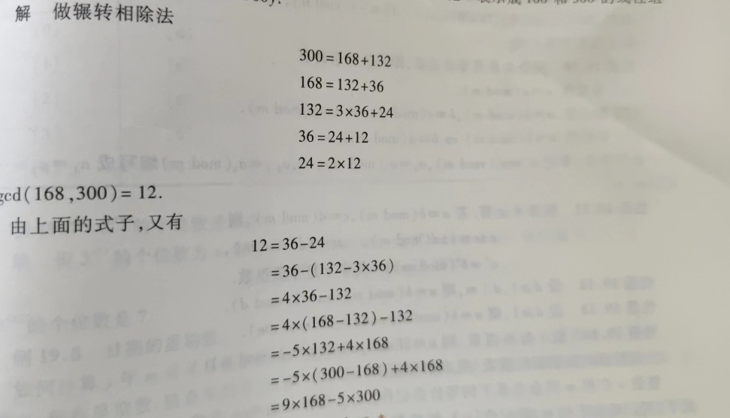

- Prove that when $n≥2$, it holds that
$$1+\frac{1}{2^{2}}+\frac{1}{3^{2}}+⋯+\frac{1}{n^{2}}<2-\frac{1}{n}$$
[10 marks]

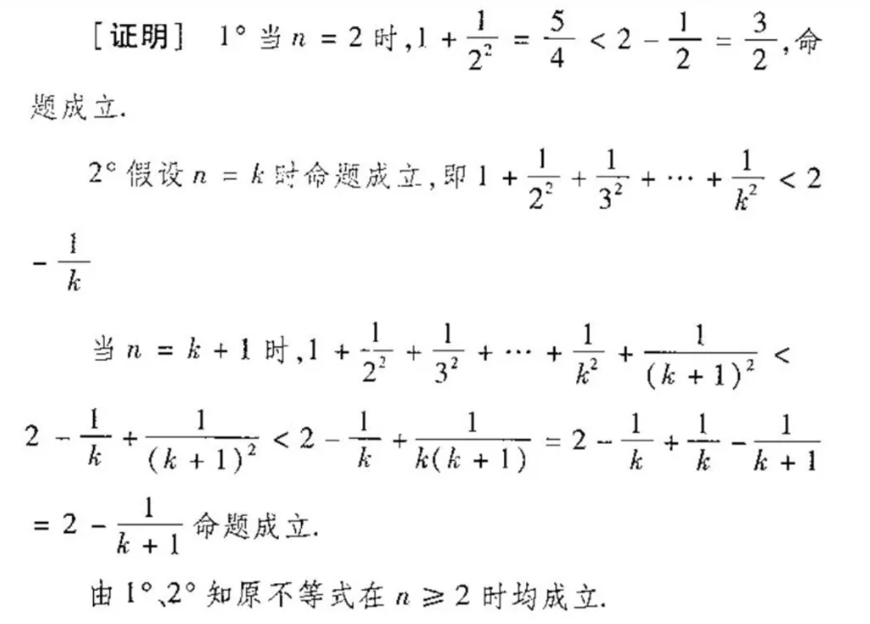

- Use the Chinese remainder theorem to find the smallest non-negative integer satisfying the three congruence.
$$x≡\left\{\begin{matrix}3 (mod 7) \\ 3 (mod 5) \\ 4 (mod 12)\end{matrix}\right.$$
[10 marks]

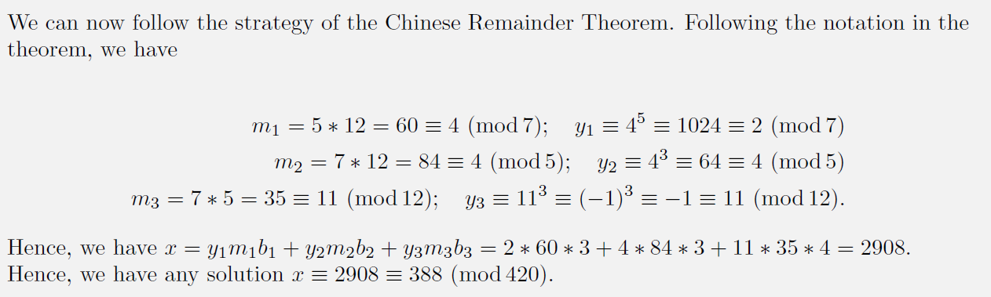

- 1) How many bit strings of length 10 either begin with three 1s or end with two 1s?
[5 marks]
2) Suppose that a cookie shop has three different kinds of cookies. How many different ways can eight cookies be chosen?
[5 marks]

- 352
- C(8+3-1, 8)

- Please use the principle of mathematical induction to prove the binomial theorem.
