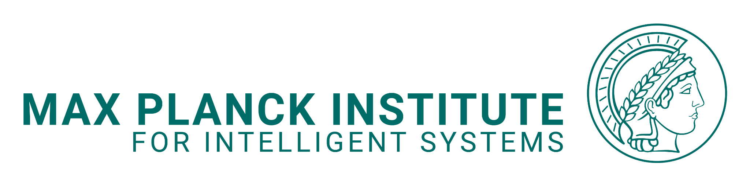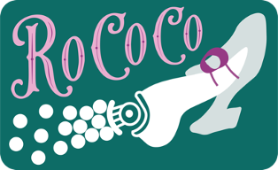

Six-Month Research & Development Review

As a research group, we have two goals: to produce excellent, ethical, and creative research, and to help each other grow into stronger researchers. The six-month review is a chance to step back from day-to-day work and look at both: what the research is doing, and how you are developing through it.

It is intended for RoCoCo members who are in the group for at least nine months. For shorter-term members, such a formal review is probably not necessary, but if you would find a similar structured discussion useful, we can schedule one.

The goal is to have an open and useful discussion about:
- where the research is going
- what is working well and what is getting in the way
- how you are developing as a researcher
- how we are working together
- and what we should focus on over the next six months.
The aim is not to have everything figured out, but to reflect and discuss together.

Preparation
- Reflect on the questions listed in the sections below. You do not need to answer every prompt exhaustively. The purpose is to guide your reflection, help you develop the content of your presentation, and identify important points for discussion during the review.
- Prepare a presentation (with slides) of approximately 20 minutes that synthesizes the most important points from your reflection, and highlights topics you would particularly like to discuss. Please use concrete examples and, where relevant, show actual data, figures, analyses, prototypes, documentation, drafts, or other research outputs rather than relying only on a general description of your work.

I (Buse) will independently prepare my own written reflections on the same prompts below before the meeting. During the review, we will compare our perspectives and agree on priorities, milestones, and what support would be useful over the next six months. I will share my written feedback with you after the meeting alongside notes.

We should book 90 minutes for this meeting.
- Review of research (the what – so far)
  - The big question / problem
What is/are the scientific question(s) or problem(s) you are trying to address in your current research, and what do you currently see as the central scientific contribution(s) of the work?
  - What has happened?
- What have you actually done over the past six months?
- What important scientific results came out of it? What did the results – including negative or inconclusive results – teach us?
- What changes occurred along the way? (e.g. in the scientific direction, methods, technology, available resources, or working environment)
Please base this section on your documentation, laboratory records, and available data, rather than only giving a general overview.
  - How’s it going?
- What are you most proud of from the last six months?
- How do you assess the overall progress of the project in the last six months?
- Where has work moved forward efficiently, and where have tasks taken longer than expected?
- Why? What scientific and/or technical factors contributed to this? (e.g. research question, experimental approach, state of prior literature, materials, equipment, etc.)
- Working process and skills (the how)
  - Working process
- How do you currently plan, prioritize, execute, and document your work? How do you decide what to work on next, follow through on decisions and commitments, and respond when something is blocked or does not work as expected?
- How do you think the working process has influenced the pace, quality, and outcomes of your research? What aspects have supported progress, and what aspects would you like to improve or change?
- Are there aspects of the working environment, supervision, infrastructure, responsibilities, or available resources that are supporting or limiting your work?
Please use concrete examples wherever possible.
  - Relevant skills
- What scientific, technical, methodological, and professional skills are important for carrying out your work successfully? Check the end of the document for inspiration, and list 5-7.
- From these skills, identify
  - 2-3 current strengths
  - 1-2 areas in which you have developed significantly
  - 1-2 skills to prioritize for further development
- Collaboration, independence, and supervision (the who)
  - Contribution to the group
- How have you contributed to the broader research group over the past six months? Consider, for example, sharing knowledge or expertise, supporting others, contributing to discussions and meetings, collaborating on projects, or contributing to shared resources and activities.
  - Collaboration
- How do you think your research collaborations with others (both within RoCoCo and with external collaborators) have worked? What has worked particularly well, and what could be improved?
- When working with others, how do you communicate responsibilities, expectations, progress, and difficulties, and how do you ensure follow-through on shared tasks?
  - Independence and ownership
- Which parts of your current research do you feel able to advance independently, and where do you need more guidance, feedback, training, resources, or other support?
- How has your level of independence and ownership changed over the past six months? Consider, for example, identifying research questions, proposing ideas or next steps, making decisions, solving problems, following through on agreed next steps, and driving projects toward concrete outcomes.
  - Feedback on supervision & support
- What aspects of supervision or feedback have been most useful, and what could make our collaboration more effective?
- Is there anything you would like more of, less of, or differently from me as your supervisor?
- Is there anything about how I communicate, give feedback, or allocate time/attention that gets in the way of your work?
- Scientific direction and forward plan (the what and the when - moving forward)
  - Upcoming major research outputs
For each main project that should lead to a publication or other significant research output:
- What is the tentative title or working description?
- What is already established and what is still missing in terms of experiments, analyses, evidence, figures, arguments, or writing?
- What are the main scientific or technical risks or uncertainties?
- What is the tentative target venue and completion date?
- What are the main milestones required to reach this output over the next six months, and what are realistic target dates?

  - Longer-term direction
- What would you like to pursue after your current project(s) as possible next directions?
- What would you like to have accomplished by the end of your time in the group?
  - Career goals
- What are your career ambitions? What direction would you like to go after your time in RoCoCo?
- Are there career or professional goals that should influence what we prioritize?

- Takeaways
This section will be filled in together during or immediately after the meeting.

What is going well and should continue?

What should change or improve?

Top priorities for the next six months (research & professional development)

Support or actions from Buse

Reference Skills List
The examples below are intended as a reference rather than a checklist. Different roles, career stages, and research projects require different combinations and levels of these skills. These are skills that researchers are expected to develop progressively over time; the aim is not to demonstrate mastery of all of them, but to identify current strengths, areas of growth, and skills that should be prioritized in the next phase.

Scientific skills:
- Domain knowledge and understanding of the relevant literature
- Formulating clear, meaningful, and answerable research questions and hypotheses
- Scientific framing: identifying what is new, why it matters, and what the work contributes
- Critical thinking and scientific judgment: questioning assumptions, asking good questions, evaluating evidence, recognizing weaknesses and considering alternative explanations.
- Scientific rigor and integrity: prioritizing evidence over desired outcomes; using appropriate controls and comparisons; reporting uncertainty, negative results, and limitations honestly
- Scientific writing, visual communication, and presentations
Technical skills:
- Experimental and laboratory skills
- Design, fabrication, and rapid prototyping
- Characterization and measurement
- Modeling, simulation, programming, or computational tools
- Data analysis and visualization
- Hardware and software integration
- Troubleshooting and developing reliable technical protocols

Methodological skills:
- Experimental design: designing experiments that answer a defined question efficiently and convincingly consider appropriate controls/comparisons
- Planning and prioritization: focusing on the work that most advances the research question
- Reflection and adaptation: periodically stepping back to assess what is working, what is not, and what should change in the research approach.
- Iterating based on evidence and making clear decisions about next steps
- Balancing exploration and convergence: knowing when to explore broadly and when to narrow the scope
- Efficient research strategy: working strategically rather than simply doing more; using existing knowledge, resources, and expertise effectively
- Follow-through: translating discussions, decisions, and plans into completed work and concrete outputs.
- Publication-oriented planning: identifying the evidence, figures, analyses, and arguments required to turn a project into a coherent research output
- Effective use of feedback: incorporating scientific discussion and critique into subsequent work

Professional skills
- Clear, timely, and effective communication: communicating information at the right level of detail, at the right time, and to the right people
- Solution-oriented communication: raising difficulties clearly, explaining what has been tried, identifying the blocker, and proposing possible next steps or stating what support is needed
- Making effective use of meetings and feedback, including preparation and follow-up
- Reliability and accountability: doing what has been agreed, or communicating promptly when circumstances change
- Ownership and initiative: taking responsibility for advancing work rather than waiting for every next step to be assigned
- Sharing credit generously: making sure you highlight who has helped you with what

