Jonathan Cyrus M. Francisco

IT41S2

Attached your midterm project here

1. visual studio code (screenshots)

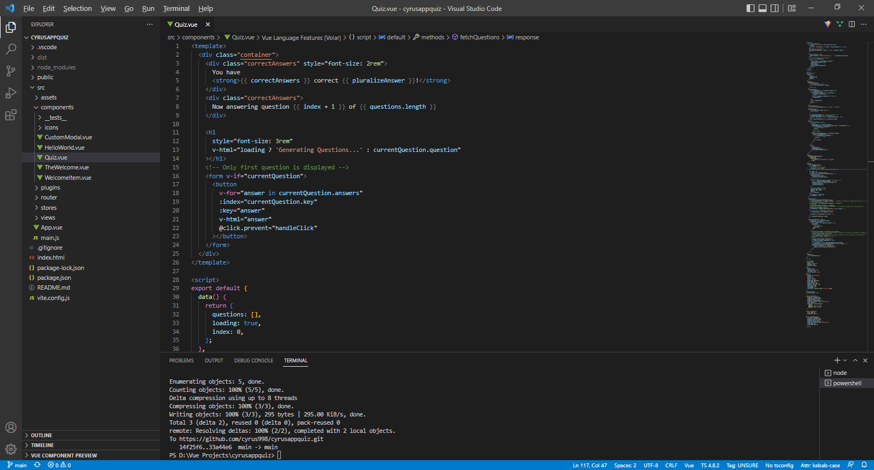

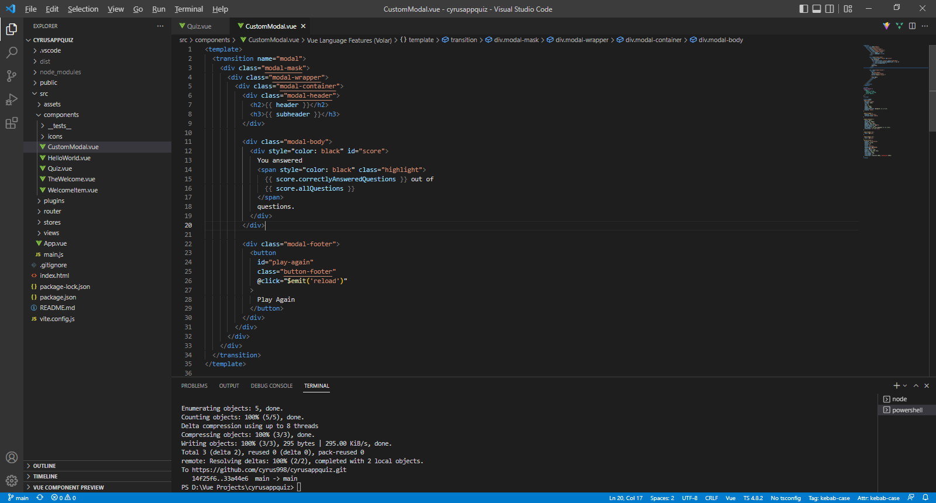

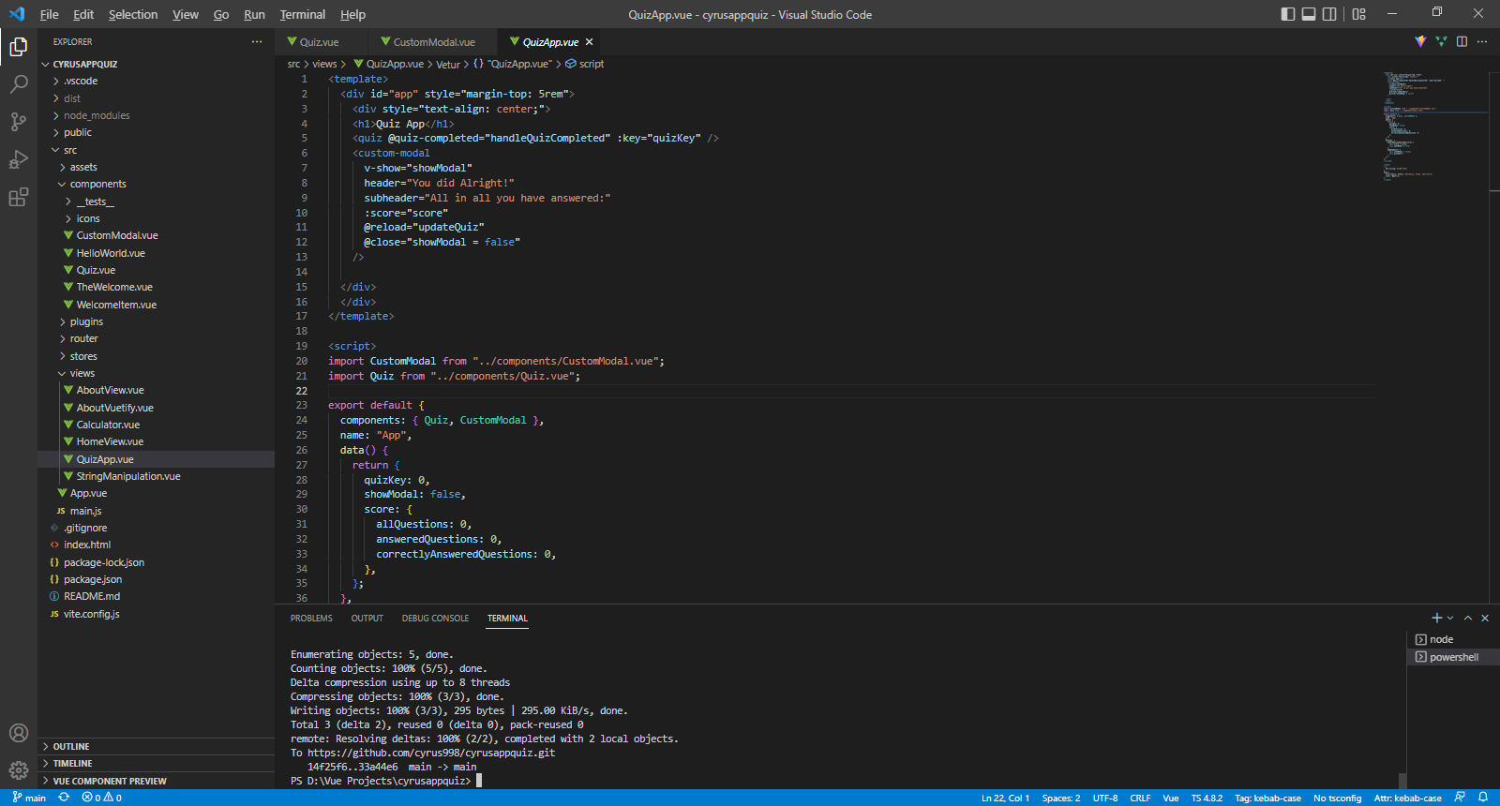

2. GitHub (screenshots)

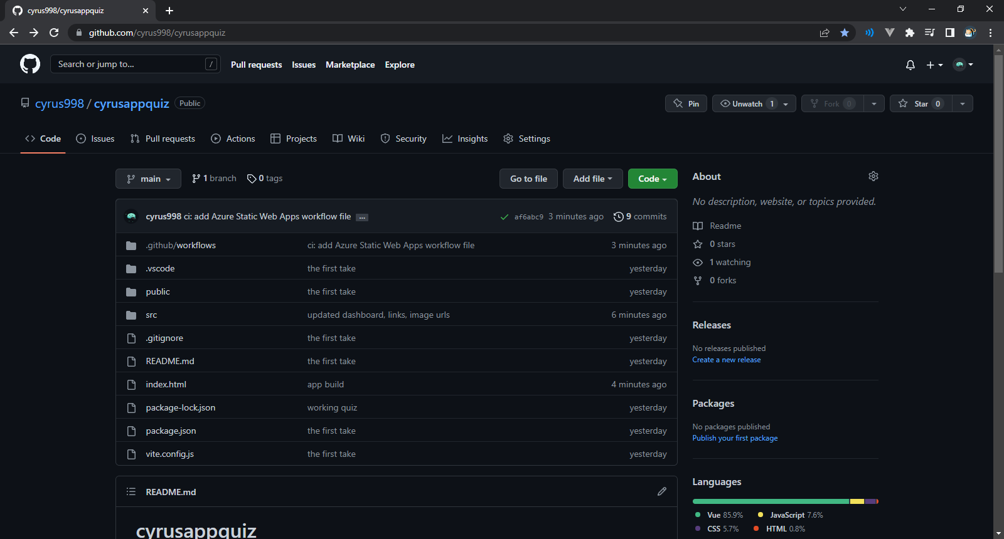

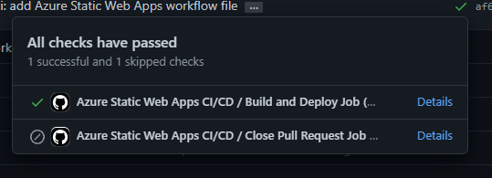

3. Azure (screenshots)

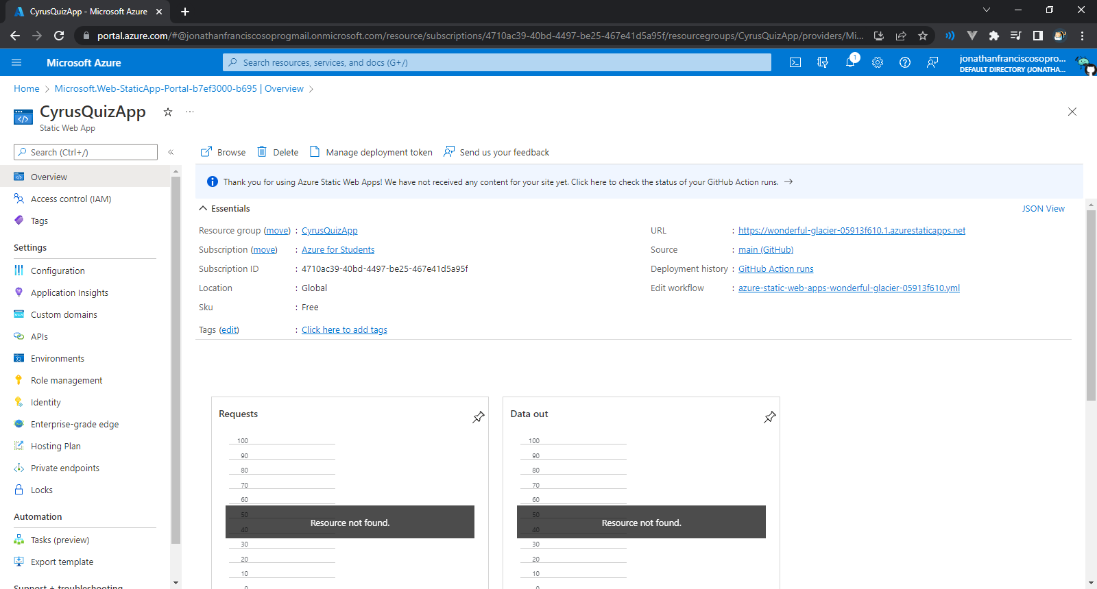

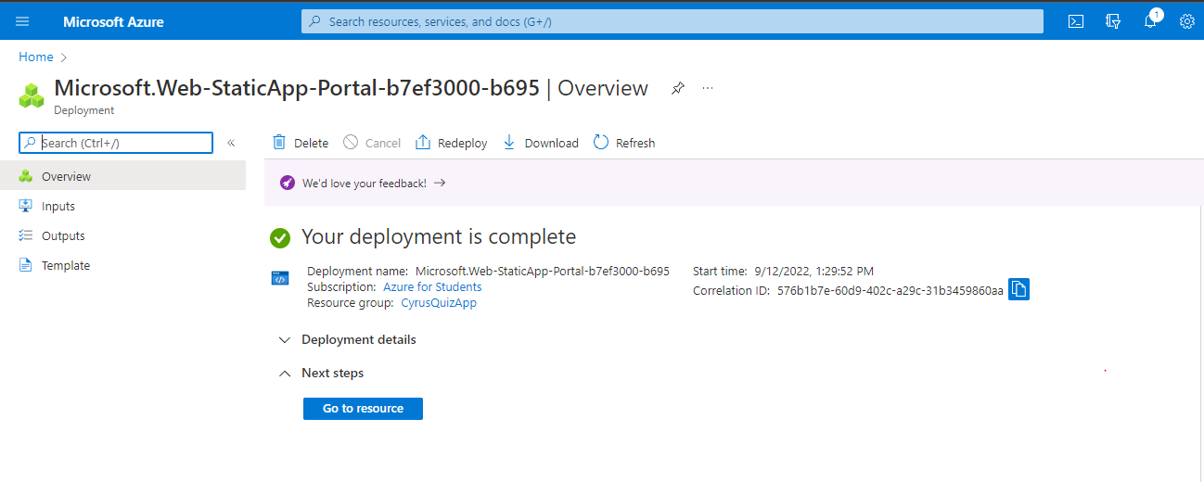

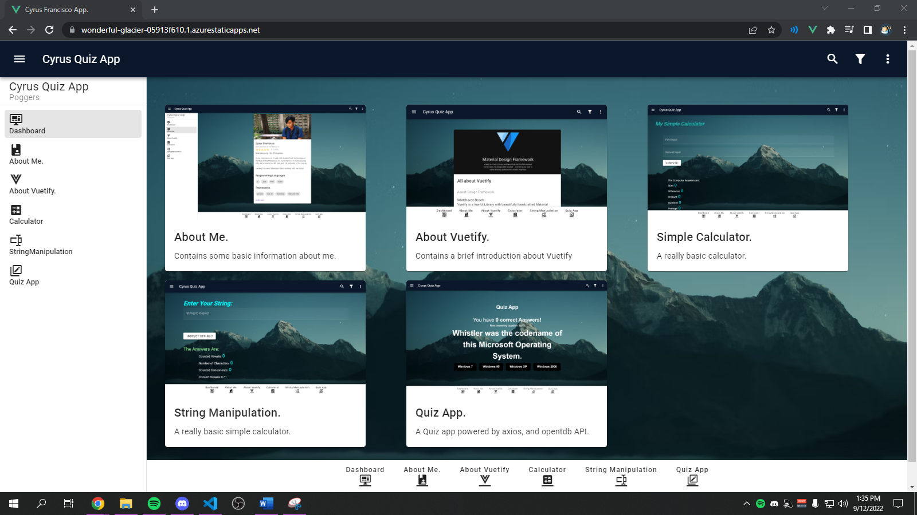

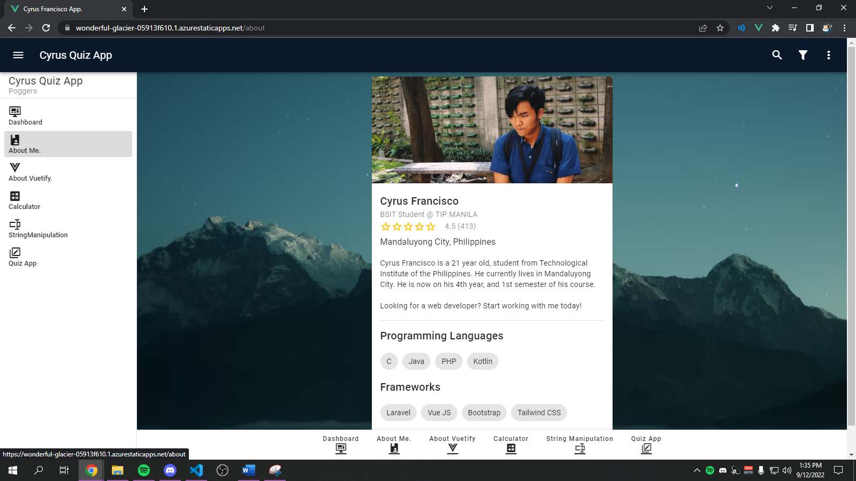

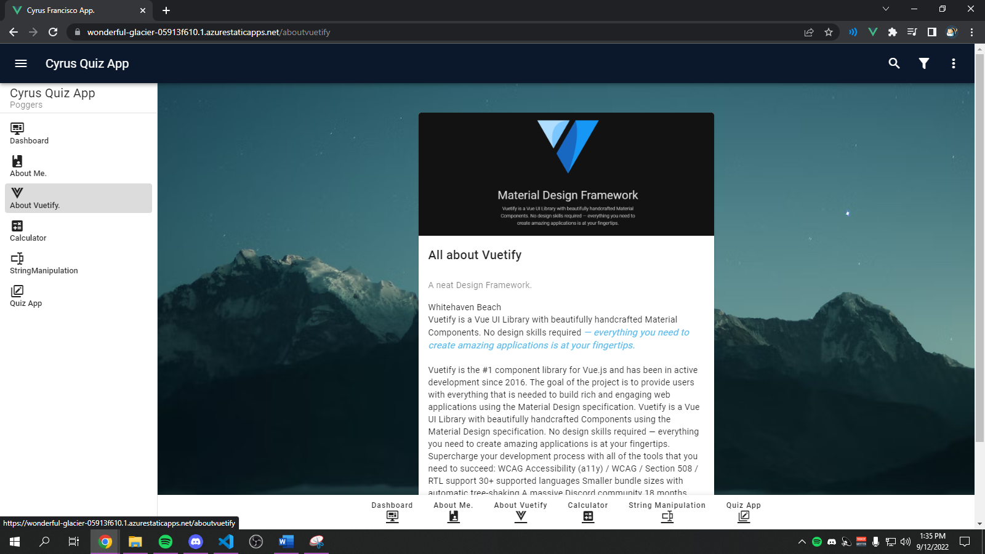

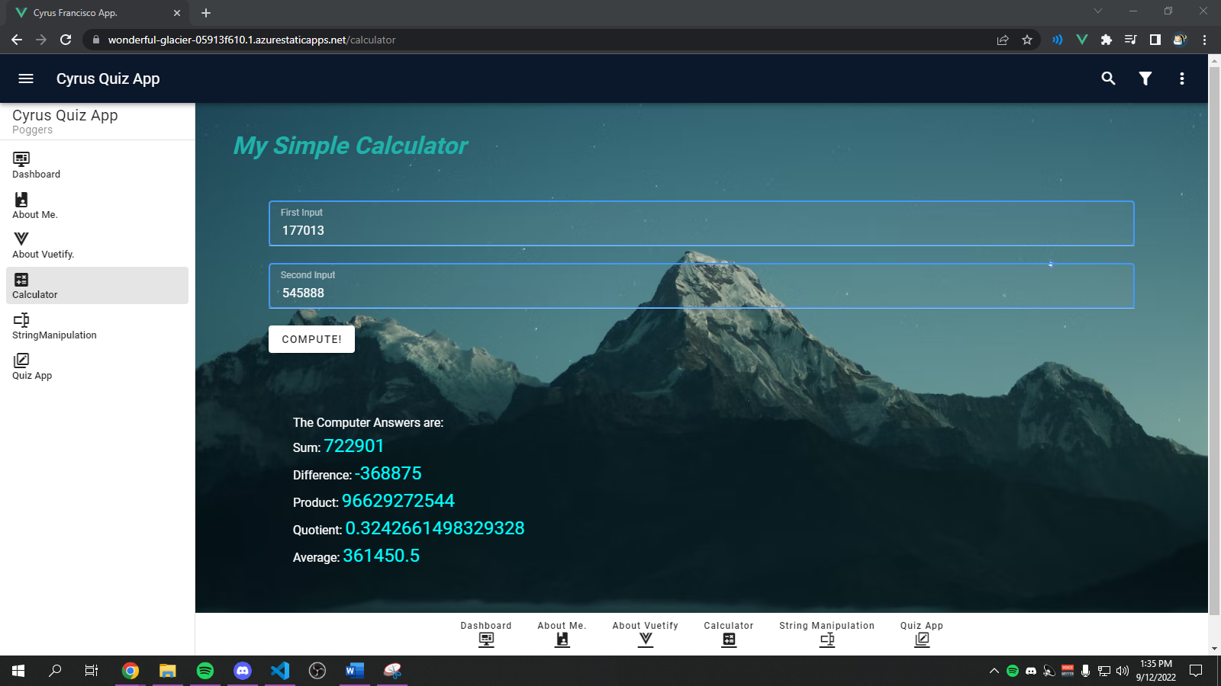

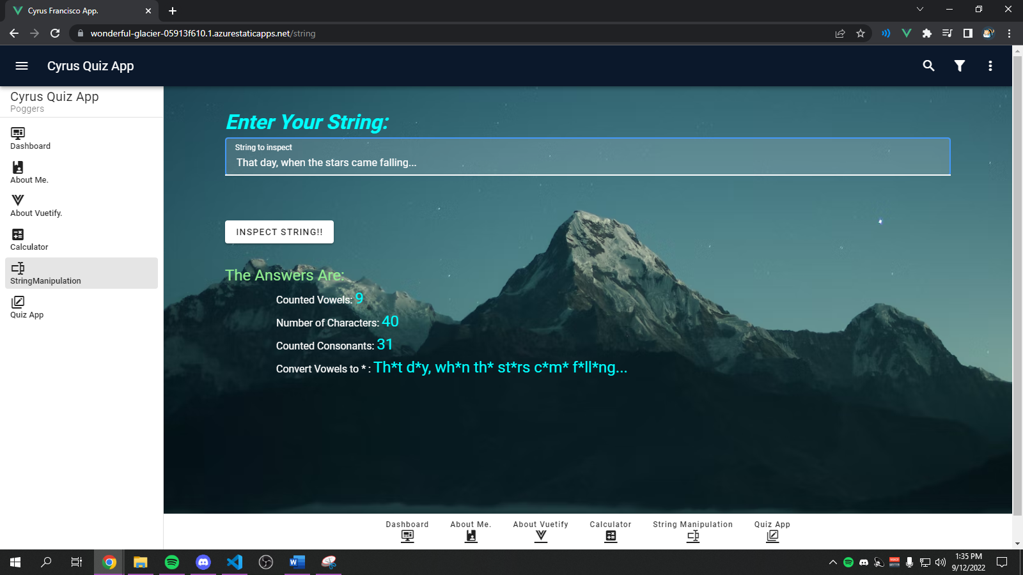

QUIZ APP

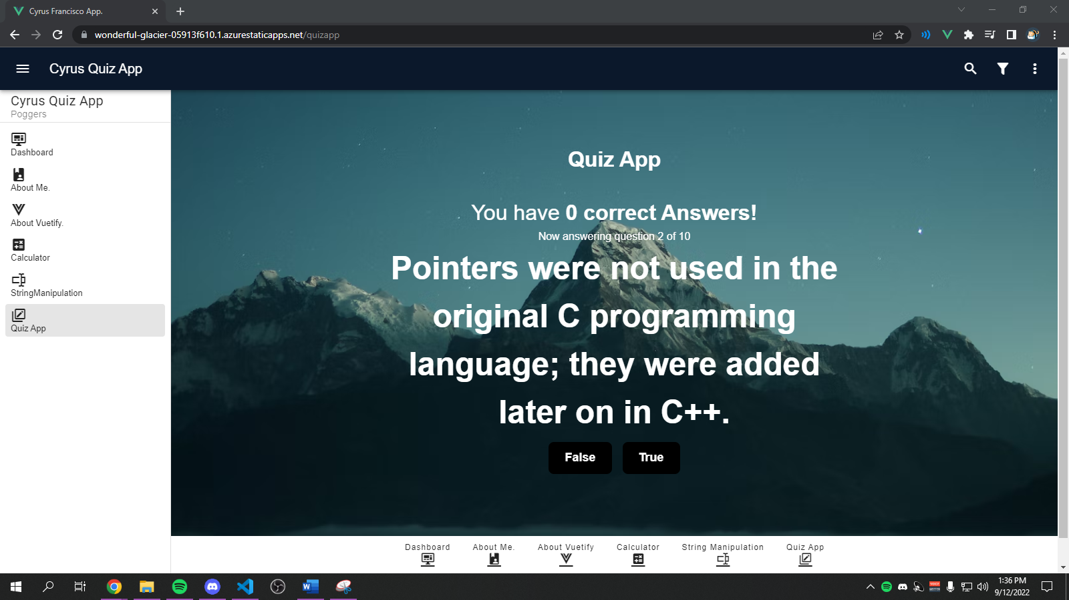

4. project link

<https://wonderful-glacier-05913f610.1.azurestaticapps.net>

5. reflection

**My Reflection:**

There were a few realizations over the duration of the making of this project, and I now see the potential of using the framework of Vue.js. I find it highly suitable for building apps on a rapid-development phase. The UI components were high scalable, and highly customizable. The syntax was clean as well, and easy to understand.

What really got my interest was how clean the Vuetify documentation is, it pretty much has all the components that I needed, and the API was fairly straight-forward to use. Overall, I would highly suggest this framework to use for medium scale or even large-scale applications.