**John Cyrus Magallanes**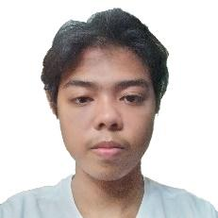

**Address:** #7 M. Prieto St., San Roque Marikina City

**Contact #:** +63 968 290 1087 | +63 965 908 2990

**Email:** [cyyjohn06@gmail.com](mailto:cyyjohn06@gmail.com)

**Website:** <https://cyrusmgllns.github.io/Resume-CV/>

**Objective**

This applicant simply wanted a job to enhance the knowledge and skills I had acquired in school by means of actual performance in your firm and help you to attain its goals and objectives.

**Personal Profile**

Age: 21 years old

Date of birth: August 11, 2001

Place of birth: Bataan

Religion: Roman Catholic

Citizenship: Filipino

Civil Status: Single

Sex: Male

Height: 5’1

Weight: 50 kg

**Work Experience**

Geoinnovative Specialist Inc Intern/Site Supervisor January - April 2023

AVM Engineering Intern/Laboratory Technician July - October 2022

**Educational Background**

Tertiary: **Marikina Polytechnic College** (2020 -2023)

Bachelor of Industrial Technology - Civil Technology

Marikina City

Secondary: **San Roque National High School** (2014 – 2020)

Technical Vocational Livelihood - Information Computer Technology

Marikina City

Primary: **San Roque Elementary School** (2013 – 2014)

Marikina City

**Skills**

* Positive Attitude
* Computer Literate

**Reference:**

Cyrus Almosara +63 967 530 6632 Antipolo, Rizal

Charlene Cavestany +63 977 330 3618 Katipunan, Quezon City

Ryan Failanga +63 926 626 6129 Malanday, Marikina City

**John Cyrus Magallanes**

**Applicant**