**FLOW CHART FOR**

**EGERTON UNIVERSITY TRANSPORT**

**MANAGEMENT SYSTEM**

**LOGIN AND REGISTRATION FLOW CHART**

**Login**

Register

Wrong password/username Not Registered

Yes

Fleet

Assistant

Transport

Manager

Mechanic

Supervisor

Department Head

**2**

**4**

**3**

**1**

**DEPARTMENT HEAD FLOW CHART**

**LOG OUT**

View Status

Cancel

Reschedule

Change

**1**

Make booking

**FLEET ASSISTANT FLOWCHART**

**2**

View Requests

Vehicle Availability

Yes

Allocate Vehicle

No

Allocate Driver

Send data to Transport Manager

**LOG OUT**

**TRANSPORT MANAGER FLOW CHART**

**3**

View all records

Notify dept. heads about allocations

Add Vehicles

Manage all users

Add drivers

Provide requisition on equipment

Remove Vehicle

Remove Driver

**LOG OUT**

**MECHANIC SUPERVISOR FLOWCHART**

**LOG OUT**

Request Equipment

Record replaced parts

Provide status of vehicle

Allocate

Mechanics

Add mechanics

**4**

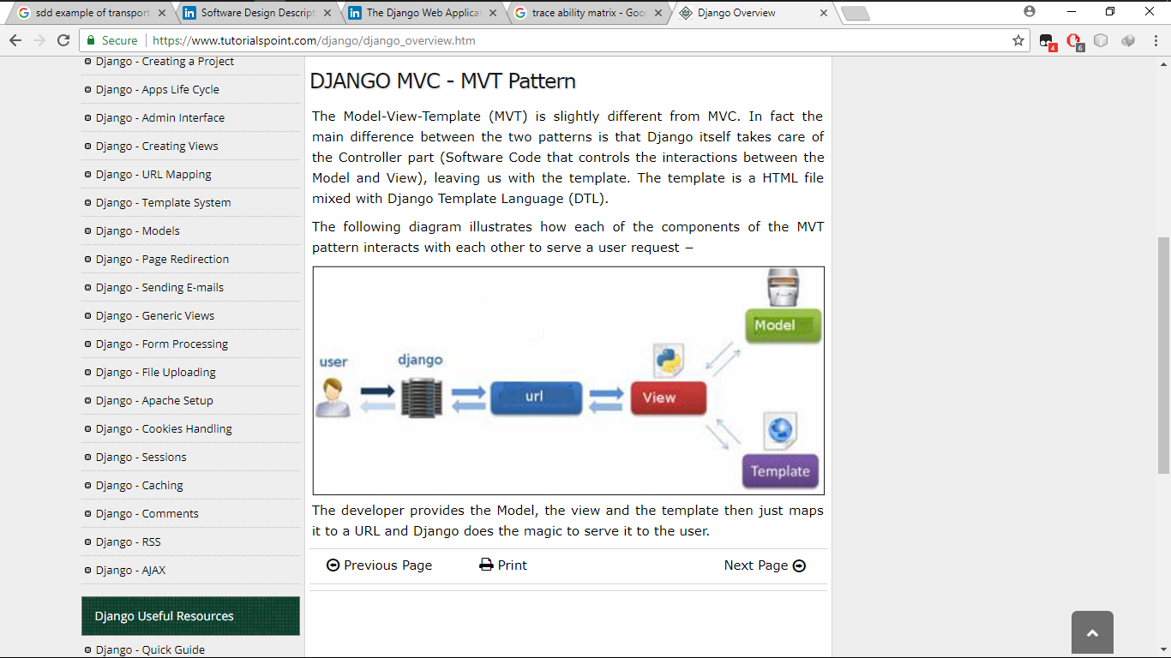

Browser

URL dispacher

Template

Views

Models

Database

For this to be done by the system, the system architecture below will be used in the different modules such as the login and registration module