GuardianAI
Privacy-Preserving Continuous Behavioral Authentication
System Architecture & Design Document
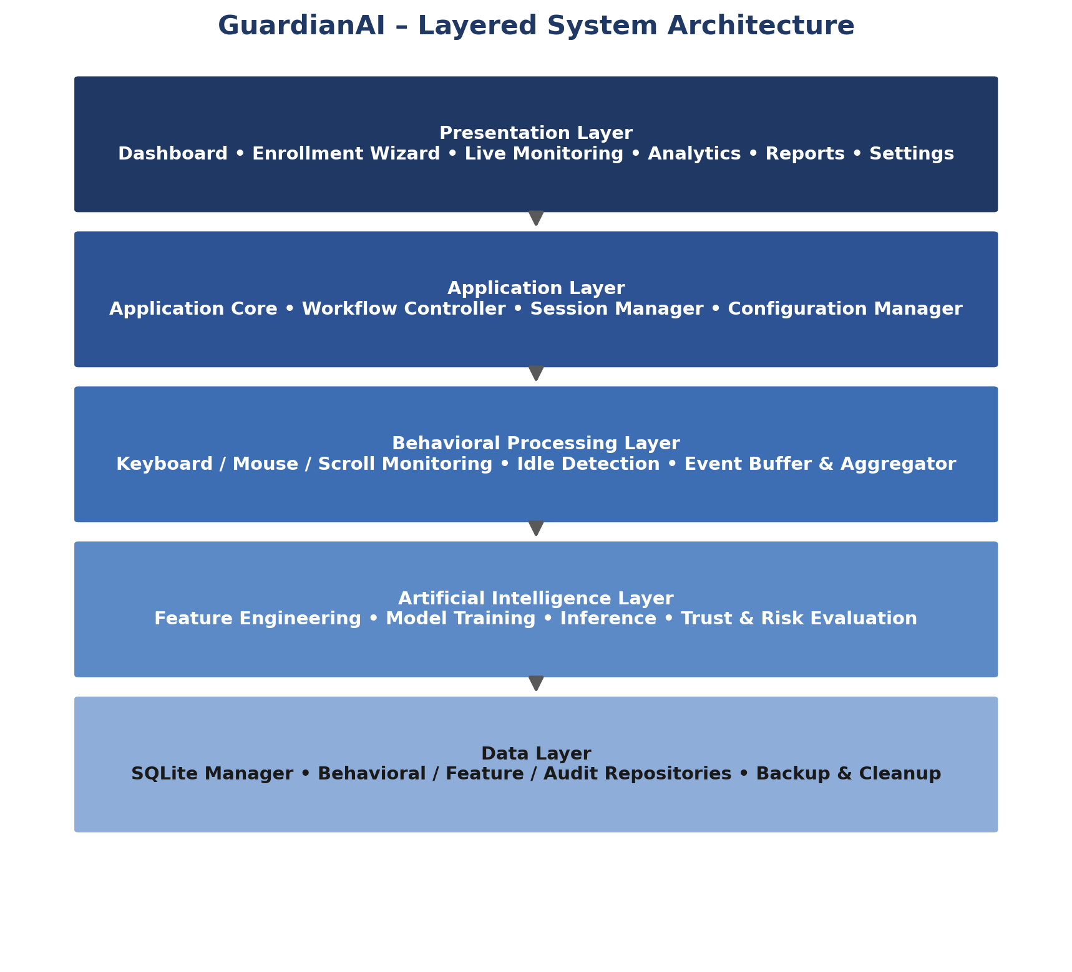
Version 1.0
Confidential — Technical Documentation

Table of Contents

(Right-click the table above and choose “Update Field” in Word to populate page numbers.)
Chapter 1 — System Architecture
Chapter 2 — Component Architecture
Chapter 3 — Component Relationships
Chapter 4 — Behavioral Feature Architecture
Chapter 5 — Machine Learning Architecture
Chapter 6 — Database Architecture
Chapter 7 — Complete Workflow
Chapter 8 — Enrollment Week
Chapter 9 — Desktop UI
Chapter 10 — Windows Integration
Chapter 11 — Security Architecture
Chapter 12 — Development Plan

Chapter 1 — System Architecture

1.1 Introduction
GuardianAI is a privacy-preserving desktop application that provides continuous user authentication using behavioral biometrics, rather than relying solely on traditional one-time authentication mechanisms such as passwords or PINs. Instead of verifying identity only at login, the system continuously observes user interaction patterns throughout the active session to confirm that the authenticated user remains the legitimate operator of the device.
The system is designed as a fully local application: every stage of processing — behavioral data collection, feature extraction, machine learning, authentication decisions, and adaptive model updates — takes place entirely on the user's computer. No behavioral information, trained models, or authentication decisions are transmitted to external servers or cloud services.
GuardianAI combines behavioral biometrics, artificial intelligence, edge computing, and adaptive learning into a unified desktop security platform that continuously strengthens authentication while preserving user privacy.

1.2 Vision
The vision of GuardianAI is to redefine desktop authentication by replacing static, one-time identity verification with continuous, intelligent, and privacy-preserving behavioral authentication. Instead of repeatedly requesting passwords, PINs, or biometric scans, the system continuously learns how the legitimate user naturally interacts with the computer and silently verifies identity throughout the session without interrupting normal workflow. The long-term vision is a self-evolving authentication system that becomes more accurate over time while ensuring complete user ownership of behavioral data.

1.3 Design Philosophy
Privacy First
All behavioral data remains exclusively on the user's device. The system never uploads behavioral datasets, trained models, authentication history, or personal information.
Local AI
Every machine learning operation — dataset generation, feature engineering, training, inference, validation, and retraining — executes locally, without requiring internet connectivity.
Continuous Authentication
Authentication is a continuous process rather than a single event, evaluated throughout the user's active session.
Adaptive Learning
The system continuously adapts to gradual behavioral change (fatigue, new hardware, experience) through trusted learning, while resisting malicious behavioral drift.
Modular Architecture
Every subsystem operates independently with clearly defined responsibilities and well-defined interfaces.
Explainable Decisions
Confidence scores, trust scores, anomaly indicators, and decision logs make authentication outcomes understandable rather than a black box.
Resource Efficiency
The system is optimized to consume minimal CPU, memory, disk I/O, and battery while running unobtrusively in the background.

1.4 System Objectives
• Continuously authenticate desktop users throughout active sessions.
• Learn personalized behavioral patterns for every individual user.
• Detect behavioral deviations that may indicate unauthorized access.
• Perform all computation entirely on the local device.
• Preserve user privacy by eliminating cloud dependency.
• Adapt to gradual behavioral changes without compromising security.
• Maintain low system resource consumption during continuous monitoring.
• Provide transparent authentication decisions using confidence and trust metrics.
• Support long-term model evolution through adaptive retraining.
• Deliver seamless authentication without interrupting user productivity.

1.5 Functional Scope
Capability | Description
User Registration | Allows new users to register their identity and initialize behavioral enrollment.
Behavioral Enrollment | A structured one-week enrollment period collects behavioral data via guided assignments and natural usage.
Behavior Collection | Continuously collects keyboard, mouse, scroll, idle, and interaction-timing events.
Feature Extraction | Converts raw behavioral events into numerical features for machine learning.
Dataset Management | Organizes behavioral features into structured datasets for training and retraining.
Model Training | Trains a personalized authentication model from the enrolled user's behavior only.
Continuous Authentication | Continuously evaluates incoming behavioral features against the trained profile.
Trust Evaluation | Every authentication decision feeds a dynamic trust score.
Adaptive Learning | Only highly trusted sessions are incorporated into future training datasets.
Model Evolution | Periodically retrains the model using newly verified behavioral information.
Analytics | Users can view authentication statistics, behavioral summaries, and trust trends.
Privacy Management | Users retain complete ownership and control of all collected behavioral information.

1.6 Non-Functional Requirements
Quality Attribute | Requirement
Privacy | All behavioral data must remain on the local machine.
Security | Behavioral datasets, models, and authentication history must be encrypted and protected.
Availability | The application remains operational during normal use without requiring continuous internet connectivity.
Reliability | Authentication decisions remain stable under varying workloads and activities.
Scalability | The architecture supports future behavioral modalities, techniques, and AI models.
Maintainability | Independent modules allow upgrades without affecting unrelated components.
Performance | Behavior collection and authentication execute with minimal latency and negligible UX impact.
Portability | The architecture allows future adaptation to other desktop operating systems.
Usability | Continuous authentication remains transparent during normal computer interaction.
Extensibility | New behavioral signals, algorithms, and authentication methods integrate without redesign.

1.7 Architectural Principles
• Single Responsibility — each module performs one clearly defined responsibility.
• Loose Coupling — modules interact through well-defined interfaces.
• High Cohesion — closely related functionality stays grouped together.
• Event-Driven Processing — behavioral events trigger pipelines instead of continuous polling.
• Layered Separation — presentation, logic, AI, storage, and security remain logically separated.
• Privacy by Design — privacy protection is integrated into every architectural layer.
• Adaptive Intelligence — the model continuously improves using verified behavioral information.
• Fail-Safe Operation — failures in one module do not compromise overall stability.
• Incremental Learning — behavioral knowledge evolves gradually through trusted observations.
• Maintainable Architecture — emphasis on readability, modularity, and long-term maintainability.

1.8 – 1.9 Layered Architecture & High-Level Design
GuardianAI is organized into six logical layers, each with a clearly defined responsibility. Behavioral events flow upward through processing and intelligence layers to produce an authentication decision, while the Security Layer protects every layer horizontally.

Figure 1.1 — GuardianAI layered system architecture
Layer | Responsibility
Presentation Layer | User interactions, dashboards, enrollment screens, analytics, reports, notifications, settings.
Application Layer | Coordinates workflows, session management, configuration, startup, and inter-module communication.
Behavioral Processing Layer | Captures interaction events, buffers them, aggregates activity, and extracts features.
Artificial Intelligence Layer | Normalization, dataset management, training, inference, confidence, trust, adaptive learning, retraining.
Data Layer | Stores behavioral datasets, authentication history, models, configuration, logs, backups.
Security Layer | Encryption, secure storage, integrity validation, audit logging, privacy enforcement.

1.10 Architectural Decisions
• Local-first computing instead of cloud-based authentication.
• Behavioral authentication replaces periodic authentication challenges.
• Machine learning models are personalized rather than shared between users.
• Continuous monitoring operates as a background service, not a foreground application.
• Only trusted behavioral sessions contribute to future model updates.
• Authentication confidence combines multiple behavioral signals rather than a single feature.
• Retraining occurs periodically rather than continuously, to maintain stability.
• Historical behavioral information uses a sliding-window strategy to prevent outdated data from dominating learning.
• Every major subsystem operates independently through modular interfaces.

1.11 Technology Stack
Category | Technology
Programming Language | Python
Desktop Framework | PySide6 (Qt)
Machine Learning | Scikit-learn, LightGBM, NumPy, Pandas
Scientific Computing | SciPy
Local Database | SQLite
Behavioral Analysis | Custom Feature Extraction Engine
OS Integration | Windows APIs
Data Visualization | PyQtGraph, Matplotlib
Local Storage | SQLite database, encrypted configuration files
Development Tools | Visual Studio Code, Git, PyInstaller

1.12 Expected System Behaviour
After installation, GuardianAI guides the user through an enrollment period in which behavioral information is collected through structured assignments and natural computer interaction. At the conclusion of enrollment, the system trains a personalized authentication model entirely on the local device.
During everyday use, GuardianAI continuously observes behavioral interactions without interrupting the user, calculating confidence and trust scores against the personalized model. Trusted sessions feed future adaptive learning; suspicious sessions are excluded. At scheduled intervals the model is retrained, validated, and replaced only if it demonstrates measurable improvement — keeping the system lightweight, privacy-preserving, adaptive, and transparent throughout its lifecycle.

Chapter 2 — Component Architecture
GuardianAI is composed of independent, interconnected components, each with a clearly defined responsibility, communicating through well-defined interfaces. This modular design improves maintainability, scalability, testing, and future extensibility. Components are organized into seven groups: Core System, Enrollment System, Behavioral Collection Layer, Artificial Intelligence Layer, Data Layer, Security Layer, and Presentation Layer.

2.2 Core System
2.2.1 Application Core
The central controller of GuardianAI; initializes the application, coordinates all major modules, manages application state, and ensures correct operation throughout the lifecycle.
Purpose: Provide centralized coordination for the entire application.
Key Responsibilities: Initialize modules; manage lifecycle and global state; coordinate subsystem communication; handle shutdown.
Dependencies: Startup Manager, Workflow Controller, Configuration Manager, Session Manager
Communication: Direct service calls
Lifecycle: Starts at launch, terminates at exit.
2.2.2 Workflow Controller
Coordinates every major workflow performed by GuardianAI.
Purpose: Manage transitions between application states.
Key Responsibilities: Control enrollment, authentication, training and retraining workflows; coordinate scheduled operations.
Dependencies: Enrollment Manager, Training Scheduler, Authentication Manager
Communication: Event-driven communication
Lifecycle: Runs continuously after startup.
2.2.3 Configuration Manager
Maintains all application configuration.
Purpose: Provide centralized configuration management.
Key Responsibilities: Load, save, and validate configuration; manage preferences.
Dependencies: Secure Storage Manager
Communication: Direct access
Lifecycle: Loads at startup, remains available.
2.2.4 Startup Manager
Responsible for application initialization.
Purpose: Prepare GuardianAI before normal execution begins.
Key Responsibilities: Verify dependencies; initialize modules; load resources; check database integrity.
Dependencies: Application Core, SQLite Manager
Communication: Sequential initialization
Lifecycle: Active only during startup.
2.2.5 Session Manager
Tracks the active desktop session.
Purpose: Manage authentication sessions.
Key Responsibilities: Create/close sessions; track duration; detect session changes.
Dependencies: Windows Integration Layer
Communication: Event-based
Lifecycle: Runs continuously.
2.2.6 Settings Manager
Manages user-configurable settings.
Purpose: Provide centralized settings management.
Key Responsibilities: Store preferences; validate settings; apply changes.
Dependencies: Configuration Manager
Communication: Direct service calls
Lifecycle: Available throughout execution.

2.3 Enrollment System
2.3.1 Enrollment Manager
Controls the complete one-week enrollment process.
Purpose: Collect sufficient behavioral data for the first personalized model.
Key Responsibilities: Start enrollment; track progress; schedule assignments; verify completion; generate dataset.
Dependencies: Assignment Manager, Progress Manager, Enrollment Validator
Communication: Workflow events
Lifecycle: Active during enrollment period.
2.3.2 Assignment Manager
Creates and schedules enrollment assignments.
Purpose: Ensure sufficient behavioral diversity.
Key Responsibilities: Generate assignments; schedule activities; record completion; monitor participation.
Dependencies: Calendar Manager
Communication: Scheduled events
Lifecycle: Active during enrollment.
2.3.3 Progress Manager
Tracks user progress throughout enrollment.
Purpose: Measure enrollment completion.
Key Responsibilities: Calculate progress; track completed activities; estimate remaining tasks.
Dependencies: Enrollment Manager
Communication: Progress notifications
Lifecycle: Enrollment period only.
2.3.4 Calendar Manager
Maintains the enrollment schedule.
Purpose: Organize daily behavioral assignments.
Key Responsibilities: Schedule activities; send reminders; track dates.
Dependencies: Assignment Manager
Communication: Scheduled notifications
Lifecycle: Enrollment period only.
2.3.5 Enrollment Validator
Verifies whether sufficient behavioral information has been collected.
Purpose: Determine enrollment completion.
Key Responsibilities: Validate dataset quality; verify feature diversity; detect missing information.
Dependencies: Dataset Manager
Communication: Validation requests
Lifecycle: Runs before initial training.

2.4 Behavioral Collection Layer
2.4.1 Keyboard Monitoring Service
Continuously captures keyboard interaction events without recording typed content.
Purpose: Collect raw keyboard interaction data required for behavioral authentication.
Key Responsibilities: Monitor events; record press/release timestamps; calculate timing; forward to Event Buffer.
Dependencies: Windows Integration Layer, Event Buffer
Communication: Event-driven
Lifecycle: Starts at initialization, active until shutdown.
2.4.2 Mouse Monitoring Service
Records user mouse interactions and movement patterns.
Purpose: Capture mouse behavioral characteristics.
Key Responsibilities: Monitor movement, clicks, drags, and timing; forward events.
Dependencies: Windows Integration Layer, Event Buffer
Communication: Event-driven
Lifecycle: Runs continuously after startup.
2.4.3 Scroll Monitoring Service
Observes scrolling behavior during normal usage.
Purpose: Collect scrolling dynamics for behavioral profiling.
Key Responsibilities: Monitor direction, speed, rhythm, and intervals.
Dependencies: Windows Integration Layer, Event Buffer
Communication: Event-driven
Lifecycle: Runs continuously.
2.4.4 Idle Detection Service
Determines whether the user is actively interacting with the desktop.
Purpose: Separate active behavioral sessions from inactive periods.
Key Responsibilities: Detect inactivity; calculate idle duration; identify interruptions; notify Session Manager.
Dependencies: Session Manager, Windows Integration Layer
Communication: Event notifications
Lifecycle: Runs continuously.
2.4.5 Windows Integration Layer
The interface between GuardianAI and the Windows operating system.
Purpose: Provide controlled access to Windows APIs.
Key Responsibilities: Register hooks; receive OS events; monitor session changes and power/lock events.
Dependencies: Windows APIs
Communication: System callbacks
Lifecycle: Initialized at startup.
2.4.6 Event Buffer
Temporarily stores behavioral events before processing.
Purpose: Prevent event loss during high activity.
Key Responsibilities: Receive, queue, and order events; forward batches to the Event Aggregator.
Dependencies: Monitoring Services, Event Aggregator
Communication: Queue-based
Lifecycle: Runs continuously.
2.4.7 Event Aggregator
Combines related behavioral events into meaningful interaction windows.
Purpose: Prepare structured behavioral sessions.
Key Responsibilities: Group events; create windows; synchronize timestamps; forward to Feature Extraction Engine.
Dependencies: Event Buffer, Feature Extraction Engine
Communication: Pipeline-based
Lifecycle: Runs continuously.

2.5 Artificial Intelligence Layer
2.5.1 Feature Extraction Engine
Converts raw behavioral events into numerical features.
Purpose: Generate machine learning features from behavioral events.
Key Responsibilities: Extract keyboard, mouse, scroll and session-level features; produce structured vectors.
Dependencies: Event Aggregator, Feature Normalization Engine
Communication: Pipeline processing
Lifecycle: Runs whenever new windows are available.
2.5.2 Feature Normalization Engine
Standardizes extracted features before storage or processing.
Purpose: Ensure feature consistency.
Key Responsibilities: Normalize values; handle missing values; detect invalid features.
Dependencies: Feature Extraction Engine, Dataset Manager
Communication: Sequential processing
Lifecycle: Runs immediately after extraction.
2.5.3 Dataset Manager
Organizes feature vectors into structured datasets.
Purpose: Maintain high-quality behavioral datasets across the application lifecycle.
Key Responsibilities: Store feature vectors; organize datasets; separate trusted/untrusted sessions; manage versions.
Dependencies: Feature Normalization Engine, Trust Score Manager, Behavioral Repository
Communication: Direct service calls
Lifecycle: Active throughout execution.
2.5.4 Training Scheduler
Determines when models should be trained or retrained.
Purpose: Schedule AI training without affecting normal usage.
Key Responsibilities: Schedule training; delay during heavy usage; verify prerequisites; notify Training Engine.
Dependencies: Workflow Controller, Model Training Engine, Session Manager
Communication: Scheduled events
Lifecycle: Runs continuously.
2.5.5 Model Training Engine
Builds personalized authentication models using local data.
Purpose: Train machine learning models for continuous authentication.
Key Responsibilities: Load datasets; train; optimize parameters; save models; generate reports.
Dependencies: Dataset Manager, Model Repository, Model Validator
Communication: Sequential processing
Lifecycle: Runs during initial training and retraining.
2.5.6 Model Validator
Evaluates trained models before deployment.
Purpose: Ensure only reliable models are used for authentication.
Key Responsibilities: Evaluate accuracy; measure consistency; detect overfitting; compare models.
Dependencies: Dataset Manager, Version Manager
Communication: Validation requests
Lifecycle: Runs after every training session.
2.5.7 Model Repository
Securely stores all trained machine learning models.
Purpose: Maintain model persistence and version history.
Key Responsibilities: Store active models; archive previous versions; load and remove models.
Dependencies: Secure Storage Manager, Version Manager
Communication: Repository access
Lifecycle: Active throughout execution.
2.5.8 Inference Engine
Performs continuous behavioral authentication using the active model.
Purpose: Predict whether current activity belongs to the legitimate user.
Key Responsibilities: Load model; receive features; predict; generate confidence; forward results.
Dependencies: Model Repository, Confidence Engine
Communication: Pipeline processing
Lifecycle: Runs continuously after enrollment.
2.5.9 Confidence Engine
Converts model predictions into standardized confidence values.
Purpose: Provide consistent confidence measurements.
Key Responsibilities: Calculate confidence; smooth fluctuations; produce trends.
Dependencies: Inference Engine, Trust Score Manager
Communication: Sequential processing
Lifecycle: Runs continuously.
2.5.10 Trust Score Manager
Maintains a continuously evolving trust score.
Purpose: Determine whether observed behavioral activity should be trusted.
Key Responsibilities: Maintain and update trust; detect degradation; select trusted sessions.
Dependencies: Confidence Engine, Behavioral Repository, Adaptive Risk Engine
Communication: Direct service communication
Lifecycle: Runs continuously.
2.5.11 Adaptive Risk Engine
Continuously estimates authentication risk from behavioral changes.
Purpose: Identify suspicious behavioral deviations.
Key Responsibilities: Calculate risk; detect anomalies; trigger alerts; recommend actions.
Dependencies: Trust Score Manager, Authentication Manager
Communication: Event notifications
Lifecycle: Runs continuously.
2.5.12 Authentication Manager
Makes the final authentication decision.
Purpose: Determine whether the session continues normally or requires additional action.
Key Responsibilities: Evaluate confidence, trust, and risk; make decisions; trigger responses; record events.
Dependencies: Adaptive Risk Engine, Session Manager, Audit Repository
Communication: Event-driven
Lifecycle: Runs continuously during every authenticated session.
2.5.13 Retraining Manager
Supervises the adaptive learning process.
Purpose: Continuously improve accuracy while preventing behavioral drift.
Key Responsibilities: Monitor schedule; collect trusted sessions; prepare and initiate retraining.
Dependencies: Dataset Manager, Training Scheduler, Model Training Engine
Communication: Scheduled service calls
Lifecycle: Runs continuously after deployment.
2.5.14 Version Manager
Maintains the lifecycle of all machine learning models.
Purpose: Ensure reliable deployment and rollback of authentication models.
Key Responsibilities: Assign versions; store metadata; activate/archive/restore models.
Dependencies: Model Repository, Model Validator
Communication: Repository operations
Lifecycle: Runs on model creation, deployment, restoration.

2.6 Data Layer
2.6.1 SQLite Manager
Provides centralized access to the local database.
Purpose: Manage all database operations.
Key Responsibilities: Open connections; execute queries; manage transactions and performance.
Dependencies: SQLite database
Communication: Direct database operations
Lifecycle: Runs throughout execution.
2.6.2 Behavioral Repository
Stores all behavioral feature vectors from authenticated sessions.
Purpose: Maintain behavioral information for authentication and adaptive learning.
Key Responsibilities: Store/retrieve behavioral history; filter trusted sessions; organize datasets.
Dependencies: SQLite Manager
Communication: Repository access
Lifecycle: Runs continuously.
2.6.3 Feature Repository
Stores normalized feature vectors.
Purpose: Provide structured access to extracted behavioral features.
Key Responsibilities: Store/retrieve feature vectors; organize collections; support analysis.
Dependencies: SQLite Manager
Communication: Repository access
Lifecycle: Runs continuously.
2.6.4 Audit Repository
Stores authentication history and security events.
Purpose: Maintain an auditable history of application activities.
Key Responsibilities: Record authentication/security events; store warnings; maintain history.
Dependencies: SQLite Manager
Communication: Logging interface
Lifecycle: Runs continuously.
2.6.5 Sliding Window Manager
Maintains an evolving behavioral dataset of recent trusted information.
Purpose: Prevent outdated behavioral patterns from influencing future models.
Key Responsibilities: Maintain window; remove obsolete sessions; prepare retraining datasets.
Dependencies: Behavioral Repository, Dataset Manager
Communication: Repository updates
Lifecycle: Runs whenever trusted sessions are added.
2.6.6 Backup Manager
Protects important application data against loss.
Purpose: Create recoverable copies of critical system information.
Key Responsibilities: Backup database, models, and configuration; verify integrity.
Dependencies: SQLite Manager, Secure Storage Manager
Communication: Scheduled operations
Lifecycle: Runs per backup schedule.
2.6.7 Cleanup Manager
Removes unnecessary application data.
Purpose: Prevent excessive storage growth.
Key Responsibilities: Remove temp files, obsolete sessions, expired backups; optimize storage.
Dependencies: Backup Manager, SQLite Manager
Communication: Scheduled maintenance
Lifecycle: Runs periodically.

2.7 Security Layer
2.7.1 Encryption Manager
Protects sensitive application data with strong encryption.
Purpose: Ensure confidentiality of behavioral data, models, configuration, and history.
Key Responsibilities: Encrypt/decrypt data; manage encryption operations; verify encrypted content.
Dependencies: Secure Storage Manager
Communication: Direct service calls
Lifecycle: Active throughout execution.
2.7.2 Privacy Manager
Enforces privacy policies throughout the application.
Purpose: Ensure behavioral information remains under the user's complete control.
Key Responsibilities: Enforce policies; prevent unauthorized access; monitor compliance.
Dependencies: Configuration Manager, Secure Storage Manager
Communication: Policy-based validation
Lifecycle: Runs continuously.
2.7.3 Integrity Manager
Ensures stored resources have not been modified or corrupted.
Purpose: Protect system integrity.
Key Responsibilities: Verify file/database/model integrity; detect tampering.
Dependencies: Model Repository, SQLite Manager
Communication: Integrity verification requests
Lifecycle: Runs at startup and scheduled maintenance.
2.7.4 Logging Manager
Records operational and security-related events.
Purpose: Provide diagnostic and operational logging.
Key Responsibilities: Record events, errors, warnings, and security activity.
Dependencies: Audit Repository
Communication: Centralized logging service
Lifecycle: Runs continuously.
2.7.5 Secure Storage Manager
Provides protected storage for confidential resources.
Purpose: Prevent unauthorized access to sensitive files.
Key Responsibilities: Store/retrieve protected resources; manage secure locations and permissions.
Dependencies: Encryption Manager
Communication: Repository access
Lifecycle: Runs continuously.

2.8 Presentation Layer
2.8.1 Dashboard Controller
Manages the application's primary dashboard.
Purpose: Provide a real-time overview of system status.
Key Responsibilities: Display authentication status, trust score, health, and recent activity.
Dependencies: Analytics Controller, Authentication Manager
Communication: UI service calls
Lifecycle: Active while the dashboard is open.
2.8.2 Live Monitoring Controller
Presents real-time behavioral monitoring information.
Purpose: Allow users to observe current authentication activity.
Key Responsibilities: Display live status, confidence, activity, and session information.
Dependencies: Authentication Manager, Confidence Engine
Communication: Event-driven UI updates
Lifecycle: Runs while the monitoring screen is active.
2.8.3 Enrollment Wizard
Guides users through the one-week behavioral enrollment.
Purpose: Simplify enrollment while ensuring sufficient data collection.
Key Responsibilities: Display assignments; track progress; explain tasks; notify completion.
Dependencies: Enrollment Manager, Assignment Manager, Progress Manager
Communication: Workflow-driven UI communication
Lifecycle: Active only during enrollment.
2.8.4 Analytics Controller
Provides long-term behavioral insights and statistics.
Purpose: Present meaningful system analytics.
Key Responsibilities: Generate statistics; display trust trends and behavioral summaries.
Dependencies: Behavioral Repository, Audit Repository
Communication: Repository queries
Lifecycle: Runs when analytics are requested.
2.8.5 Reports Controller
Generates downloadable authentication and performance reports.
Purpose: Provide structured summaries of application activity.
Key Responsibilities: Generate and export authentication/behavioral/security reports.
Dependencies: Analytics Controller, Audit Repository
Communication: Repository queries
Lifecycle: Runs when reports are requested.
2.8.6 Notification Manager
Delivers important information through desktop notifications.
Purpose: Provide timely communication without interrupting work.
Key Responsibilities: Display reminders, alerts, and warnings; prioritize and de-duplicate.
Dependencies: Workflow Controller, Authentication Manager, Training Scheduler
Communication: Event-driven notifications
Lifecycle: Runs continuously after startup.

Chapter 3 — Component Relationships
GuardianAI follows a top-down dependency model: higher-level components coordinate workflows while lower-level components provide specialized services. Every component depends only on components within its own layer or the layer immediately below it, and the Security Layer supports every layer horizontally.

3.2 Dependency Hierarchy
Layer | Depends On
Presentation Layer | Application Layer
Application Layer | Enrollment System
Enrollment System | Behavioral Collection Layer
Behavioral Collection Layer | Artificial Intelligence Layer
Artificial Intelligence Layer | Data Layer
Data Layer | Security Layer (supported by)

3.3 Component Communication
Mechanism | Characteristics | Example
Direct Service Communication | Synchronous, immediate response, strong consistency | Workflow Controller requests Enrollment Manager to begin enrollment
Event-Based Communication | Loosely coupled, asynchronous, scalable | Keyboard/Mouse Monitoring Services publish behavioral events
Repository Communication | Encapsulates database logic, improves maintainability | Dataset Manager accesses the Behavioral Repository
Scheduler Communication | Time-based, independent execution, minimal interruption | Monthly retraining, daily backup, cleanup tasks

3.4 Event Communication Pipeline
Behavioral monitoring relies heavily on event-based communication. Keyboard, mouse, scroll, and idle events all flow through the same pipeline shown below, independently, until aggregated into behavioral windows.
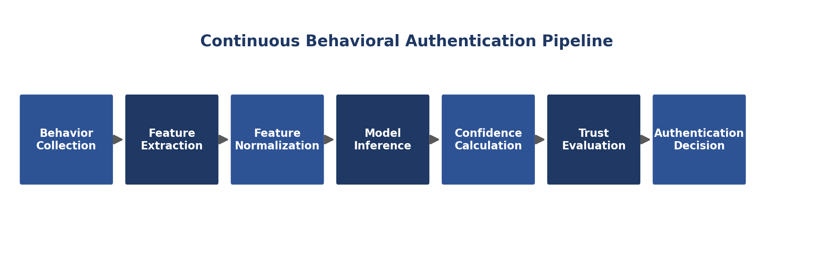
Figure 3.1 — Behavioral event processing pipeline (also applies to mouse, scroll and idle events)
Full pipeline: Keyboard/Mouse/Scroll Monitoring Service → Event Buffer → Event Aggregator → Feature Extraction Engine → Feature Normalization Engine → Inference Engine → Confidence Engine → Trust Score Manager → Authentication Manager → Dashboard Controller.

3.6 Shared Repositories
Repository | Used By
Behavioral Repository | Dataset Manager, Trust Score Manager, Analytics Controller, Sliding Window Manager
Feature Repository | Feature Normalization Engine, Dataset Manager, Analytics Controller
Audit Repository | Authentication Manager, Logging Manager, Reports Controller, Analytics Controller
Model Repository | Model Training Engine, Model Validator, Inference Engine, Version Manager
Configuration Repository | Configuration Manager, Settings Manager, Startup Manager

3.7 Startup Sequence
Step | Action
1 | Application Core starts execution
2 | Startup Manager verifies application resources
3 | Configuration Manager loads application configuration
4 | Secure Storage Manager initializes protected storage
5 | Encryption Manager loads encryption services
6 | SQLite Manager establishes database connection
7 | Integrity Manager validates database and model integrity
8 | Repositories become available
9 | Windows Integration Layer registers operating system hooks
10 | Behavioral monitoring services begin execution
11 | Workflow Controller initializes workflows
12 | Presentation Layer loads user interface
13 | GuardianAI enters normal operating mode

3.8 Shutdown Sequence
• Stop accepting new behavioral events.
• Flush the Event Buffer.
• Complete pending feature extraction.
• Save unfinished behavioral sessions.
• Store updated trust information.
• Commit pending database transactions.
• Write application logs.
• Release Windows hooks.
• Close repositories and database connection.
• Terminate background workers.
• Application exits safely.

3.9 – 3.11 Threads, Workers & Scheduling
GuardianAI runs six cooperating background threads — UI, Behavior Collection, Feature Processing, Authentication, Database, and Maintenance — communicating through thread-safe queues. Corresponding background workers (Behavior Collection, Feature Extraction, Authentication, Training, Retraining, Backup, Cleanup, Logging, Notification) execute independently so the desktop interface remains responsive.
Schedule | Representative Tasks
Real-Time | Keyboard/mouse/scroll monitoring, feature extraction, authentication, trust updates
Short Interval | Behavioral aggregation, confidence calculation, session updates, notifications
Daily | Enrollment progress evaluation, database optimization, log maintenance
Weekly | Enrollment completion verification, dataset validation
Monthly | Retraining eligibility, model retraining/validation/replacement, repository maintenance
Maintenance | Database backup, cleanup, integrity verification, storage optimization

Chapter 4 — Behavioral Feature Architecture
Behavioral authentication depends on extracting measurable characteristics from the user's interaction with the computer. GuardianAI converts interactions into numerical behavioral features rather than storing raw events permanently; every authentication decision is based on these computed features. Features are grouped into five categories: Keyboard, Mouse, Scrolling, Session, and Derived Features.

4.3 Keyboard Features
Feature | Definition / Purpose
Dwell Time | Duration between pressing and releasing the same key — measures how long the user naturally holds each key.
Flight Time | Elapsed time between releasing one key and pressing the next — captures typing rhythm and coordination.
Hold Time | Average key-hold duration across a window — an overall typing pressure/timing profile.
N-Graph Latency | Timing across sequences of keys (digraph/trigraph/four-key) — represents typing rhythm.
Error Rate | Frequency of typing mistakes, via backspace/delete frequency and correction intervals.
Typing Speed | Characters typed per minute over a behavioral window.
Burst Pattern | Rapid typing followed by pauses — identifies productivity rhythm.
Typing Rhythm | Overall timing consistency during typing; often unique even as speed changes.

4.4 Mouse Features
Feature | Definition / Purpose
Cursor Velocity | Average cursor movement speed.
Cursor Acceleration | Rate of change of cursor speed.
Cursor Curvature | Amount of curvature in movement paths — movement smoothness.
Click Timing | Time intervals between clicks.
Double Click Delay | Time between consecutive clicks in a double-click.
Drag Speed / Distance | Speed and distance covered during drag operations.
Click Distribution | Relative frequency of left/right/middle clicks.

4.5 Scrolling Features
Feature | Definition / Purpose
Scroll Speed | Average scrolling velocity.
Scroll Rhythm | Consistency of scrolling intervals.
Scroll Direction Changes | Frequency of switching between up/down scrolling.
Scroll Length | Average scrolling distance.
Scroll Pause Duration | Time spent reading between scroll actions.

4.6 Session Features
Feature | Definition / Purpose
Idle Time | Duration without keyboard or mouse activity.
Active Time | Continuous interaction duration.
Break Frequency | Number of inactive periods during a session.
Time-of-Day Pattern | Period during which behavioral data was collected.
Session Duration | Length of an authenticated session.
Interaction Density | Amount of interaction performed during a session.

4.7 Derived Features
• Statistical Features — mean, median, standard deviation, variance, min/max, percentiles.
• Temporal Features — time intervals, event frequency, sequence duration, timing consistency.
• Consistency Metrics — stability across repeated behavioral windows.
• Stability Index — overall measurement of long-term consistency.
• Behavioral Entropy — randomness/predictability of behavioral patterns.
• Feature Correlation — relationships between different behavioral characteristics.
• Behavioral Trend — long-term change in behavioral characteristics.

4.8 Feature Quality Requirements
• Uniqueness — helps distinguish one user from another.
• Consistency — remains reasonably stable for the same user.
• Robustness — tolerates minor behavioral variations.
• Efficiency — computed with minimal computational overhead.
• Privacy — describes interaction behavior without revealing actual content typed or viewed.
• Scalability — supports continuous long-term collection.
• Interpretability — contributes meaningfully to authentication decisions.

4.9 Feature Storage Strategy
GuardianAI stores only processed behavioral features, not raw interaction events. Raw events exist temporarily in memory during authentication and are discarded immediately after feature extraction, unless temporary buffering is required. Generated feature vectors are stored in the Feature Repository; trusted vectors are retained under the sliding-window policy for future adaptive learning, while suspicious or low-trust vectors are excluded from retraining but remain available for audit according to the configured retention policy.

Chapter 5 — Machine Learning Architecture
The Machine Learning Architecture transforms behavioral feature vectors into personalized authentication decisions. Unlike traditional systems relying on predefined credentials, GuardianAI learns the unique behavioral characteristics of an individual user and continuously verifies identity throughout the session. The entire pipeline operates locally — no features, datasets, models, or results ever leave the device.

5.2 Machine Learning Objectives
• Learn personalized behavioral characteristics.
• Perform continuous authentication.
• Minimize false authentication decisions.
• Adapt to gradual behavioral evolution.
• Preserve user privacy through local processing.
• Maintain computational efficiency.
• Improve authentication accuracy over time.
• Prevent model degradation caused by abnormal behavior.

5.3 Machine Learning Pipeline
Behavior Collection → Feature Extraction → Feature Normalization → Dataset Generation → Initial Model Training → Model Validation → Model Deployment → Continuous Inference → Confidence Calculation → Trust Evaluation → Adaptive Learning → Retraining → Model Validation → Model Replacement.

5.5 Dataset Types
Dataset | Description
Enrollment Dataset | Collected during the initial one-week enrollment period.
Training Dataset | Used to train the first authentication model.
Validation Dataset | Used to evaluate model performance before deployment.
Production Dataset | Contains trusted behavioral samples collected after deployment.
Retraining Dataset | Contains newly verified behavioral samples used for adaptive learning.
Every behavioral sample records: Sample ID, Session ID, Timestamp, Feature Vector, Trust Level, Collection Source, Enrollment Status, and Validation Status. All datasets remain completely local.

5.7 Personalized Models
GuardianAI trains one independent authentication model per user. Each model is unique, trained locally, never leaves the device, evolves continuously, and remains fully independent from other users' models — yielding better accuracy, better privacy, no centralized behavioral database, and personalized authentication thresholds.

5.10 Trust-Based Learning
GuardianAI does not automatically learn from every session; only highly trusted sessions contribute to future training, which prevents model poisoning, prevents learning from unauthorized users, maintains model quality, and reduces behavioral drift.
Trust Category | Effect on Learning
High Trust | Behavior is accepted for future retraining.
Medium Trust | Behavior is temporarily retained but not immediately used.
Low Trust | Behavior is excluded from retraining.

5.12 Model Validation Metrics
• Authentication Accuracy
• False Acceptance Rate
• False Rejection Rate
• Precision
• Recall
• F1 Score
• Prediction Stability
• Confidence Consistency

5.13 – 5.15 Retraining, Versioning & Rollback
Retraining is triggered monthly, when sufficient trusted samples exist, and while system conditions are stable. Every trained model receives a unique version (number, creation date, dataset version, training duration, validation results, deployment date, status). If a newly trained model performs worse than production — due to validation failure, increased false acceptance, reduced stability, corruption, or deployment failure — GuardianAI automatically deactivates it and restores the previous production model, guaranteeing uninterrupted authentication.

5.16 Model Lifecycle & Adaptive Loop
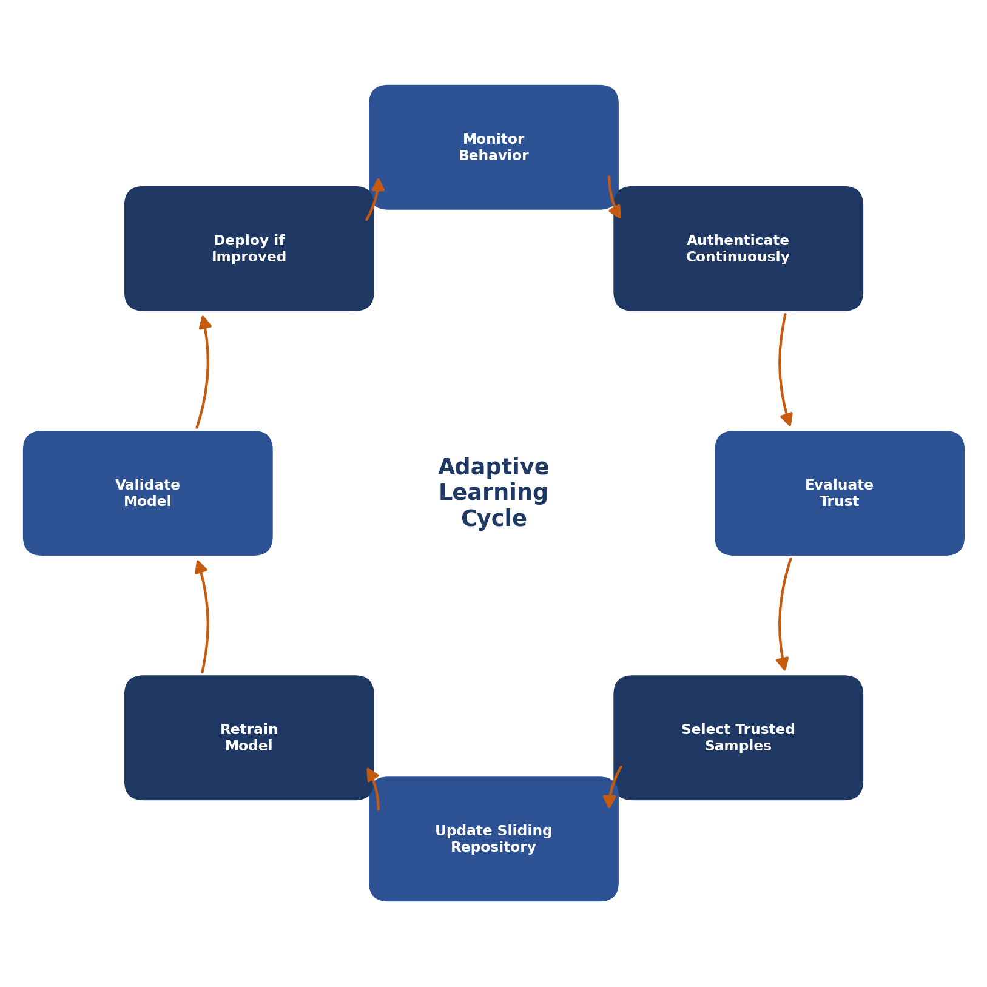
Figure 5.1 — The continuous adaptive-learning cycle

Chapter 6 — Database Architecture
GuardianAI uses SQLite as its local embedded database for behavioral information, authentication history, machine learning metadata, configuration, and system logs. All operations occur locally; nothing is synchronized externally. The database follows the Repository Pattern — application components communicate through repositories rather than direct SQL.

6.3 Database Structure
Group | Tables
Core Tables | Users, Sessions, Configuration
Behavioral Tables | BehavioralEvents, BehavioralFeatures, TrustedFeatures
Machine Learning Tables | Datasets, Models, ModelVersions, TrainingHistory
Authentication Tables | AuthenticationHistory, TrustHistory, RiskHistory
Enrollment Tables | Enrollment, Assignments, AssignmentProgress
System Tables | AuditLogs, Notifications, BackupHistory
Maintenance Tables | CleanupHistory, IntegrityChecks

6.4 – 6.23 Key Tables
Table | Purpose | Key Fields
Users | Registered users | User ID, Full Name, Registration Date, Enrollment Status, Active Model Version
Sessions | Every authenticated desktop session | Session ID, User ID, Start/End Time, Authentication Status, Avg. Trust Score
Behavioral Events | Temporary raw events before extraction | Event ID, Session ID, Event Type, Timestamp, Event Data
Behavioral Features | Processed feature vectors | Feature ID, Session ID, Timestamp, Keyboard/Mouse/Scroll/Session/Statistical Features
Trusted Features | Trusted samples eligible for learning | Trusted Feature ID, Feature ID, Trust Score, Collection Date
Datasets | Tracks ML datasets | Dataset ID, Type, Creation Date, Sample Count, Feature Count, Status
Models | Trained model metadata | Model ID, Version, Training Date, Active/Validation Status, File Location
Model Versions | Complete version history | Version ID, Model ID, Deployment Date, Validation Result, Rollback Status
Training History | Every training operation | Training ID, Dataset ID, Model Version, Start/End, Duration, Result
Authentication History | Every authentication decision | Authentication ID, Session ID, Confidence, Trust, Result, Risk Level
Trust / Risk History | Historical trust and risk values | Record ID, Session ID, Timestamp, Score/Level, Category/Reason
Enrollment / Assignments | One-week enrollment tracking | Enrollment ID, User ID, Assignment ID, Day, Completion Status
Audit Logs | Important system activities | Log ID, Timestamp, Component, Severity, Description

6.25 Indexing Strategy
Index Type | Fields
Primary | User ID, Session ID, Feature ID, Model ID, Authentication ID
Secondary | Timestamp, Trust Score, Model Version, Enrollment Status, Validation Status
Composite | User ID + Session ID; Session ID + Timestamp; Model Version + Deployment Date

6.26 – 6.30 Encryption, Retention, Backup & Repository Pattern
Sensitive contents — behavioral features, models, user information, configuration, and authentication history — are encrypted before storage by the Encryption Manager and Secure Storage Manager. Raw events are retained only until feature extraction completes; behavioral features follow the sliding-window policy; authentication history and audit logs follow long-term retention and maintenance policies respectively.
Scheduled encrypted backups (full database, configuration, model backups) are verified for integrity before being marked valid. Recovery locates the latest verified backup, verifies integrity, and restores the database, models, and configuration — prioritizing continuity of authentication and behavioral learning history.
All application components communicate only with repositories (User, Session, Behavioral, Feature, Dataset, Model, Authentication, Audit, Configuration), which in turn communicate directly with SQLite — improving maintainability, simplifying testing, and reducing coupling.

Chapter 7 — Complete Workflow
The GuardianAI workflow describes the complete lifecycle of the application, from installation to continuous adaptive authentication. Every stage executes locally on the user's computer.

7.2 Installation
Install files, verify requirements, create directories, initialize database and secure storage, generate encryption keys, create default configuration, register background services, prepare Windows integration, and launch GuardianAI.

7.3 User Registration
Enter user information, accept the privacy policy, configure preferences, and initialize the user and behavioral profile with a unique identifier.

7.4 – 7.5 Enrollment
Schedule the enrollment period, generate daily assignments, and begin continuous behavioral monitoring while assignment completion is validated and tracked.

7.6 – 7.9 Collection, Aggregation, Extraction, Normalization
Capture keyboard/mouse/scroll/idle/session events (never typed content); group them into behavioral windows; extract numerical features; normalize and validate them.

7.10 – 7.11 Dataset Generation & Validation
Store and categorize behavioral samples, remove duplicates, and verify sufficient behavioral diversity, session coverage, and data quality before training.

7.12 – 7.14 Initial Training, Validation & Deployment
Train the first personalized model, evaluate it against acceptance criteria, and — if approved — deploy it as the active production model.

7.15 – 7.18 Continuous Authentication
Continuously capture, extract, normalize, infer, calculate confidence, update trust, evaluate risk, and reach an authentication decision (continue, increase monitoring, request re-authentication, lock, or notify).

7.19 – 7.20 Trusted Session Selection
Evaluate trust thresholds, remove suspicious sessions, and update the sliding behavioral repository with newly trusted samples.

7.21 – 7.24 Retraining, Comparison & Replacement
Evaluate retraining eligibility, retrain and validate an updated model, compare it against the current production model, and replace it only if it performs better.

7.25 Scheduled Maintenance
Database optimization, backup creation, cleanup, integrity verification, and historical data compression.

7.26 Continuous Evolution
The complete lifecycle — monitor, authenticate, evaluate trust, select trusted samples, update the repository, retrain, validate, and replace if improved — repeats indefinitely.

Chapter 8 — Enrollment Week
The enrollment week is the foundation of GuardianAI's personalized authentication system. Rather than requiring specialized hardware or dedicated sessions, behavioral information is collected through guided assignments and normal computer usage across seven consecutive days — capturing behavioral variation across workloads, times of day, and interaction patterns.

8.6 – 8.13 Daily Assignment Structure
Day | Assignment | Duration | Behavioral Features Collected
Monday | Natural Typing Assessment | 20–30 min | Dwell/flight/hold time, typing speed & rhythm, error rate, burst pattern
Tuesday | Copy Typing Assessment | 20 min | Digraph/trigraph latency, typing consistency, error recovery, correction behavior
Wednesday | Mouse Interaction Assessment | 20 min | Cursor velocity/acceleration/curvature, click timing, drag speed & distance
Thursday | Scrolling & Navigation Assessment | 20 min | Scroll speed/rhythm/direction changes/length, reading pause duration
Friday | Mixed Productivity Assessment | 30–40 min | Combined keyboard, mouse, scroll, session, and activity-transition features
Saturday | Free Usage Observation | 1–2 hours | All available behavioral features, collected silently during natural use
Sunday | Final Validation & Model Training | 20–40 min | No new collection — dataset validation, feature-quality check, and initial model training

8.15 Enrollment Completion Criteria
• Minimum number of behavioral sessions collected.
• All mandatory assignments completed.
• Adequate keyboard, mouse, and scrolling behavioral diversity.
• Sufficient feature quality.
• Successful dataset validation.
If any requirement is not satisfied, GuardianAI schedules additional assignments before beginning model training. Upon success, GuardianAI transitions from Enrollment Mode into Continuous Authentication Mode.

Chapter 9 — Desktop UI
The desktop interface provides a centralized surface for enrollment, monitoring, analytics, reports, configuration, and privacy management. Most authentication activity happens silently in the background; the UI exists primarily for visibility, configuration, and administration.

9.3 Navigation Structure
• Dashboard
• Enrollment
• Live Authentication
• Analytics
• Reports
• Privacy
• Settings
• Notification Center / System Tray / Status Bar

9.4 – 9.13 Screens Overview
Screen | Purpose | Key Information Displayed
Dashboard | Overview of current system status | Authentication status, trust/confidence score, risk level, model version, enrollment status
Enrollment | Guide new users through the one-week process | Current day, daily assignment, completion %, remaining days
Live Authentication | Real-time authentication activity | Confidence, trust, risk level, active session duration, timeline
Analytics | Long-term behavioral analytics | Accuracy, trust/confidence trends, activity, model performance
Reports | Generate/export reports | Authentication, behavioral, trust, risk, model, and enrollment summaries
Privacy | Control privacy-related settings | Data storage/encryption status, retention policy, backup status
Settings | Configure application behavior | Authentication sensitivity, trust/risk thresholds, retraining schedule

9.16 Error Handling Categories
• Enrollment Errors — assignment interruption, incomplete enrollment, insufficient data.
• Authentication Errors — authentication unavailable, confidence/trust evaluation delay.
• Database Errors — database unavailable, storage or backup failure.
• Model Errors — loading, validation, or retraining failure.
• System Errors — Windows integration unavailable, background service failure, configuration corruption.

Chapter 10 — Windows Integration
The Windows Integration Layer is the interface between GuardianAI and the operating system, providing controlled access to services required for behavioral monitoring, session management, notifications, background execution, and system events. GuardianAI uses only officially supported Windows APIs and follows the principle of least privilege.

10.3 Supported Windows Versions
• Windows 10
• Windows 11
• 64-bit operating system required
• SQLite support required
• Administrative privileges only during installation, when necessary

10.6 – 10.8 What Is / Isn't Collected
Signal | Collected | Never Collected
Keyboard | Key press/release timestamps, timing | Actual typed characters, passwords, clipboard, application text
Mouse | Cursor position/movement, click timing, drag operations | Screen contents, images, user files, application data
Scroll | Timing, speed, direction, frequency, pauses | The content being viewed

10.9 – 10.10 Session & Idle Integration
GuardianAI monitors logon, logoff, lock, unlock, session start/end, and inactivity events to synchronize authentication activity with the operating system, and to inform trust evaluation, behavioral profiling, and retraining quality.

10.15 Power Management Integration
GuardianAI detects sleep, resume, hibernate, shutdown, and restart events — pausing monitoring before sleep, resuming after wake, restoring authentication state, and maintaining database consistency.

10.16 Multi-User Support
Each registered Windows user maintains an independent database, authentication model, configuration, behavioral repository, and enrollment history. Behavioral information from one user is never mixed with another's.

10.19 Security Integration
GuardianAI works alongside — and never replaces or weakens — existing Windows security mechanisms (account authentication, file permissions, secure storage, encryption support, process isolation, access control). It provides continuous identity verification after the user has already signed in to Windows.

Chapter 11 — Security Architecture
The Security Architecture ensures the confidentiality, integrity, availability, and privacy of behavioral authentication data throughout the application lifecycle, applying a defense-in-depth strategy across every architectural layer rather than relying on a single protection mechanism. All security operations are performed locally.

11.3 Security Principles
Principle | Description
Least Privilege | Components receive only the permissions required for their responsibilities.
Defense in Depth | Multiple independent mechanisms protect every critical component.
Privacy by Design | Privacy requirements are incorporated into every stage of development.
Zero Trust for Behavioral Data | Every behavioral sample is evaluated before being accepted for adaptive learning.
Secure by Default | Security features are enabled automatically after installation.
Fail Secure | Unexpected failures place the system into a secure state, not an insecure one.
Auditability | Every important security event is recorded for future analysis.

11.4 Security Layers
• Layer 1 — Operating System Security
• Layer 2 — Application Security
• Layer 3 — Behavioral Data Security
• Layer 4 — Database Security
• Layer 5 — Machine Learning Security
• Layer 6 — Authentication Security
• Layer 7 — Monitoring and Audit Security

11.8 Data Privacy — What Is and Isn't Collected
Collected | Never Collected
Behavioral timing | Password contents
Movement characteristics | Typed text / clipboard contents
Statistical interaction features | Screen recordings, audio, camera images, user documents, browsing content

11.21 Threat Model
Threat | Mitigation
Unauthorized Local Access | File permissions, encryption, secure storage
Database Tampering | Integrity verification, repository abstraction, audit logging
Model Poisoning | Trust-based learning, validation, model comparison
Behavioral Data Theft | Encryption, local-only storage, data minimization
Configuration Manipulation | Validation, integrity checks, version control
Application Crash | Graceful recovery, backup, automatic restart where appropriate

11.23 Security Incident Handling
Incident Detection → Risk Evaluation → Event Logging → Protective Action → User Notification (if required) → Recovery → Audit Recording. Protective actions scale with the severity of the detected event.

Chapter 12 — Development Plan
The Development Plan divides the project into manageable phases so each module is designed, developed, tested, and integrated systematically, following an iterative methodology: Requirement Analysis → Design → Implementation → Unit Testing → Integration Testing → Documentation → Review → Refinement.

12.4 – 12.13 Development Phases
Phase | Focus | Key Deliverables
1. Project Foundation | Structure, environment, database, logging, configuration | Repository, folder structure, DB init, config manager, logging
2. Core Application | Application Core, Workflow/Session/Startup Managers, repositories | Functional application framework, repository pattern
3. Windows Integration | Keyboard/mouse/scroll monitoring, idle detection, tray | Behavioral monitoring subsystem, background services
4. Enrollment Module | Enrollment workflow, assignments, progress, validation | One-week enrollment system, assignment engine
5. Behavioral Processing | Event buffering/aggregation, feature extraction/normalization | Feature extraction engine, feature repository
6. Machine Learning | Dataset manager, initial training, validation, inference | Personalized model, inference engine, model repository
7. Continuous Authentication | Trust manager, risk engine, authentication manager | Continuous authentication, trust evaluation, risk assessment
8. Adaptive Learning | Sliding repository, retraining, versioning, rollback | Adaptive learning engine, retraining workflow, versioning
9. User Interface | Dashboard, enrollment, live monitoring, analytics, reports, settings | Complete desktop interface, notification center
10. Security | Encryption, secured DB/config, audit logging, backup/recovery | Security framework, backup system, recovery mechanism

12.14 Testing Levels
• Unit Testing — each component tested independently.
• Integration Testing — interactions between components verified.
• System Testing — the complete application tested as a whole.
• Performance Testing — CPU, memory, database performance, authentication latency.
• Security Testing — encryption, access control, integrity verification, recovery.
• User Acceptance Testing — usability, enrollment experience, authentication reliability.

12.17 Risk Management
Risk | Mitigation
Insufficient behavioral data | Modular architecture, incremental testing
Machine learning performance issues | Model validation, continuous performance monitoring
Windows API compatibility changes | Version control and rollback support
Database corruption | Automated backups
Resource utilization exceeding expectations | Continuous performance monitoring
Model overfitting | Model validation
Integration failures | Incremental testing, modular architecture

12.19 Project Completion Criteria
• Successful one-week enrollment.
• Continuous authentication operating correctly.
• Machine learning model trained and validated.
• Trust-based adaptive learning implemented.
• Retraining and rollback functioning correctly.
• User interface fully operational.
• Security mechanisms verified.
• Backup and recovery tested.
• Documentation completed.
• Final testing successfully passed.

12.20 Development Lifecycle
Requirements Analysis → System Design → Architecture Design → Module Development → Windows Integration → Behavior Collection → Machine Learning Implementation → Continuous Authentication → Adaptive Learning → Security Implementation → Testing → Deployment → Maintenance.
This structured development plan provides a clear roadmap for implementing GuardianAI while ensuring quality, scalability, maintainability, and long-term reliability.

