* Identify the first six /35 address blocks out of 2406:6400::/32

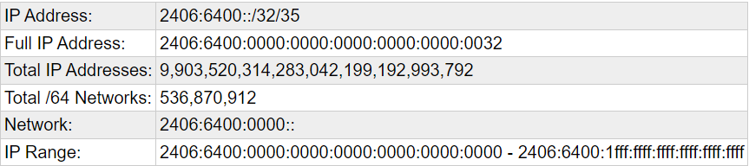

* Identify the first six /37 address blocks out of 2001:DB8::/32

