* Scan and show the entire IP range using nmap.

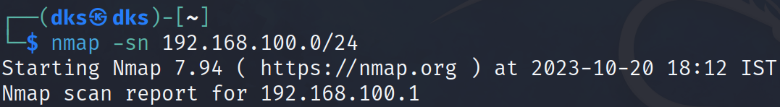

* 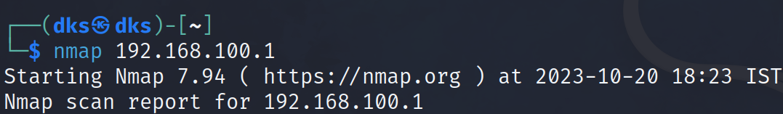Showcase how to scan a specific port or entire port range using namp
* 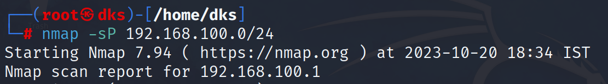Scan and show active Host using nmap
* 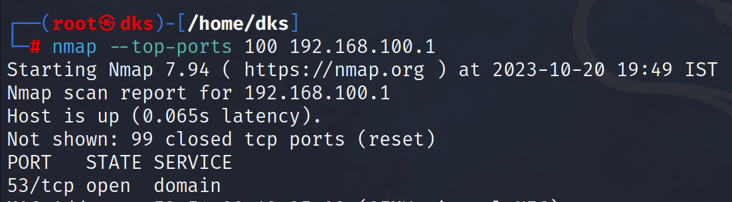How to scan the fixed number of most popular ports using nmap.
* 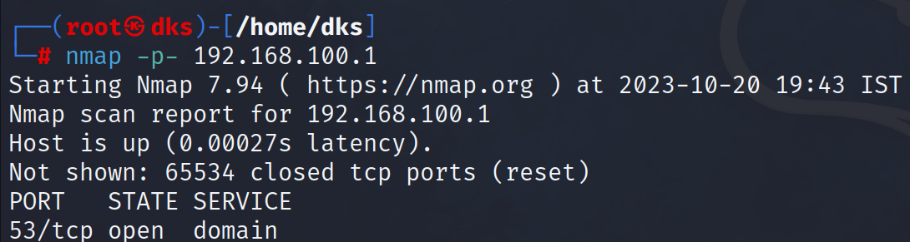How to detect open ports using nmap.
* Do a scan using nmap by excluding the host/IP addresses

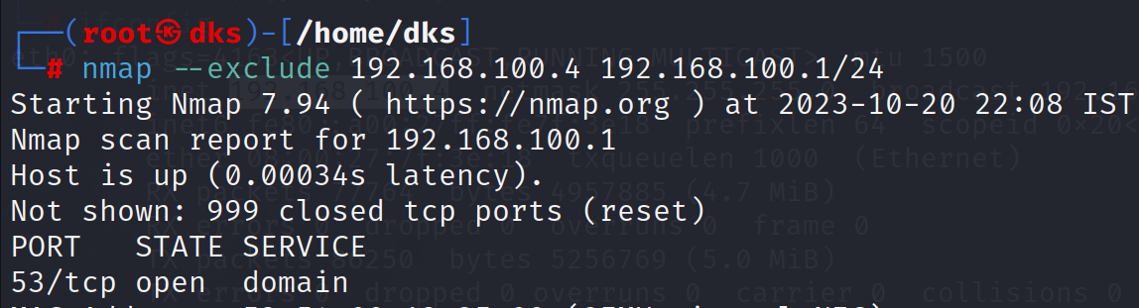

* 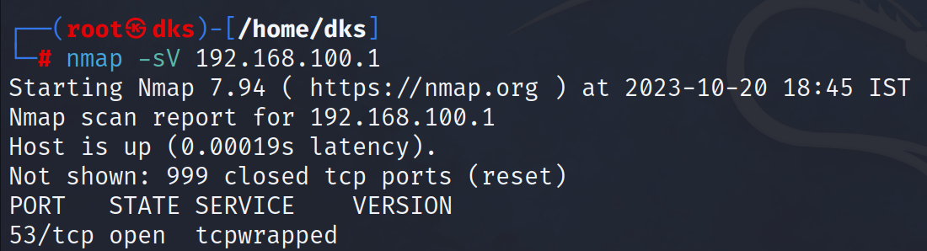How to detect services and its version running in your machine using nmap
* Search for possible sub domains of any domain (eg:www.indeed.com) using Dmitry tool

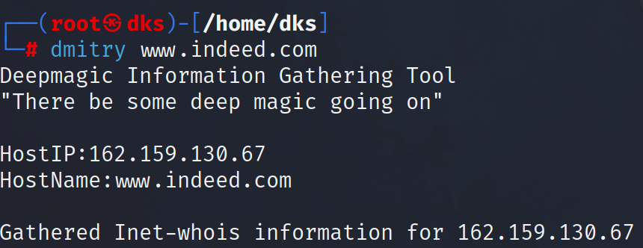

* 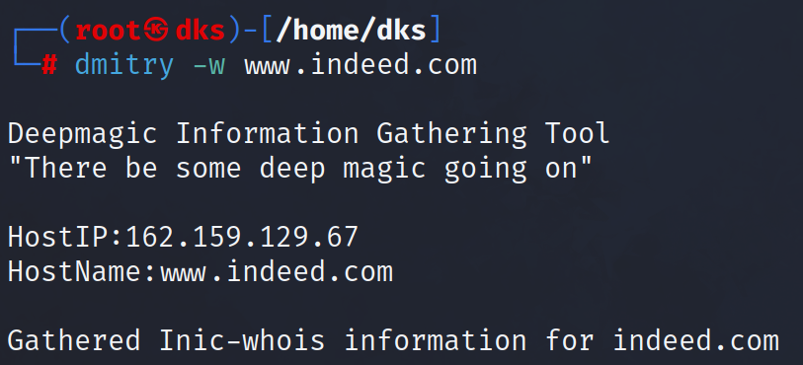Perform a whois lookup on any domain (eg:www.indeed.com) using Dmitry tool
* 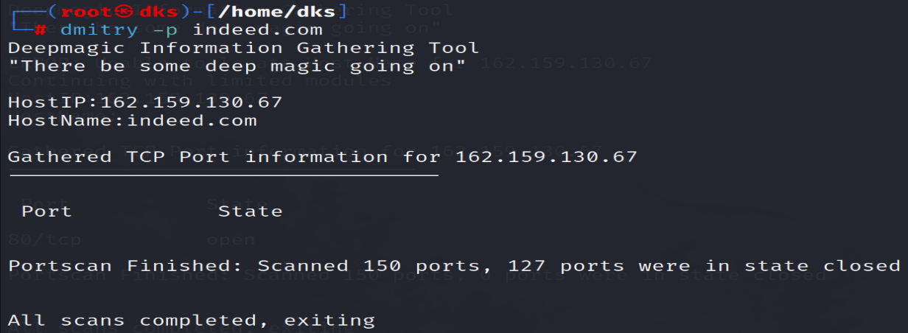Using Dmitry tool perform a TCP port scan on any Host
* 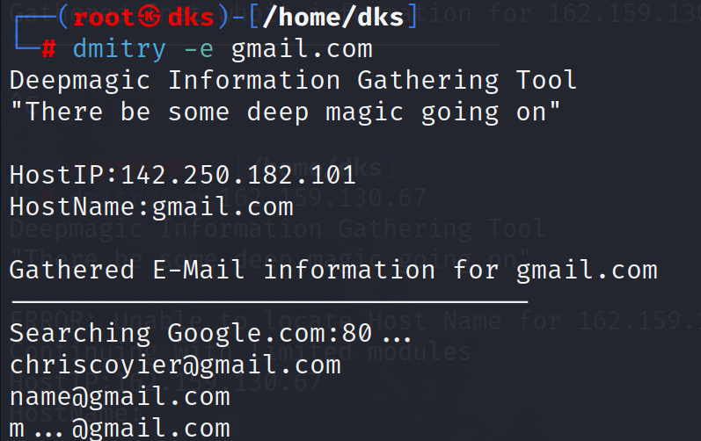Using Dmitry tool perform a search for possible email addresses scan on any domain
* Using Netcat, copy the content of a confidential file from one machine to another machine.
* Using Netcat, take the shell control of one machine to another machine.
* Using nslookup & whois, gather the info. of a domain ([www.indeed.com](http://www.indeed.com))

