UI: Image Uploader (Cannot not support IE789)

Requirement:

1. Select file to upload: click upload button and upload file

2. Preview uploaded image

3. Re-upload image, show "re-upload" message

4. Alert file size and file type

5. Customize UI

6. support: ff, chrome, ie78910

-----------------------------------------------------------------------------------------------------------------

Wireframe:

Step 1: Select file to upload.

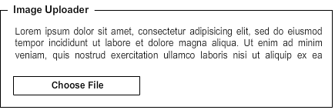

Step 2: Uploading.

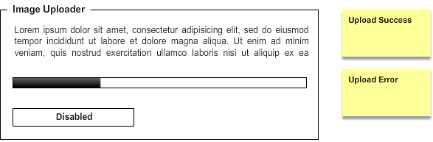

Step 2-1: Upload Success: If the uploaded file is not right, click “Remove” button to remove it. If it is the right file, click “Confirm File” to submit.

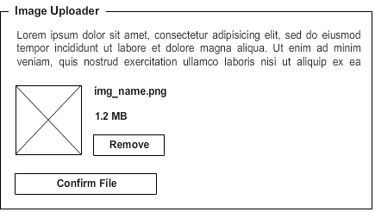

Step 2-2: Upload Error.

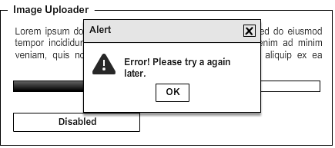

Step 3: Confirm / Submit file.

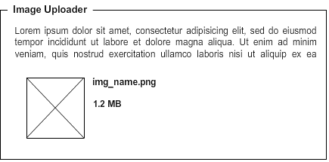

-----------------------------------------------------------------------------------------------------------------

Snapshot:

Step 1: Click “Select File to Upload” to upload image.



Step 2: Select a file.

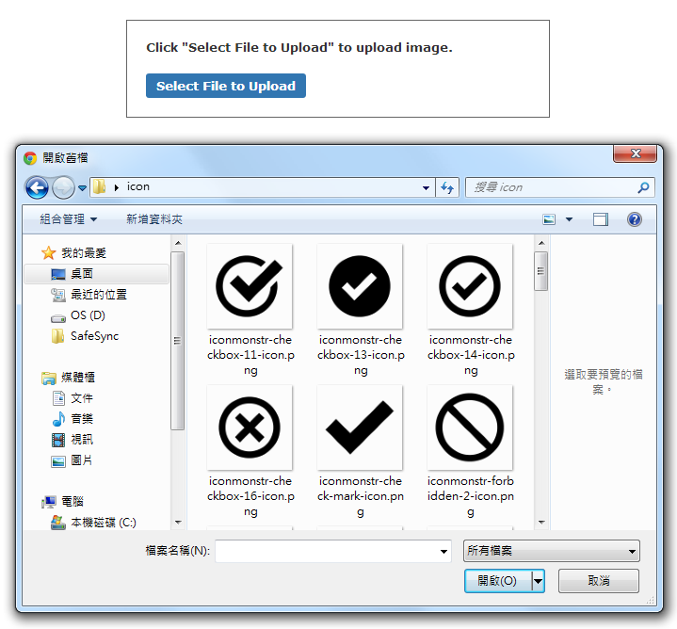

Step 3: After selecting, start to upload the image. Show the loading gif.

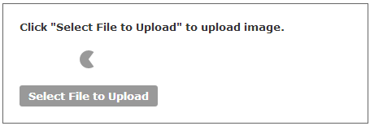

Step 4: Upload success. If the uploaded file is not right, click “Remove” button to remove it. If it is the right file, click “Confirm” to submit.

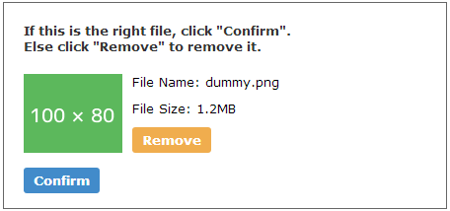

Step 5: Click “Confirm” to submit.

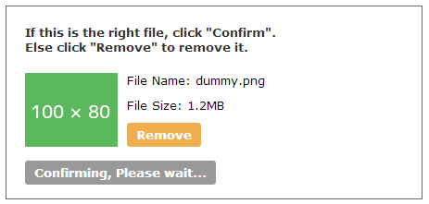

Step 6: Comfirmed.

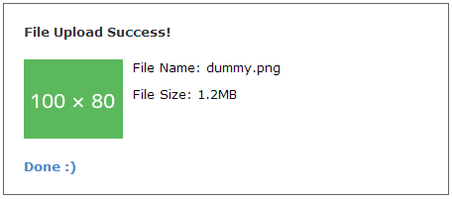

-----------------------------------------------------------------------------------------------------------------

Effort: 3.5hr

-----------------------------------------------------------------------------------------------------------------

Bug: **Cannot not support IE789(IE無法執行.reset()?)**

Support: ff, chrome

html, css, js lint: OK

Learnt:

1. <img>外再放一層<div>的原因是讓該出現img的空間大小先被佔據，不然就會在其他內容出現後，才依<img>佔據的大小再做調整，這時使用者會在畫面上看到這個調整的過程，是很突兀的。

2. 做不同事情的按鈕，不要綁在同一顆。因為綁在同一顆，要做事件綁定和解除、css class與文字轉換，很麻煩，不如分成兩顆按鈕，分別綁定css class和js event， 然後再依流程決定按鈕出現與消失的時機。