fcstd01.fcs
File Description
2 parameters:
FS (Forward Scatter)
SS (Side Scatter)

Homogenous matrix:
FS: 40,80,120,160,…1000 (25 different values)
SS: 20,40,60,80,…1000 (50 different values)

All together: 1250 events (25*50)

Figure:
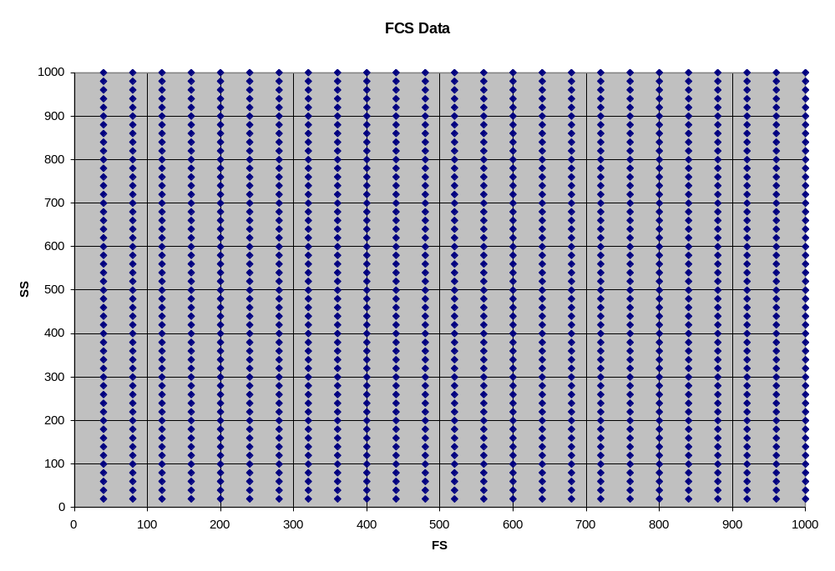

Tests:
File rectangles.xml contains 49 gates; expected results are mentioned as comments in the xml file as well as in Expected_results.txt file.

