Industrializing the Discovery of Disease Biology
The pharmaceutical innovation ecosystem is currently bifurcated. Academia excels at foundational discovery but lacks the infrastructure for industrial-scale validation, while the For-Profit Industry excels at compound optimization but is economically constrained to pursue low-risk, patentable assets with short return horizons. This structural gap has created a "Valley of Death" in which valid biological insights languish for decades before being translated.

Cytognosis is proposed as a Focused Research Organization (FRO) to bridge this gap. By operating as a non-profit "public utility" for disease biology, Cytognosis will industrialize the validation of drug targets, compressing the timeline from discovery to clinic. Crucially, we move beyond the industry's reliance on late-stage, symptom-based diagnoses (ICD codes) toward a continuous-spectrum approach, enabling a shift from reactive treatment to proactive prevention and preemption.

Structural Gaps and Market Failures
The current model of drug development is inefficient, not because of a lack of scientific ideas, but because of structural misalignments in time, economics, and diagnostic frameworks.

The Timeline Mismatch: The 32-Year Gap and the Sevabertinib Lesson
While the private sector drives late-stage execution, most foundational innovation remains publicly funded. Research indicates that NIH funding contributed to 354 of 356 drugs (99.4%) approved from 2010 to 2019, totaling $187 billion in investment.1 However, the maturation of this research is inefficiently slow, taking an average of 32 years to move from initial discovery to FDA approval. This timeline is fundamentally incompatible with the for-profit investment model, which typically demands returns within a 10-year fund lifecycle.
The development of Sevabertinib (Hyrnuo), approved by the FDA in November 2025, serves as a potent illustration of this delay.
- The Discovery (2005): Researchers at the Broad Institute identified "exon 20 insertions" in EGFR/HER2 genes as drivers of lung cancer. The mechanism was clear: the mutation locked the receptor in an "always on" state.
- The "Valley of Death" (2005–2013): Despite the discovery, no drug existed because the mutation distorted the drug-binding pocket, making it a "high-risk" target. For eight years, this insight sat effectively dormant because academia lacked the chemical libraries to screen for a solution, and industry viewed the biology as too complex and unvalidated.
- The Resolution (2013–2025): Success was only achieved when the Broad Institute (academic insight) formally allied with Bayer (industrial screening) in 2013. This partnership enabled the team to screen millions of compounds and eventually engineer Sevabertinib. It took another 12 years to reach approval.

The Cytognosis Advantage: It took 20 years for the Sevabertinib story to unfold because it relied on a chance alliance that formed nearly a decade after the initial discovery. Cytognosis institutionalizes this synergy. Instead of waiting for partnerships to form organically, Cytognosis houses both deep biological exploration and high-throughput screening under one roof, theoretically compressing the "dormant" years into an active engineering process.

The "Commons" Problem: Unpatentable Biology
The US patent system protects compounds, not biological mechanisms. This creates a perverse economic incentive: pharmaceutical companies invest disproportionately in creating patentable molecules (Lead Optimization) rather than understanding the underlying disease biology (Target Identification).

As illustrated below, Target Identification accounts for only 3–7% of direct out-of-pocket R&D costs, yet decisions made during this phase govern over 90% of downstream attrition risk.2
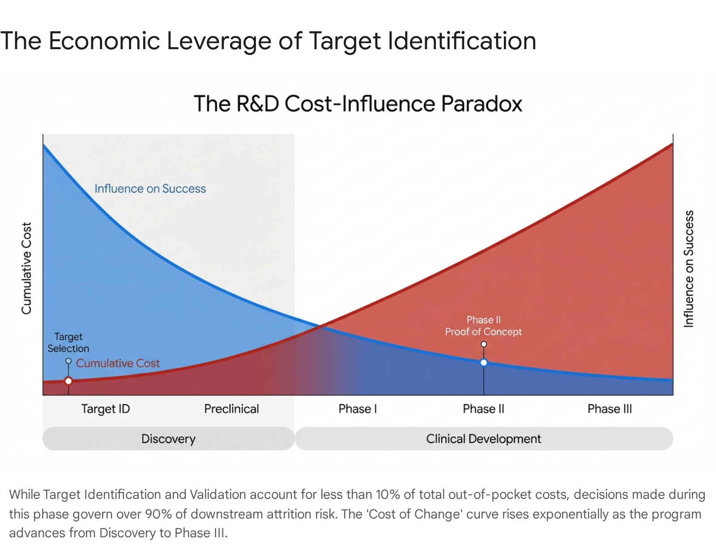
In complex fields like neurodegeneration, where pathophysiology is opaque, this underinvestment in biology leads to failure rates exceeding 99%. Companies effectively gamble billions on unvalidated mechanisms because no single entity is incentivized to map the "public good" of disease biology.
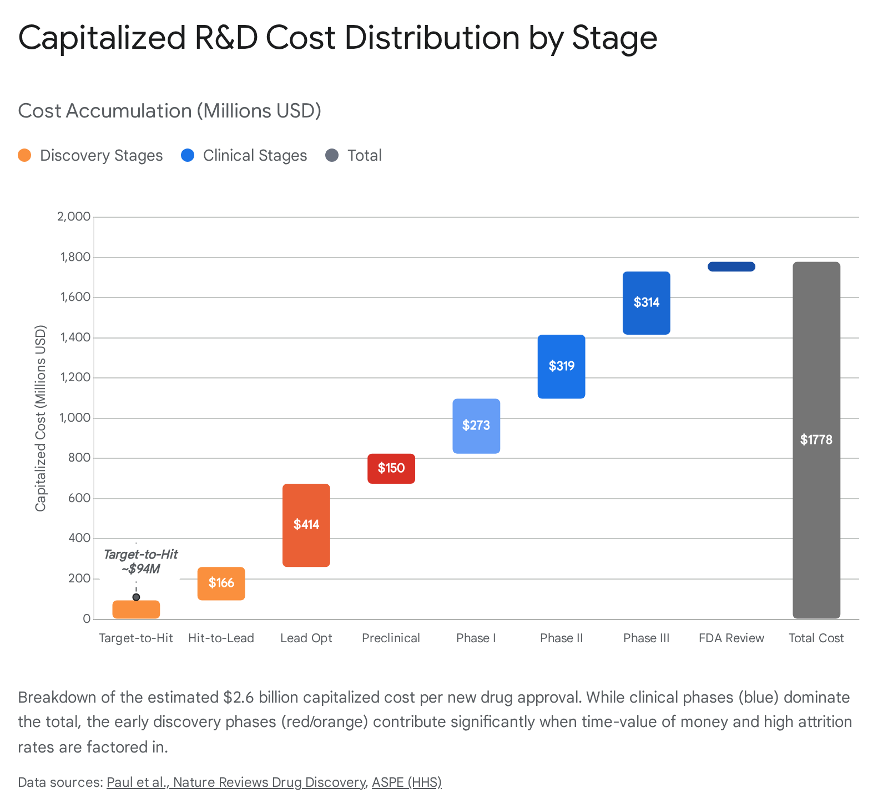

The Prevention Paradox and The Limitations of ICD Codes
Traditional pharma focuses on treating disease once clinical symptoms have emerged. By this stage, it is typically too late; significant, often irreversible organ damage has occurred, leading to poor prognosis and high healthcare costs.
- The Economics of Prevention: Developing preventative therapies is prohibitively expensive for the for-profit sector. Proving that a drug prevents a disease requires larger patient populations and longer trial durations than proving it treats an acute symptom. However, research consistently shows that earlier diagnosis is associated with significantly higher success rates and lower long-term costs.
- The ICD Silo Problem: A critical failure in current drug development is the reliance on International Classification of Diseases (ICD) codes for clinical trial recruitment. ICD codes are symptom-centric and often fail to capture the underlying biological reality. This creates artificial "disease silos" (e.g., strictly distinguishing between different forms of dementia or psychiatric disorders that share common mechanisms) and forces research into a late-stage, reactive framework. It blinds researchers to cross-disorder mechanistic discoveries that do not fit neatly into a billing code.

The Cytognosis Solution
Cytognosis fits neither the academic model (which rewards novel publications over robust standardization) nor the for-profit model (which requires patent protection and rapid ROI). It is a necessary third pillar designed to:
- De-risk the "Public Good": Just as AddGene standardized access to genetic material, Cytognosis acts as a centralized hub for validating disease targets. We provide the "tight feedback loops and standardization" that the private sector cannot justify funding for unvalidated biology.
- Move to Continuous Spectrum Mapping: We reject the binary "sick/healthy" dichotomy of ICD codes. Cytognosis employs a continuous spectrum approach, mapping axes of disease biology (e.g., inflammation, proteostasis) across populations. By tracking individuals along these continuous biological trajectories—rather than waiting for them to cross an arbitrary symptom threshold—Cytognosis can identify "pre-patients" and intervene at the earliest point of disease initiation.
- Industrialize Validation: We replicate the "Sevabertinib Model" systematically. By housing industrial-grade screening alongside academic-grade biological exploration, we eliminate the years of lag time typically required to set up ad-hoc public-private partnerships.

Conclusion
Cytognosis represents a structural correction to the pharmaceutical R&D ecosystem. By funding the "unprofitable" work of target validation, continuous disease mapping, and preventative biology, it will unblock the 32-year bottleneck, de-risk downstream commercial investment, and enable a shift from treating sickness to engineering health.

Works cited
- Spending on Phased Clinical Development of Approved Drugs by the US National Institutes of Health Compared With Industry - Scholars @ Bentley, accessed February 4, 2026, https://scholars.bentley.edu/cgi/viewcontent.cgi?article=1050&context=nas_facpubs
- Drug Development - https: // aspe . hhs . gov., accessed February 4, 2026, https://aspe.hhs.gov/sites/default/files/documents/ce102c41a7626cd885f7c88a9f2c4807/drug-development.pdf

