REPORT
North Star Metric
Total Monthly Revenue
Formula: SUM(payment_value) for delivered orders grouped by month.
Why it matters: It is the simplest measure of actual cash coming into the business.
Guardrail Metrics
Average Delivery Time
Formula: Average of (order delivered date minus order purchase date).
Why it matters: Slow shipping is the easiest way to lose customers to competitors.
Average Review Score
Formula: Average of the review score column.
Why it matters: It provides a direct numerical check on customer happiness.
Order Cancellation Rate
Formula: Count of cancelled orders divided by the count of all orders.
Why it matters: Cancelled orders lead to lost money and broken seller logistics.

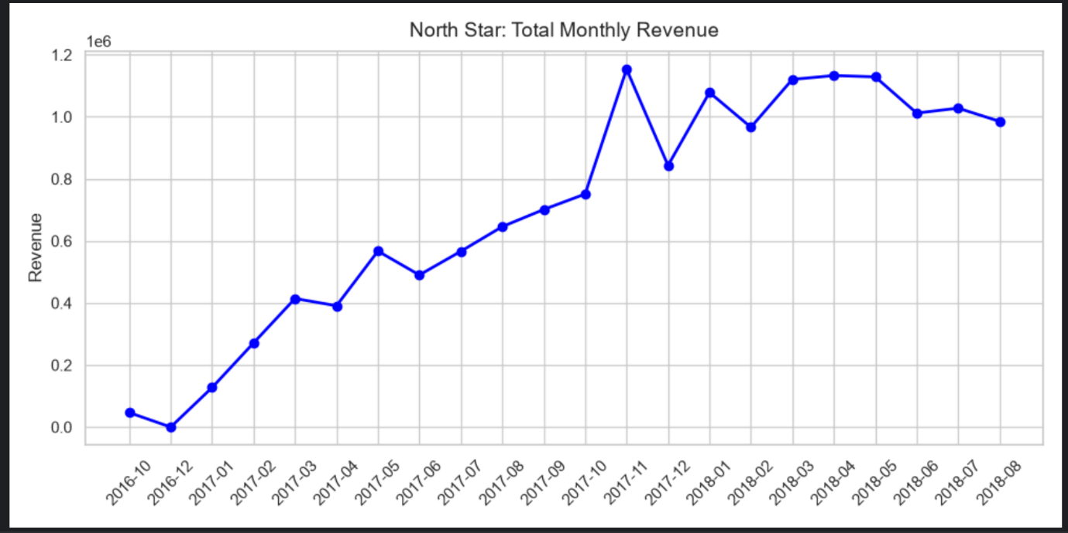

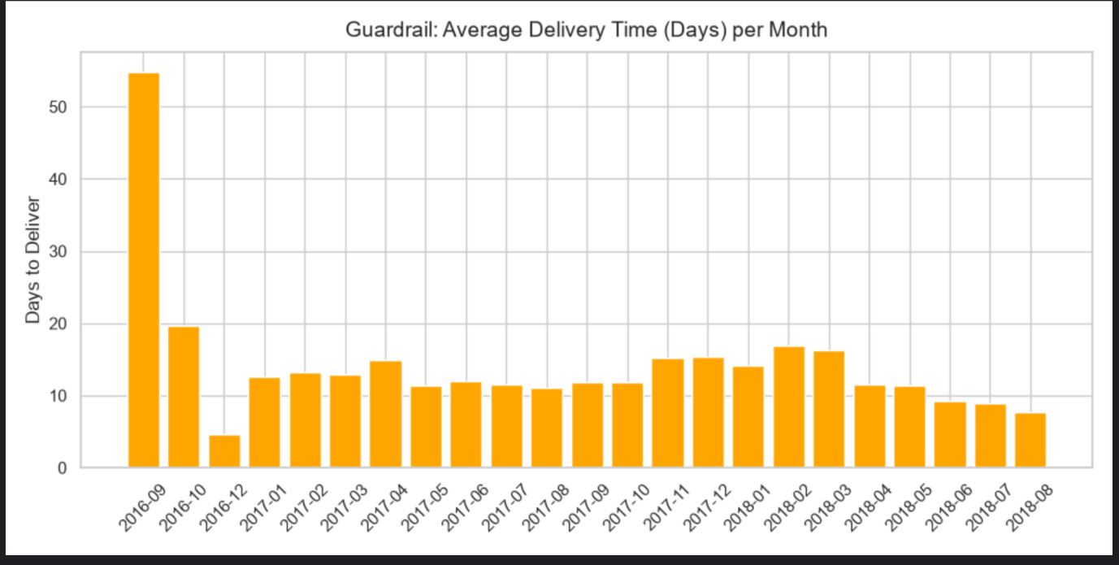

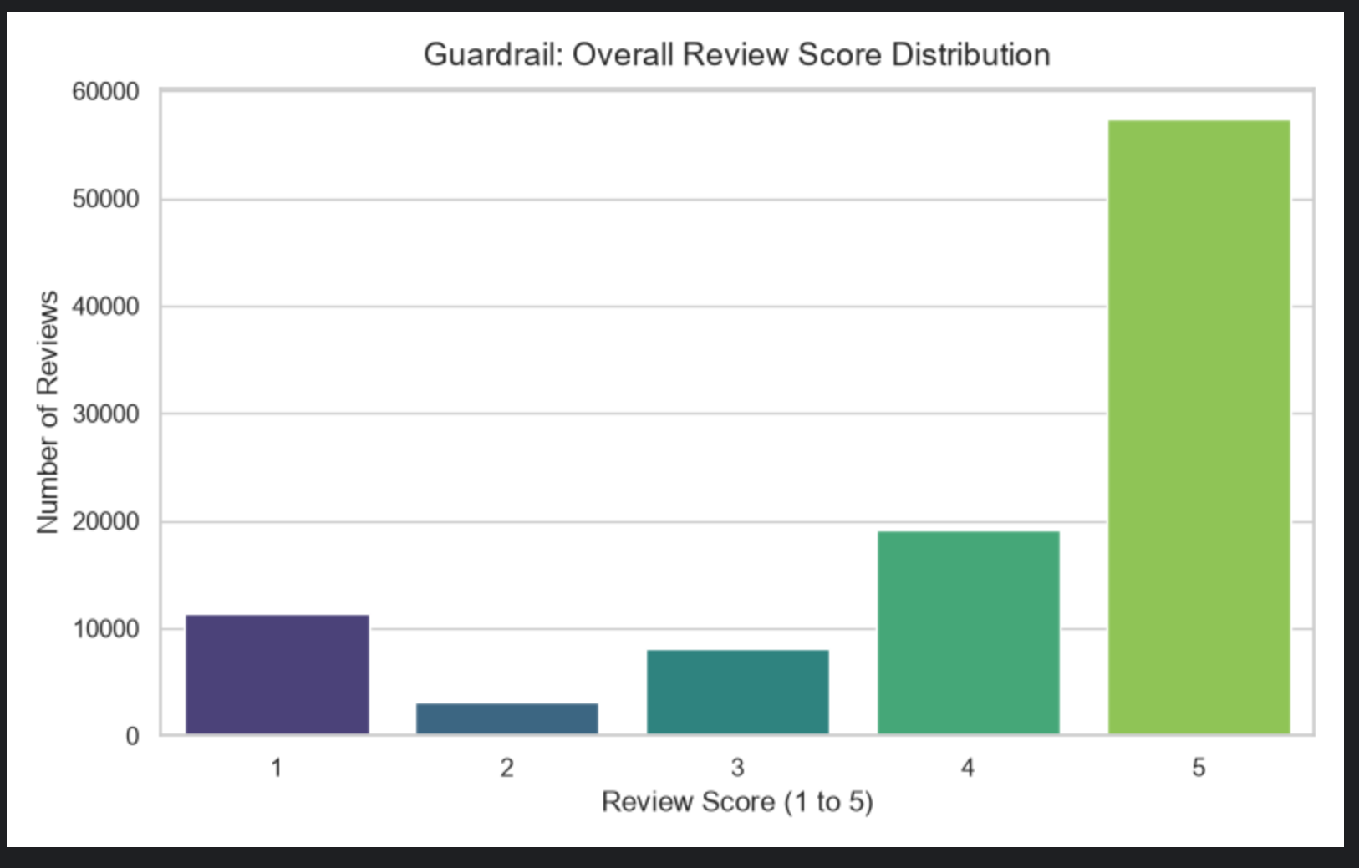

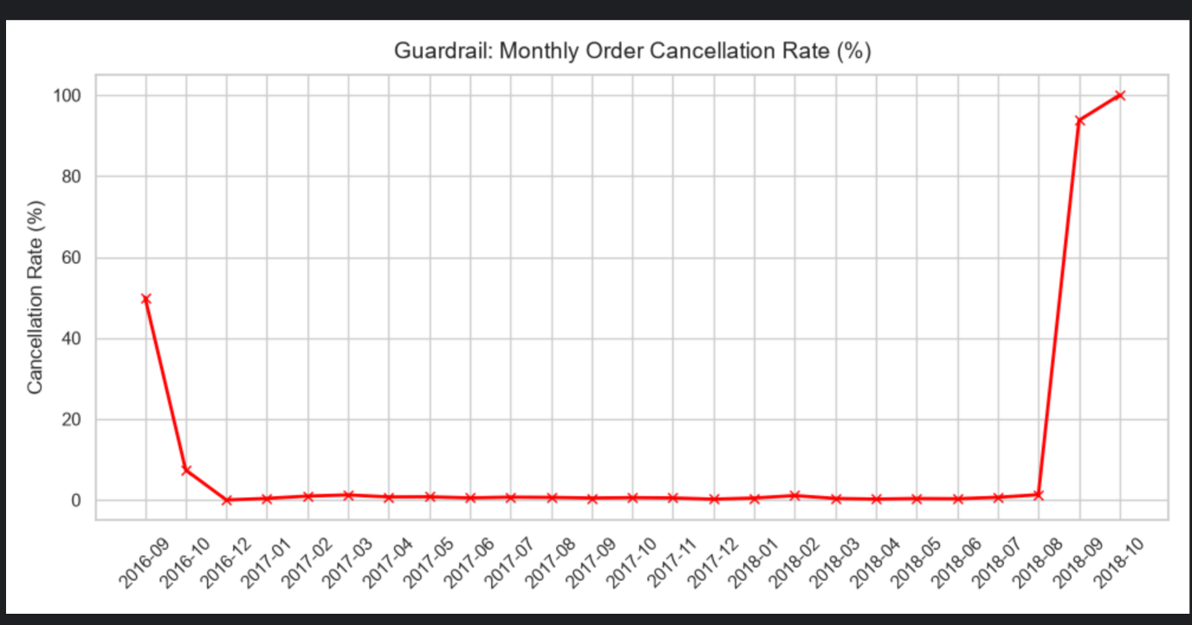

MEMORANDUM TO VICE PRESIDENT
Key Finding
We are bringing in lots of new customers, but we are losing them to slow shipping and a sudden, massive spike in cancelled orders.
The Evidence
Revenue: Overall sales are growing steadily.
Delivery Time: Shipping frequently takes over 10 days.
Cancellations: Almost all new orders were recently cancelled instead of shipped. From the current data we are unable to tell if customers, sellers, or a system glitch caused this spike.
Actionable Recommendation
Automatically add few extra days to the delivery estimate at checkout so packages feel like they arrive early. We need to investigate the reason for cancellations through further work on available data.
DATA QUALITY FINDINGS
The Python script successfully processed all data and filled 610 missing product categories.
Four of the five SQL data quality checks passed completely with zero errors.
The system caught 259 orders where the customer payment did not equal the item price plus freight.
These 259 financial mismatches triggered the fatal pipeline alarm during execution.
The alarm successfully crashed the pipeline to stop bad revenue data from entering the warehouse.
QUERY SUMMARY
The first query successfully documents the month-over-month revenue growth.
The second query successfully documents the top categories by state.
The third query successfully documents the 7-day rolling average of daily order count.
The fourth query successfully documents the repeat purchase rate.
The fifth query successfully documents average delivery delay versus the estimated delivery date and how it relates to review score.
The results can be viewed by running the individual SQL files.
Other relevant queries are documented in the metrics_analysis.py file for the proposed metrics.

