Hebrew TrOCR — Training Report
Model: cyttic/trocr-hebrew-untrained (ViT encoder + DictaBERT decoder), fine-tuned on synthetic Hebrew line images. Two-stage frozen-encoder run: stage-1 pretrain (1 epoch) followed by a warm-started continuation (4 epochs). Evaluation on the held-out synthetic test split (leak-free).

CER / WER progression
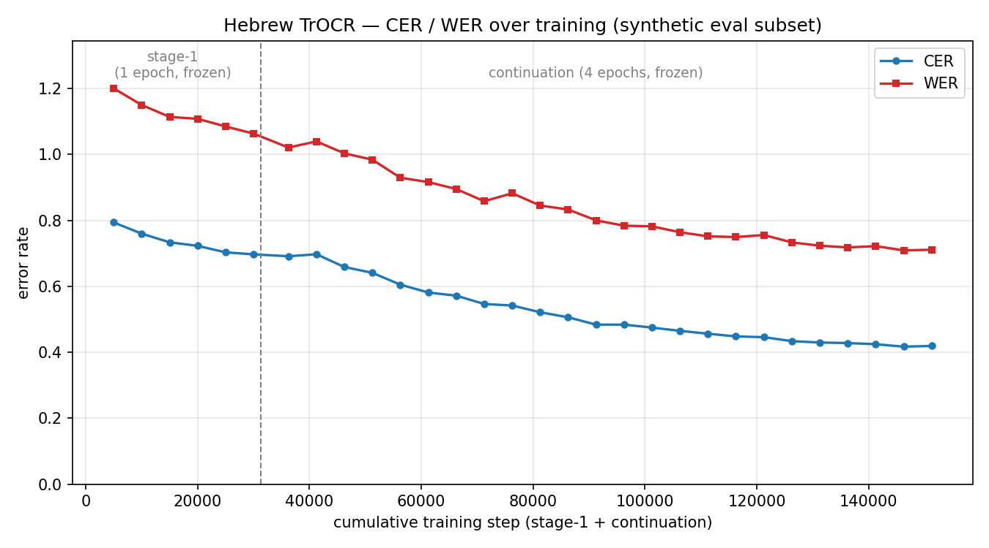
CER falls from 0.794 at the start of stage-1 to 0.419 at the end of the continuation. The curve is still descending — the model is learning but undertrained (usable OCR wants CER < ~0.10).

Per-step metrics

Stage-1 (1 epoch, frozen encoder)
Step | Train loss | Val loss | CER | WER
5000 | 5.8475 | 5.7263 | 0.7938 | 1.2005
10000 | 5.4956 | 5.2508 | 0.7599 | 1.1501
15000 | 5.0336 | 4.9340 | 0.7336 | 1.1140
20000 | 4.8256 | 4.7091 | 0.7229 | 1.1082
25000 | 4.7902 | 4.5252 | 0.7032 | 1.0852
30000 | 4.6081 | 4.4217 | 0.6971 | 1.0634

Continuation (4 epochs, frozen encoder)
Step | Train loss | Val loss | CER | WER
5000 | 4.2399 | 4.4891 | 0.6913 | 1.0211
10000 | 4.2872 | 4.5325 | 0.6974 | 1.0397
15000 | 4.1116 | 4.3374 | 0.6587 | 1.0034
20000 | 4.0617 | 4.0891 | 0.6410 | 0.9843
25000 | 4.1289 | 3.8432 | 0.6052 | 0.9295
30000 | 3.8996 | 3.6492 | 0.5813 | 0.9163
35000 | 3.3861 | 3.5239 | 0.5717 | 0.8951
40000 | 3.3523 | 3.4106 | 0.5465 | 0.8583
45000 | 3.3804 | 3.2932 | 0.5418 | 0.8824
50000 | 3.0626 | 3.1215 | 0.5214 | 0.8452
55000 | 3.1077 | 3.0222 | 0.5061 | 0.8332
60000 | 2.9628 | 2.9605 | 0.4839 | 0.8001
65000 | 2.6318 | 2.8618 | 0.4839 | 0.7841
70000 | 2.6647 | 2.8199 | 0.4749 | 0.7820
75000 | 2.6347 | 2.7244 | 0.4650 | 0.7642
80000 | 2.6061 | 2.6680 | 0.4564 | 0.7518
85000 | 2.4846 | 2.6197 | 0.4481 | 0.7496
90000 | 2.4784 | 2.5839 | 0.4458 | 0.7558
95000 | 2.2199 | 2.5551 | 0.4338 | 0.7333
100000 | 2.1109 | 2.5319 | 0.4296 | 0.7233
105000 | 2.0974 | 2.4896 | 0.4280 | 0.7181
110000 | 2.1572 | 2.4514 | 0.4245 | 0.7221
115000 | 2.2318 | 2.4256 | 0.4170 | 0.7091
120000 | 2.2032 | 2.4105 | 0.4192 | 0.7111

Final evaluation (held-out synthetic test)
Samples | Beams | CER | WER | BLEU
500 | 1 (greedy) | 0.4301 | 0.8259 | 15.76
2000 | 4 | 0.4146 | 0.8084 | 19.02
Headline number: CER 0.415 (beam=4, 2000 samples). Biggest remaining lever: unfreeze the encoder for the next continuation run.

