Delhi Public School, Hapur



PROJECT FILE
ON
COMPUTER SCIENCE (083)

SESSION:2024-25

Submitted By: SUBMITTED TO:

STUDENT’S NAME: Khushi Umrao Mr. Vivek Maheshwari

ROLL NO. : 10

CLASS & SECTION: XII-C

PROJECT
BASED ON

TRAVEL
PLANNER
APP
CERTIFICATE

This is to certify that Computer Science project on Travel Planner
App has been successfully completed by Khushi Umrao of Class XII C, Delhi Public School, Hapur for consideration in partial fulfillment of curriculum of Central Board of Secondary Education (CBSE) of Computer Science (083) for the AISSCE Practical Examination 2024-25. I certify that this project is up to my expectation and as per the guidelines issued by the CBSE.

_________________
(External Examiner)

________________ ______________
(Internal Examiner) (Principal)

Acknowledgment

I take this opportunity to express my deep sense of gratitude to all those who have been instrumental in preparation of this project. I feel great pleasure to express my obligation to Mrs. Meena Anand, Principal of Delhi Public School, Hapur. I am also sincerely grateful to Mr. Vivek Maheshwari PGT(Computer Science), Delhi Public School for his encouragement and valuable guidance during the entire period of work. I would also like to express my gratitude towards my peer, Kinjal Jain, Class XII - A, for being a valuable addition to the team. Without all of them, the project wouldn’t have been successful. I could not forget Internet and Textbooks which provided me with sufficient matter for reference.

Index

Sr. No. | Content | Page No.
1 | Certificate | 3
2 | Acknowledgment | 4
3 | Introduction | 6
4 | Requirements | 7
5 | System Designs | 8
6 | Implementation | 12
7 | Output Wndow | 18
8 | Conclusion | 20
9 | Future enhancements | 21
10 | References | 22

INTRODUCTION

Travel Planner App

The objective of the travel planner app is to provide users with a comprehensive, user- friendly, and personalized platform to plan, organize, and manage their trips efficiently.

SCOPE

This app allows users to log their trips, share itineraries and store their travel data for later.

REQUIREMENTS

Hardware Requirements:
- CPU – Intel i3 (recommended)
- RAM – 4GB (recommended)

Software Requirements:
- Operating System – any (Linux/Windows/Mac)
- Python (>=3.5.x)
- mysql-connector-python (>=9.1.0)
- Database - MySQL

SYSTEM DESIGNS

FLOWCHART:

START

CALL connect_to_mysql()

Check if DB exists

YES
NO

Create tables(users,trips,itineraries)
Create database

End function

main_menu(register or login)

LOGIN
REGISTER

Call login_user
Call register_user

Print registration successful
Check if login
successful

Yes
No

End
Print login successful
Print invalid login

Return to main_menu
End

Display user options

Log a trip
Add activity to itinerary
View trips
Logout

Call add_itinerary()
Call view_trip()
Call log_trip()
End

END

DATABASE DESIGNS:

Tables:
                - users(user_id, username, password)
                - trips(trip_id, user_id, destination, start_date, end_date)
                - itineraries(itinerary_id, trip_id, activity)

IMPLEMENTATION CODE SNIPPETS

- import mysql.connector
- import config

- def connect_to_mysql():
- conn = mysql.connector.connect(host = config.DB_HOST, user = config.DB_USER, database = config.DB_NAME, password = config.DB_PASSWORD)
- cursor = conn.cursor()

- # Check if the database exixts
- cursor.execute("show databases;")

- existing_databases = [row[0] for row in cursor.fetchall()]

- if config.DB_NAME not in existing_databases:

- # Create the database if it doesn't exist
- cursor.execute(f"create database {config.DB_NAME}")

- print(f"Database '{config.DB_NAME}' created successfully")

- # Create users table
- cursor.execute('''create table if not exists users(
- user_id int primary key auto_increment,
- username varchar(20),
- password varchar(15)
- );''')

- # Create trips table
- cursor.execute('''create table if not exists trips(
- trip_id int primary key auto_increment,
- user_id int,
- destination varchar(20),
- start_date date,
- end_date date,
- foreign key(user_id) references users(user_id)
- );''')

- # Create itineraries table
- cursor.execute('''create table if not exists itineraries(
- itinerary_id int primary key auto_increment,
- trip_id int,
- activity varchar(100),
- foreign key(trip_id) references trips(trip_id)
- );''')

- # Close cursor and connection to the MySql server
- cursor.close()
- conn.close()
- connect_to_mysql()

- import mysql.connector

- # Function to register a new user
- def register_user(username,password):
- conn = mysql.connector.connect(host = config.DB_HOST, user = config.DB_USER, database = config.DB_NAME, password = config.DB_PASSWORD)
- cursor = conn.cursor()

- cursor.execute('''insert into users(username,password)
- values(%s,%s)''' , (username,password))

- conn.commit()
- conn.close()

- print(f"User '{username}' registered successfully")

- # Function to log in a user
- def login_user(username,password):
- conn = mysql.connector.connect(host = config.DB_HOST, user = config.DB_USER, database = config.DB_NAME, password = config.DB_PASSWORD)
- cursor = conn.cursor()

- cursor.execute('''select * from users
- where username = %s and password = %s''',
- (username,password))

- user = cursor.fetchone()

- conn.close()

- if user:
- print(f"Welcome, {user[1]}")
- return user[0] # Return user_id

- else:
- print("Invalid login... Please check username or password and try again!")
- return None

- # Function to log a trip
- def log_trip(user_id,destination,start_date,end_date):
- conn = mysql.connector.connect(host = config.DB_HOST, user = config.DB_USER, database = config.DB_NAME, password = config.DB_PASSWORD)
- cursor = conn.cursor()

- cursor.execute('''insert into trips(user_id,destination,start_date,end_date)
- values(%s, %s, %s, %s)''', (user_id,destination,start_date,end_date))

- conn.commit()
- conn.close()

- print(f"Trip to '{destination}' logged successfully")

- # Function to add an activity to the itinerary for a trip
- def add_itinerary(trip_id,activity):
- conn = mysql.connector.connect(host = config.DB_HOST, user = config.DB_USER, database = config.DB_NAME, password = config.DB_PASSWORD)
- cursor = conn.cursor()

- cursor.execute('''insert into itineraries(trip_id,activity)
- values(%s, %s)''', (trip_id,activity))

- conn.commit()
- conn.close()

- print("Activity added to itinerary")

- # Function to display user's trips
- def view_trips(user_id):
- conn = mysql.connector.connect(host = config.DB_HOST, user = config.DB_USER, database = config.DB_NAME, password = config.DB_PASSWORD)
- cursor = conn.cursor()

- cursor.execute('''select * from trips
- where user_id = %s''', (user_id,))

- trips = cursor.fetchall()

- if trips:
- print("\nYour Trips:")
- for trip in trips:
- print(f"Trip ID: {trip[0]} , Destination: {trip[2]}, Dates: {trip[3]} to {trip[4]}")

- else:
- print("No trips found!")

- conn.close()

- def main_menu():
- print("Welcome to the Travel Planner")

- action = input("Do you want to: (1)Register or (2)Login? ---> ")

- if action == "1":
- username = input("Enter username: ")
- password = input("Enter password: ")
- register_user(username,password)

- elif action == "2":
- username = input("Enter username: ")
- password = input("Enter password: ")
- user_id = login_user(username,password)

- if user_id:
- while True:
- print("\nOptions:")
- print("1. Log a new trip")
- print("2. Add activity to itinerary")
- print("3. View your trips")
- print("4. Logout")

- choice = input("Choose an option from above: ")

- if choice == "1":
- destination = input("Enter destination: ")
- start_date = input("Enter start date (YYYY-MM-DD): ")
- end_date = input("Enter end date (YYYY-MM-DD): ")
- log_trip(user_id, destination, start_date, end_date)

- elif choice == '2':
- trip_id = int(input("Enter trip ID to add activity to: "))
- activity = input("Enter activity: ")
- add_itinerary(trip_id, activity)

- elif choice == '3':
- view_trips(user_id)

- elif choice == '4':
- print("Logging out...")
- break

- else:
- print("Invalid option, try again.")

- main_menu()

Output Window

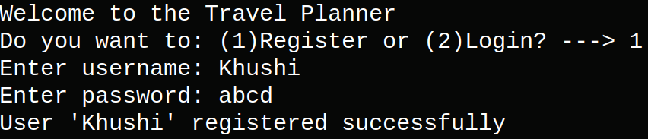
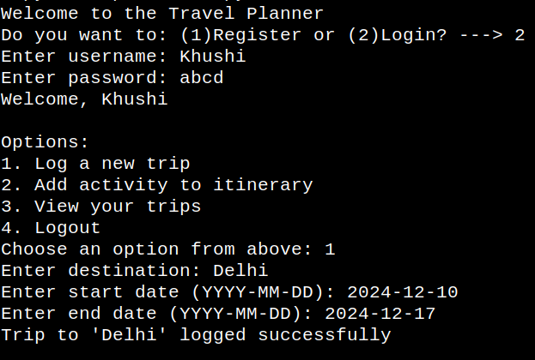

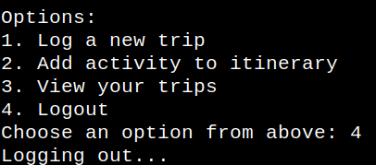
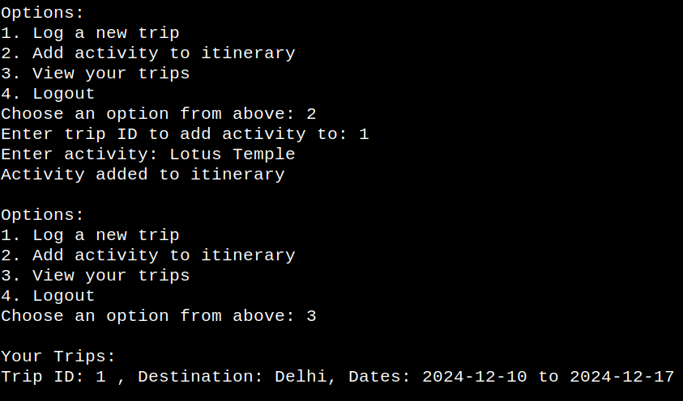

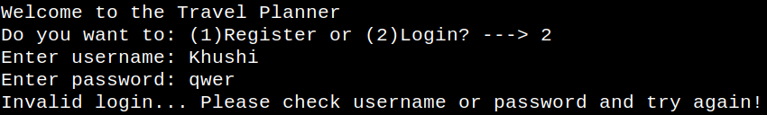

CONCLUSION

- Enhances user engagement
- Streamlines travel planning
- Ensures user data privacy
- Personalized platform
- Time efficient
- Performance optimization: Achieved through code refactoring, caching and optimizing database queries.
- User testing feedback: Incorporated user feedback for overall experience

FUTURE ENHANCEMENTS

- If VR(Virtual Reality) feature is ever added so the users can have tours for pre-planning trips.
- AI (Artificial Intelligence) powered travel recommendations for better experience
- Personalized travel budgeting and expense tracking
- Real-time location sharing and safety tracking

REFERENCES

- Wikipedia
- Meta AI
- ChatGPT
- Computer Science with python Class-XII by Sumita Arora
- www.ncert.co.in

