


Product Requirement Document (PRD)
(CSIT321 – Final Year Project)
CSIT-26-S2-05: A Mobile Application for Wise Workout

Supervisor: Mr Premrajan
Group ID: FYP-26-S2-37
Name | UOW ID | SIM ID | E-Mail Address
CHIA YUAN JUN | 9096383 | 10250237 | yjchia007@mymail.sim.edu.sg
DEVANANDI PRAVEEN | 8575800 | 10256847 | devanand001@mymail.sim.edu.sg
FOONG JUN YAN | 8465824 | 10255961 | jyfoong002@mymail.sim.edu.sg
JEDIDIAH GOH CHOR SZER | 9096723 | 10263623 | jcsgoh001@mymail.sim.edu.sg

Document Version Control

Version | Date | Modified By | Description
1.0 | 2nd May 2026 |  | Initial version

Table of Contents
Document Version Control 2
1. Introduction 7
1.1. Overview 7
1.2. Problem Statement 7
1.3. Project Scope 8
1.4. Project Objectives 9
2. Research Summary 11
2.1. Overview of Fitness App Market 11
2.2. Fitness Applications in the Market 11
2.2.1. Strava 11
2.2.2. MyFitnessPal 12
2.2.3. adidas Running 13
2.2.4. Google Fit 14
2.2.5. Freeletics 15
2.2.6. MapMyFitness 15
2.2.7. Lyfta 16
2.3. Product Comparison Table 18
2.4. Key Findings from Existing Apps 19
2.5. Research Gap 19
2.6. Case Studies 20
2.6.1 Strava: Community-Based Fitness Tracking 20
2.6.2 MyFitnessPal: Nutrition and Habit Tracking 20
2.6.3 Freeletics: AI-Based Coaching 21
2.6.4 Google Fit: Health Data Aggregation 21
2.7. Data Acquisition and Connectivity Protocols 21
2.8. Algorithms / Techniques Considered 22
2.8.1. Rule-Based Recommendation 22
2.8.2. Personalised Recommendation System 23
2.8.3. Activity Classification 23
2.8.4. Progress Tracking and Trend Analysis 23
2.8.5. Notification and Reminder Logic 23
2.8.6. Expert Matching 23
2.8.7. Data Visualisation 24
3. Target Users and User Categories 24
3.1. Target Users 25
3.2. Unregistered User 25
3.3. Registered Free User 26
3.4. Registered Premium User 27
3.5. Expert User 27
3.6. System Admin 27
4. Proposed Product 28
4.1. Product Motivation 28
4.2. Proposed Product Overview 29
4.3. Value Proposition 30
4.4. Main Features 31
4.4.1. (FR1) – User Account and Authentication 31
4.4.2. (FR2) – Fitness Profile Management 31
4.4.3. (FR3) – Workout Activity Recording 32
4.4.4. (FR4) – Data Acquisition and Wearable Integration 32
4.4.5. (FR5) – Progress Dashboard and Analytics 32
4.4.6. (FR6) – AI-Assisted Guidance 33
4.4.7. (FR7) – Fitness Plan, Reminder, and Alert Management 34
4.4.8. (FR8) – Expert Profile and Service Management 35
4.4.9. (FR9) – Expert Discovery and Service Requests 35
4.4.10. (FR10) – Community Feed, Social Sharing, Competitions, and Gamification 36
4.4.11. (FR11) – Subscription and Tiered Access Control 37
4.4.12. (FR12) – Administrative Management 37
4.5. Marketing Website 38
5. Business Model 39
5.1. Proposed Business Model 39
5.2. User Tiers 40
5.3. Free vs Premium Feature Access 41
5.4. Revenue Model 43
5.5. Justification of Business Model 44
6. Functional Hierarchy Diagram 45
7. Use Case Diagram and Description 46
7.1. Preliminary User Stories 46
7.1.1. (Preliminary User Stories) – Unregistered User 46
7.1.2. (Preliminary User Stories) – Registered Free User 47
7.1.3. (Preliminary User Stories) – Registered Premium User 49
7.1.4. (Preliminary User Stories) – Expert User 51
7.1.5. (Preliminary User Stories) – System Administrator 52
7.2. Preliminary Use Case Diagrams 54
7.2.1. (Preliminary Use Case Diagrams) – Unregistered User 54
7.2.2. (Preliminary Use Case Diagrams) – Downloading App 55
7.2.3. (Preliminary Use Case Diagrams) – Registered Free User 56
7.2.4. (Preliminary Use Case Diagrams) – Registered Premium User 57
7.2.5. (Preliminary Use Case Diagrams) – Expert User 58
7.2.6. (Preliminary Use Case Diagrams) – System Admin 59
7.3. Preliminary Use Case Descriptions 60
8. Project Schedule 75
8.1. Project Deadlines and Milestones 75
8.2. Project Timeline 77
8.2.1. Phase 1: Project Planning and Initial Setup 78
8.2.2. Phase 2: Research and Project Requirement Documentation 78
8.2.3. Phase 3: System Requirement Specification 79
8.2.4. Phase 4: Analysis, Design, and Initial Functional Prototype 79
8.2.5. Phase 5: Basic Prototype Development and Progress Report 80
8.2.6. Phase 6: Continued Implementation and Module Testing 80
8.2.7. Phase 7: Integrated Development and Integration Testing 81
8.2.8. Phase 8: Final Development and Supervisor Demonstration 81
8.2.9. Phase 9: Final Project Presentation and Demonstration 82
8.3. Roles and Responsibilities 82
9. Development Tools 83
9.1. Mobile Application Development Tools 83
9.2. Marketing Website Development Tools 84
9.3. Backend, Database, and System Support Tools 85
9.4. Design, Documentation, and Collaboration Tools 86
10. Development Methodologies 88
10.1. Agile Iterative Development Methodology 88
10.2. Justification for Using Agile 88
10.3. Iteration / Sprint Approach 89
10.4. Team Collaboration and Task Management 90
10.5. Testing and Feedback Approach 91
10.6. Relevance to Wise Workout Development 91
11. References 93

Introduction

Overview
Wise Workout is a fitness tracking, AI-assisted guidance, and expert service platform designed to help users record workout activities, monitor their fitness progress, receive personalised guidance, and connect with verified experts across different fitness and wellness categories. The platform combines workout data recording, progress analytics, AI-assisted recommendations, expert-led services, and subscription-based access within a single mobile application.
The proposed product is intended for users who want to improve their fitness through self-guided tracking, as well as users who prefer professional support from experts across areas such as running, cycling, strength training, nutrition, and recovery. Experts on the platform can provide services such as workout plans, coaching advice, fitness content, sport-specific guidance, nutrition support, and recovery recommendations.
By combining fitness tracking with access to expert services, Wise Workout aims to provide a more complete fitness support platform than a standard workout tracker. Instead of only recording workout data, the platform enables users to use their fitness progress as a basis for seeking relevant expert guidance and improving their overall fitness journey.

Problem Statement
Many fitness users can record workout activities using existing applications, but they may still struggle to understand how their progress relates to their fitness goals. Basic statistics such as calories burned, workout duration, and distance are useful, but they do not always provide enough context for users to decide whether they are improving, undertraining, overtraining, or following a suitable fitness plan.
In addition, users who require more specific support often need to search outside the application for professional guidance. For example, a user who wants to improve running endurance, plan better nutrition, recover from training fatigue, or develop sport-specific skills may need to use separate platforms to find suitable experts. This creates a fragmented experience where workout tracking, progress monitoring, and professional fitness support are separated.
Some users may also struggle to stay motivated when fitness applications only provide tracking data without structured goals, reminders, challenges, or achievement-based encouragement.
Wise Workout addresses this problem by combining workout tracking, progress monitoring, AI-assisted guidance, expert discovery, expert-created content, and expert service requests in one platform. Registered free users will be able to access limited core features such as basic workout tracking, simple progress summaries, and limited AI-assisted guidance, while registered premium users will have full access to platform tools such as advanced progress analytics, full AI-assisted recommendations, personalised reports, and personalised fitness planning. Expert services will remain a separate paid layer available through service requests. Verified experts provide an additional service layer by offering professional content, training plans, consultations, and specialised guidance.

Project Scope
The scope of this project is to develop Wise Workout, a mobile fitness tracking and expert service platform that allows users to record workout activities, monitor fitness progress, and connect with verified experts across different fitness and wellness categories. The project will focus on building a platform where users can manage their fitness journey while accessing professional guidance from experts such as running coaches, cycling coaches, football coaches, strength trainers, nutritionists, and recovery specialists.
The system will support several user groups, including unregistered users, registered free users, registered premium users, experts, and system administrators. Unregistered users will be able to access the marketing website and view general information about the platform. Registered users will be able to create fitness profiles, record workout activities, view progress summaries, browse expert profiles, and request expert-related content or services through the separate paid expert service layer. Premium users will have access to advanced progress analytics, full AI-assisted guidance, personalised reports, and personalised fitness planning. Expert profile browsing, expert category suggestions, and expert service requests will be available to registered users, while paid expert services remain a separate service layer outside the free and premium subscription structure. Experts will be able to create and manage professional profiles, select their areas of expertise, publish fitness or wellness-related content, create service listings, and respond to user service requests. System administrators will manage user accounts, expert applications, expert categories, content, service listings, and platform governance.
The project will include core features such as user account management, fitness profile management, workout activity recording, progress dashboards, expert profile management, expert category management, expert content publishing, expert search and filtering, service request handling, subscription-based feature access, and administrative management. These features are intended to demonstrate how Wise Workout can support both users who prefer self-guided fitness tracking and users who want professional support from verified experts.
The system will also support data acquisition from smartphone sensors, wearable devices, and third-party health platforms where applicable. This allows the platform to collect fitness-related data such as steps, distance, workout duration, calories burned, and heart rate, which can be used to support progress tracking, analytics, AI-assisted recommendations, and expert service workflows.
AI-assisted features will be included to support progress summaries, workout-related recommendations, personalised reports, and expert category suggestions based on user profile and activity data. Basic AI support may be available to registered free users, while advanced AI insights, full workout recommendations, personalised reports, and personalised fitness planning will be provided under the premium tier. Expert discovery and expert service requests will remain available to registered users, while paid expert services will act as a separate service layer where users may access expert-created content, training plans, consultations, and specialised guidance through additional paid expert service requests.
The project will also include fitness plan management, reminder and alert functions, and basic social motivation features. Users may receive suggested fitness plans, workout reminders, inactivity alerts, rest alerts, and progress notifications based on their goals and activity data. Registered users may also participate in simple fitness challenges, view competition progress, earn achievement badges, and share selected workout or challenge results where applicable.
The project will not include the implementation of advanced features such as video consultation, live chat, medical-grade health monitoring, or professional diagnosis. These features may be considered as future enhancements. The main focus of this project is to deliver a functional application that demonstrates the key concept of combining fitness tracking, progress monitoring, and expert-led fitness services within a single mobile application platform.

Project Objectives
The objectives of the Wise Workout project are as follows:
Objective | Short Summary
Develop a fitness tracking platform | Allow users to record workout activities such as running, cycling, football, gym training, and other exercises.
Support fitness profile management | Allow users to manage fitness goals, activity preferences, workout categories, and personal fitness information.
Provide progress monitoring | Enable users to view workout history, track progress, and understand activity patterns through dashboards and summaries.
Provide AI-assisted guidance | Support users with progress summaries, workout-related recommendations, personalised reports, and expert category suggestions.
Support fitness plan and reminder management | Allow users to receive suggested fitness plans, workout reminders, rest alerts, and progress notifications.
Create an expert service platform | Allow verified experts in areas such as running, cycling, football, strength training, nutrition, and recovery to offer services and content.
Enable expert discovery and service requests | Allow users to search, filter, view expert profiles, and request expert guidance based on their fitness needs.
Provide social motivation and gamification | Allow users to join simple challenges, view rankings, earn badges, and share selected fitness achievements.
Implement tiered access and expert service layer | Provide limited access to core platform tools for free users, while premium users receive full access to advanced self-guided tools such as advanced analytics, full AI-assisted guidance, personalised reports, and personalised fitness planning. Expert services will remain a separate paid layer available through expert service requests.
Provide administrative management features | Allow system administrators to manage users, approve experts, manage categories, monitor content, oversee service listings, and maintain platform quality.
Deliver a functional prototype | Demonstrate the integration of fitness tracking, AI-assisted guidance, progress monitoring, fitness planning, expert-led services, social motivation, and administrative management in one mobile platform.

Research Summary

Overview of Fitness App Market
The fitness application market has grown rapidly in recent years due to increasing health awareness, widespread smartphone adoption, and the popularity of wearable fitness devices. Modern users are no longer looking only for simple workout recording tools; they increasingly expect applications to provide progress tracking, personalised recommendations, social engagement, and integration with other health platforms.
Current fitness applications generally include features such as activity tracking, calorie monitoring, route mapping, workout planning, and data analytics. Many applications also integrate with smartwatches, heart rate monitors, and external health platforms to provide a more complete view of a user’s fitness journey. In addition, artificial intelligence and machine learning are becoming more common in the industry, allowing applications to generate workout recommendations, adaptive coaching, and health insights based on user activity and preferences.
Another major trend in the market is the use of freemium monetisation models, where basic tracking functions are offered for free while advanced analytics, personalised plans, and premium coaching are available through subscription. More recently, there has also been growing interest in combining self-guided fitness tools with access to professional experts such as coaches, trainers, nutritionists, and recovery specialists. This shows that the market is shifting towards more personalised, data-driven, and service-oriented fitness platforms.

Fitness Applications in the Market
To better understand the current fitness app landscape, several existing applications were reviewed. These include Strava, MyFitnessPal, adidas Running, Google Fit, Freeletics, MapMyFitness, and Lyfta. These applications were selected because they represent different segments of the fitness and wellness market, including activity tracking, nutrition tracking, AI-based coaching, health data aggregation, and strength training support.
The purpose of reviewing these applications is to identify common features, understand how AI or machine learning is currently used, examine monetisation strategies, and highlight areas where improvement or differentiation may be possible. This review also helps position the proposed Wise Workout platform within the current market.

Strava

Overview:
Strava is a fitness tracking application that supports activities such as running, cycling, swimming, hiking, and other sports. It uses GPS technology to track workout routes, distance, pace, duration, and performance metrics. The app is especially popular among endurance athletes and users who want to record and share outdoor activities.

Key Features:
Strava provides activity tracking, route discovery, performance analysis, challenges, clubs, leaderboards, and social sharing. Users can share completed activities, give likes or “kudos”, comment on workouts, and compare their performance with other users through leaderboards and route segments.

AI / ML Usage:
Strava uses intelligent and data-driven features to generate workout insights, activity summaries, progress comparisons, and personalised suggestions based on user activity history and fitness level. These features help users understand their performance and track improvements over time.

Monetisation Model:
Strava uses a freemium model. Basic activity tracking and social features are available for free, while premium features such as advanced training analysis, route planning, personalised recommendations, leaderboards, and live safety tracking are included in the paid subscription.

Relevance to Wise Workout:
Strava shows the value of combining activity tracking with community engagement. However, it is mainly focused on endurance activities and social fitness sharing. Wise Workout can differentiate itself by combining activity tracking with AI guidance and access to verified fitness experts.

MyFitnessPal

Overview:
MyFitnessPal is a nutrition and calorie tracking application designed to help users monitor their daily food intake and manage weight-related goals. It allows users to record meals, track calories, and monitor macronutrients such as protein, carbohydrates, and fats. Although its main focus is nutrition, it also supports exercise logging and integration with other fitness platforms.

Key Features:
MyFitnessPal provides food logging, calorie tracking, macronutrient tracking, barcode scanning, meal records, weight goal tracking, and progress monitoring. It also integrates with external applications and wearable devices such as Fitbit, Apple Health, and Garmin Connect. This allows users to combine nutrition, exercise, and health data for a more complete view of their fitness progress.

AI / ML Usage:
MyFitnessPal uses intelligent features to support food recognition, meal logging, calorie estimation, and personalised nutrition insights. By analysing user habits and historical data, the app can help identify eating patterns and provide suggestions that support healthier dietary decisions.

Monetisation Model:
MyFitnessPal uses a freemium monetisation model. Basic food logging and calorie tracking features are available for free, while advanced features such as detailed nutrient insights, custom goals, meal scanning, barcode scanning, and ad-free usage are included in the premium subscription. The free version may also generate revenue through advertisements and brand partnerships.

Relevance to Wise Workout:
MyFitnessPal highlights the value of nutrition tracking and personalised dietary insights. However, it is mainly focused on food and calorie management rather than complete workout tracking or expert coaching. Wise Workout can learn from its data logging approach while focusing more strongly on exercise analytics, AI workout support, and expert services.

adidas Running

Overview:
adidas Running is a GPS-based fitness application designed mainly for tracking running, walking, and cycling activities. It records real-time workout information such as distance, pace, duration, calories burned, and route data. The app is useful for users who want structured activity tracking and goal-based training support.

Key Features:
adidas Running provides GPS workout tracking, route mapping, training plans, progress tracking, challenges, and social sharing features. Users can set fitness goals, monitor performance over time, and participate in challenges to stay motivated. The app also supports integration with selected third-party platforms and wearable devices, helping users connect their workout data across different services.

AI / ML Usage:
adidas Running uses data-driven personalisation to support training recommendations and adaptive workout planning. By analysing user activity history, fitness level, and goals, the app can provide more relevant training suggestions and help users follow structured plans that adjust according to their progress.

Monetisation Model:
adidas Running follows a freemium subscription model. Basic activity tracking features are available for free, while more advanced functions such as structured training plans, deeper analytics, and coaching-related features are available through paid membership. The app also supports adidas brand engagement by connecting users to the wider adidas fitness ecosystem.

Relevance to Wise Workout:
adidas Running shows the value of structured training plans and goal-based fitness support. However, it is mainly focused on running and related cardio activities. Wise Workout can expand beyond this by supporting a wider range of workout types, AI recommendations, and paid expert services across multiple fitness categories.

Google Fit

Overview:
Google Fit is a health and activity tracking platform that helps users monitor daily movement and general wellness data. It tracks metrics such as steps, calories burned, movement minutes, and heart-related activity. Unlike specialised fitness apps, Google Fit functions more as a central health data hub that collects information from smartphones, smartwatches, and connected fitness services.

Key Features:
Google Fit provides activity tracking, step counting, calorie estimation, Heart Points, health data organisation, and integration with third-party fitness apps and wearable devices. The Heart Points system encourages users to perform moderate or intense physical activity based on health guidelines. Its integration features allow users to view different health and fitness metrics in one place.

AI / ML Usage:
Google Fit uses intelligent activity recognition and data interpretation to identify movement patterns, estimate physical activity, and organise health data from multiple sources. It can help users understand their daily activity levels and health trends by combining information from connected devices and applications.

Monetisation Model:
Google Fit does not primarily use a direct subscription model. Instead, it supports the wider Google and Android ecosystem by encouraging health data integration, wearable device usage, and engagement with connected services. Its value is mainly linked to ecosystem support rather than direct premium feature sales.

Relevance to Wise Workout:
Google Fit shows the importance of data integration and compatibility with third-party devices. However, it does not provide strong workout coaching, expert consultation, or detailed fitness programme guidance. Wise Workout can learn from its connected health ecosystem approach while adding stronger AI guidance and expert-led services.

Freeletics

Overview:
Freeletics is a fitness training application focused on personalised workout plans and AI-guided coaching. It is especially known for bodyweight training, allowing users to complete workouts without needing gym equipment. The app is designed for users who want structured guidance, adaptive workouts, and a more personalised training experience.

Key Features:
Freeletics provides personalised workout plans, bodyweight exercises, guided training sessions, progress tracking, fitness goal setting, and coaching feedback. Users can select goals such as improving strength, endurance, or general fitness. The app then adapts the training experience based on the user’s performance, feedback, schedule, and available equipment.

AI / ML Usage:
Freeletics uses AI through its AI Coach. The AI Coach adapts workout plans based on user goals, fitness level, performance history, feedback, and recovery needs. It can adjust exercise selection, training intensity, and workout structure over time, making the experience more personalised than a fixed workout programme.

Monetisation Model:
Freeletics mainly uses a subscription-based monetisation model. While some limited features may be available for free, the core value of the app is its paid AI coaching and personalised training plans. Users pay for access to more complete workout guidance and adaptive coaching features.

Relevance to Wise Workout:
Freeletics is highly relevant to Wise Workout because it demonstrates how AI coaching can become a premium feature. However, Freeletics focuses mainly on automated workout coaching. Wise Workout can differentiate itself by combining AI-powered guidance with human expert services such as coaches, trainers, nutritionists, and recovery specialists.

MapMyFitness

Overview:
MapMyFitness is a fitness tracking application that supports various physical activities such as running, cycling, walking, and gym workouts. It uses GPS tracking to record routes and provides performance data such as distance, pace, duration, and calories burned. The app is designed for users who want to track workouts and analyse their activity progress over time.

Key Features:
MapMyFitness provides GPS activity tracking, route mapping, workout logging, training plans, performance analysis, audio coaching, challenges, and third-party integrations. It can connect with wearable devices and related fitness platforms, allowing users to synchronise workout data across multiple services. Its route and performance tracking features are useful for users who want detailed activity records.

AI / ML Usage:
MapMyFitness uses data-driven insights to analyse workout patterns, monitor progress, and provide performance feedback. It can help users identify preferred routes, activity habits, and changes in fitness performance over time. These insights support more personalised training and allow users to make better decisions about their routines.

Monetisation Model:
MapMyFitness operates on a freemium model. Basic tracking features are available for free, while premium features such as advanced analytics, personalised training plans, heart rate analysis, live tracking, and deeper performance insights are available through subscription. It also contributes to the wider Under Armour fitness ecosystem.

Relevance to Wise Workout:
MapMyFitness shows the value of detailed activity tracking, route mapping, and premium analytics. However, it is less focused on AI-guided decision-making and does not strongly provide expert-based fitness support. Wise Workout can build on these ideas by offering smarter recommendations and a paid expert service layer.

Lyfta

Overview:
Lyfta is a strength training and workout planning application focused on gym-based training, visual exercise guidance, and structured workout routines. It is useful for users who want to plan workouts, track progress, and understand exercises more clearly through visual demonstrations.

Key Features:
Lyfta provides workout planning, exercise tracking, progress monitoring, body measurement tracking, training routines, and an exercise library with visual guidance. One of its main strengths is its use of high-quality 3D exercise animations, which help users understand proper exercise form and targeted muscle groups. This makes it especially useful for beginners and users who prefer visual learning.

AI / ML Usage:
Lyfta appears to use lighter personalisation compared to fully AI-driven apps such as Freeletics. Its recommendations are mainly based on user inputs such as fitness level, workout goals, available equipment, and targeted muscle groups. The app focuses more on structured planning, usability, and visual guidance rather than advanced predictive AI coaching.

Monetisation Model:
Lyfta uses a freemium monetisation model. Limited workout planning and tracking features are available for free, while premium subscriptions unlock full workout programmes, advanced tracking, full access to the exercise library, and additional training features.

Relevance to Wise Workout:
This supports Wise Workout’s opportunity to provide strength training support while also extending into broader fitness tracking, AI recommendations, and expert-led services.

Product Comparison Table
Feature / Function | Strava | MyFitnessPal | adidas Running | Google Fit | Freeletics | MapMyFitness | Lyfta | Our Product
Activity Tracking (Steps, Workouts) | Yes | Yes | Yes | Yes | Yes | Yes | Yes | Yes
Health Metrics (Heart Rate, Calories) | Yes | Yes | Yes | Yes | Yes | Yes | Yes | Yes
Workout / Performance Insights | Yes | Yes | Yes | Yes | Yes | Yes | Yes | Yes
Personalised Fitness Plans / Guidance | Third-party | Yes | Yes | No | Yes | Yes | Yes | Yes
Smart Reminders & Motivation | Yes | Yes | Yes | Limited | Yes | Yes | Yes | Yes
Social Features (Community, Challenges) | Yes | Limited | Yes | No | Yes | Yes | Yes | Yes
Social Media Sharing | Yes | Limited | Yes | No | Yes | Yes | Yes | Yes
Wearables Integration | Yes | Yes | Yes | Yes | Yes | Yes | Yes | Yes
Nutrition Tracking | Third-party | Yes | No | No | Yes | Third-party | No | Yes
AI / Adaptive Coaching | Limited | Limited | Yes | No | Yes | Limited | No | Yes
Gamification (Badges, Challenges) | Yes | Yes | Yes | Limited | Yes | Yes | Yes | Yes
Data Visualization (Trends, Reports) | Yes | Yes | Yes | Yes | Yes | Yes | Yes | Yes
Cross-Platform Support (iOS & Android) | Yes | Yes | Yes | Yes | Yes | Yes | Yes | Yes

Yes — Feature is supported | No — Feature is not supported | Limited – feature is partially supported or available with restrictions

Key Findings from Existing Apps
Based on the reviewed fitness applications and the product comparison table, several key findings were identified.
Firstly, activity tracking has become a standard feature in modern fitness applications. Apps such as Strava, adidas Running, MapMyFitness, Google Fit, and Lyfta allow users to record workouts, monitor activity, and review progress over time. This shows that users generally expect fitness apps to support basic workout recording and progress monitoring.
Secondly, wearable integration is common across many fitness apps. Most applications support data collection from smartwatches, heart rate monitors, or external health platforms. This allows users to collect more accurate fitness data, such as heart rate, calories burned, distance, steps, and workout duration. As a result, users are able to view a more complete picture of their fitness progress.
Thirdly, personalisation is becoming an important factor in fitness app development. Freeletics provides AI-based coaching, while apps such as Strava, MyFitnessPal, adidas Running, and MapMyFitness use user data to provide personalised insights or recommendations. This shows that users increasingly expect fitness applications to provide guidance that is relevant to their goals, habits, and activity history.
Fourthly, most apps use a freemium or subscription-based monetisation model. Basic features are usually available for free, while advanced analytics, personalised plans, AI coaching, and premium insights are locked behind a paid subscription. This suggests that users may be willing to pay for more advanced and personalised fitness support.
Finally, although many apps provide strong tracking, analytics, or AI-based features, fewer apps provide a complete connection between self-guided workout tracking and access to human fitness experts. This creates an opportunity for Wise Workout to combine fitness tracking, AI-powered recommendations, and paid expert services within a single platform.

Research Gap
The research shows that existing fitness applications are strong in specific areas, but many of them focus on only one main function. For example, Strava and MapMyFitness focus mainly on activity tracking and route-based workouts, MyFitnessPal focuses mainly on nutrition tracking, Google Fit focuses on health data aggregation, Freeletics focuses on AI-based workout coaching, and Lyfta focuses on strength training and visual exercise guidance.
Although these applications provide useful features, there is still a gap in the market for a more complete fitness support platform that combines workout tracking, AI recommendations, progress analytics, and access to verified fitness experts. Many existing apps provide automated recommendations, but they do not strongly support expert-led services such as personal trainers, running coaches, cycling coaches, nutritionists, or recovery specialists.
There is also a gap in how fitness support is monetised. Most apps use a simple free and premium subscription structure. However, Wise Workout can use a more layered model where users can access basic tracking for free, advanced AI and analytics through a premium plan, and expert services as an additional paid layer. This allows the platform to support different types of users, from casual users who only need basic tracking to more serious users who want personalised expert guidance.
Therefore, the research gap identified is the lack of an integrated platform that combines workout tracking, AI-powered fitness recommendations, progress analytics, wearable and third-party data support, expert-led fitness services, and flexible monetisation through free, premium, and expert-based tiers.
Wise Workout aims to address this gap by providing a more complete and service-oriented fitness platform.

Case Studies
The reviewed applications can be grouped into several case studies based on their main strengths and market positioning. These case studies were selected because they represent important design approaches that are relevant to the development of Wise Workout.

2.6.1 Strava: Community-Based Fitness Tracking
Strava is a strong example of how community engagement can improve user motivation. The app does not only track workouts, but also allows users to share activities, join clubs, participate in challenges, and compare performance through leaderboards. This shows that social features can encourage users to stay active and continue using the platform.
For Wise Workout, this case study shows that community features can improve user engagement. Features such as challenges, shared achievements, and progress sharing can help users feel more motivated and connected.

2.6.2 MyFitnessPal: Nutrition and Habit Tracking
MyFitnessPal demonstrates the importance of food logging, calorie tracking, and habit monitoring. Its strength comes from helping users understand how their diet affects their health and fitness goals. This makes the app useful for users who are focused on weight loss, weight maintenance, or nutrition improvement.
For Wise Workout, this case study shows that nutrition support can add value to a fitness platform. Even if Wise Workout does not focus mainly on calorie tracking, it can include nutrition-related insights or allow nutrition experts to provide paid guidance.

2.6.3 Freeletics: AI-Based Coaching
Freeletics is an important case study because it uses AI coaching as a core feature. Its AI Coach adapts workout plans based on user goals, performance, feedback, and available equipment. This makes the app more personalised than a fixed workout plan.
For Wise Workout, this case study supports the use of AI as a premium feature. AI can be used to recommend workouts, adjust training plans, identify progress trends, and provide personalised fitness suggestions.

2.6.4 Google Fit: Health Data Aggregation
Google Fit is useful as a case study because it acts as a central hub for health and fitness data. It collects information from devices, wearables, and other health applications, helping users view different health metrics in one place.
For Wise Workout, this shows the importance of data acquisition and integration. The platform should be able to collect data from smartphones, wearable devices, and third-party services where possible, so users can get a more complete view of their fitness progress.

Data Acquisition and Connectivity Protocols
Wise Workout requires accurate and consistent fitness data in order to provide useful tracking, analytics, and recommendations. Data acquisition refers to how the system collects user fitness data, while connectivity protocols refer to how the app communicates with devices, platforms, and external services.
The main sources of data for Wise Workout will include smartphone sensors, wearable devices, manual user input, and third-party fitness platforms where applicable. Smartphone sensors can collect basic data such as steps, distance, movement, and location. Wearable devices can provide additional health metrics such as heart rate, calories burned, sleep data, and workout duration. Manual input allows users to record exercises, body measurements, workout notes, and fitness goals. Third-party integrations can allow the app to synchronise data from platforms such as Apple Health, Google Fit, Garmin, Fitbit, or similar services.

The following connectivity methods are considered for the proposed system:
Connectivity Method | Purpose
Smartphone sensors | Collect movement, steps, GPS routes, and basic activity data
Wearable integration | Collect heart rate, calories, sleep, and workout data
APIs | Exchange data with third-party fitness platforms
Bluetooth | Connect with nearby fitness devices or sensors
Cloud synchronisation | Store and update user fitness data across devices
Manual input | Allow users to record workouts, goals, and body measurements

For the proposed system, APIs and wearable integrations are important because they allow Wise Workout to collect more complete and accurate fitness data. Cloud synchronisation is also important because users may access their fitness records from different devices. Manual input remains necessary because not all workouts can be automatically detected, especially strength training, stretching, recovery activities, or expert-recommended routines.
Data acquisition must also consider privacy and security. Since fitness data may include personal health-related information, the system should only collect data that is necessary, store it securely, and give users control over what information is shared with experts.

Algorithms / Techniques Considered
Several algorithms and techniques may be considered for Wise Workout to support activity tracking, progress analysis, AI recommendations, and expert services.

Rule-Based Recommendation
A rule-based recommendation approach can be used for simple fitness suggestions. For example, if a user has completed too many high-intensity workouts in a short period, the system can recommend a rest day or lower-intensity activity. If a user has not exercised for several days, the system can send a reminder or suggest a beginner-friendly workout.
This approach is easier to implement and suitable for the early version of Wise Workout because it is transparent and predictable.

Personalised Recommendation System
A personalised recommendation system can suggest workouts based on user goals, fitness level, past activity, preferred workout types, and available equipment. For example, a user who focuses on weight loss may receive more cardio-based recommendations, while a user focused on strength may receive resistance training suggestions.
This technique supports the AI-powered guidance feature of Wise Workout and can improve user engagement by making recommendations more relevant.

Activity Classification
Activity classification can be used to identify different types of physical activity based on sensor or wearable data. For example, movement patterns may help distinguish between walking, running, cycling, and resting. This can reduce the need for manual logging and improve tracking accuracy.
This technique is especially useful if Wise Workout integrates with smartphone sensors or wearable devices.

Progress Tracking and Trend Analysis
Progress tracking can be used to analyse changes in user performance over time. The system can compare workout duration, calories burned, heart rate, frequency, distance, strength progress, or body measurements across daily, weekly, and monthly periods.
Trend analysis helps users understand whether they are improving, maintaining, or declining in performance. This can support dashboard visualisations and progress reports.

Notification and Reminder Logic
Smart reminders can be used to encourage users to stay consistent. Notifications may be based on workout schedules, inactivity, recovery needs, or upcoming expert sessions. Instead of sending generic reminders, the system can personalise notifications based on user behaviour.
For example, if a user usually works out in the evening but misses several sessions, the app can send a reminder at a suitable time.

Expert Matching
Since Wise Workout includes expert services, an expert matching technique can be used to recommend suitable experts to users. Matching may be based on user goals, fitness category, budget, availability, preferred communication method, and expert specialisation.
For example, a user training for a marathon may be matched with a running coach, while a user focused on diet improvement may be matched with a nutritionist.

Data Visualisation
Data visualisation techniques are important for presenting fitness progress clearly. Charts, summaries, and trend reports can help users understand their activity patterns, achievements, and areas for improvement. Useful visualisations may include weekly workout frequency, calories burned, distance covered, heart rate trends, and strength progression.
This supports the goal of making fitness data easier to understand and more actionable for users.

Target Users and User Categories

Wise Workout is designed for several user groups with different needs, access levels, and responsibilities. This section first identifies the target users of the platform, then describes the user categories based on their access levels and roles within the system. Detailed product features, AI-assisted functions, expert service workflows, and subscription details will be explained in the Proposed Product and Business Model sections.

Target Users
The target users of Wise Workout are individuals who want a more organised way to manage their fitness activities, monitor their progress, and receive guidance based on their goals. These users may have different fitness experience levels, ranging from beginners who need simple workout guidance to more active users who want detailed progress tracking and personalised recommendations.
The main target user groups include:
- Casual fitness users who want to record basic workout activities and maintain a more active lifestyle.
- Beginners who need simple guidance, reminders, and progress summaries as they start their fitness journey.
- Regular exercisers who want to track workout history, monitor improvements, and understand activity patterns over time.
- Goal-oriented users who have specific fitness objectives, such as improving endurance, losing weight, building strength, preparing for a sport, or improving recovery habits.
- Users who require expert support and want to discover verified professionals, such as running coaches, cycling coaches, football coaches, strength trainers, nutritionists, and recovery specialists.
The ideal user profile for Wise Workout is a fitness user who wants to improve their health or performance but needs a more structured way to track workouts, understand progress, and receive guidance. This user may already exercise regularly or may be starting a new fitness routine, and may want support in areas such as endurance, strength, weight management, nutrition, or recovery. They are likely to value personalised recommendations, clear progress summaries, and the option to seek professional support when needed.
Wise Workout is also intended for verified fitness and wellness professionals who want to offer services, content, and guidance through the platform. In addition, system administrators are included as internal users who manage the platform, verify experts, and maintain the quality and reliability of the system.

Unregistered User
Unregistered users are users who have not created an account for the Wise Workout platform. For the project prototype, unregistered users will first access the marketing website to learn about the platform, view its features, and create an account. The Android prototype may be distributed through the website as an APK after registration, while the system is still designed to support both Android and iOS development through Flutter.
Unregistered users can view general platform information and create a new account. However, they cannot log in or access the prototype mobile application until they have successfully registered. Once registration is completed, they become registered users.
General access:
- View the Wise Workout marketing website
- View general platform information
- View feature and subscription highlights
- View available expert service categories
- Create a new account
Limitations:
- Cannot log in before account creation
- Cannot access the prototype mobile application before registration
- Cannot use workout tracking, AI-assisted guidance, or expert service features

Registered Free User
Registered free users are users who have created an account and can log in to the Wise Workout platform. After logging in through the website, registered users may access the prototype mobile application. For the project prototype, this may include downloading the Android APK file, while iOS support may be tested through the development environment or considered for future deployment.
This user category is suitable for users who want to access the basic version of Wise Workout. Free users can use core input features such as fitness profile management, workout recording, and supported sensor or wearable synchronisation, while longer workout history, advanced analytics, full AI-assisted guidance, personalised reports, and personalised fitness planning require premium access. Expert services are treated as a separate paid service layer that registered users may request when needed.
General access:
- Log in to the Wise Workout website
- Access the prototype mobile application after logging in
- Use basic fitness tracking features
- View basic progress information
- Access limited AI-assisted support
- Browse expert profiles and service categories
- Upgrade to premium access

Registered Premium User
Registered premium users are users who have subscribed to the paid premium plan. This user category is suitable for users who want full access to the platform’s advanced self-guided tools. Premium users receive advanced progress insights, full AI-assisted guidance, personalised reports, and personalised fitness planning. Expert discovery and expert service requests remain available to registered users, while paid expert services are treated as a separate service layer outside the free and premium subscription structure.
General access:
- Access all free user features
- Use full workout history, progress analytics, and personalised guidance features
- Receive full AI-assisted recommendations
- View advanced analytics and personalised reports
- Access personalised fitness planning
- Browse expert profiles and service categories
- Request or purchase expert-related services as a paid add-on

Expert User
Expert users are verified professionals who provide fitness or wellness-related services through the Wise Workout platform. This may include coaches, trainers, nutritionists, recovery specialists, or other relevant fitness professionals.

Expert users are different from normal registered users because their main role is to provide professional support rather than only use the application for personal fitness tracking. They may create expert profiles, manage service-related information, and respond to user requests, subject to admin approval and platform rules.
General access:
- Create and manage an expert profile
- Provide professional fitness or wellness information
- Manage expert-related service information
- Receive and respond to user service requests
- Build credibility through platform verification and reviews

System Admin
System admins are responsible for managing and maintaining the Wise Workout platform. They help ensure that user accounts, expert profiles, content, service listings, and platform activity are managed properly.
The admin role is important because the platform includes subscription access and expert-led services. Admins help maintain platform quality, verify experts, manage inappropriate content, and ensure that the system remains reliable and trustworthy.
General access:
- Manage user accounts
- Review and verify expert users
- Manage expert categories
- Monitor expert content and service listings
- Manage reports and platform activity
- Maintain platform quality and reliability

Proposed Product

Product Motivation
Wise Workout is proposed as a response to the growing need for a more integrated fitness support platform. Based on the research conducted, many existing fitness applications provide useful features such as workout tracking, progress monitoring, wearable integration, nutrition tracking, AI-based coaching, and social engagement. However, these features are often separated across different platforms, requiring users to use multiple applications to manage their fitness journey.
For example, some applications focus mainly on activity tracking, while others focus on nutrition, AI coaching, or health data aggregation. Although these applications are useful, users who want a more complete fitness experience may still need to search outside the application for expert support, personalised guidance, or specialised fitness advice. This creates a fragmented experience where workout data, progress analysis, AI recommendations, and professional support are not fully connected.
Wise Workout aims to address this gap by combining fitness tracking, wearable data acquisition, AI-assisted guidance, progress analytics, social motivation features, and verified expert services within a single mobile application. The motivation behind the product is to help users better understand their fitness progress, receive guidance based on their goals and activity data, and access professional support when needed.
The product is also motivated by the need to support different types of users. Casual users may only need basic tracking and simple progress summaries, while more committed users may want advanced analytics and personalised recommendations. Users who need professional support may request paid expert services as an additional service layer. Therefore, Wise Workout will use a tiered access model where free users can access basic features, premium users can access advanced AI and analytics, and expert services can be offered as an additional paid service layer.

Proposed Product Overview
Wise Workout is a mobile fitness tracking and expert service platform designed to help users record workout activities, monitor fitness progress, receive AI-assisted guidance, and connect with verified fitness and wellness experts. The platform supports users who want to manage their fitness journey independently, as well as users who prefer additional support from professionals such as running coaches, cycling coaches, football coaches, strength trainers, nutritionists, and recovery specialists.
The application will allow registered users to create fitness profiles, record workout activities, view progress dashboards, receive AI-assisted summaries, follow suggested fitness plans, join simple challenges, and browse expert profiles or service categories. Fitness data may be collected through manual input, smartphone sensors, wearable devices, and third-party health platforms where applicable. This data will be used to support progress tracking, analytics, AI-assisted recommendations, and expert service workflows.
Wise Workout will support different access levels. Registered free users will be able to use basic fitness tracking features, view simple progress summaries, access limited AI-assisted support, and browse expert profiles. Registered premium users will receive full access to advanced platform tools such as detailed progress analytics, full AI-assisted recommendations, personalised reports, and personalised fitness planning. Expert discovery and expert service requests will remain available to registered users, while paid expert services will act as an additional service layer where users may request or purchase expert-created content, training plans, consultations, or specialised guidance.
The platform will also include expert user functions and administrative management features. Expert users will be able to create professional profiles, manage service information, publish content, and respond to user service requests. System administrators will manage user accounts, expert verification, expert categories, content, reports, and service listings to maintain platform quality and reliability.

Value Proposition
Wise Workout provides value by combining fitness tracking, AI-assisted guidance, wearable data support, and expert-led services into one platform. Instead of only recording workouts, the system helps users understand their progress and take more informed action based on their fitness goals.
For registered free users, Wise Workout provides an accessible way to start tracking fitness activities, view basic progress information, and receive limited AI-assisted support. This helps users build consistency and understand their activity patterns without needing to immediately subscribe to a paid plan.
For registered premium users, Wise Workout provides a more personalised and data-driven fitness experience. Premium users can access advanced progress analytics, personalised reports, full AI-assisted recommendations, and personalised fitness planning. Expert services remain separate from the premium subscription and can be requested as an additional paid service layer. This allows users to receive more meaningful guidance based on their goals, workout history, and health-related data.
For expert users, Wise Workout provides a platform to offer professional fitness and wellness services. Experts can create verified profiles, publish content, manage service information, and respond to user requests. This allows experts to reach users who are actively looking for specialised support.
For system administrators, Wise Workout provides management tools to maintain platform quality, approve expert users, manage categories, monitor content, and oversee service listings. This helps ensure that the platform remains reliable, organised, and trustworthy.
Overall, the main value of Wise Workout is that it connects self-guided fitness tracking with AI-assisted insights, structured fitness planning, social motivation, and optional expert support, giving users a more complete fitness management experience.

Main Features
The main features of Wise Workout are grouped into functional requirements. These requirements describe the key functions that the proposed system should provide.

(FR1) – User Account and Authentication
The system shall allow users to create and manage accounts. Users will be able to register, log in, and access the platform based on their user category and subscription tier.
This feature will support different types of users, including registered free users, registered premium users, expert users, and system administrators. Each user category will have different access rights depending on their role within the platform.
Key functions include:
- User registration
- User login and logout
- Account profile management
- Role-based access control
- Subscription-tier access control
- Secure access to the mobile application and website

(FR2) – Fitness Profile Management
The system shall allow registered users to create and manage their fitness profiles. The fitness profile will store information that helps the system understand the user’s fitness goals, activity preferences, and personal fitness needs.
This feature is important because AI-assisted guidance and expert recommendations should be based on relevant user information. For example, a user who wants to improve running endurance may require different recommendations from a user who wants to build strength or improve recovery.
Key functions include:
- Create and update fitness profile
- Set fitness goals
- Select preferred workout categories
- Record fitness level and activity preferences
- Manage personal fitness information
- Update goals and preferences over time

(FR3) – Workout Activity Recording
The system shall allow users to record workout activities. Users may record different types of activities such as running, cycling, football, gym training, walking, strength training, stretching, and recovery-related exercises.
Workout records will provide the foundation for progress tracking, analytics, AI-assisted recommendations, and expert service support. Users should be able to review their workout history and understand how their activity patterns change over time.
Key functions include:
- Add workout activity records
- Select workout type or category
- Record workout duration
- Record distance, calories, heart rate, or other relevant metrics
- Add workout notes where applicable
- View workout history
- Edit or delete workout records

(FR4) – Data Acquisition and Wearable Integration
The system shall support data acquisition from smartphone sensors, wearable devices, and third-party health platforms where applicable. This allows Wise Workout to collect fitness-related data such as steps, distance, workout duration, calories burned, heart rate, sleep data, and activity records.
This feature supports more accurate progress tracking and allows the system to provide more useful analytics and AI-assisted recommendations. Manual input will also be supported because some activities, such as strength training, stretching, recovery sessions, or expert-recommended routines, may not always be automatically detected.
Key functions include:
- Collect basic activity data from smartphone sensors
- Collect health and workout data from wearable devices
- Support third-party health platform integration where applicable
- Allow manual workout and body measurement input
- Synchronise fitness data with the user profile
- Use collected data for progress dashboards and AI-assisted guidance

(FR5) – Progress Dashboard and Analytics
The system shall provide users with dashboards and summaries to help them monitor their fitness progress. The dashboard will present workout history, activity trends, and performance summaries in a clear and understandable way.
For free users, the dashboard may provide basic progress information such as recent workouts, total activities, calories burned, workout frequency, and simple summaries. For premium users, the dashboard may include more detailed analytics, trend reports, personalised insights, and progress comparisons over different time periods.
The analytics feature will also support short-term and long-term exercise effect estimation by summarising activity results over different time periods, such as individual activities, daily progress, weekly progress, monthly progress, or a custom selected period. This allows users to understand the effect of their workouts over time and make more informed decisions about their fitness routine.
Key functions include:
- View workout history
- View daily, weekly, and monthly progress summaries
- Display activity trends
- Display calories, duration, distance, and heart rate summaries
- Provide visual charts and reports
- Compare progress over time
- Provide advanced analytics for premium users
- Estimate exercise effects for individual workout activities
- Estimate daily, weekly, monthly, and custom-period progress
- Display average and maximum heart rate where data is available
- Show calories burned, workout duration, distance, and progress trends

(FR6) – AI-Assisted Guidance
The system shall provide AI-assisted guidance based on user fitness profile information, workout history, activity data, goals, and selected preferences. This feature helps users better understand their progress and receive suggestions that are relevant to their fitness needs.
The AI-assisted guidance feature will mainly support progress summaries, workout-related suggestions, personalised reports, activity pattern analysis, and expert category suggestions. For example, the system may help users understand whether their workout frequency is improving, whether their activity level is consistent, or what type of fitness support may be suitable based on their goals.
Registered free users may receive limited AI-assisted support, such as simple progress summaries or basic workout suggestions. Registered premium users will have access to full AI-assisted workout recommendations, personalised reports, and deeper fitness insights. Expert category suggestions may be available to registered users as part of the expert discovery flow.
Where applicable, AI-assisted recommendations may support the fitness plan and reminder features. However, the management of fitness plans, schedules, reminders, and alerts will be handled separately under the Fitness Plan, Reminder, and Alert Management feature.
Key functions include:
- Generate basic progress summaries
- Provide workout-related recommendations
- Identify activity patterns and progress trends
- Provide personalised reports for premium users
- Suggest suitable expert categories as part of the expert discovery flow
- Provide context-aware suggestions based on user profile, activity history, and goals
- Support limited AI access for free users and advanced AI access for premium users

(FR7) – Fitness Plan, Reminder, and Alert Management
The system shall allow registered users to manage fitness plans, workout reminders, rest alerts, and progress-related notifications. This feature helps users follow a more structured routine, remain consistent with their fitness goals, and avoid excessive exercise without proper rest.
Fitness plans may be suggested or created based on the user’s fitness goals, preferred workout categories, activity history, and fitness profile information. For example, a user who wants to improve endurance may follow a plan that focuses on running or cycling frequency, while a user who wants to improve strength may follow a plan that focuses on gym-based or resistance training activities.
Fitness plan suggestions may be generated using a combination of rule-based logic and AI-assisted recommendations. Rule-based logic will help ensure that the suggested plan follows basic constraints such as selected goal, workout frequency, activity type, and rest needs. AI-assisted recommendations may then personalise the plan based on the user’s fitness profile, activity history, preferences, and progress patterns. Users may customise selected plan settings such as plan duration, workout frequency, preferred workout categories, and target goals.
The reminder and alert functions will help users stay on track with their planned activities. The system may send reminders when users have not completed scheduled workouts, when they have been inactive for a period of time, or when they may need to take a break due to high activity levels. Progress-related notifications may also be used to highlight milestones, achievements, or changes in activity patterns.
For free users, this feature may provide basic reminders and simple fitness plan options. For premium users, the system may provide more personalised fitness plans, adaptive reminders, rest suggestions, and progress-based alerts based on the user’s profile, activity history, and selected preferences.
Key functions include:
- Create or display suggested fitness plans based on user goals
- Allow users to customise plan duration, workout frequency, and target goals
- Recommend suitable workout categories based on user fitness profile
- Schedule planned workout activities
- Provide workout reminders based on planned activities
- Provide inactivity reminders when users have not met scheduled goals
- Provide rest alerts when users may be exercising too much
- Notify users about progress milestones and achievements

(FR8) – Expert Profile and Service Management
The system shall allow verified expert users to create and manage professional profiles. Expert profiles will help registered users understand the expert’s background, specialisation, services, and credibility.
Experts may include running coaches, cycling coaches, football coaches, strength trainers, nutritionists, recovery specialists, and other relevant fitness or wellness professionals. The expert onboarding process begins with an application submitted through the marketing website. Expert users will be subject to admin approval before being verified on the platform.
Key functions include:
- Create expert profile
- Manage professional information
- Select expertise categories
- Upload or manage expert-related content
- Create and update service listings
- View and respond to user service requests
- Build credibility through verification and reviews

(FR9) – Expert Discovery and Service Requests
The system shall allow registered users to browse, search, and filter expert profiles based on their fitness needs. Users should be able to discover suitable experts and request expert-related services as an additional paid service layer based on their needs.
Expert discovery may be supported by search filters and AI-assisted expert category suggestions. For example, a user training for a marathon may be directed towards running coaches, while a user focused on diet improvement may be directed towards nutritionists.
Key functions include:
- Browse expert categories
- Search for expert users
- Filter experts by specialisation
- View expert profiles
- View expert service listings
- Request expert guidance or services
- Receive expert responses
- Access expert-related content and services when purchased or approved as part of a paid expert service

(FR10) – Community Feed, Social Sharing, Competitions, and Gamification
The system shall provide social engagement, community, and gamification features to motivate users and encourage continued fitness participation. This feature allows registered users to post and interact in a community feed, take part in simple fitness challenges, compare progress with other registered users, earn achievement badges, and share selected workout or challenge results.
The community feed will allow registered users to post workout updates, like posts, and comment on other users’ activity. Users may also follow other registered users to keep up with their shared fitness progress. The feed supports a sense of community within the platform and encourages users to stay engaged with their fitness journey through peer interaction.
Competitions may be created around different fitness goals, such as total steps, workout frequency, calories burned, distance completed, or consistency over a selected period. Registered users may join available challenges or invite other registered users to participate. The system may display challenge progress, rankings, and basic results to help users stay motivated.
Gamification features will provide incentive-based motivation by rewarding users for consistent activity and progress. For example, users may receive badges for completing a certain number of workouts, achieving weekly goals, maintaining workout streaks, or completing challenges. These rewards are intended to encourage users to remain active and engaged with the platform.
The system may also allow users to share selected achievements, workout summaries, or competition results on supported social media platforms where applicable. To protect user privacy, users should have control over what information they choose to share.
Key functions include:
- Join or create simple fitness challenges
- View community feed and other users’ posts
- Create posts, like posts, and comment on posts
- Follow other registered users
- Invite registered users to participate in competitions
- Track challenge progress and rankings
- View competition results
- Earn badges or achievements for activity milestones
- Support workout streaks and consistency rewards
- Share selected workout achievements or competition results
- Allow users to control what fitness information is shared

(FR11) – Subscription and Tiered Access Control
The system shall support different access levels for free users, premium users, and expert-related services. This feature ensures that users can access features based on their subscription tier and service eligibility.
The tiered access model supports the business model of Wise Workout. Free users will have limited access to core platform tools, including basic tracking, basic progress summaries, and limited AI-assisted support. Premium users will have full access to advanced self-guided platform tools, including advanced analytics, full AI-assisted recommendations, personalised reports, and personalised fitness planning. Expert discovery and expert service requests remain available to registered users, while paid expert services are treated as an additional paid layer outside the free and premium subscription structure.
Key functions include:
- Manage free and premium access levels
- Restrict premium features to subscribed users
- Provide limited AI access for free users
- Provide advanced AI features for premium users
- Control access to premium platform tools and paid expert service eligibility
- Support simulated or prototype-based subscription access
- Display upgrade options to free users

(FR12) – Administrative Management
The system shall provide administrative functions to help manage the platform. System administrators will be responsible for maintaining platform quality, managing users, approving expert applications, managing categories, and monitoring expert-related content or service listings.
This feature is important because Wise Workout includes expert services and subscription-based access. Admin controls help ensure that only verified experts can provide services and that platform activity remains organised and reliable.
Key functions include:
- Manage user accounts
- Review and verify expert applications
- Manage expert categories
- Monitor expert content
- Monitor service listings
- Manage reports and platform activity
- Handle inappropriate content or service issues
- Maintain platform quality and reliability

Marketing Website
Wise Workout will include a marketing website to support user registration and platform access. For the project prototype, the marketing website will act as the main entry point for users to learn about Wise Workout, create an account, log in, and access the prototype mobile application. The Android version may be distributed as an APK through the website after user registration, while the system remains designed with Flutter to support both Android and iOS development.
Unregistered users will be able to view general information about Wise Workout, including the platform’s purpose, key features, subscription highlights, and expert service categories. However, they will not be able to access the prototype mobile application until they have created an account.
Registered users will be able to log in through the website and access the prototype mobile application. For the project prototype, this may include downloading the Android APK file. The website may also show subscription information, feature comparisons, and upgrade options. This supports the product’s tiered access model and helps users understand the difference between free, premium, and expert-related services.
Key functions include:
- Display general platform information
- Display key features and benefits
- Display subscription highlights
- Display expert service categories
- Allow user registration
- Allow user login
- Provide prototype mobile application access for registered users
- Show upgrade or premium access information
- Provide a contact or enquiry form for unregistered users to ask questions before creating an account

Business Model

Proposed Business Model
Wise Workout will use a freemium business model supported by a premium subscription plan and an additional paid expert service layer. This model allows users to access the basic version of the platform for free, while advanced self-guided tools such as full AI-assisted guidance, analytics, personalised reports, and personalised fitness planning are provided through the premium subscription. Paid expert services are offered as a separate service layer.
The free tier is designed to attract users by offering essential fitness tracking features, basic progress summaries, limited AI-assisted support, and access to browse expert profiles. This allows users to experience the core value of Wise Workout without an upfront payment.
The premium tier is designed for users who want full access to the platform’s advanced self-guided tools. Premium users will have access to advanced progress analytics, full AI-assisted recommendations, personalised reports, and personalised fitness planning. Expert discovery and expert service requests are available to registered users, while paid expert services remain a separate service layer outside the free and premium subscription structure. The premium tier provides more meaningful self-guided support for users who are serious about improving their fitness performance, consistency, or health goals.
In addition to the free and premium tiers, Wise Workout will include expert services as an additional paid layer. Users may request or purchase services from verified experts, such as workout plans, coaching advice, nutrition support, recovery guidance, or sport-specific training recommendations. This creates an extra value-added service beyond automated AI guidance.
Overall, the business model allows Wise Workout to support different user needs while creating multiple revenue opportunities through premium subscriptions and expert-based services.

User Tiers
Wise Workout will support several user tiers based on access level and platform role. These tiers allow the platform to separate free access, paid subscription access, expert service access, and administrative management.
User Tier | Business Role / Access Level
Unregistered User | Can view the marketing website, read general platform information, view subscription highlights, and create an account.
Registered Free User | Can access basic fitness tracking, basic progress summaries, limited AI-assisted support, social features, and expert browsing features.
Registered Premium User | Can access full platform tools, including advanced analytics, full AI-assisted recommendations, personalised reports, and personalised fitness planning.
Expert User | Can offer additional paid professional fitness or wellness services through verified profiles, content, service listings, and user service requests.
System Admin | Manages platform operations, including users, expert verification, categories, content, service listings, and platform quality control.

This tier structure supports the overall business model by allowing users to begin with free features, upgrade to premium features, and purchase expert services when they require more specialised support.

Free vs Premium Feature Access
The free and premium tiers provide different levels of access to Wise Workout’s self-guided platform tools. Core input functions such as fitness profile management, workout activity recording, manual workout input, and sensor or wearable data synchronisation are available to both free and premium users. The free tier focuses on basic progress summaries, basic reminders, limited workout history, basic exercise effect estimates, and limited AI-assisted guidance, while the premium tier provides full access to advanced analytics, full AI-assisted recommendations, personalised reports, full workout history, and personalised fitness planning. Social features and expert discovery access are available to both free and premium users, while paid expert services remain a separate service layer.

Feature / Function | Free User | Premium User
Account registration and login | Yes | Yes
Fitness profile management | Yes | Yes
Workout activity recording | Yes | Yes
Manual workout input | Yes | Yes
Sensor / wearable data synchronisation | Yes | Yes
Workout history | Limited | Full
Basic progress summaries | Yes | Yes
Advanced progress analytics | No | Yes
Daily, weekly, and monthly trend reports | Limited | Full
Exercise effect estimates | Basic | Full
AI-assisted progress summaries | Limited | Full
AI workout recommendations | Limited | Full
Personalised fitness reports | No | Yes
Fitness plan suggestions | Basic | Full / personalised
Workout reminders | Basic | Full / personalised
Rest and inactivity alerts | Basic | Full / personalised
Fitness challenges | Yes | Yes
Badges and achievements | Yes | Yes
Competition progress and rankings | Yes | Yes
Social sharing of achievements | Yes | Yes
Expert profile browsing | Yes | Yes
Expert category suggestions | Yes | Yes
Expert service requests | Available as paid add-on | Available as paid add-on
Access to expert-created content | Available as paid add-on | Available as paid add-on
Subscription upgrade options | Yes | Already subscribed

Expert services are treated as an additional paid service layer outside the free and premium subscription structure. This means that both free and premium users may request or purchase expert-led services, such as personalised coaching plans, consultation sessions, nutrition guidance, recovery advice, or specialised fitness support. Premium access unlocks the full version of Wise Workout’s self-guided platform tools, but it does not automatically include all paid expert services.

Revenue Model
Wise Workout may generate revenue through several sources. The main revenue streams are premium subscriptions and expert-related service payments.

Premium Subscription Fees
The premium subscription will be the main recurring revenue source for the platform. Users who subscribe to the premium plan will gain access to advanced analytics, full AI-assisted recommendations, personalised reports, and personalised fitness planning.
This revenue stream is suitable because many users may be willing to pay for deeper insights, more personalised guidance, and features that help them better understand their fitness progress.

Expert Service Fees
Wise Workout will also generate revenue through expert-related services. Users may pay for services such as:
- Personalised workout plans
- Running, cycling, football, or strength coaching
- Nutrition guidance
- Recovery advice
- Expert-created fitness content
- Specialised fitness consultations
The platform may earn revenue by charging a service fee, taking a commission from expert service transactions, or offering paid expert listing features in future versions.

Prototype Payment Handling
For the project prototype, subscription and expert payment features may be represented through simulated payment status or manually assigned access levels. Full payment gateway integration may be considered as a future enhancement because the main focus of the project is to demonstrate the platform’s feature access model, AI-assisted guidance, and expert service workflow.

Future Revenue Opportunities
In future development, Wise Workout may also consider additional revenue sources such as:
- Sponsored fitness content
- Partnerships with fitness brands
- Featured expert listings
- Corporate wellness packages
- Premium digital fitness programmes
These future opportunities are not the main focus of the current prototype, but they show how the platform could expand if it grows beyond the initial version.

Justification of Business Model
The proposed business model is suitable for Wise Workout because it matches the way many modern fitness applications are monetised. Based on the research summary, many existing fitness apps use a freemium or subscription-based model, where basic features are free and advanced features such as analytics, personalised plans, AI coaching, and premium insights are offered through paid subscriptions.
This model is appropriate because Wise Workout provides different levels of value to different types of users. Casual users may only need basic workout tracking and simple progress summaries, so the free tier allows them to use the platform without financial commitment. More committed users may want advanced analytics, full AI-assisted guidance, and personalised reports, making the premium tier suitable for them.
The expert service layer also strengthens the business model because it provides value beyond automated fitness recommendations. While AI can help users understand activity patterns and receive general guidance, some users may still prefer professional advice from verified experts. By allowing users to request paid services from coaches, trainers, nutritionists, and recovery specialists, Wise Workout can support users with more specific fitness needs.
This layered model also gives users flexibility. They can start with free features, upgrade to premium when they need deeper insights, and purchase expert services when they require professional support. This makes the platform more accessible while still creating opportunities for sustainable revenue.
Overall, the freemium, premium subscription, and paid expert service model supports Wise Workout’s goal of combining fitness tracking, AI-assisted guidance, progress analytics, structured fitness planning, social motivation, and expert-led support within a single platform.

Functional Hierarchy Diagram

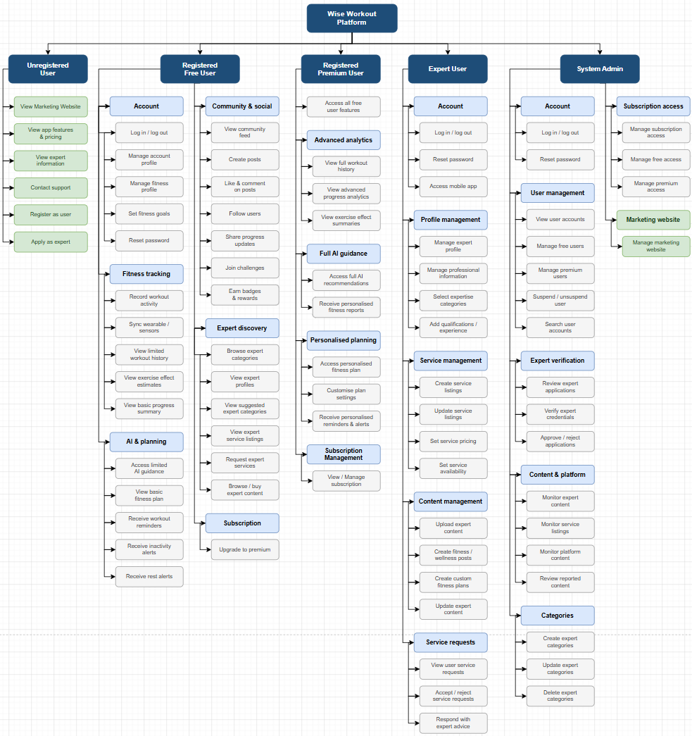

Use Case Diagram and Description

Preliminary User Stories
These user stories describe the main functions of Wise Workout from the perspective of each user type. They help identify what users need from the system and support the preparation of the preliminary use case diagram and use case descriptions.
These user stories are preliminary because they are based on the current project requirements and proposed product features. They may be refined further during the System Requirement Specification and Technical Design stages.
The user stories are grouped according to the main user categories of the system: unregistered users, registered free users, registered premium users, expert users, and system administrators.

(Preliminary User Stories) – Unregistered User
User Story ID | User Type | User Story | Related Functional Requirement
US01 | Unregistered User | As an unregistered user, I want to view the Wise Workout marketing website so that I can understand the platform before creating an account. | Marketing Website
US02 | Unregistered User | As an unregistered user, I want to view app features, subscription highlights, and pricing so that I can understand the difference between free and premium access. | FR11, Marketing Website
US03 | Unregistered User | As an unregistered user, I want to view expert information so that I can understand what types of professional support are available through the platform. | FR9, Marketing Website
US04 | Unregistered User | As an unregistered user, I want to contact support so that I can ask questions about the platform before creating an account. | Marketing Website, FR12
US05 | Unregistered User | As an unregistered user, I want to create an account so that I can become a registered user and access the mobile application. | FR1
US06 | Unregistered User | As an unregistered user, I want to apply as an expert so that I can offer professional fitness or wellness services through the platform after approval. | FR1, FR8, FR12

(Preliminary User Stories) – Registered Free User
User Story ID | User Type | User Story | Related Functional Requirement
US07 | Registered Free User | As a registered free user, I want to log in securely so that I can access my account and use the basic features of the platform. | FR1
US08 | Registered Free User | As a registered free user, I want to log out of my account so that I can securely end my session after using the platform. | FR1
US09 | Registered Free User | As a registered free user, I want to reset my password so that I can regain access if I forget my login details. | FR1
US10 | Registered Free User | As a registered free user, I want to access the prototype mobile application after logging in so that I can install or use the application during the project prototype. | FR1, Marketing Website
US11 | Registered Free User | As a registered free user, I want to create and update my fitness profile so that the system can understand my goals, preferences, and fitness needs. | FR2
US12 | Registered Free User | As a registered free user, I want to record and manage workout activities so that I can keep my exercise history accurate. | FR3
US13 | Registered Free User | As a registered free user, I want to manually enter workout details so that I can record activities that are not automatically detected. | FR3, FR4
US14 | Registered Free User | As a registered free user, I want to synchronise exercise data from smartphone sensors or supported wearable devices so that my fitness records are more complete. | FR4
US15 | Registered Free User | As a registered free user, I want to view limited workout history and basic progress summaries so that I can understand my recent activity and consistency. | FR5
US16 | Registered Free User | As a registered free user, I want to view basic exercise effect estimates so that I can understand the results of my workout activities. | FR5
US17 | Registered Free User | As a registered free user, I want to view simple charts or reports so that my fitness progress is easier to understand. | FR5
US18 | Registered Free User | As a registered free user, I want to receive limited AI-assisted summaries and basic workout recommendations so that I can get simple guidance from my activity data. | FR6
US19 | Registered Free User | As a registered free user, I want to view simple fitness plan options so that I can follow a more structured workout routine. | FR7
US20 | Registered Free User | As a registered free user, I want to receive workout reminders so that I can stay consistent with my planned exercise activities. | FR7
US21 | Registered Free User | As a registered free user, I want to receive inactivity alerts so that I am reminded when I have not met my scheduled exercise goals. | FR7
US22 | Registered Free User | As a registered free user, I want to receive rest alerts when I may be exercising too much so that I can avoid overtraining. | FR7
US23 | Registered Free User | As a registered free user, I want to view community posts so that I can stay connected with other fitness users. | FR10
US24 | Registered Free User | As a registered free user, I want to create posts, like posts, and comment on posts so that I can participate in the Wise Workout community. | FR10
US25 | Registered Free User | As a registered free user, I want to follow other users so that I can keep up with their shared fitness progress. | FR10
US26 | Registered Free User | As a registered free user, I want to join simple fitness challenges and earn badges so that I can stay motivated. | FR10
US27 | Registered Free User | As a registered free user, I want to share selected achievements or challenge results so that I can show my progress while controlling what information is shared. | FR10
US28 | Registered Free User | As a registered free user, I want to browse expert categories, profiles, and service listings so that I can find professional support when needed. | FR9
US29 | Registered Free User | As a registered free user, I want to view suggested expert categories so that I can identify what type of expert support may suit my fitness goals. | FR6, FR9
US30 | Registered Free User | As a registered free user, I want to request expert services as a paid add-on so that I can receive professional support when needed. | FR9, FR11
US31 | Registered Free User | As a registered free user, I want to browse and purchase expert-created content so that I can access professional fitness guidance when needed. | FR8, FR9, FR11
US32 | Registered Free User | As a registered free user, I want to view upgrade options so that I can decide whether to subscribe to premium features. | FR11

(Preliminary User Stories) – Registered Premium User
User Story ID | User Type | User Story | Related Functional Requirement
US33 | Registered Premium User | As a registered premium user, I want to access all registered free user features so that I can use the full platform experience. | FR11
US34 | Registered Premium User | As a registered premium user, I want to view full workout history so that I can review my long-term activity records. | FR5, FR11
US35 | Registered Premium User | As a registered premium user, I want to access advanced progress analytics so that I can understand my fitness trends in more detail. | FR5, FR11
US36 | Registered Premium User | As a registered premium user, I want to view detailed short-term and long-term exercise effect summaries so that I can understand how my workouts affect my progress over time. | FR5, FR11
US37 | Registered Premium User | As a registered premium user, I want to receive full AI-assisted recommendations and personalised fitness reports so that I can get more relevant guidance. | FR6, FR11
US38 | Registered Premium User | As a registered premium user, I want to receive context-aware suggestions based on my profile, activity history, and goals so that the guidance matches my needs. | FR6, FR11
US39 | Registered Premium User | As a registered premium user, I want to access personalised fitness plans so that my workout routine is better aligned with my goals. | FR7, FR11
US40 | Registered Premium User | As a registered premium user, I want to customise plan duration, workout frequency, and target goals so that the fitness plan fits my schedule and needs. | FR7, FR11
US41 | Registered Premium User | As a registered premium user, I want to receive personalised workout reminders, inactivity alerts, and rest alerts so that I can maintain a balanced routine. | FR7, FR11
US42 | Registered Premium User | As a registered premium user, I want to view or manage my subscription status so that I can understand and control my paid access. | FR11

(Preliminary User Stories) – Expert User
User Story ID | User Type | User Story | Related Functional Requirement
US43 | Expert User | As an expert user, I want to register or apply as an expert so that I can offer professional fitness or wellness services through the platform. | FR1, FR8, FR12
US44 | Expert User | As an expert user, I want to log in securely so that I can access my expert account and manage my expert functions. | FR1
US45 | Expert User | As an expert user, I want to log out of my expert account so that I can securely end my session. | FR1
US46 | Expert User | As an expert user, I want to reset my password so that I can regain access if I forget my login details. | FR1
US47 | Expert User | As an expert user, I want to create and manage my expert profile so that users can understand my background, specialisation, and services. | FR8
US48 | Expert User | As an expert user, I want to manage my professional information and expertise categories so that my profile accurately represents my services. | FR8
US49 | Expert User | As an expert user, I want to create and manage service listings so that users can request the services I offer. | FR8
US50 | Expert User | As an expert user, I want to upload or manage expert-related content so that I can provide useful fitness or wellness information to users. | FR8
US51 | Expert User | As an expert user, I want to view user service requests so that I can understand what support users are asking for. | FR8, FR9
US52 | Expert User | As an expert user, I want to accept or reject service requests so that I can manage the services I provide through the platform. | FR8, FR9
US53 | Expert User | As an expert user, I want to respond with expert advice so that I can provide coaching advice, workout plans, nutrition support, or recovery guidance to users. | FR8, FR9
US54 | Expert User | As an expert user, I want my profile to be verified by an admin so that users can trust the professional services offered on the platform. | FR8, FR12

(Preliminary User Stories) – System Administrator
User Story ID | User Type | User Story | Related Functional Requirement
US55 | System Admin | As a system admin, I want to log in securely so that I can access administrative functions. | FR1, FR12
US56 | System Admin | As a system admin, I want to log out securely so that I can end my administrative session. | FR1, FR12
US57 | System Admin | As a system admin, I want to reset my password so that I can regain access to the admin system if needed. | FR1, FR12
US58 | System Admin | As a system admin, I want to manage user accounts, roles, and access levels so that users can only access features suitable for their role and subscription tier. | FR1, FR11, FR12
US59 | System Admin | As a system admin, I want to review, approve, or reject expert applications so that only suitable experts can provide services on the platform. | FR8, FR12
US60 | System Admin | As a system admin, I want to manage expert categories so that expert services are organised clearly for users. | FR12
US61 | System Admin | As a system admin, I want to monitor expert content and service listings so that inappropriate or low-quality content can be handled. | FR12
US62 | System Admin | As a system admin, I want to manage reports and platform activity so that the system remains reliable, organised, and trustworthy. | FR12
US63 | System Admin | As a system admin, I want to monitor subscription-tier access so that premium features are only available to eligible users. | FR11, FR12
US64 | System Admin | As a system admin, I want to manage subscription access so that free and premium access levels can be controlled correctly. | FR11, FR12
US65 | System Admin | As a system admin, I want to manage the marketing website so that platform information, feature highlights, subscription details, and expert service information remain accurate. | Marketing Website, FR12
US66 | System Admin | As a system admin, I want to maintain platform quality and reliability so that users and experts can use the system safely and consistently. | FR12

The user stories above will be used to identify the main use cases for the Wise Workout system. Similar user stories may be grouped together in the preliminary use case diagram to keep the diagram clear and readable. For example, account access, workout recording, data synchronisation, progress analytics, AI guidance, fitness planning, expert services, social motivation, subscription access, and administrative management will be represented as major use case areas.

Preliminary Use Case Diagrams

(Preliminary Use Case Diagrams) – Unregistered User
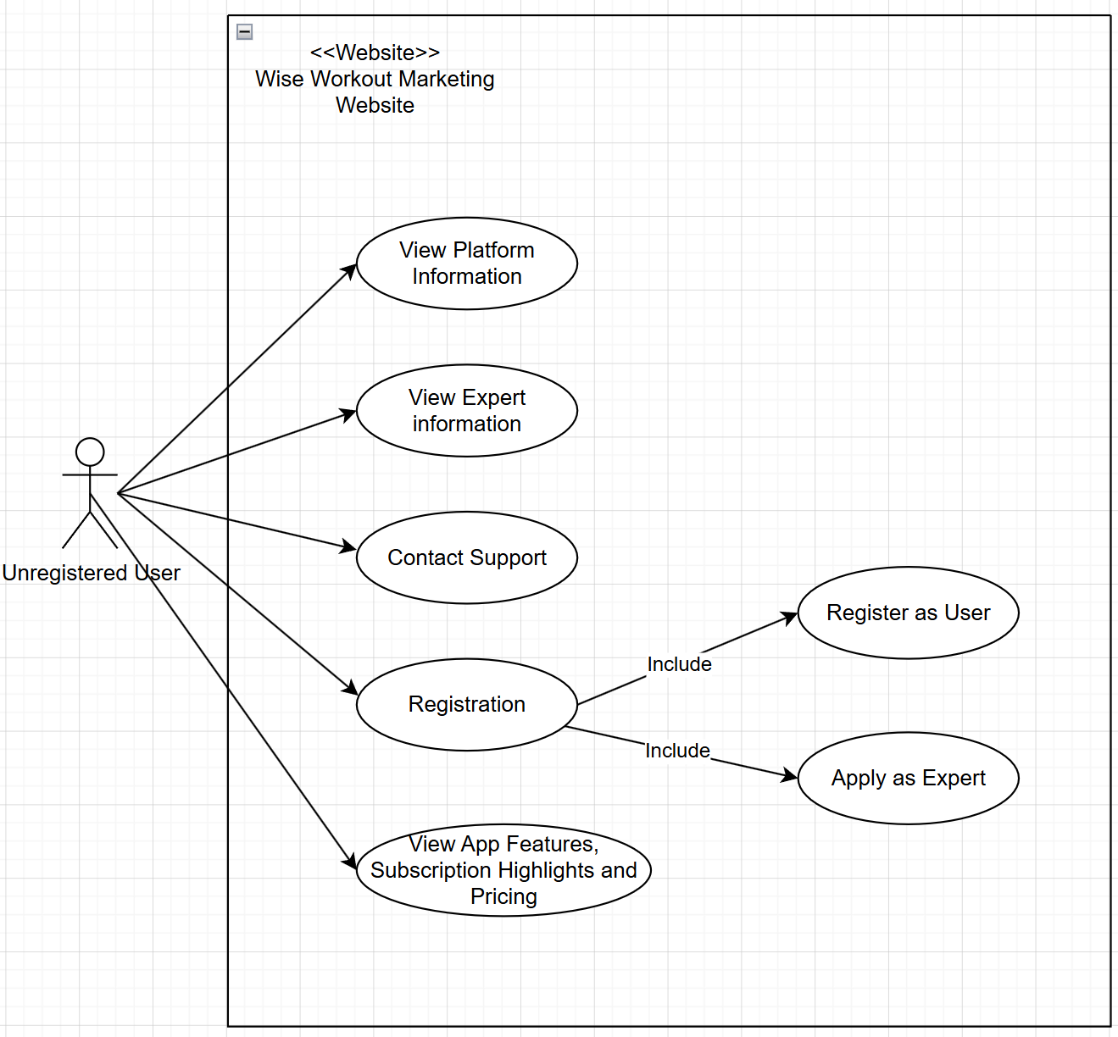

(Preliminary Use Case Diagrams) – Downloading App
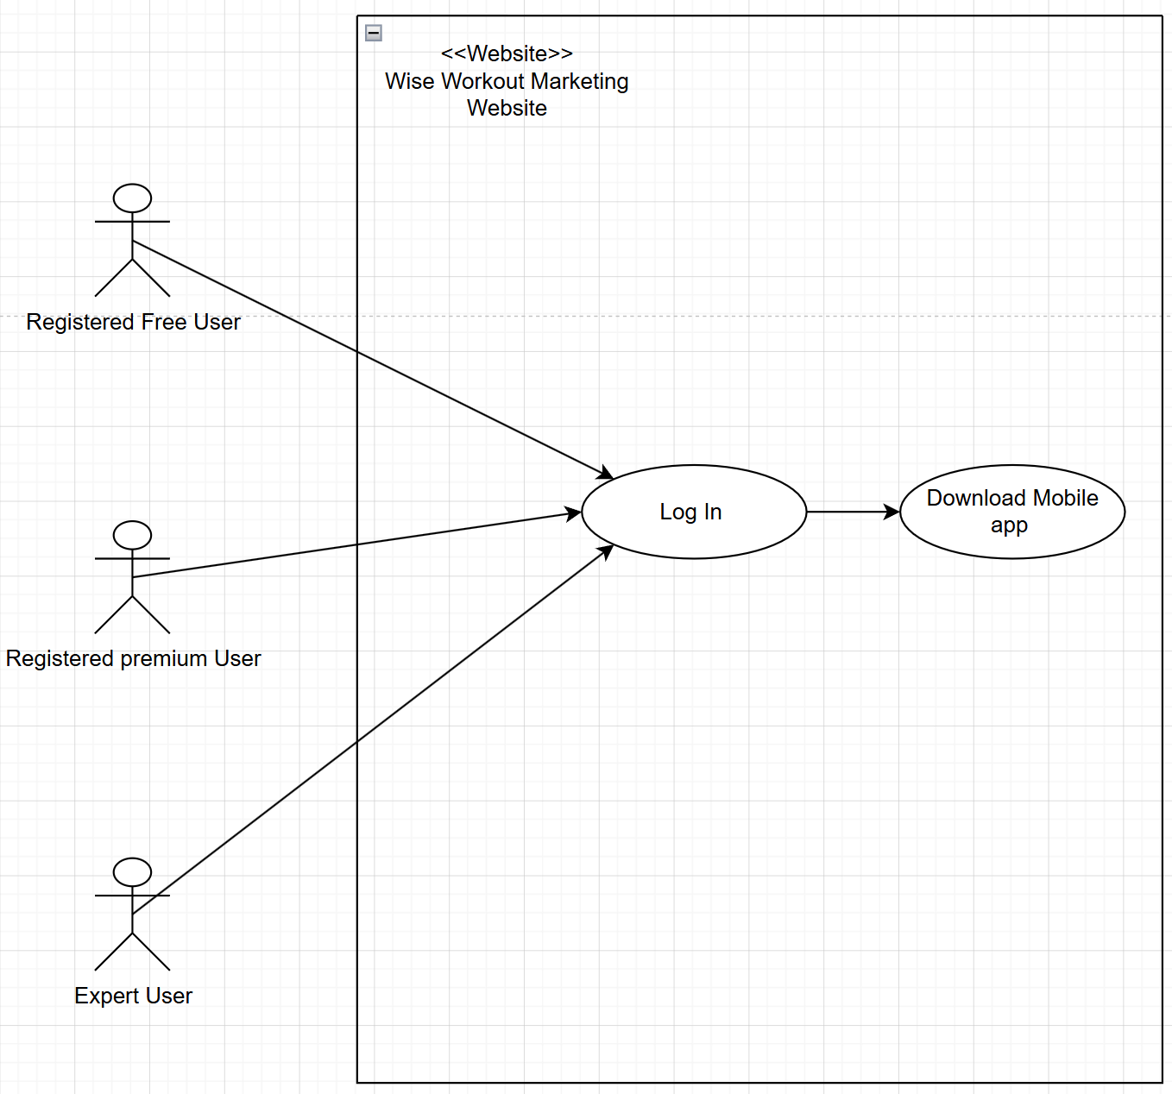

(Preliminary Use Case Diagrams) – Registered Free User
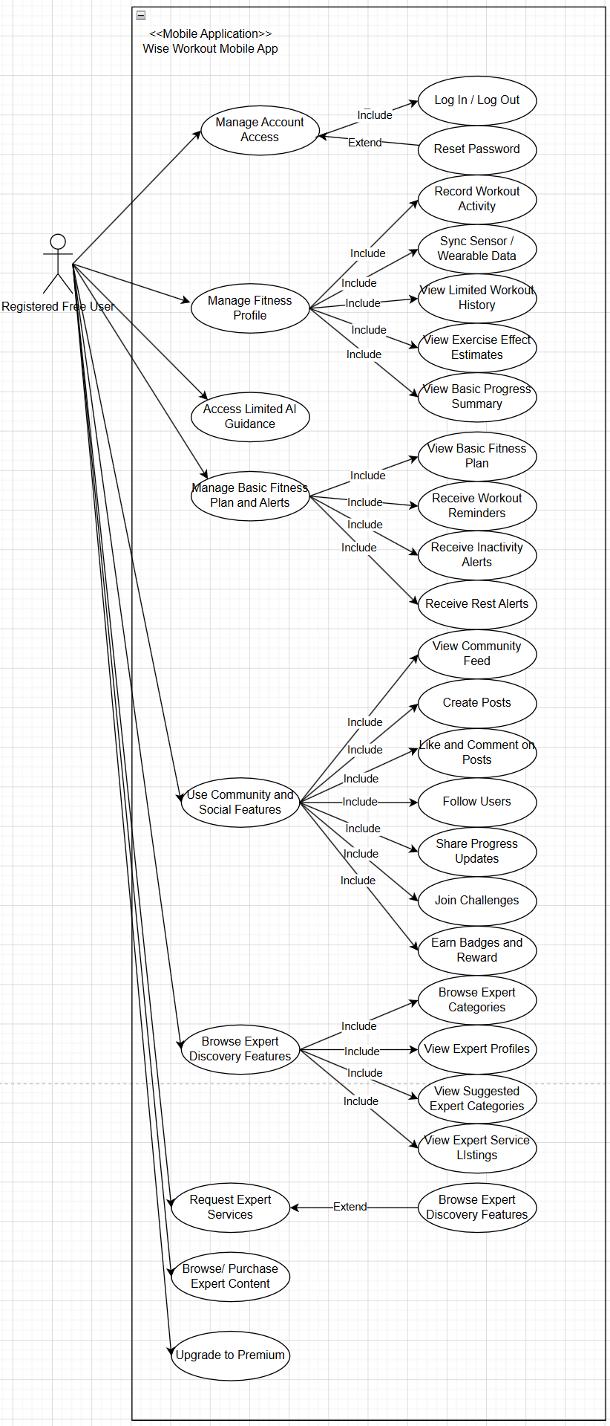

(Preliminary Use Case Diagrams) – Registered Premium User
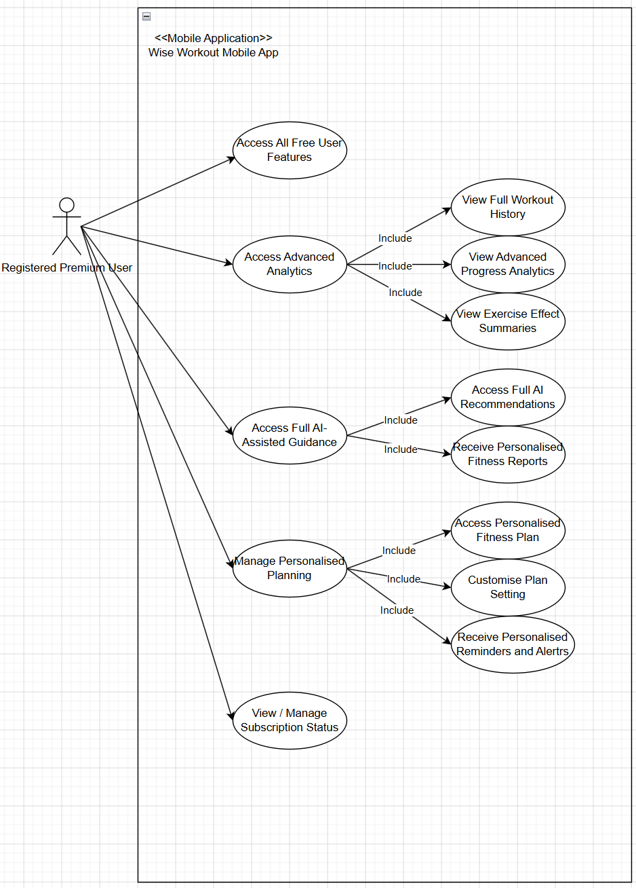

(Preliminary Use Case Diagrams) – Expert User
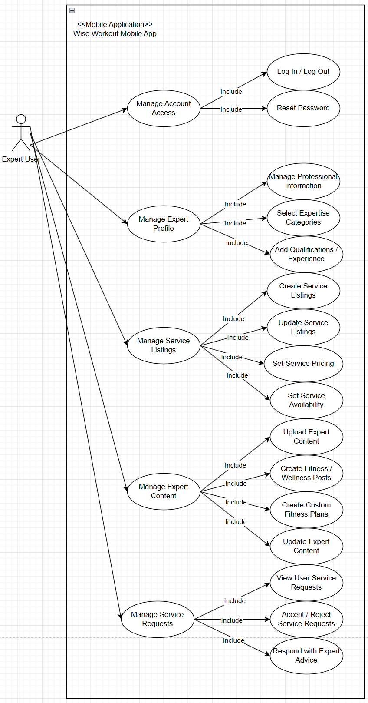

(Preliminary Use Case Diagrams) – System Admin
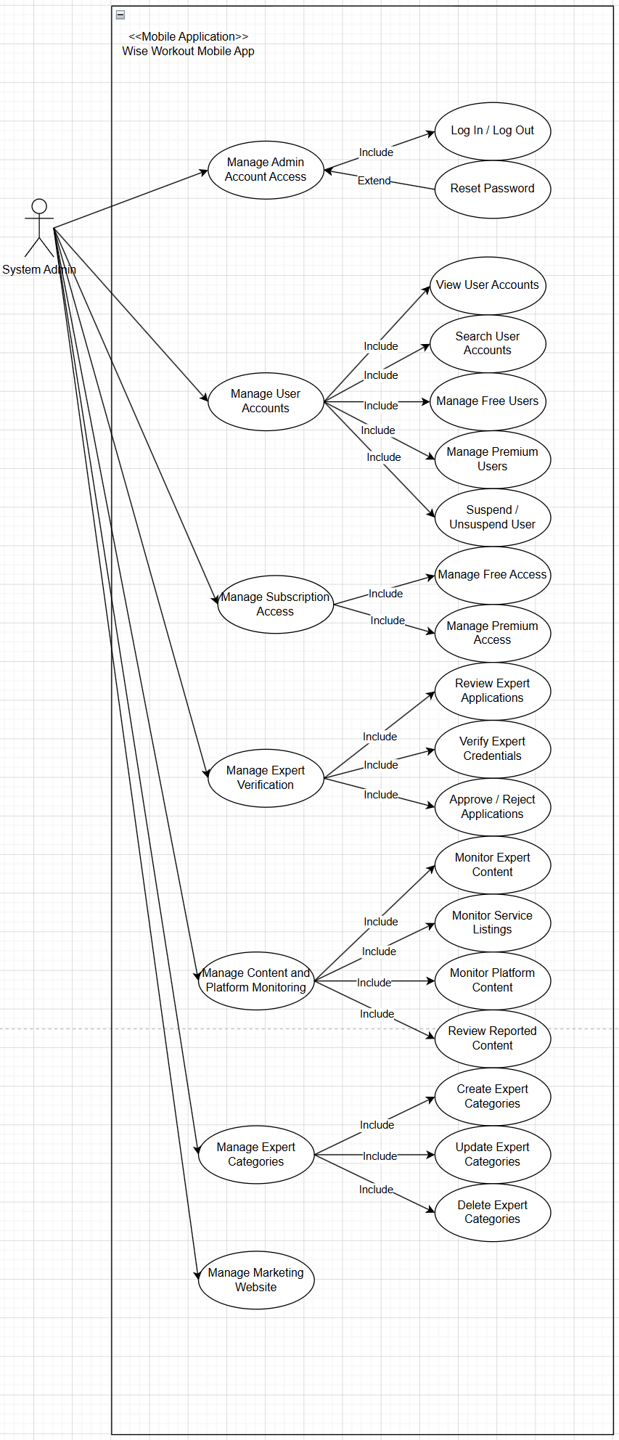

Preliminary Use Case Descriptions
User Story ID | #US05
Name | Create account
Description | This use case describes how an unregistered user creates a new Wise Workout account through the marketing website in order to gain access to the mobile application.
Trigger | An unregistered user clicks the 'Sign Up' or 'Create Account' button on the marketing website.
Actor(s) | Unregistered User, System
Pre-condition | The user has not previously registered. The marketing website is accessible.
Normal Flow | 1. The user navigates to the Wise Workout marketing website.  2. The user clicks 'Create Account'.  3. The system displays the registration form requesting name, email address, and password.  4. The user fills in all required fields and submits the form.  5. The system validates the input and checks that the email address is not already registered.  6. The system creates a new registered free user account.  7. The system sends a confirmation email to the user.  8. The user is redirected to the login page with a success message.
Alternative Flow | 4a. The user leaves a required field blank — the system displays an inline validation error and does not submit the form.  5a. The email address is already registered — the system displays an error message and prompts the user to log in or reset their password.

User Story ID | #US07
Name | Login
Description | This use case describes how a registered user logs in to their Wise Workout account through the marketing website to gain access to the mobile application.
Trigger | A registered user clicks the 'Login' button on the marketing website.
Actor(s) | Registered User (Free / Premium / Expert / Admin), System
Pre-condition | The user has a valid registered account. The marketing website is accessible.
Normal Flow | 1. The user navigates to the Wise Workout marketing website.  2. The user clicks 'Login'.  3. The system displays the login form requesting email address and password.  4. The user enters their credentials and submits the form.  5. The system validates the credentials against the database.  6. The system identifies the user's role and subscription tier.  7. The system grants access and redirects the user to their account dashboard.  8. The user may access the prototype mobile application from the dashboard.
Alternative Flow | 5a. The credentials are incorrect — the system displays an error message and allows the user to retry.  5b. The user has forgotten their password — the user clicks 'Forgot Password' and the system initiates a password reset flow.

User Story ID | #US11
Name | Manage fitness profile
Description | This use case describes how a registered user creates or updates their fitness profile, which is used by the system to provide personalised recommendations, fitness plans, and AI-assisted guidance.
Trigger | The user navigates to the 'Fitness Profile' section of the mobile application.
Actor(s) | Registered Free User, Registered Premium User, System
Pre-condition | The user is logged in. The mobile application is accessible.
Normal Flow | 1. The user opens the Wise Workout mobile application and navigates to the Fitness Profile section.  2. The system displays the current profile information, or a blank form if the profile has not been created yet.  3. The user enters or updates their fitness goals, preferred workout categories, fitness level, and personal fitness information.  4. The user saves the profile.  5. The system validates the input and saves the updated profile to the database.  6. The system confirms that the profile has been saved successfully.  7. The system uses the updated profile to personalise AI-assisted guidance, fitness plan suggestions, and expert category recommendations.
Alternative Flow | 3a. The user attempts to save the profile with required fields missing — the system displays a validation error and does not save.  7a. For free users, personalisation is limited to basic recommendations only.

User Story ID | #US12
Name | Record workout activity
Description | This use case describes how a registered user manually records a workout activity in the Wise Workout mobile application.
Trigger | The user taps 'Log Workout' or 'Add Activity' in the mobile application.
Actor(s) | Registered Free User, Registered Premium User, System
Pre-condition | The user is logged in. The mobile application is accessible. The user has completed or is recording a workout.
Normal Flow | 1. The user opens the mobile application and taps 'Log Workout'.  2. The system displays the workout entry form.  3. The user selects the workout type or category (e.g. running, gym, cycling).  4. The user enters workout details such as duration, distance, calories, heart rate, and any notes.  5. The user confirms and saves the workout record.  6. The system validates the input and saves the workout record linked to the user's profile.  7. The system updates the user's workout history and progress dashboard.  8. The system confirms the workout has been recorded successfully.
Alternative Flow | 3a. The desired workout type is not listed — the user selects a general category and adds a note.  4a. The user does not enter all optional fields — the system saves with only the provided data.

User Story ID | #US14
Name | Sync wearable / sensors
Description | This use case describes how a registered user connects and synchronises fitness data from a smartphone sensor or supported wearable device to the Wise Workout mobile application.
Trigger | The user navigates to 'Device and Sync Settings' and initiates a sync or connection.
Actor(s) | Registered Free User, Registered Premium User, System, Wearable Device / Health Platform
Pre-condition | The user is logged in. The mobile application is installed. A supported wearable device or third-party health platform is available.
Normal Flow | 1. The user navigates to the Device and Sync Settings section of the application.  2. The system displays available connection options including Bluetooth devices, smartphone sensors, and third-party platforms.  3. The user selects the desired device or platform and initiates the connection.  4. The system requests the necessary permissions (e.g. Bluetooth, health data access).  5. The user grants the required permissions.  6. The system establishes a connection with the device or platform.  7. The system retrieves available fitness data such as steps, heart rate, calories burned, and workout duration.  8. The system syncs the data to the user's profile and updates the progress dashboard.
Alternative Flow | 4a. The user denies permissions — the system informs the user that syncing requires the requested permissions and returns to settings.  6a. The connection fails — the system displays an error message and allows the user to retry.

User Story ID | #US15
Name | View basic progress
Description | This use case describes how a registered free user views their basic workout history and progress summary through the dashboard in the Wise Workout mobile application.
Trigger | The user navigates to the 'Dashboard' or 'Progress' section of the mobile application.
Actor(s) | Registered Free User, System
Pre-condition | The user is logged in. The user has at least one recorded workout activity.
Normal Flow | 1. The user opens the mobile application and navigates to the Dashboard.  2. The system retrieves the user's recent workout history, basic activity totals, and simple progress summaries.  3. The system displays the dashboard showing recent workouts, total calories burned, workout frequency, and basic activity trends.  4. The user reviews their progress information.  5. The user may tap on a specific workout to view its details.  6. The system displays the selected workout record with its recorded metrics.
Alternative Flow | 2a. The user has no recorded workouts — the system displays an empty state with a prompt to log the first workout.  4a. The user attempts to access advanced analytics — the system displays a prompt to upgrade to premium.

User Story ID | #US18
Name | Get AI suggestions
Description | This use case describes how a registered user receives AI-assisted guidance based on their fitness profile, workout history, and activity data.
Trigger | The user navigates to the 'Guidance' or 'AI Suggestions' section, or the system proactively generates a summary after a workout is logged.
Actor(s) | Registered Free User, Registered Premium User, System (AI component)
Pre-condition | The user is logged in. The user has a completed fitness profile and at least one recorded workout.
Normal Flow | 1. The user navigates to the AI Suggestions section, or the system generates a suggestion after a workout is logged.  2. The system retrieves the user's fitness profile, workout history, and activity patterns.  3. The system sends the relevant data to the AI component.  4. The AI component generates a progress summary and workout-related suggestions based on the user's goals and activity data.  5. The system displays the AI-generated suggestions to the user.  6. The user reviews the suggestions and may choose to act on them (e.g. follow a recommended workout or update their plan).
Alternative Flow | 4a. For free users, the suggestions are basic summaries only — advanced recommendations require a premium subscription.  4b. Insufficient data is available — the system displays a message informing the user that more workout records are needed for better suggestions.

User Story ID | #US19
Name | View fitness plan
Description | This use case describes how a registered user views a suggested fitness plan generated by the system based on their fitness profile and goals.
Trigger | The user navigates to the 'Fitness Plan' section of the mobile application.
Actor(s) | Registered Free User, Registered Premium User, System
Pre-condition | The user is logged in. The user has a completed fitness profile with at least one fitness goal set.
Normal Flow | 1. The user navigates to the Fitness Plan section of the mobile application.  2. The system retrieves the user's fitness profile, goals, preferred workout categories, and activity history.  3. The system generates or displays a suggested fitness plan based on rule-based logic and AI-assisted recommendations.  4. The system displays the plan showing scheduled workout types, frequency, and duration.  5. The user reviews the suggested plan.  6. For premium users, the user may customise plan settings such as plan duration, workout frequency, and target goals.  7. The user confirms the plan and the system saves it to their profile.
Alternative Flow | 2a. The user has not completed their fitness profile — the system prompts the user to complete their profile before a plan can be generated.  6a. For free users, customisation options are limited — the system prompts the user to upgrade for full personalisation.

User Story ID | #US20
Name | Receive workout reminders
Description | This use case describes how the system sends workout reminders to a registered user when they have not met their scheduled exercise goals.
Trigger | The system detects that a user has not completed a scheduled workout activity within the expected timeframe.
Actor(s) | Registered Free User, Registered Premium User, System
Pre-condition | The user is logged in. The user has an active fitness plan with scheduled workouts. Push notifications are enabled on the user's device.
Normal Flow | 1. The system monitors the user's workout activity against their scheduled fitness plan.  2. The system detects that the user has not completed a planned workout within the scheduled timeframe.  3. The system generates a workout reminder notification.  4. The system sends the push notification to the user's device.  5. The user receives the notification and taps on it to open the mobile application.  6. The system displays the relevant workout or fitness plan for the user to act on.
Alternative Flow | 4a. The user has disabled push notifications — the system records the reminder internally but cannot deliver the notification. The reminder may be displayed as an in-app message when the user next opens the application.  5a. The user dismisses the notification without opening the app — no further action is taken by the system for that reminder.

User Story ID | #US28
Name | Browse expert profiles
Description | This use case describes how a registered user searches and browses verified expert profiles on the Wise Workout platform to find professional fitness or wellness support.
Trigger | The user navigates to the 'Experts' or 'Find an Expert' section of the mobile application.
Actor(s) | Registered Free User, Registered Premium User, System
Pre-condition | The user is logged in. At least one verified expert profile exists on the platform.
Normal Flow | 1. The user navigates to the Experts section of the mobile application.  2. The system displays a list of verified expert profiles.  3. The user may search for experts by name or filter by expertise category (e.g. running coach, nutritionist, recovery specialist).  4. The system returns matching expert profiles based on the search or filter criteria.  5. The user selects an expert profile to view.  6. The system displays the expert's profile including their background, specialisation, service listings, and reviews.  7. The user may choose to request a service or purchase expert-created content from the profile.
Alternative Flow | 4a. No experts match the search or filter criteria — the system displays an empty result with a suggestion to broaden the search.  7a. The user is not ready to request a service — the user exits the profile without taking further action.

User Story ID | #US30
Name | Request expert service
Description | This use case describes how a registered user submits a paid service request to a verified expert on the Wise Workout platform.
Trigger | The user taps 'Request Service' on an expert's profile or service listing.
Actor(s) | Registered Free User, Registered Premium User, Expert User, System
Pre-condition | The user is logged in. The selected expert is verified and has at least one active service listing. The user has viewed the expert's profile.
Normal Flow | 1. The user views an expert's profile and selects a service listing.  2. The system displays the service details including description, format, and price.  3. The user taps 'Request Service'.  4. The system presents a service request form for the user to provide details about their needs or goals.  5. The user completes the form and confirms the request.  6. The system records the service request and notifies the expert.  7. The expert reviews the request and accepts or rejects it.  8. The system notifies the user of the expert's response.  9. If accepted, the user proceeds with payment and the service is initiated.
Alternative Flow | 7a. The expert rejects the request — the system notifies the user with the expert's reason, and the user may select a different expert.  9a. Payment fails — the system displays a payment error and prompts the user to retry or use a different payment method.

User Story ID | #US31
Name | Browse and buy expert content
Description | This use case describes how a registered user browses and purchases expert-created fitness or wellness content available on the Wise Workout platform.
Trigger | The user navigates to an expert's profile and views their published content listings.
Actor(s) | Registered Free User, Registered Premium User, Expert User, System
Pre-condition | The user is logged in. The selected expert has published at least one content listing. The expert is verified.
Normal Flow | 1. The user navigates to an expert's profile.  2. The system displays the expert's published content listings such as workout plans, nutrition guides, or training articles.  3. The user selects a content item to view its details and price.  4. The system displays the content description, format, and purchase price.  5. The user taps 'Purchase Content'.  6. The system processes the payment.  7. The system grants the user access to the purchased content.  8. The user may access the content at any time from their purchases section.
Alternative Flow | 3a. The content listing is not available or has been removed — the system displays a message informing the user.  6a. Payment fails — the system displays an error and prompts the user to retry or use a different payment method.

User Story ID | #US47
Name | Manage expert profile
Description | This use case describes how a verified expert user creates and manages their professional profile on the Wise Workout platform.
Trigger | The expert navigates to the 'My Profile' or 'Expert Profile' section of the mobile application.
Actor(s) | Expert User, System
Pre-condition | The expert has been approved and verified by a system administrator. The expert is logged in.
Normal Flow | 1. The expert navigates to the Expert Profile section of the mobile application.  2. The system displays the current profile information or a blank form for a new profile.  3. The expert enters or updates their professional information including name, bio, credentials, and areas of expertise.  4. The expert selects their expertise categories from the available list.  5. The expert uploads a profile image and any supporting credentials where applicable.  6. The expert saves the profile.  7. The system validates and saves the updated profile.  8. The updated profile is visible to registered users browsing the Experts section.
Alternative Flow | 3a. Required fields are missing — the system displays a validation error and does not save the profile.  5a. The uploaded file format is not supported — the system displays an error and prompts the expert to upload a supported file type.

User Story ID | #US59
Name | Approve expert application
Description | This use case describes how a system administrator reviews and approves or rejects an expert application submitted through the Wise Workout platform.
Trigger | A new expert application is submitted and appears in the admin management dashboard.
Actor(s) | System Administrator, System
Pre-condition | The administrator is logged in with admin privileges. At least one expert application is pending review.
Normal Flow | 1. The administrator navigates to the Expert Applications section of the admin dashboard.  2. The system displays a list of pending expert applications.  3. The administrator selects an application to review.  4. The system displays the applicant's submitted information including professional background, credentials, and proposed expertise categories.  5. The administrator reviews the application and determines whether it meets the platform's verification requirements.  6. The administrator approves the application.  7. The system updates the applicant's account to the expert user role.  8. The system notifies the applicant that their expert application has been approved.  9. The expert's profile becomes available for setup and publishing on the platform.
Alternative Flow | 6a. The administrator rejects the application — the system prompts the administrator to provide a reason, updates the application status to rejected, and notifies the applicant.  6b. The administrator requires more information — the administrator may flag the application for follow-up before making a decision.
User Story ID | #US58
Name | Manage user accounts
Description | This use case describes how a system administrator manages registered user accounts on the Wise Workout platform, including viewing account details, updating roles, and handling account issues.
Trigger | The administrator navigates to the User Management section of the admin dashboard.
Actor(s) | System Administrator, System
Pre-condition | The administrator is logged in with admin privileges.
Normal Flow | 1. The administrator navigates to the User Management section of the admin dashboard.  2. The system displays a list of registered user accounts with their role, subscription tier, and account status.  3. The administrator searches or filters the list to locate a specific user account.  4. The system returns the matching user account.  5. The administrator selects the account to view its details.  6. The system displays the full account details including role, subscription status, and activity summary.  7. The administrator makes the required changes, such as updating the user's role, adjusting subscription access, or disabling the account.  8. The system saves the changes and updates the user's access accordingly.
Alternative Flow | 3a. No matching account is found — the system displays an empty result and the administrator may broaden the search.  7a. The administrator disables an account — the system prevents the user from logging in and displays an appropriate message when the user attempts to access the platform.

Project Schedule

This section presents the proposed project schedule for the development of the Wise Workout system. The schedule is prepared based on the official project plan deadlines and the Agile iterative development approach selected for the project. The purpose of the schedule is to guide the team in completing the project progressively, meeting key deliverables, and preparing the final product within the required timeline.
The project schedule is divided into four parts: project deadlines and milestones, project timeline, roles and responsibilities, and Gantt chart. The project deadlines and milestones section identifies the main submission dates and review checkpoints. The project timeline explains how the team will organise the work around those deadlines. The roles and responsibilities section explains how work will be divided among team members, while the Gantt chart provides a visual overview of the schedule.

Project Deadlines and Milestones
This section outlines the key project deadlines and milestones for the Wise Workout project. These deadlines are based on the project plan and are used to guide the team’s progress throughout Term 1 and Term 2. Each milestone represents an important project checkpoint, deliverable, or demonstration requirement. The project begins on 4 April 2026, with major deliverables scheduled from April to August 2026.

No. | Milestone / Checkpoint | Deadline | Key Deliverables
1 | Team Formation and Project Website Setup | 11 April 2026 | - Team members confirmed  - Team leader identified  - Project website created  - First reflective diary completed
2 | Project Requirement Documentation Completion | 2 May 2026  Submission by 9 May 2026 | - Project Requirement Documentation:  - Research summary  - Functional hierarchy diagram  - Use case diagrams  - Project schedule  - Development tools and methodology
3 | System Requirement Specification Completion | 14 May 2026 | - Refined project functionalities:  - System services  - Functional requirements  - Non-functional requirements  - Security requirements  - Interfaces and constraints
4 | Technical Design Manual and Functional Prototype | 21 May 2026 | - Technical Design Manual:  - System design  - Architectural design  - Database design  - Wireframes  - Initial functional prototype
5 | Basic Prototype and Project Progress Report | 10 June 2026  Submission by 13 June 2026 | - Basic system prototype:  - Project Progress Report  - Preliminary technical documents  - Preliminary user manual  - Peer assessment form
6 | End of Term 1 Review | 20 June 2026 | - Prototype demonstration:  - Present basic functionalities  - Term 2 development direction
7 | Functional Modules and Module Testing | 11 July 2026 | - Individual functional modules :  - Centralised database prepared  - Module test plan completed  - Module-level testing carried out
8 | Integrated Module Functionalities and Integration Testing | 1 August 2026 | - Integrated module functionalities completed  - Functional modules tested in integrated environment  - Technical documentation updated  - Draft user manual prepared  - Integration test summary completed
9 | Final Product Demonstration to Supervisor | 13 August 2026  Submission by 15 August 2026 | - Final fully functional product demonstrated to supervisor  - Final technical documentation completed  - Final user manual completed  - Project video created  - Presentation slides prepared
10 | Final Project Presentation and Demonstration | 22 August 2026 | - Final product demonstrated to supervisor and assessor  - Final project documentation submitted  - User manual submitted  - Project video submitted  - Peer assessment form submitted  - Source code submitted

Project Timeline
The Wise Workout project will follow an Agile iterative development approach. The project will be divided into several sprints and development phases, with each phase focusing on a specific set of tasks and deliverables. This allows the team to develop the system progressively, review completed work regularly and make improvements based on supervisor feedback.
The project timeline follows the official Final Year Project schedule, which begins in April 2026 and ends in August 2026. Term 1 focuses mainly on research, requirements, design, early prototype development, and progress review. Term 2 focuses on continued implementation, module testing, integration testing, final documentation, and final product demonstration.
The duration of each phase is not fixed. Instead, each phase is planned according to the official project schedule and the amount of work required for that milestone. Shorter phases, such as project setup and final presentation preparation, take around one week, while larger phases, such as research, requirement refinement, prototype development, module development, and integration testing, may take two to four weeks. This allows the team to allocate more time to complex development tasks while still meeting the required project deadlines.

Phase 1: Project Planning and Initial Setup

Timeline:
4 April 2026 to 11 April 2026

Description:
This phase focuses on starting the Final Year Project, forming the project team, identifying the team leader, and setting up the project website. The team will also begin preliminary research on the project topic and prepare for weekly reflective diary submissions.
During this phase, the team will confirm the general direction of Wise Workout as a mobile application that supports fitness tracking, profile-based services, AI-assisted guidance, data acquisition, and user-friendly access across mobile devices.

Expected Output:
Team formation, team leader confirmation, project website setup, first reflective diary, and preliminary project direction.

Phase 2: Research and Project Requirement Documentation

Timeline:
4 April 2026 to 2 May 2026

Description:
This phase focuses on researching the fitness application market and preparing the Project Requirement Documentation. The team will review existing workout monitoring applications, compare their features, study how they collect data, identify common protocols, examine business models, and analyse how similar systems provide recommendations, alerts, analytics, and cross-platform support.
The team will also define the target users, intended product features, algorithms or techniques considered, case studies, functional hierarchy diagram, use case diagrams, project schedule, development tools, and development methodology.

Expected Output:
Completed Project Requirement Documentation, including research summary, product comparison, research gap, user categories, functional hierarchy diagram, use case diagram, project schedule, development tools, and development methodologies.

Phase 3: System Requirement Specification

Timeline:
3 May 2026 to 24 May 2026

Description:
This phase focuses on refining the project requirements. The team will identify the system’s services, constraints, goals, functional requirements, non-functional requirements, security requirements, interfaces, and relevant algorithms or techniques.

For Wise Workout, this includes refining requirements for user accounts, fitness profiles, workout activity recording, wearable or sensor data acquisition, progress dashboards, AI-assisted guidance, fitness plans, reminders, social motivation features, expert services, subscription access, and administrative management.

Expected Output:
Completed System Requirement Specification with refined project functionalities and system requirements.

Phase 4: Analysis, Design, and Initial Functional Prototype

Timeline:
25 May 2026 to 7 June 2026

Description:
This phase focuses on preparing the system design and early implementation plan. The team will produce system designs, architectural designs, database design, wireframes, and other modelling or visualisation outputs. The team will also finalise the main system functionalities and begin work on the prototype.

For Wise Workout, this phase will include planning the mobile application structure, marketing website structure, backend architecture, database relationships, user flows, AI-assisted feature flow, fitness plan and reminder flows, social challenge flows, expert service workflows, and admin functions.

Expected Output:
Technical Design Manual, system architecture, database design, wireframes, and initial functional prototype.

Phase 5: Basic Prototype Development and Progress Report

Timeline:
8 June 2026 to 21 June 2026

Description:
This phase focuses on developing the system prototype with basic functionalities. The team will continue implementation based on the technical design and complete the main foundation features required for the Term 1 review.
The basic prototype should include early working functions such as user registration, login, user roles, fitness profile management, basic workout recording, and initial interface screens. The team will also prepare the Project Progress Report, preliminary technical documentation, preliminary user manual, and peer assessment form.

Expected Output:
Basic system prototype, Project Progress Report, preliminary technical documentation, preliminary user manual, and Term 1 prototype demonstration.

Phase 6: Continued Implementation and Module Testing

Timeline:
21 June 2026 to 11 July 2026

Description:
This phase focuses on continuing the development of individual system modules. Each module will be developed and tested at module level before full integration.
For Wise Workout, the functional modules may include mobile user functions, workout activity module, progress dashboard module, expert profile module, service request module, subscription access module, admin module, backend APIs, and centralised database. The team will also update technical documents if there are changes to the original design.

Expected Output:
Individual functional modules, centralised database, updated technical design documents, module test plan, and module testing results.

Phase 7: Integrated Development and Integration Testing

Timeline:
12 July 2026 to 1 August 2026

Description:
This phase focuses on integrating completed modules into a working system. The team will connect the mobile application, marketing website, backend APIs, database, AI-assisted guidance features, expert service workflows, subscription access control, and admin features.
The team will also test the system in an integrated environment to ensure that different modules work together correctly. Technical documentation and the user manual will be updated during this phase.

Expected Output:
Integrated module functionalities, integrated system testing, draft final progress report, draft user manual, and integration test summary.

Phase 8: Final Development and Supervisor Demonstration

Timeline:
2 August 2026 to 15 August 2026

Description:
This phase focuses on wrapping up the development of the Wise Workout system and preparing for the final product demonstration. The team will fix remaining bugs, refine the user interface, complete final documentation, prepare the project video, and prepare presentation slides.
The team will demonstrate the final fully functional product to the supervisor before the final project presentation.

Expected Output:
Final functional product, final technical documentation, final user manual, project video, presentation slides, and supervisor demonstration.

Phase 9: Final Project Presentation and Demonstration

Timeline:
16 August 2026 to 22 August 2026

Description:
This final phase focuses on presenting and demonstrating the completed Wise Workout product to the supervisor and assessor. The team will prepare the final deliverables, including the final project documentation, technical documentation, user manual, project video, peer assessment form, source code, and fully functional product.

Expected Output:
Final project presentation, final product demonstration, source code submission, and final project deliverables.

Roles and Responsibilities
This section describes the main responsibilities assigned to each team member. Although each member has a primary role, all members will also support testing, documentation, review, and integration where required.

Team Member | Main Role | Responsibilities
CHIA YUAN JUN | Project coordination, documentation, and system planning | Coordinate project direction, maintain the PRD structure, review section consistency, prepare the project schedule, support requirement analysis, assist with system planning, and help prepare final presentation materials.
DEVANANDI PRAVEEN | Mobile application development and UI support | Develop mobile application screens, implement user-facing functions, support fitness profile screens, workout activity recording, progress dashboard interfaces, expert discovery screens, and assist with UI testing.
FOONG JUN YAN | Backend, database, and API development | Design the database structure, develop backend APIs, manage user accounts, workout records, expert profiles, service requests, subscription access, and support system integration.
JEDIDIAH GOH CHOR SZER | Marketing website, expert features, and admin support | Develop marketing website pages, support expert profile and service request features, assist with admin management functions, and contribute to testing and documentation.

Development Tools

This section describes the tools and technologies proposed for developing the Wise Workout system. The tools are grouped according to the main parts of the system, including the mobile application, marketing website, backend system, database, AI-assisted features, authentication, design, documentation, and collaboration.

Mobile Application Development Tools

Tool / Technology | Purpose
Flutter | Used to develop the Wise Workout mobile application for both iOS and Android using a single codebase.
Dart | Used as the programming language for building the Flutter mobile app interface, logic, and data models.
Android Studio | Used to install Android SDK tools, run Android emulators, and test the Android version of the app.
Android SDK | Used to build and run the Android version of the mobile application.
Xcode | Used to build, run, and test the iOS version of the mobile application.
iOS Simulator / Android Emulator / Physical Devices | Used to test the mobile application on both iOS and Android environments.
Visual Studio Code | Used as the main code editor for mobile application development.
Flutter and Dart Extensions | Used in Visual Studio Code to support Flutter and Dart development.

Flutter and Dart are selected for the Wise Workout mobile application because the app needs to run on both iOS and Android. Flutter allows the team to develop the mobile application using a single codebase, reducing the need to build two completely separate native applications. Dart will be used as the programming language for implementing the application interface, logic, and data models.
Flutter is suitable for Wise Workout because the mobile application will include several user-facing screens such as workout activity recording, fitness profile management, progress dashboards, AI-assisted guidance, expert discovery, service requests, and subscription-based access. These features require a smooth and consistent mobile interface across both iOS and Android devices.
Android Studio, Android SDK, and an Android Emulator or physical Android device will be used to build, run, test, and prepare the Android prototype version of the application. For prototype distribution, the Android version may be provided as an APK file through the marketing website after user registration. Xcode and the iOS Simulator will be used to build, run, and test the iOS version during development where applicable. Physical devices may also be used to test the app more realistically across different screen sizes and operating systems.
Visual Studio Code, together with the Flutter and Dart extensions, will be used as the main coding environment because it provides a lightweight and convenient setup for Flutter development. This setup allows the team to develop and test the Wise Workout mobile application for both major mobile platforms while maintaining one shared codebase.

Marketing Website Development Tools

Tool / Technology | Purpose
Next.js | Used to develop the Wise Workout marketing website.
HTML | Used to structure the website pages.
CSS | Used to style the website layout, colours, and visual design.
JavaScript / TypeScript | Used to add interactivity and logic to the website.
Visual Studio Code | Used as the main code editor for website development.

Next.js is selected for the Wise Workout marketing website because the website will act as the main entry point for users before they access the mobile application. The marketing website will allow unregistered users to view general platform information, understand the key features, view subscription highlights, create an account, and log in. Registered users may access platform download or installation information for the mobile application, depending on the supported deployment method.
HTML, CSS, and JavaScript or TypeScript will be used to build the website structure, design the page layout, and add interactive functions. These tools are suitable for developing pages such as the landing page, feature information page, subscription page, registration page, login page, and mobile application access page.
Using Next.js for the website is appropriate because it allows the team to create reusable web components and maintain a clean website structure. This is useful for presenting Wise Workout’s features, expert service categories, and free versus premium access model clearly to users.

Backend, Database, and System Support Tools

Tool / Technology | Purpose
Node.js | Used to build the backend server for the system.
Express.js | Used to create backend APIs for users, workouts, experts, subscriptions, and admin functions.
MySQL / PostgreSQL | Used to store user accounts, fitness profiles, workout records, expert profiles, service requests, and subscription data.
OpenAI API / Gemini API | Used to support AI-assisted progress summaries, workout recommendations, personalised reports, and expert category suggestions.
Firebase Authentication / JWT | Used to support user registration, login, role-based access control, and subscription-tier access control.
Firebase Storage / Supabase Storage | Used to store uploaded files such as expert profile images, content images, and other media files where required.
Postman | Used to test backend API endpoints during development.

Node.js with Express.js is selected for backend development because it can be used to create REST APIs that connect the mobile application, marketing website, database, AI service, and admin functions. The backend will manage important system functions such as user accounts, fitness profiles, workout records, expert profiles, service requests, subscription access, and administrative management.
MySQL or PostgreSQL is suitable for the database because Wise Workout needs to store structured information. This includes user accounts, fitness profiles, workout activities, expert profiles, expert service listings, subscription tiers, and service requests. A relational database is appropriate because many of these records are linked together. For example, a user may have many workout records, an expert may have many service listings, and a service request may be linked to both a user and an expert.
OpenAI API or Gemini API may be used to support the AI-assisted features of Wise Workout. These tools can help generate progress summaries, workout-related recommendations, personalised reports, and expert category suggestions based on user fitness profiles, workout history, activity data, and goals.
Firebase Authentication or JWT may be used to manage secure registration, login, role-based access control, and subscription-tier access. This is important because Wise Workout has different user categories, including registered free users, registered premium users, expert users, and system administrators. Firebase Storage or Supabase Storage may also be used to store uploaded media files such as expert profile images, content images, and other platform-related files.
Postman will be used to test backend API endpoints during development. This helps ensure that functions such as login, workout record creation, expert profile retrieval, service request submission, and subscription access checks are working correctly before they are connected to the mobile app or website.

Design, Documentation, and Collaboration Tools

Tool / Technology | Purpose
Figma | Used to design wireframes, mobile app screens, website layouts, and prototypes.
Draw.io / Lucidchart | Used to create diagrams such as the functional hierarchy diagram, use case diagram, and workflow diagrams.
GitHub | Used for source code management, version control, and team collaboration.
Microsoft Word / Google Docs | Used to prepare project documentation, reports, and requirement documents.

Figma is selected for UI and UX design because it allows the team to design wireframes, screen layouts, and prototypes before development begins. This is useful for planning the mobile application screens, website pages, dashboard layout, expert profile pages, and admin-related interfaces.
Draw.io or Lucidchart will be used to create system diagrams required in the PRD, such as the functional hierarchy diagram, use case diagram, and workflow diagrams. These tools help present the system structure and user interactions clearly.
GitHub is selected for version control and team collaboration. It allows team members to manage source code, track changes, collaborate on different parts of the system, and maintain a clear development history throughout the project.

Microsoft Word or Google Docs will be used for preparing project documentation, reports, and requirement documents. These tools are suitable for maintaining the PRD and other written deliverables required for the final year project.
Overall, the selected tools support the full development of Wise Workout, including the mobile application, marketing website, backend APIs, database, AI-assisted guidance, authentication, expert service workflows, administrative management, system diagrams, and documentation.

Development Methodologies

This section describes the development methodology proposed for the Wise Workout project. A suitable methodology is important because the project includes several connected components, such as the mobile application, marketing website, backend system, database, AI-assisted features, expert service workflows, subscription access, and administrative management. It allows the team to develop the system in stages, test features regularly, and make improvements based on feedback.

Agile Iterative Development Methodology
Wise Workout will use an Agile iterative development methodology. Agile is suitable for this project because the system contains multiple modules that can be developed, tested, reviewed, and improved in stages. Instead of completing the entire system at once, the team can divide the project into smaller development cycles and focus on delivering working features progressively.
Each development iteration will focus on a specific group of features. For example, the early iterations may focus on user registration, login, user roles, and fitness profile management. Later iterations may focus on workout activity recording, progress dashboards, AI-assisted guidance, fitness plans, reminders, expert profiles, service requests, social challenges, gamification, subscription access, and administrative management.
This approach allows the team to identify issues earlier, make changes when requirements become clearer, and improve the quality of the prototype throughout the project. Since Wise Workout includes AI-assisted features and expert service workflows, an iterative approach is useful because these features may require testing, refinement, and adjustment based on user needs and supervisor feedback.

Justification for Using Agile
Agile is selected because it provides flexibility during development. The Wise Workout project may require changes as the team refines the product features, diagrams, user flows, and prototype screens. Using Agile allows the team to respond to these changes without disrupting the entire project plan.
Agile is also suitable because the project can be divided into manageable parts. The mobile application, website, backend APIs, database, AI-assisted features, expert functions, and admin functions can be developed as separate but connected modules. This makes it easier for team members to work on different parts of the system while still following the same overall project direction.
Another reason for using Agile is that it supports regular testing and feedback. After each iteration, the team can review the completed features, check whether they meet the project requirements, and make improvements before moving on to the next set of features. This helps reduce the risk of major issues being discovered only at the end of development.
Agile also supports teamwork and communication. Since the project involves several group members, regular discussion and progress tracking will help ensure that tasks are completed on time and that all team members understand their responsibilities.

Iteration / Sprint Approach
The project will be divided into several iterations or sprints. Each sprint will focus on a specific set of tasks and deliverables. At the end of each sprint, the team will review the completed work, identify issues, and plan the next development tasks.
The proposed iteration approach is shown below:
Sprint / Iteration | Main Focus | Expected Output
Sprint 1 | Project setup and system planning | Confirm requirements, finalise system scope, prepare development tools, and set up project structure
Sprint 2 | User account and role management | Registration, login, user roles, and access control for free users, premium users, experts, and admins
Sprint 3 | Fitness profile and workout recording | Fitness profile management, workout activity recording, workout categories, and manual input
Sprint 4 | Progress dashboard and analytics | Workout history, progress summaries, charts, trend reports, short-term and long-term exercise effect summaries, and basic analytics
Sprint 5 | AI-assisted guidance, fitness plans, reminders, and alerts | Basic AI progress summaries, workout recommendations, suggested fitness plans, workout reminders, inactivity alerts, and rest alert logic
Sprint 6 | Expert service features | Expert profiles, expert categories, service listings, expert discovery, and service request functions
Sprint 7 | Social sharing, competitions, gamification, subscription, and admin features | Simple fitness challenges, competition progress, badges or achievements, selected sharing functions, tiered access control, admin approval, content monitoring, and platform management
Sprint 8 | Testing, refinement, and documentation | System testing, usability testing, UI improvements, bug fixing, final documentation, and preparation for demonstration

This sprint structure allows the team to build the system gradually from the core functions to the more advanced features. It also ensures that basic functions such as account management, fitness profiles, workout recording, and progress tracking are completed before more complex features such as AI guidance, fitness planning, reminders, expert service workflows, social competitions, gamification, subscription control, and administrative management.

Team Collaboration and Task Management
The team will collaborate by dividing tasks according to the main parts of the system. Each team member may be responsible for specific areas such as mobile application development, website development, backend development, database design, AI-assisted features, expert service workflows, admin features, testing, or documentation.
Task management will be carried out by identifying the work required for each sprint and assigning responsibilities to team members. The team will track progress regularly to ensure that development remains aligned with the project schedule. Any issues or delays will be discussed so that tasks can be adjusted when necessary.
GitHub will be used for source code management and version control. This allows team members to work on different parts of the system while maintaining a shared codebase. It also helps the team track changes, manage updates, and reduce the risk of losing development progress.
Regular team discussions will be used to review progress, clarify requirements, and ensure that the mobile application, website, backend system, database, AI features, expert service functions, and admin functions remain consistent with the overall Wise Workout concept.

Testing and Feedback Approach
Testing will be carried out throughout the development process instead of only at the end of the project. This is important because Wise Workout includes different user roles and access levels, so each feature must be tested based on the correct user category.
The team will perform functional testing to ensure that each feature works as intended. For example, registration and login will be tested to ensure that users can access the correct features based on their role and subscription tier. Workout recording will be tested to ensure that users can add, view, update, and delete workout records correctly. Expert service features will be tested to ensure that users can browse experts, view service listings, and submit service requests.
The team will also perform usability testing to check whether the application is easy to use. This includes reviewing the layout of mobile screens, dashboard summaries, expert profile pages, service request flows, and admin management pages. Feedback from the supervisor and team members will be used to improve the system design and user experience.
For AI-assisted features, testing will focus on whether the generated progress summaries, recommendations, personalised reports, and expert category suggestions are relevant and understandable. Since AI output may vary, the team will review whether the responses are useful, appropriate, and aligned with the user’s fitness goals and activity data.
Fitness plan, reminder, social sharing, competition, and gamification features will also be tested to ensure that they support the intended user experience. The team will check whether users can view suggested plans, receive reminders, respond to alerts, join simple challenges, view rankings, earn badges, and share selected achievements correctly. These tests help ensure that the motivation and engagement features work together with the main fitness tracking functions.

Relevance to Wise Workout Development
The Agile iterative methodology is relevant to Wise Workout because the project contains both standard system features and more advanced features. Standard features include user accounts, fitness profile management, workout recording, dashboards, and admin management. More advanced features include AI-assisted guidance, fitness plan management, reminder and alert functions, expert service workflows, social sharing, competitions, gamification, subscription-based access, and expert category suggestions.
By using Agile, the team can first build the foundation of the system before adding more complex features. This reduces development risk because the core functions can be tested early. Once the basic platform is working, the team can improve the system by adding analytics, AI support, fitness planning, reminders, expert services, social motivation features, subscription controls, and admin controls.
This methodology also supports the prototype nature of the project. Since the final year project aims to demonstrate a functional system, Agile allows the team to prioritise the most important features first and refine the prototype based on available time, feedback, and technical feasibility.
Overall, Agile iterative development is suitable for Wise Workout because it supports flexibility, regular testing, continuous improvement, and structured teamwork throughout the development process.

References

- adidas, 2026. Running app. Available at: https://www.adidas.com/us/running-app
[Accessed 2 May 2026].
- adidas, 2026. adidas training plans: running plans to get fit. Available at: https://www.runtastic.com/training-plans/running?lang=en
[Accessed 2 May 2026].
- Apple, 2026. Freeletics: Workouts & Fitness. Available at: https://apps.apple.com/us/app/freeletics-workouts-fitness/id654810212
[Accessed 2 May 2026].
- Flutter, 2026. Build apps for any screen. Available at: https://flutter.dev/
[Accessed 2 May 2026].
- Flutter, 2026. Adaptive and responsive design in Flutter. Available at: https://docs.flutter.dev/ui/adaptive-responsive
[Accessed 2 May 2026].
- Freeletics, 2026. Intensive workouts and individual training plans. Available at: https://www.freeletics.com/en/training/
[Accessed 2 May 2026].
- Freeletics, 2026. Choose your Freeletics Training Journey. Available at: https://help.freeletics.com/hc/en-us/articles/360001805519-Choose-your-Freeletics-Training-Journey
[Accessed 2 May 2026].
- Google, 2026. Google Fit. Available at: https://www.google.com/fit/
[Accessed 2 May 2026].
- Google, 2026. Google Fit: Activity Tracking. Available at: https://play.google.com/store/apps/details?id=com.google.android.apps.fitness&hl=en_SG
[Accessed 2 May 2026].
- Google, 2026. Track your fitness activity. Available at: https://support.google.com/fit/answer/6075066
[Accessed 2 May 2026].
- Lyfta, 2026. Lyfta: Think Less. Lift More. Get Stronger!. Available at: https://www.lyfta.app/
[Accessed 2 May 2026].
- Lyfta, 2026. Lyfta: Gym Workout Planner. Available at: https://play.google.com/store/apps/details?id=com.lyfta&hl=en_SG
[Accessed 2 May 2026].
- MapMyFitness, 2026. MapMyFitness: MapMy — Track Runs, Rides & Walks. Available at: https://www.mapmyfitness.com/
[Accessed 2 May 2026].
- MapMyFitness, 2026. Map My Fitness Workout Tracker. Available at: https://play.google.com/store/apps/details?id=com.mapmyfitness.android2
[Accessed 2 May 2026].
- MyFitnessPal, 2025. What are the features of MyFitnessPal Premium? Available at: https://support.myfitnesspal.com/hc/en-us/articles/360032625951-What-are-the-features-of-MyFitnessPal-Premium
[Accessed 2 May 2026].
- MyFitnessPal, 2025. What’s the difference between Free, Premium, and Premium+? Available at: https://support.myfitnesspal.com/hc/en-us/articles/34889191368077-What-s-the-difference-between-Free-Premium-and-Premium
[Accessed 2 May 2026].
- MyFitnessPal, 2026. Go further, faster with Premium+. Available at: https://www.myfitnesspal.com/premium
[Accessed 2 May 2026].
- Strava, 2026. Strava | Running, Cycling & Hiking App - Train, Track & Share. Available at: https://www.strava.com/
[Accessed 2 May 2026].
- Strava, 2026. Strava GPS Cycling and Running App. Available at: https://www.strava.com/mobile
[Accessed 2 May 2026].
20. Strava, 2026. Strava: Run, Cycle, Walk. Available at: https://play.google.com/store/apps/details?id=com.strava&hl=en_SG
[Accessed 2 May 2026].
- The Verge, 2025. Garmin adds AI and a subscription tier to its app. Available at: https://www.theverge.com/news/636211/garmin-connect-plus-subscription-wearables
[Accessed 2 May 2026].
- The Verge, 2025. Strava updates its AI route planning and cheater detection. Available at: https://www.theverge.com/news/671452/strava-ai-routes-leaderboard-update
[Accessed 2 May 2026].
- Reuters, 2026. Fitness and health app MyFitnessPal explores sale, sources say. Available at: https://www.reuters.com/legal/transactional/fitness-health-app-myfitnesspal-explores-sale-sources-say-2026-04-09/
[Accessed 2 May 2026].

