1st Team Meeting with Mr Premrajan
2026-04-18 // 1630hrs

General Notes:
- All submissions must include team ID (FYP-26-S2-37)
- Reflective diaries to be submitted individually
- All other submissions by group leader
- Group leader to CC all members in all email communications
- Meetings done as and when needed (Team must request)
  - Schedule 2-3 days in advance
  - Notify is unable to make it

Project Plan (General):
- Verify all details in project plan and make sure they are accurate:
  - Name
  - UOW ID
  - Email
- Follow Project Plan for all deadlines

Project Plan (Project Desc):
- Decide functionality
- Refine
- Make sure to match these points:
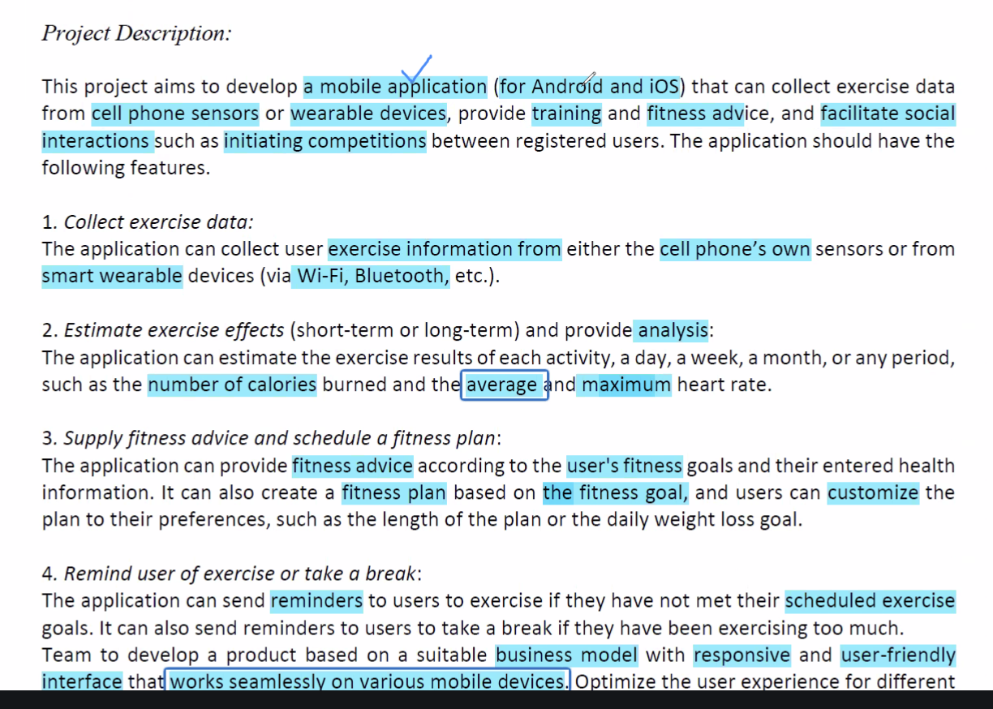
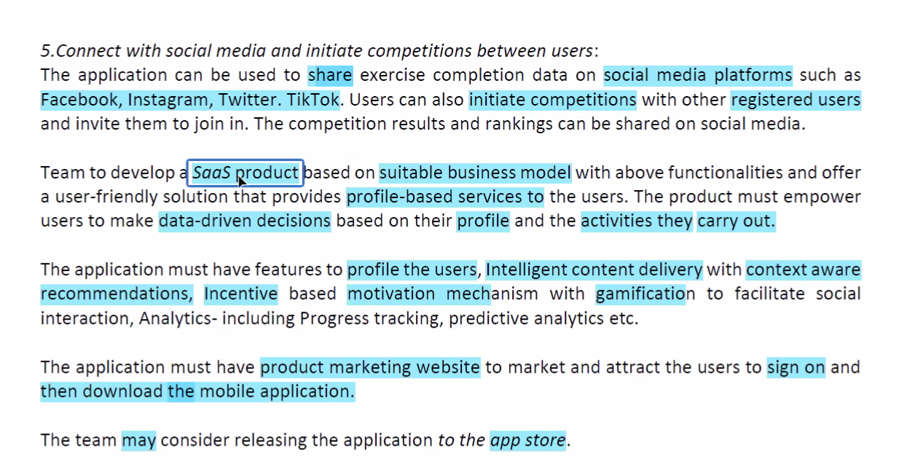

- Keep in mind:
  - Either APK or release to app store
  - Do marketing on our website:
    - Display features, etc

Project Plan (Diary):
- Just send weekly
- Should receive reply within 2-3 days, if not, email again to confirm

Project Plan (Individual Research):
- Make the app generic in nature, no need to specifically work on one form of exercise
- Missing:
  - Food tracking (calorie counting etc)

Project Plan (PRD – Project Requirement Documentation):
- Due 2nd May (1 week before actual moodle submission on 9th May)
- Refer to sample for structure and flow:

Project Plan (SRS - System Requirement):
- Due 14th May (no need to submit to moodle)
- Submit to supervisor

Project Plan (TDM - Technical Design Manual):
- Due 21st May (no need to submit to moodle)
- Contains:
  - Entity diagram
  - Dataflow diagram
  - Sequence diagram
  - Wireframe (best to use figma)
  - Etc…

Project Plan (Prototype):
- Due 21st May (no need to submit to moodle)
- Scaled down version of app
  - Focus on a few key user functions

10. Final Submission for 1st Half of FYP:
- Due 10th Jun (3 days before actual submission in moodle)
- Deliverables:
  - Application prototype with basic functionalities
  - Project Progress Report consisting of Preliminary Project Documents:
    - Preliminary Technical Documents – consisting of:
      - PRD
      - SRS
      - TDM
    - Preliminary User Manual (User manual for prototype)
    - Peer Assessment form

11. Final Assessment:
- Demo to supervisor one week before (actual assessment in person on 20th Jun)
- Deliverables:
  - Application prototype with basic functionalities
  - Project Progress Report consisting of Preliminary Project Documents:
    - Preliminary Technical Documents – consisting of:
      - PRD
      - SRS
      - TDM
    - Preliminary User Manual (User manual for prototype)

12. Next Steps:
- Look into:
  - What are the different tools required?
  - What business models are there / which is better for this project?
  - What functionalities do the users want?
  - What are the key functions that are important for the app?
- Examples:
  - Before eating, use app to key in information (collect data on food consumed)
    - What are the things that should be recorded?
    - What are the methods of collection?
    - How can we automate the collection for ease of use for the user?

- What are the types of data to be collected?
  - Static data:
    - Gender
    - Age
    - Height
    - Weight
  - Dynamic data:
    - What u eat
    - What u do
    - Goals

12. By Next Friday (24th Apr):
- Work on:
  - Functional Hierarchy Diagram
  - Work Breakdown Structure
- Create Taiga / Jira
  - Create:
    - Task
    - Timeline
    - Track when done, etc
- Start work on PRD
