


Product Comparison, Functional Hierarchy Diagram, Work Breakdown Structure
(CSIT321 – Final Year Project)
CSIT-26-S2-05: A Mobile Application for Wise Workout

Supervisor: Mr Premrajan
Group ID: FYP-26-S2-37
Name | UOW ID | SIM ID | E-Mail Address
CHIA YUAN JUN | 9096383 | 10250237 | yjchia007@mymail.sim.edu.sg
DEVANANDI PRAVEEN | 8575800 | 10256847 | devanand001@mymail.sim.edu.sg
FOONG JUN YAN | 8465824 | 10255961 | jyfoong002@mymail.sim.edu.sg
JEDIDIAH GOH CHOR SZER | 9096723 | 10263623 | jcsgoh001@mymail.sim.edu.sg

Product Comparison Table (Existing Features)

Feature / Function | Strava | MyFitnessPal | adidas Running | Google Fit | Freeletics | MapMyFitness | Lyfta | Our Product
Activity Tracking (Steps, Workouts) | Yes | Yes | Yes | Yes | Yes | Yes | Yes | Yes
Health Metrics (Heart Rate, Calories) | Yes | Yes | Yes | Yes | Yes | Yes | Yes | Yes
Workout / Performance Insights | Yes | Yes | Yes | Yes | Yes | Yes | Yes | Yes
Personalized Fitness Plans / Guidance | Third-party | Yes | Yes | No | Yes | Yes | Yes | Yes
Smart Reminders & Motivation | Yes | Yes | Yes | Limited | Yes | Yes | Yes | Yes
Social Features (Community, Challenges) | Yes | Limited | Yes | No | Yes | Yes | Yes | Yes
Social Media Sharing | Yes | Limited | Yes | No | Yes | Yes | Yes | Yes
Wearables Integration | Yes | Yes | Yes | Yes | Yes | Yes | Yes | Yes
Nutrition Tracking | Third-party | Yes | No | No | Yes | Third-party | No | Yes
AI / Adaptive Coaching | Limited | Limited | Yes | No | Yes | Limited | No | Yes
Gamification (Badges, Challenges) | Yes | Yes | Yes | Limited | Yes | Yes | Yes | Yes
Data Visualization (Trends, Reports) | Yes | Yes | Yes | Yes | Yes | Yes | Yes | Yes
Cross-Platform Support (iOS & Android) | Yes | Yes | Yes | Yes | Yes | Yes | Yes | Yes

Yes — confirmed | No — confirmed | Limited

Functional Hierarchy Diagram

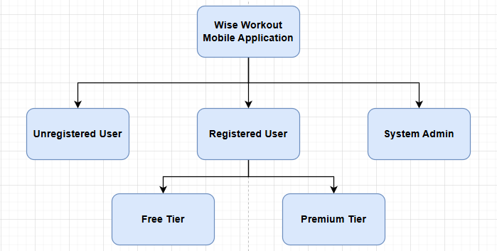
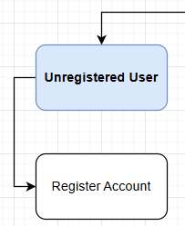

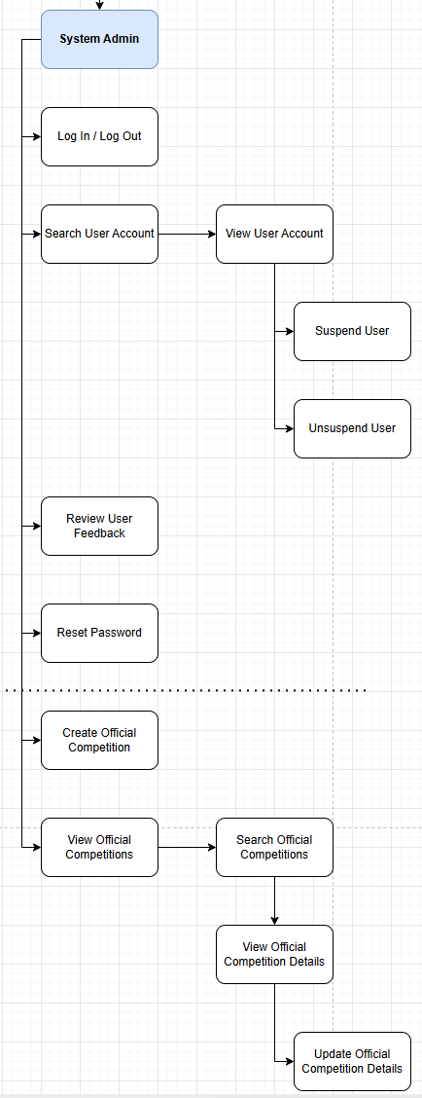

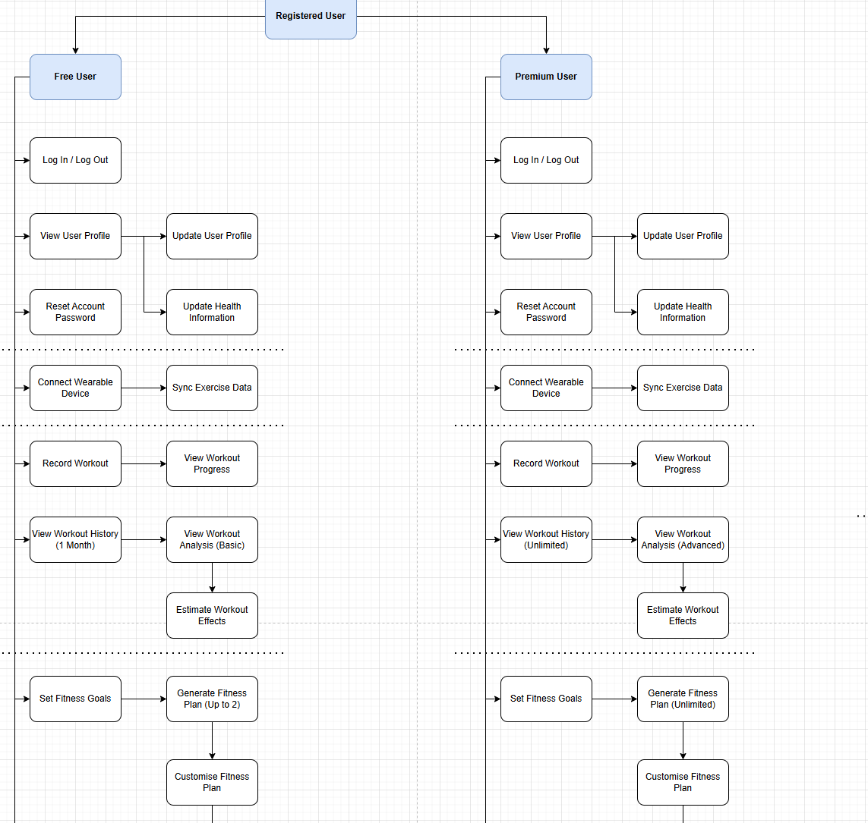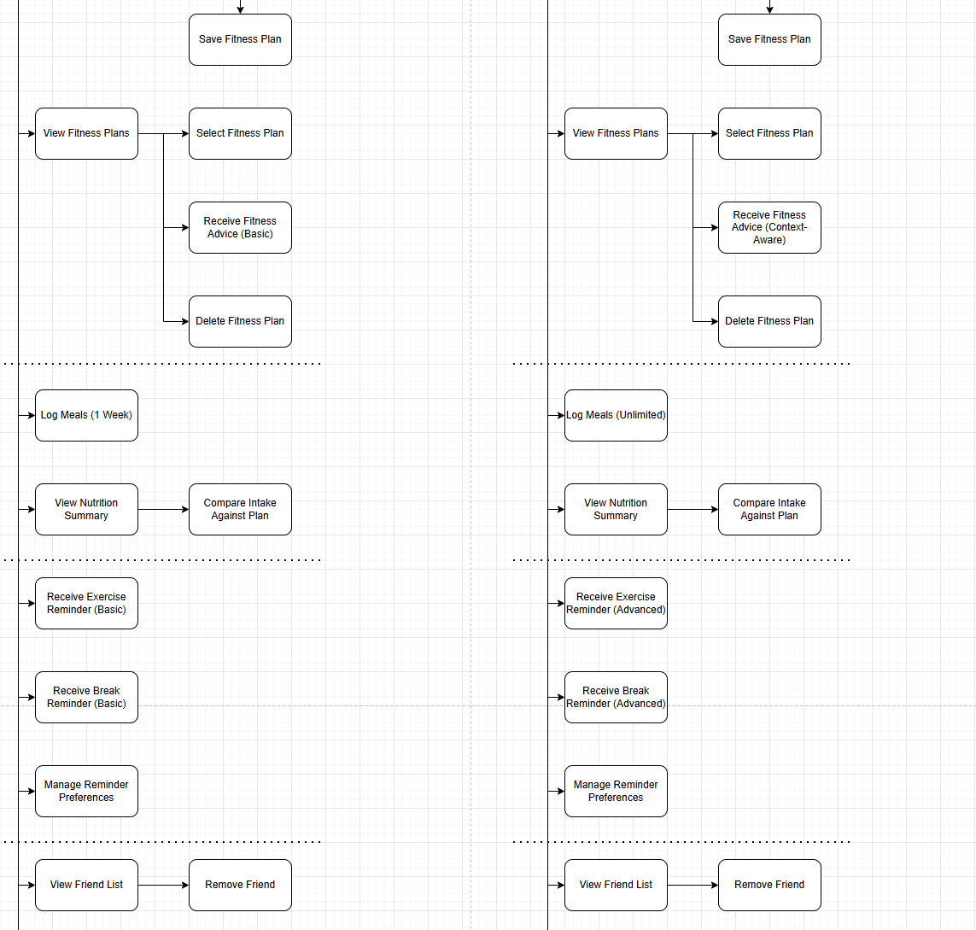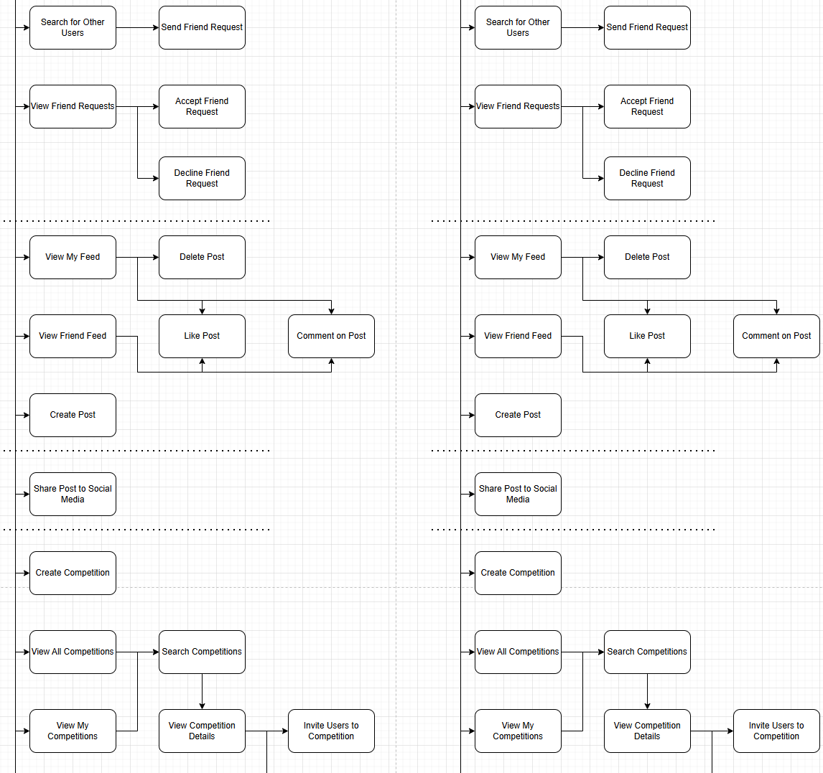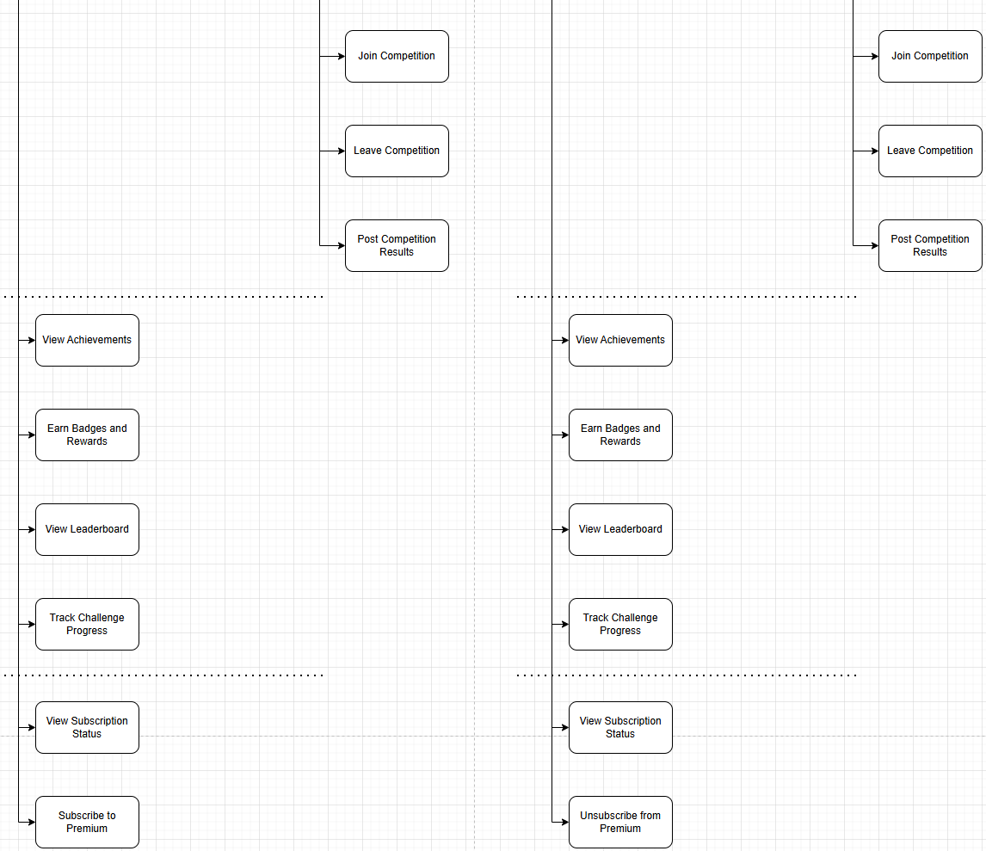

Work Breakdown Structure