Product Comparison Table (Existing Features)

Feature / Function | Strava | MyFitnessPal | adidas Running | Google Fit | Freeletics | MapMyFitness | Lyfta | Our Product
Activity Tracking (Steps, Workouts) | Yes | Yes | Yes | Yes | Yes | Yes | Yes | Yes
Health Metrics (Heart Rate, Calories) | Yes | Yes | Yes | Yes | Yes | Yes | Yes | Yes
Workout / Performance Insights | Yes | Yes | Yes | Yes | Yes | Yes | Yes | Yes
Personalized Fitness Plans / Guidance | Third-party | Yes | Yes | No | Yes | Yes | Yes | Yes
Smart Reminders & Motivation | Yes | Yes | Yes | Limited | Yes | Yes | Yes | Yes
Social Features (Community, Challenges) | Yes | Limited | Yes | No | Yes | Yes | Yes | Yes
Social Media Sharing | Yes | Limited | Yes | No | Yes | Yes | Yes | Yes
Wearables Integration | Yes | Yes | Yes | Yes | Yes | Yes | Yes | Yes
Nutrition Tracking | Third-party | Yes | No | No | Yes | Third-party | No | Yes
AI / Adaptive Coaching | Limited | Limited | Yes | No | Yes | Limited | No | Yes
Gamification (Badges, Challenges) | Yes | Yes | Yes | Limited | Yes | Yes | Yes | Yes
Data Visualization (Trends, Reports) | Yes | Yes | Yes | Yes | Yes | Yes | Yes | Yes
Cross-Platform Support (iOS & Android) | Yes | Yes | Yes | Yes | Yes | Yes | Yes | Yes

Yes — confirmed | No — confirmed | Limited

Product Comparison Table (Differentiating Features)

Feature / Function | Strava | MyFitnessPal | adidas Running | Google Fit | Freeletics | MapMyFitness | Lyfta | Our Product
 |  |  |  |  |  |  |  | Yes
 |  |  |  |  |  |  |  | Yes
 |  |  |  |  |  |  |  | Yes
 |  |  |  |  |  |  |  | Yes
 |  |  |  |  |  |  |  | Yes

Functional Hierarchy Diagram

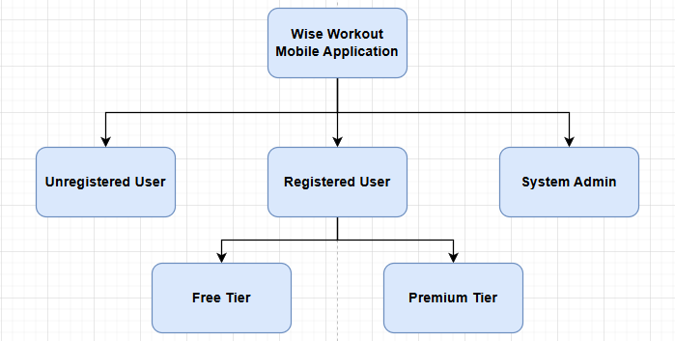
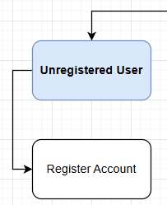

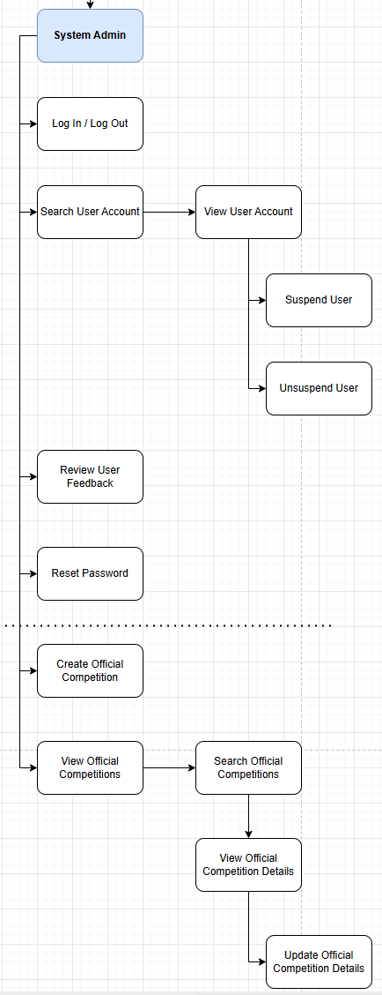

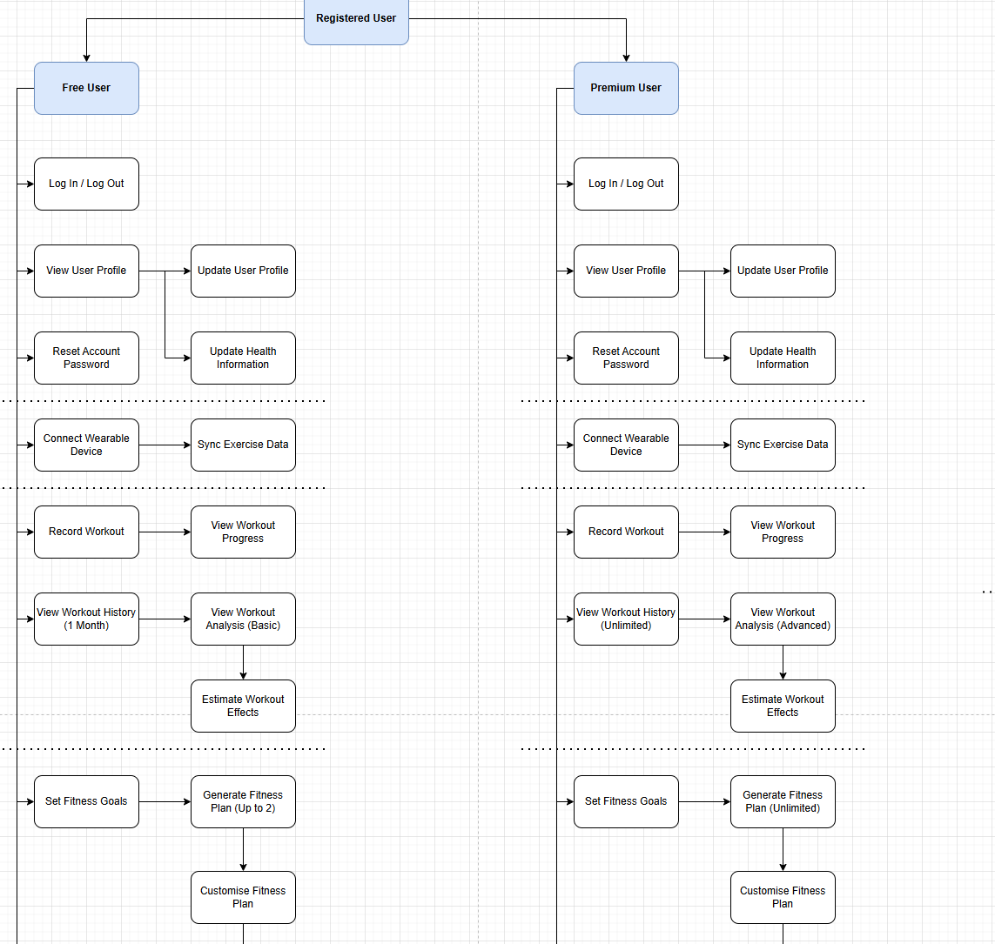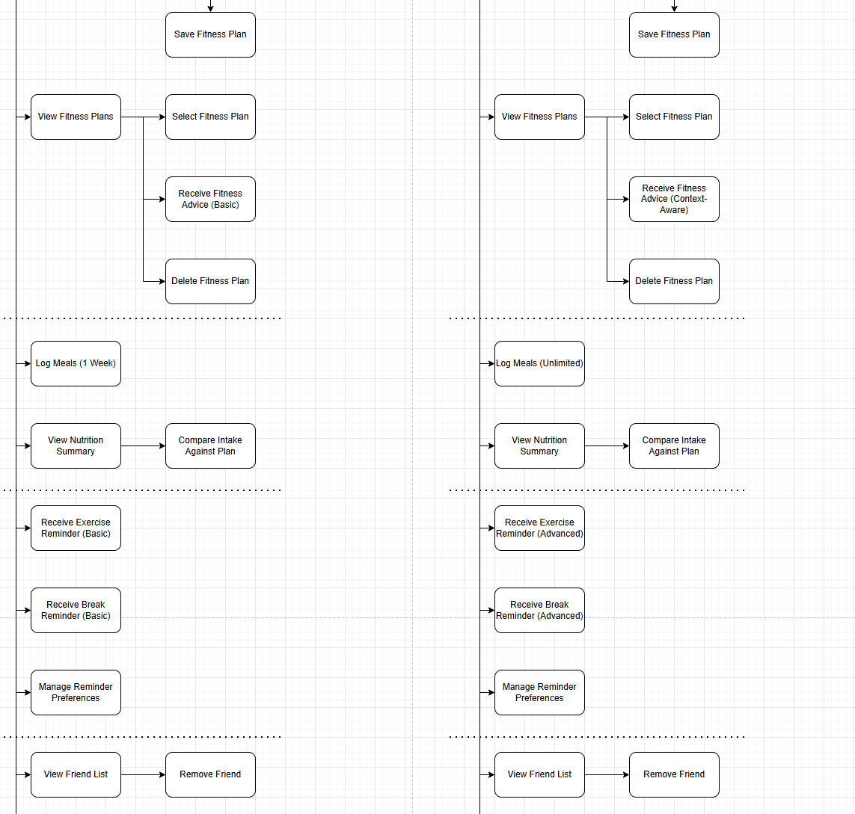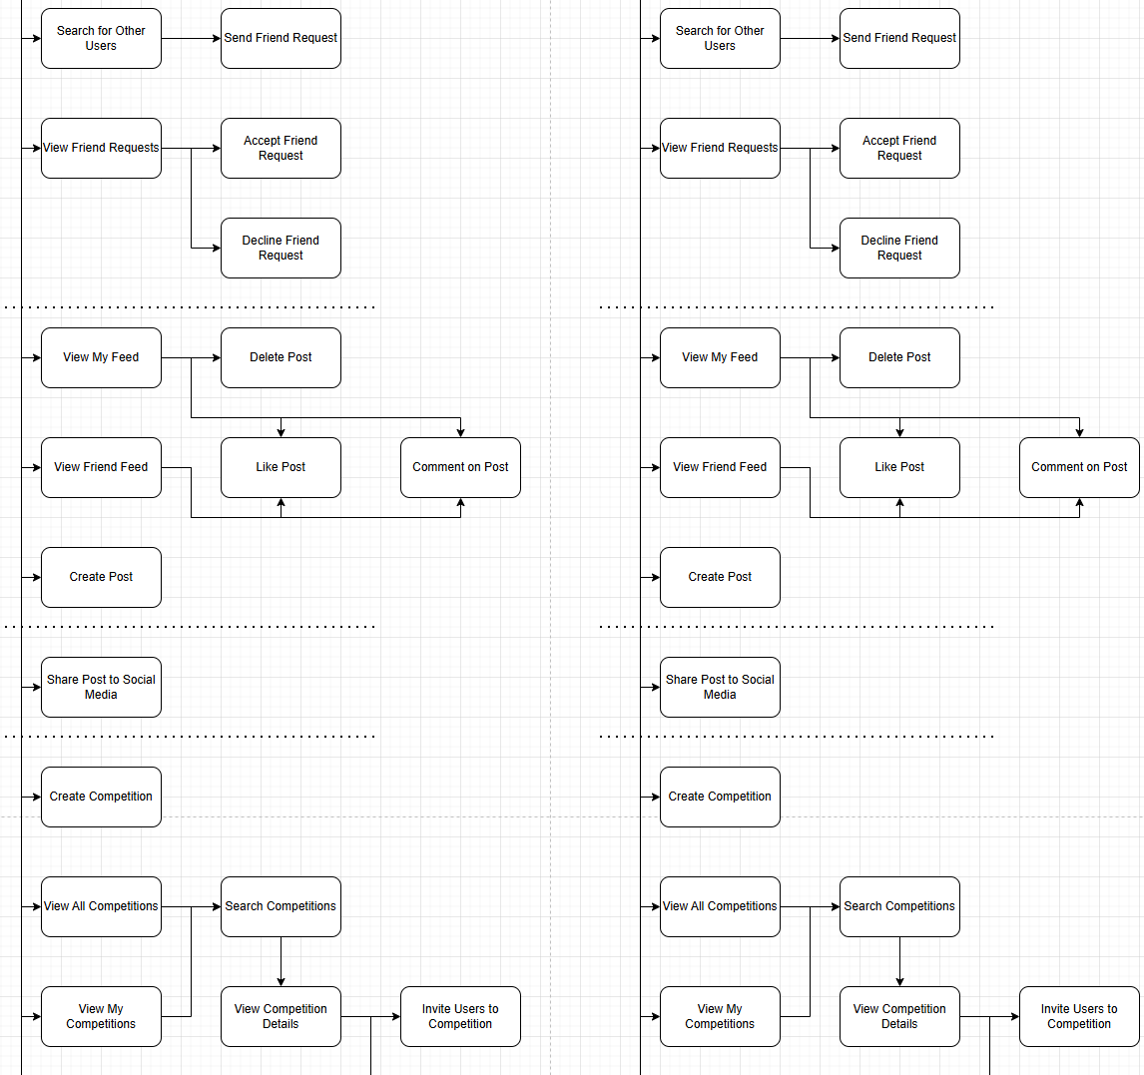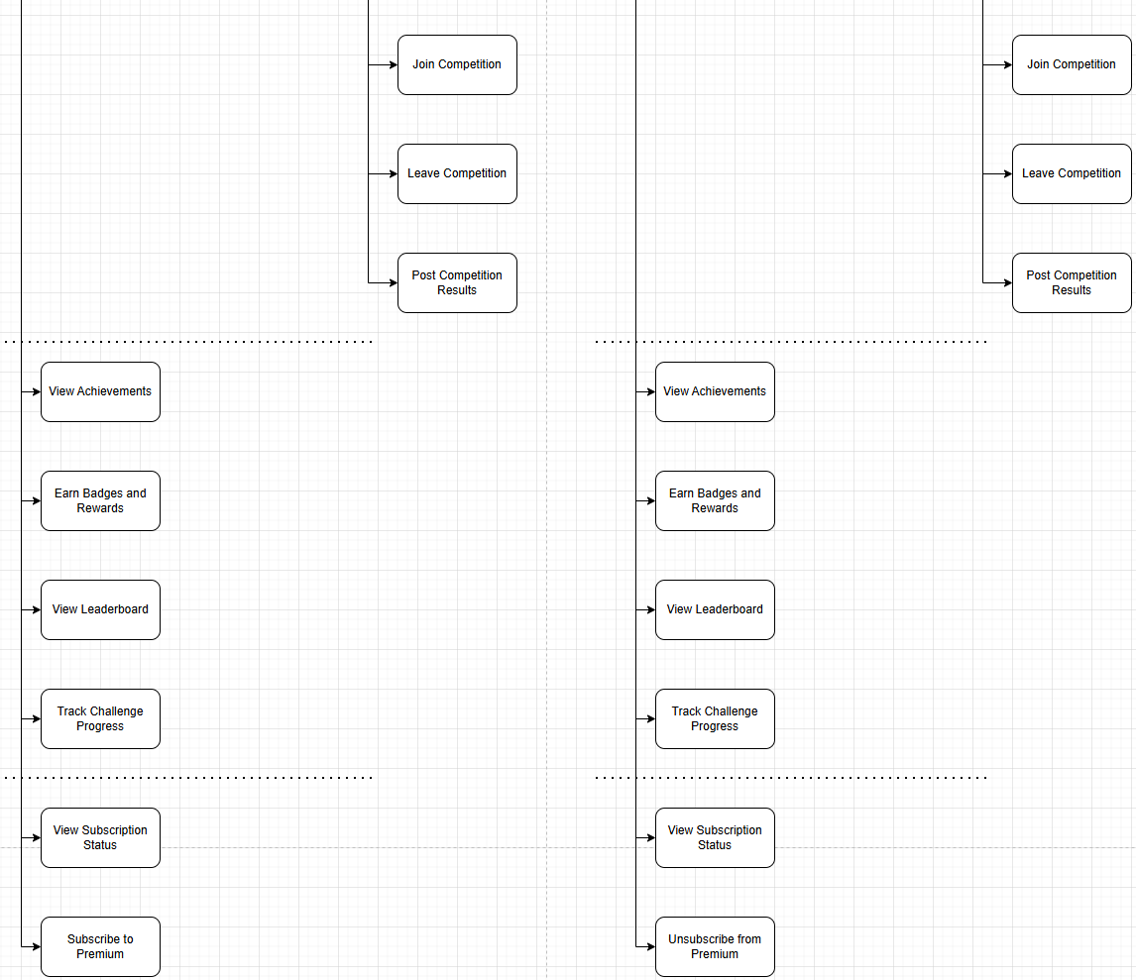

Work Breakdown Structure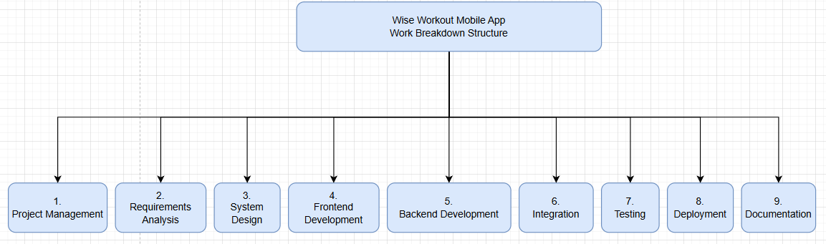 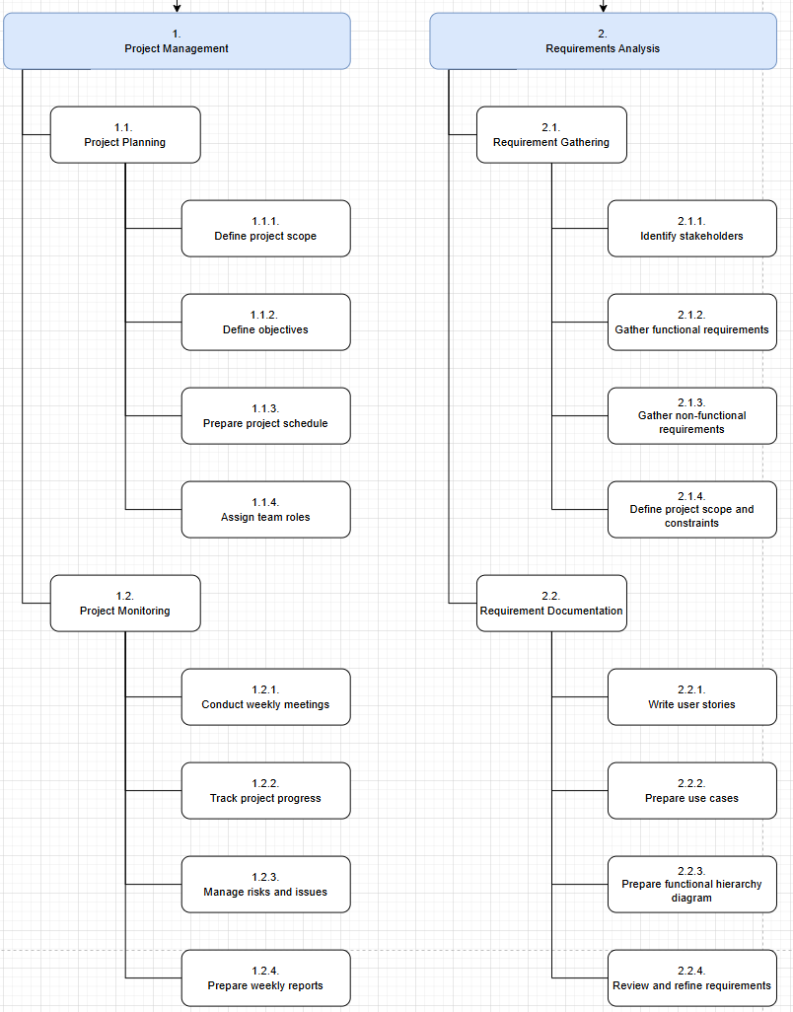

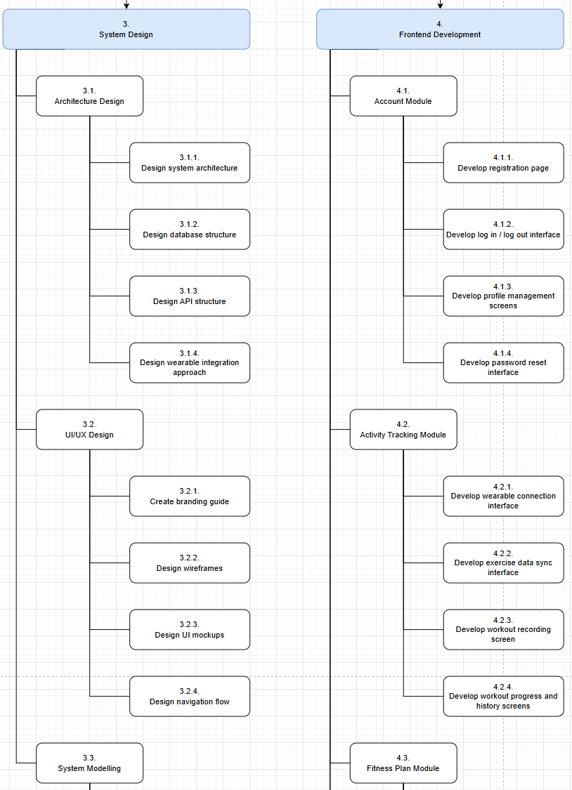
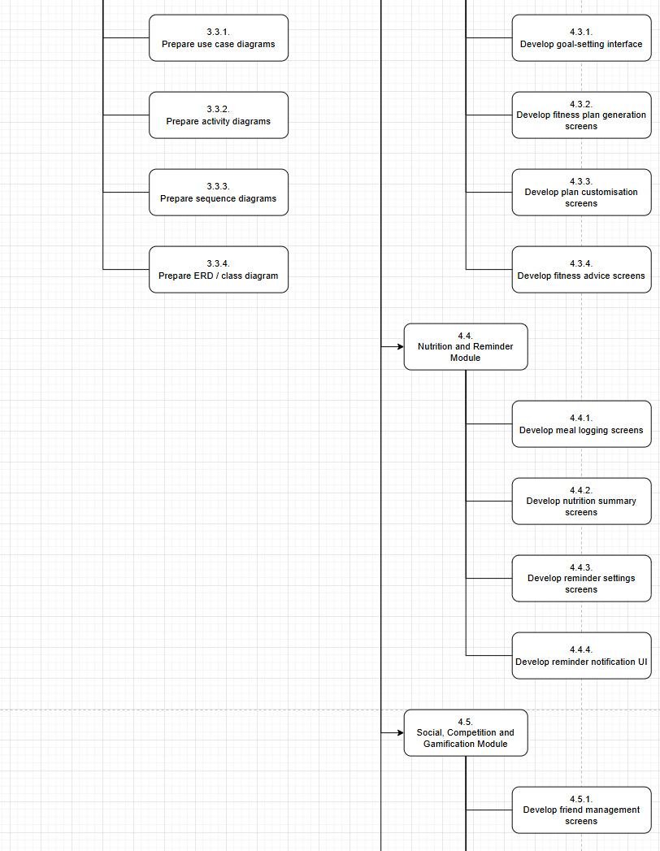
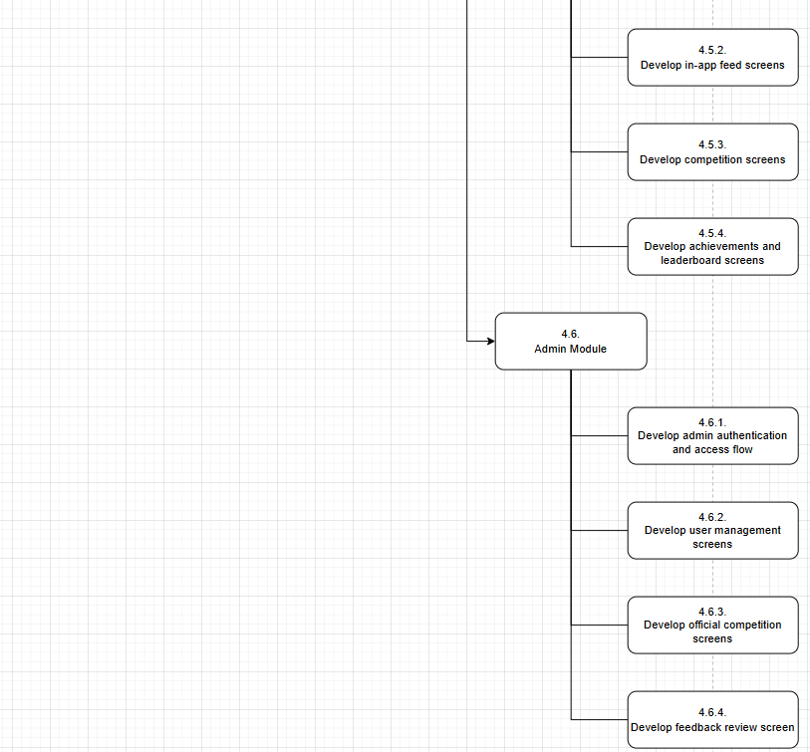

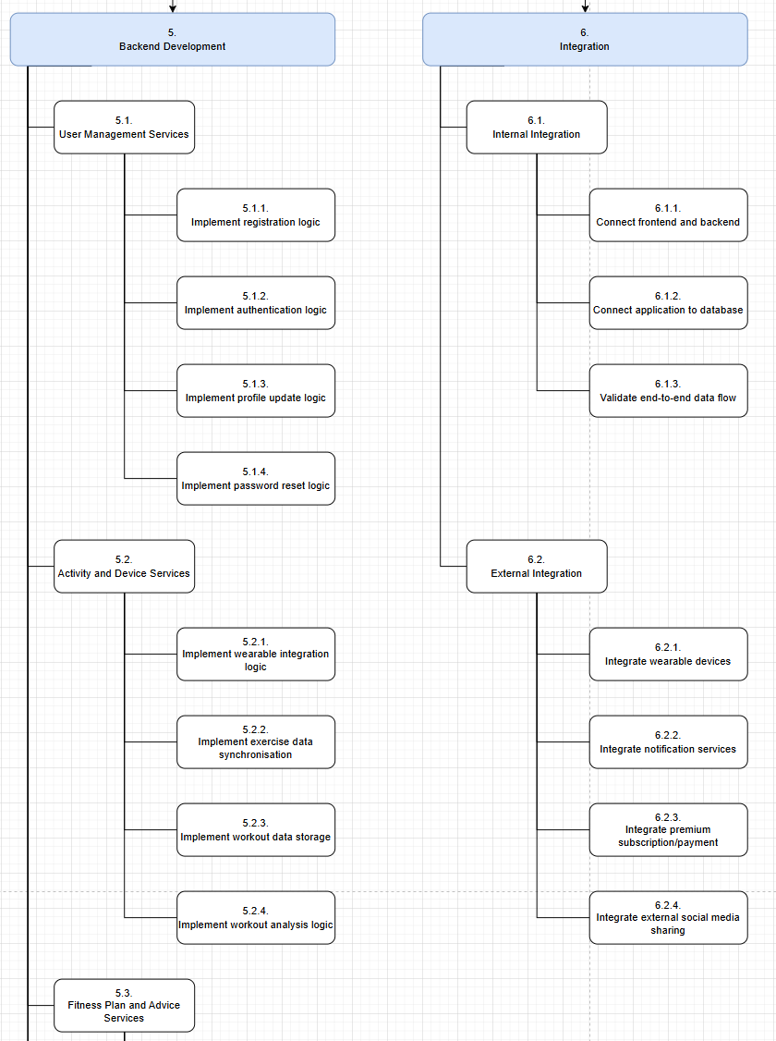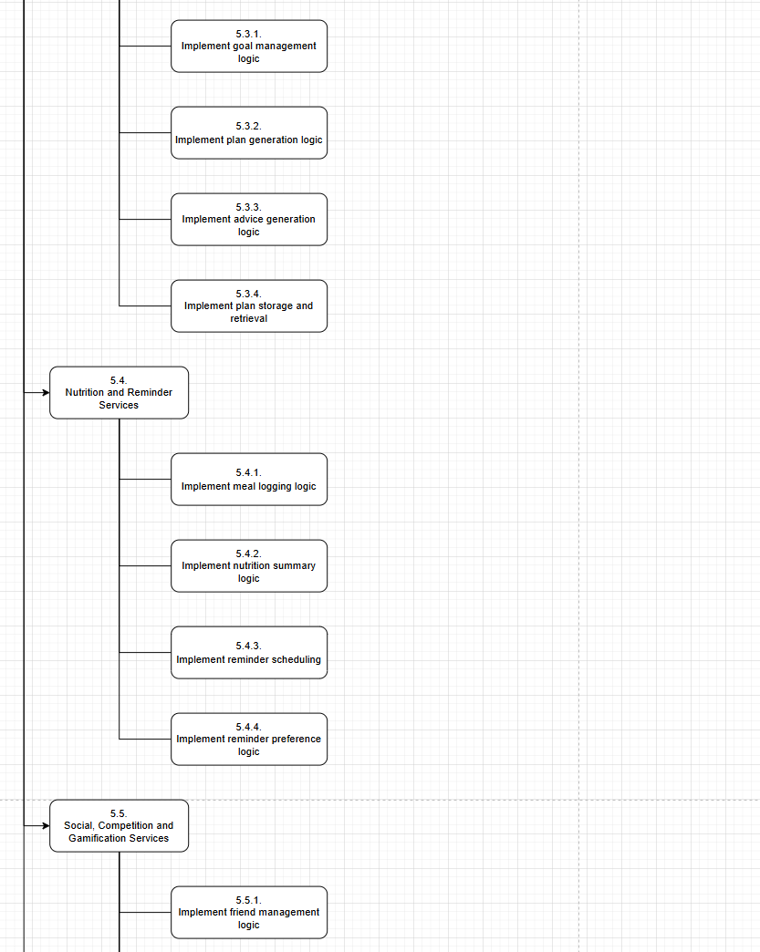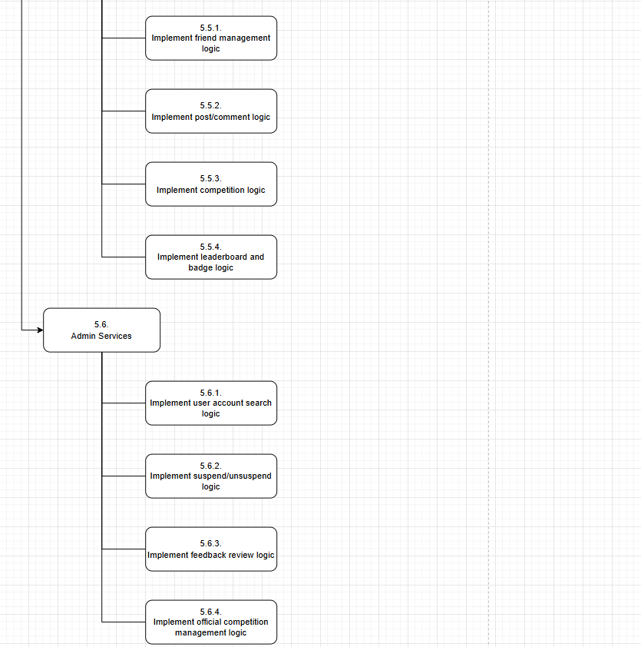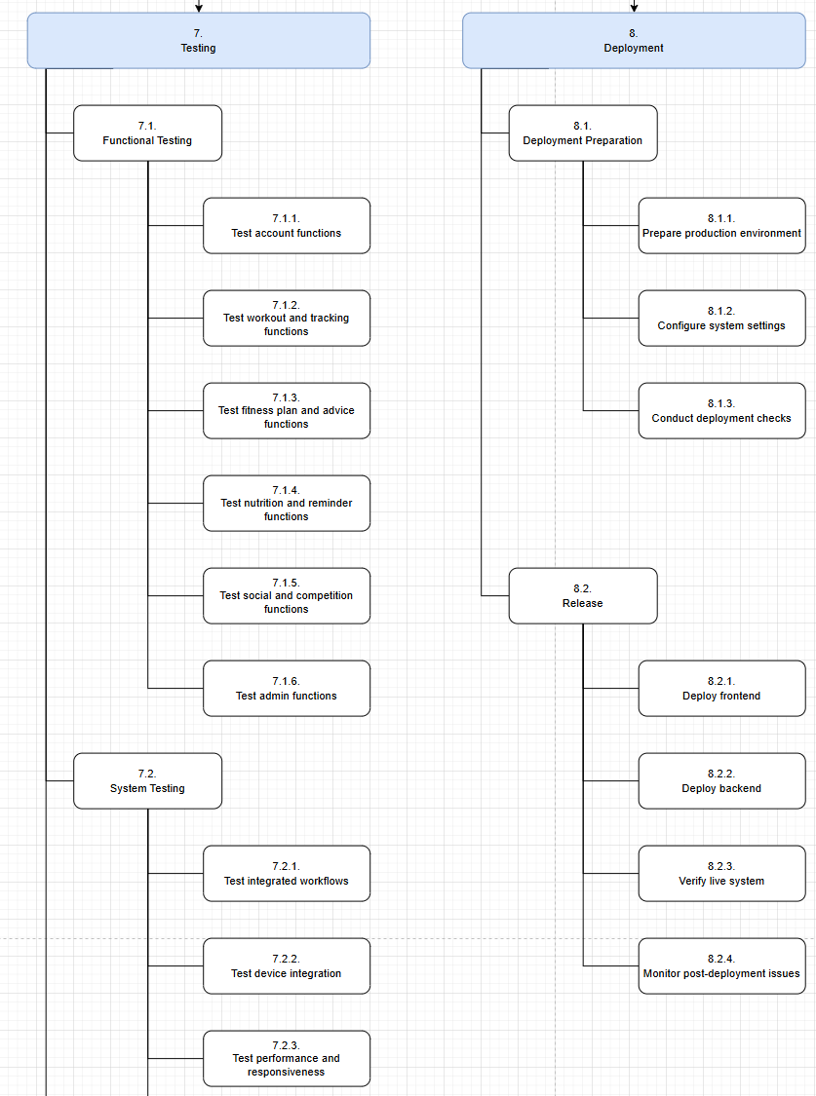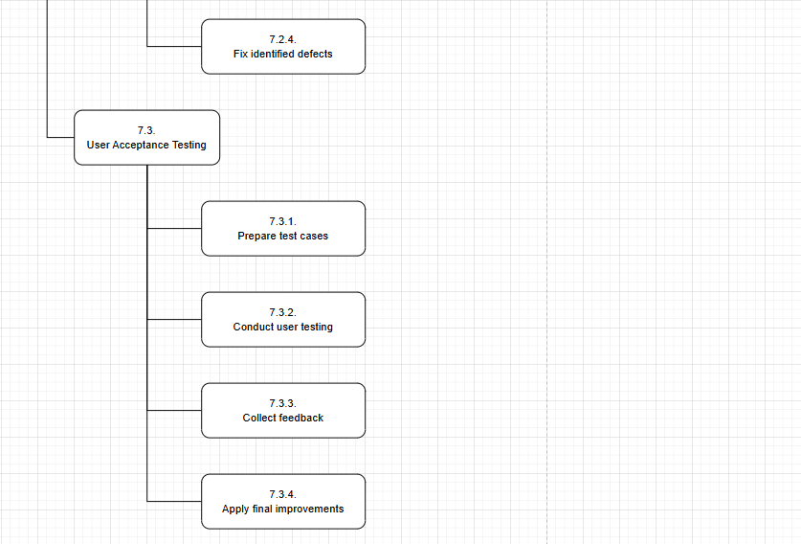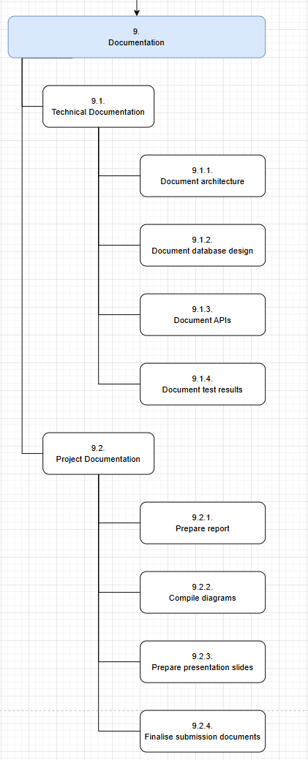
References:

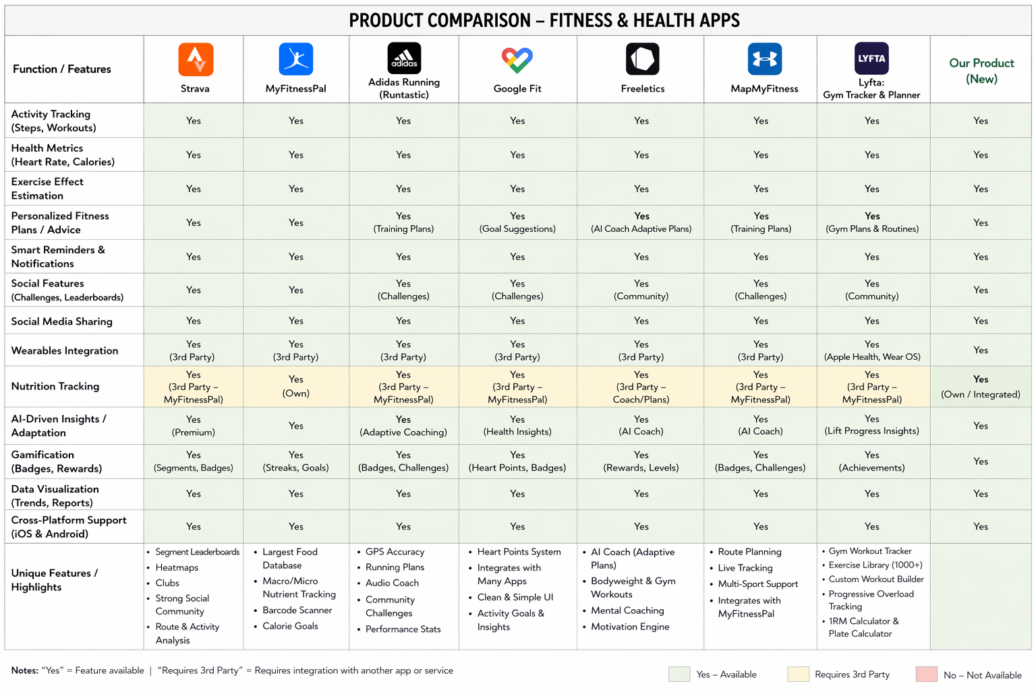
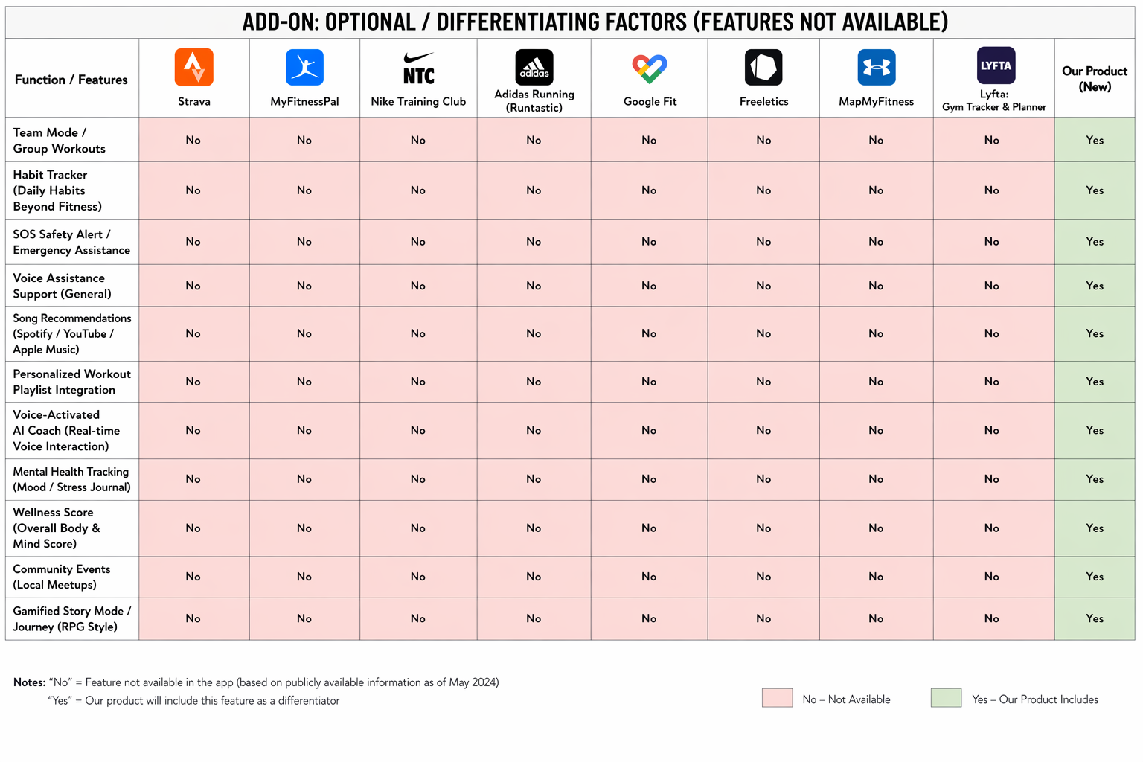

Functional Hierarchy Diagram (Planning)

Unregistered User

Register Account

Free Tier

Account Management

Log In / Log Out

View User Profile

Update User Profile

Update Health Information

Reset Account Password

Activity Tracking & Device Integration

Connect Wearable Device

Sync Exercise Data

Workout & Fitness Monitoring

Record Workout

View Workout Progress

View Workout History (1 Month)

View Workout Analysis (Basic)

Estimate Workout Effects

Fitness Advice & Plan Management

Set Fitness Goals

Generate Fitness Plan (Up to 2)

Customise Fitness Plan

Save Fitness Plan

View Fitness Plans

Select Fitness Plan

Receive Fitness Advice (Basic)

Delete Fitness Plan

Nutrition Tracking

Log Meals (1 Week)

View Nutrition Summary

Compare Intake Against Plan

Reminder Features

Receive Exercise Reminder (Basic)

Receive Break Reminder (Basic)

Manage Reminder Preferences

Social Features

In-App Friend Management

View Friend List

Search for Other Users

Send Friend Request

Remove Friend

View Friend Requests

Accept Friend Request

Decline Friend Request

In-App Feed Management

View My Feed

View Friend Feed

Create Post

Delete Post

Like Post

Comment on Post

External Social Media Sharing

Share Post to Social Media

Competition Features

Create Competition

Invite Users to Competition

View All Competitions

View My Competitions

Search Competitions

View Competition Details

Join Competition

Leave Competition

Post Competition Results

Gamification Features

View Achievements

Earn Badges and Rewards

View Leaderboard

Track Challenge Progress

Subscription

View Subscription Status

Subscribe to Premium

Premium Tier

Account Management

Log In / Log Out

View User Profile

Update User Profile

Update Health Information

Reset Account Password

Activity Tracking & Device Integration

Connect Wearable Device

Sync Exercise Data

Workout & Fitness Monitoring

Record Workout

View Workout Progress

View Workout History (Unlimited)

Estimate Workout Effects

View Workout Analysis (Advanced)

Fitness Advice & Plan Management

Set Fitness Goals

Generate Fitness Plan (Unlimited)

Customise Fitness Plan

Save Fitness Plan

View Fitness Plans

Select Fitness Plan

Receive Fitness Advice (Context-Aware)

Delete Fitness Plan

Nutrition Tracking

Log Meals (Unlimited)

View Nutrition Summary

Compare Intake Against Plan

Reminder Features

Receive Exercise Reminder (Advanced)

Receive Break Reminder (Advanced)

Manage Reminder Preferences

Social Features

In-App Friend Management

View Friend List

Search for Other Users

Send Friend Request

Remove Friend

View Friend Requests

Accept Friend Request

Decline Friend Request

In-App Feed Management

View My Feed

View Friend Feed

Create Post

Delete Post

Like Post

Comment on Post

External Social Media Sharing

Share Post to Social Media

Competition Features

Create Competition

Invite Users to Competition

View All Competitions

View My Competitions

Search Competitions

View Competition Details

Join Competition

Leave Competition

Post Competition Results

Gamification Features

View Achievements

Earn Badges and Rewards

View Leaderboard

Track Challenge Progress

Subscription

View Subscription Status

Unsubscribe from Premium

System Admin

Account Management

Log In / Log Out

Search User Account

View User Account

Suspend User

Unsuspend User

Review User Feedback

Reset Password

Competition Administration

Create Official Competition

View Official Competitions

Search Official Competitions

View Official Competition Details

Update Official Competition Details

