


Product Requirement Document (PRD)
(CSIT321 – Final Year Project)
CSIT-26-S2-05: A Mobile Application for Wise Workout

Supervisor: Mr Premrajan
Group ID: FYP-26-S2-37
Name | UOW ID | SIM ID | E-Mail Address
CHIA YUAN JUN | 9096383 | 10250237 | yjchia007@mymail.sim.edu.sg
DEVANANDI PRAVEEN | 8575800 | 10256847 | devanand001@mymail.sim.edu.sg
FOONG JUN YAN | 8465824 | 10255961 | jyfoong002@mymail.sim.edu.sg
JEDIDIAH GOH CHOR SZER | 9096723 | 10263623 | jcsgoh001@mymail.sim.edu.sg

Document Version Control

Version | Date | Modified By | Description
1.0

Table of Contents
Document Version Control 2
1. Introduction 5
1.1. Overview 5
1.2. Project Scope 5
1.3. Project Description 5
2. Research Summary 6
2.1. Overview of Fitness App Market 6
2.2. Fitness Applications in the market 6
2.2.1. Strava 6
2.2.2. MyFitnessPal 6
2.2.3. adidasRunning 6
2.2.4. GoogleFit 6
2.2.5. Freeletics 6
2.2.6. MapMyFitness 6
2.2.7. Lyfta 6
2.3. Product Comparison Table 7
2.4. Key Findings from Existing Apps 8
3. Proposed Product 9
3.1. Proposed Product Overview 9
3.2. Main Features 9
3.3. Value Proposition 9
4. Target Users and User Categories 10
4.1. Unregistered User 10
4.2. Registered Free User 10
4.3. Registered Premium User 10
4.4. Fitness Coach 10
4.5. System Admin 10
5. Business Model 11
5.1. Proposed Business Model 11
5.2. Free and Premium User Tiers 11
5.3. Revenue Model 11
5.4. Justification of Business Model 11
6. Functional Hierarchy Diagram 12
7. Use Case Diagram 19
7.1. User Story 19
8. Project Schedule 19
8.1. Fes 19
9. Development Tools 19
9.1. fesfes 19
10. Development Methodologies 19
10.1. Fesfes 19
11. References 19

Introduction

Overview
Insert overview here

Project Scope
Inset project scope here

Project Description
Insert project description here

Research Summary

Overview of Fitness App Market
Insert app summary here

Fitness Applications in the market
Insert info here

Strava
Insert strava summary here

MyFitnessPal
Insert MyFitnessPal summary here

adidasRunning
Insert adidasRunning summary here

GoogleFit
Insert GoogleFit summary here

Freeletics
Insert strava summary here

MapMyFitness
Insert MapMyFitness summary here

Lyfta
Insert Lyfta summary here

Product Comparison Table
Feature / Function | Strava | MyFitnessPal | adidas Running | Google Fit | Freeletics | MapMyFitness | Lyfta | Our Product
Activity Tracking (Steps, Workouts) | Yes | Yes | Yes | Yes | Yes | Yes | Yes | Yes
Health Metrics (Heart Rate, Calories) | Yes | Yes | Yes | Yes | Yes | Yes | Yes | Yes
Workout / Performance Insights | Yes | Yes | Yes | Yes | Yes | Yes | Yes | Yes
Personalized Fitness Plans / Guidance | Third-party | Yes | Yes | No | Yes | Yes | Yes | Yes
Smart Reminders & Motivation | Yes | Yes | Yes | Limited | Yes | Yes | Yes | Yes
Social Features (Community, Challenges) | Yes | Limited | Yes | No | Yes | Yes | Yes | Yes
Social Media Sharing | Yes | Limited | Yes | No | Yes | Yes | Yes | Yes
Wearables Integration | Yes | Yes | Yes | Yes | Yes | Yes | Yes | Yes
Nutrition Tracking | Third-party | Yes | No | No | Yes | Third-party | No | Yes
AI / Adaptive Coaching | Limited | Limited | Yes | No | Yes | Limited | No | Yes
Gamification (Badges, Challenges) | Yes | Yes | Yes | Limited | Yes | Yes | Yes | Yes
Data Visualization (Trends, Reports) | Yes | Yes | Yes | Yes | Yes | Yes | Yes | Yes
Cross-Platform Support (iOS & Android) | Yes | Yes | Yes | Yes | Yes | Yes | Yes | Yes

Yes — confirmed | No — confirmed | Limited

Key Findings from Existing Apps
Insert summary here

Proposed Product

Proposed Product Overview
Insert proposed product here

Main Features
Insert main features here

Value Proposition
Insert value proposition here

Target Users and User Categories

Unregistered User
Insert proposed product here

Registered Free User
Insert main features here

Registered Premium User
Insert value proposition here

Fitness Coach
Insert value proposition here

System Admin
Insert value proposition here

Business Model

Proposed Business Model
Insert business model here

Free and Premium User Tiers
Insert business model here

Revenue Model
Insert business model here

Justification of Business Model
Insert business model here

Functional Hierarchy Diagram

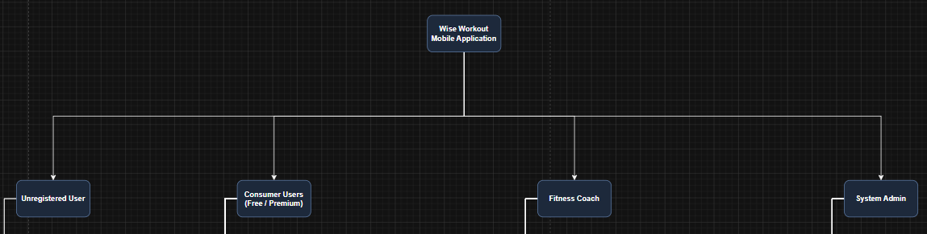
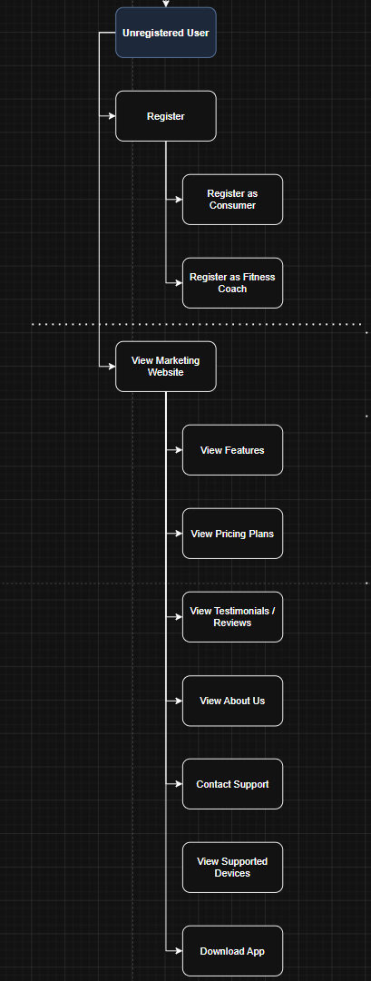
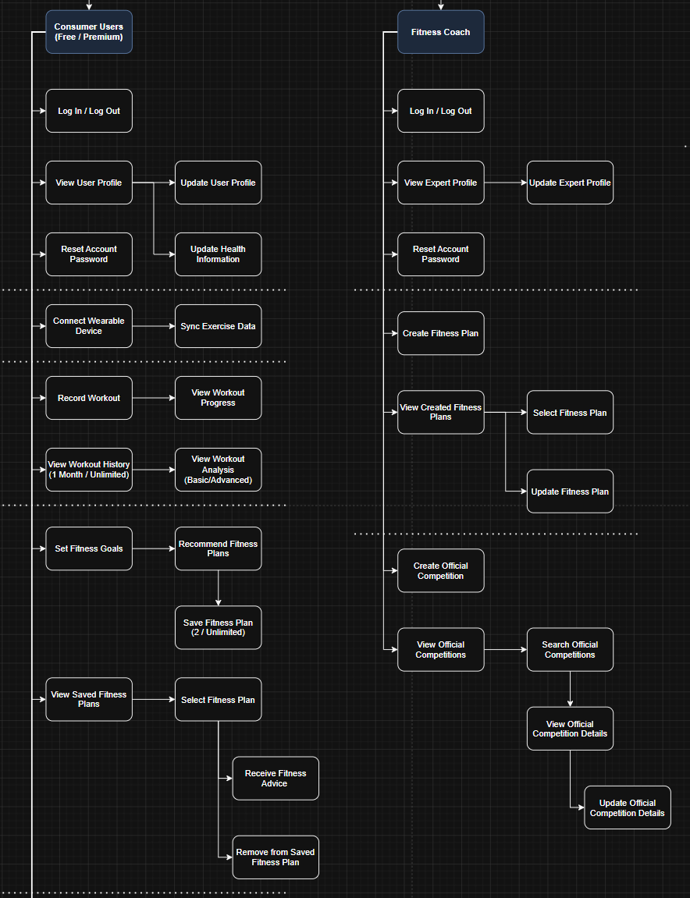

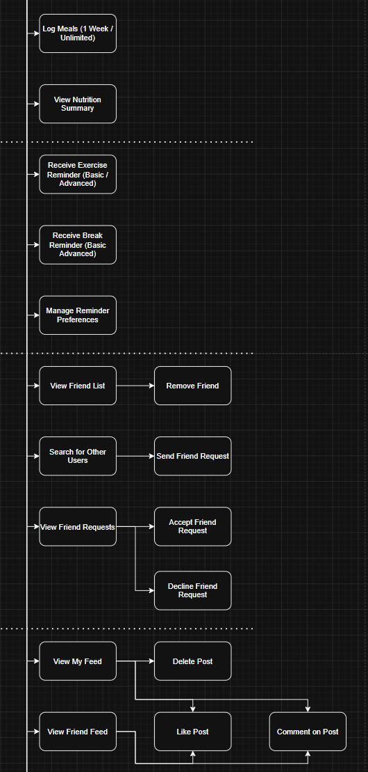
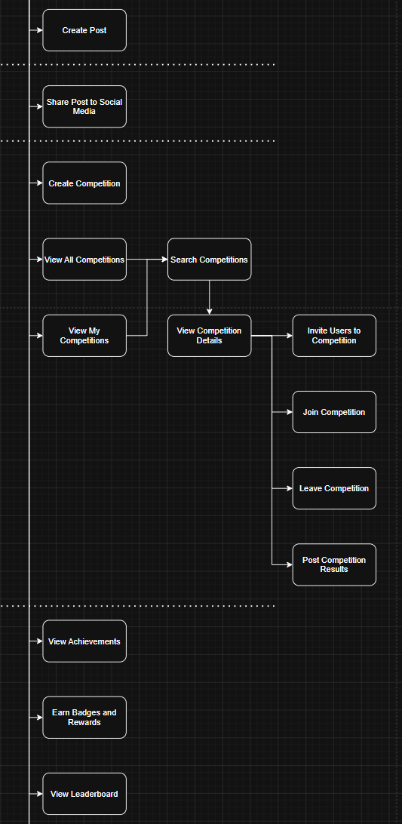
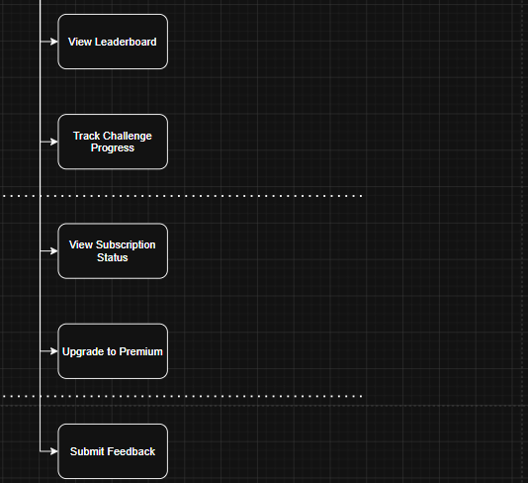
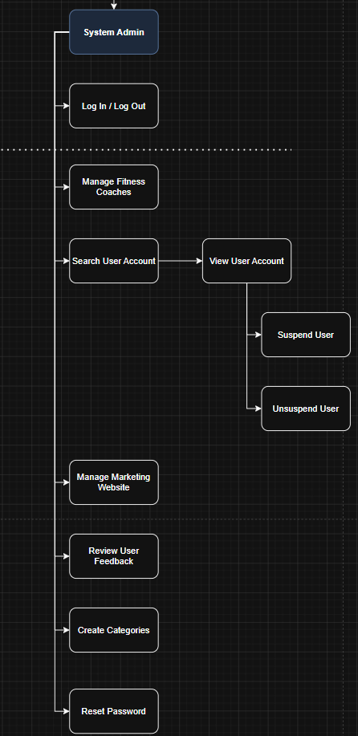

Use Case Diagram

User Story

Project Schedule

Fes

Development Tools

fesfes

Development Methodologies

Fesfes

References

