Project Proposal: EAT ASAP - Revolutionizing Fast-Food Dining

Contents

Project Overview: 1

Target Audience: 1

Key Elements of the "EAT ASAP" Journey: 1

Main Outcomes: 1

Advantages for Restaurants: 2

Functionalities: 2

Wireframe Overview: 2

Key Indicators of Success: 2

Long-Term Impact: 3

Approval and Feedback Mechanism: 3

Project Vision and Confidence: 3

Team Members: 3

Team Communications: 3

Mockups 4

Note: this project is subject to ideas implementations. If any major changes happen, we will contact the professor to declare the changes.

# Project Overview:

"EAT ASAP" aims to transform the fast-food dining experience by introducing a virtual self-ordering system in downtown restaurants. This innovative system will streamline the ordering process, reduce wait times, and enhance the overall dining experience.

**Key Elements of the "EAT ASAP" Journey - A Sales Pitch Story:**

Imagine a bustling fast-food restaurant in the heart of downtown. The excitement of delicious food is in the air, but there's one problem - long queues that often deter customers. Now, what if I told you there's a solution that can not only change this but also revolutionize the entire fast-food dining experience? That's where "EAT ASAP" comes in.

1. **Discovering Efficiency through QR Codes:** Picture this: Customers walking in, curious, and ready to satisfy their cravings. They see a prominently displayed QR code that piques their interest. A quick scan opens a digital menu, a visually appealing array of culinary delights, where they can customize their orders effortlessly. It's like having a personal chef at your fingertips.
2. **Seamless Integration of Technology (Future Vision):** Inside the restaurant, a transformation is happening. Our project seamlessly integrates technology into the dining experience. Customers witness restaurant staff equipped with tablets, a glimpse of the future mobile app integration. Orders are processed efficiently, ensuring a smooth flow of service. The traditional order-taking process is a thing of the past, replaced by a new era of efficiency.
3. **Contactless Transactions and Enhanced Dining Experience:** We take the digital transformation a step further. Customers experience a contactless journey from providing digital receipts to completing secure and quick payments. We align with modern hygiene standards and elevate the overall dining experience. It's not just about the food; it's about the entire journey.
4. **Client Reflection and Realization:** As customers enjoy their meals in the vibrant dining area, they can't help but reflect on the transformative journey they've been on. What initially seemed like a potential inconvenience - a long queue - has now become a streamlined and enjoyable adventure, thanks to the "EAT ASAP" system. It's a realization of the future of dining.

# Target Audience:

Our primary target audience for "EAT ASAP" is fast-food restaurants and small businesses in the food industry, looking to improve operational efficiency and customer satisfaction.

# Key Elements of the "EAT ASAP" Journey:

1. **Discovering Efficiency through QR Codes:**
   * Clients can easily access the system by scanning a QR code, opening a digital menu for customized orders.
2. **Seamless Integration of Technology (Future Vision):**
   * Restaurant staff equipped with tablets (future mobile app integration) efficiently process orders, transforming traditional order-taking.
3. **Contactless Transactions and Enhanced Dining Experience:**
   * The system offers contactless payments and digital receipts, aligning with modern hygiene standards.
4. **Client Reflection and Realization:**
   * Clients reflect on the transformative journey, realizing the convenience of the "EAT ASAP" system.

# Main Outcomes:

* Reduced Wait Times
* Efficient Ordering
* Affordable Solution

# Advantages for Restaurants:

* Enhanced Operational Efficiency
* Increased Customer Turnover
* Improved Customer Experience
* Cost Savings
* Data-Driven Insights
* Adaptation to Modern Trends
* Hygiene and Safety Measures
* Multilanguage Platform
* Flexible live menu editing and updating.
* Live waiting-time monitoring of orders

# Functionalities:

1. QR Code Integration
2. Digital Menu Presentation
3. Customization Options
4. Real-Time Pricing Updates
5. Efficient Order Processing
6. Digital Receipts
7. Contactless Payment Integration
8. Data Capture and Insights
9. User-Friendly Interface
10. Efficient Customer Communication

# Wireframe Overview:

1. Landing Page (B2B Marketing)
2. About Us
3. Contact Us
4. Restaurant Sign-Up/Sign-In Form
5. Explore Page (Menu Exploration)
6. Restaurant Profile Page (Menu Management)
7. Client-Facing Menu Page
8. Checkout Page (Client)
9. Receipt Page (Client)
10. Order Operations Page (Restaurant)

# Key Indicators of Success:

* Customer Satisfaction Feedback
* Increased Orders Per Restaurant
* Adoption Rate among Small Businesses

# Long-Term Impact:

"EAT ASAP" aims to revolutionize the restaurant industry, making technology accessible to businesses of all sizes and improving the dining experience for customers.

# Approval and Feedback Mechanism:

1. Internal Feedback: Regular Team Meetings.
2. External Feedback: Usage of the website by clients and restaurant owners.

# Project Vision and Confidence:

"EAT ASAP" is committed to transforming dining through innovative technology. We invite you to join us in shaping the future of dining.

# Team Members:

Note: we like the idea that each one of us could enhance his skills in HTML, CSS, and JAVASCRIPT.

1. Sleiman Abou-Antoun - Team Leader (Project coordination):
   * Pages assigned: Landing, Order Operations, Explore, Sign Up/Sign in for Admins.
2. Ashot Harutyunyan - Frontend Developer:
   * Pages assigned: About Us, Contact Us, Client Sign-Up/Sign-In.
3. Kawthar Mashhour - Frontend Developer:
   * Pages assigned: Restaurant Profile, Menu.
4. Chen Yue - Frontend Developer:
   * Pages assigned: Checkout, Receipt.

# Team Communications:

Our team maintains daily communication to share ideas and progress, fostering a collaborative and efficient work environment.

# Mockups

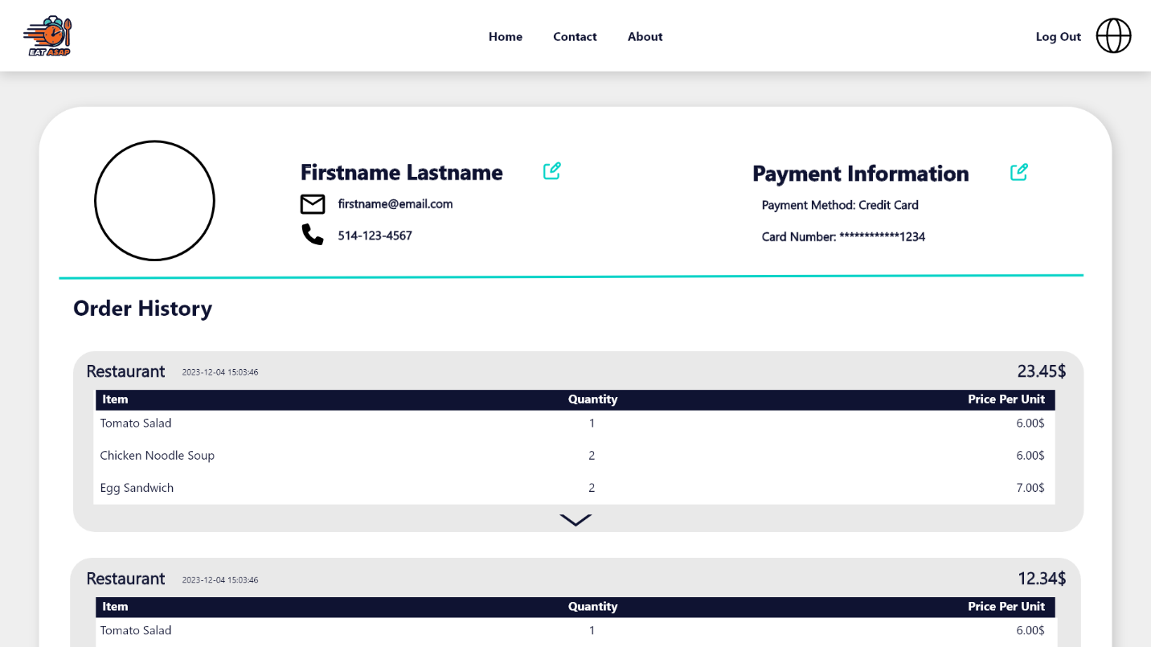

Kawthar:

XD Mockup : [https://xd.adobe.com/view/c703a0 95-c938-49b6-89b8-13c586f2c668-9250/](https://xd.adobe.com/view/c703a0%2095-c938-49b6-89b8-13c586f2c668-9250/)

Ashot:

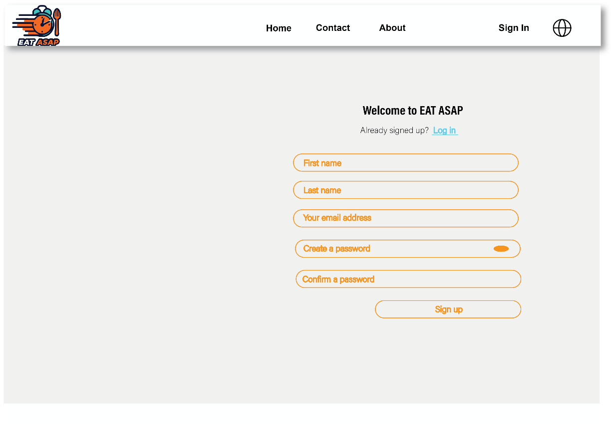

Solomon:

XD Mockup Link: <https://xd.adobe.com/view/1faa2cda-567d-4247-9d6f-f8a625b7a86f-4af9/>