Carol Yuen

March 1, 2020

IT FDN 100 B

Foundation of Programming Assignment 6

Modifying a code and using Functions

# Introduction

In this Module we learned how to further use functions (a way for us to Group statements). In order for us to use functions, we must first Define before we can call the function. Once called the function, this will execute the code and return the results.

We looked at how we would document the functions (using CRTL +I allow us to see this in our “Help” window), we reviewed using Keywords such as “None”, and how to use Global Variables and constrants.

Along with Functions, we were introduced to Classes which we will go further into details in module 8.

# The Practice

Since the script for Assignment #6 was more of a modification, I wanted to take this time to comment on the Labs instead in this section. With the Labs, I thought it was a good way to break down the steps when creating Functions. We started with a more relatively easier change to the “Simple Math” script and as we were introduced more concepts, we were able to build on top of it. This helped me organized my notes and learning a lot better.

In Lab C, I made a few modifications to the original script (LabA) and got the results that to match the results that Dirk provided in his video, but I believe my script may not be the best. would love to understand if there is a better way to write this script (listing-1).

Listing – Lab C Script

# Modifying the Data

For our assignment this week, we were provided a script as a starter from Dirk. The goal of this assignment was to modify the code so that we were using functions and not just the few in the script. This assignment was to also help us understand when taking over a script from another person what are the pain points that we could face when the comments and organization is hard to understand.

When I first opened the script, I found this very hard to understand and did not know where to start and had to read the script a few times before I started making changes.

With the script having minimal spacing, it was hard for me to understand what groupings were together. I had to put the spacing in myself to make sure I was able to follow each section. After making the changes of the script to functions, I added my own comments to help better organize the script.

# Summary

In summary, I thought this section was helpful in building on what we learned. I thought the concept of functions were a little less complicated that the previous modules.

For the function to work, we needed to define the function, which I thought was similar to a component SQL used as well.

In this section, having gone through modifying of other people’s script, I realized the importance of having an organized code where others are able to follow. This is importance especially in a work setting when developers are coding a program what are used across the company since there are chances developers are moving from projects to projects or moving on to different roles.

# Appendix

References:

* [1] Foundation of Programming (Python) By Dirk Biesinger Module 6 Part 1 to Part 4
* [2] <https://www.geeksforgeeks.org/python-list-index/> , Python List | Index
* [3] Terminal Screen Shots (last two pages of Assignment06.docx)
* [4] Stack OverFlow: <https://stackoverflow.com/questions/50548051/python-concatenation-of-string-and-integer-sum/50548070>

Terminal Screen Shots:

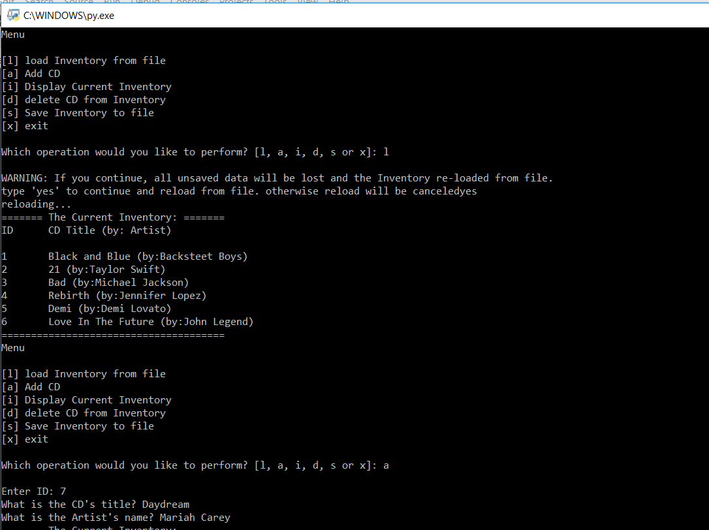

Table - Terminal Screen Shot 1

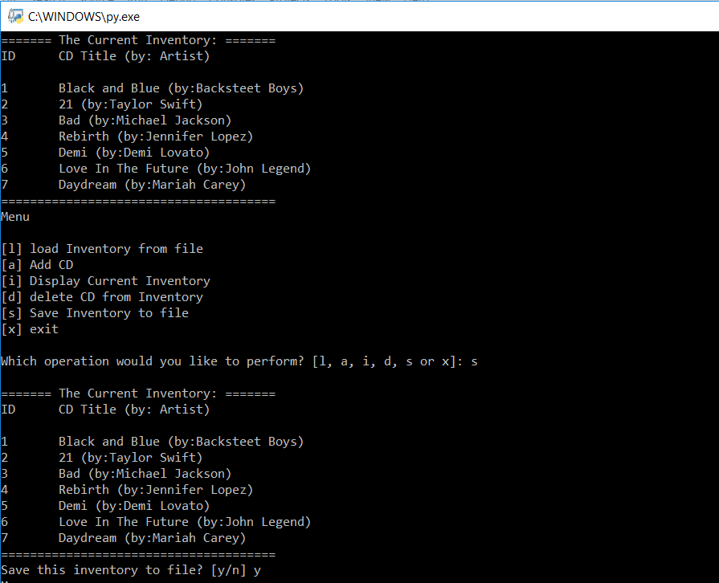

Table - Terminal Screen Shot 2

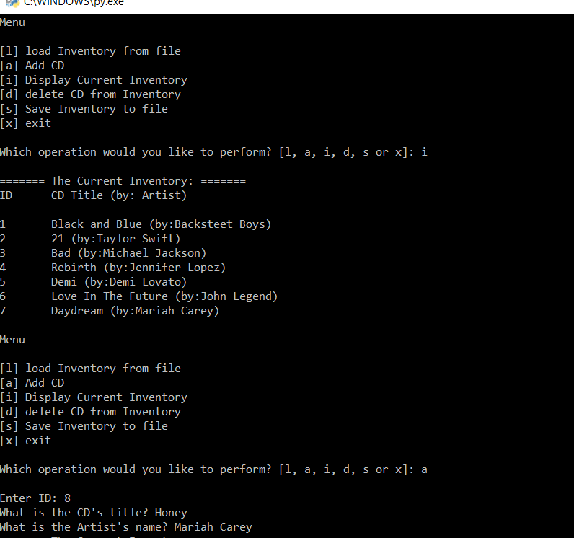

Table - Terminal Screen Shot 3

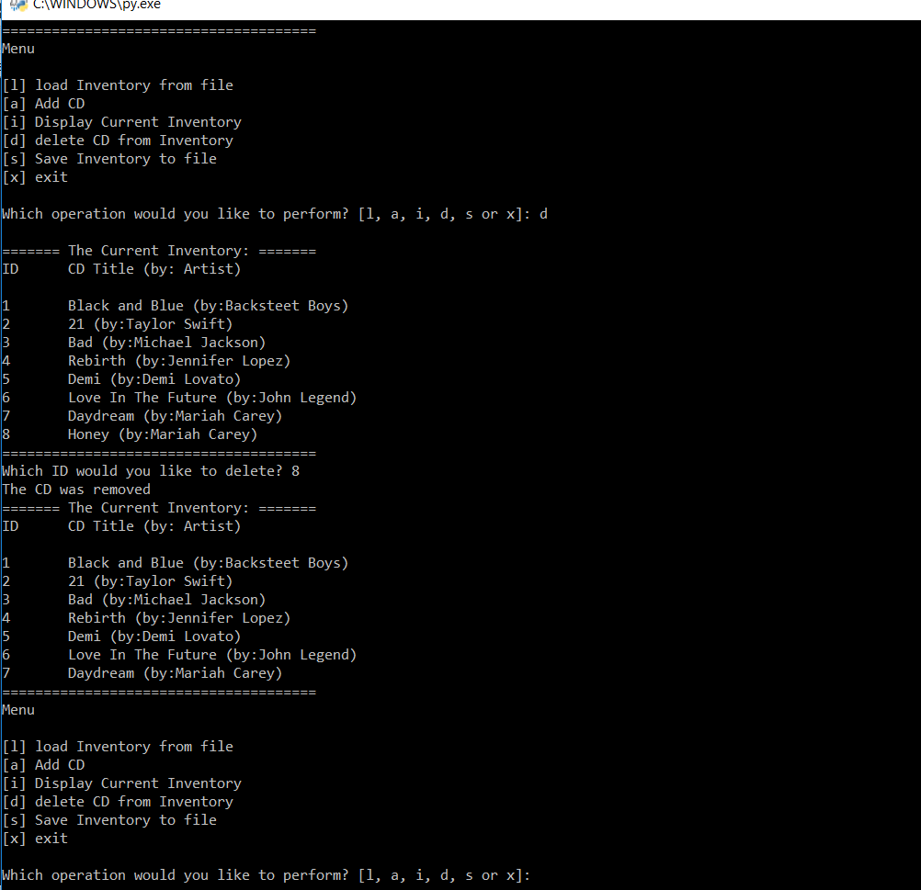

Table - Terminal Screen Shot 4