Carol Yuen

March 9, 2020

IT FDN 100 B

Foundation of Programming Assignment 7

Modifying a code and using Functions

# Introduction

In Module 7 we learned about the new ways to save, read, and append files. We were able to open(), write() and close() all in one function.

In this section, we also looked at reading lines from the file. For example if we needed to just read the 4th line from the file, we were able to set the function and not read the rest of the Text.

In addition to learning these new ways handling text files, we touched on how to use error handling in our codes. These error handling allows for the system to generate an error message to the user without stopping the program from ending.

# Modifying the Script

Taking the script that we wrote in assignment 6, we took this and add error handling message where we saw fit. In my script, I added the “Try” and “Except” to the functions where we loaded the file, added cd, and delete cd.

Using the FileNotFoundError [5], allowed for the script to generate an error handling when the file is not located and advising that you will not be able to proceed with loading if that was selected. The user in this case, will still be able to add, delete and save, but when saving would create a new text file.

In Figure 1, I intentionally change the file name before running the script, to check if the error handling worked. As seen on the right side of figure 1, the console show “This File CDInventory2.txt could not be loaded”

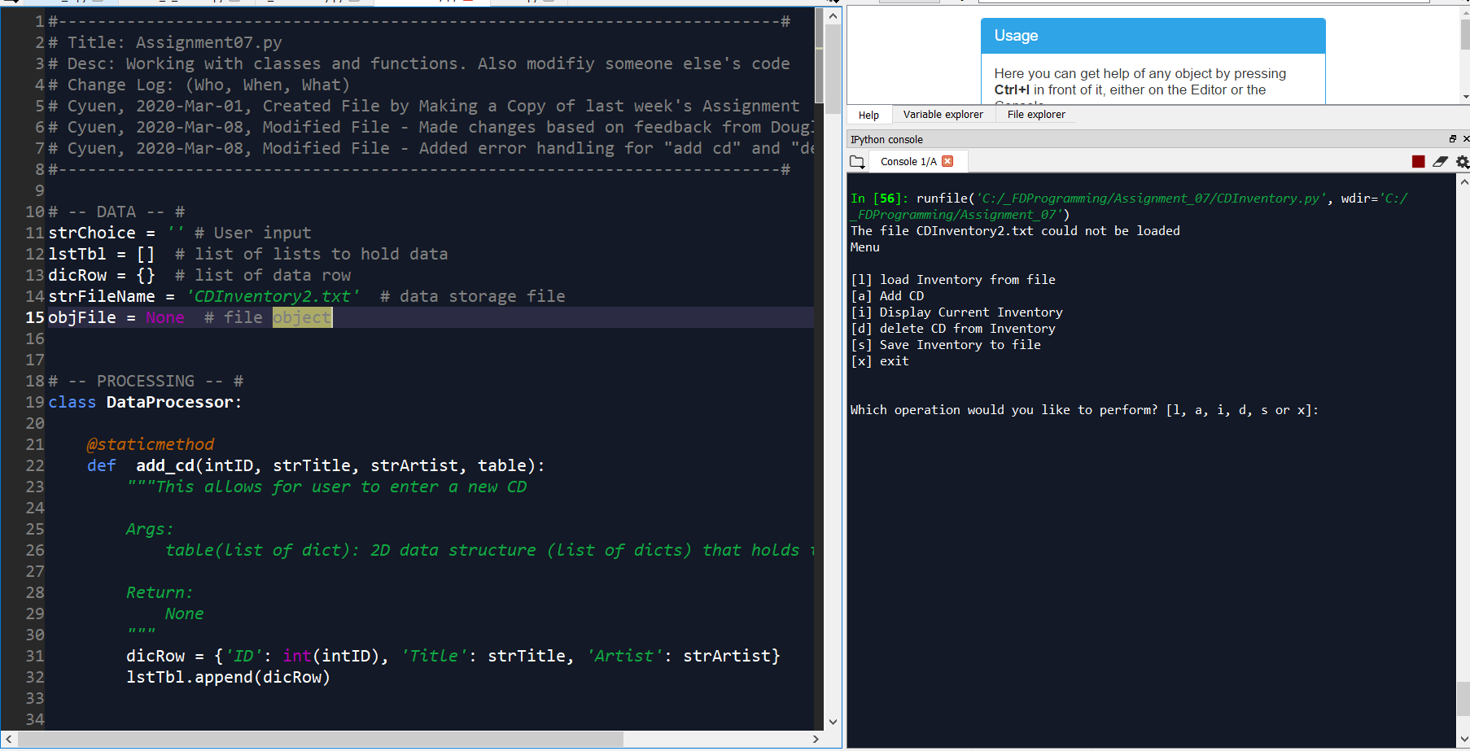

Figure - FileNotFoundError

In the Add and Delete CD selection, I added the error handling to ensure the user is entering an integer for the ID and not anything else.

Figure - Add_Cd_Error

In figure 2, we can see that I intentionally for the “ID” entered “P” instead of an integer and as a result the provided an error and allows for the user to start over from the menu. Without this error handling we would have seen the result differently as shown in figure 3.

In figure 3, we see that the code allows for the user to proceed till adding of the Artist Name but will stop and reflect an error. As a result the script will stop running due to the error.

# Summary

In Summary, I thought this section was very useful for me as I’m writing out these codes and learning how items are structured. Using a function to save, read and append a file, I thought was much simpler and easier to read.

The Error handling took a couple of trials and modification on my end when writing the code as I initially got lost in how it should have been structured. After understanding what was required, I was able to get the error handling to work and made the testing of the script easier on my end.

# Appendix

References:

* [1] Foundation of Programming (Python) By Dirk Biesinger Module 7 Part 1 to Part 4
* [2] Terminal Screen Shots (last two pages of Assignment07.docx)
* [3] Python Standard Library: Built-In Exceptions <https://docs.python.org/3/library/exceptions.html>

[2] Terminal Screen Shot:

Listing - Error Handling with AddCd

Listing - Error handling with DeleteCd