Campus Incident Reporting App: A Technical Report on the Architecture,
Data Model, Access Control, and Testing of a Flutter and Firebase Application

Germain Cyuzuzo
African Leadership University
Mobile Application Development
Instructor: ______________________
November 6, 2026

Abstract
This report documents the design and implementation of the Campus Incident Reporting App, a cross-platform mobile application that lets university students report campus problems (for example, broken lights, water leaks, or safety hazards) and lets campus staff review and resolve them. The application is built with Flutter and uses Firebase Authentication, Cloud Firestore, and Firebase Storage as its backend. It follows a layered architecture in which presentation widgets depend on Cubits for state, Cubits depend on repositories, and only repositories communicate with Firebase. Two roles, student and staff, are enforced in three places: the router, the user interface, and, most importantly, server-side Firestore and Storage security rules. Students can submit, edit, and withdraw their own reports while they are still pending, browse every report on campus in read-only form, and mark themselves as affected by a classmate’s report. Staff move reports through a Submitted, In Progress, and Resolved workflow with optional comments, or reject them with a mandatory reason. The report explains the Firebase data structure, the state management approach, the access-control model, and the user interface decisions, and justifies each major technical choice. It also describes a testing strategy of 111 automated unit, Cubit, and widget tests plus 35 security-rule scenarios run against the Firestore emulator, the challenges encountered during development, and the lessons learned.
Keywords: Flutter, Firebase, Cloud Firestore, security rules, Cubit, role-based access control, mobile application architecture

Campus Incident Reporting App: A Technical Report
Universities depend on students to notice problems with shared facilities, but informal channels such as word of mouth, messaging groups, or emails to a general inbox make it hard to know whether an issue has been reported, who is handling it, and when it was fixed. The Campus Incident Reporting App replaces those channels with a single, structured workflow. A student describes the problem, chooses one of five categories (Facilities, Water, Electricity, Safety, Sanitation) and a campus location, optionally attaches a photo, and then follows the report as staff move it forward. Staff see every report on a dashboard and update its status, leaving comments that the student can read.
The objectives of the project were to (a) deliver a usable student and staff experience on Android, with the same code also running in a web browser; (b) keep the code maintainable through a clear separation of concerns; (c) enforce roles on the server rather than only in the interface; and (d) verify behaviour through automated tests. This report describes how those objectives were met. It covers the application architecture, the Firebase data structure, the state management approach, user roles and access control, user interface and user experience (UI/UX) decisions, the testing strategy, the challenges encountered, and the lessons learned. Major technical decisions are justified throughout and summarised in Table 8.

Scope and Features
The feature set was deliberately kept to what the assignment and the follow-up requirements specified. Table 1 lists the features by role.
Table 1
Features by Role
Role | Feature | Where it lives
Student | Sign up (always as a student), log in, reset a forgotten password | Login, Sign Up, Forgot Password screens
Student | Report an incident: category, title, description, location, optional photo, with inline validation | Report an Incident screen
Student | Track own reports with search, status filters and a category filter; live status timeline | Home, My Reports, Incident Details
Student | Browse every student’s reports read-only; mark or unmark “This affects me too” | Campus Reports tab, Incident Details
Student | Edit or withdraw an own report while it is still Submitted | Incident Details, Edit Report screen
Staff | See all reports with counts per status, search and filters | Staff Dashboard
Staff | Move a report one step forward with an optional comment | Incident Details (Update Status card)
Staff | Reject an open report with a mandatory reason | Incident Details (Reject Report dialog)
Both | Profile with role badge and log out | Profile screen

Technology Stack
The application targets Flutter 3.44 with Dart 3.12. Table 2 lists the main packages and the reason each was chosen.
Table 2
Main Packages and Their Purpose
Package (version) | Purpose
firebase_core 5.1, firebase_auth 7.0, cloud_firestore 7.1, firebase_storage 14.0 | Firebase initialisation, email/password authentication, the document database, and photo storage
flutter_bloc 9.1, equatable 3.0 | Cubit-based state management with value-equality states (Angelov, n.d.-a)
go_router 17.5 | Declarative routing, nested navigation shells per role, and central redirects (Flutter Team, n.d.)
image_picker 1.2 | Taking or choosing a photo on Android and in the browser
intl 0.20 | Date and time formatting
bloc_test 10.0, mocktail 1.0 (development) | Testing Cubits and mocking repositories without code generation (Angelov, n.d.-b)

Application Architecture
The code base (70 Dart source files, about 6,900 lines) is organised as four layers with dependencies pointing in one direction only, as shown in Figure 1. This mirrors the layered approach recommended in Flutter’s own architecture guidance, which separates a UI layer from a data layer of repositories and services (Google, n.d.-e), and applies the dependency rule of Clean Architecture: inner, more stable layers never depend on outer, more volatile ones (Martin, 2017).
Figure 1
Layered Architecture of the Application
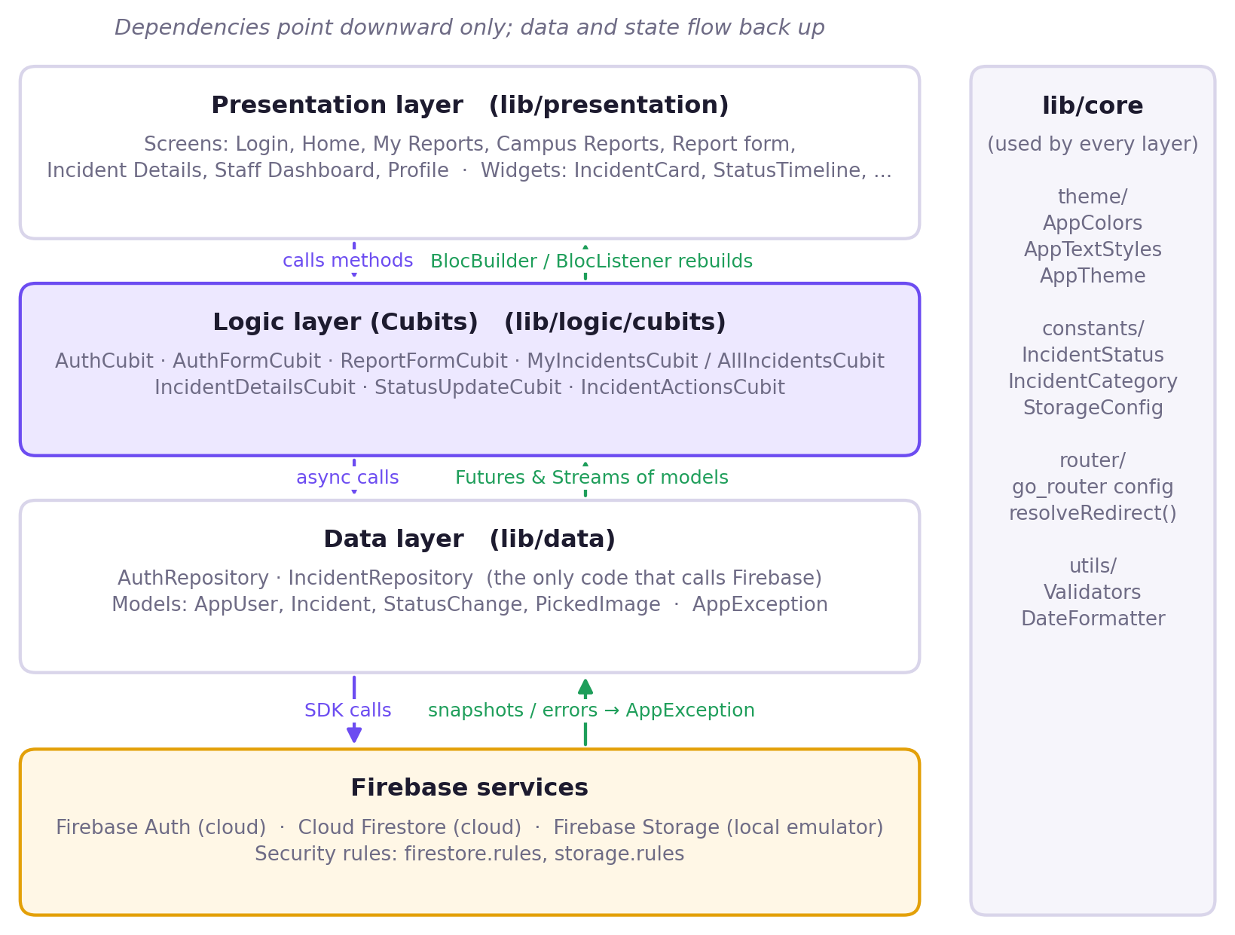
Note. Arrows on the left show calls going down; arrows on the right show data and state coming back up. lib/core holds cross-cutting code (theme, constants, router, and utilities) that every layer may use.

Layer Responsibilities
- Presentation (`lib/presentation`). Screens and reusable widgets. Widgets read state through BlocBuilder and BlocListener and call Cubit methods in response to user actions. They never call a repository or a Firebase SDK directly.
- Logic (`lib/logic/cubits`). One Cubit and one immutable state class per feature. Cubits hold the rules of each interaction (for example, that a rejection needs a reason) and translate repository results into states.
- Data (`lib/data`). Immutable models (AppUser, Incident, StatusChange, PickedImage) and two repositories, AuthRepository and IncidentRepository. The repositories are the only classes that import Firebase packages, and they convert every Firebase error into an AppException that carries a message suitable for the user.
- Core (`lib/core`). The design tokens (AppColors, AppTextStyles, AppTheme), domain enumerations (IncidentStatus, IncidentCategory), the router and its pure redirect function, validators, and date formatting.
This separation has three practical benefits. First, Cubits can be unit-tested with a mocked repository, so most logic is tested without Firebase. Second, swapping the backend, for example moving photos from the Storage emulator to a cloud bucket, touches only the data layer and a configuration flag. Third, user-facing error messages are produced in one place, so the interface never shows raw exception text.

Deployment View
Figure 2 shows how the running application connects to its services. Authentication and Firestore always use the real Google Cloud project. Photos use the official Firebase Storage Emulator on the developer’s machine, for reasons explained in the Challenges section. The same security rules files are evaluated by the cloud services and by the emulator.
Figure 2
Deployment and System Context
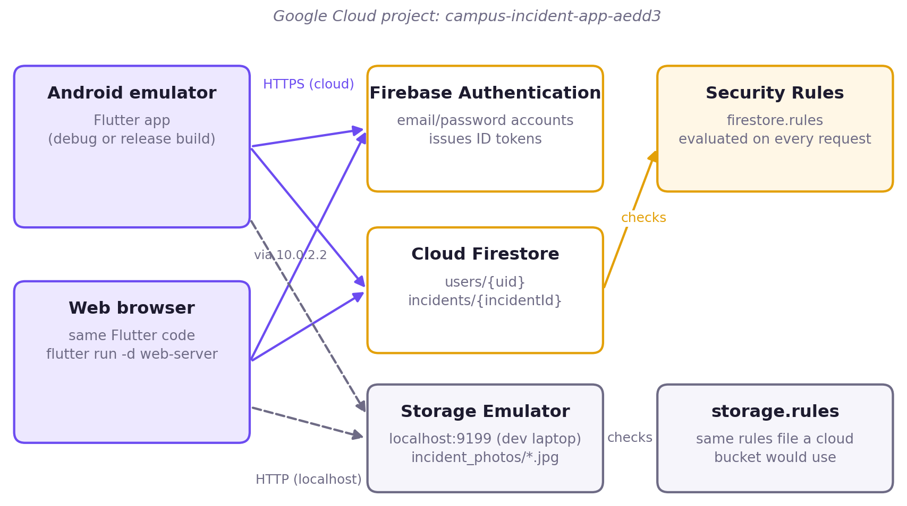
Note. The Android emulator reaches the developer machine at the alias address 10.0.2.2, while the browser uses 127.0.0.1. StorageConfig.displayUrl rewrites saved photo URLs so that a photo uploaded from one platform also displays on the other.

Navigation and Routing
Navigation uses go_router with one StatefulShellRoute per role. The student shell has four tabs (Home, My Reports, Campus Reports, Profile) and a central button that opens the report form; the staff shell has a Dashboard and a Profile tab. Each tab keeps its own navigation stack, so switching tabs does not lose a scroll position or an open screen. Incident Details and the Edit Report screen are shared routes pushed above the shells.
All redirect decisions are made by a single pure function, resolveRedirect(authState, location), which the router re-runs every time the authentication state changes (Figure 3). Because it is a pure function of its inputs, every rule (signed-out users go to the login screen, students can never open /staff routes, staff never see student-only tabs) is covered by plain unit tests without building a widget tree.
Figure 3
Role-Based Routing Decided by resolveRedirect
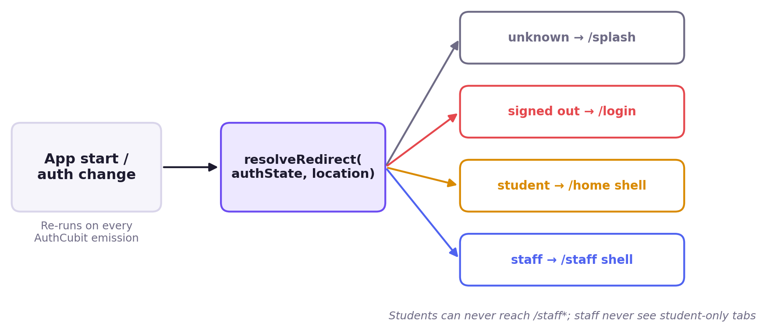

Firebase Data Structure
Cloud Firestore stores data as documents grouped in collections, and its pricing and performance depend mainly on the number of documents read and written (Google, n.d.-b). The schema was therefore designed so that each screen is served by one query or one document listener. There are two top-level collections, users and incidents, plus a folder of photos in Storage (Figure 4).
Figure 4
Firestore Collections, Embedded History, and Storage Paths
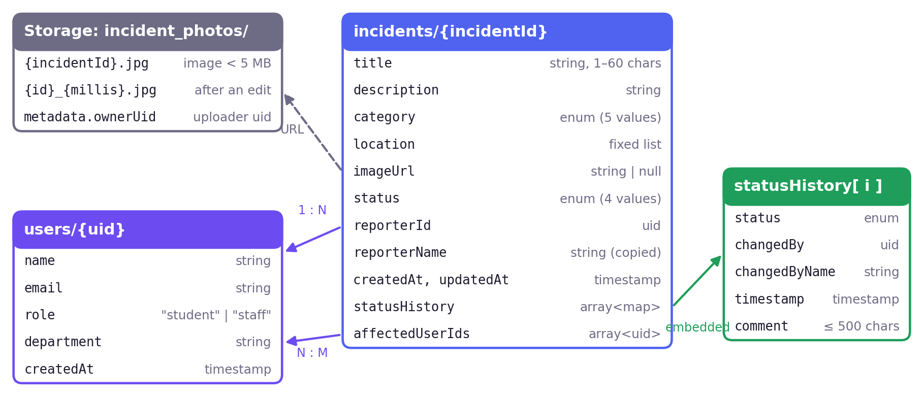
Note. Arrows show references by ID or URL; statusHistory entries are embedded maps inside the incident document rather than a separate collection.

The users Collection
Each document is keyed by the Firebase Authentication user ID, so a user’s profile can be fetched without a query, and security rules can compare the document ID with request.auth.uid directly.
Table 3
Fields of users/{uid}
Field | Type | Notes
name | string | Full name entered at sign-up
email | string | Copy of the Auth email, for display
role | string | student or staff; always student at sign-up; only changeable from the Firebase console
department | string | Shown on the profile and My Reports header
createdAt | timestamp | Server timestamp

The incidents Collection
Table 4
Fields of incidents/{incidentId}
Field | Type | Notes
title, description | string | Title 1–60 characters (checked in the app and in the rules); description at least 10 characters
category | string | One of facilities, water, electricity, safety, sanitation
location | string | Chosen from a fixed list of campus locations
imageUrl | string or null | Download URL of the optional photo
status | string | submitted, in_progress, resolved or rejected
reporterId, reporterName | string | Who filed the report; the name is copied (denormalised) for display
createdAt, updatedAt | timestamp | Server timestamps
statusHistory | array of maps | One entry per status change: status, changedBy, changedByName, timestamp, optional comment (at most 500 characters)
affectedUserIds | array of strings | IDs of other students who marked themselves as affected

Design Decisions in the Data Model

Embedding the Status History
The history of status changes is stored as an array inside the incident rather than as a subcollection. An incident has at most four history entries, so the document stays small, the details screen needs only one listener, and a status change and its history entry are written atomically in the same update. The trade-off is that history entries cannot be queried on their own, which the application never needs to do.

Denormalising the Reporter’s Name
Storing reporterName on each incident avoids an extra read of the reporter’s profile for every card in a list. Because names cannot be edited inside the app, the copy cannot drift out of date. Staff names in history entries are copied for the same reason.

An Array for Affected Students
affectedUserIds lets a student add or remove themselves with Firestore’s atomic arrayUnion and arrayRemove operations, and lets the security rules check that the only change is the caller’s own ID. Arrays are appropriate for the tens of affected students expected per report; if a single report could gather thousands, a subcollection with a counter would scale better.

Avoiding Composite Indexes
The My Reports query filters on reporterId and sorts on the client, and the all-reports query only orders by createdAt. Neither needs a composite index, which keeps deployment simple. Client-side sorting is acceptable because a single student has a small number of reports.

Photo Storage Layout
Photos are stored at incident_photos/{incidentId}.jpg. When a reporter replaces a photo while editing, the new one gets a time-stamped name ({incidentId}_{milliseconds}.jpg), so cached copies of the old image are never shown and no file is ever overwritten. Every upload records the uploader’s ID in the object metadata (ownerUid), which the Storage rules use to allow only that user to delete the photo.

State Management Approach
The application uses the Cubit pattern from the flutter_bloc library (Angelov, n.d.-a). A Cubit is a class that exposes a stream of immutable states and public methods that emit new states; widgets rebuild when the state they depend on changes. States extend Equatable, so two states with the same values are equal, which prevents unnecessary rebuilds and makes test expectations simple to write. The project rule is that setState is never used for app-wide state; it is used only for short-lived widget concerns such as a text controller or a password-visibility toggle.
Table 5
Cubits and Their Responsibilities
Cubit | Responsibility
AuthCubit | Session for the whole app: listens to Auth changes, then to the user’s profile document; exposes the role used by the router. Signs out with a clear message if no profile appears within 10 seconds.
AuthFormCubit | Submission state for log-in, sign-up and password-reset forms
ReportFormCubit | Category, location and photo selections, validation and submission; also handles editing when given an existing incident
MyIncidentsCubit, AllIncidentsCubit | Live lists (own reports; all reports) built on a shared IncidentListCubit that adds client-side search, status and category filters
IncidentDetailsCubit | Live stream of one incident for the details and edit screens
StatusUpdateCubit | Staff actions: move forward with an optional comment, or reject with a required reason
IncidentActionsCubit | Student actions: mark or unmark as affected, withdraw an own report

Figure 5 traces a staff status update through the layers. The Cubit first emits an updating state, which disables the buttons and shows a spinner. The repository performs a Firestore transaction that re-reads the incident and checks that the requested move is still valid, so two staff members acting at once cannot skip or repeat a step (Google, n.d.-i). The security rules check the same conditions on the server. When the write commits, the Cubit emits success and a snackbar confirms the change; independently, the details screen’s live listener receives the new document and redraws the timeline and badge. Because lists and details are driven by Firestore streams rather than by manual refreshes, every open screen, including another user’s, updates within moments.
Figure 5
Sequence of a Staff Status Update Through the Layers
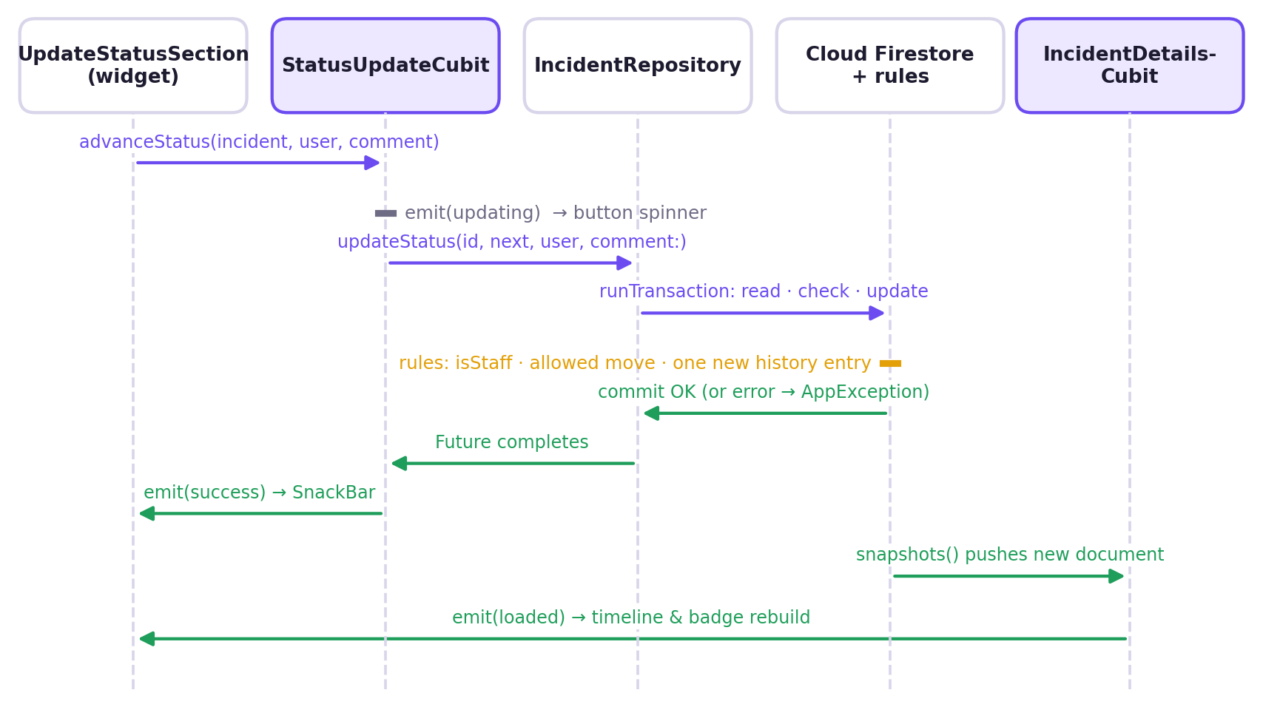

Why Cubit
Several alternatives were considered. Plain setState with InheritedWidget would have mixed business logic into widgets and made it hard to test. Provider with ChangeNotifier is simpler, but mutable notifiers make it easier to forget a notification and harder to assert on a sequence of states. The full Bloc pattern with event classes adds traceability, but for this app every interaction is a direct method call, so events would have added boilerplate without benefit. Cubit kept the logic out of the UI, produced a predictable sequence of immutable states that bloc_test can assert on exactly, and fitted the course’s recommended tooling.

User Roles and Access Control
The application has two roles stored in the role field of each user document. Sign-up always creates a student; a staff account is created by signing up and then having an administrator change the field to staff in the Firebase console. The application never offers a way to choose or change a role. This follows the principle of least privilege, under which every user operates with the smallest set of permissions needed for the job (Saltzer & Schroeder, 1975), and addresses insecure authorisation, one of the most common risks in mobile apps (OWASP Foundation, 2024).

Defence in Depth
Roles are enforced in three layers, and each layer assumes the one before it can be bypassed:
- Router. resolveRedirect keeps students out of staff routes and sends each role to its own shell.
- User interface and Cubits. Controls are shown only to users who may use them (for example, the Update Status card only for staff, and Edit and Withdraw only for the reporter of a Submitted report), and each Cubit re-checks the role and the incident’s state before calling the repository.
- Security rules. firestore.rules and storage.rules are evaluated by Google’s servers on every request, regardless of which client sends it (Google, n.d.-d). They are the only layer that a modified or hand-written client cannot skip, so every permission in Table 6 is enforced there.
Table 6
Permission Matrix Enforced by the Firestore Rules
Action | Student (own report) | Student (others’ report) | Staff
Read any incident | Yes | Yes (read-only) | Yes
Create an incident | Yes, as themselves, status submitted, empty affected list | — | Not offered in UI
Edit title, description, category, location, photo | Only while submitted | No | No
Withdraw (delete) | Only while submitted | No | No
Mark or unmark as affected | No | Only their own ID; joining closed once resolved or rejected | No (UI)
Change status | No | No | Only allowed transitions, one new history entry, comment ≤ 500 characters, reason required to reject
Change own role | No | No | No (console only)

Status Workflow
Figure 6 shows the status workflow that the rules enforce. Staff may move a report one step forward (Submitted to In Progress, In Progress to Resolved) with an optional comment, or reject a Submitted or In Progress report with a reason. Resolved and Rejected are final. The rules check the old and new status against the allowed transitions, require that exactly one history entry be appended and that its status match the new status, and require a non-empty comment on a rejection. Staff status is determined by reading the caller’s own user document with get() inside the rules. Firebase custom claims would avoid that extra document read, but setting them requires the Admin SDK running on a server or in Cloud Functions, which would need the paid Blaze plan; the document lookup was judged an acceptable cost for this project.
Figure 6
Incident Status Workflow
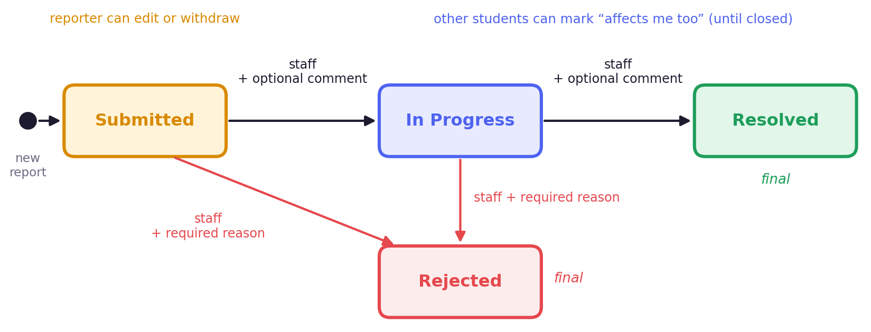
Note. Transitions in red require a written reason. While a report is Submitted, its reporter may also edit or withdraw it.

UI/UX Decisions
The interface follows a provided mockup: a light lavender background (#F6F5FB), a purple primary colour (#6C4CF1) with a purple gradient banner, white cards with 20-pixel rounded corners and a subtle border instead of shadows, 52-pixel-tall rounded buttons, and filled rounded input fields. All colours and text styles come from shared tokens (AppColors, AppTextStyles, AppDimens) and the Material 3 theme (Google, n.d.-g), so new screens stay consistent automatically. The decisions below are explained with reference to Nielsen’s (1994) usability heuristics.

Key Decisions
- Visibility of system status. Every incident shows a colour-coded status badge (Submitted amber, In Progress blue-purple, Resolved green, Rejected red) and a vertical timeline with the date, the staff member and any comment for each step. Buttons show a spinner while work is in progress, and snackbars confirm the result.
- Colour is never the only signal. Each badge also carries its text label and each category has an icon, in line with WCAG 2.2 success criterion 1.4.1, which forbids conveying information by colour alone (World Wide Web Consortium [W3C], 2023).
- Recognition rather than recall. Categories are large tiles with icons, and locations come from a fixed drop-down list, so students do not have to type or remember names and staff receive consistent data.
- Error prevention. Irreversible actions (moving a status, rejecting, withdrawing) open a confirmation dialog that names the report and states that the action cannot be undone. The reject dialog will not close until a reason is entered.
- Helpful errors. Forms validate inline and show a specific message under each field; failed network actions show a plain-language message from AppException instead of a technical error.
- Empty, loading and failure states. Every list has a distinct empty state, a loading indicator and a failure state with a Try again button.
- Transparency for students. A rejected report shows a red banner with the staff member’s reason at the top of the details screen, so the student understands the decision without contacting anyone.
- Touch targets. Primary buttons are 52 pixels tall, above the 48-pixel minimum recommended by Material Design (Google, n.d.-g).
- Accessibility tree. Standard Flutter widgets with text labels expose a complete semantics tree, which screen readers use. The same labels made the user interface scriptable for the automated screenshots in this report.

Screenshots of Important Workflows
The screenshots in Figures 7 to 14 were captured from the web build of the application in a 412 × 915 logical-pixel phone viewport, signed in as demonstration accounts created for this report (students Aline Uwase and Kevin Mugisha, and staff member Grace Ineza). Lists also contain a few reports created earlier during development. Long screens were captured in full, and large empty areas of plain background were shortened.
Figure 7
Authentication and Role Display
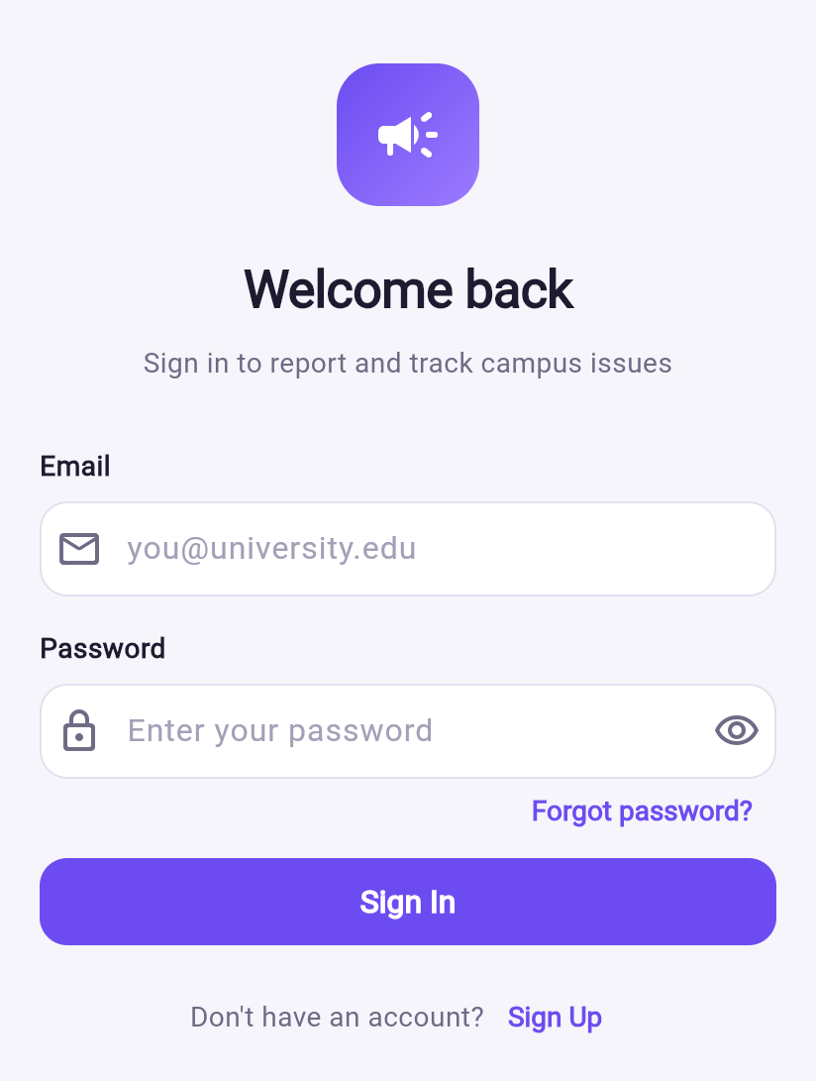  (a) Log in | 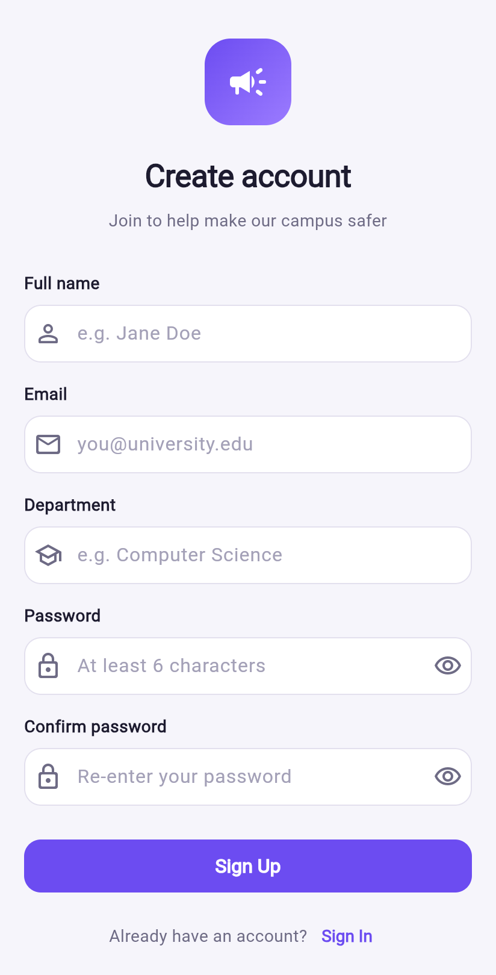  (b) Sign up (always a student) | 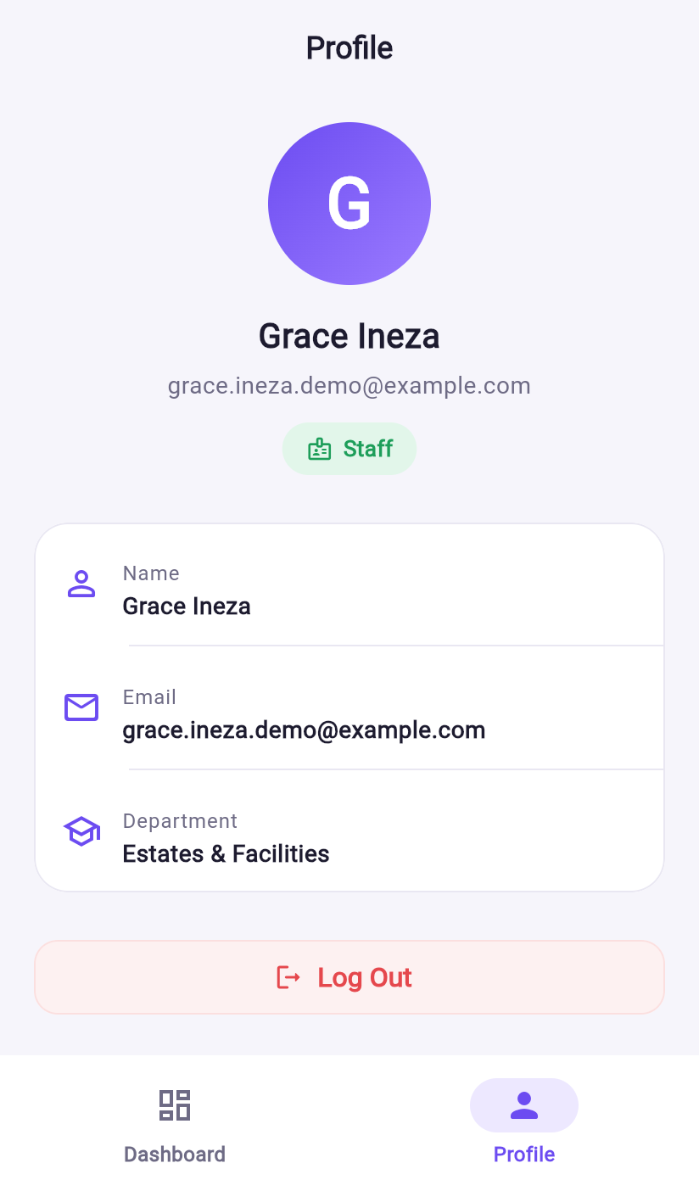  (c) Profile with Staff role badge
Figure 8
Student Home, My Reports, and Campus Reports
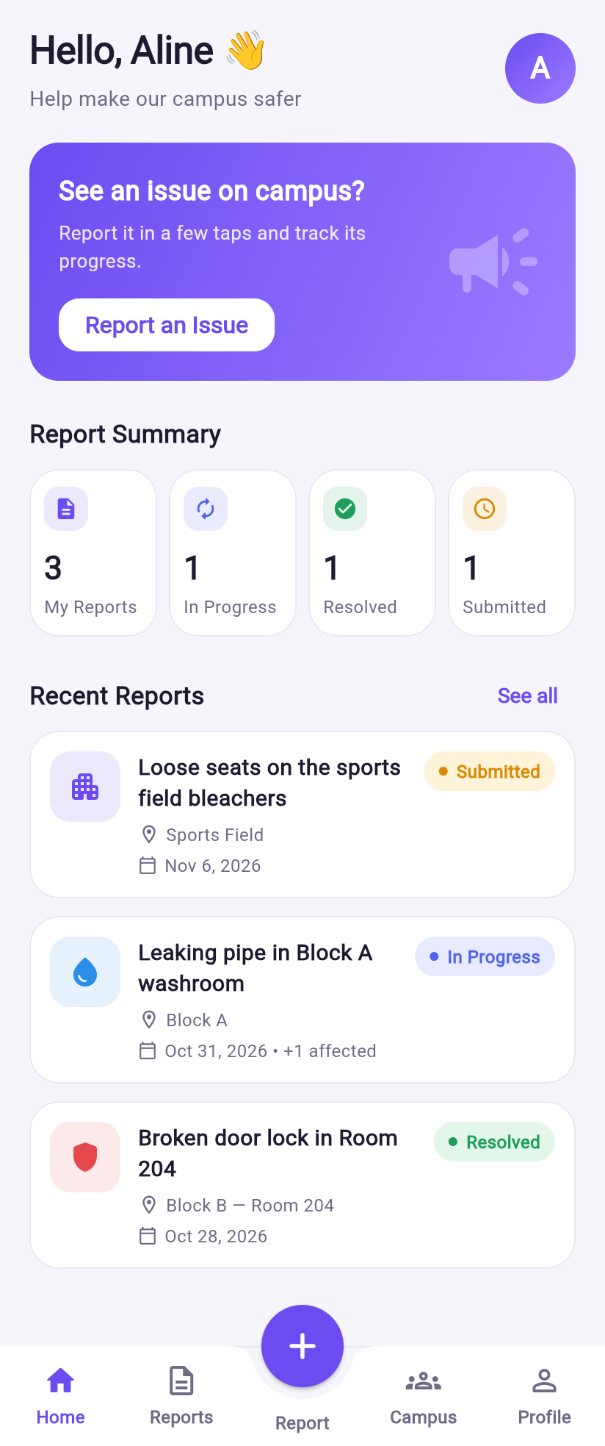  (a) Home with summary and recent reports | 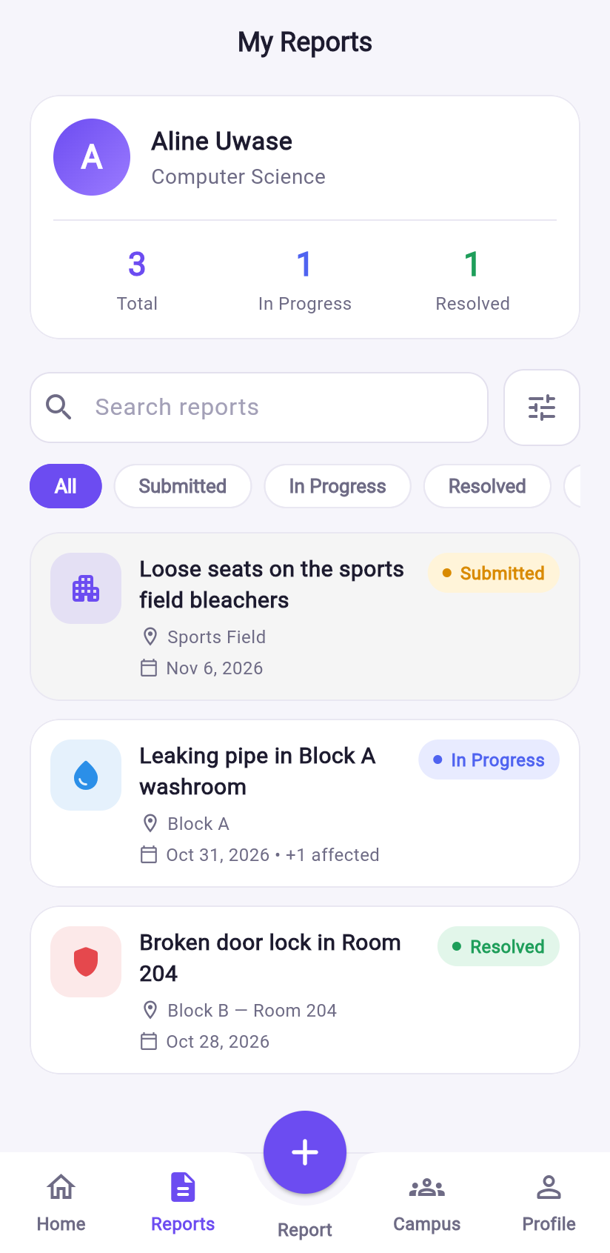  (b) My Reports with search and filters | 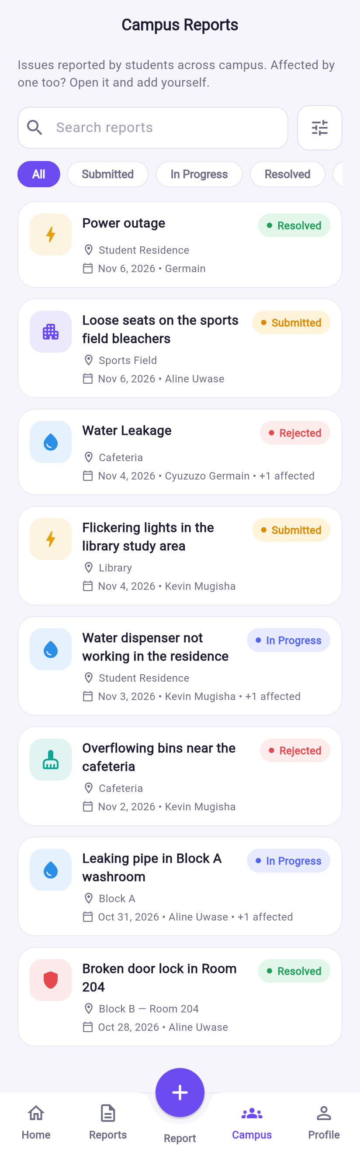  (c) Campus Reports (read-only)
Figure 9
Reporting an Incident
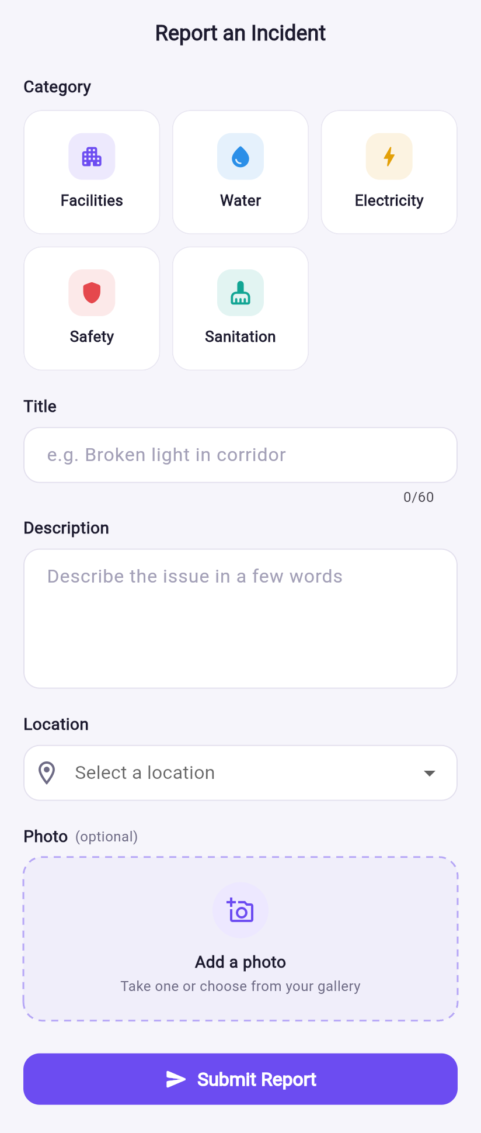  (a) Report form | 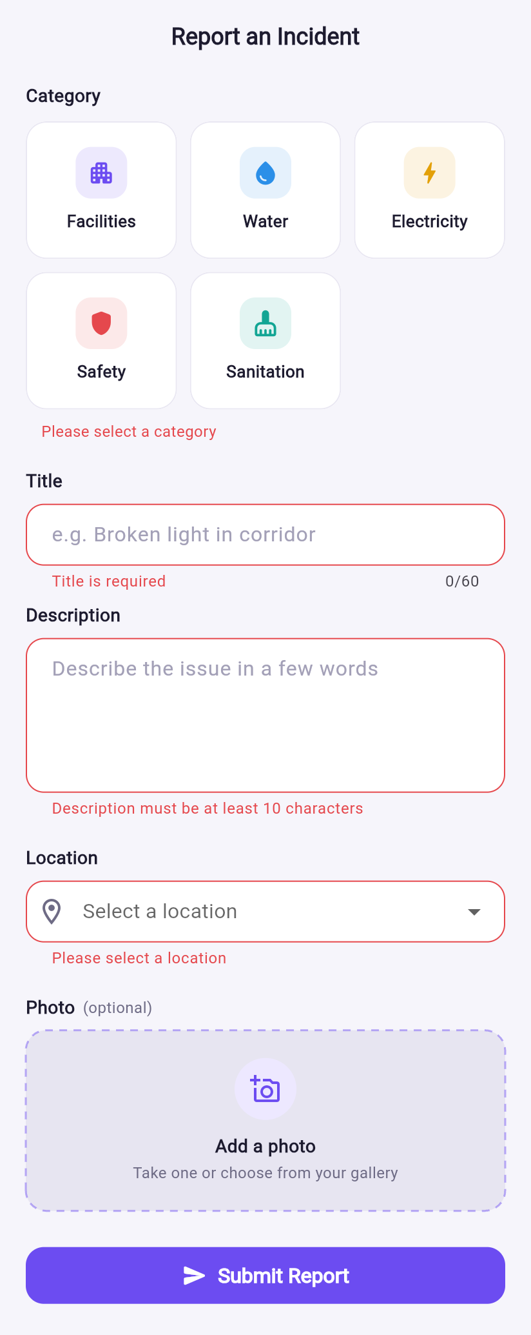  (b) Inline validation on an empty submit
Note. The photo field opens a choice between the camera and the gallery; the photo is optional.
Figure 10
Managing an Own Report While It Is Submitted
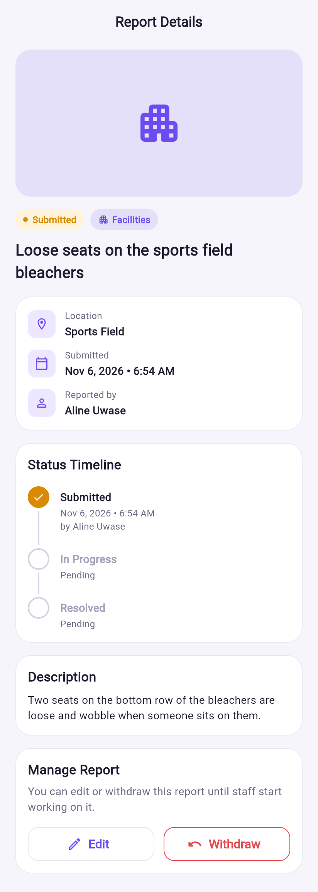  (a) Details with Edit and Withdraw | 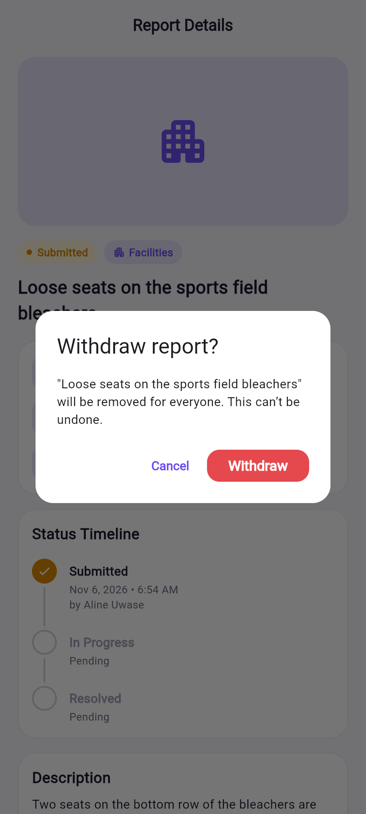  (b) Withdraw confirmation | 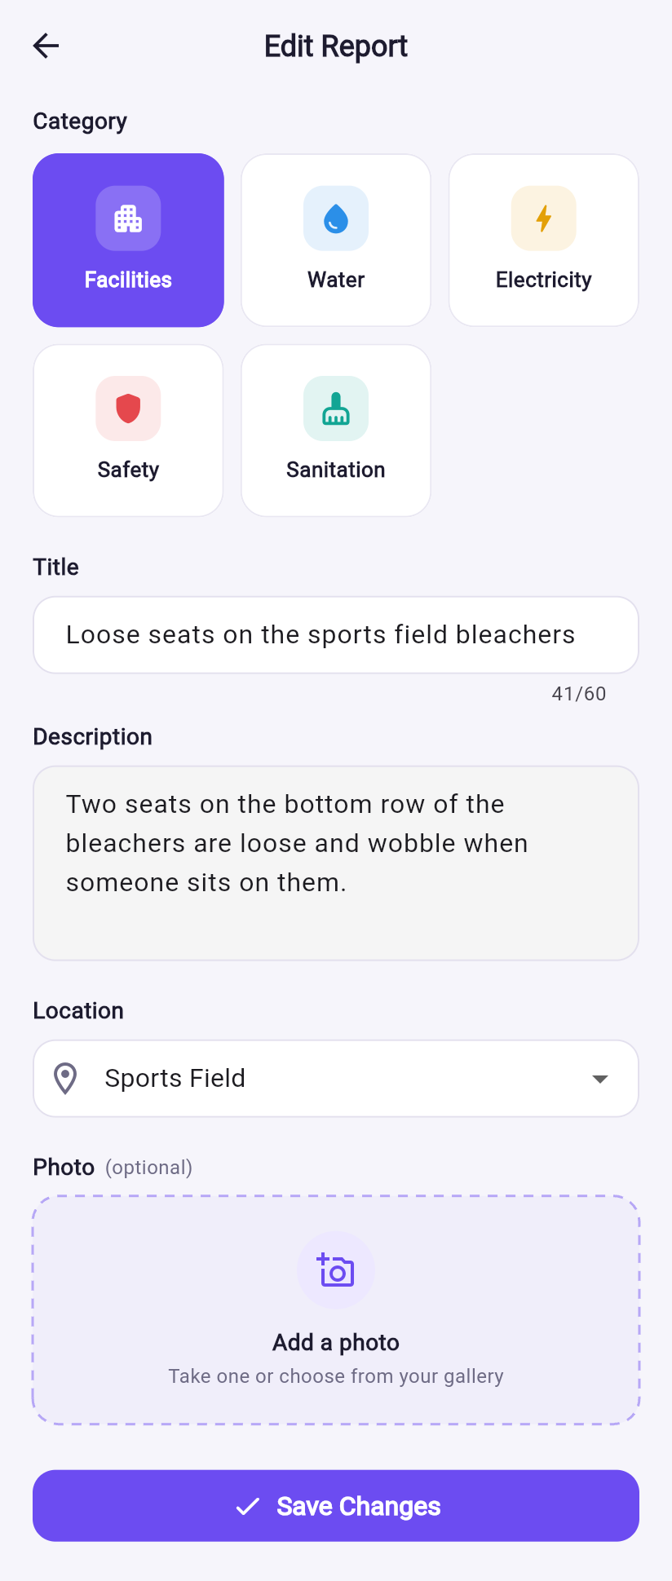  (c) Edit form, pre-filled
Figure 11
Viewing Other Students’ Reports and an In-Progress Report
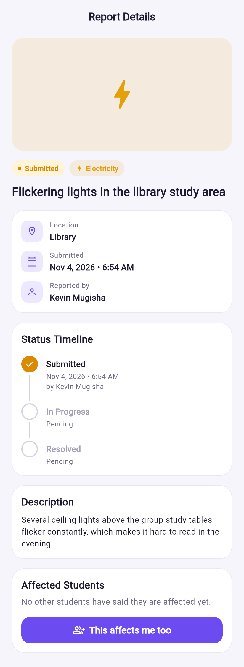  (a) Classmate’s report: “This affects me too” | 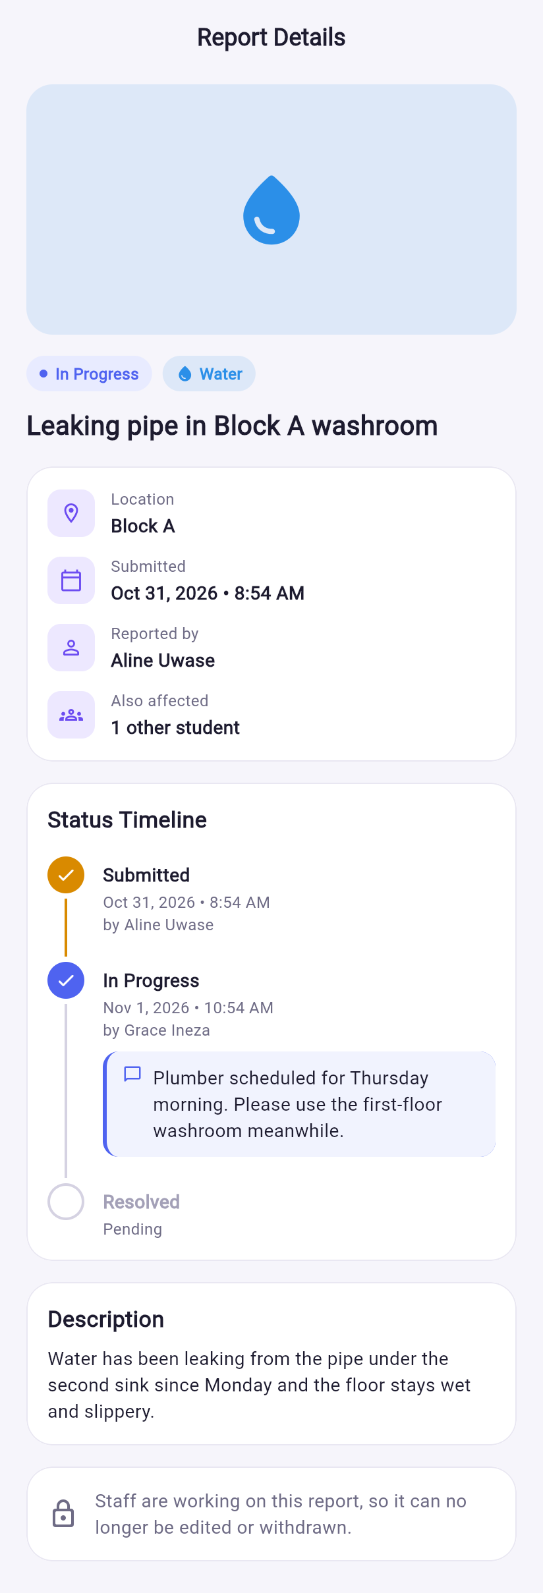  (b) Own report in progress: staff comment, affected count, locked
Figure 12
Staff Dashboard and Report Details
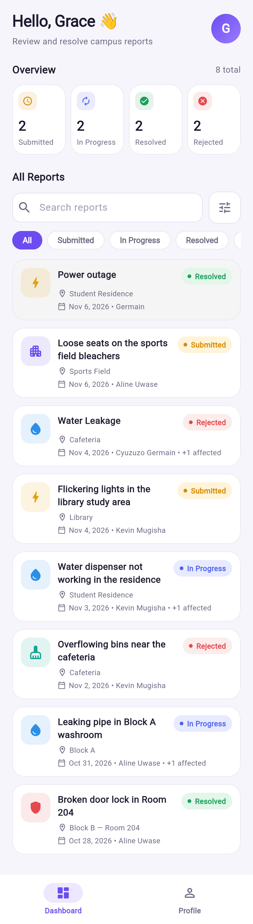  (a) Dashboard with counts per status | 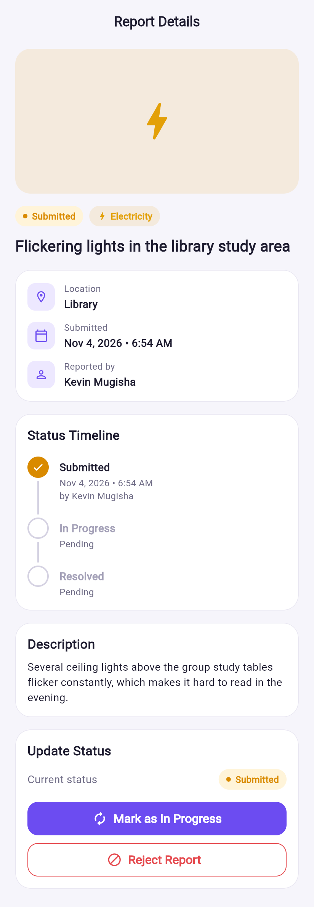  (b) Update Status card
Figure 13
Staff Update and Rejection Dialogs
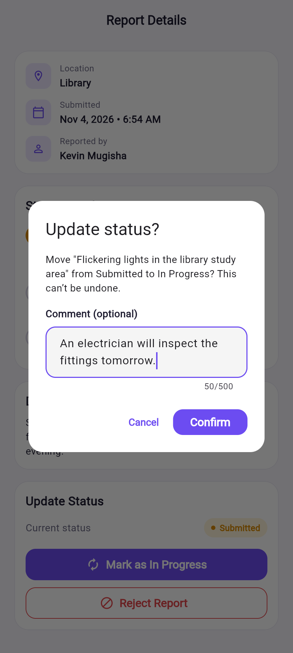  (a) Moving forward with an optional comment | 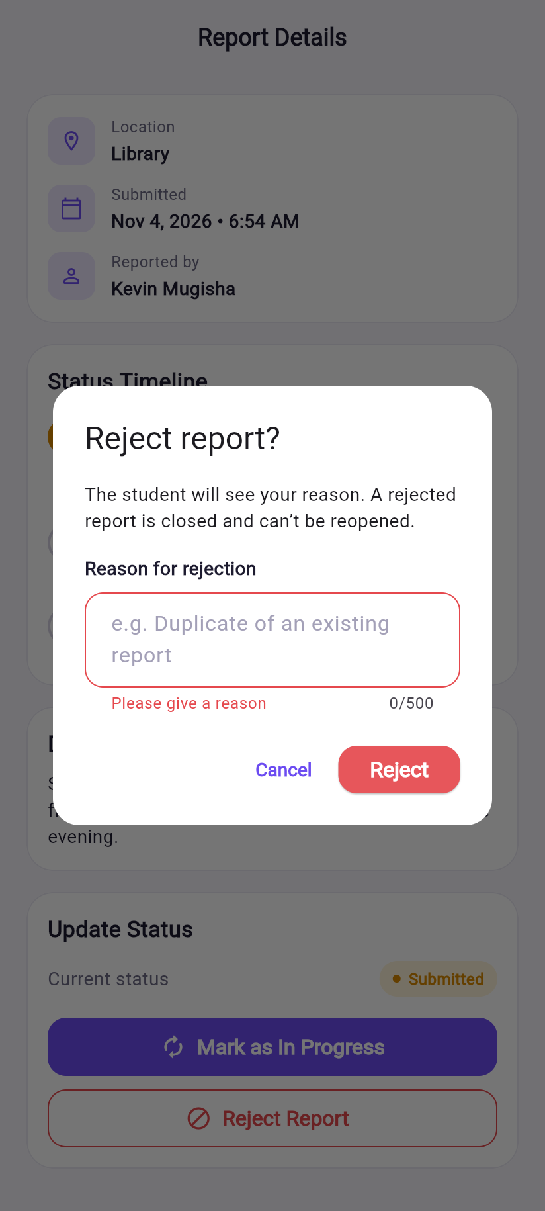  (b) Rejection requires a reason
Figure 14
Closed Reports
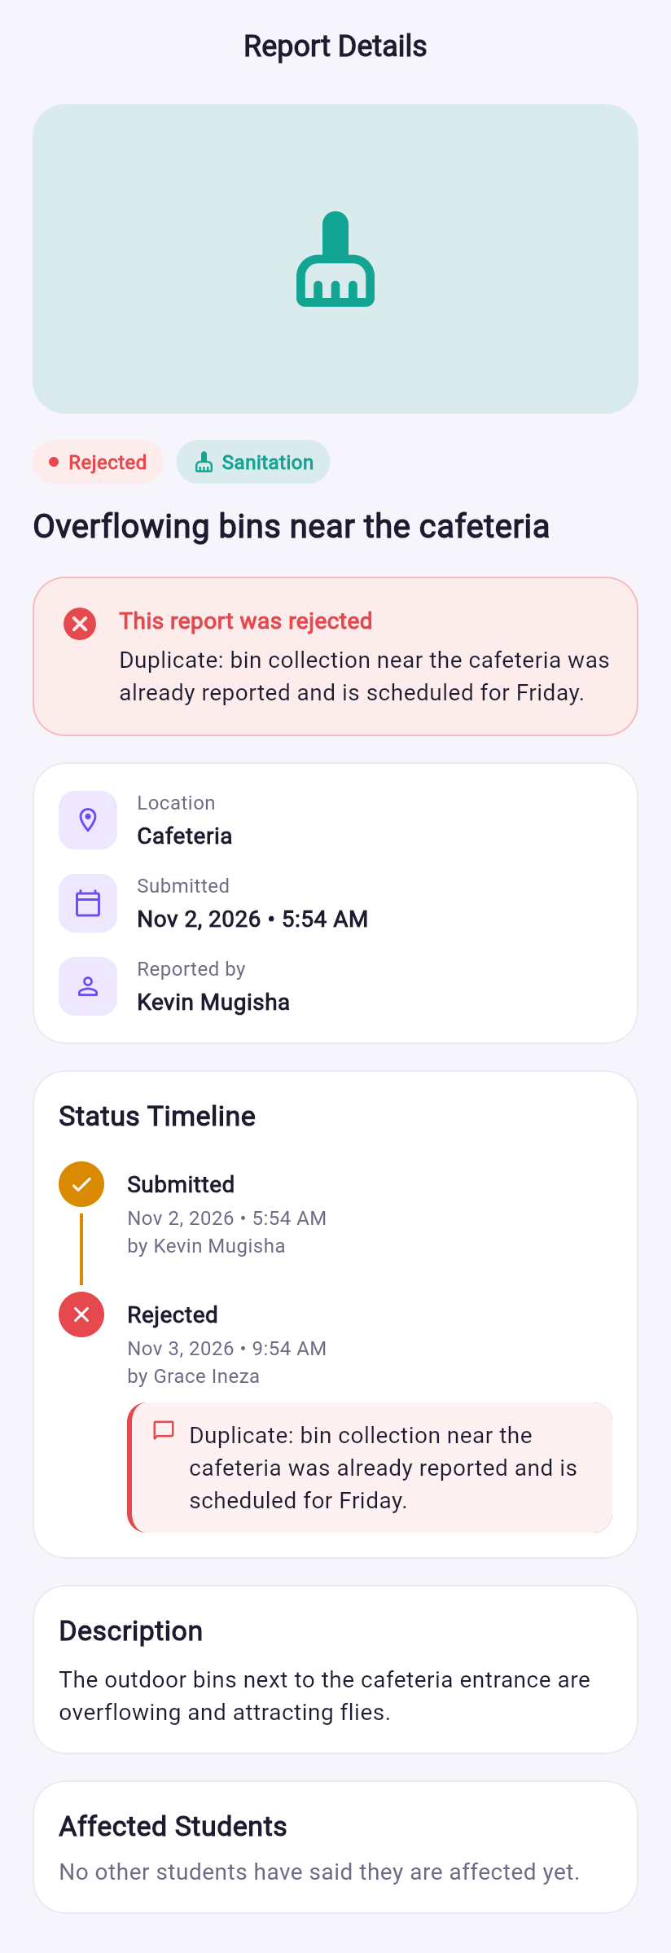  (a) Rejected: reason banner and timeline | 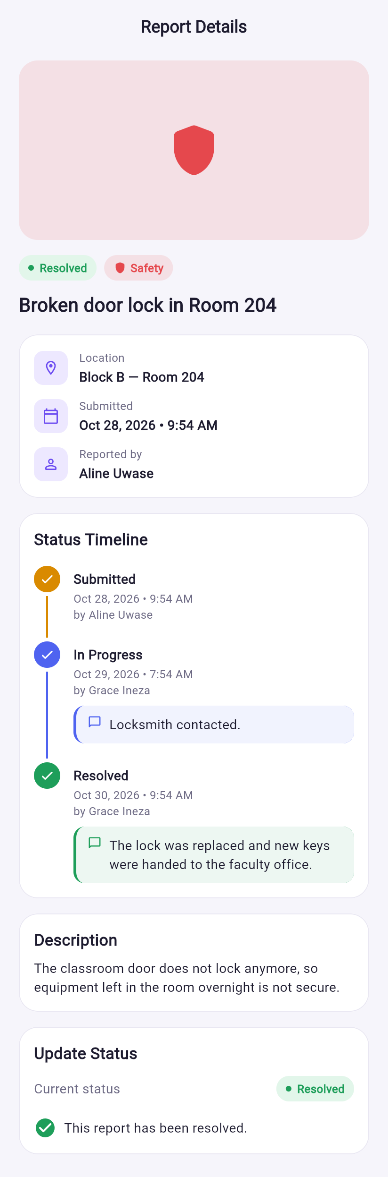  (b) Resolved: timeline with staff comments

Testing Strategy
Testing followed the shape of the test pyramid: many fast, isolated tests at the bottom and fewer, slower tests that exercise larger parts of the system at the top (Fowler, 2012; Google, n.d.-h). Repositories were replaced with mocktail mocks in Cubit and widget tests, so the automated suite runs in about 15 seconds without network access. Table 7 summarises the automated tests; all 111 pass.
Table 7
Automated Test Suite
Level | Files | Tests | What is covered
Unit | 6 | 43 | Models (fromMap/toMap round trips, defaults, rejection reason), status and category enums, validators, resolveRedirect, AppException messages, storage URL rewriting
Cubit (bloc_test) | 5 | 46 | Exact state sequences for authentication, report creation and editing, list filtering, status updates (comments, rejection rules, staff-only checks) and student actions (affected, withdraw)
Widget | 6 | 22 | Report form validation, incident card, status badge colours, timeline (comments, rejected path), staff dialogs (optional comment, required reason), student action sections
Total | 17 | 111

Security Rules Tests
Because the security rules are the real enforcement layer, they were tested separately against the Firestore emulator from the Firebase Local Emulator Suite (Google, n.d.-f). A script sent real requests as different signed-in users (two students and a staff member) and as an anonymous client, and checked whether each was allowed or denied. The 35 scenarios included: a student reading a classmate’s report (allowed); a signed-out read (denied); adding someone else to the affected list (denied); a reporter editing a report after it moved to In Progress (denied); staff skipping from Submitted straight to Resolved (denied); rejecting without a reason or with an empty reason (denied); a comment longer than 500 characters (denied); and changing a rejected report again (denied). All 35 behaved as expected. Creating the demonstration data for this report through the client APIs exercised the deployed rules a second time.

Manual Testing
A manual checklist (TESTING.md in the repository) covers what automated tests cannot: running on the Android emulator, using the camera and gallery, photo upload to the Storage emulator, and checking that two signed-in users see each other’s changes live. Static analysis with flutter analyze and the recommended lint rules reports no issues.

Limitations
The rules scenarios were run as an ad-hoc script and are not yet part of the repository’s automated suite, and there are no end-to-end integration tests that drive the full app against the emulators. Both are listed as future work.

Challenges Encountered

Cloud Storage Required a Paid Plan
New Firebase projects need the pay-as-you-go Blaze plan to use Cloud Storage (Google, n.d.-c). To avoid billing on a student project, photos were moved to the official Firebase Storage Emulator, which uses the same firebase_storage SDK and the same storage.rules. This introduced its own problems: the Android emulator reaches the host machine at 10.0.2.2 while the browser uses 127.0.0.1, so saved URLs from one platform did not load on the other; and Android release builds block plain-HTTP traffic. These were solved with a single configuration class (StorageConfig) whose displayUrl rewrites emulator URLs for the current platform, a debug-only network security exception, and an explicitly named bucket, because the project has no default bucket. Switching to a cloud bucket later only requires turning off one flag.

Running the Same Code on Android and the Web
The first photo implementation used dart:io files, which do not exist in browsers. Photos are now read into memory as bytes (PickedImage), previewed with Image.memory, and uploaded with putData, which works on both platforms.

A Login That Worked Once and Then Failed
During testing, an account that had signed in successfully reported “account profile could not be found” the next day, while signing up again said the account already existed. Investigation with the Firebase command-line tools showed that the Cloud Firestore database had never been created for the project. Firestore’s latency compensation had shown the profile from the device’s local cache, so sign-in appeared to succeed, but the write never reached a server and disappeared when the cache was cleared (Google, n.d.-a). The database was created, and the sign-up code was hardened: the profile write now waits for server confirmation with a timeout and removes the half-created Auth account on failure, and signing up again with the same email and correct password now completes an interrupted sign-up instead of failing.

Security Rules That Were Too Permissive
The original rules checked that only staff could change an incident’s status, but not which status changes were valid. A modified client could therefore have skipped steps. When rejection and comments were added, the rules were rewritten to validate the transition, the appended history entry and the comment, and the emulator scenarios described earlier were written to prove it.

Extending the Status Model
Adding the Rejected status exposed code that had treated “has no next status” as meaning “resolved”, which would have given wrong messages for rejected reports. Named predicates (isClosed, canBeRejected) replaced those checks. The extra status also did not fit in the staff dashboard’s single row of summary cards on a phone, so the total count moved into the section heading.

Reused Screens When Navigating Between Reports
While capturing screenshots, changing the browser address from one report’s details to another’s kept showing the first report, because the router reused the existing screen and its Cubit kept watching the old ID. Normal in-app navigation was unaffected, but deep links on the web were. Giving the details and edit screens a key based on the incident ID fixed it.

Justification of Major Technical Decisions
Table 8 brings together the main decisions, the alternatives considered and the reasons for each choice.
Table 8
Major Technical Decisions
Decision | Alternatives considered | Justification
Flutter | Native Kotlin; React Native | One code base for Android and the web; Material 3 widgets match the mockup; course requirement
Firebase (Auth, Firestore, Storage) | Custom REST API and database | No server to build or host; live listeners for real-time updates; rules give server-side access control
Layered architecture with repositories | Calling Firebase from widgets | Testability, single place for error handling, backend can change without touching the UI
Cubit + Equatable | setState, Provider, full Bloc, Riverpod | Logic out of widgets, exact state sequences in tests, less boilerplate than events
go_router with role shells and a pure redirect function | Navigator 1.0 with manual checks | Central, testable role rules; per-tab navigation stacks; web URLs
Embedded statusHistory, affectedUserIds array | Subcollections | One read per screen, atomic updates, small bounded sizes
Role in a Firestore document checked with get() | Custom claims | Claims need the Admin SDK on a server or Cloud Functions (Blaze plan)
Firestore transactions for status, edit and withdraw | Plain updates | Prevents two users acting on stale data at the same time
Storage Emulator for photos | Blaze plan; storing images in Firestore | No billing; same SDK and rules as production; one-flag switch to the cloud
Withdraw deletes the report | A Withdrawn status | Removes it for everyone without adding a fifth status to every screen; allowed only before staff start

Lessons Learned
- The server is the security boundary. Hiding a button is a convenience, not a control. Writing the rules first and testing them with real allowed and denied requests caught gaps that UI testing never would have.
- Pure functions are the easiest code to trust. Moving the redirect logic into a function of the session state and the requested location made the most security-sensitive part of navigation testable in milliseconds.
- Local caches can hide backend problems. Firestore’s offline cache makes an app feel fast, but critical writes such as account profiles must be confirmed by the server, and failures must be surfaced instead of silently queued.
- Name the intent, not the mechanism. Checks such as “has no next status” broke as soon as the model grew; named predicates such as isClosed stayed correct.
- Emulators make constraints manageable. The Local Emulator Suite allowed realistic photo storage without billing and made it possible to test security rules safely.
- Immutable state pays off in tests. Because every Cubit emits value-equal states, tests can assert the exact sequence of states a user would see, which made regressions easy to spot when features were added.

Conclusion and Future Work
The Campus Incident Reporting App meets its objectives: students can report and follow campus issues, see what their classmates have reported and add their voice to it, and correct or withdraw their own reports before work starts; staff can manage every report with comments and documented rejections. A layered architecture with Cubit-based state management kept the code testable, and server-side security rules enforce the role model independently of the client. The main limitations are the use of the Storage emulator instead of a production bucket and the absence of end-to-end tests.
Future work includes moving photos to a cloud bucket once the Blaze plan is available; adding the rules scenarios to the repository as an automated @firebase/rules-unit-testing suite; integration tests that run the full app against the emulators; push notifications when a report’s status changes; and, if the number of affected students per report grows large, moving them to a subcollection with a counter.

References
Angelov, F. (n.d.-a). Bloc library documentation. Retrieved November 6, 2026, from https://bloclibrary.dev/
Angelov, F. (n.d.-b). mocktail (Version 1.0.5) [Computer software]. pub.dev. https://pub.dev/packages/mocktail
Flutter Team. (n.d.). go_router (Version 17.5.0) [Computer software]. pub.dev. https://pub.dev/packages/go_router
Fowler, M. (2012, May 1). TestPyramid. martinfowler.com. https://martinfowler.com/bliki/TestPyramid.html
Google. (n.d.-a). Access data offline. Firebase Documentation. Retrieved November 6, 2026, from https://firebase.google.com/docs/firestore/manage-data/enable-offline
Google. (n.d.-b). Cloud Firestore data model. Firebase Documentation. Retrieved November 6, 2026, from https://firebase.google.com/docs/firestore/data-model
Google. (n.d.-c). FAQs about changes to Cloud Storage for Firebase pricing and default buckets. Firebase Documentation. Retrieved November 6, 2026, from https://firebase.google.com/docs/storage/faqs-storage-changes-announced-sept-2024
Google. (n.d.-d). Get started with Cloud Firestore Security Rules. Firebase Documentation. Retrieved November 6, 2026, from https://firebase.google.com/docs/firestore/security/get-started
Google. (n.d.-e). Guide to app architecture. Flutter Documentation. Retrieved November 6, 2026, from https://docs.flutter.dev/app-architecture/guide
Google. (n.d.-f). Introduction to Firebase Local Emulator Suite. Firebase Documentation. Retrieved November 6, 2026, from https://firebase.google.com/docs/emulator-suite
Google. (n.d.-g). Material Design 3. Retrieved November 6, 2026, from https://m3.material.io/
Google. (n.d.-h). Testing Flutter apps. Flutter Documentation. Retrieved November 6, 2026, from https://docs.flutter.dev/testing/overview
Google. (n.d.-i). Transactions and batched writes. Firebase Documentation. Retrieved November 6, 2026, from https://firebase.google.com/docs/firestore/manage-data/transactions
Martin, R. C. (2017). Clean architecture: A craftsman’s guide to software structure and design. Prentice Hall.
Nielsen, J. (1994, April 24). 10 usability heuristics for user interface design. Nielsen Norman Group. https://www.nngroup.com/articles/ten-usability-heuristics/
OWASP Foundation. (2024). OWASP Mobile Top 10. https://owasp.org/www-project-mobile-top-10/
Saltzer, J. H., & Schroeder, M. D. (1975). The protection of information in computer systems. Proceedings of the IEEE, 63(9), 1278–1308. https://doi.org/10.1109/PROC.1975.9939
World Wide Web Consortium. (2023). Web content accessibility guidelines (WCAG) 2.2. https://www.w3.org/TR/WCAG22/

