MSc Summer Project Plan

[Max. 1000 Words]

|  |  |
| --- | --- |
| Student Name: | Ching Yuk Wong |
| Student ID: | 4315889 |
| Course: | MSc Computer Science |

**Project title:** Predict and classifying strabismus for better diagnosis

**Statement of Research Problem:**

Aim to predict and classify type of the strabismus from position matching data.

Aim to create model allow clinician to visualise fMRI retinotopic mapping.

Aim to discover the relation of the these position matching data and fMRI retinotopic maps cause by abnormal retinal correspondence from strabismus individual.

**Research background / motivation:**

Amblyopia subjects with strabismus underwent position matching task to estimate corresponding positions to the opposite hemifield, experiment details are describe in Hussain et, al. 2018. A generally acknowledged reliable clinical method to determine the angle of deviation. Ocular deviated ranged from 2 to 20 prism diopters. Shifting for the response in the test are expected correlated to degree of prism diopter and type of the strabismus. However, the relationship observed is not apparent. An accurate and early diagnosis not only important to preventing irreversible vision loss later in life it can helps tailored treatment strategies to improve the alignment of the eyes and to correct the resulting vision loss.

It is interesting that how some individuals manage to have better dichoptic vision with same degree and type of strabismus. Understand the relationship between the retinotopic mapping and the position matching task might allow to understand the relationship retinotopic mapping is it altered by abnormal retinal correspondence to compensated by the readjustment of the normal retinal correspondence to regain the binocular competence.

Ultimately understanding these relationship (including fMRI retinotopic maps of strabismus individual with abnormal retinal correspondence together with the position matching data) could help to allow target design software to individual to train developed strabismus. Train individual with microstrabismus to reduce the number surgery. Additionally, while surgery does have a place in treatment which surgery eliminates the mechanical demand to align the eyes and makes them appear straighter. However, surgery rarely makes the eyes work together perfectly normal, therefore further treatment are still required.

Different method will be design and implement to interpret the data obtain and compare to interpretation publish  in Hussain et, al. 2018 to gain fuller picture allow quantifying accurate diagnosis and develop tailor treatments.

**Methodology:**

Use different method (average,linear regression) to estimate the centrality and then implementation and test the data take into account various variable (visual acuity, ocular deviation (angle of strabismus), type of strabismus) to look at the association/correlation.

Design model and split datas to train to allow identify the type and angle of deviation of strabismus from data.

Bilinear Regression will be employed for estimate the error of response for the rest the visual field from the 32 testing points.

Render the fMRI data into 3D model with Unity to allow visualisation of the retinotopic map.

Using machine learning algorithms to study data collect from strabismus patients of the position judgement test to determine fMRI retinotopic map.

**Work programme:**

***Work Package 1 (W1) –*** Literature Review.

Understanding the objective of the project, the medical problem and terminology, understanding how to use the method chosen (liner filter and bilinear regression) , how to group datas to apply on this research problem. Research into type of method to create repenseting central points.

***Work Package 2 (W2) –*** Understand machine learning (Linear filter and bilinear regression) and design model for testing.

***Work Package 3 (W3) –*** Implement design on data provided. Splitting data for training and performing predictions.

***Work Package 4 (W4) –*** Analyse data and evaluate results and compare with the published results & method.

***Work Package 5 (W5) –*** Research into method relevant for position matching data to retinotopy.

***Work Package 6 (W6) –*** Render the fMRI data into 3D model with Unity

***Work Package 7 (W7) –*** Design model understanding data form fMRI retinotopic map and position matching.

***Work Package 8 (W8) –*** Evaluate testing

***Work Package 9 (W9) –*** Complete report

Milestone (M)

M1 – Complete introduction.

M2 – Literature review for medical background and W2 complete.

M3 – Complete design , implementation and testing for W2, W3, W4.

M4 – Presentation for the project.

**Timeplan:**

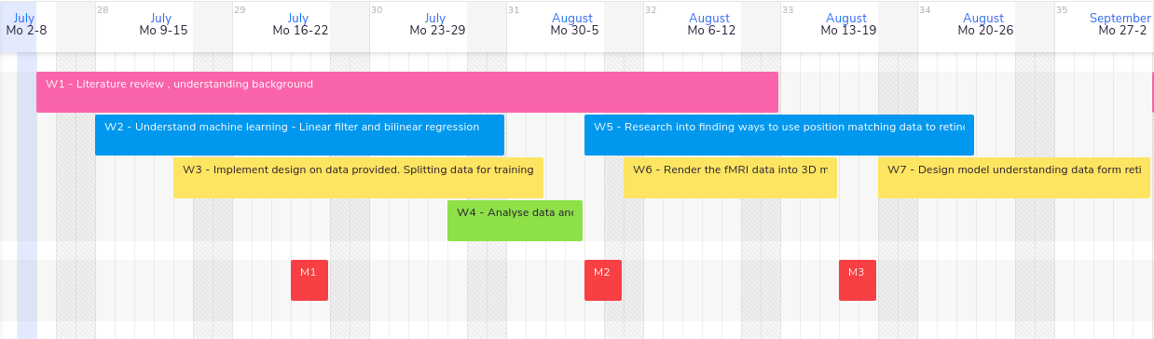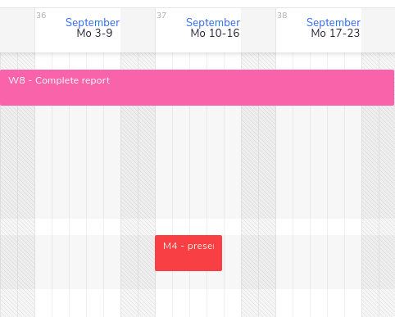

Reference

Hussain, Zahra and Astle, Andrew T. and Webb, Ben S. and McGraw, Paul V. (2018) Position matching between the visual fields in strabismus. Journal of Vision, 18 (1). p. 9.