Lab. 5 HW 結報

* Homework:

1. Simulate the symbol error rates (SERs) of the 16-QAM scheme with SNRs of 5dB, 10dB, 15dB, etc such that you can plot a SER curve.
2. Calculate the theoretical SERs and also plot a curve.
3. Put two curves in the same figure to see if your simulation results are OK.
4. 星座圖：

模擬1.2e6 bits ，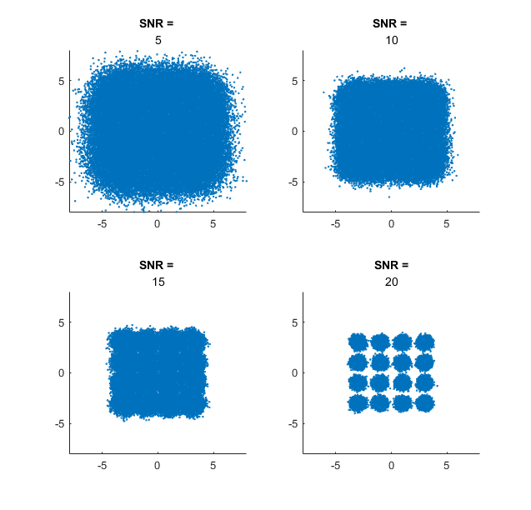SNR = 5、10、15、20。

1. Symbol Error Rates：

模擬值與理論值比較

|  |  |  |  |  |
| --- | --- | --- | --- | --- |
|  | SNR = 5 | SNR = 10 | SNR = 15 | SNR = 20 |
| 模擬 | 0.5360 | 0.2229 | 0.0180 | 9.999e-06 |
| 理論 | 0.5373 | 0.2220 | 0.0177 | 1.161e-05 |



1. 比較結論：

兩條曲線幾乎重疊，代表此次的模擬結果與實際相去不遠。