Lab. 8 HW 結報

* Homework:

1. Let the symbol rate for a system be 1MHz, the sampling rate of the DAC be 4MHz, and sampling rate for DMA filter be 32MHz.
2. Let the modulation be BPSK, and the digital pulse shaping is SRRC.
3. Design an IIR DMA filter with 5 coefficients that maximizes stopband attenuation.
4. Conduct the transmit and receive operation for a sequence (without modulation).
5. Let the carrier frequency be 8MHz, and conduct the upconversion operation for the pulse shaped sequence.
6. IIR filter with 5 coefficients：

依照題目所給定的設計Specify order = 2、Wc = 0.1725，從impulse response 可以看見在n = 8的時候其值接近零。

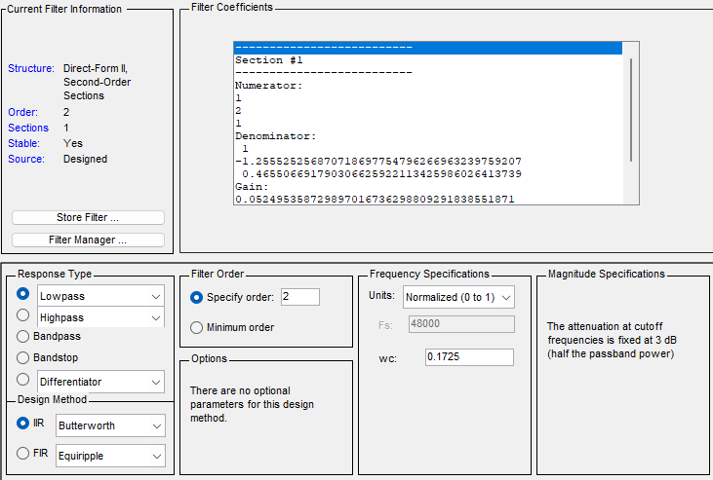

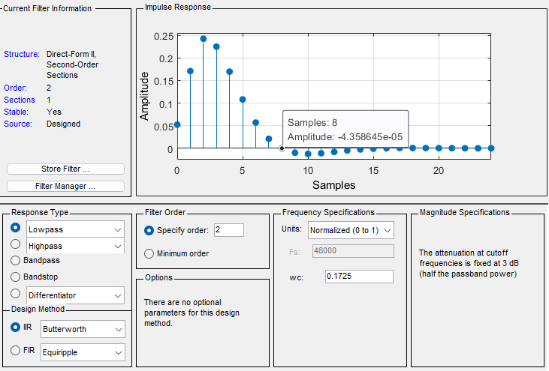

1. BPSK Transmit and Receive Operation：

模擬100個BPSK訊號(symbol rate = 1MHz)，對該訊號進行4倍的Up-sample (sampling rate = 4MHz) 通過SRRC DAC，再進行8倍的Up-sample (sampling rate = 32MHz) 通過IIR filter DMA，接收端則是相反的流程。



1. Digital carrier：

根據講義的式子 $f_{a,c}=MRf_{d,c}$ 要求出數位的載波頻率設計值，考量此題目所給的情境M = 32、R = 1MHz、 $f_{a,c}=8MHz$，算出 $f_{d,c}=1/4$。



1. 結論：

BPSK訊號的收發結果完全一致；經過數位載波之後，從頻域可以看見訊號確實被載上8MHz了，代表這次的模擬有成功還原。