Computer Simulations of Communication Systems
Final, 6/25/2021

1. Make sure that your programs are executable when you hand in them.
2. Unless specified, you cannot use special built-in routines

- (25%) A MIMO system is given as y = Hx+w where x is the transmit signal vector, y the received signal vector, and H the channel matrix. Find the estimated x with the maximum likelihood method, and the corresponding symbol error rates (Given: x_1, y_1, H_1, Return: xml_1, SER_1).

(2) (25%) Consider an IF demodulation system shown below. Let f_{c}=32MHz and f_{IF}=2MHz.
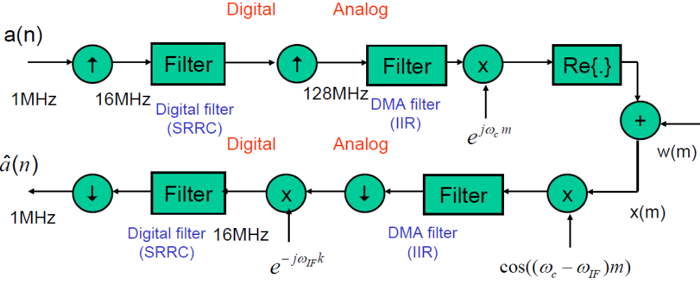
- (13%) Let noise is not present. Design transmit/receive DMA filter and construct the system. The required SNR for the recovered signal is at least 25dB. (Given: a_2a, Return: a_2ha, SNR_2a).
- (12%) Add an interference signal and design an image rejection DMA filter, placed before the downconverter, to reject the interference. The required SNR is at least 20dB (Given: intf_2b, Return: a_2hb, SNR_2b).
Hint: The roll-off factor of the SRRC can be set as 0.3 and the one-side span as 5. You can call the function of the SRRC; e.g., h=rcosine(1,16,'fir/sqrt',0.3,5).
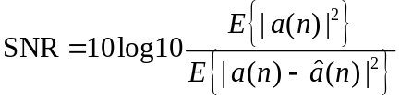

- (25%) A communication system is shown below. It is known that f_{c}=32MHz and there is a frequency offset in the carrier of the transmitter. Let the first half of transmitted symbols are known as the training sequence.
- (9%) Implement the receiver (Given: x_3, Return: a_3ha)
- (8%) Find the frequency offset. (Given: a_3b, Return: CFO_3b)
- (8%) Compensate the frequency offset (Return: a_3hc)
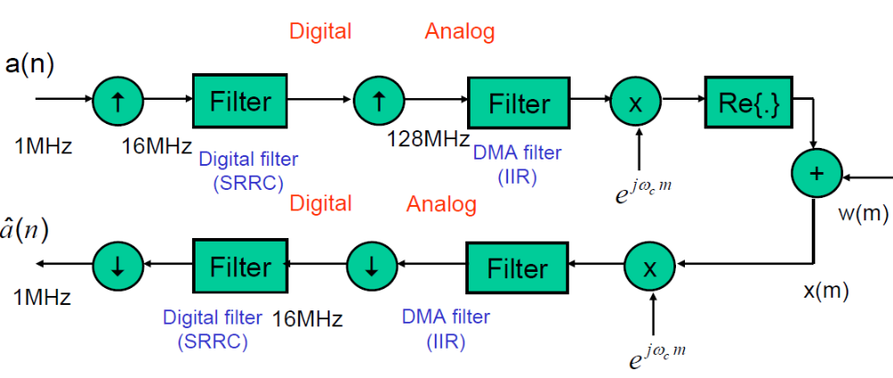
Hint 1: x_3 is x(m) in the above figure.
Hint 2: Use training sequence to remove the transmit signal and then calculate the angle rotation rate.

(4) (25%) Consider a baseband equivalent model shown below. Let the channel response be {1,-1.2,-0.25,0.3}. Suppose that the total number of taps for the equalizer is 20, i.e., 20 multipliers. Implement a ZF equalizer (an FIR cascaded with an IIR filters). (Given: a_4)
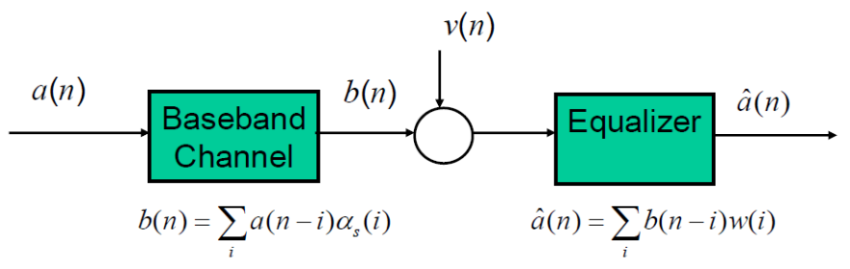
(a) (5%) Plot the impulse response of the equalizer and that of the equalized channel (Return: imp_4a, eqc_4a).
(b) (5%) Calculate the SNR of the equalized signal (v(n)=0). (Return, a_4hb, SNR_4b)
(c) (5%) Add 10-dB noise and re-calculate the equalized SNR. (Return: sd_4c,SNR_4c)
(d) (5%) Calculate the SER (Return: SER_4d).
(e) (5%) Find an equalizer whose SER is lower than that of the ZF equalizer (Return: SER_4e).

