# Introduction

The **DeepLesion** dataset contains 32,120 axial computed tomography (CT) slices from 10,594 CT scans (studies) of 4,427 unique patients. There are 1–3 lesions in each image with accompanying bounding boxes and size measurements, adding up to 32,735 lesions altogether. The lesion annotations were mined from NIH’s picture archiving and communication system (PACS). Some meta-data are also provided. The contents include:

* Folder “Images_png”: png image files. We named each slice with the format “{patient index}_{study index}_{series index}_{slice index}.png”, with the last underscore being / or \ to indicate sub-folders. The images are stored in unsigned 16 bit. One should **subtract 32768** from the pixel intensity to obtain the original Hounsfield unit (HU) values.

We provide not only the key CT slice that contains the lesion annotation, but also its 3D context (30mm extra slices above and below the key slice). Due to the large size of the data (221GB), we packed them to 56 smaller zip files for downloading.

* Folder “Key_slices”: key slices with overlaid lesion annotations for review purposes.
* DL_info.csv: The annotations and meta-data. See Section “Annotations” below.
* DL_save_nifti.py: demo python codes that can convert the provided 2D 16-bit png images to 3D nifti sub-volumes.

# Reference

If you find the dataset useful for your research projects, please cite our JMI 2018 paper:

* Ke Yan, Xiaosong Wang, Le Lu, Ronald M. Summers, "DeepLesion: Automated Mining of Large-Scale Lesion Annotations and Universal Lesion Detection with Deep Learning", Journal of Medical Imaging, 2018.

The following paper and code are also related with the dataset:

* Ke Yan, Xiaosong Wang, Le Lu, Ling Zhang, Adam Harrison, Mohammadhadi Bagheri, Ronald M. Summers, "Deep Lesion Graphs in the Wild: Relationship Learning and Organization of Significant Radiology Image Findings in a Diverse Large-scale Lesion Database", IEEE CVPR, 2018, <https://arxiv.org/abs/1711.10535>
* Ke Yan, Mohammadhadi Bagheri, Ronald M. Summers, "3D Context Enhanced Region-based Convolutional Neural Network for End-to-End Lesion Detection", MICCAI, 2018, <https://arxiv.org/abs/1806.09648>
* Jinzheng Cai*, Youbao Tang*, Le Lu, Adam P. Harrison, Ke Yan, Jing Xiao, Lin Yang, Ronald

M. Summers, "Accurate Weakly-Supervised Deep Lesion Segmentation using Large-Scale Clinical Annotations: Slice-Propagated 3D Mask Generation from 2D RECIST", MICCAI, 2018, <https://arxiv.org/abs/1807.01172>

* Youbao Tang, Adam P. Harrison, Mohammadhadi Bagheri, Jing Xiao, Ronald M. Summers, "Semi-Automatic RECIST Labeling on CT Scans with Cascaded Convolutional Neural Networks", MICCAI, 2018, <https://arxiv.org/abs/1806.09507>
* Ke Yan, Le Lu, Ronald Summers, "Unsupervised Body Part Regression via Spatially Self- ordering Convolutional Neural Networks", IEEE ISBI, 2018, <https://arxiv.org/abs/1707.03891>
  + <https://github.com/rsummers11/CADLab/tree/master/body_part_regressor>

# Annotations

In DL_info.csv, each row is the information of a lesion in DeepLesion. The meaning of the columns are:

1. File name. Please replace the last underscore with / or \ to indicate sub-folders.
2. Patient index starting from 1.
3. Study index for each patient starting from 1. There are 1~26 studies for each patient.
4. Series ID.
5. Slice index of the key slice containing the lesion annotation, starting from 1.
6. 8D vector, the image coordinates of the two RECIST diameters of the lesion. [*x*11, *y*11, *x*12, *y*12, *x*21, *y*21, *x*22, *y*22]. The first 4 coordinates are for the long axis. Please see our paper and its supplementary material for further explanation.
7. 4D vector, the bounding-box [*x*1, *y*1, *x*2, *y*2] of the lesion estimated from the RECIST diameters, see our paper.
8. 2D vector, the lengths of the long and short axes. The unit is pixels.
9. The relative body position of the center of the lesion. The z-coordinates were predicted by the self-supervised body part regressor. See our paper for details. The coordinates are approximate and just for reference.
10. The type of the lesion. Types 1~8 correspond to bone, abdomen, mediastinum, liver, lung, kidney, soft tissue, and pelvis, respectively. See our paper for details. The lesion types are

coarsely defined and just for reference. Only the lesions in the val and test sets were annotated with others denoted as -1.

1. This field is set to 1 if the annotation of this lesion is possibly noisy according to manual check. We found 35 noisy annotations out of 32,735 till now.
2. Slice range. Context slices neighboring to the key slice were provided in this dataset. For example, in the first lesion, the key slice is 109 and the slice range is 103~115, meaning that slices 103~115 are provided. For most lesions, we provide 30mm extra slices above and below the key slice, unless the long axis of the lesion is larger than this thickness (then we provide more) or the beginning or end of the volume is reached.
3. Spacing (mm per pixel) of the *x*, *y*, and *z* axes. The 3rd value is the slice interval, or the physical distance between two slices.
4. Image size.
5. The windowing (min~max) in Hounsfield unit extracted from the original DICOM file.
6. Patient gender. F for female and M for male.
7. Patient age.
8. Official randomly generated patient-level data split, train=1, validation=2, test=3.

# Applications

DeepLesion is a large-scale dataset that contains a variety types of lesions. It can be used for lesion detection, classification, segmentation, retrieval, measurement, growth analysis, relationship mining between different lesions, etc.

# Limitations

Since DeepLesion was mined from PACS, it has a few limitations:

* DeepLesion contains only 2D diameter measurements and bounding-boxes of lesions. It has no lesion segmentation masks, 3D bounding-boxes, or fine-grained lesion types. Therefore, some applications (e.g. lesion segmentation) may need extra manual annotations.
* Not all lesions were annotated in the images. Radiologists typically mark only representative lesions in each study. Therefore, some lesions remain unannotated.
* According to manual examination, although most bookmarks represent abnormal findings or lesions, a small proportion of the bookmarks are actually measurement of normal structures, such as lymph nodes of normal size.

We encourage our fellow researchers / radiologists to share their own annotations on the dataset to benefit the medical imaging community.

# Data visualization

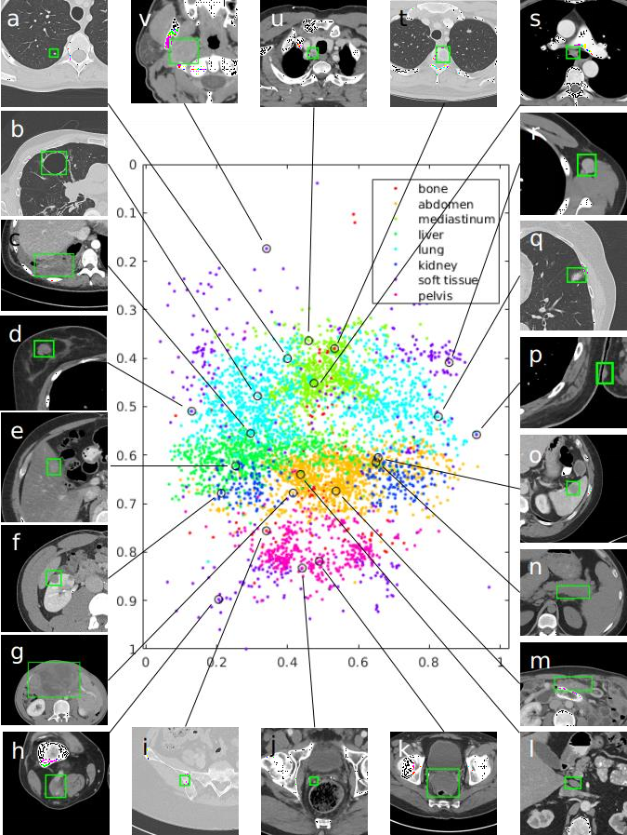

**Fig. 1** Visualization of a subset (15%) of the DeepLesion dataset. The *x*- and *y*-axes of the scatter

map correspond to the *x*- and *z*-coordinates of the relative body location of each lesion, respectively. Therefore, this map is similar to a frontal view of the human body. Colors indicate the manually labeled lesion types. Sample lesions are exhibited to show the great diversity of DeepLesion, including: a. lung nodule; b. lung cyst; c. costophrenic sulcus (lung) mass/fluid; d. breast mass; e. liver lesion; f. renal mass; g. large abdominal mass; h. posterior thigh mass; i. iliac sclerotic lesion;

j. perirectal lymph node (LN); k. pelvic mass; l. periportal LN; m. omental mass; n. peripancreatic lesion; o. splenic lesion; p. subcutaneous/skin nodule; q. ground glass opacity; r. axillary LN; s. subcarinal LN; t. vertebral body metastasis; u. thyroid nodule; v. neck mass.

***FAQ***

# *What are the naming conventions of the images?*

We named each slice with the format “{patient index}_{study index}_{series index}_{slice index}.png” , with the last underscore being / or \ to indicate sub-folders, depending on the operating system. Note that one patient often underwent multiple CT scans (studies) for different purposes or follow-up. Each study contains multiple volumes (series) that are scanned at the same time point but differ in image filters, contrast phases, etc. Every series is a 3D volume composed of tens to hundreds of axial image slices.

# *Why are only part of the slices provided in each volume?*

The DeepLesion dataset was collected based on radiologists’ annotations called “bookmarks”. We provide key slices that contain the bookmarks as well as at least 60 mm contexts (extra slices above and below the key slice) to facilitate usage of 3D information. Currently we have no plan to release the whole volumes because the data size will be too big.

# *Are the radiological reports included in the publicly accessible DeepLesion dataset?*

No. We currently do not have a plan to release the radiological reports.

1. ***Are there any restrictions in using this dataset?***

The usage of the data set is unrestricted. However, it is recommended to cite our JMI 2018 paper and provide the link to our original download site in your paper.

# *Are the images available in DICOM format?*

We decided to provide the losslessly compressed 16-bit png images currently, which are anonymized, more compact, and bear no information loss. Please subtract 32768 from the 16-bit pixel intensities to obtain the original Hounsfield unit (HU) values.

# *What are the definition of “lesions” in the dataset?*

DeepLesion is built upon RECIST bookmarks in NIH’s PACS, which are annotations marked by radiologists during their daily work to measure target image findings; see our paper. We did not further filter these annotations after obtaining them, so they reflect what the radiologists thought were important and measurable findings. Among them, there are commonly studied lesion types such as lung nodules, enlarged lymph nodes, liver tumors, and so on, as well as many less common ones such as bone and soft tissue lesions. Thus, it is a dataset with great diversity.

It should be noted that not all lesions were annotated in the images because radiologists typically

mark only representative lesions in each study. There are also a small proportion of the bookmarks that are actually measurements of normal structures, such as lymph nodes of normal size.

1. ***What do the values in the “Possibly_noisy” column in “DL_info.csv” mean?***

We manually checked several things for each lesion, for example, whether the two RECIST diameters intersect, the width-height-ratio of the bounding-box, the mean and standard deviation of the pixels inside the box, and so on. 35 lesion annotations were found to be noisy. A few of them are imaging phantoms. They are marked with 1 in the “Possibly_noisy” column and can be omitted in analysis.

1. ***What are the definition of the 8 lesion types?***

The lesion types are coarsely defined and just for reference.

* 1. Bone
  2. Abdomen: lesions in the abdominal cavity that are not in liver or kidney
  3. Mediastinum
  4. Liver
  5. Lung
  6. Kidney
  7. Soft tissue: miscellaneous lesions in the body wall, muscle, skin, fat, limbs, head, and neck
  8. Pelvis

1. ***Is there any official data split?***

The official split randomly generated in patient level is in the 18th column of DL_info.csv, where train=1, validation=2, test=3. It can be used in tasks such as lesion detection, retrieval, etc.