❖ ❖ ❖

A CIVILIZATION OF THE NILE
Ancient Egypt
古 埃 及 · 文 明 史 诗
◆ — ◆ — ◆
Cradle of Civilization along the Nile River
c. 3150 BC — 30 BC

Source: Wikipedia · Wikimedia Commons
❖ ❖ ❖

Table of Contents

目 录
01 文明概述 · Overview 3
02 王朝年代表 · Timeline of Kingdoms 4
03 地理与尼罗河 · Geography & the Nile 5
04 前王朝时期 · Predynastic Period 6
05 古王国 · Old Kingdom 7
06 中王国与新王国 · Middle & New Kingdoms 8
07 宗教与诸神 · Religion & Gods 9
08 文字与数学 · Writing & Mathematics 10
09 建筑与艺术 · Architecture & Art 11
10 成就与遗产 · Achievements & Legacy 12

01 · OVERVIEW

文 明 概 述

Ancient Egypt — A Civilization of the Nile

时期 Period | 年代 Dates | 王朝 Dynasties | 亮点 Highlights
Early Dynastic Period  早期王朝 | c. 3150 – 2686 BC | 1st – 2nd | Unification by Menes/Narmer; founding of Memphis.  美尼斯统一上下埃及；建立孟菲斯城。
Old Kingdom  古王国 | 2686 – 2181 BC | 3rd – 6th | Age of Pyramids — Giza, Saqqara; solar cult of Ra.  金字塔时代——吉萨、萨卡拉；太阳神拉崇拜。
1st Intermediate  第一中间期 | 2181 – 2055 BC | 7th – 11th | Collapse of central authority; regional rulers.  中央集权崩溃，地方统治者割据。
Middle Kingdom  中王国 | 2055 – 1650 BC | 11th – 14th | Reunification; literary classic; Faiyum irrigation.  再度统一；文学经典；法尤姆绿洲灌溉。
2nd Intermediate  第二中间期 | 1650 – 1550 BC | 15th – 17th | Hyksos rule in the Delta; horse & chariot introduced.  喜克索斯人在三角洲建都；引入马与战车。
New Kingdom  新王国 | 1550 – 1069 BC | 18th – 20th | Imperial Egypt — Hatshepsut, Akhenaten, Tutankhamun, Ramesses II.  帝国时代——哈特谢普苏特、埃赫那顿、图坦卡蒙、拉美西斯二世。
Late Period  后期王朝 | 664 – 332 BC | 26th – 31st | Persian invasions; last native dynasty.  波斯入侵；最后本土王朝。
Ptolemaic  托勒密时期 | 332 – 30 BC | Ptolemaic | Greek rule after Alexander; Cleopatra VII ends dynasty.  亚历山大之后的希腊统治；克娄巴特拉七世终结王朝。

03 · GEOGRAPHY

地 理 与 尼 罗 河

Geography & the Nile
A civilization born of the world's longest river — stretching from the First Cataract to the Mediterranean Delta, the Nile's predictable flooding shaped agriculture, trade, religion, and the very concept of Egyptian kingship. The river was not merely a geographical feature but the very source of Egyptian identity, prosperity, and cosmic order (ma'at).
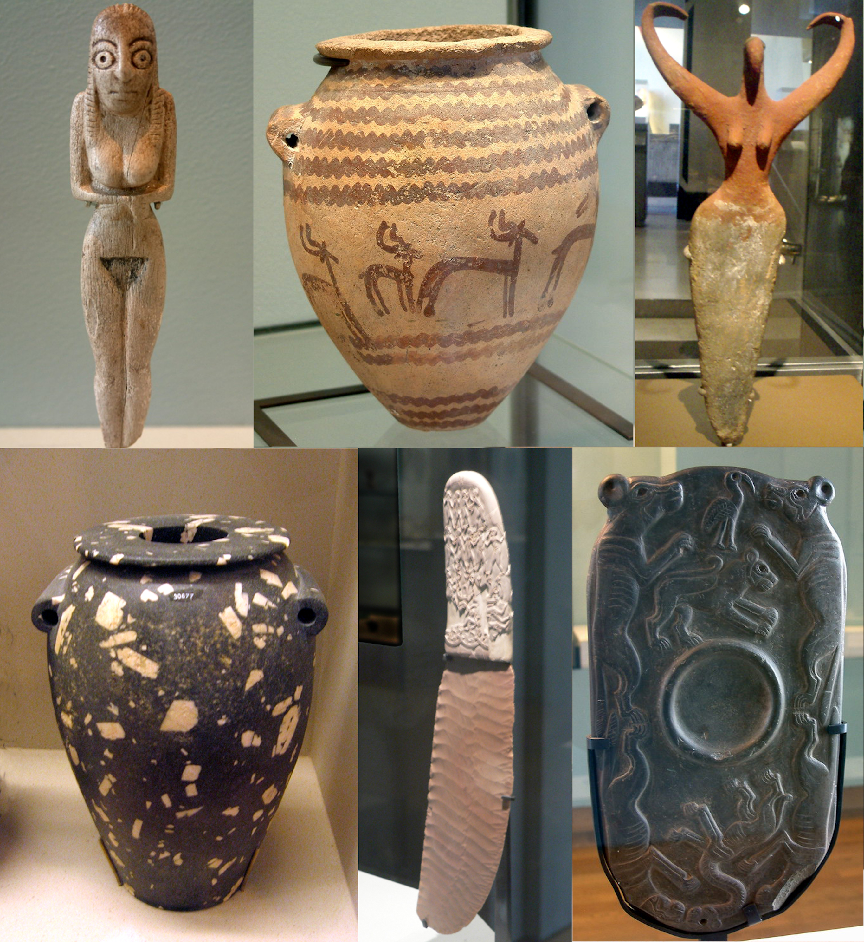
Predynastic Egyptian artefacts · Birmingham & Ashmolean Museums
特征 Feature | 详情 Detail
地理范围 Region | Lower Nile, NE Africa · 尼罗河下游，东北非
气候 Climate | Hot arid desert, fertile floodplain · 炎热干旱的沙漠与肥沃河谷
经济基础 Economy | Irrigated agriculture + Nile trade · 灌溉农业 + 尼罗河贸易
首都 Capitals | Memphis · Thebes · Alexandria · 孟菲斯 · 底比斯 · 亚历山大
领土 Reach | Nubia to Levant (New Kingdom peak) · 努比亚至黎凡特（新王国鼎盛期）

04 · PREDYNASTIC PERIOD

前 王 朝 时 期
c. 5000 – 3100 BCE

The formative era when scattered farming settlements along the Nile gradually coalesced into larger political units. Key developments included copper metallurgy, the rise of Upper Egyptian kingdoms (Naqada culture), early hieroglyphic writing, and the emergence of divine kingship.
尼罗河沿岸的史前聚落逐步发展为更大规模的政治实体。这一时期出现了铜器冶炼、上埃及那伽达文化、早期象形文字雏形以及神权王权的萌芽。陶俑、调色板、化妆石板等遗物显示出独特的艺术风格。

Predynastic Egyptian artefacts · Idols, pottery, palettes, maceheads
阶段 Phase | 年代 Period | 意义 Significance
Naqada I  巴达里文化 | c. 5000 – 4000 BC | Agriculture, pottery, early settlements · 农业、制陶、早期定居
Naqada II  那伽达二期 | c. 4000 – 3500 BC | Long-distance trade, chiefdoms · 远程贸易、部族联盟
Naqada III  那伽达三期 | c. 3500 – 3100 BC | Prototype kingship, writing emerges · 王权雏形、文字萌芽
05 · OLD KINGDOM

古 王 国 · 金 字 塔 时 代
Age of the Pyramid Builders · 2686 – 2181 BC

Dynasties 3 – 6 · Memphis as capital · Birth of monumental funerary architecture

☥ 神圣王权 · Divine Kingship
The pharaoh was worshipped as a living god, the intermediary between the gods and the people. The pyramid was both tomb and stairway to the eternal stars. 法老被视为活神，是神人之间的中介。金字塔既是陵墓，也是通往永恒星辰的天梯。

△ 纪念碑建筑 · Monumental Architecture
The Great Pyramid of Giza (Khufu), the Sphinx, and the sun temples of Abu Gurab define this era of stone. Engineering, mathematics, and labor organization reached new heights. 吉萨大金字塔（胡夫）、狮身人面像、阿布古拉布太阳神庙——石造建筑的巅峰。工程、数学与组织能力达到空前高度。

☉ 太阳神信仰 · Solar Religion
The cult of Ra dominated. Pharaohs took the title "Son of Ra", and the Pyramid Texts inscribed on tomb walls ensured safe passage through the afterlife. 太阳神拉信仰占据主导。法老自称"拉之子"，金字塔铭文确保来世之旅的顺利。

06 · CLASSICAL & IMPERIAL AGES

中 王 国 与 新 王 国

中王国 · Middle Kingdom (2055 – 1650 BC)
◆ Reunification after 1st Intermediate · 第一中间期后再度统一
◆ Classical literature: Tale of Sinuhe, Story of the Shipwrecked Sailor · 经典文学：《辛努赫的故事》《遇难水手》
◆ Faiyum irrigation project; large scale agricultural expansion · 法尤姆水利工程 · 农业大扩张
◆ Nubia campaigns; trade with the Levant · 努比亚战事 · 黎凡特贸易
◆ Cataract forts along the Nile · 尼罗河沿线的要塞
◆ Democratization of the afterlife — Coffin Texts · 来世观念普及——《棺文》

新王国 · New Kingdom (1550 – 1069 BC)
✦ Expulsion of the Hyksos; reunification · 驱逐喜克索斯人，重新统一
✦ Hatshepsut — female pharaoh, Punt expedition · 哈特谢普苏特女王，蓬特远征
✦ Akhenaten's monotheistic Aten cult · 埃赫那顿一神教改革
✦ Tutankhamun restores traditional religion · 图坦卡蒙恢复传统宗教
✦ Ramesses II — Battle of Kadesh, first peace treaty · 拉美西斯二世，卡迭石战役，世界上最早的和约
✦ Tomb of the Kings in the Valley of the Kings · 帝王谷王陵
✦ Temples of Karnak & Luxor; Abu Simbel · 卡纳克、卢克索神庙；阿布辛贝

07 · RELIGION & GODS

宗 教 与 诸 神

From household amulets to cosmic theology, ancient Egyptian religion wove together daily life and the eternal. Gods took many forms — animal-headed, anthropomorphic, abstract — and amulets brought divine protection into the most intimate spaces of Egyptian homes.
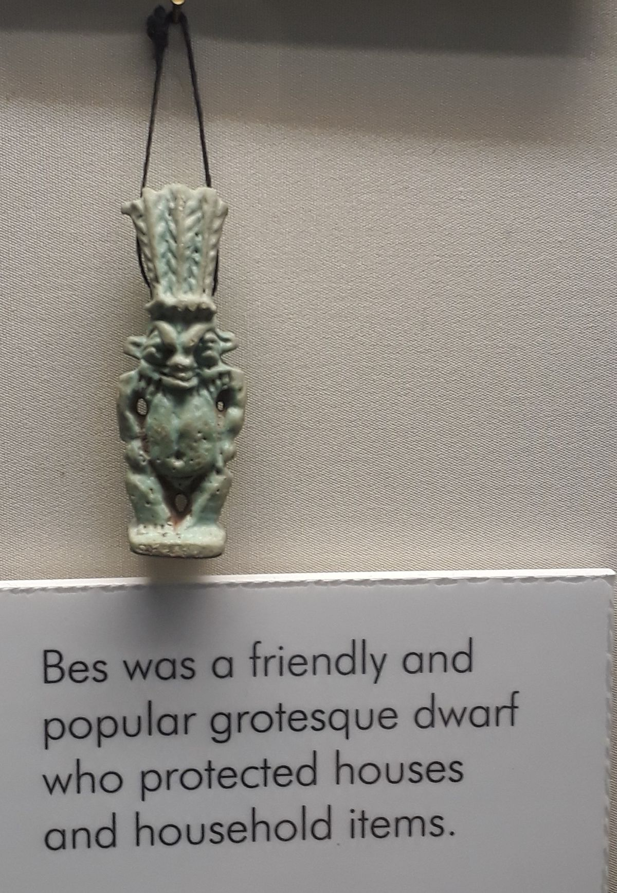  BES  Protector of Households  家庭守护神  A friendly grotesque dwarf deity who warded off evil spirits and protected mothers, children, and homes. | 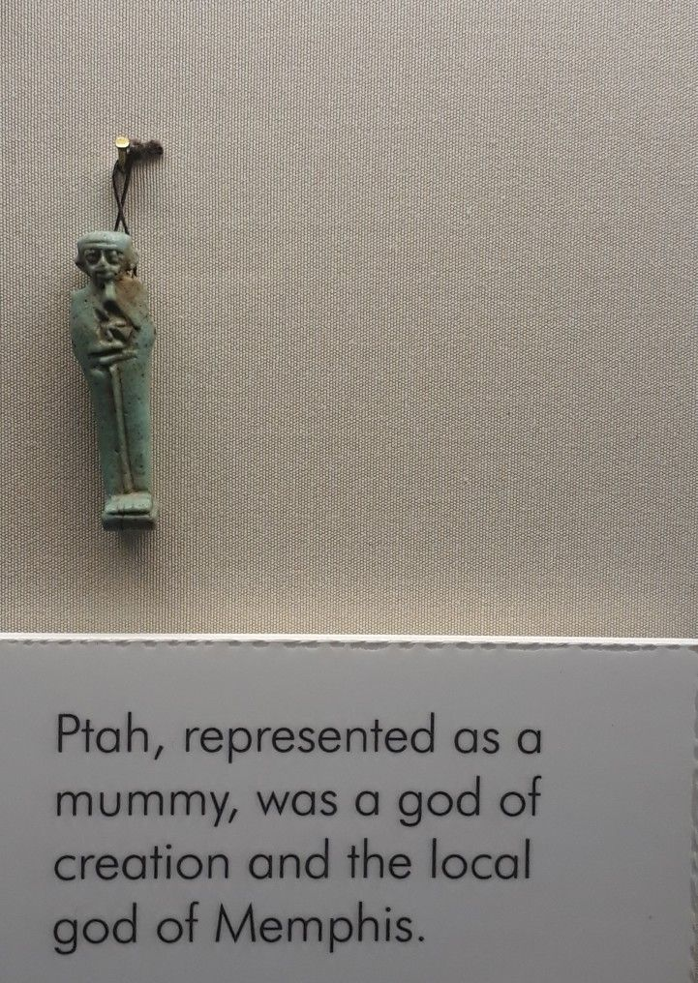  PTAH  God of Memphis & Creation  孟菲斯主神 · 创造之神  Dressed as a mummified man with a tight cap; patron of craftsmen, architects, and the entire creative arts.
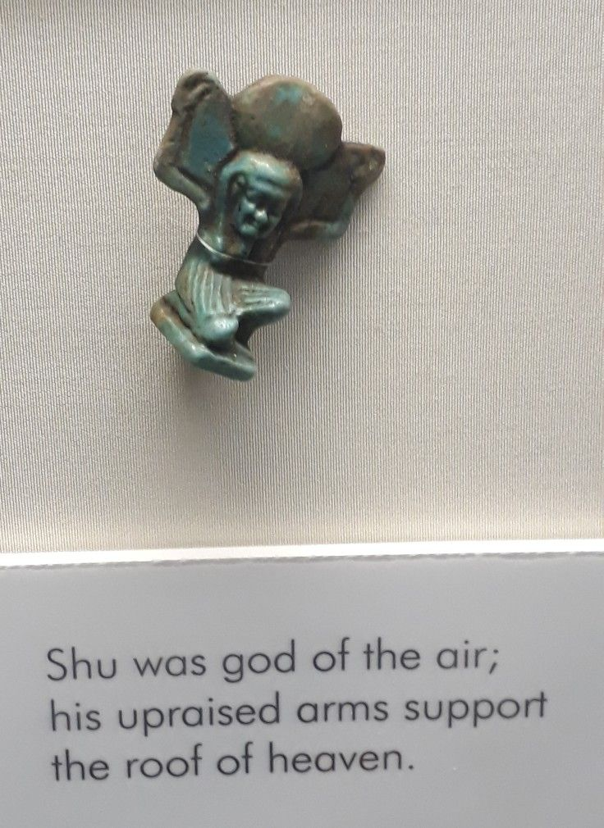  SHU  God of Air  空气之神  His upraised arms hold up the sky, separating it from the earth. Son of Atum/Ra. | 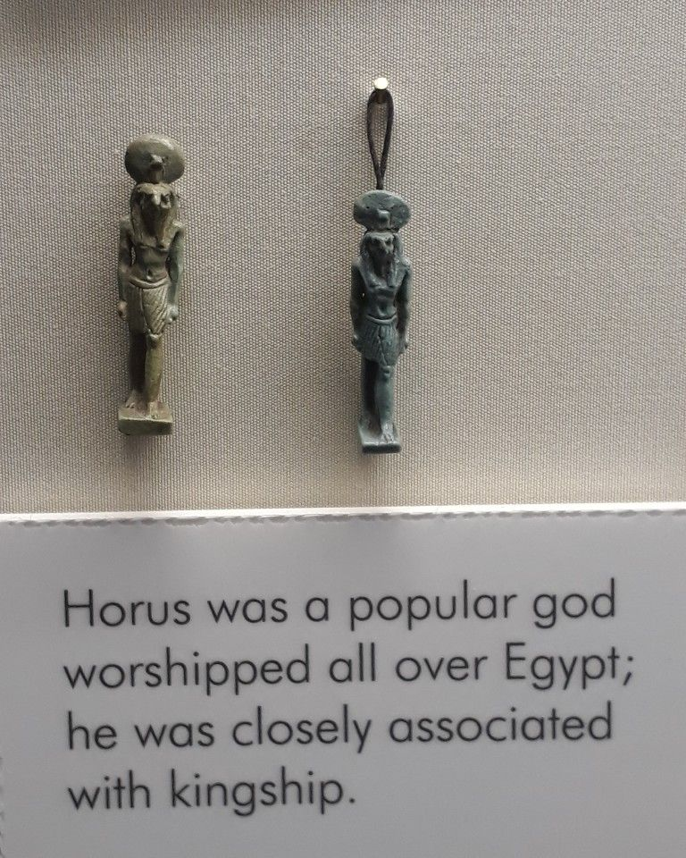  HORUS  Sky God of Kingship  天空之神 · 王权象征  Falcon-headed son of Osiris and Isis. The living pharaoh was his earthly embodiment.
Amulets · Birmingham Museum & Art Gallery

08 · LANGUAGE & MATHEMATICS

语 言 · 文 字 · 数 学

Writing Systems · 文字系统
字体 Script | 用途 Use | 备注 Notes
Hieroglyphic  象形文字 | Monuments, tombs · 纪念碑 · 陵墓 | 800+ symbols · 800+ 符号
Hieratic  僧侣体 | Administrative, literary · 行政 · 文学 | Cursive shorthand · 简化的草书体
Demotic  世俗体 | Daily business · 日常商务 | From 7th c. BC · 公元前7世纪起
Coptic  科普特文 | Late Egyptian · 晚期埃及 | Greek-based alphabet · 希腊字母改造

Three Sacred Symbols · 三大神圣符号
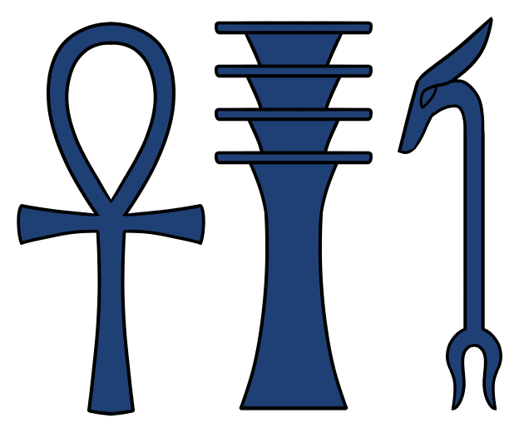
Ankh (☥) symbolizes life and immortality · Djed (𓊽) symbolizes stability · Was (𓌀) symbolizes power and dominion. These three hieroglyphs appear throughout Egyptian art and architecture.

Mathematics · 古埃及数学
Egyptian mathematics — visible on the Rhind Mathematical Papyrus (~1650 BC) — used hieratic numerals and fractions. Scribes solved problems of surveying, grain storage, and pyramid construction with remarkable sophistication.
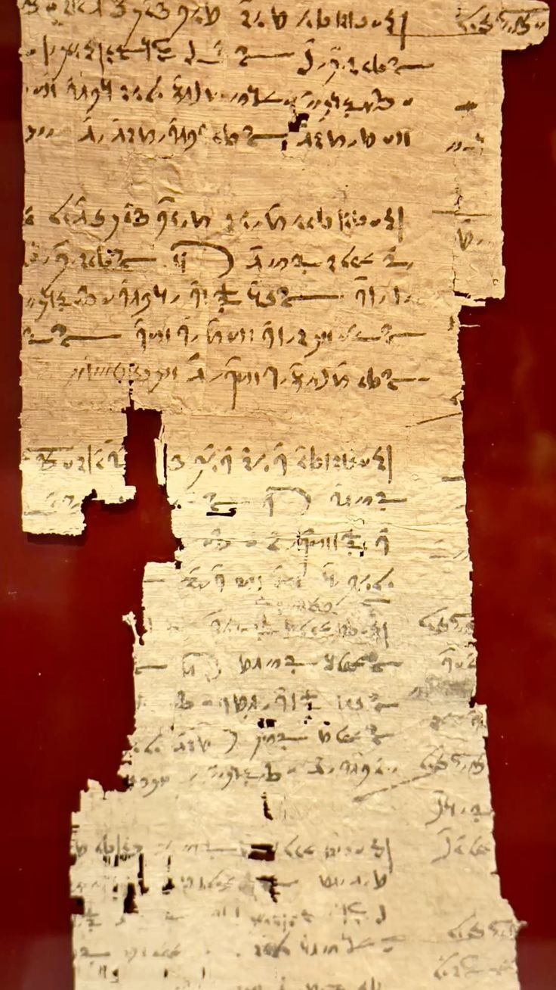
Mathematical ostracon · c. 50 BCE – 10 CE · Ashmolean Museum

09 · ARCHITECTURE & ART

建 筑 与 艺 术

Architectural Marvels · 建筑奇迹
建筑 Monument | 年代 Era | 描述 Note
Pyramid of Djoser  乔塞尔金字塔 | 27th c. BC | First stone pyramid; Imhotep architect · 首座石造金字塔，印何阗设计
Great Pyramid of Giza  吉萨大金字塔 | c. 2560 BC | 146 m; ancient wonder · 146米，古代世界七大奇迹之一
Karnak Temple Complex  卡纳克神庙群 | Middle – Late | Largest religious complex · 最大宗教建筑群
Abu Simbel  阿布辛贝神庙 | 13th c. BC | Ramesses II rock-cut temple · 拉美西斯二世岩凿神庙
Valley of the Kings  帝王谷 | New Kingdom | Royal tombs including Tutankhamun · 图坦卡蒙陵墓所在地
10 · ACHIEVEMENTS & LEGACY

文 明 成 就 与 千 载 遗 产

Science & Technology · 科学与技术
✦ Quarrying, surveying, construction techniques · 采石、测量、建筑技术
✦ Mathematical system & geometry · 数学体系与几何学
✦ Effective medicine & surgery · 有效的医学与外科手术
✦ First known planked boats · 已知最早的木板船
✦ Faience and glass technology · 釉陶与玻璃技术

Culture & Writing · 文化与文字
✦ Earliest peace treaty with Hittites · 已知最早的与赫梯的和约
✦ Rich literary tradition · 丰富的文学传统
✦ Hieroglyphic writing system · 象形文字书写系统
✦ Calendar of 365 days · 365天的历法
✦ Monumental art & architecture · 纪念性艺术与建筑

Legacy · 千载影响
✦ Inspired Greek & Roman art · 启发希腊与罗马艺术
✦ Influence on Coptic Christianity · 影响科普特基督教
✦ Modern Egyptology (since 1822) · 现代埃及学（始于1822年）
✦ Universal symbol of antiquity · 古代文明的普遍象征
✦ UNESCO world heritage sites · 联合国教科文组织世界遗产
"Its art and architecture were widely copied and its antiquities carried off to be studied, admired, or coveted in the far corners of the world."
— T H A N K Y O U —
Source: Wikipedia · Wikimedia Commons

