WIKIPEDIA - WORLD HERITAGE SERIES
THE GREAT WALL
OF CHINA

21,196 km of fortifications - 2,000+ years of history - A UNESCO World Heritage Site since 1987
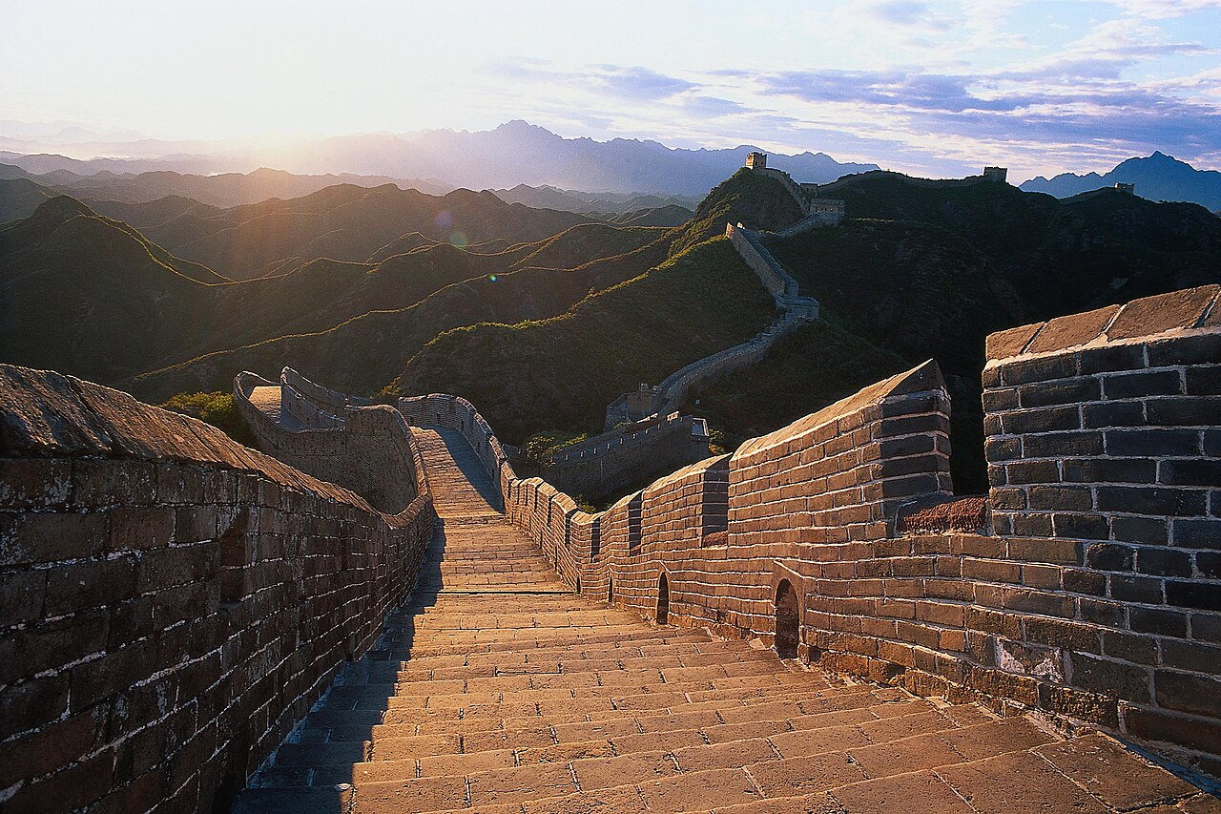
The Great Wall at dawn - by Hao Wei
Content extracted from Wikipedia, the free encyclopedia

Contents
1. Overview
2. Key Facts
3. History - Early Walls
4. History - The Ming Dynasty
5. Architecture & Characteristics
6. Condition & Conservation
7. Visibility from Space
8. Timeline
9. Gallery
10. Conclusion & Sources

1. Overview
The Great Wall of China is a series of fortifications in China, built across the historical northern borders of ancient Chinese states and Imperial China as protection against various nomadic groups from the Eurasian Steppe. The first walls date to the 7th century BC; these were joined together in the Qin dynasty. Successive dynasties expanded the wall system; the best-known sections were built by the Ming dynasty (1368-1644).
To aid in defense, the Great Wall utilized watchtowers, troop barracks, garrison stations, signaling capabilities through smoke or fire, and its status as a transportation corridor. Other purposes included border controls, the imposition of duties on goods transported along the Silk Road, and the regulation of trade.
The collective fortifications stretch from Liaodong in the east to Lop Lake in the west, and from the present-day Sino-Russian border in the north to the Tao River in the south - an arc that roughly delineates the edge of the Mongolian steppe, spanning 21,196.18 km in total.
It is a UNESCO World Heritage Site, and was voted one of the New 7 Wonders of the World in 2007. Today, the defensive system of the Great Wall is recognized as one of the most impressive architectural feats in history.
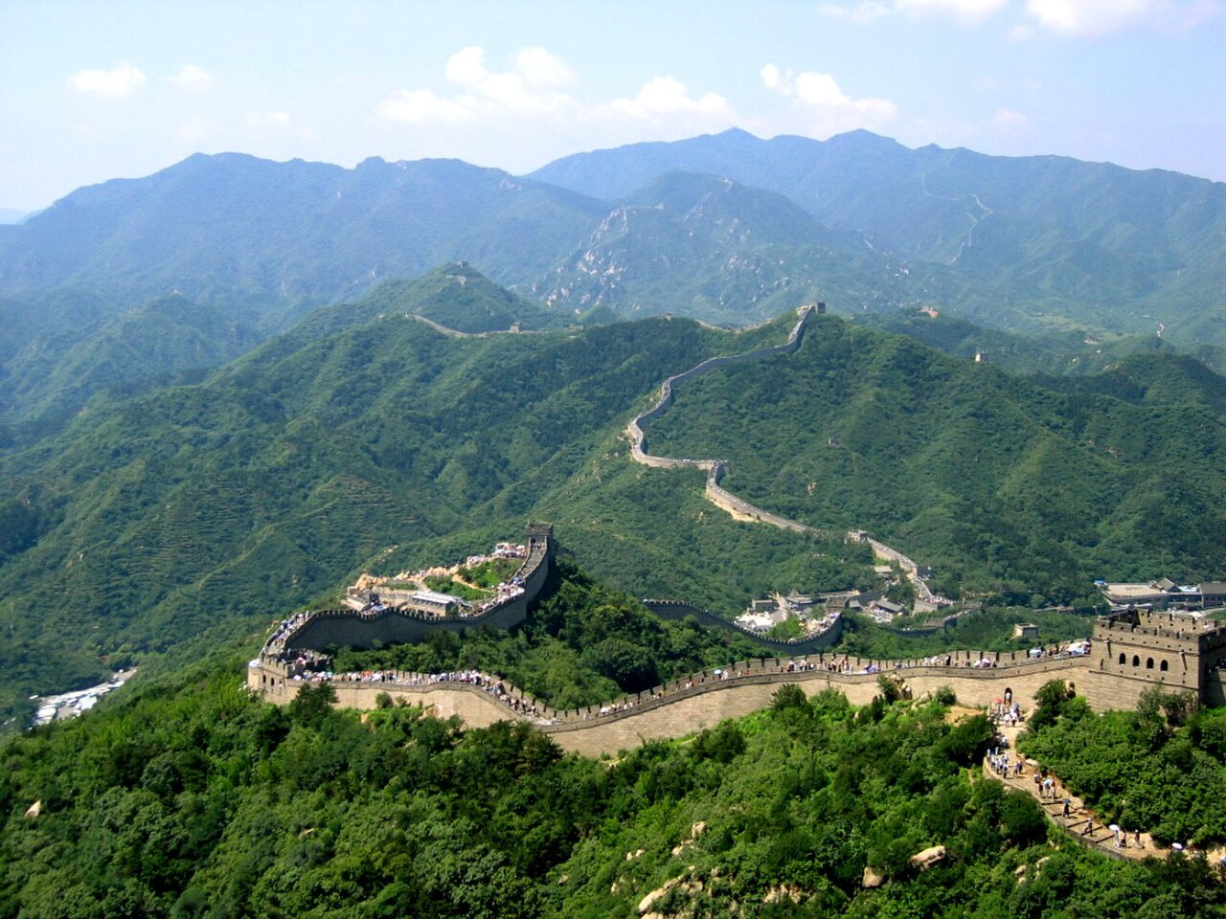
The Great Wall at Badaling

2. Key Facts
Field | Value
Type | Fortification
Location | China
Coordinates | 40 25 53 N, 116 33 52 E
Official name | The Great Wall
UNESCO Criteria | Cultural: i, ii, iii, iv, vi
UNESCO Reference | 438
Inscription | 1987 (11th Session)
Area | 2,151.55 ha (5,316.6 acres)
Buffer zone | 4,800.8 ha (11,863 acres)
Total length | 21,196.18 km (13,170.70 mi)

3. History - Early Walls
The Chinese were already familiar with the techniques of wall-building by the time of the Spring and Autumn period between the 8th and 5th centuries BC. During this time and the subsequent Warring States period, the states of Zheng, Chu, Qin, Wei, Zhao, Qi, Lu, Han, Yan, Zhongshan and Zhou all constructed extensive fortifications to defend their own borders.
Built to withstand the attack of small arms such as swords and spears, these walls were made mostly of stone or by stamping earth and gravel between board frames. The state of Qin emerged victorious in 221 BC; its ruler, now the First Emperor of a unified China, ordered the destruction of the sections of the walls that divided his empire, and the building of new walls to connect the remaining fortifications along the northern frontier against the Xiongnu.
Build and move on was a central guiding principle, implying that the Chinese were not erecting a permanently fixed border. Builders always tried to use local resources: stone in montane areas, rammed earth on the plains. Later, the Han, the Northern dynasties and the Sui all repaired, rebuilt, or expanded sections of the Great Wall at great cost.
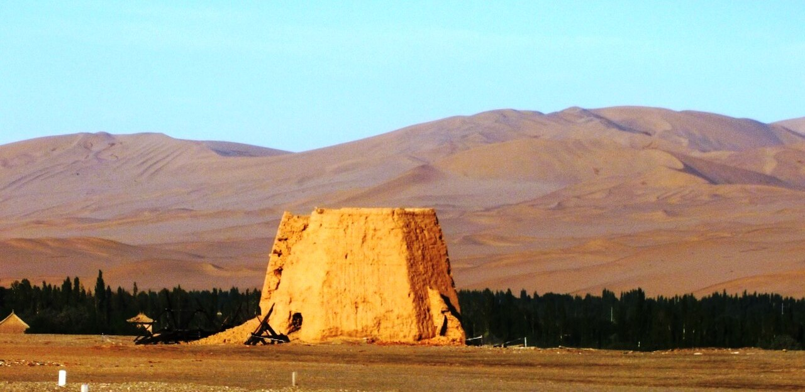
Remains of a beacon tower near Yumenguan, 2011

4. History - The Ming Dynasty
The Ming dynasty made substantial contributions to the Great Wall, following their defeat to the Oirats in the Battle of Tumu. Acknowledging the Mongol control established in the Ordos Desert, the wall followed the desert southern edge. Unlike the earlier fortifications, the Ming construction was stronger and more elaborate, due to the use of bricks and stone instead of rammed earth. Up to 25,000 watchtowers are estimated to have been constructed on the wall.
Under General Qi Jiguang supervision, 1,200 watchtowers from Shanhaiguan Pass to Changping were constructed between 1567 and 1570, and sections of the ram-earth wall were faced with bricks. Towards the end of the Ming, the Great Wall helped defend the empire against the Manchu invasions that began around 1600. Even after the loss of all of Liaodong, the Ming army held the heavily fortified Shanhai Pass, preventing the Manchus from conquering the Chinese heartland.
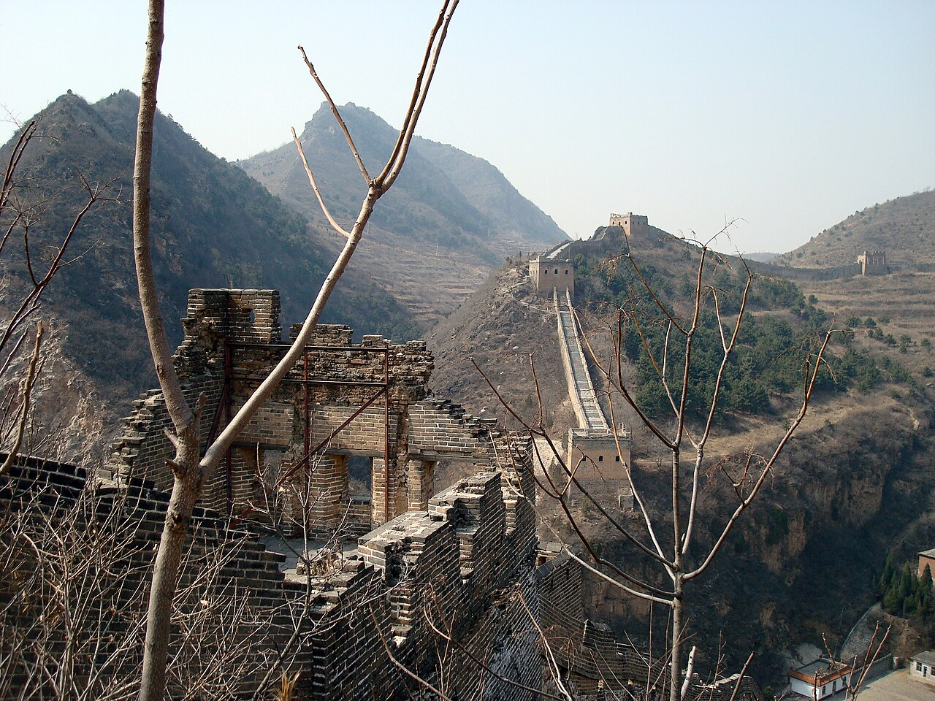
Ming Great Wall at Simatai, overlooking the gorge

5. Architecture & Characteristics
Before the use of bricks, the Great Wall was mainly built from rammed earth, stones, and wood. During the Ming, however, bricks were heavily used in many areas of the wall, as were materials such as tiles, lime, and stone. The size and weight of the bricks made them easier to work with than earth and stone, so construction quickened. Additionally, bricks could bear more weight and endure better than rammed earth.
Stone can hold under its own weight better than brick, but is more difficult to use. Consequently, stones cut into rectangular shapes were used for the foundation, inner and outer brims, and gateways of the wall. Battlements line the uppermost portion of the vast majority of the wall, with defensive gaps a little over 30 cm tall and about 23 cm wide.
Sticky rice mortar, consisting of sticky rice soup mixed with slaked lime, was extensively used to hold bricks together. No human bones or body parts were ever incorporated into the mortar or any part of the wall, contrary to urban legend. Signal towers were built upon hill tops or other high points along the wall for their visibility. Barracks, stables, and armories were built near the wall inner surface.
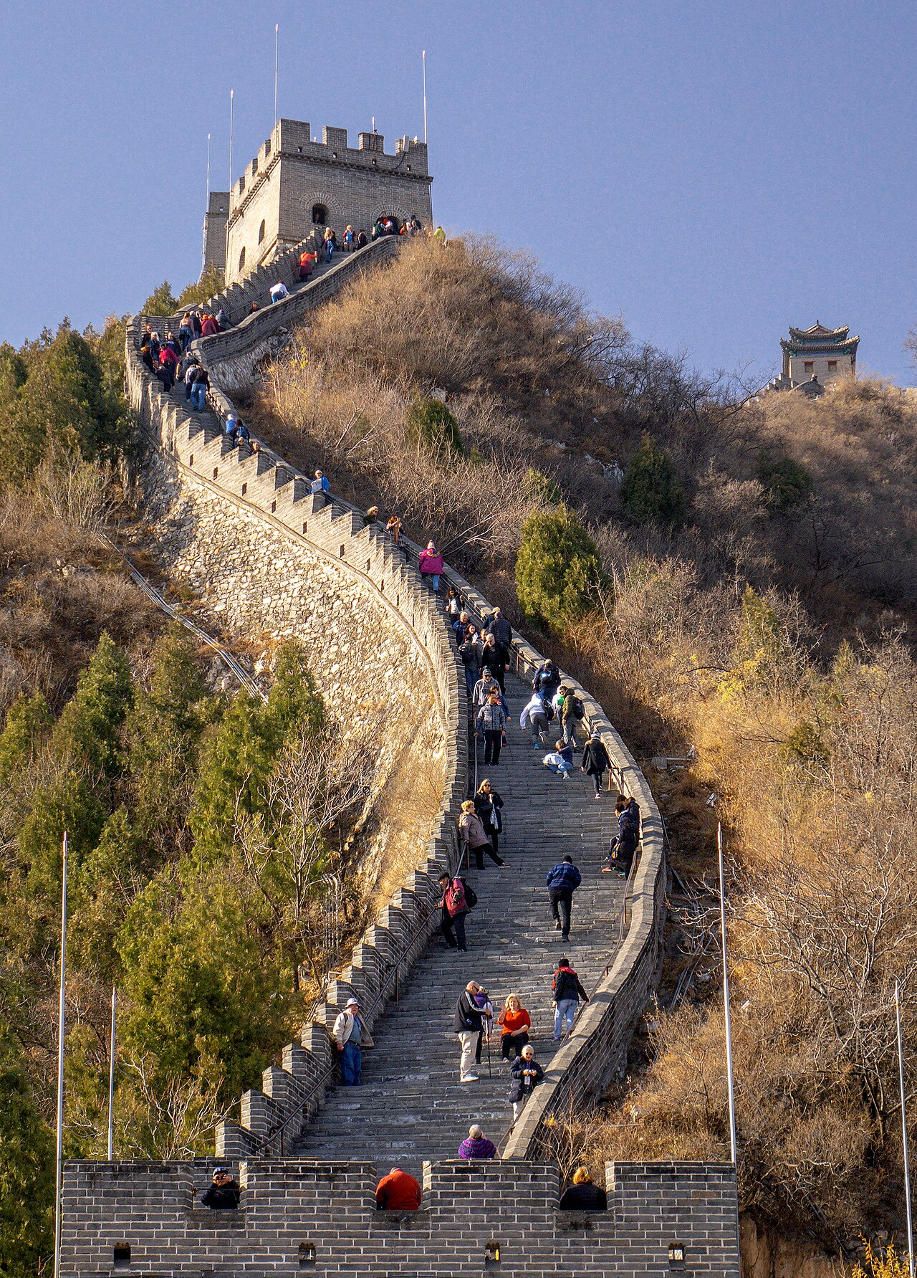
The Juyongguan area of the Great Wall

6. Condition & Conservation
While portions north of Beijing and near tourist centers have been preserved and even extensively renovated, in many other locations the wall is in disrepair. The wall sometimes provided a source of stones to build houses and roads. Sections of the wall are also prone to graffiti and vandalism, while inscribed bricks were pilfered and sold on the market.
Statistic | Value
Ming wall disappeared (2012 report) | 22% - 1,961 km
Gansu wall at risk (2007 estimate) | More than 60 km in 20 years
Height reduced in some places | From more than 5 m to less than 2 m
Ming watchtowers (estimate) | Up to 25,000
2023 Shanxi damage | Gap widened by an excavator
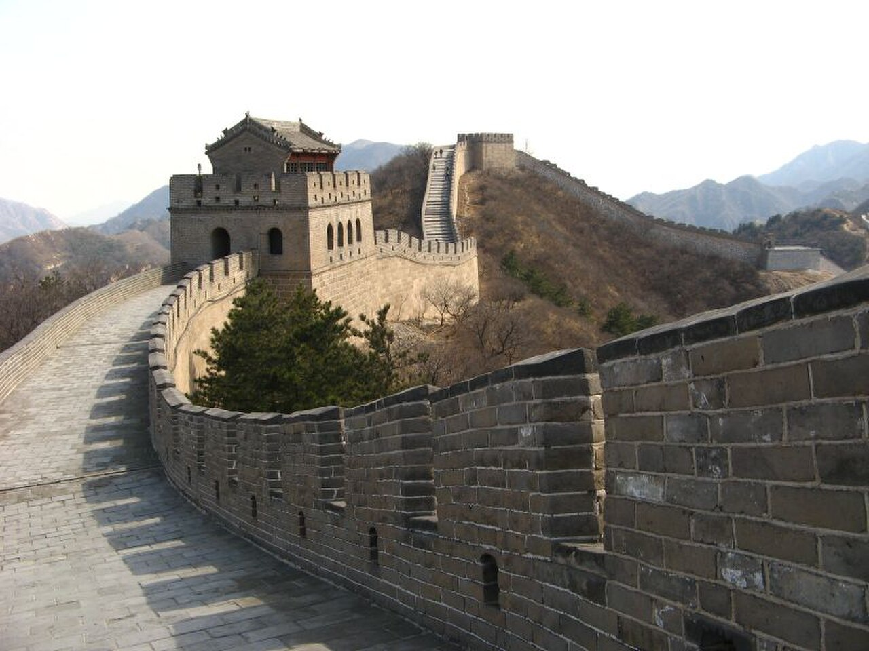
Badaling Great Wall during winter

7. Visibility from Space
Various factoids in popular culture claim that the Great Wall can be seen with the naked eye from space, with questionable degrees of veracity. A significant barrier is that although the Wall is long enough, it is too narrow, and astronauts report that, as it is made of local materials, there is a camouflage effect as well.
From the Moon, the wall is far beyond the limit of human vision. From low Earth orbit, it is only occasionally visible under ideal conditions - and even then it is not the distinctive ribbon of legend. The myth endures, but the wall true wonder lies in its scale: 21,196 km of human engineering across mountains, deserts and steppe.

The Great Wall at dawn

8. Timeline
Period | Era | Contribution
8th-5th c. BC | Spring & Autumn | First state fortifications built
221 BC | Qin dynasty | Walls joined under the First Emperor
206 BC-220 AD | Han dynasty | Expansion along the Silk Road frontier
1368-1644 | Ming dynasty | Brick & stone; the best-known sections
1644-1912 | Qing dynasty | Maintenance; the wall loses its role
1987 | Modern era | UNESCO World Heritage inscription
2007 | Modern era | Voted one of the New 7 Wonders

9. Gallery

Simatai - over the gorge
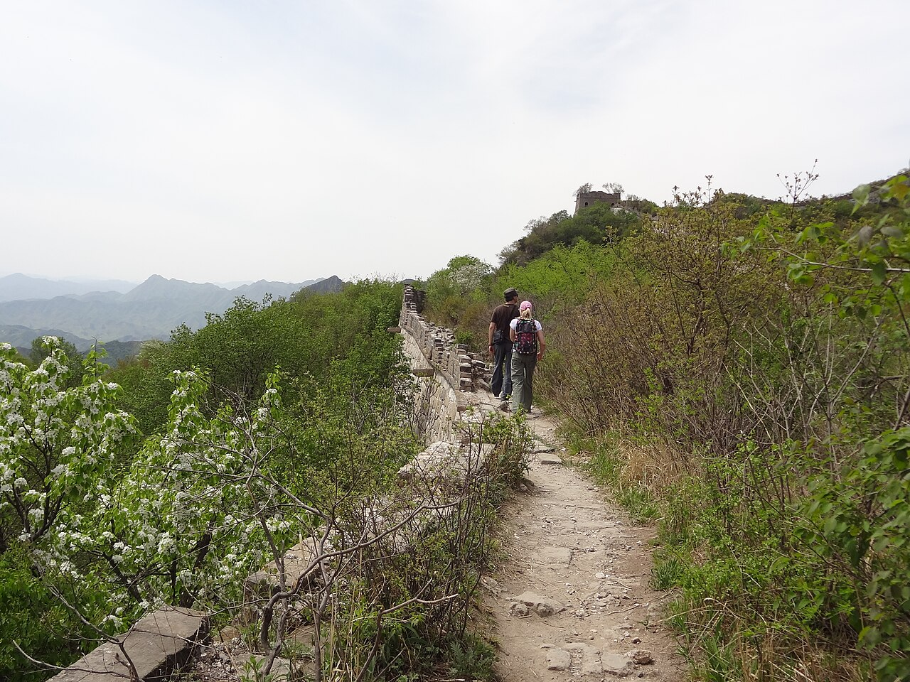
Mutianyu - a wild, unrestored section
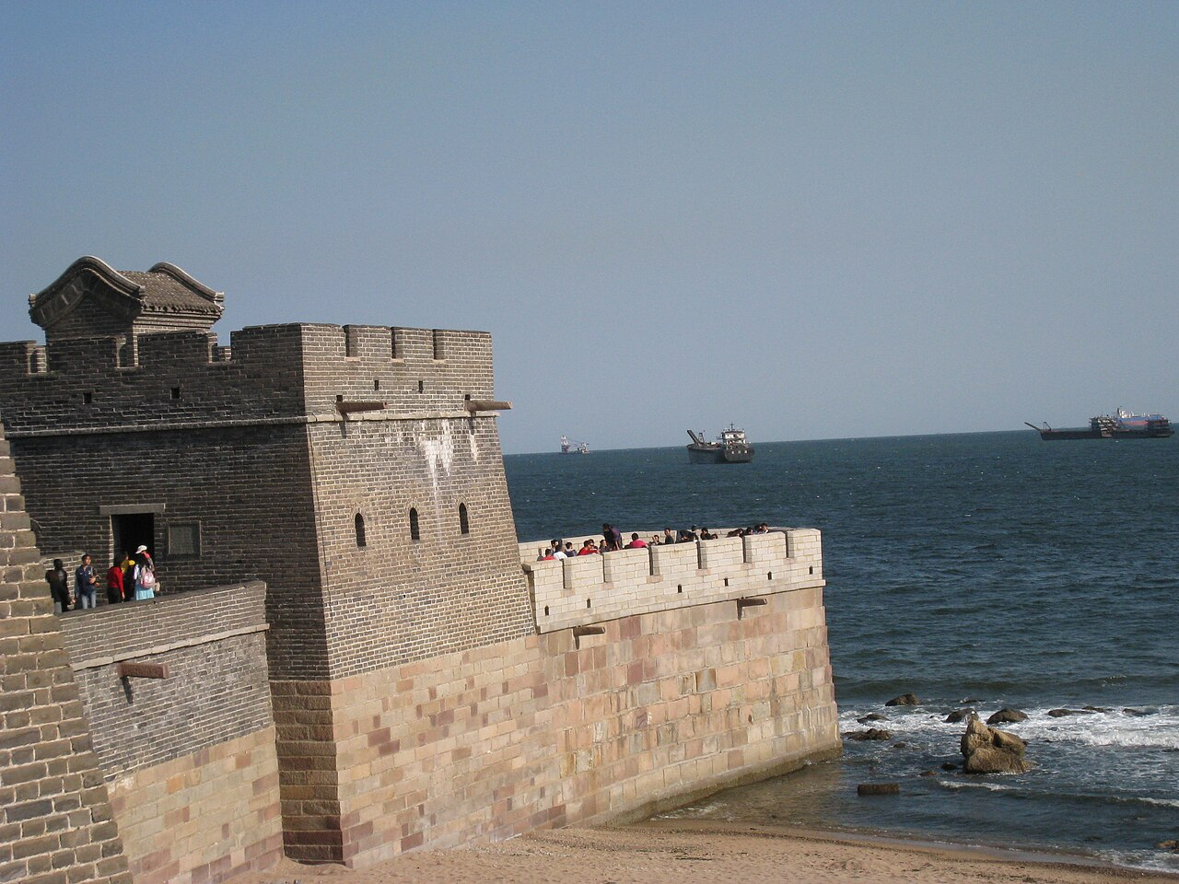
The Old Dragon Head - where the wall meets the sea

Badaling - the most visited section

10. Conclusion & Sources
The Great Wall of China is far more than a single wall - it is a 21,196 km system of fortifications built over more than two millennia, embodying the engineering genius, strategic vision and cultural identity of successive Chinese dynasties. Inscribed as a UNESCO World Heritage Site in 1987 and voted one of the New 7 Wonders of the World in 2007, it remains one of the most impressive architectural feats in history.

Sources
- Wikipedia: Great Wall of China (en.wikipedia.org/wiki/Great_Wall_of_China)
- UNESCO World Heritage Centre - The Great Wall (whc.unesco.org)
- Images: Wikimedia Commons, respective authors

Thank You

