ECON 628

Assignment 2

# Q1.4

Theta 1 using random effect model with (T=2,N=20000)

Estimation=-0.9929, S.D=1.2973

Estimation=0.5269, S.D=0.9020

Estimation=-0.9245, S.D=1.2426

Estimation=-1.1047, S.D=0.6552

Theta 1 using random effect model with (T=10,N=4000)

Estimation=-1.0337, S.D=1.0212

Estimation=0.5181, S.D=0.8304

Estimation=-1.0041, S.D=1.3349

Estimation=-1.0191, S.D=0.9766

# Q1.5

Theta 2 with (T=2,N=20000)

Estimation=-1.1381, S.D=0.4062

Estimation=1.3120, S.D=0.2635

Estimation=0.0003, S.D=0.0648

Estimation=-0.5028, S.D=0.0000

Theta 2 with (T=10,N=4000)

Estimation=-1.0454, S.D=0.2668

Estimation=0.5485, S.D=0.2260

Estimation=-1.0006, S.D=0.3506

Estimation=-1.0220, S.D=0.2505

The problem of misspecification such that y_i0 is independent of c_i will tend to more significant in the case T=2. If T=10, the effect will be averaged out in the multiple observations for each i. Thus the result is less biased under T=10.

# Q1.6

Theta 3 with (T=2,N=20000)

Estimation=-1.1380, S.D=1.4362

Estimation=1.3118, S.D=0.9317

Theta 3 with (T=10,N=4000)

Estimation=-1.1587, S.D=1.4308

Estimation=1.3357, S.D=0.9258

The unobserved c_i will be accounted by the persistence of rho_bar as well. Then this will give a higher estimation of rho_bar.

# Q1.7

Theta with sum(y)=3

Estimation=-0.9810, S.D=0.3974

Estimation=-0.0604, S.D=0.2053

Theta with sum(y)=4

Estimation=-0.5889, S.D=0.3943

Estimation=0.0324, S.D=0.2392

Theta with sum(y)=5

Estimation=-0.2267, S.D=0.4475

Estimation=0.1216, S.D=0.3024

Theta with sum(y)=6

Estimation=0.1218, S.D=0.5144

Estimation=0.1006, S.D=0.3793

The estimates of rho is closer to the true value 0.5 than question 6. This is due to selection of subsample controls the heterogeneity across agents.

# Q1.8

(a)

Export percentage in time 0 : 34.14

Export percentage in time 1 : 34.21

Export percentage in time 2 : 34.34

Export percentage in time 3 : 34.29

Export percentage in time 4 : 34.84

Export percentage in time 5 : 34.37

Export percentage in time 6 : 34.23

Export percentage in time 7 : 34.39

Export percentage in time 8 : 34.28

Export percentage in time 9 : 34.46

Export percentage in time 10 : 34.45

(b)

Export percentage in time 0 : 34.38

Export percentage in time 1 : 52.58

Export percentage in time 2 : 54.54

Export percentage in time 3 : 54.37

Export percentage in time 4 : 53.85

Export percentage in time 5 : 54.25

Export percentage in time 6 : 54.29

Export percentage in time 7 : 54.28

Export percentage in time 8 : 53.96

Export percentage in time 9 : 54.45

Export percentage in time 10 : 54.60

(c)

Export percentage in time 0 : 34.38

Export percentage in time 1 : 49.97

Export percentage in time 2 : 52.28

Export percentage in time 3 : 52.74

Export percentage in time 4 : 52.51

Export percentage in time 5 : 52.48

Export percentage in time 6 : 52.60

Export percentage in time 7 : 52.51

Export percentage in time 8 : 52.68

Export percentage in time 9 : 52.59

Export percentage in time 10 : 52.57

# Q1.9

time (a) (b) (c) true

0 34.14 34.38 34.38 34.52

1 34.21 52.58 49.97 35.23

2 34.34 54.54 52.28 34.48

3 34.29 54.37 52.74 34.13

4 34.84 53.85 52.51 33.05

5 34.37 54.25 52.48 34.98

6 34.23 54.29 52.60 34.63

7 34.39 54.28 52.51 34.02

8 34.28 53.96 52.68 34.23

9 34.46 54.45 52.59 36.30

10 34.45 54.60 52.57 33.35

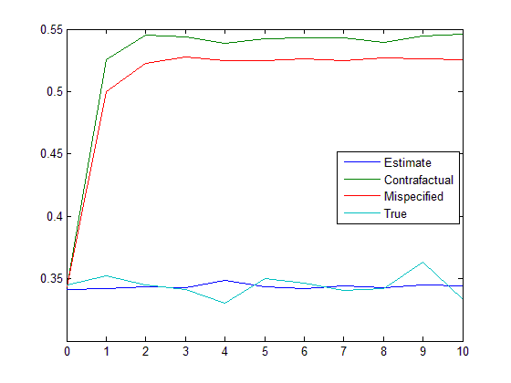

# Q1.10

If we want the confidence interval, we can repeatedly construct counterfactual data, and use the nonparametric distribution to construct 90% interval.

# Q1.11

Theta 1 using random effect model

Estimation=-2.4081, S.D=0.4077

Estimation=3.0305, S.D=0.3837

Estimation=-1.1956, S.D=0.8894

Estimation=-1.5050, S.D=0.5564

Theta 2

Estimation=-2.5460, S.D=0.6679

Estimation=4.7801, S.D=0.4267

Estimation=-1.2994, S.D=0.0002

Estimation=0.0000, S.D=0.3783

Theta 3

Estimation=-2.5373, S.D=0.6687

Estimation=4.7776, S.D=0.4257

Theta with sum(y)=3

Estimation=-0.5938, S.D=0.2318

Estimation=1.1719, S.D=0.1433

Theta with sum(y)=4

Estimation=-0.4700, S.D=0.2096

Estimation=1.6740, S.D=0.1500

Theta with sum(y)=5

Estimation=0.9029, S.D=0.2091

Estimation=0.4640, S.D=0.1699

Theta with sum(y)=6

Estimation=14.3584, S.D=0.1509

Estimation=-12.0448, S.D=0.1511

time (a) (b) (c) true

0 39.00 36.07 36.07 29.39

1 37.47 44.43 41.23 33.98

2 37.47 48.19 46.24 34.96

3 36.77 49.16 47.77 36.35

4 37.47 50.00 47.63 37.05

5 37.47 49.03 46.38 36.77

6 37.74 48.47 45.82 38.02

