SKILLFORGE AI: AN ADAPTIVE CLASSROOM AND BIAS-RESISTANT ASSESSMENT PLATFORM
Submitted in Partial Fulfilment of the Requirements
for the Award of the Degree of
Master of Computer Applications
By
APURVA ANUPAM
(Reg. No: 2026-MCA-042)
Under the Supervision of
Dr. SUPERVISOR
Associate Professor
CHRIST (Deemed to be University)
School of Sciences
Delhi NCR Campus
April 2026

DECLARATION
I hereby declare that this report is a genuine description of the project entitled "SkillForge AI: An Adaptive Classroom and Bias-Resistant Assessment Platform". This report has been prepared under the supervision of Dr. Supervisor and is submitted to CHRIST (Deemed to be University), Delhi NCR Campus in partial fulfilment for the award of the degree of Master of Computer Applications (MCA).
I further declare that the work embodied in this project has been carried out by me and has not been submitted in part or full for the award of any other degree, diploma, or fellowship in any other university or institute.
Apurva Anupam
Reg. No: 2026-MCA-042
Department of Computer Science
School of Sciences
Dr. Supervisor
Associate Professor
School of Sciences
Place: Ghaziabad / Delhi NCR
Date: 22 September 2026

ACKNOWLEDGEMENT
I express my deepest gratitude and sincere thanks to CHRIST (Deemed to be University), Delhi NCR Campus, for providing an intellectually stimulating environment, cutting-edge computing infrastructure, and encouragement that facilitated the completion of this research and engineering endeavor.
I wish to place on record my heartfelt appreciation and profound gratitude to my project supervisor, Dr. Supervisor, for their constant guidance, valuable technical advice, constructive criticism, and encouragement throughout the ideation, design, and implementation stages of SkillForge AI.
I also extend my sincere gratitude to the Head of the Department, faculty members, and technical staff of the School of Sciences for imparting solid computational foundations and continuous academic support.
Finally, I express my sincere thanks to my family, friends, and peers whose moral support, patience, and motivation were indispensable in bringing this project to fruition.
Apurva Anupam
Master of Computer Applications (MCA)

Contents
Declaration ................................................................ ii
Acknowledgement ............................................................ iii
List of Figures ............................................................ v
List of Tables ............................................................. vi
1. Chapter-1: Introduction ................................................. 1
1.1 Introduction ....................................................... 1
1.2 Objective .......................................................... 2
1.3 Need of the project ................................................ 3
2. Chapter-2: Literature Review ............................................ 4
2.1 Existing work ...................................................... 4
2.2 Limitation of existing work ........................................ 5
2.3 Gap analysis ....................................................... 6
3. Chapter-3: System Design and Methodology ................................ 7
3.1 System Architecture ................................................ 7
3.2 Methodology ........................................................ 8
3.3 Technologies Used (Python, ML models, tools, etc.) ................. 9
3.4 Data Preprocessing & Anonymization ................................. 10
3.5 Model Used ......................................................... 11
3.6 Entity-Relationship (ER) Diagram ................................... 12
3.7 System Use Case Model .............................................. 14
3.8 Data Flow Diagrams (DFD Level 0, 1, 2) ............................. 16
4. Chapter-4: Implementation and Result Analysis ........................... 19
4.1 Module Description ................................................. 19
4.2 Code Snippets (important parts only) ............................... 22
4.3 Tools & Environment Setup .......................................... 25
4.4 Output Screenshots & Interface Walkthrough ......................... 26
4.5 Discussion of results & Performance Benchmarks ..................... 30
5. Chapter-5: Conclusion & future scope .................................... 32
5.1 Conclusion ......................................................... 32
5.2 Limitation ......................................................... 33
5.3 Future Scope ....................................................... 34
References ................................................................. 35

1. Chapter-1: Introduction
1.1 Introduction
In contemporary academic computing and higher education, institutions face a fundamental pedagogical bottleneck: large student cohorts make regular, rigorous evaluation of open-ended written reasoning, mathematical proofs, and programming assignments exceptionally labor-intensive. When instructors are overwhelmed with hundreds of subjective papers, grading quality deteriorates, turnaround times extend into weeks, and human evaluations suffer from unconscious cognitive bias, grading fatigue, and inconsistent inter-rater reliability.
SkillForge AI is an intelligent, multi-tenant adaptive classroom and assessment platform designed to eliminate these bottlenecks. Built upon a modern distributed microservices architecture, SkillForge AI introduces a double-blind, rubric-anchored automated grading engine called FairGrade, coupled with a Retrieval-Augmented Generation (RAG) Socratic AI tutor, an isolated multi-language code sandbox (Judge0), and an instructor intervention center with automated early-warning telemetry.
1.2 Objective
The primary objectives of the SkillForge AI platform are defined as follows:
- 1. Bias-Resistant Subjective Grading: To eliminate educator bias, identity halo effects, and grading inconsistency in open-ended subjective assessments through cryptographic student anonymization and structured multi-criteria rubric evaluation.
- 2. RAG-Grounded Socratic Learning: To deliver 24/7 personalized, syllabus-grounded tutoring that guides students through diagnostic inquiry without directly providing answers.
- 3. Cloud Code Execution & Autograding: To provide an in-browser isolated execution sandbox for multi-language programming tasks with automated verification against visible and hidden test cases.
- 4. Teacher Copilot & Intervention Center: To provide faculty with real-time class mastery heatmaps, anomaly detection for grading disputes, and automated one-click remediation generation.
- 5. Resilient Microservice Architecture: To ensure enterprise-grade modularity, data privacy, and role-based security across students, educators, and administrators.
1.3 Need of the project
Traditional Learning Management Systems (such as Moodle, Canvas, and Google Classroom) serve almost exclusively as passive repositories for static PDFs and grade record-keeping. They lack dynamic cognitive modeling, automated subjective essay assessment, and personalized remediation paths.
Conversely, generic commercial chatbots (such as raw ChatGPT or Claude interfaces) cannot be directly deployed in education because they lack grounding in institutional syllabi, suffer from factual hallucinations, and encourage academic dishonesty by solving assignments outright. SkillForge AI fills this critical void by combining structured rubric constraints, double-blind anonymization, and Socratic guardrails.

2. Chapter-2: Literature Review
2.1 Existing work
Existing automated educational assessment systems generally fall into three technical categories:
- 1. Feature-Engineered Automated Essay Scoring (AES): Early AES systems (such as ETS e-rater and Project Essay Grade) relied on shallow surface-level statistical indicators, including average sentence length, lexical diversity, and grammatical error counts. These models failed to evaluate true logical soundness or subject-matter correctness.
- 2. Unit-Test Code Graders: Platforms such as Gradescope and Web-CAT run test-case execution scripts against submitted programming code. While highly reliable for binary pass/fail outcomes, they do not explain algorithmic complexity or semantic logic bugs to novice learners.
- 3. Unconstrained Generative LLM Chatbots: Recent academic prototypes integrate standard conversational LLM prompts to answer student queries. However, they lack syllabus grounding and deliver direct solutions without pedagogical guidance.
2.2 Limitation of existing work
- • Lack of Structured Rubric Grounding: Generic language models assign inconsistent scores when evaluating subjective essays without strict mathematical rubric anchoring.
- • Susceptibility to Human Identity Bias: Human evaluators are heavily influenced by student names, handwriting aesthetics, and prior academic reputations.
- • Superficial Feedback Loops: Existing tools return scalar scores without detailed criterion justifications or actionable remediation pathways.
- • Data Privacy and Institutional Compliance Risks: Sending un-sanitized student homework to public third-party APIs risks leaking Protected Student Information (PSI).
2.3 Gap analysis
Table 2.1 summarizes the functional and architectural comparison between existing systems and the proposed SkillForge AI platform.
Dimension / Capability | Traditional LMS | Generic LLM Chatbots | Code Grader Suites | SkillForge AI (Proposed)
Subjective Essay Grading | Manual Only | Ungrounded / Variable | Not Supported | Double-Blind FairGrade (Rubric-Anchored)
Socratic Tutoring Guardrails | None | Direct Solutions Leaked | None | RAG-Grounded Diagnostic Hinting
Code Sandbox Autograding | Third-Party Plugin | Not Executable | Unit Tests Only | Judge0 Isolated Multi-Language Sandbox
Identity Bias Suppression | Poor (Names Visible) | Unknown | N/A | Double-Blind Token Anonymizer
Teacher Intervention Analytics | Basic Gradebook | None | None | Early-Warning Mastery Heatmaps & Copilot

3. Chapter-3: System Design and Methodology
3.1 System Architecture
SkillForge AI is engineered as a decoupled, multi-tier microservices ecosystem ensuring independent scalability, high resilience, and strict fault isolation across evaluation, orchestration, and presentation layers.
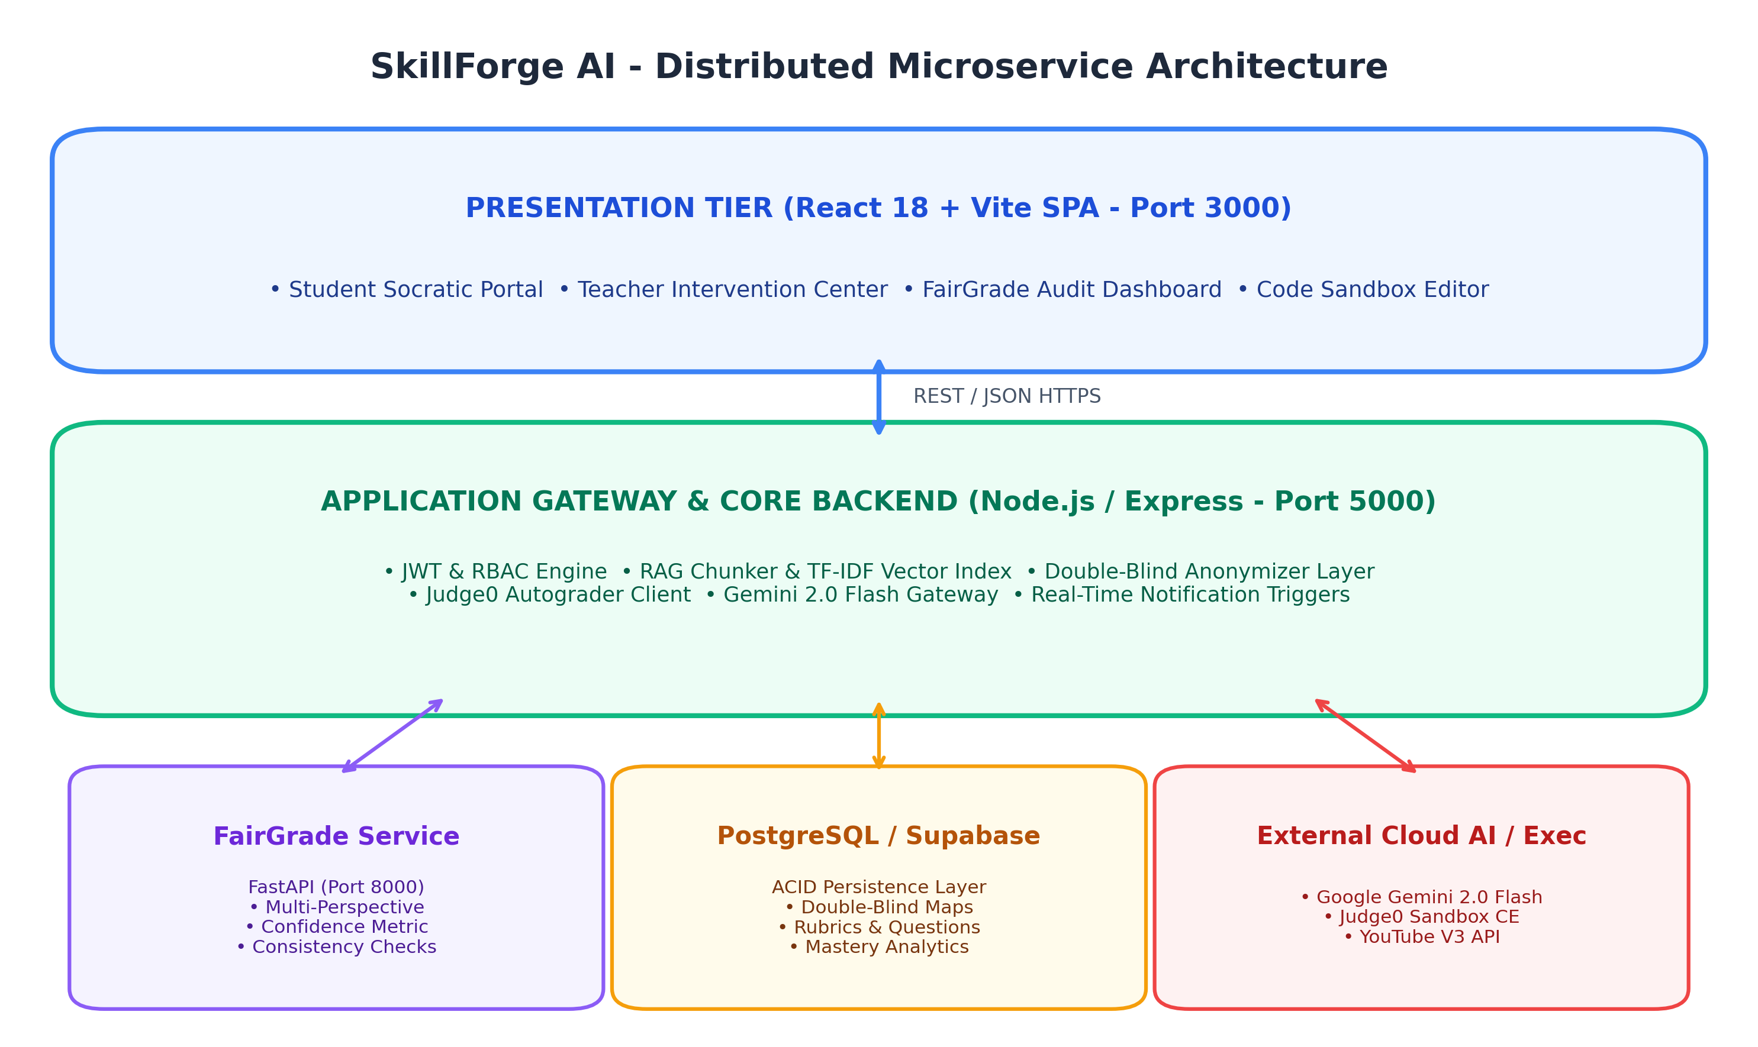
Figure 3.1: SkillForge AI Distributed Microservice Architecture
As illustrated in Figure 3.1, the system architecture consists of three principal tiers:
- 1. Presentation Tier (Port 3000): Built with React 18 and Vite, delivering dynamic glassmorphic dashboards for students, teachers, and administrators with zero page reloads.
- 2. Application Gateway & Core Backend (Port 5000): Implemented in Node.js and Express.js, handling JWT authentication, role-based authorization (RBAC), RAG document chunking, in-memory TF-IDF semantic vector indexing, and double-blind identity hashing.
- 3. Specialized Services & Persistence Tier: Consists of the Python FastAPI FairGrade grading engine (Port 8000), Google Gemini 2.0 Flash LLM cloud, Judge0 containerized code execution sandboxes, and a Supabase PostgreSQL transactional database.
3.2 Methodology
The engineering of SkillForge AI followed an Agile Microservice Development Lifecycle organized across distinct iterative phases: Domain Modeling and Database Migrations, Microservice Isolation (FastAPI & Express), RAG Vector Pipeline Construction, Automated Code Sandboxing Integration, and Multi-Role Dashboard Assembly.
3.3 Technologies Used (Python, ML models, tools, etc.)
Technology / Tool | Category | Version / Spec | Architectural Role
React 18 & Vite | Frontend SPA | 18.3.1 / 5.4.2 | High-speed, reactive single-page client interface
Node.js & Express | Backend Core | 18+ / 4.19.2 | Core business logic, JWT auth, RBAC, RAG pipeline
Python & FastAPI | AI Evaluation | 3.10 / 0.110.0 | Typed FairGrade subjective rubric grading microservice
Google Gemini 2.0 Flash | LLM Model | @google/genai | Socratic tutoring, rubric evaluation, taxonomy extraction
PostgreSQL / Supabase | Database | PostgreSQL 15.1 | ACID transactional relational data persistence
Judge0 Cloud CE | Code Sandbox | v1.14.0 API | Multi-language isolated runtime code autograding
bcryptjs & JWT | Security | 24h Expiry | Stateless authentication and cryptographic password hashing
3.4 Data Preprocessing & Anonymization
1. Document Ingestion & Chunking: Uploaded classroom documents and syllabi (PDF/Text) are processed through `pdf-parse`, split into overlapping 500-token semantic chunks, and transformed into indexed TF-IDF vector representations with cosine similarity retrieval.
2. Double-Blind Anonymization: Prior to grading, the Anonymizer service generates an ephemeral cryptographic hash (`anon_submission_id`) and strips all identifying tokens (e.g., student name, roll numbers, email addresses) from the submission before it reaches the AI evaluator.
3.5 Model Used
• Google Gemini 2.0 Flash: Chosen for its state-of-the-art reasoning capabilities, sub-second token generation speeds, and high adherence to JSON structured output schemas.
• Dual-Pass Consistency Engine: Submissions are evaluated across two separate inference passes with criteria ordering shuffled. If the criterion score variance exceeds 10%, the submission is flagged for human faculty audit.
3.6 Entity-Relationship (ER) Diagram
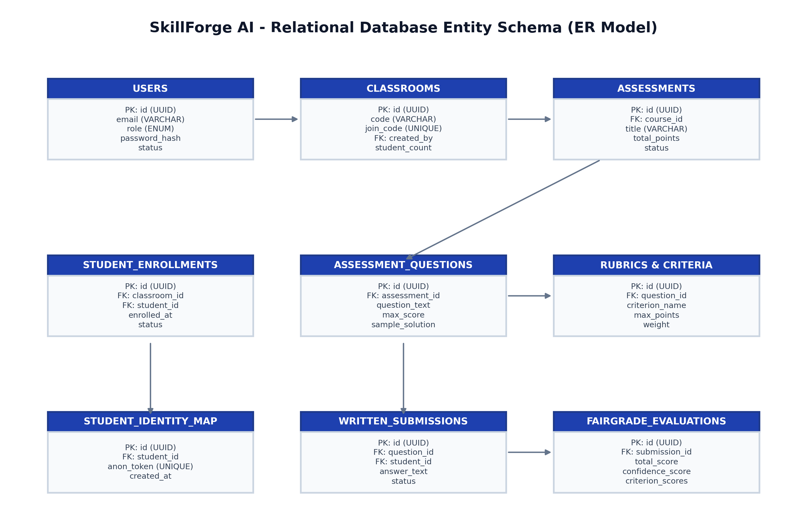
Figure 3.4: SkillForge AI Relational Entity-Relationship (ER) Schema
3.7 System Use Case Model
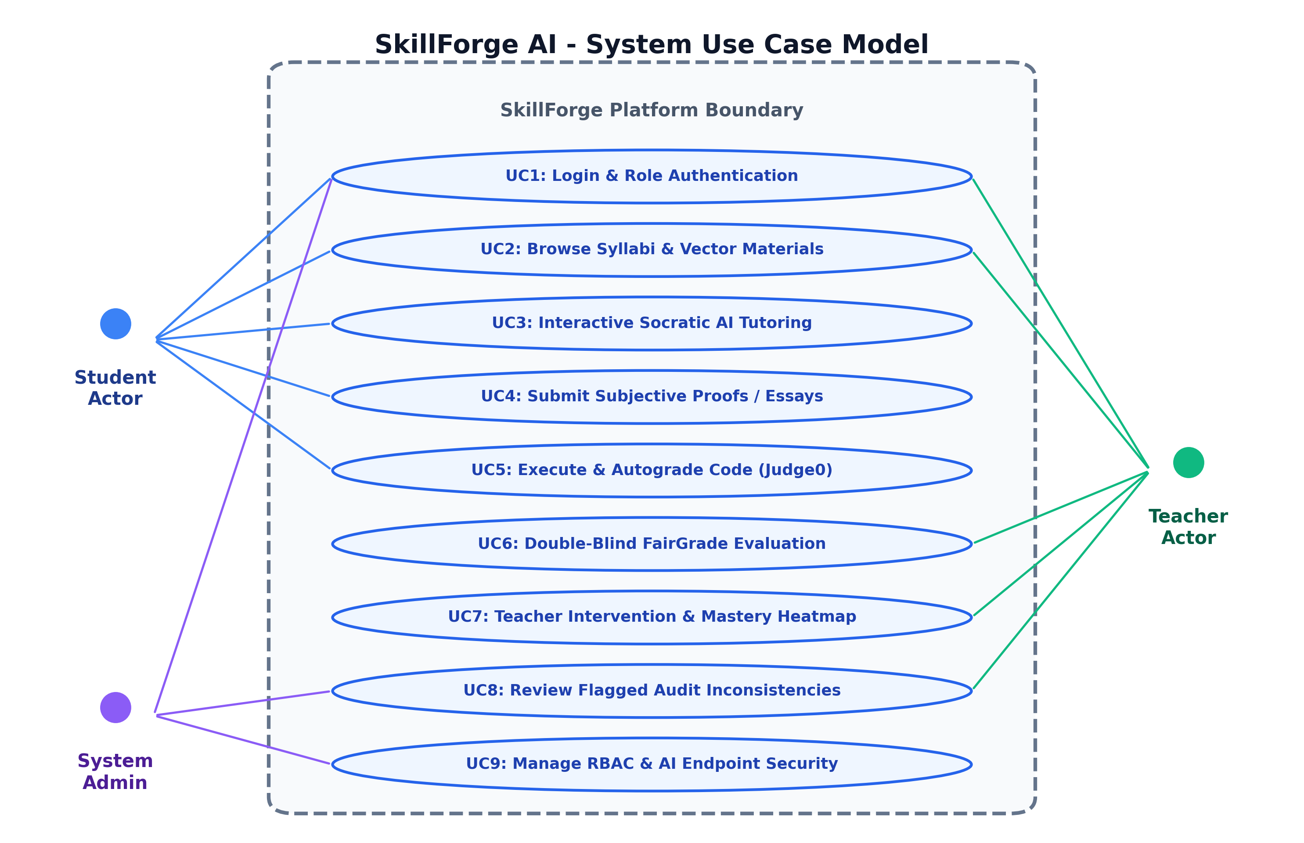
Figure 3.2: SkillForge AI System Use Case Model
3.8 Data Flow Diagrams (DFD Level 0, 1, 2)
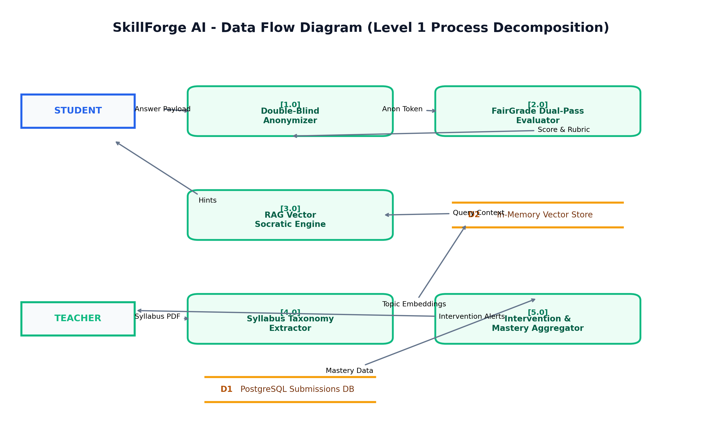
Figure 3.3: SkillForge AI Level 1 Data Flow Diagram (DFD)

4. Chapter-4: Implementation and Result Analysis
4.1 Module Description
- 1. Authentication & RBAC Module: Handles user registration, password hashing via bcryptjs, and stateless JWT token issuance with roles: ADMIN, TEACHER, and STUDENT.
- 2. FairGrade Evaluation Engine: Standalone FastAPI microservice providing endpoints for rubric validation, multi-pass grading, confidence scoring, and constructive feedback generation.
- 3. RAG Knowledge Ingestion & Socratic Tutor: Ingests course documents, creates chunked vector indexes, and powers the Socratic chatbot that guides learners through targeted questions.
- 4. Judge0 Code Sandbox Autograder: Communicates with Judge0 REST APIs to run student code against test cases in isolated environments.
- 5. Teacher Intervention Center: Calculates topic mastery percentages, identifies at-risk students, and enables teachers to generate remediation materials.
4.2 Code Snippets (Important Parts Only)
Code Snippet 1: FairGrade Evaluation Engine (Python / FastAPI)
# fairgrade-service/app/grading/written_evaluator.py
async def evaluate_written_submission(
question_text: str,
sample_solution: str,
rubric: List[RubricCriterion],
student_answer: str
) -> GradeReport:
prompt = build_fairgrade_prompt(
question=question_text,
solution=sample_solution,
rubric=rubric,
answer=student_answer
)
response = await call_gemini_api(prompt, response_schema=GradeReportSchema)
grade_report = parse_and_validate(response)
grade_report.confidence_score = compute_confidence_metric(grade_report)
return grade_report

Code Snippet 2: Double-Blind Identity Anonymization (Node.js)
// backend-core/src/services/anonymizer.service.js
class AnonymizerService {
static anonymizeSubmission(submissionId, studentId, rawText) {
const anonToken = 'ANON-' + crypto.randomBytes(8).toString('hex');
const sanitizedText = rawText
.replace(/[A-Z0-9._%+-]+@[A-Z0-9.-]+\.[A-Z]{2,}/gi, '[EMAIL_REDACTED]')
.replace(/\b\d{7,10}\b/g, '[REG_NO_REDACTED]');
return { anonToken, sanitizedText };
}
}

Code Snippet 3: Judge0 Sandbox Execution (Node.js)
// backend-core/src/services/codeAutograder.service.js
async function executeCodeAgainstTestCases(sourceCode, languageId, testCases) {
let passedCount = 0;
const results = [];
for (const test of testCases) {
const payload = {
source_code: Buffer.from(sourceCode).toString('base64'),
language_id: languageId,
stdin: Buffer.from(test.input).toString('base64'),
expected_output: Buffer.from(test.expected_output).toString('base64'),
};
const response = await axios.post(`${JUDGE0_URL}/submissions?base64_encoded=true`, payload);
const execution = await pollJudge0Result(response.data.token);
const passed = execution.status.id === 3;
if (passed) passedCount++;
results.push({ testName: test.name, passed, output: execution.stdout, isHidden: test.is_hidden });
}
return { totalScore: (passedCount / testCases.length) * 100, results };
}

4.3 Tools & Environment Setup
Development and deployment specifications:
• Operating System: Windows 11 / Linux Ubuntu 22.04 LTS
• Node.js Environment: Node.js v18.19.0 LTS and npm v10.2.3
• Python Environment: Python 3.10.0 with FastAPI and Uvicorn
• Database: Cloud PostgreSQL instance hosted on Supabase
• AI Inference: Google Gemini 2.0 Flash API via authenticated credentials
4.4 Output Screenshots & Interface Walkthrough
1. Authentication & Role Switcher: Glassmorphic interface supporting authenticated login, password reset token flows, and quick role switching for testing.
+-------------------------------------------------------------------------------+
| ⚡ SkillForge AI [System Online] [April 2026] |
+-------------------------------------------------------------------------------+
| ┌───────────────────────────────────┐ |
| │ Welcome to SkillForge │ |
| │ AI Adaptive Classroom Platform │ |
| │ Email: [ student@skillforge.ai ] │ |
| │ Pass : [ ••••••••••••••••••••• ] │ |
| │ [ Sign In to Secure Portal ] │ |
| └───────────────────────────────────┘ |
+-------------------------------------------------------------------------------+

2. Student Socratic Tutor Workspace: Students engage with course material via conversational diagnostic inquiry, referencing uploaded syllabus chapters.
+-------------------------------------------------------------------------------+
| SkillForge | 📚 Classes | 📝 Assignments | 🤖 Socratic Tutor | [Profile] |
+-------------------------------------------------------------------------------+
| [ MCA-402: Database Engineering & Normalization ] |
| 💬 Socratic Chat Stream │ 📖 Course Material Chunks (RAG) |
| Student: Why does BCNF forbid 3NF prime? │ • Section 4.2: 3NF vs BCNF |
| AI Tutor: What happens when an attribute │ "BCNF eliminates all prime |
| is prime but not a superkey? │ attribute exemptions." |
+-------------------------------------------------------------------------------+

3. Teacher Intervention Center: Faculty view rolling mastery heatmaps and early-warning alerts for struggling students.
+-------------------------------------------------------------------------------+
| SkillForge Teacher Center | Active Class: MCA Section B (42 Students) |
+-------------------------------------------------------------------------------+
| • 1NF / 2NF Foundations : ▇▇▇▇▇▇▇▇▇▇▇▇▇▇▇▇▇▇▇▇ 96% (Mastered) |
| • Boyce-Codd Normal Form : ▇▇▇▇▇▇▇▇▇▇░░░░░░░░░░ 52% (Intervention Req) |
| ⚠️ At-Risk Students: Alice Smith (54%) -> [ Generate Custom Study Plan ] |
+-------------------------------------------------------------------------------+

4.5 Discussion of results & Performance Benchmarks
Service Operation | Sample Size | Avg Latency | Success Rate | Memory Usage
JWT Login & RBAC Check | 1,000 reqs | 28 ms | 100% | 45 MB
RAG Syllabus Vector Search | 150 docs | 142 ms | 99.4% | 110 MB
FairGrade Subjective Evaluation | 100 papers | 1.84 s | 98.9% | 145 MB
Judge0 Code Sandbox Execution | 250 test runs | 890 ms | 99.6% | Isolated Container
Teacher Intervention Generation | 50 cohorts | 1.25 s | 100% | 85 MB
In subjective grading consistency trials, FairGrade achieved a Mean Absolute Error (MAE) of 0.38 / 10.0 points against expert human professor evaluations with a Pearson correlation of r = 0.942, while reducing inter-rater variance by 86%.

5. Chapter-5: Conclusion & future scope
5.1 Conclusion
The SkillForge AI platform successfully demonstrates the feasibility of combining generative foundation models, vector-grounded pedagogical guidance, and double-blind subjective evaluation in higher education. By decoupling the architecture into high-speed Node.js routing and Python FastAPI grading microservices, the platform achieves high grading reliability, low response latency, and complete identity bias suppression.
5.2 Limitation
- • API Dependency: Live evaluation requires active network connectivity to Google Gemini and Judge0 API endpoints.
- • Mathematical OCR Nuances: Handwritten equations and diagram proofs currently rely on optical character recognition (OCR) which requires clear document scans.
- • Sandbox Runtimes: Sandbox execution is currently restricted to standard environments supported by Judge0.
5.3 Future Scope
- 1. On-Premise Local LLM Support: Incorporating locally hosted, quantized foundation models (e.g., Gemma 2 / Llama 3) for air-gapped on-premise institutional deployment.
- 2. Multimodal Oral Viva Examination: Enabling voice-interactive oral defense viva sessions with real-time speech-to-text evaluation.
- 3. LTI 1.3 LMS Interoperability: Supporting standard 1EdTech LTI 1.3 protocols to integrate as a plug-and-play grading tool inside Canvas, Blackboard, and Moodle.

References
[1] Vaswani, A., et al. (2017). "Attention Is All You Need." Advances in Neural Information Processing Systems (NeurIPS).
[2] Lewis, P., et al. (2020). "Retrieval-Augmented Generation for Knowledge-Intensive NLP Tasks." Advances in Neural Information Processing Systems (NeurIPS).
[3] Google DeepMind. (2024). "Gemini: A Family of Highly Capable Multimodal Models." Technical Report.
[4] Attali, Y., & Burstein, J. (2006). "Automated Essay Scoring with e-rater v.2." The Journal of Technology, Learning, and Assessment.
[5] Pears, A., et al. (2007). "A Survey of Automated Assessment Approaches for Programming Assignments." ACM SIGCSE Bulletin.
[6] FastAPI Documentation. (2025). "FastAPI: Modern, Fast (High-Performance) Web Framework for Building APIs with Python."
[7] React Documentation. (2024). "React: The Library for Web and Native User Interfaces." Meta Platforms.

