BUG REPORT

Company Name: Ecove Solutions P.v.t Ltd, Mohali

Project Name: http://hashking.ecovesolutions.com/ user id: kapil/123456
http://hashking.ecovesolutions.com/admin admin id: admin/admin

Project Description: (________________________________)

Environment: (C.I (COde-Ignator)
Testing Using Techniques: Manually & Regression Testing

Tested By: Q.A. Anmol_Sharma

Tested on Dated: 08-Aug-2017

Resolve Date: ___________________

Project Tested Status: (Pass, In-progress or Fail)

“RED” Color Bugs is Web-Development Issue.
“Pink” Color Bugs is U.I-(Designing) Issue.

Testing Browser Platform:
$> Latest <Google-Chrome (59.0.3071.104)
$> Latest <Mozilla-Firefox--(Version 54.0)
$> Latest <Opera-(Version- 43.0.2442.1144)
$> Latest <UC Browser--(Version-6.1.2015.1007)
$> Latest <Safari-(Version 5.1.7)

U.I Issue
- Link

http://hashking.ecovesolutions.com/client/buy

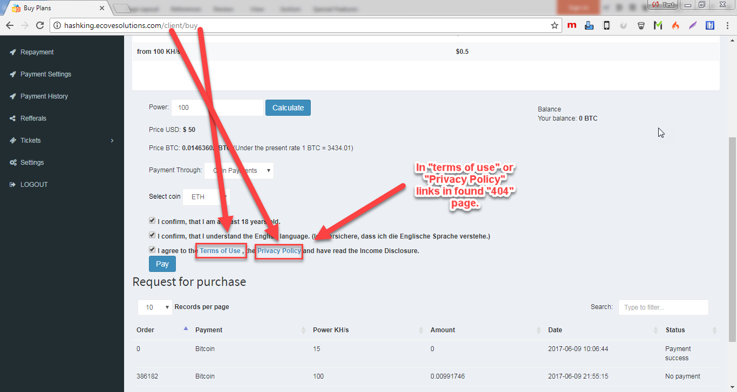

Done(Page has been changed)
Screen-Shot
Please Fix It Issue A.S.A.P
Web Issue
- Link
http://hashking.ecovesolutions.com/client/payment_settings

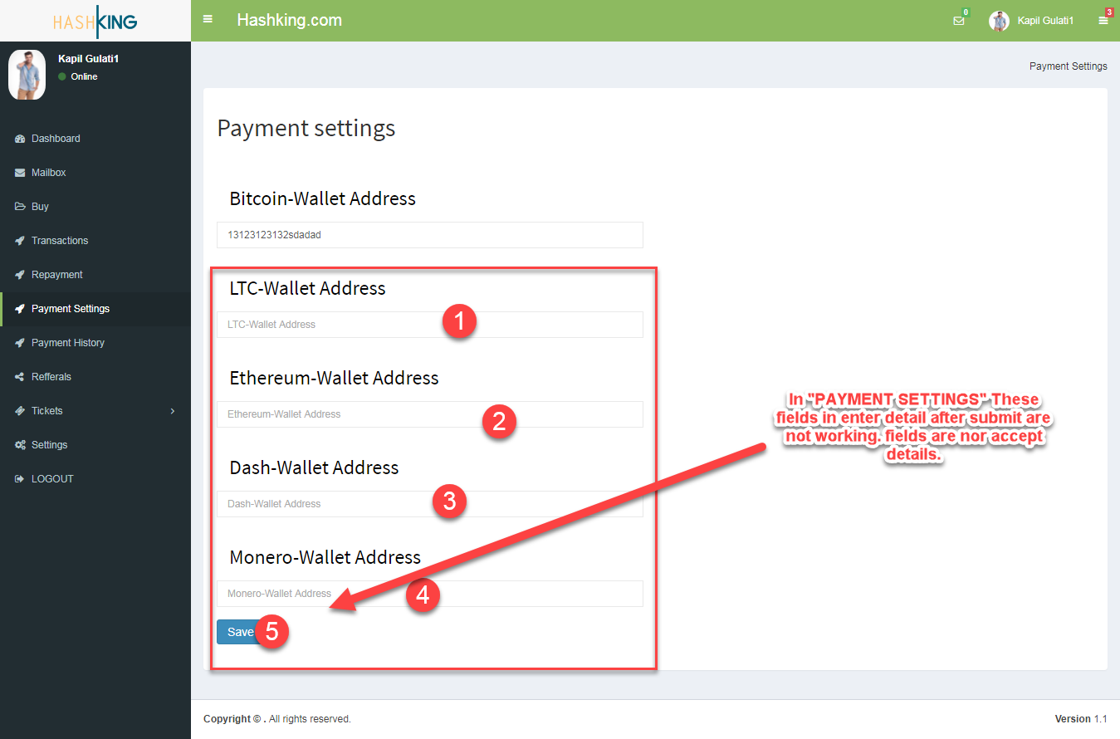
Done
Screen-Shot
Please Fix It Issue A.S.A.P
Web Issue
- Link
http://hashking.ecovesolutions.com/client/repayment

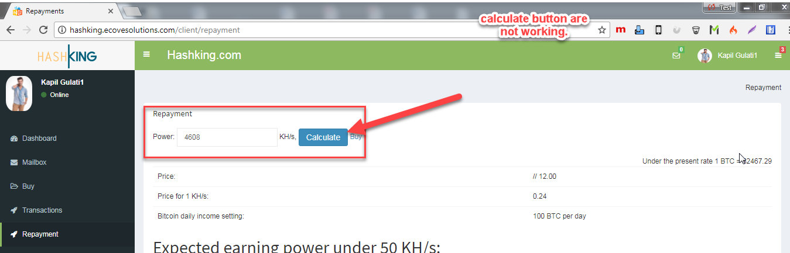
Not have to done

Screen-Shot
Please Fix It Issue A.S.A.P
Web Issue
- Link
http://hashking.ecovesolutions.com/client/tickets/open

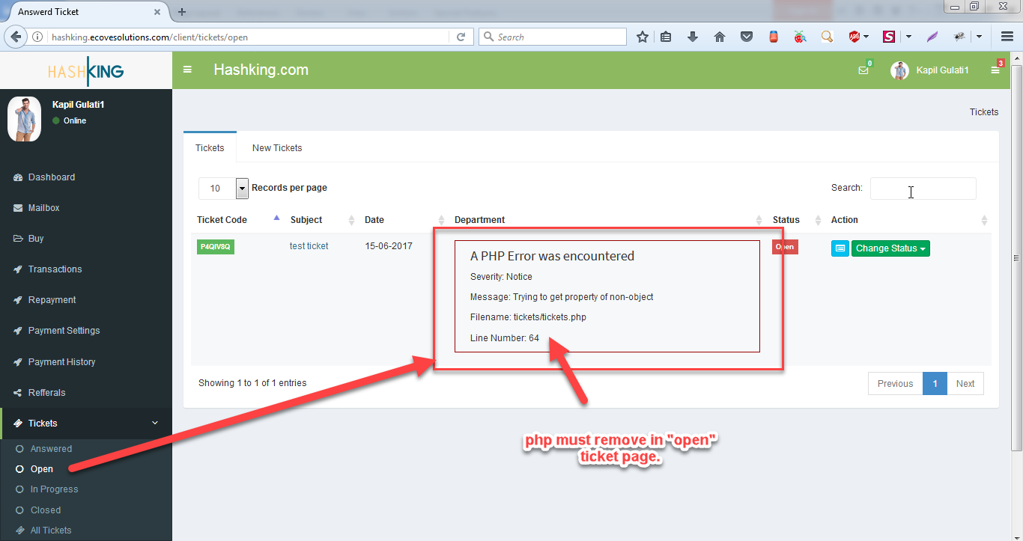

Done
Screen-Shot
Please Fix It Issue A.S.A.P
Web Issue
- Link
http://hashking.ecovesolutions.com/client/tickets/index/tickets_details/2

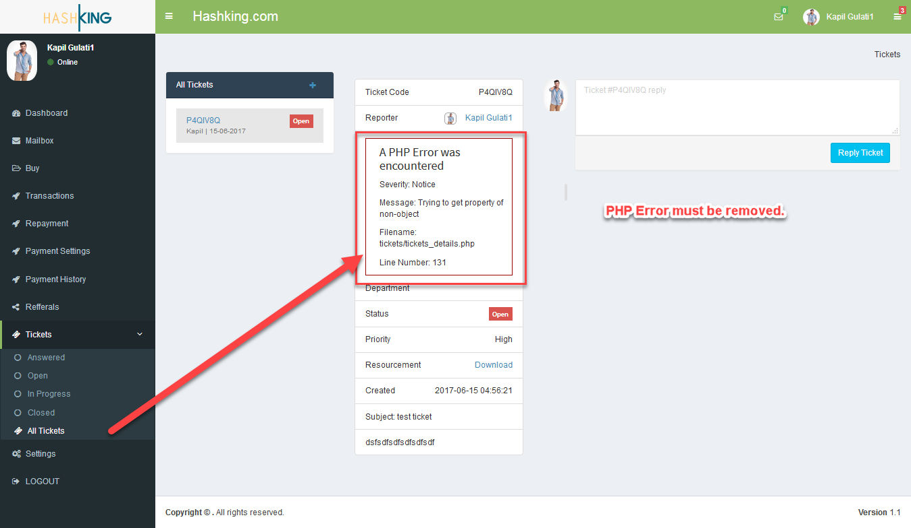
Done
Screen-Shot
Please Fix It Issue A.S.A.P
Web Issue
- Link

http://hashking.ecovesolutions.com/client/tickets
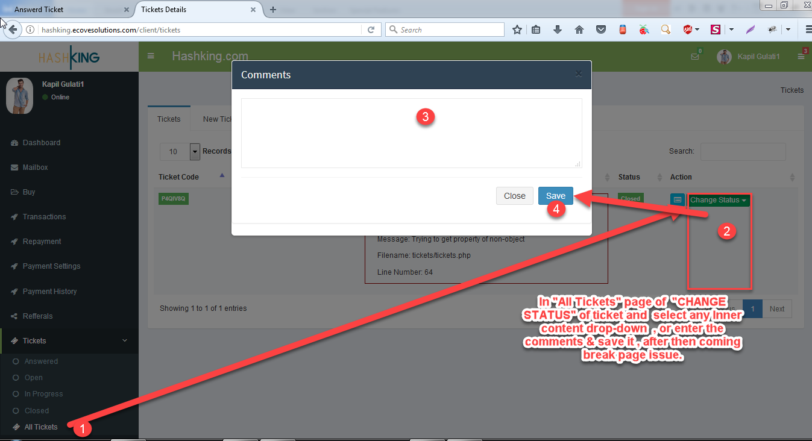
2
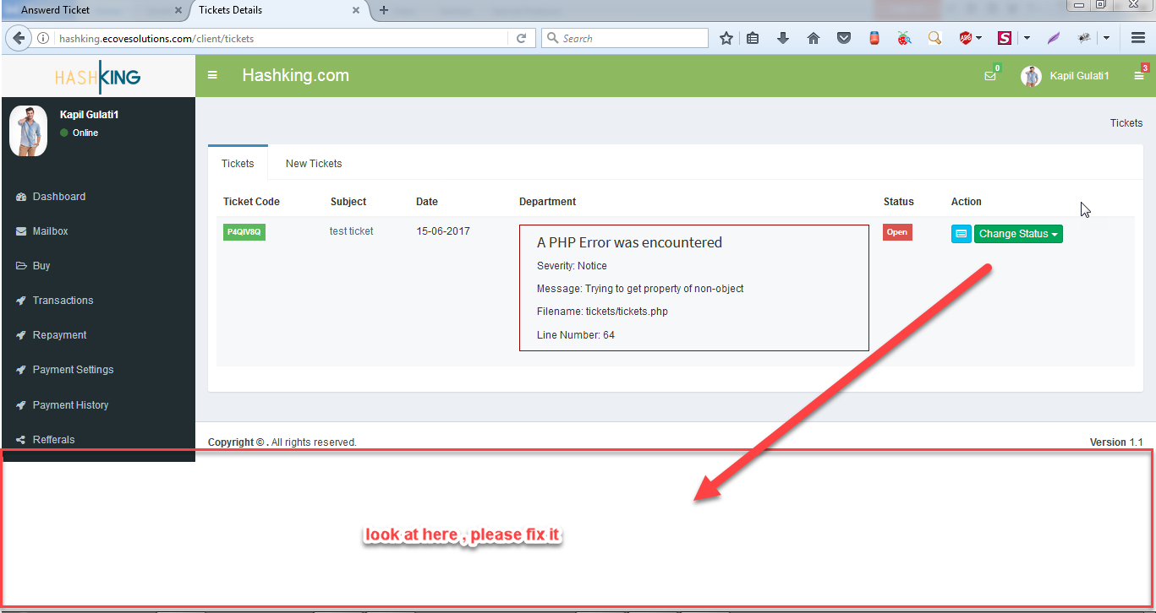
Designer issue
Screen-Shot
Please Fix It Issue A.S.A.P
Web Issue
- Link
http://hashking.ecovesolutions.com/client/refferal

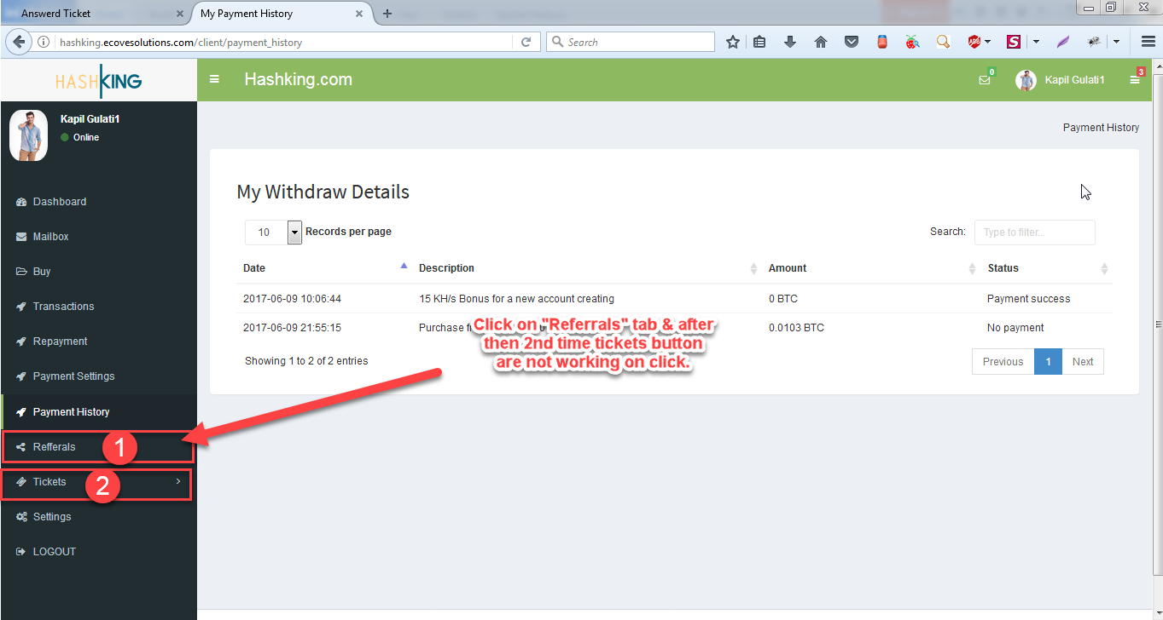
Done

Screen-Shot
Please Fix It Issue A.S.A.P
Web Issue
- Link
http://hashking.ecovesolutions.com/client/tickets/index/tickets_details/2
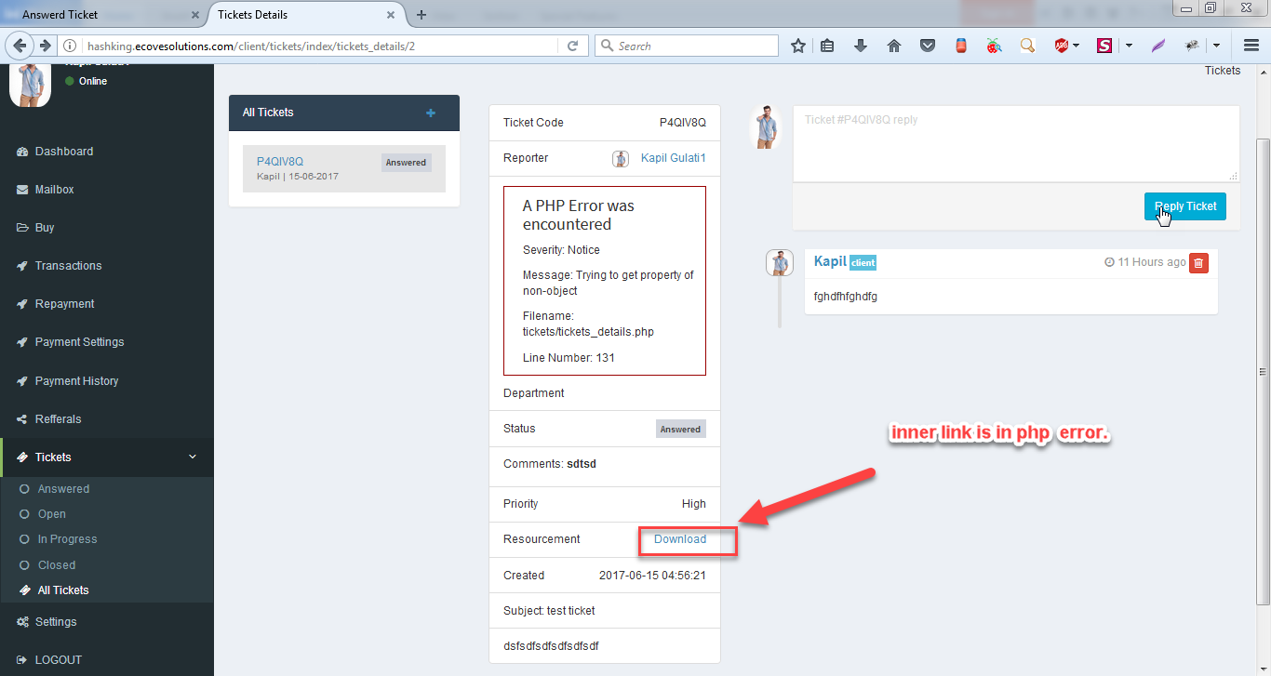

Screen-Shot
Please Fix It Issue A.S.A.P
Web Issue
- Link

http://hashking.ecovesolutions.com/login/register
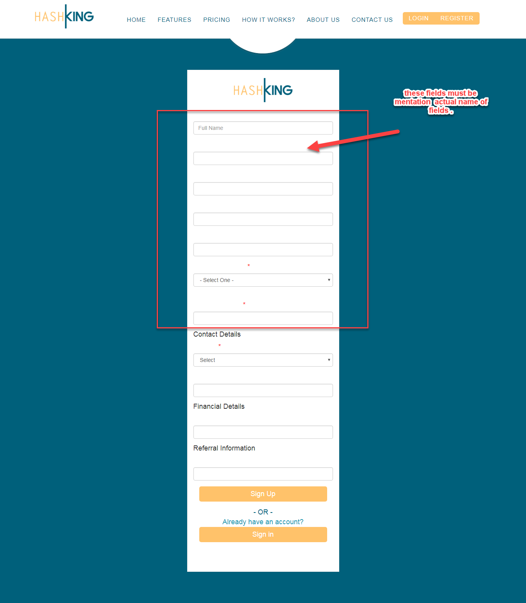
Done

Screen-Shot
Please Fix It Issue A.S.A.P
Web Issue
- Link
http://hashking.ecovesolutions.com/login/forgot_password

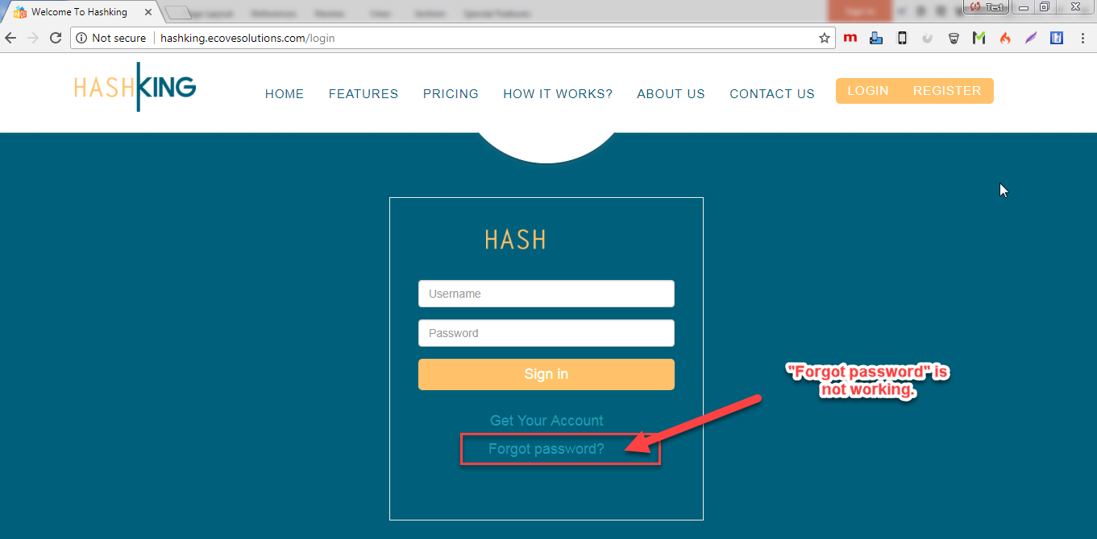

Done

Screen-Shot
Please Fix It Issue A.S.A.P
Web Issue
- Link
http://hashking.ecovesolutions.com/contact
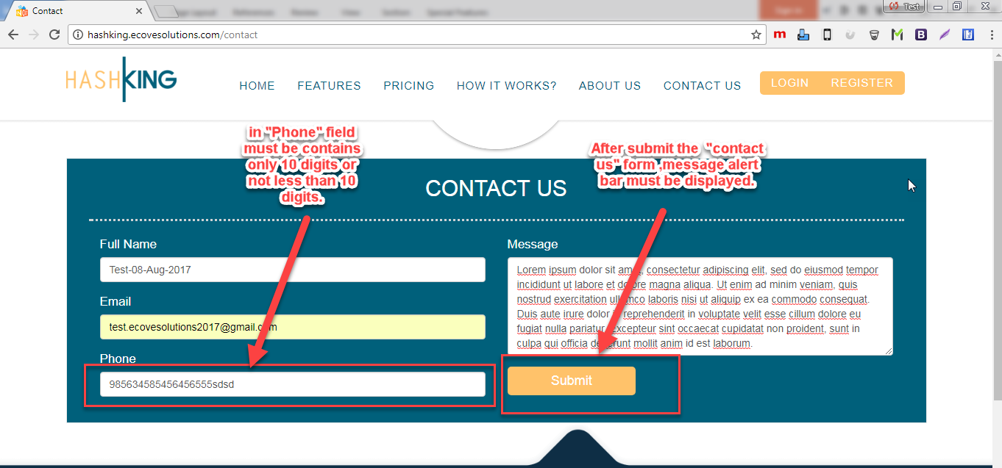

Screen-Shot
Please Fix It Issue A.S.A.P
Web Issue
- Link
http://hashking.ecovesolutions.com/contact
1
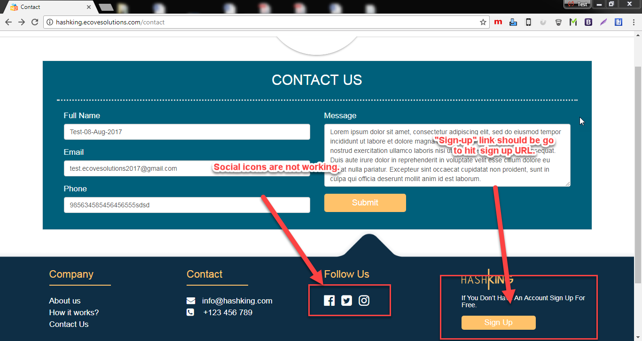

Done
2
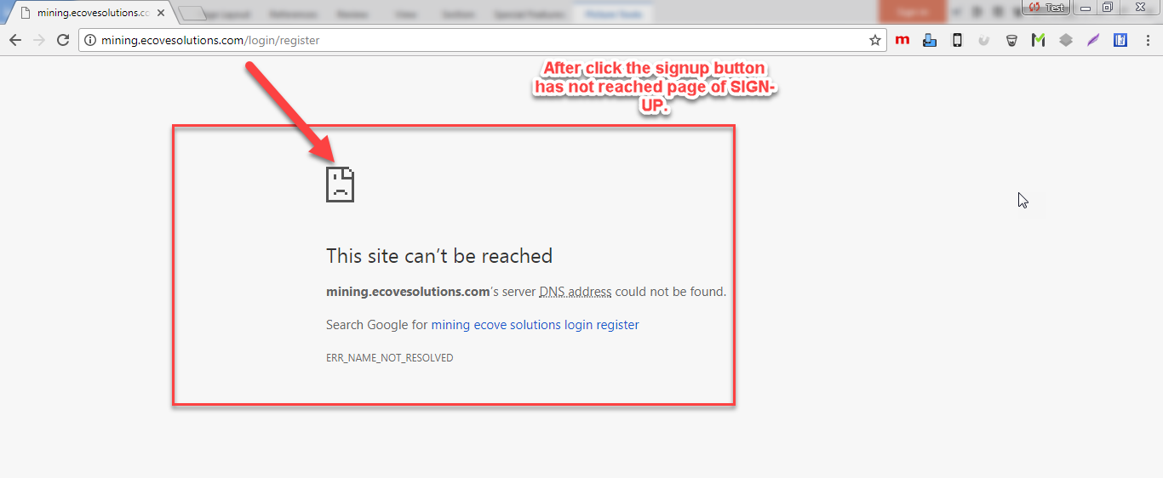
Done
Screen-Shot
Please Fix It Issue A.S.A.P

