# Sample of GWAS Results – Carrie Zhu

## Heritability Plots

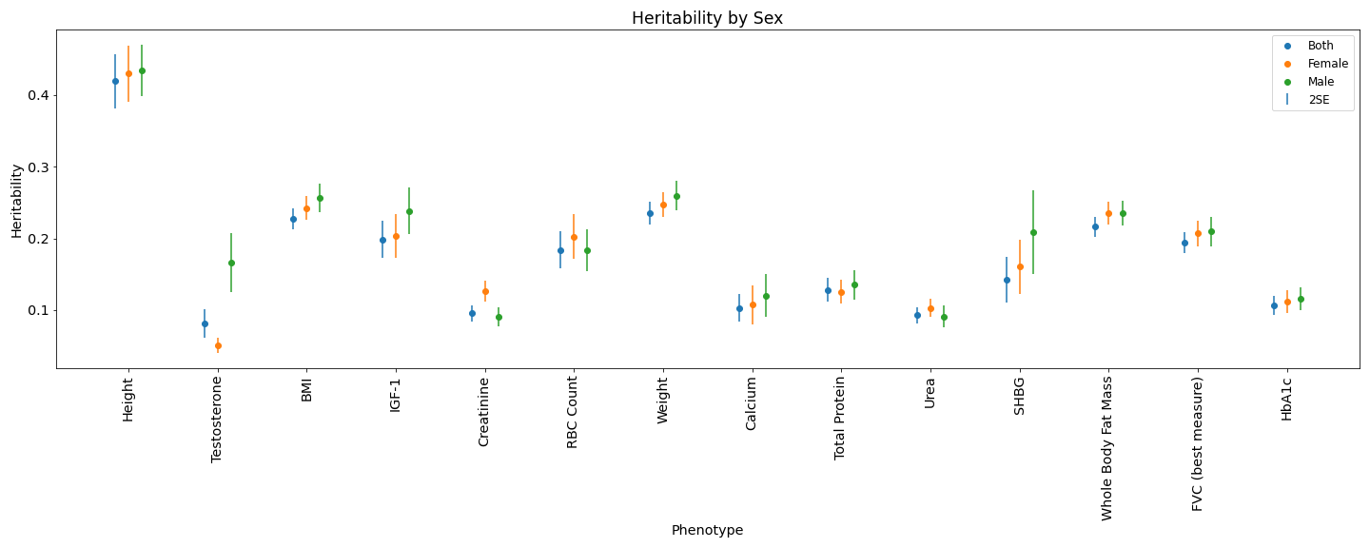

Heritability for 14 phenotypes (from female-specific, male-specific, and both GWAS)

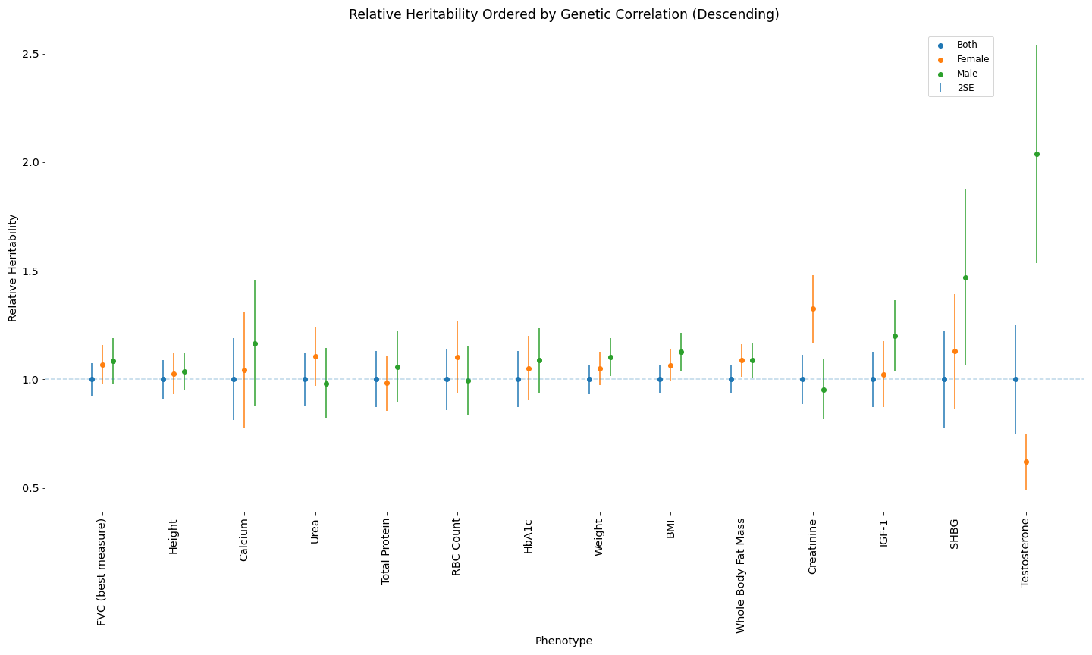

Relative heritability (h2 / {h2 of Both}) for phenotypes, in descending order by genetic correlation

## Partitioned Heritability Plots

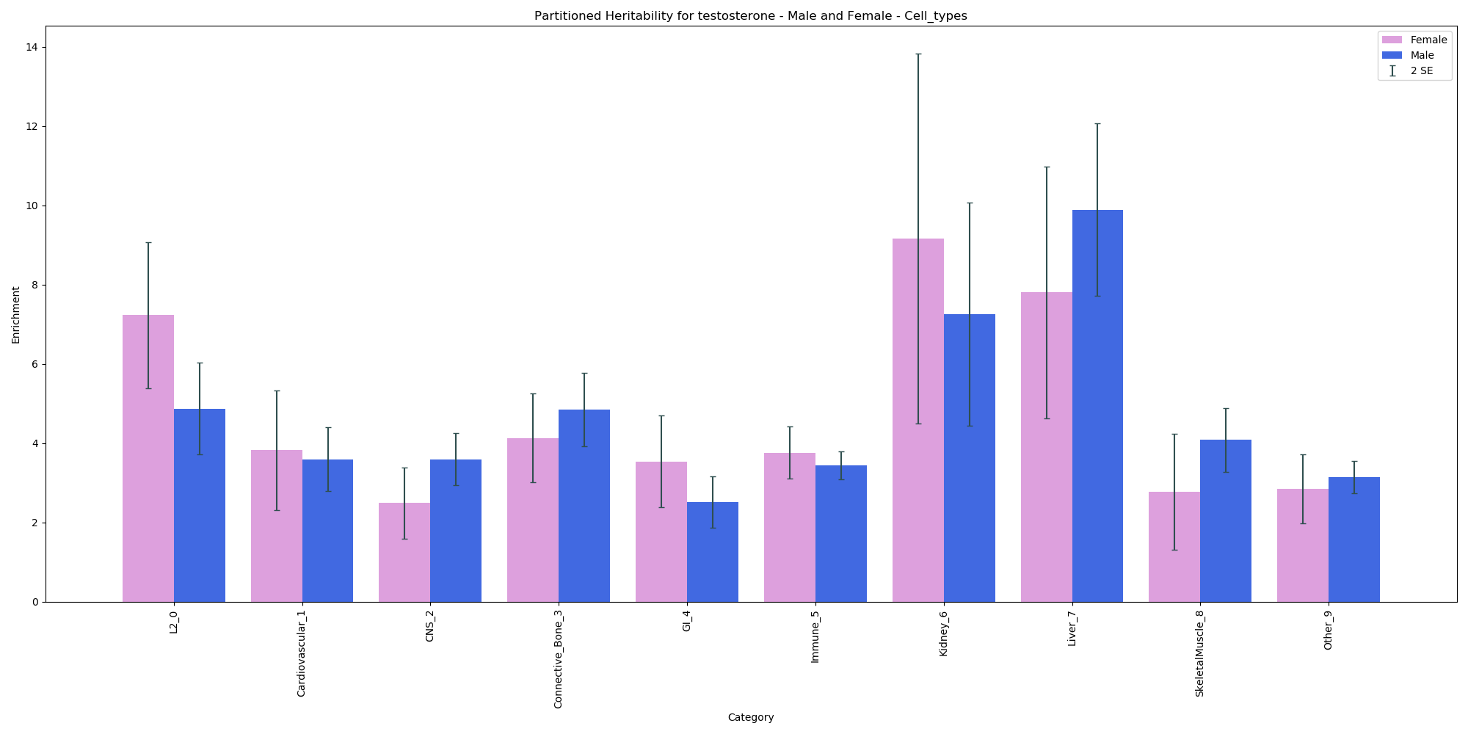

Enrichment plot separated by cell type for testosterone

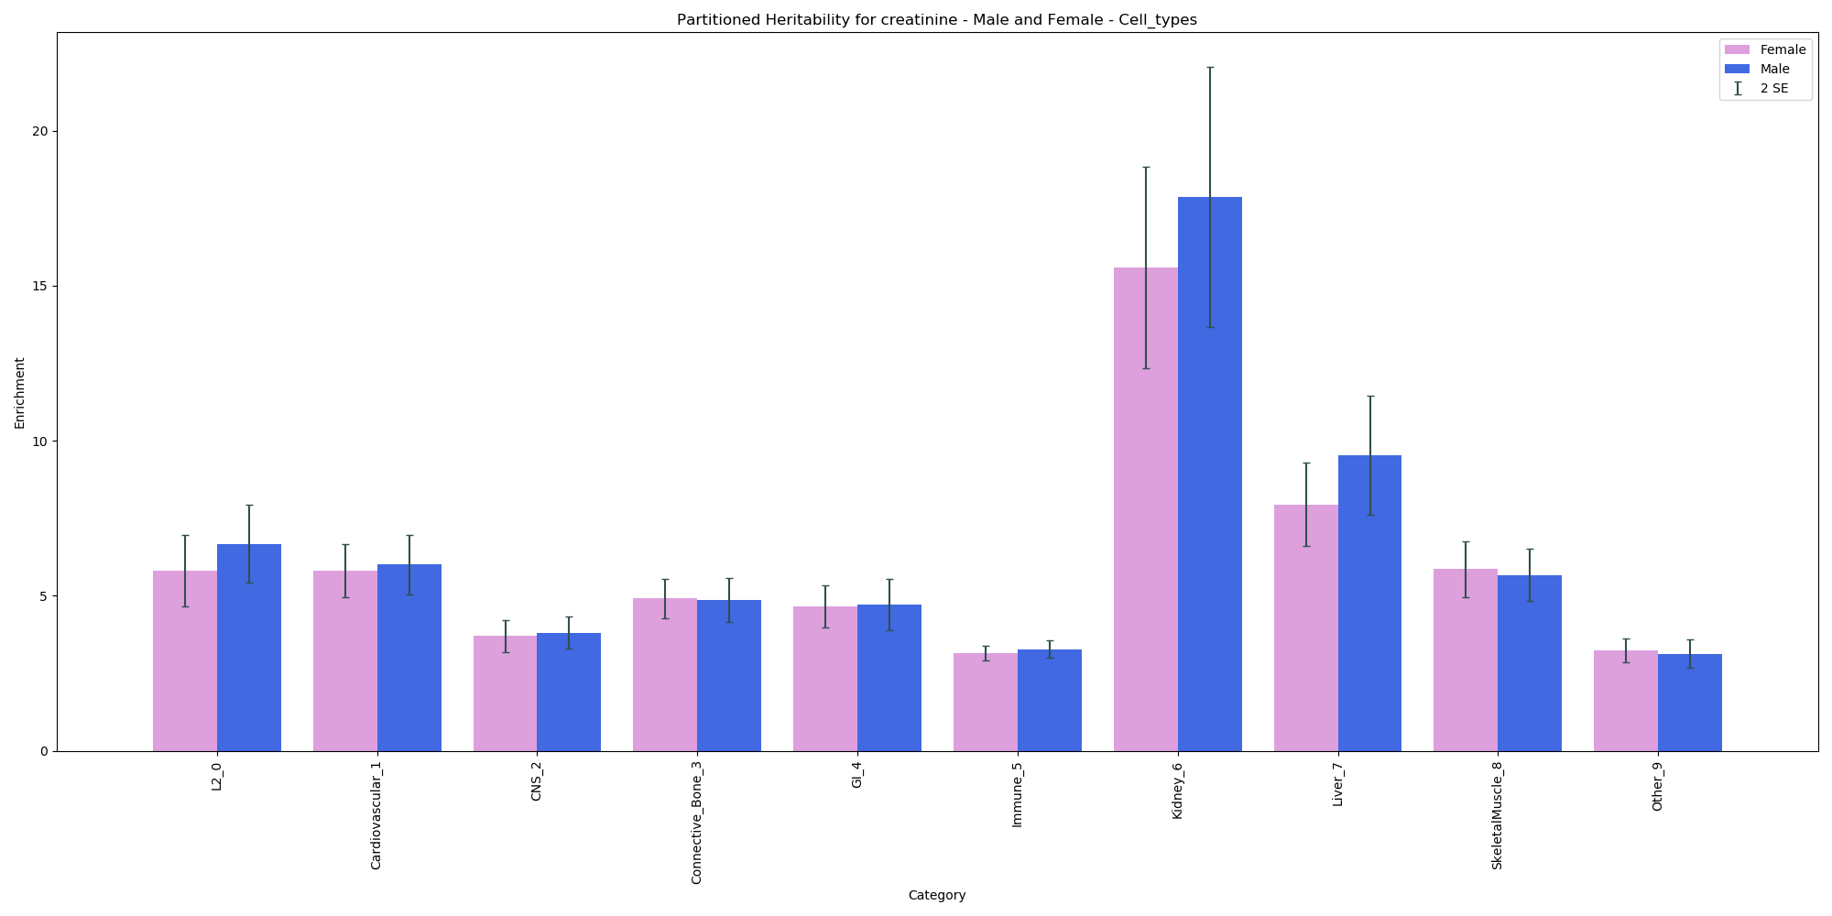

Enrichment plot separated by cell type for creatinine

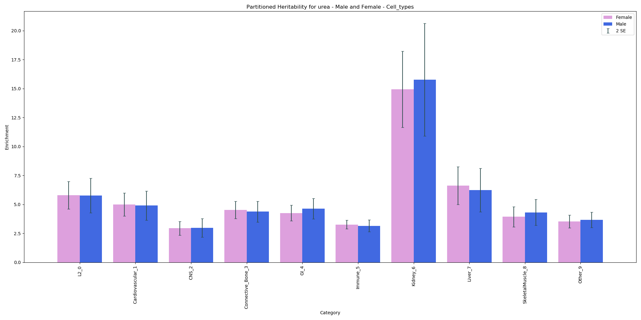

Enrichment plot separated by cell type for urea

## Manhattan Plots

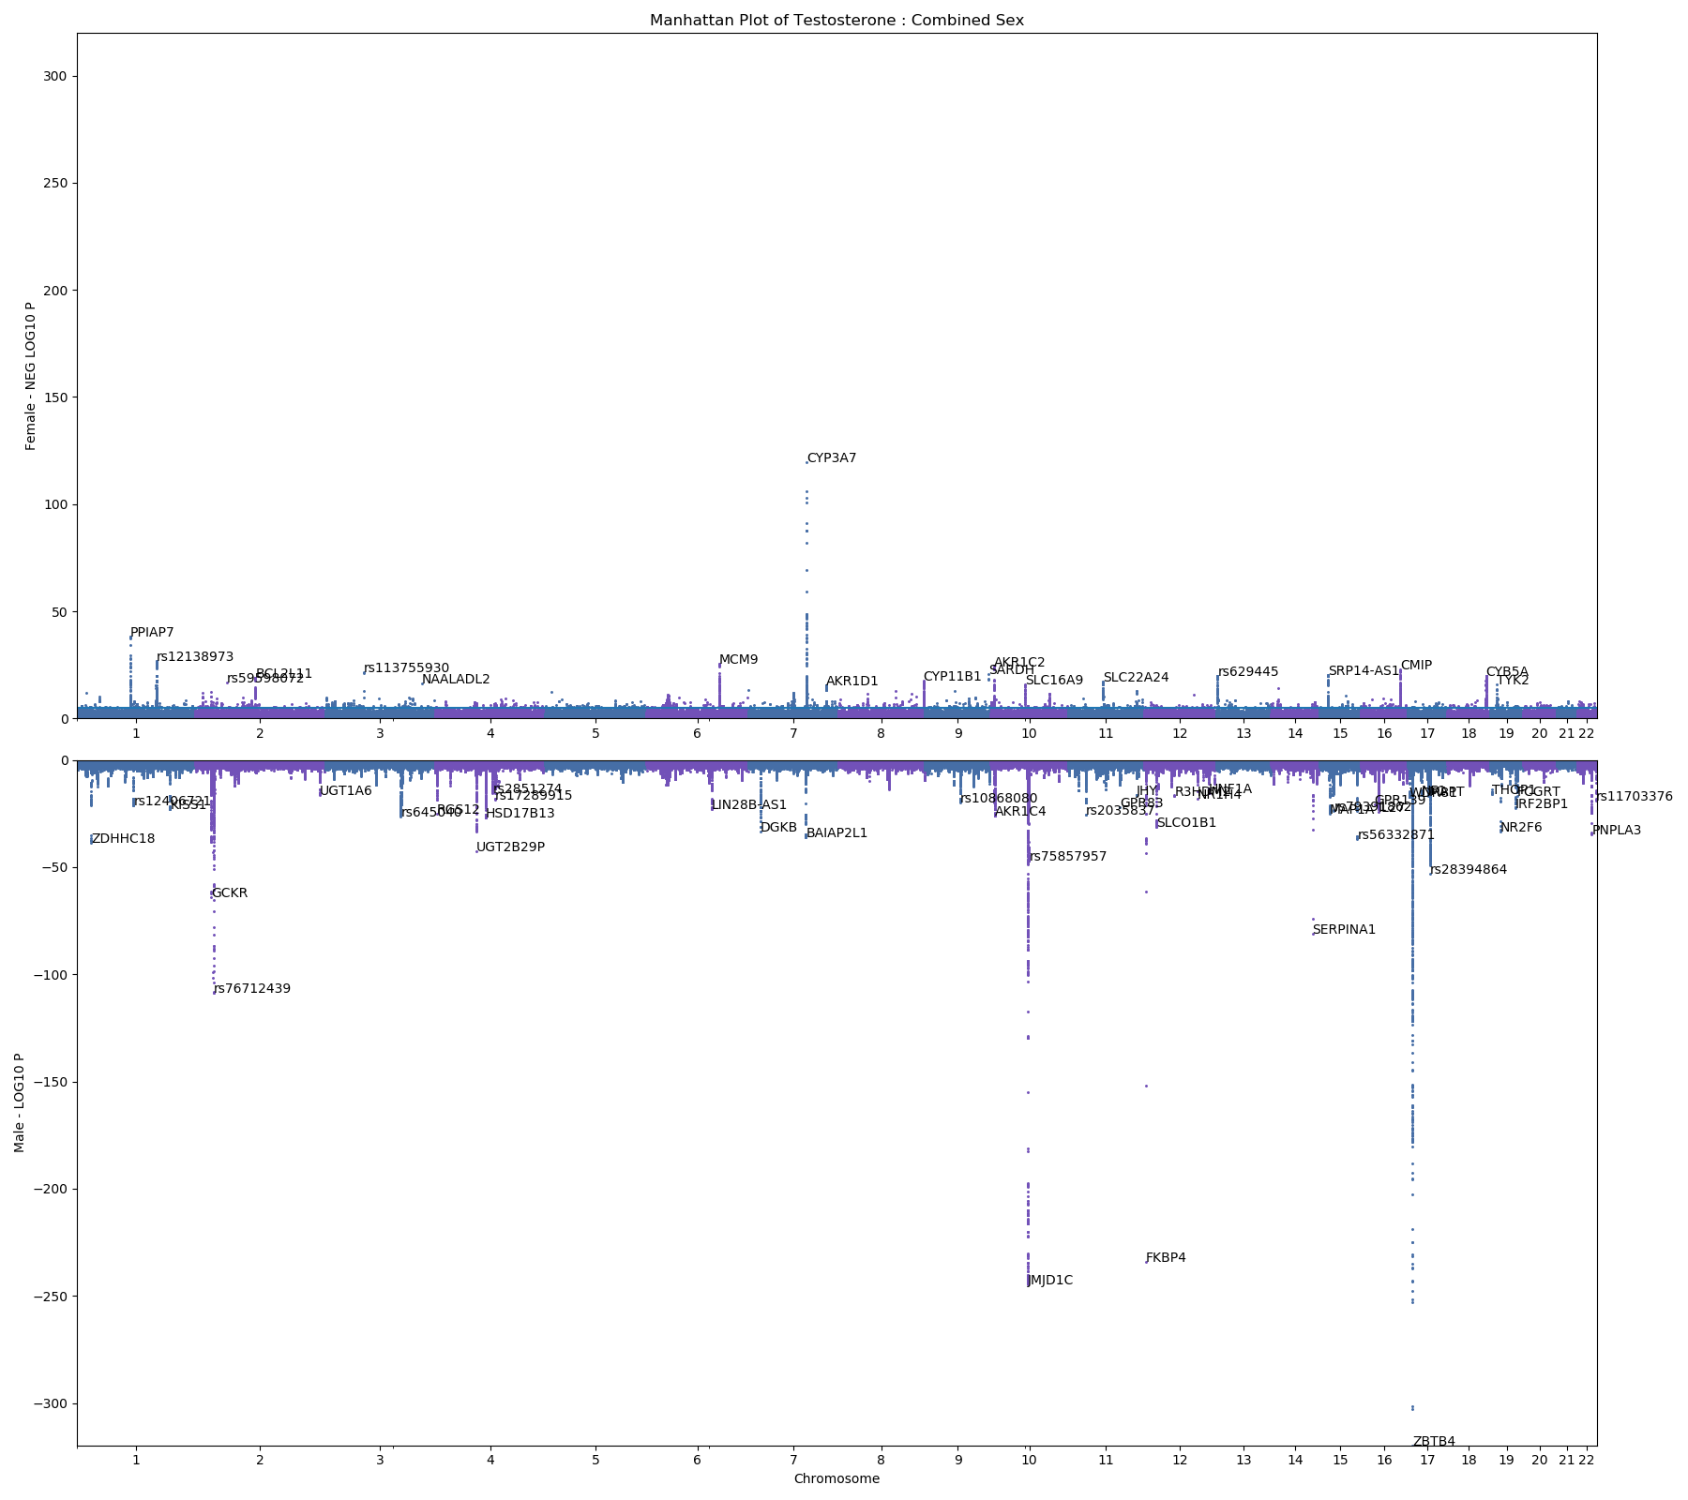

Manhattan plot for male and female GWAS of testosterone

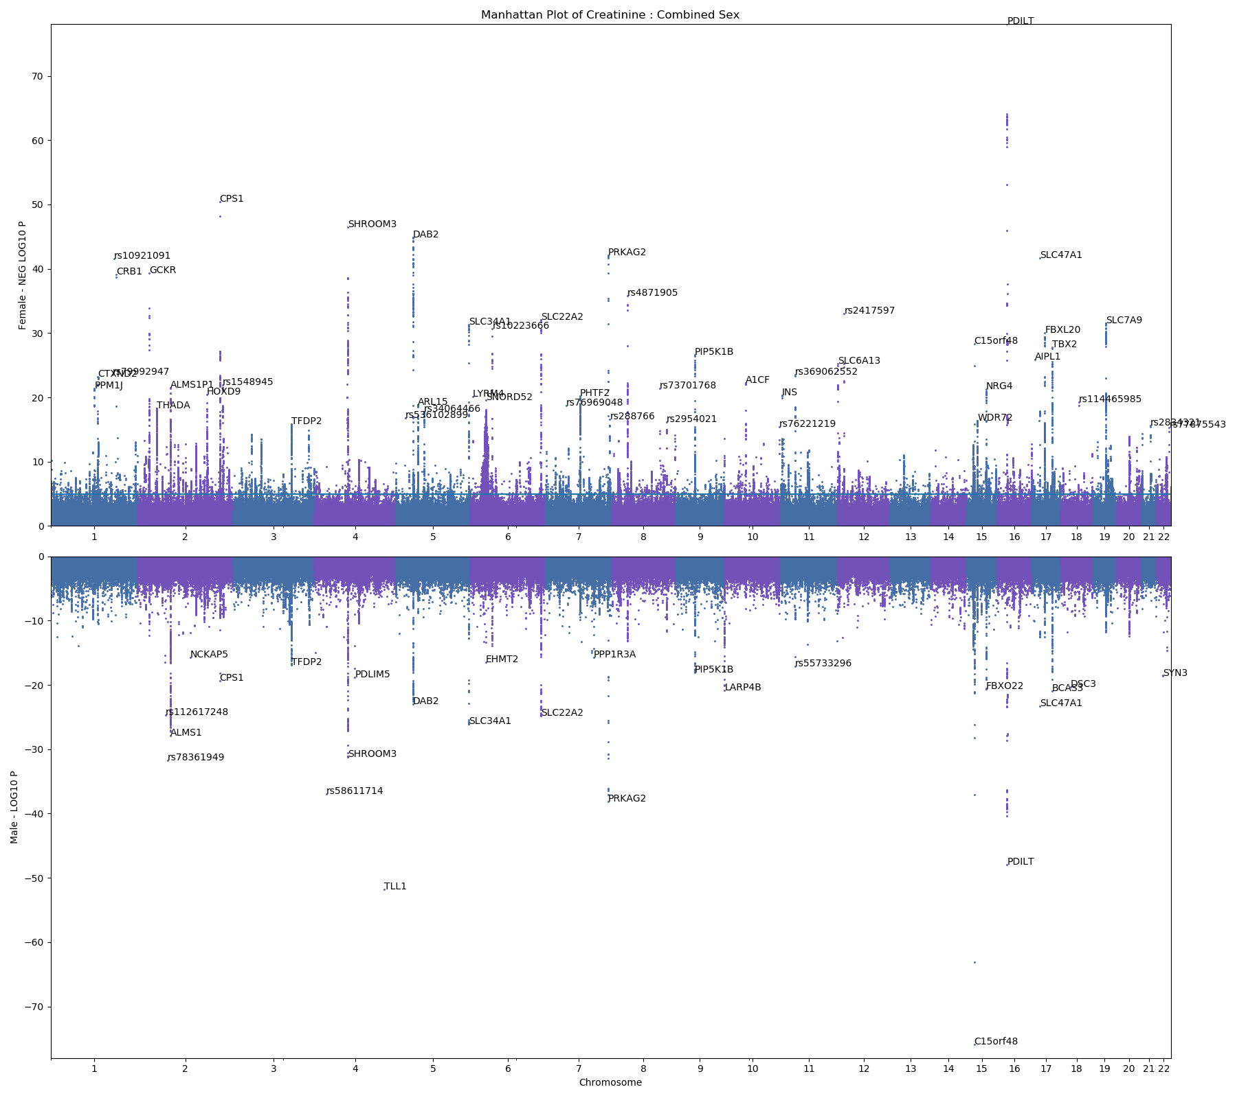

Manhattan plot for male and female GWAS of creatinine

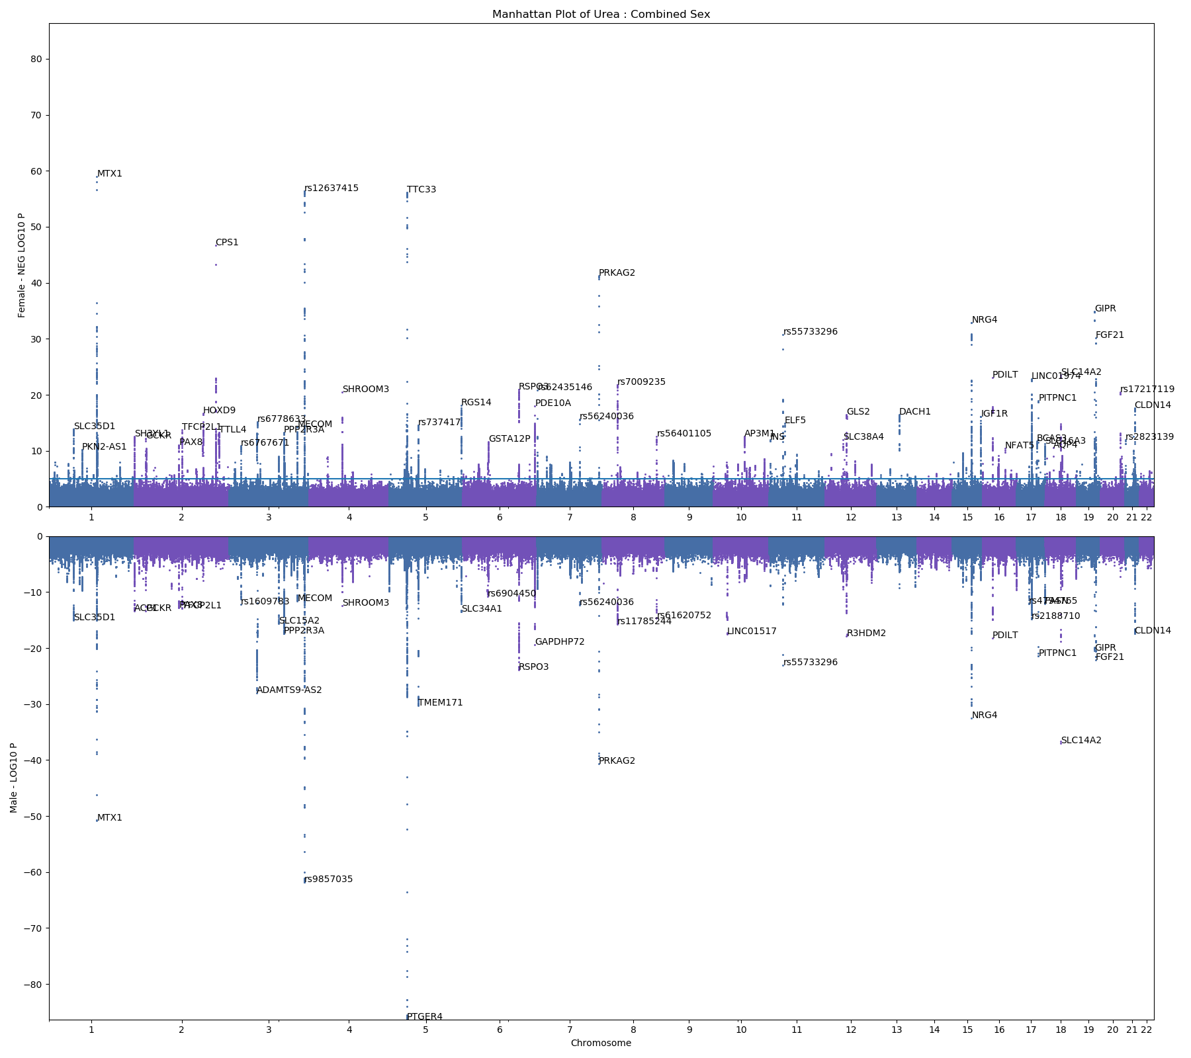

Manhattan plot for male and female GWAS of urea