Zach Evans – Team Leader

Ryan A James - Co-Programmer

Trey Scarborough - Co-Programmer

Zach Czarnecki – Documentation Lead

CSC-406 Banking system final

Team 2

Systems Table of Contents

**Requirements Document4**

**Use Case Diagram**

Open/Close Account6

Savings Account6

Checking Account7

Loan Account8

ATM8

**Activity Diagram**

Open/Close Account9

Savings Account10

Checking Account11

Loan Account12

ATM13

**Sequence Diagram**

Open/Close Account14

Checking/Savings Deposit and Withdraw Transaction15

Overdraft Charge16

Open Loan/Credit Card17

Late Payment17

Close CD18

ATM19

**Class Diagram20**

**Users Manual**

Log-In18

Open/Close Account18

Withdraw and Deposit19

Overdraft Charge13

Open Loan/Credit Card14

Late Payment14

Close CD15

ATM22

**System Manual**

Open/Close Account6

Savings Account7

Checking Account8

Loan Account9

ATM10

**Usability:**

* The Customer shall have access to ATM interface, paper deposits, and/or use of credit cards to make withdrawals and deposits
* Tellers shall have access account balances, recent debits, accounts status (current or behind), loans, withdrawal, deposit, and other account operations such as opening and closing of accounts. Tellers can credit any account they have access to and transfer money between them.
* Managers shall have access to all the same systems and functions as Tellers, in addition to setting up and managing Loans and CDs, including interest rates on payments. They shall send bills each month out to credit and mortgage accounts. They shall also process rollover notices for CDs and set the interest rates paid monthly on checking and savings accounts.

1. **Interface Functionalities:**
   1. **Checking and Saving Account Interfaces:**
      1. The Interfaces shall allow tellers to credit money from checking / saving accounts except CD’s.
      2. The Interfaces shall allow tellers to debit money from checking / saving accounts except CD’s.
      3. The Interfaces shall allow tellers to open and close checking accounts.
      4. The Interfaces shall allow managers to credit money from all accounts.
      5. The Interfaces shall allow managers to debit money from all accounts.
      6. The Interfaces shall allow tellers to open and close saving accounts except CD’s.
      7. The interface shall allow customers to enter a payment amount to balance their credit card account.(payments)
   2. **ATM interfaces:**
      1. The Interfaces shall allow tellers and managers to issue atm cards.
      2. The Interface shall have a “Yes/No” buttons on all warning prompts.
      3. The Interface shall allow customers to choose from savings or credit accounts.
      4. The Interface shall allow customers to input withdrawal amount.
      5. The Interface shall reset every 24 hours.
   3. **Loan interface**
      1. The interface shall allow managers to credit money from all accounts.
      2. The interface shall allow managers to open and close all loan accounts.
      3. The interface shall allow the customer/tellers to choose how much they would like to pay on loan and credit card payment for the month.
      4. The interface shall allow managers to set interest rate of accounts.
   4. **Employee Interfaces:**
      1. The interface shall allow Tellers to pull up all related records of a customer.
      2. The interface shall allow Managers to open and close accounts on request from customer.
      3. The Interface shall allow Managers to make short term or long term loans, as well as set interest rates for each loan
      4. The Interface shall allow Tellers and Managers to assign credit and ATM cards.
      5. The Interface shall have a set of buttons to switch between each account of a customer.
      6. The Interface shall allow Tellers to transfer money amongst accounts.
      7. The Interface shall allow Managers to run reports for credit cards and CD accounts.
      8. The Interface shall allow employees to pull up records of all of a customer's transactions
2. **System Functionality:**
   * 1. The System shall maintain a record of ALL transactions.
     2. The System shall allow for loans to be taken out at on 5, 15 or 30 year plans.
        1. If a loan payment is missed the customer is labeled a problem account.
     3. The Systems shall have an automated system to alert users of when their funds   are to low. This is tied to the overdraw accounts, and the Gold/Diamond accounts. The alert amounts are $50 and $1000, respectively.
     4. The System shall send an alert if a credit card purchase of over $1000 is made.
     5. The System shall keep a record of a customer’s daily ATM usage, and keep them from using that process more than twice a day.
     6. The System shall auto compound interest on savings and loans.
        1. Standard Savings have a daily compound rate
        2. CDs have a fixed rate of return established by management at    creation of the CD
        3. Gold/Diamond have a daily interest rate on all checking and savings accounts of 0.5 x (the rate on the day the account was established)
        4. Account Status is based on the average account balance by adding balance on first and last days of the month divided by 2.
     7. The System shall be able to impose various charges such as bill 50 cents per small withdrawals and deposits on a “That’s my Bank” account, and 75 cents for each automatic debt pay (mortgages, loans, etc.)
     8. The System shall bill no cents per any transaction on a “Gold/Diamond” account.
     9. The System shall assign a late fee of $75 on all missed loan payments.
     10. The System shall assign a fee of $20 on all overdrafted accounts without backup savings set up.
     11. The System shall debit savings accounts for amount overdrafted if that account is setup as a backup account with no fee.
     12. The System shall allow a manager to run reports on a CD or credit card account.
     13. The System shall allow a manager to set interest on checking and savings accounts.
     14. The System shall allow for Stop-Payment for checks issued by “check number”
     15. The System shall allow a user to cancel a transaction at any time; there is a $15 stop payment fee.
     16. The System shall have a checkpoint modification protocol that allows the system to resume where it left off.
     17. The System shall “terminate accounts” by draining the assets to the customer and freezing the account, marking it as inactive.
3. **Screen Functionality:**
   * 1. The Screen shall display a login screen
        1. ATM shall ask for PIN
        2. Teller workstation shall ask for Employee ID and password
     2. The Screen shall display a list of accounts.
     3. The Screen shall allow Management to look at the status of user accounts.
     4. The Screen shall display recent transactions debited to each credit card account.
     5. The Screen shall have an error display for withdrawing more than twice in one day.
     6. The Screen shall have an error display if the user inputs the wrong PIN.
     7. The Screen shall have a display stating change of status for checking accounts.
     8. The Screen shall have a display showing account details such as balance, etc.
     9. The screen shall display a “Are You sure prompt?” on all termination transactions.
     10. The Screen shall display a warning if a withdrawal (ATM) or credit payment (manager) will go over the funds/credit limit of the account in question.

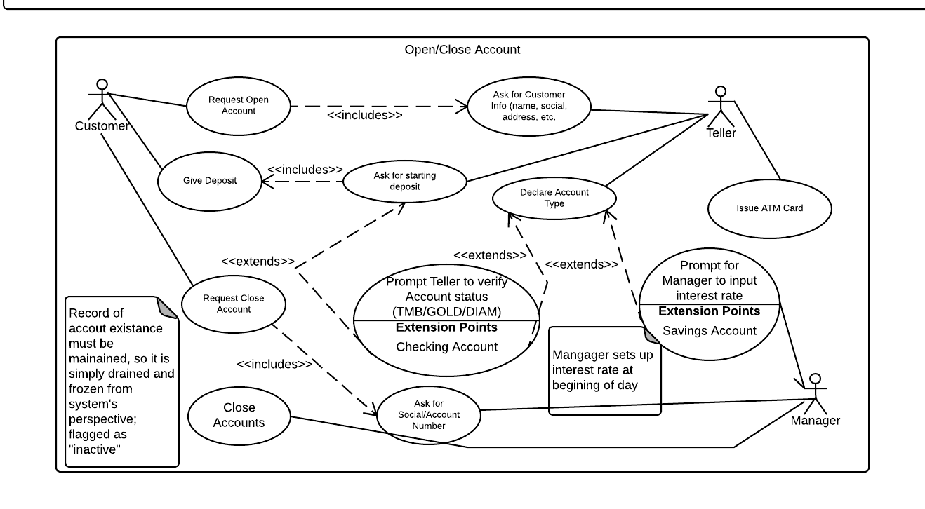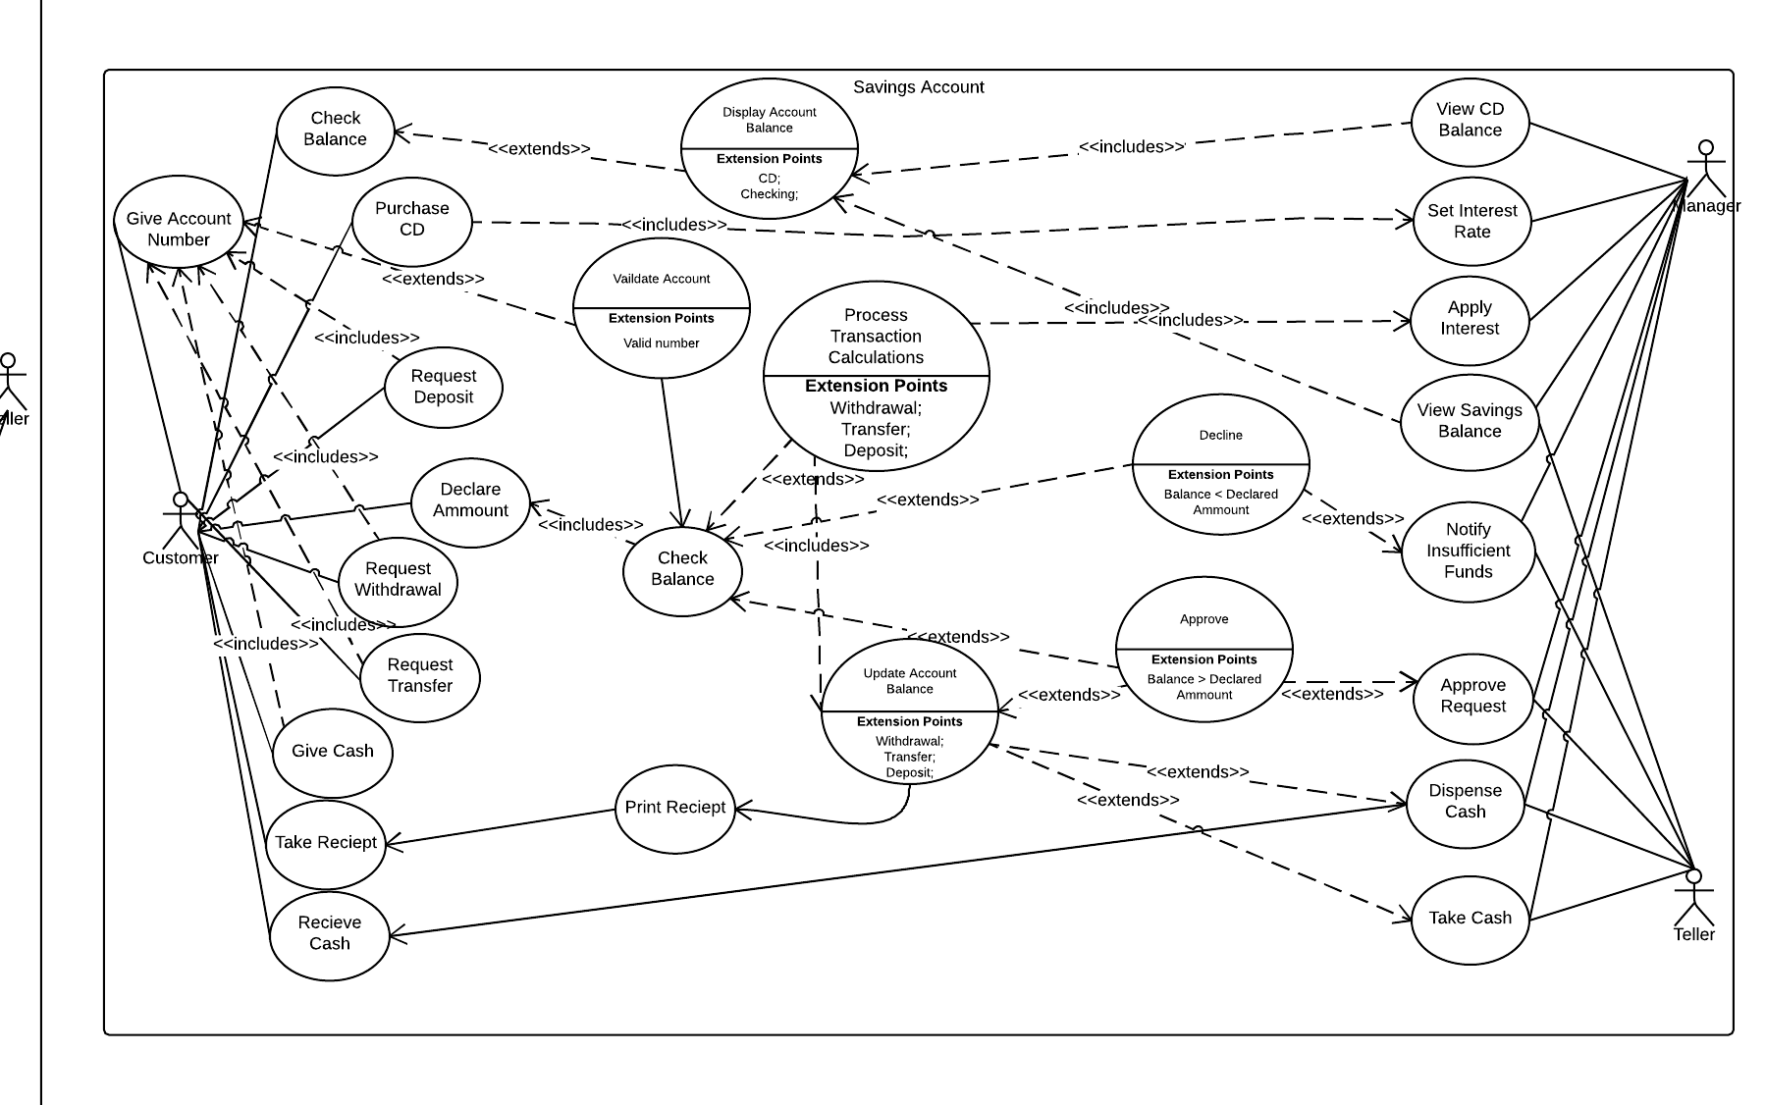

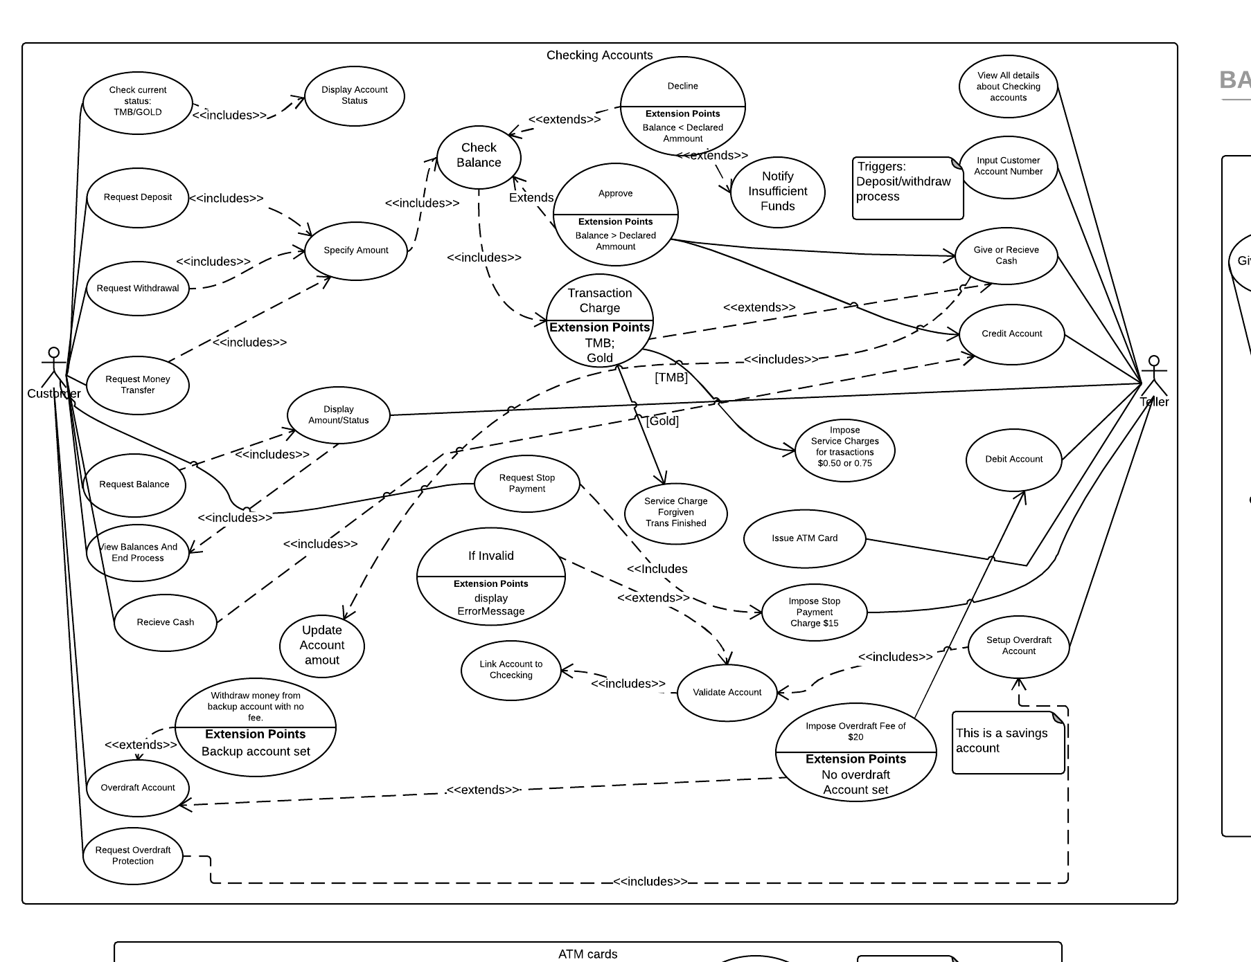

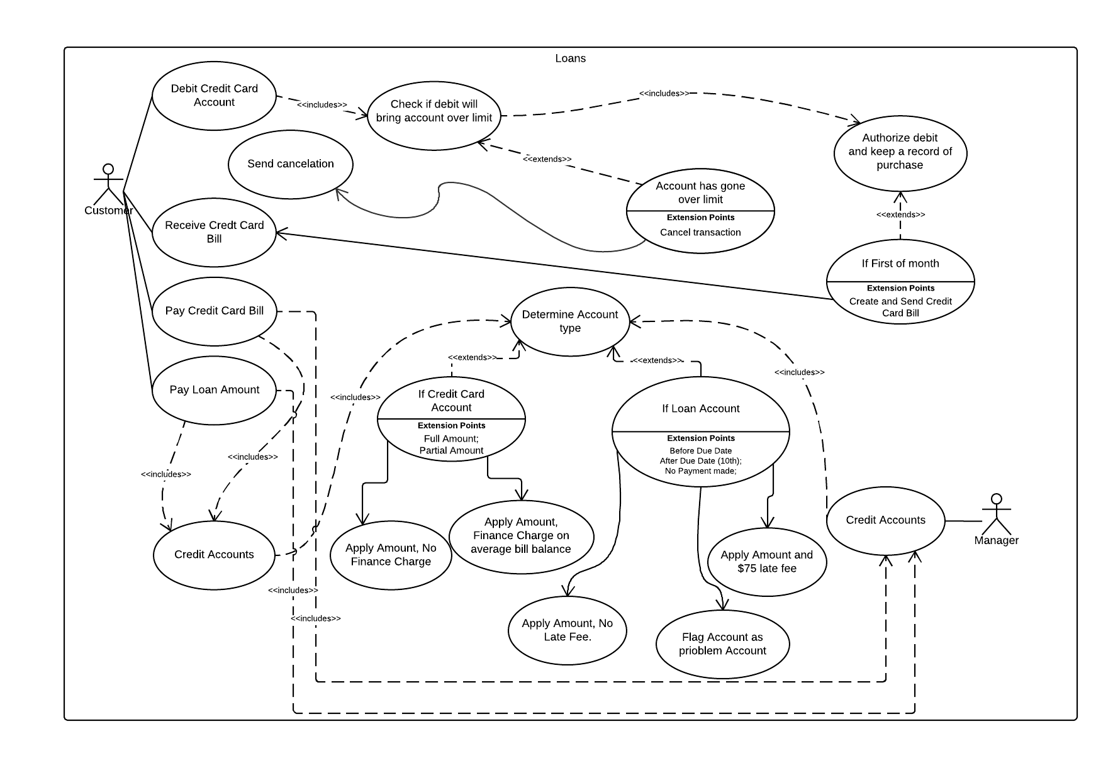

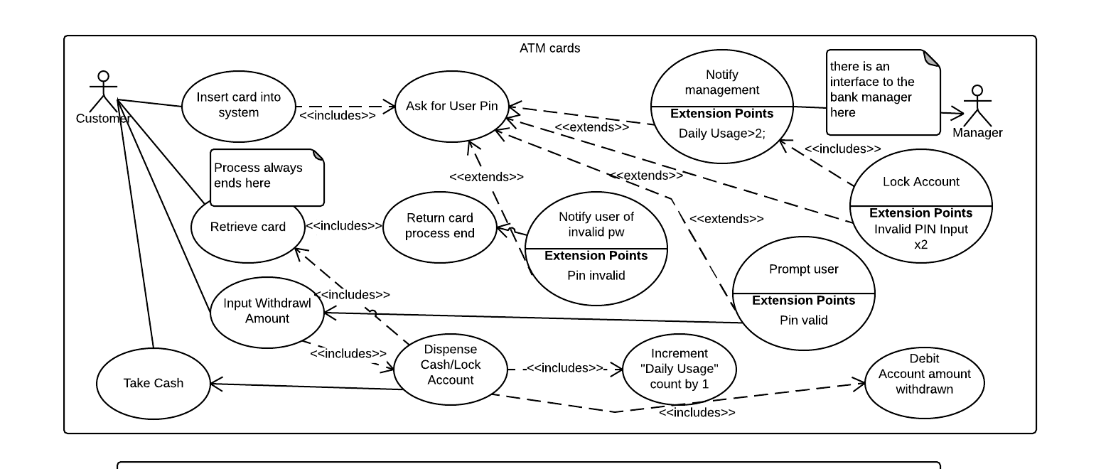

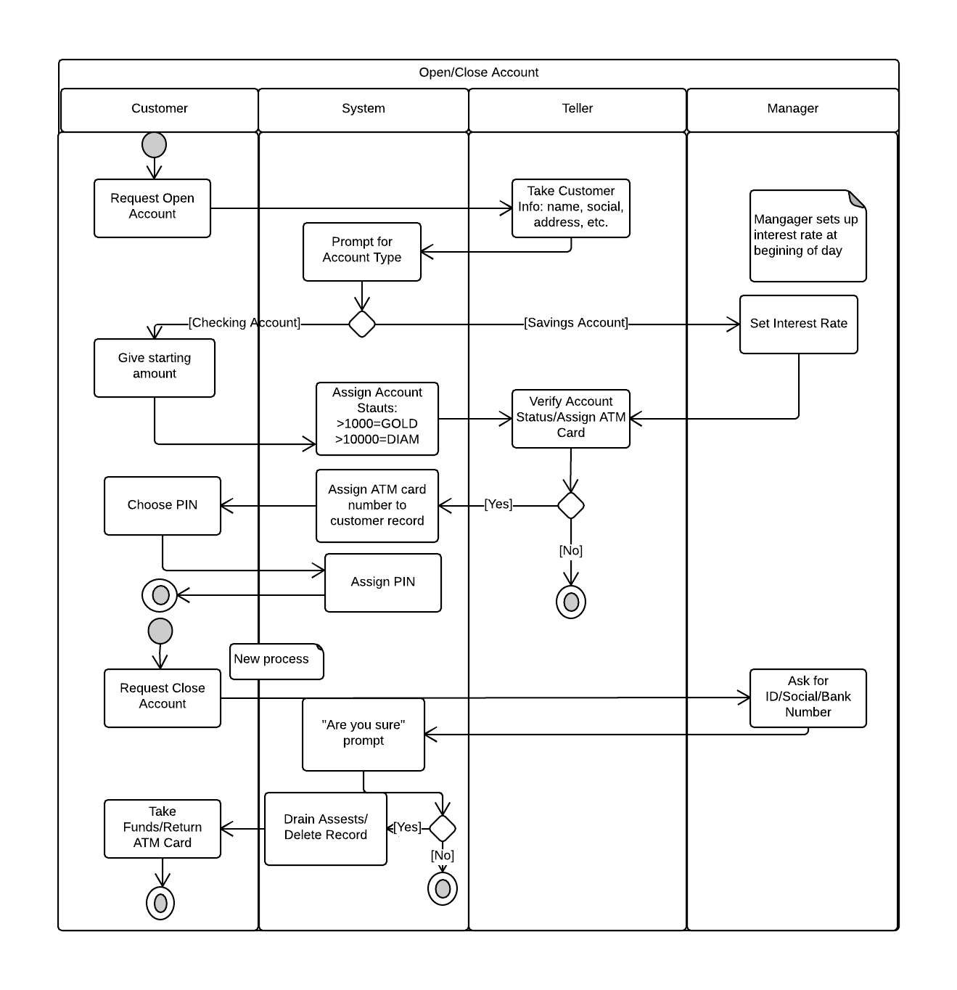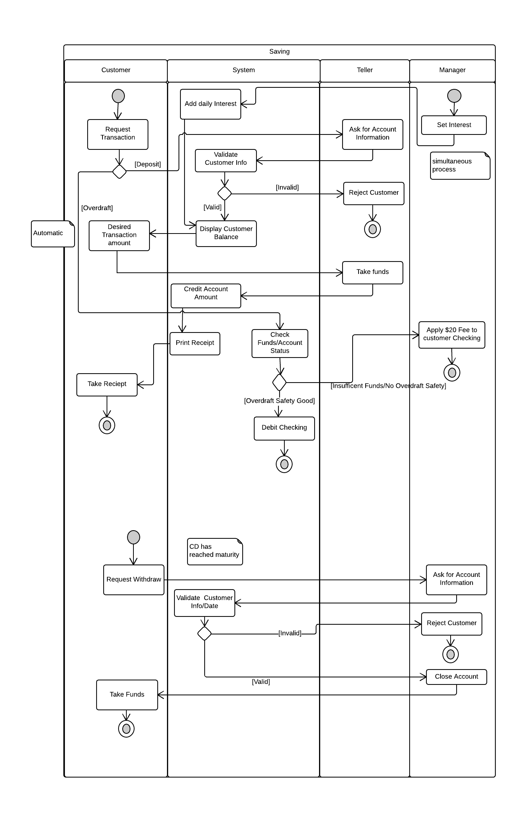

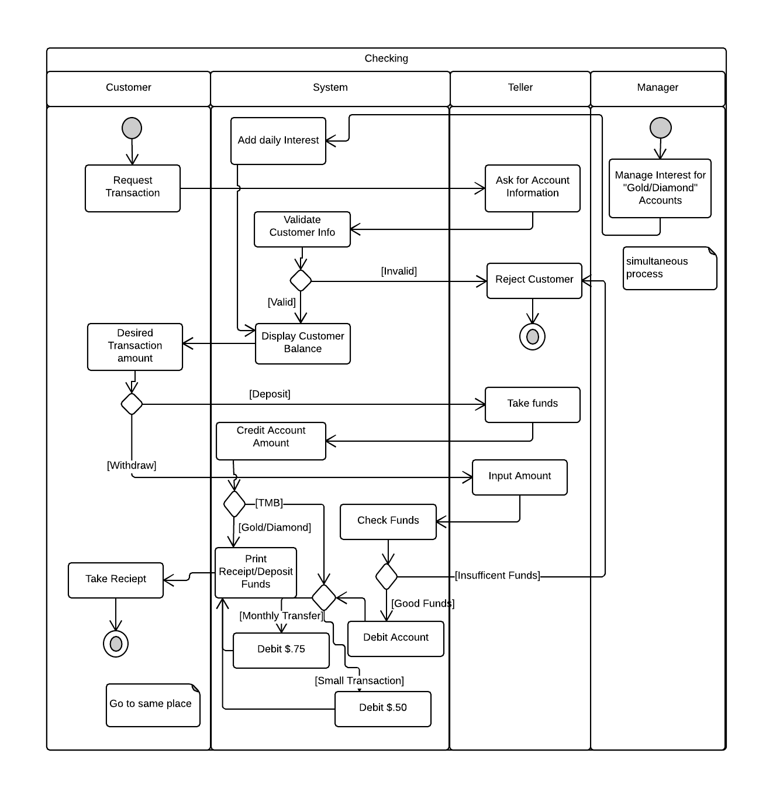

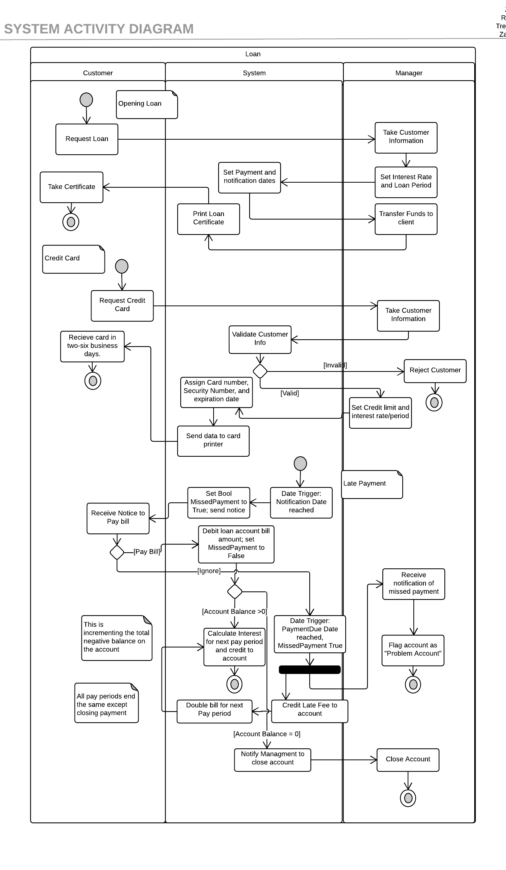

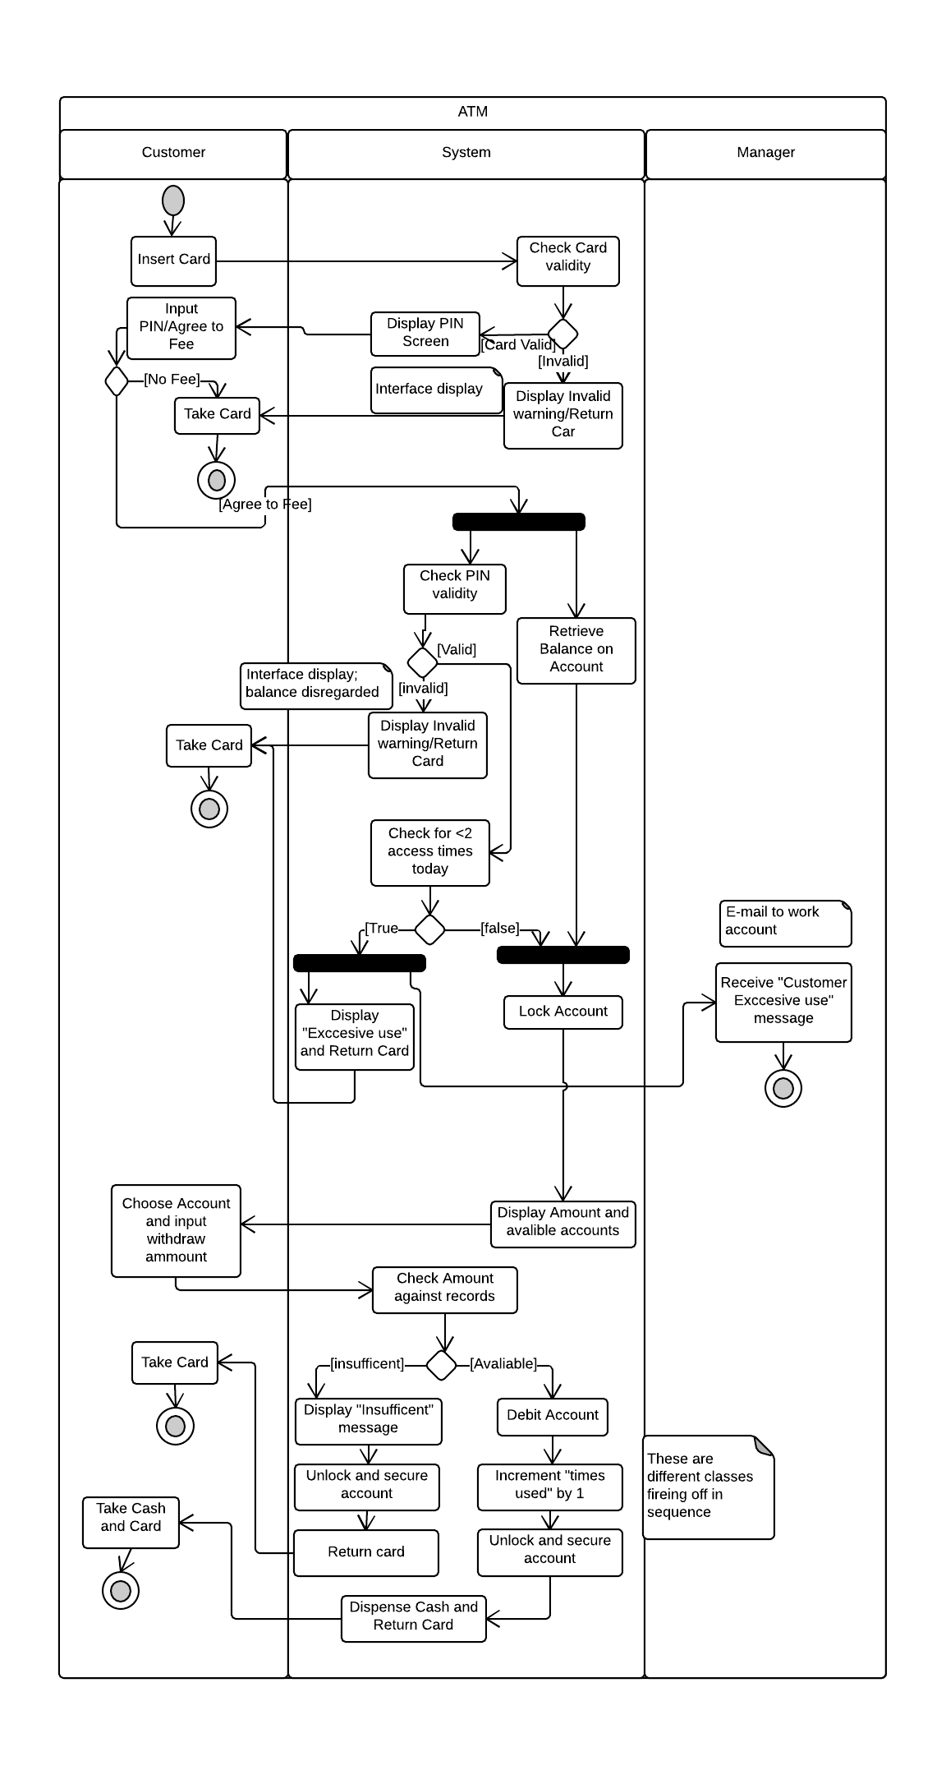

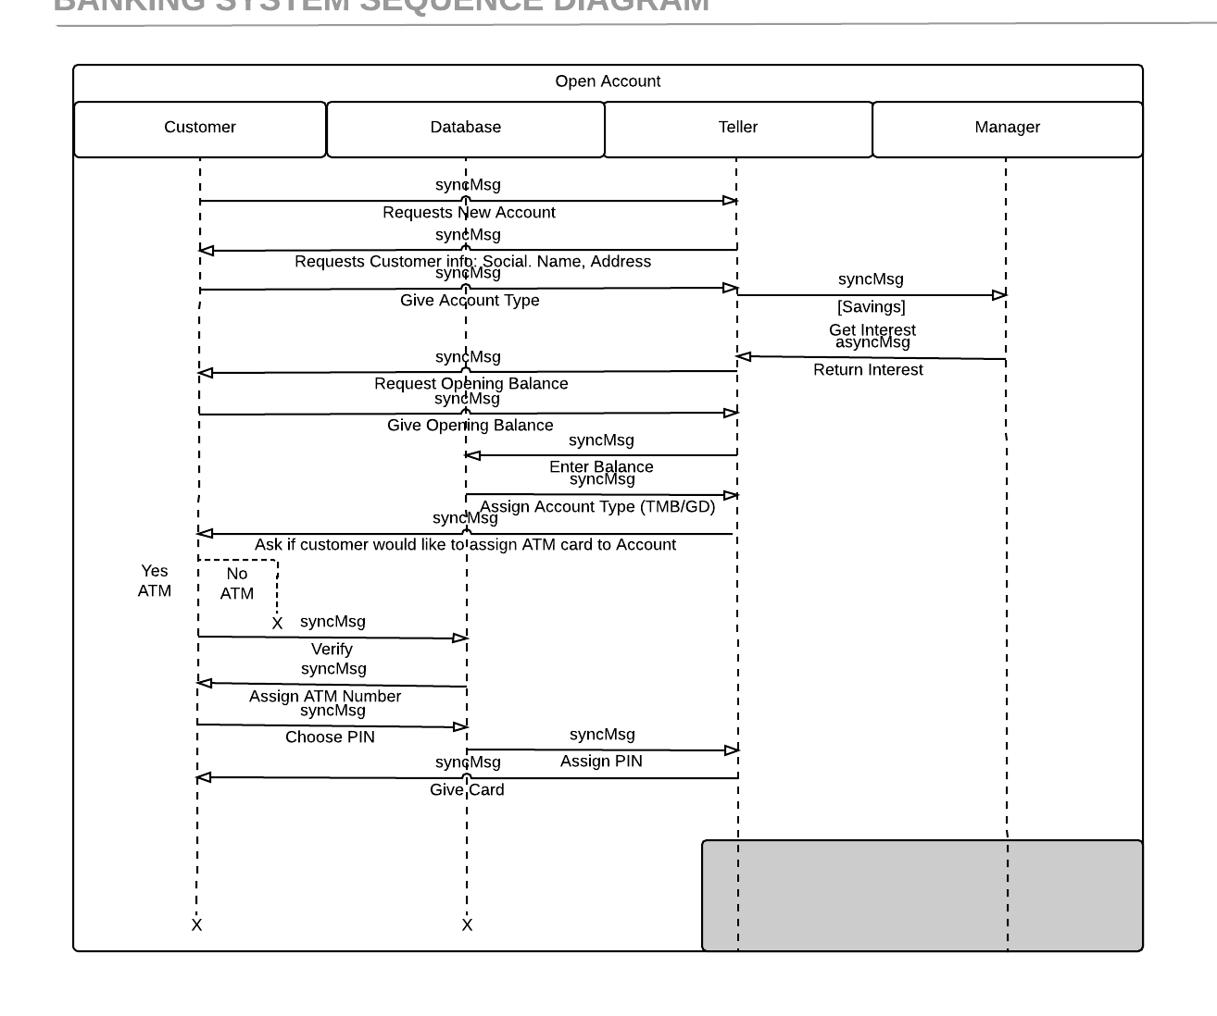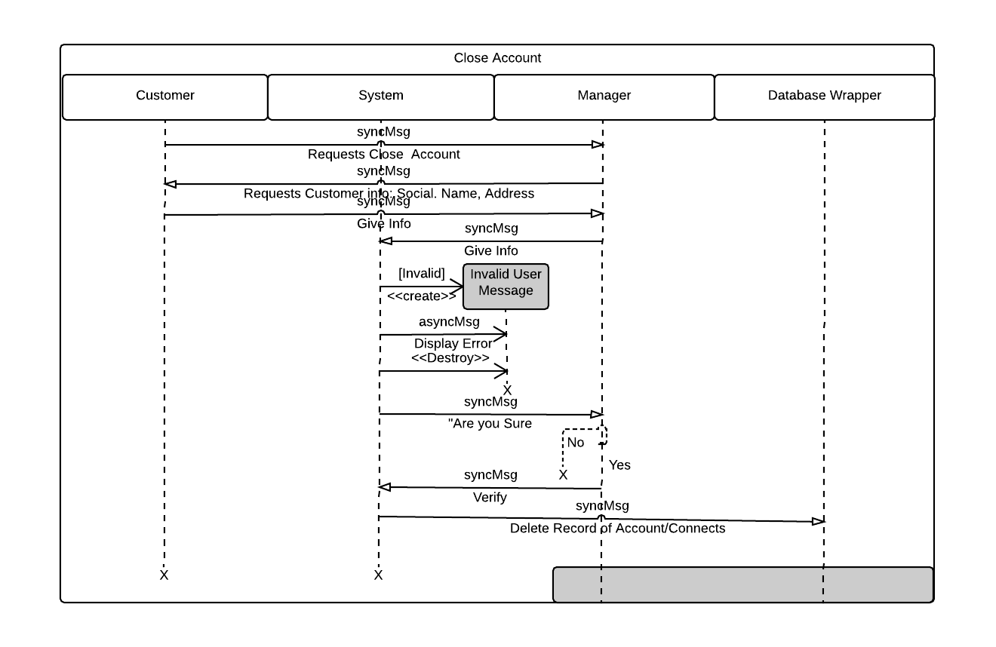

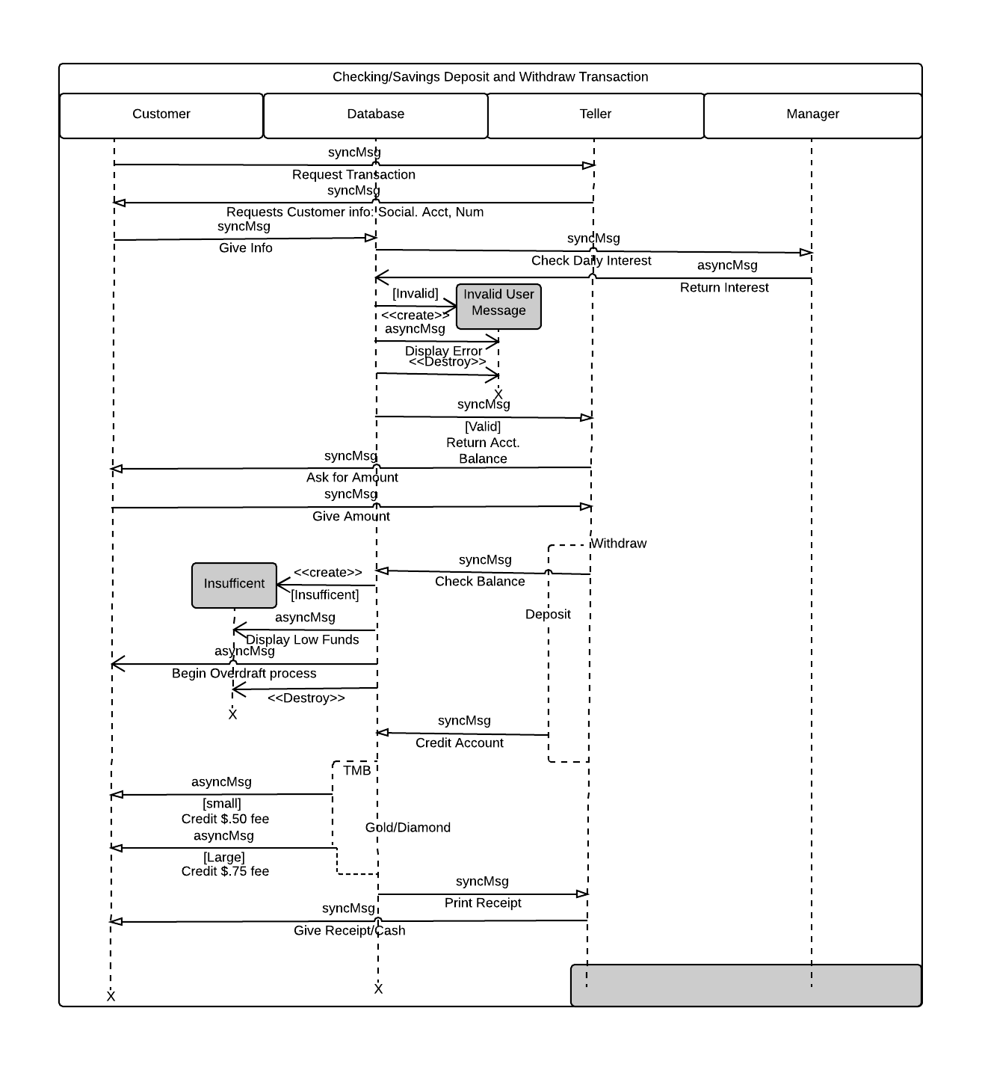

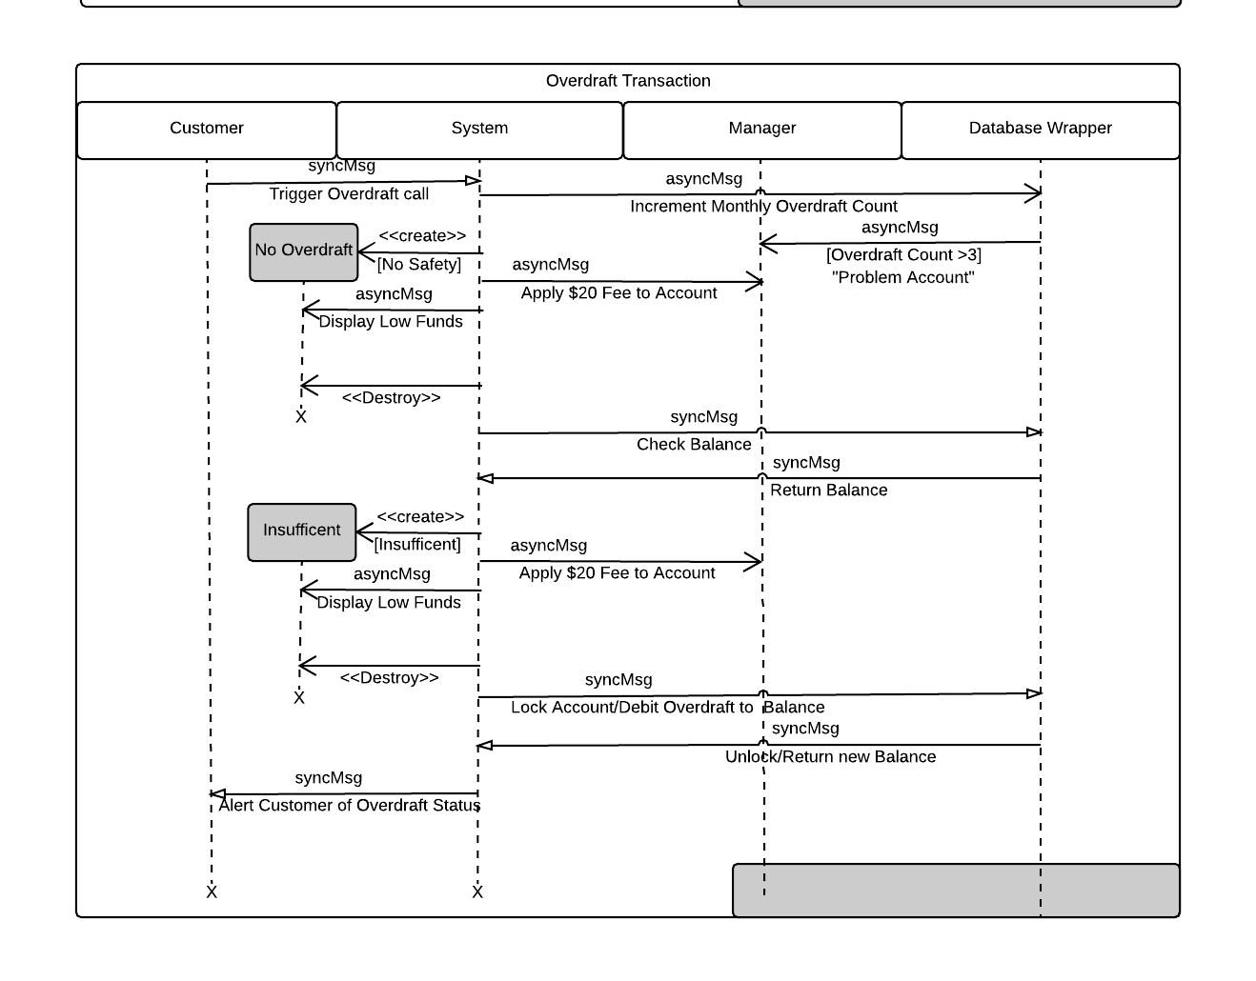

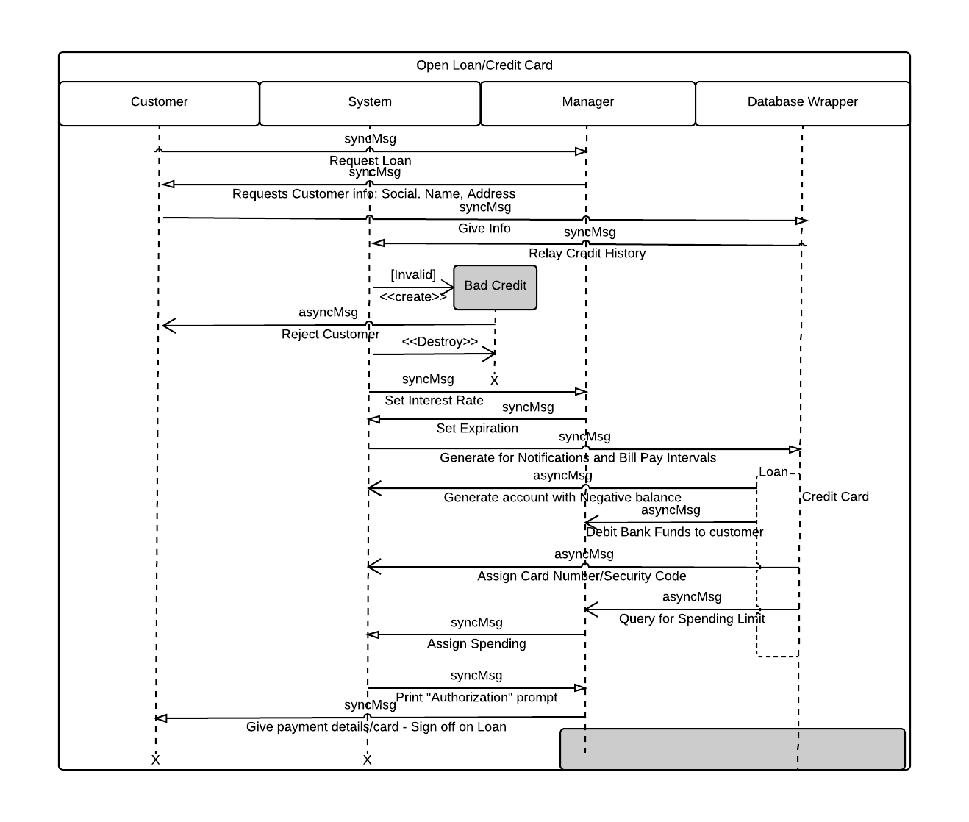

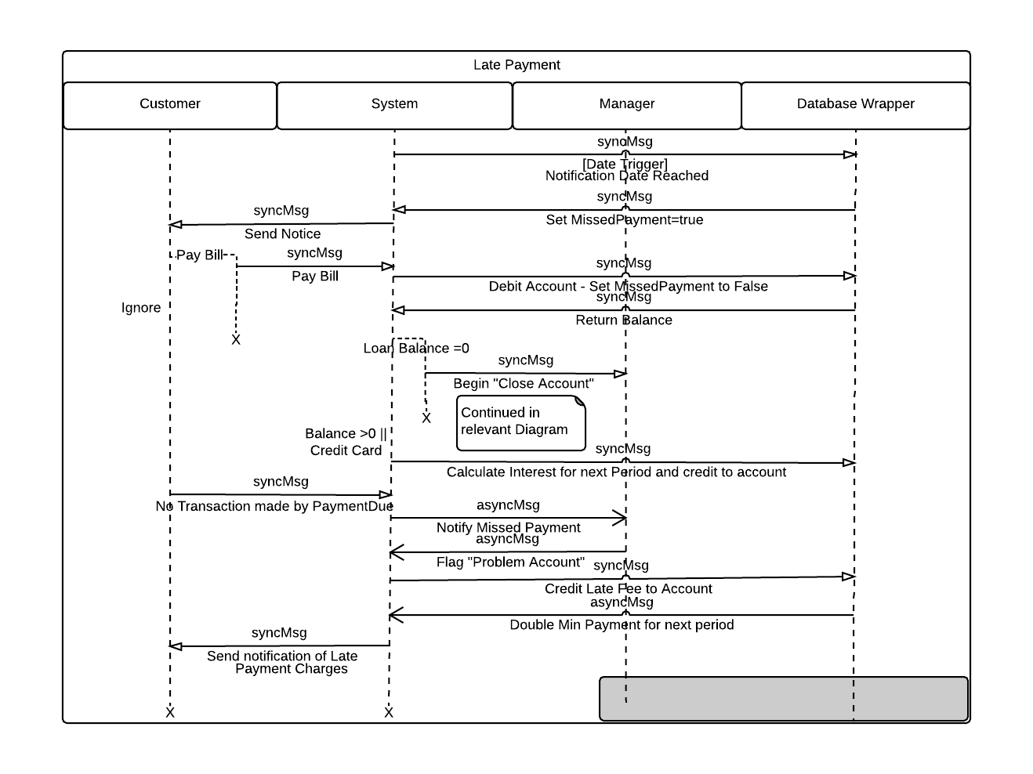

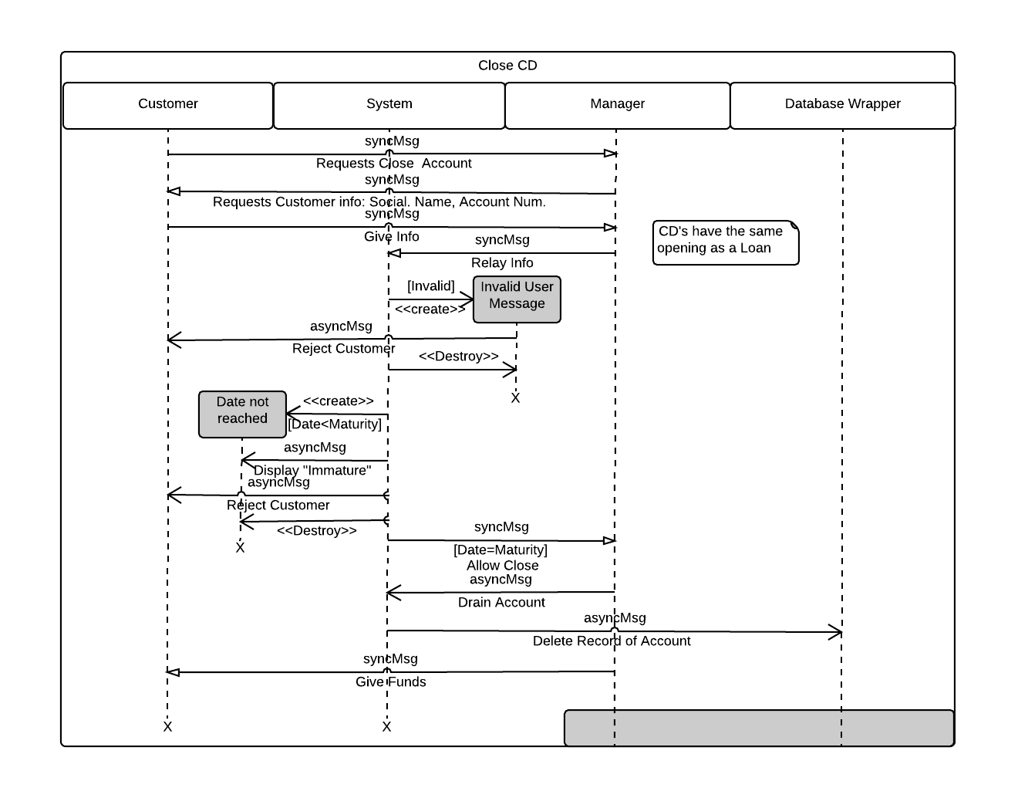 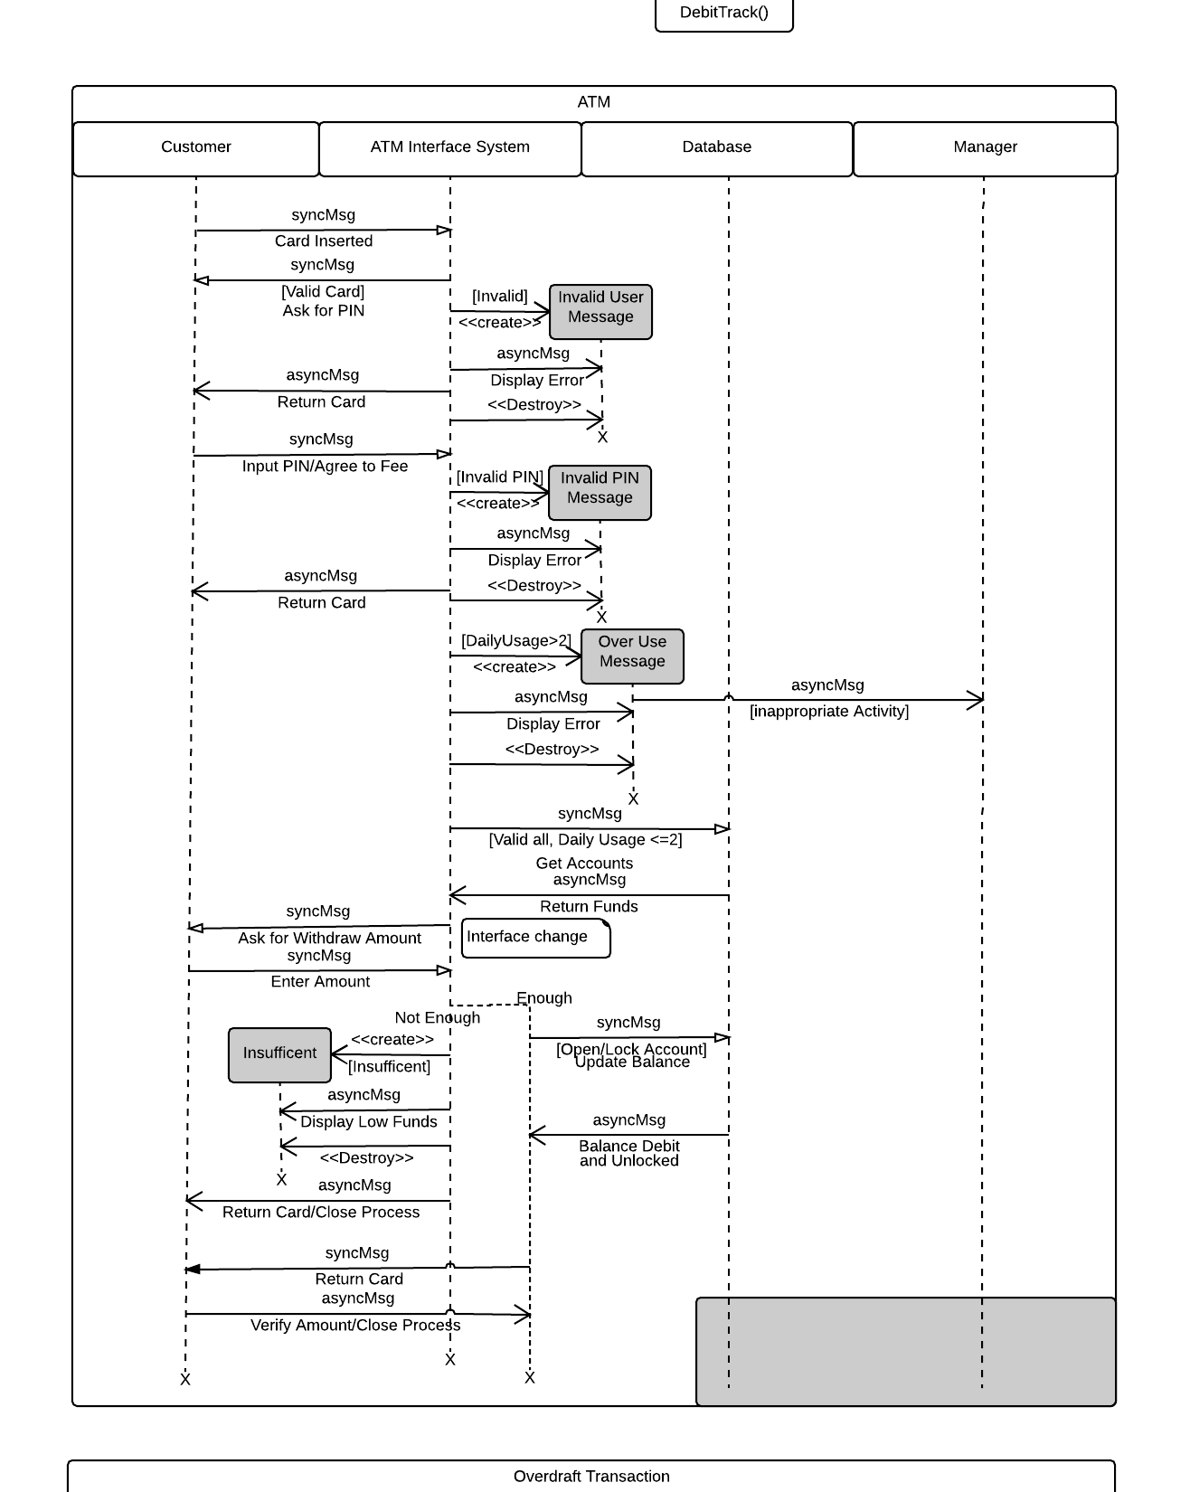

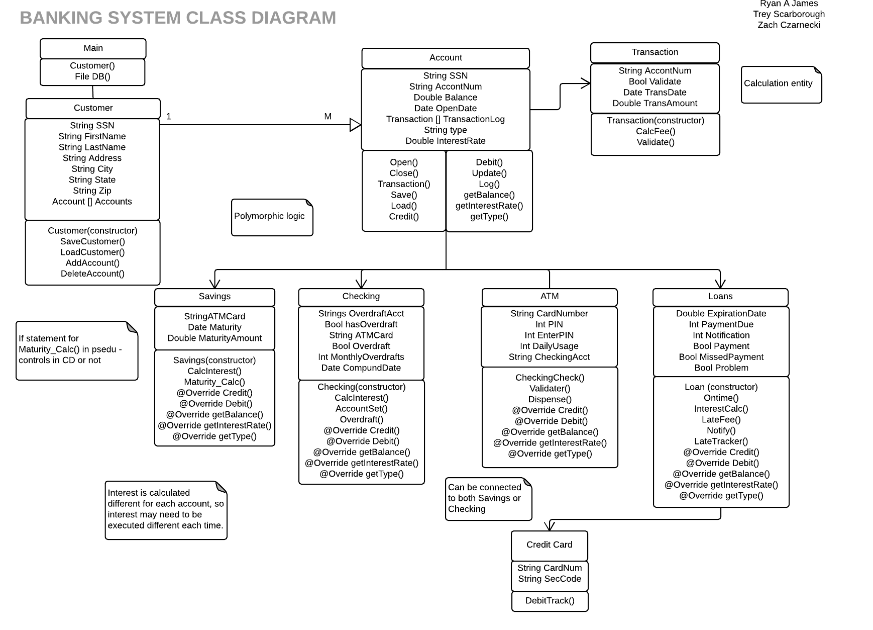

Welcome to Pickett Savings & Loans, the easiest and cheapest way to bank. This manual section will outline all the various functions and systems that rank us one of the “cheapest” and “certainly exists” banks in the nation.

# Log-In

As a bank employee, you will be prompted to enter an employee ID(your own social) as well as a password in order to access the system. Your capabilities will be different depending on if you are a teller or a manager.

# Opening Account

As a teller, you are responsible for making checking and savings accounts.

First, check to see if the customer is already in the system by searching for them based on their social security number.

* If no results pop up, that means they are a new customer. Create a new customer by entering their Social Security number, address, city, state (2 letters), zip code, Last Name, and First Name

Once you’ve found the customer, select which type of account the customer wants: Savings or Checking. Simply enter the initial deposit, and one of two possibilities will happen.

**Savings:**

* Interests rates are assigned daily by management (see Loans). All you as a Teller need to do is enter the starting deposit, and the system will log that interest rate and attach the appropriate amount to the account for the foreseeable future.

**Checking:**

* If a client gives a starting balance of over $1000, or $10,000 they are automatically assigned Gold/Diamond account status. Accounts lower than $1000 are called “That’s my Bank.” Interest is then assigned based on the rate management set at the beginning of the day

Customers also have the option to get and ATM card to access either type of account from any PSL ATM upon opening an account. If they so desire one, ask them what they would like their PIN to be and input into the interface. The system will generate a card number. The information will then be sent to our third-party card printing partners, and the card will be mailed to the customer in 5-10 business days.

# Closing Account

Managers have the ability to close savings and checking accounts on request from the customer/a legally appointed third party. Search for a customer’s accounts based on their social security number.

If such a customer does not exist, the following error will display

If a customer is found, the following warning will display

Choosing yes will drain the account amount from bank assets, and delete the record of the account from the bank data base.

# Withdraw and Deposit

As a Teller, customers come to you for deposits and withdraws.

Step 1: The customer gives you their social security number, and the number of the account they wish to interact with.

* The system checks the validity of the customer information. If it isn’t the following error window is displayed
* At the same time, the system will que up the interest rate for the account to add the daily interest to the account if applicable

Step 2: Ask the customer for the amount they would like to withdraw/deposit.

Step 3: For Withdraw: the system will check that the user has enough funds to make the transaction. If not, the overdraft process is initiated. For Deposit - the amount is simply credited to the account.

Step 4: If the account had under $1000 at the start of transaction (“That’s my Bank”), a fee is applied to the transaction, and debited from the account. $.50 for amounts lower than $500, and $.75 for larger.

Step 5: A digital receipt is displayed/printed.

# Overdraft

This is a safety net a customer can request in the event of an overdraft on either their ATM card, or during an in-person transaction. A customer can request that their savings account can be set up as an “overdraft account” for their checking in the event that they try to withdraw too much from a checking.

The Overdraft process is automatically triggered and works as follows:

1. The system looks to see if that checking account is set up with and overdraft account. If not, then the account is fined $20 for their next interest period.
2. If there is an overdraft account, the system will query the amount of the overdraft. If the overdraft account does not have adequate funds, the $20 fee is still applied.
3. If the account does have adequate funds, the extra funds are automatically withdrawn from that account.

Customer accounts are flagged for each instance of an overdraft. Those with more than 3 in one month are “problem accounts.”

# Opening Loan, CD or Credit Card

Managers are the only people with this ability. Similar to opening a savings or checking account, the manager must first ask and input the customer’s Social Security Number, name and Address. Only pre-existing customers may open a loan/CD/credit account.

With this information, the system will query the client’s credit history* and relay it back for interest calculation purposes. This step is skipped if applying for CD.

*A base score will be used across all accounts in the demonstration

If the customer has bad credit, the system will reject them. If they have good credit, the system will give a recommended Interest Rate, though the manager has the ability to overwrite this.

* If a customer wishes to open a CD, they give an initial deposit at this point

The manager must then set an expiration/maturity rate for the account. From here, the system will generate bill pay and notification intervals, and create the account.

* If it is a Loan, a negative account will be created with a debit of the requested loan amount, and the funds will be credited to the customer/customer’s checking account. The starting balance is the negative of amount loaned out
* If it is a credit card, the database will assign a Card number and Security code to the account, and prompt for a spending limit to be set by the manager. The starting balance is zero.
* If it is a CD, then there is no additional step here. The balance is the starting investment.

The display will then print out a confirmation of the establishment of the account. Credit cards will be mailed to the customer in 5-10 business days.

# Notification and Late Payment

The system is set up to automatically track the pay period and lateness of payment on a loan or accrued spending on a credit account. Once a date is reached (usually 5 days before the due date of the payment for that month), the system will send an e-mail to the customer, as well as setting an alert variable (MissedPayement) to true.

1. They pay the bill:
   1. The amount is debited to the account, and alert variable is set to false, and the customer goes about their day.
   2. The system then calculates the interest for the next pay period and credits it too amount.
   3. If it is a loan account and the balance is $0 the closing process initiates.
2. The Bill is not paid:
   1. If the variable has not been reset to false by the date of payment, management is notified to set the account to “Problem account.”
   2. The database will then credit a late fee to the account balance of $20.
   3. The bill pa amount for the next period is doubled.
   4. The customer is sent a notification of all this.

# Closing CD/Loan

While Credit Cards will reset on reaching their expiration date (this process is automatic in the system), a CD or Loan reach a maturity date. For loans, the maturity date is more of a calculated estimation of when the account will reach a balance of $0, but for CD’s it is when the customer can cash out the accrued interest.

Again, the customer gives their social security number, name, and account number. If the system detects that the account has not matured, or that the information provided is incorrect, then it will reject the customer.

If the date has been reached, the system will drain the funds of the CD to the customer/customer’s checking account, and delete the record of the account from the database.

# ATM

The following are simple instructions on how to use a PSL ATM/Customer Interface.

1. Insert card/input card number
2. If the card is valid, a prompt will appear asking for the User’s Pin. Otherwise, they are rejected and the card is returned.
3. If the PIN is valid, the customer’s daily usage is checked and incremented. If the usage is already greater than 2 they are rejected and the card is returned.
4. If the Usage is allowable, the funds attached to the card are returned and displayed.
5. From here the user is allowed to input the funds they wish to withdraw.
6. The user inputs the desire amount and the system checks available funds. If there are not enough funds, the following error displays and the card is returned.
7. If there are enough funds, the account is debited and the following message is displayed. The card is returned.